What’s the line?
Through the contexts of landing planes and sinking battleships, students explore graphing using the gradient and$y$-intercept, as well as finding the equation of a line using the gradient and $y$-intercept.
Students will need at least one digital device per pair to interact with Desmos during this lesson.

Visible learning

Learning intentions
- To be able to graph a straight line.

Success criteria
- I can explain how to find the gradient and the $y$-intercept from a graph.
- I can explain how to find the gradient and the $y$-intercept from an equation
- I can write the equation of a line given the graph.
- I can graph the equation of a line using the gradient and $y$-intercept.

Syllabus outcomes
- develops understanding and fluency in mathematics through exploring and connecting mathematical concepts, choosing and applying mathematical techniques to solve problems, and communicating their thinking and reasoning coherently and clearly MAO-WM-01
- determines the midpoint, gradient and length of an interval, and graphs linear relationships, with and without digital tools MA5-LIN-C-01
- graphs and interprets linear relationships using the gradient/slope-intercept form
MA5-LIN-C-02
Mathematics K–10 Syllabus © NSW Education Standards Authority (NESA) for and on behalf of the Crown in right of the State of New South Wales, 2022.

Activity structure
Please use the associated PowerPoint What’s the line to display images in this lesson.

Launch
- Print Appendix A ‘Less, same, more’ on A3 paper.
- Place each sheet in a plastic pocket and place the pockets on walls around the room using adhesive putty.
- Working in visibly random groups of 3 (bit.ly/visiblegroups) on vertical non-permanent surfaces (bit.ly/VNPSstrategy), students are to complete Appendix A ‘Less, same, more’ by sketching straight lines that have a gradient or y-intercept, less, the same or more than the one provided.
- Students are to go on a gallery walk (bit.ly/DLSgallerywalk) and complete TAG feedback (bit.ly/TAGstrategy) for another group’s work.

Explore
- Display slide 2 of the PowerPoint What’s the line, which displays a line graph.
Figure 1 – line graph
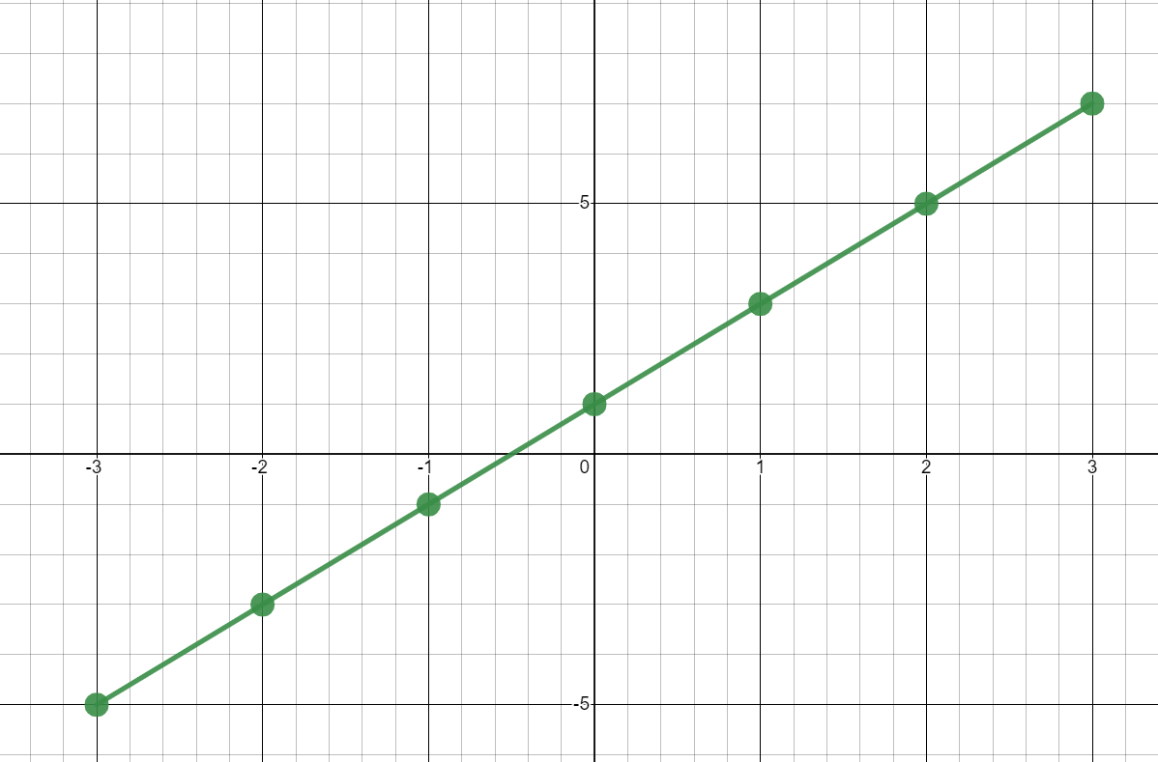

- Working in visibly random groups of 3 at vertical non-permanent surfaces, challenge students to create a correct equation for the line, and then as many incorrect equations as they can. Their incorrect equations should be based on common errors that they think students might make when finding the equation.
- Combine groups with another group and ask them to compare and discuss the incorrect equations they created. They should explain to each other the errors they thought that students would make.
- Still in their random groups of 3, challenge students to create a correct graph for the equation $y=3x-5$ and as many incorrect graphs as they can. Tell students they are not allowed to use a table of values to create their graphs. Again, challenge students to consider common errors when creating their incorrect graphs.
Encourage students to use the information they know from the equation to create their graphs. For instance, the gradient and $y$-intercept. You may need to prompt students to consider how we define the gradient of a line. They can then be prompted to draw a line with the given gradient.
- Again, combine each group with a different group and ask them to compare the strategies they used to create their correct graph and discuss the incorrect graphs they created. They should again explain to each other the errors they thought that students would make.
- Use a Pose-Pause-Pounce-Bounce [PDF 200KB] (bit.ly/pausepouncebounce) questioning technique to share the strategies that students used to create their correct graph.
- Assign students the Desmos activity ‘Land the plane’ (bit.ly/desmosplaneactivity) to practice their skills of finding equations that land the plane on the runway.
For students to access this activity, you must set up a Desmos classroom and assign the activity. Instructions to do so can be found on the Desmos website (bit.ly/desmosclassroomstrategy).

Summarise
- Watch the video ‘Drawing linear graphs using gradient and intercept - Corbettmaths’ (3:36) (https://bit.ly/GraphingWithGradient). Slides 2–5 of the PowerPoint ‘What’s the line?’ could be used to supplement this explanation.
- Students are to complete Appendix B ‘Worked examples’. This gives students an incorrect worked example followed by a correct worked example on graphing with gradient and y-intercept and prompting questions to promote thinking.
- Students are to create notes to their future forgetful self (bit.ly/notesstrategy) on how to graph equations using the gradient-intercept form and how to find the equation given a graph.

Apply
- Students, in pairs, are to complete Appendix C ‘Battleship’. In this activity students create equations of lines to sink battleships against an opponent. They can play this multiple times. Instructions for play are included in Appendix C.
- Students are to complete Appendix D ‘Battleship Exit ticket’. This poses a scenario from the game just played and asks the students to explain their thinking on how to approach creating a line that sinks the battleship.

Assessment and differentiation

Suggested opportunities for differentiation
Launch
- For vision impaired students, create graphs on a geoboard with pins and elastics or string.
- This activity deliberately has no numbers associated with the gradient or y-intercepts. Teachers could choose to provide numbers for the centre graph.
Explore
- Encourage the students to consider things they could do incorrectly when creating their graphs or equation and to use these mistakes for their incorrect examples.
- This activity is designed to address common misconceptions and for students to be aware of these when completing future problems.
- Students at this point have only graphed equations using tables of values. Advancing questions could include:
- What information does the equation tell us?
- What information does the gradient tell us?
- Can you draw a line with the given gradient?
- How would you use the $y$-intercept to graph your line?
Apply
- Students can be given a Cartesian plane each to play Battleship, before putting them on the same Cartesian plane.
- Students could play a game against the teacher to begin with as a class to understand the rules.
- Students may be extended to the point gradient formula to find the equation of lines.

Suggested opportunities for assessment
Launch
- The Less, same, more activity establishes if students understand that the larger the numerical value of the gradient, the steeper the line. It also assesses whether students understand where the y-intercept appears on the graph. Teachers should monitor student conversations during this activity to assess for misconceptions.
Explore
- Teachers can use this activity to formatively assess whether students can write an equation from a given graph.
Summarise
- Student ‘notes to their future forgetful self’ could be collected to check for misconceptions.
Apply
- The exit ticket provides students with the opportunity to explain their thinking and to demonstrate their problem-solving skills.

Appendix A

Less, same, more
Complete the table below by sketching straight lines that have a gradient or y-intercept, less than, the same or more than the one provided.
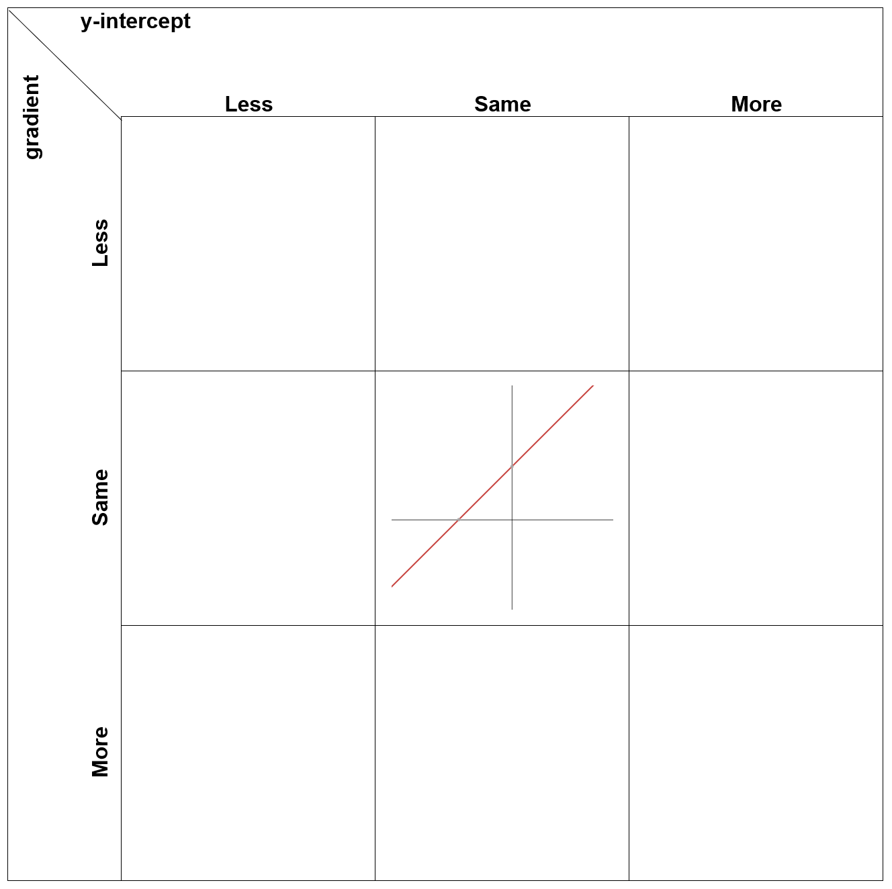

Appendix B

Worked examples

Incorrect example
Charlie didn’t graph this equation correctly.
The equation they needed to graph was: $y=\frac{1}{4}x+2$.
Their work can be seen below:
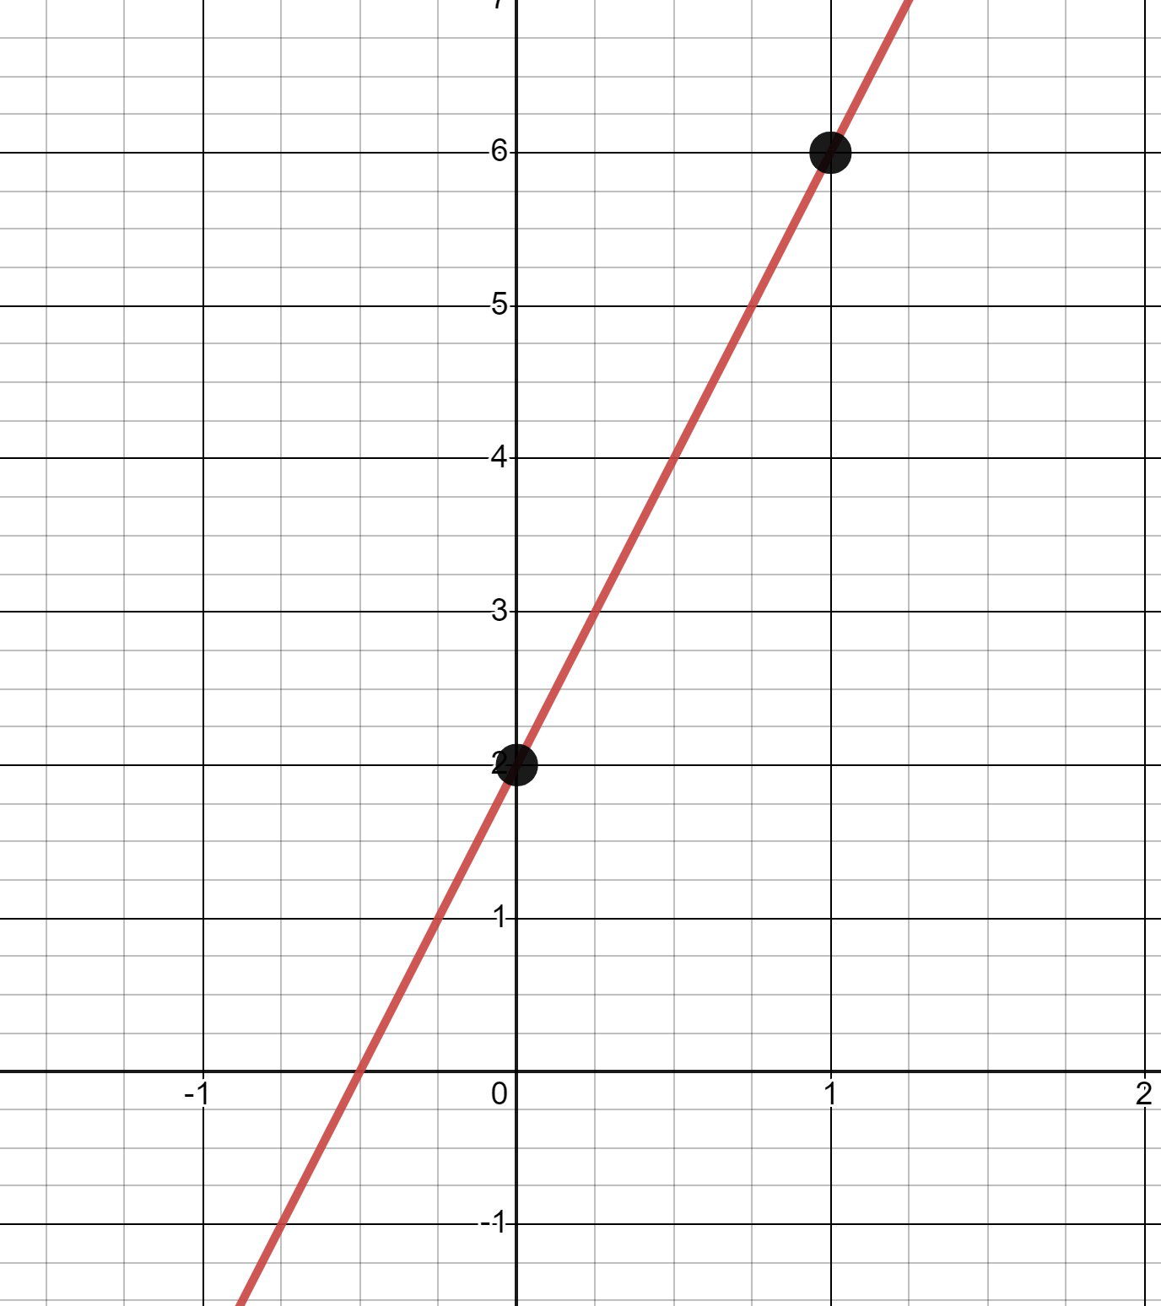
- Charlie incorrectly graphed the gradient. What gradient did they graph?
- How many units up and to the right from the point (0,2) should Charlie have gone when graphing this gradient?
Up:
Right:
- Correctly graph the equation $y=\frac{1}{4}x+2$
- Your turn, graph $y=3x-4$.

Correct example
Quinn graphed this equation correctly.
They graphed $y=-x-3$
Here is their work.
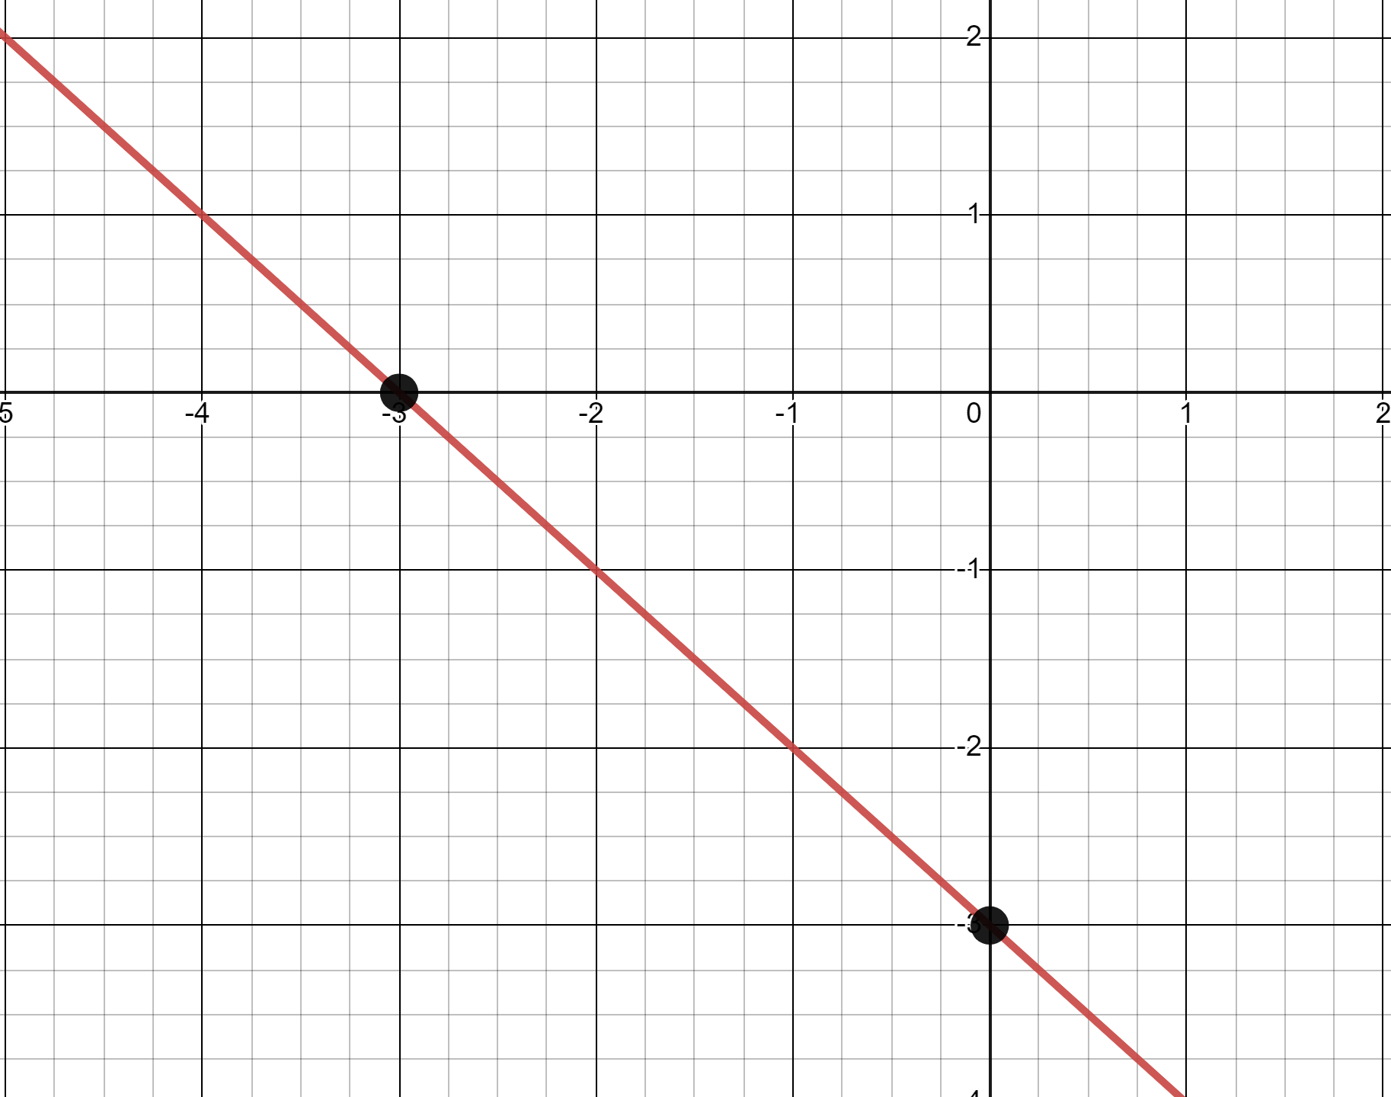
- How did the negative sign in this equation affect the graph?
- How did Quinn know what the gradient was when there is no coefficient in front of $x$?
- Your turn to graph $y=-x+2$.

Appendix C

Battleship

Rules
Note: there is only one game board for both sets of boats so you will see each other’s boats the entire game. This means you can be strategic and hit more than one ship at once, but you cannot hit your own ship.
- Each player picks a different colour.
- Each player draws the 3 ships below on the same Cartesian plane:
- Battleship (4 points)
- Destroyer (3 points)
- Submarine (2 points)
Ships may be placed horizontally or vertically, but not diagonally.
- To get a hit, write an equation in gradient-intercept form that crosses through a point that an enemy ship occupies. You cannot use horizontal or vertical lines.
- Graph the equation. Record the move on your attack log and mark an ‘X’ on any points of a ship you have hit.
- Your aim is to sink all of your opponent’s ships.

Game board
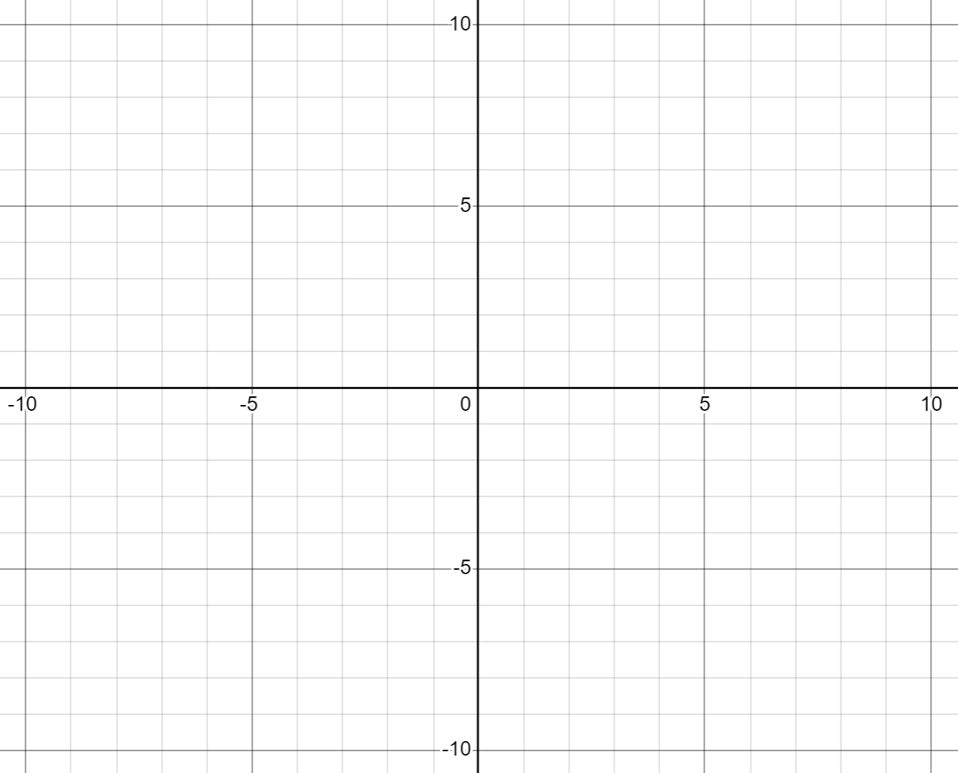

Attack log
Player 1 | Player 2
Name: | Name:
Colour: | Colour:
Equation 1:  Ordered pair hits: | Equation 1:  Ordered pair hits:
Equation 2:  Ordered pair hits: | Equation 2:  Ordered pair hits:
Equation 3:  Ordered pair hits: | Equation 3:  Ordered pair hits:
Equation 4:  Ordered pair hits: | Equation 4:  Ordered pair hits:
Equation 5:  Ordered pair hits: | Equation 5:  Ordered pair hits:
Equation 6:  Ordered pair hits: | Equation 6:  Ordered pair hits:
Equation 7:  Ordered pair hits: | Equation 7:  Ordered pair hits:
Equation 8:  Ordered pair hits: | Equation 8:  Ordered pair hits:
Equation 9:  Ordered pair hits: | Equation 9:  Ordered pair hits:
Equation 10:  Ordered pair hits: | Equation 10:  Ordered pair hits:

Appendix D

Battleship exit ticket
You are playing gradient-intercept Battleship. You opponent has placed a ship as shown in the image below.
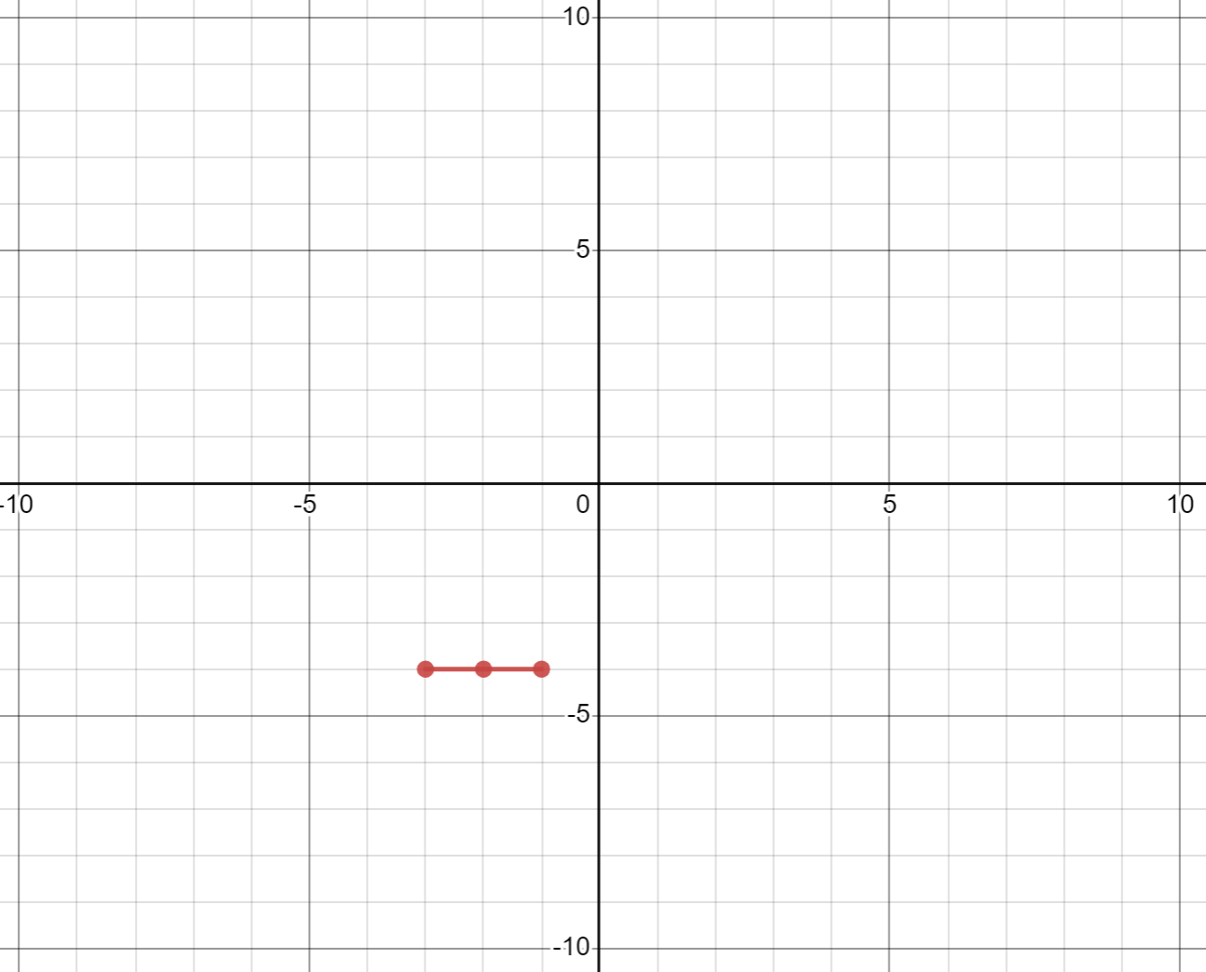
- Write 3 equations in gradient-intercept form that you would use to sink this ship, and state which point each equation passes through.
- Graph the equations on the Cartesian plane.
- Explain the strategy you used to play this game. You might discuss what you thought when selecting your equations, where you placed your ships, or how you changed your strategy while you played the game.

Sample solutions

Less, same, more
Complete the table below by sketching straight lines that have a gradient or y-intercept, less than, the same or more than the one provided.
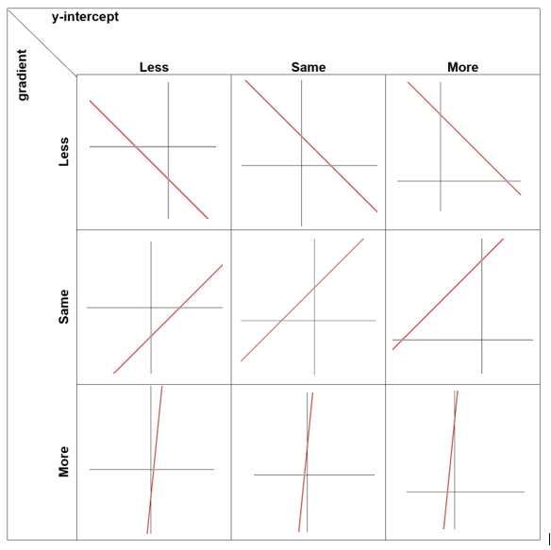

Appendix B – incorrect worked example
- They graphed a gradient of 4.
- Up: 1
Right: 4
- Your turn, graph $y=3x-4$.
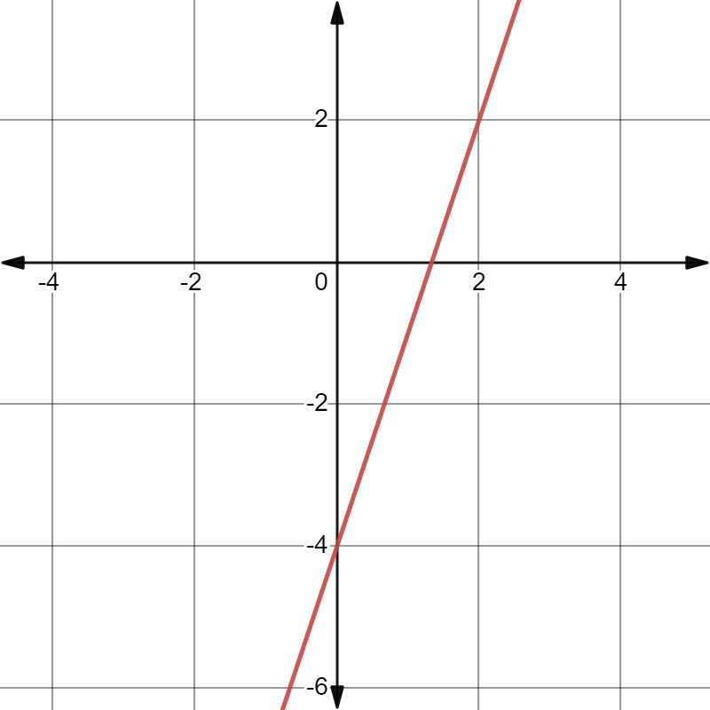

Worked example
- The negative sign made the graph decrease from left to right.
- When there is no coefficient, it is 1, therefore the gradient is 1.
- Your turn to graph $y=x+2$.
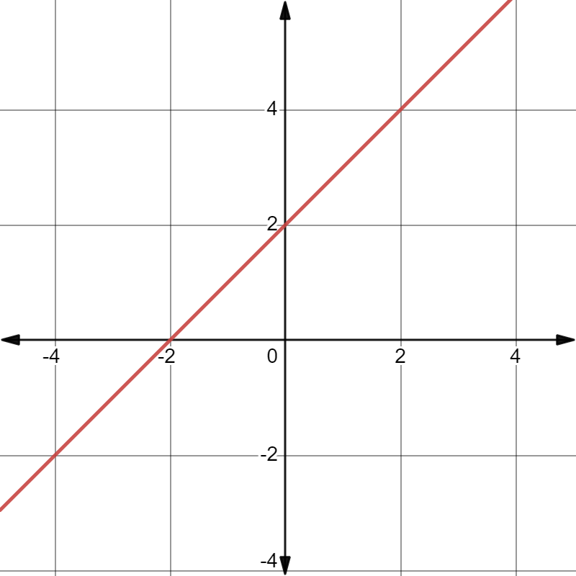

Appendix E – battleship exit ticket
- Write 3 equations in gradient-intercept form that you would use to sink this ship, and state which point each equation passes through.
$$y=x-2$$
$$y=x-1$$
$$y=x$$
- Graph the equations on the Cartesian plane.
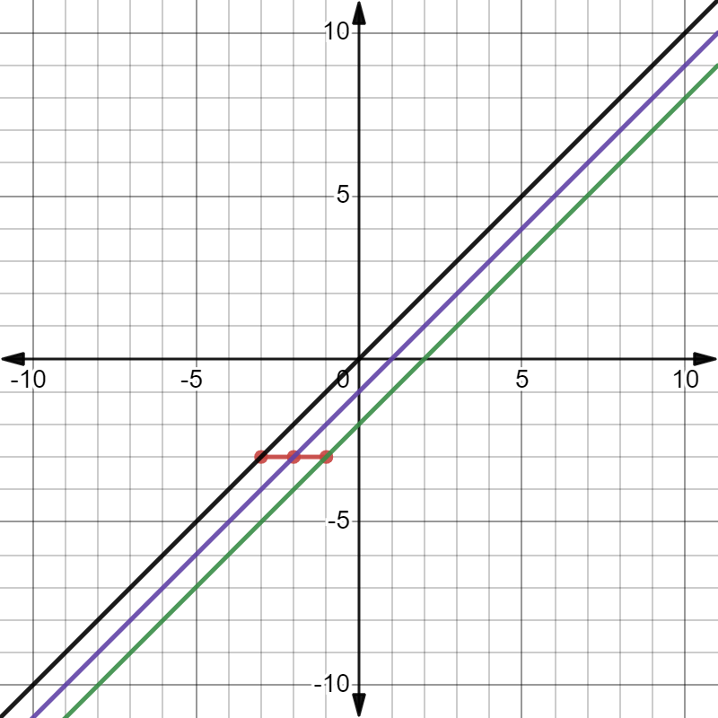

References
This resource contains NSW Curriculum and syllabus content. The NSW Curriculum is developed by the NSW Education Standards Authority. This content is prepared by NESA for and on behalf of the Crown in right of the State of New South Wales. The material is protected by Crown copyright.
Please refer to the NESA Copyright Disclaimer for more information https://educationstandards.nsw.edu.au/wps/portal/nesa/mini-footer/copyright.
NESA holds the only official and up-to-date versions of the NSW Curriculum and syllabus documents. Please visit the NSW Education Standards Authority (NESA) website https://educationstandards.nsw.edu.au/ and the NSW Curriculum website https://curriculum.nsw.edu.au/home.
Mathematics K–10 Syllabus © NSW Education Standards Authority (NESA) for and on behalf of the Crown in right of the State of New South Wales, 2022.

© State of New South Wales (Department of Education), 2023
The copyright material published in this resource is subject to the Copyright Act 1968 (Cth) and is owned by the NSW Department of Education or, where indicated, by a party other than the NSW Department of Education (third-party material).
Copyright material available in this resource and owned by the NSW Department of Education is licensed under a Creative Commons Attribution 4.0 International (CC BY 4.0) licence.
This licence allows you to share and adapt the material for any purpose, even commercially.
Attribution should be given to © State of New South Wales (Department of Education), 2023.
Material in this resource not available under a Creative Commons licence:
- the NSW Department of Education logo, other logos and trademark-protected material
- material owned by a third party that has been reproduced with permission. You will need to obtain permission from the third party to reuse its material.
Links to third-party material and websites
Please note that the provided (reading/viewing material/list/links/texts) are a suggestion only and implies no endorsement, by the New South Wales Department of Education, of any author, publisher, or book title. School principals and teachers are best placed to assess the suitability of resources that would complement the curriculum and reflect the needs and interests of their students.
If you use the links provided in this document to access a third-party's website, you acknowledge that the terms of use, including licence terms set out on the third-party's website apply to the use which may be made of the materials on that third-party website or where permitted by the Copyright Act 1968 (Cth). The department accepts no responsibility for content on third-party websites.

