Holiday money
Students create and solve problems by using and creating conversion graphs to estimate the amount of money they would need to travel overseas.
Students will need at least one digital device per pair to interact with online calculators during this lesson.

Visible learning
This lesson incorporates Path content but could be taught by omitting the language of direct variation.

Learning intention
- To know how to create and use conversion graphs.

Success criteria
- I can create a conversion graph.
- I can compare values using a conversion graph.
- I can explain the characteristics of a direct relationship.

Syllabus outcomes
A student:
- develops understanding and fluency in mathematics through exploring and connecting mathematical concepts, choosing and applying mathematical techniques to solve problems, and communicating their thinking and reasoning coherently and clearly MAO-WM-01
- identifies and solves problems involving direct and inverse variation and their graphical representations MA5-RAT-P-01
- determines the midpoint, gradient and length of an interval, and graphs linear relationships, with and without digital tools MA5-LIN-C-01
- graphs and interprets linear relationships using the gradient/slope-intercept form
MA5-LIN-C-02
Mathematics K–10 Syllabus © NSW Education Standards Authority (NESA) for and on behalf of the Crown in right of the State of New South Wales, 2022.

Activity structure
Please use the associated PowerPoint Holiday money to display images in this lesson.

Launch
- Verbally present the following scenario.
Sam and Matt have a trip planned to visit the USA and Canada. They have a tour booked for US$800. Matt thinks that they will need $1000 to cover the cost of the tour for the week and they will each need $1000 spending money. Sam thinks this is not enough and that they will need $1500 each to cover the cost of the tour. Who do you think is correct and why?
The purpose of this activity is not to consider whether they have enough money but for the students to realise that one Australian dollar is not equal to one American dollar or one English pound and so on.
- Start a class discussion by asking students how much money they think they would need to travel to a different country for 2 weeks. Prompt students to think about this in terms of Australian currency and the currency of their destination.
- Display the Currency Exchange Table website (https://bit.ly/Aus_exchange).
- Ask students to Think-Pair-Share (bit.ly/thinkpairsharestrategy) which country would be the best to visit, and which would be the worst.
- Use a Pose-Pause-Pounce-Bounce question strategy [PDF 200KB] (bit.ly/pausepouncebouncestrategy) for students to share their answers and reasoning.
We want students to identify that visiting countries like America is more expensive because the Australian dollar is not worth as much there.

Explore
- Display Figure 1 for students. This can be found on Slide 2 of the PowerPoint Holiday money. Inform students that the graph shows the currency conversion from Australian dollars to Japanese yen.
Figure 1: Australian Dollars to Japanese yen conversion graph
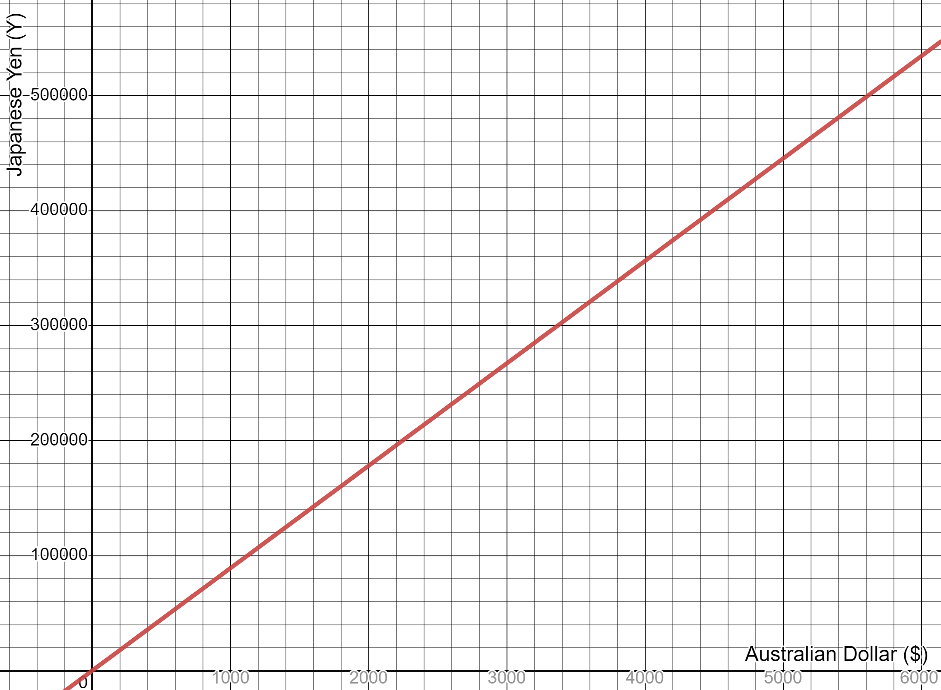
- Students are to state all the information they can determine from the graph.
From this graph, students can interpolate, extrapolate, find the value of $k$ or the gradient, identify the relationship as a direct relationship and state the exchange rate.
- Instruct students to open the ‘Foreign exchange calculator’ (https://bit.ly/exchange_calculator) to complete Appendix A ‘How much money do I have?’ Students will pick a country they would like to visit and create a conversion graph of its currency to the Australian dollar.
- Call on non-volunteer students to share their thoughts about why items have different values in different countries.

Summarise
- Students are to display their graphs from Appendix A around the room for a gallery walk (bit.ly/DLSgallerywalk). Ask students to look at all the graphs around the room and to generalise what is the same about the conversion graphs.
Students should notice:
- all graphs are straight lines
- all graphs have a positive gradient
- all graphs start at (0,0)
- graphs are direct relationships
- graphs have different gradients depending on the conversion rate
- graphs should not include negative values.
- Ask students to use the language of proportionality to write a statement linking Australian dollars to their chosen currency. Discuss with students if it matters which one is proportional to the other in this scenario.
- In a Think-Pair-Share (bit.ly/thinkpairsharestrategy), ask students to brainstorm other units we need to convert between. For example, temperature can be measured in Celsius or Fahrenheit and we often need to convert the temperatures used in recipes.
- Ask students to consider if conversion of all units results in a direct relationship.

- Display the graph on slide 3 of the PowerPoint Holiday money. This shows the conversion between temperatures in Celsius and Fahrenheit. This graph can be used to highlight that not all conversion graphs are direct relationships.
Figure 2: Fahrenheit to Celsius conversion graph
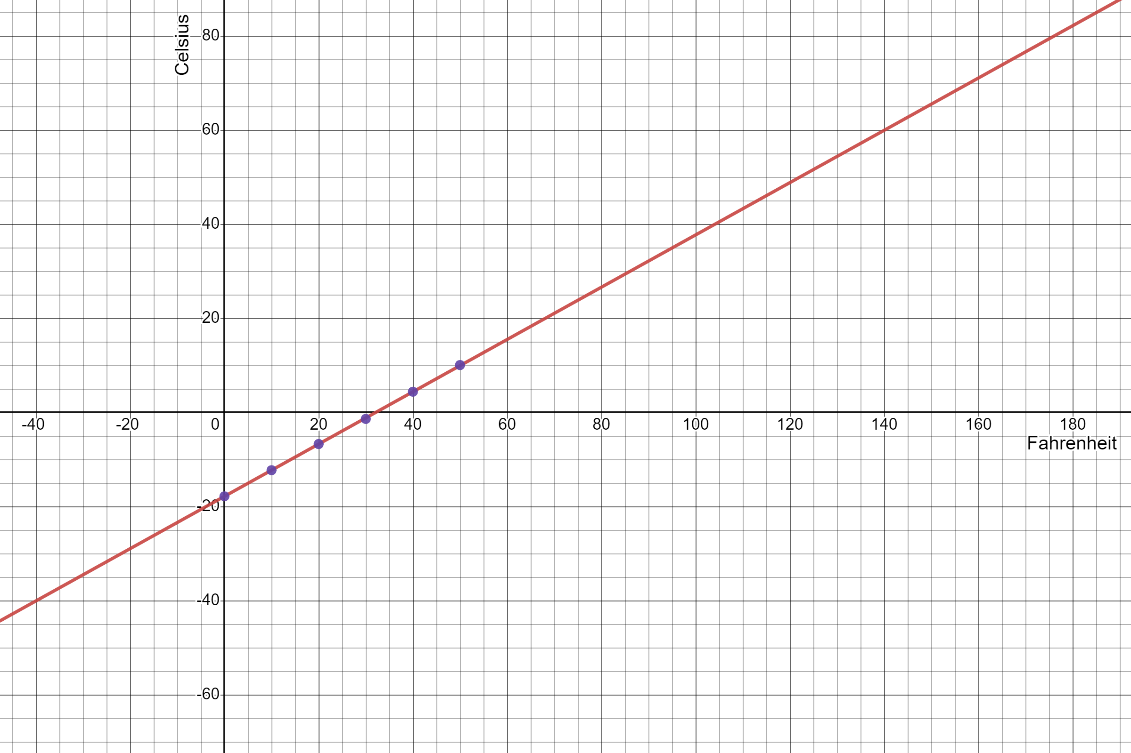

Apply
In pairs, ask students to create a budget to determine the amount of money they would need for a holiday in their chosen country. They are to show the breakdown of costs in both currencies to prove this is enough.
Students have studied budgets in Unit 5 – ‘Financial Mathematics’ (lesson 3).
This is an opportunity for students to use a spreadsheet to create their budgets. You can prompt students to use headings such as items and cost, and basic functions such as sums.
To get students started you could suggest items to budget for such as accommodation, souvenirs, food and travel.

Assessment and differentiation

Suggested opportunities for differentiation
For students working on Core content, teachers can choose to omit the language of direct variation.
Launch
- This activity is designed to have no right or wrong answers so that all students may contribute. Students may use their personal experience of travelling to another country to contribute to the discussion.
Explore
- Students may benefit from being told what scale to use for the axes of their graphs.
Summarise
- Have students find the reverse relationship between currencies (such as Japanese yen to the Australian dollar) How does this differ from the original graph? Ask students if this new relationship is still directly proportional. Why is this the case?

Suggested opportunities for assessment
Explore
- The goal-free problem can be used as a formative assessment opportunity in relation to direct relationships and linear graphs.
Summarise
- Teachers should monitor discussions to formatively assess students’ knowledge of proportionality and the language of direct variation.
- Student understanding of direct relationships can be assessed when looking at the graph of Fahrenheit to Celsius. Prompt students to explore why it is not a direct relationship even though it is a conversion graph.
Apply
- Student budgets could be collected and used as formative or summative assessment.

Appendix A

How much money do I have?
Open the Foreign exchange calculator (https://bit.ly/exchange_calculator) to complete the activity below.
- Record the country you are investigating and the name of their currency.
Country | Currency
- Complete the table of values by using the foreign exchange calculator to find the value of Australian dollars in your chosen destination country’s local currency.
Australian | 0 | 100 | 200 | 300 | 400
Country:
- Plot the relationship on the graph.
- Is this a direct relationship? How do you know?
- Write an equation for this relationship.
- What does the gradient or constant of variation represent in this case?

Differing values
- Navigate to https://bit.ly/globalprices.
- Using the country you have chosen to investigate, fill in the prices of common items in the first column of the table.
- Using your conversion graph, convert the value of the items into Australian dollars and write these values in column 2.
- Use the equation you created for your conversion graph to convert the value of the items into Australian dollars and write these values in column 3.
Item | Value in Country | Converted value in Australian dollars (from graph) | Converted value in Australian dollars (from equation) | Actual cost to purchase in Australia
Flour
Chicken (1kg)
Potatoes (1kg)
Bottled water
Phone
- Which was easier to use to convert the value of items, the conversion graph or equation? Explain your reasoning.
- Use an online supermarket website to find out how much each item actually costs in Australia.
- How does the converted value differ to the amount each item actually costs in Australia? Why do you think there is a difference?

References
This resource contains NSW Curriculum and syllabus content. The NSW Curriculum is developed by the NSW Education Standards Authority. This content is prepared by NESA for and on behalf of the Crown in right of the State of New South Wales. The material is protected by Crown copyright.
Please refer to the NESA Copyright Disclaimer for more information https://educationstandards.nsw.edu.au/wps/portal/nesa/mini-footer/copyright.
NESA holds the only official and up-to-date versions of the NSW Curriculum and syllabus documents. Please visit the NSW Education Standards Authority (NESA) website https://educationstandards.nsw.edu.au/ and the NSW Curriculum website https://curriculum.nsw.edu.au/home.
Mathematics K–10 Syllabus © NSW Education Standards Authority (NESA) for and on behalf of the Crown in right of the State of New South Wales, 2022.

© State of New South Wales (Department of Education), 2023
The copyright material published in this resource is subject to the Copyright Act 1968 (Cth) and is owned by the NSW Department of Education or, where indicated, by a party other than the NSW Department of Education (third-party material).
Copyright material available in this resource and owned by the NSW Department of Education is licensed under a Creative Commons Attribution 4.0 International (CC BY 4.0) license.
This license allows you to share and adapt the material for any purpose, even commercially.
Attribution should be given to © State of New South Wales (Department of Education), 2023.
Material in this resource not available under a Creative Commons license:
- the NSW Department of Education logo, other logos and trademark-protected material
- material owned by a third party that has been reproduced with permission. You will need to obtain permission from the third party to reuse its material.
Links to third-party material and websites
Please note that the provided (reading/viewing material/list/links/texts) are a suggestion only and implies no endorsement, by the New South Wales Department of Education, of any author, publisher, or book title. School principals and teachers are best placed to assess the suitability of resources that would complement the curriculum and reflect the needs and interests of their students.
If you use the links provided in this document to access a third-party's website, you acknowledge that the terms of use, including licence terms set out on the third-party's website apply to the use which may be made of the materials on that third-party website or where permitted by the Copyright Act 1968 (Cth). The department accepts no responsibility for content on third-party websites.

