Slope-a-palooza
By exploring a Desmos Mableslides activity, students investigate how changing the gradient changes the slope of a line. They are required to estimate gradients, as well as identify and write equations with different gradients.
Students will need at least one digital device per pair to interact with Desmos during this lesson.

Visible learning

Learning intention
- To understand how the value of the gradient in an equation changes the graph.

Success criteria
- I can identify where the gradient is represented in a linear equation.
- I can describe how a graph would look when given the gradient.
- I can write an equation for a linear graph, given the gradient.

Syllabus outcomes
A student:
- develops understanding and fluency in mathematics through exploring and connecting mathematical concepts, choosing and applying mathematical techniques to solve problems, and communicating their thinking and reasoning coherently and clearly MAO-WM-01
- determines the midpoint, gradient and length of an interval, and graphs linear relationships, with and without digital tools MA5-LIN-C-01
- graphs and interprets linear relationships using the gradient/slope-intercept form MA5-LIN-C-02
Mathematics K–10 Syllabus © NSW Education Standards Authority (NESA) for and on behalf of the Crown in right of the State of New South Wales, 2022.

Activity structure

Launch
The launch activity is designed to review calculating the gradient of a line explored in Unit 2 – Working with triangles (lessons 14–16).
- Print Appendix A ‘How steep is the slope?’ on A3 paper and place them on the walls around the room.
- In visibly random groups of 3 (bit.ly/visiblegroups) allow students to work through the activity.
In this activity students are to draw lines on a Cartesian Plane, with as many different gradients as possible.
Use prompts to ensure students consider negative and fractional gradients.
It is not assumed that students would draw a gradient of $∞$ or undefined, as they may not have learnt this concept.
- Once students have drawn as many gradients as possible, refocus groups and conduct a class discussion. Key points to discuss include:
- How many different gradients did your group find?
- Which gradient is the steepest?
- How do we know if the gradient is negative?
- Is a negative gradient as steep as a positive gradient?
- How would you describe the gradient of the line to a friend?

Explore
- Working individually, or in pairs, assign students the Desmos classroom activity ‘Marbleslides: Modifying lines’ (https://bit.ly/desmosmarbleline). In this activity students modify the gradient of lines to collect stars and explore gradient.
Before doing this activity, you will need to set up a Desmos classroom (bit.ly/desmosclassroomstrategy) and use the pacing feature to restrict the students to slides 1–19.
- Use the pacing or syncing feature to move students to slide 20 in the Desmos activity or display the Desmos graph ‘Gradient’ (https://bit.ly/Gradient_Desmos).
- In a Think-Pair-Share (bit.ly/thinkpairsharestrategy), students are to complete the following questions:
- What happens as the value of $m$ increases from one?
- Predict what the line would look like if the value of $m$ was extremely large.
- What happens as the value of $m$ gets smaller from one towards zero?
- Predict what the line would look like if the value of $m$ was zero.
- What happens when the value of $m$ is negative?
- What is the difference between positive and negative slopes?
These questions help students visualise horizontal and vertical lines in terms of their gradients. Relating these to what they look like in an equation could help further students’ understanding. Highlight that a negative gradient tells us the line is decreasing as the $x$ value increases.
- Ask students which line is steeper, $y=3x$ or $y=-4x$.
- Using the Pose-Pause-Pounce-Bounce question strategy [PDF 200KB] (bit.ly/pausepouncebouncestrategy), ask students to share their reasoning.
The purpose of this is to highlight to students that the negative changes the direction of the graph but does not affect the steepness.

Summarise
- In their pairs, use the pacing feature for students to complete slides 21–23 of the previous Desmos activity. Students are given equations of linear relationships that they must put in ascending order according to the numerical value of their gradients, and then according to their steepness.
Alternatively, students can complete the same activity in Appendix B ‘Put them in order’.
- In their pairs, use the pacing feature for students to complete slides 24 and 25 of the Desmos activity. Students are given gradients, equations, and graphs to sort into positive gradient, negative gradient, zero gradient (horizontal line), and infinite gradient (vertical line) groups.
Alternatively, distribute Appendix C ‘Card sort’, where students are to individually cut out the cards and sort them into the above mentioned piles.
- Students are to create notes to their future forgetful self (bit.ly/notesstrategy) on how to find the gradient of a line from graphs and equations.

Apply
- Students are to complete Appendix D ‘Roller coaster’ to write potential equations for different parts of the roller coaster. They are to select 10 points to make line intervals on the rollercoaster, estimate and find their gradients, write an equation, and describe how the gradient changes the ride.
Students are not expected to find the y-intercept in this activity, nor are they expected to include it in the equation of their line interval. The equations they produce will be in the form $y=mx$.
- Students are to check their estimations using slide 26 in the Desmos activity or on the Desmos graph ‘Roller coaster’(https://www.desmos.com/calculator/yyitendnuq).
Direct students to double click on the image so they can drag the image around on the Cartesian plane to enable them to find the gradient. Alternatively, students can check their estimations using a clear plastic grid overlay.

Assessment and differentiation

Suggested opportunities for differentiation
Launch
- As students complete the activity in groups of 3, those not as confident with the concept of gradient can seek the assistance of their peers.
- Challenge students to consider fractional gradients.
Explore
- The Desmos environment is designed to provide a non-threatening space where students can test out their ideas. All students will be able to change values and observe the effect this has on the straight line.
- Students could work in pairs if there are students that require extra support.
Summarise
- Students may benefit from considering the integer gradients initially before moving onto fractional gradients.
- The number of equations in Appendix B could be reduced or increased to suit the needs of your students.
- Teachers could choose to label the axes on the graphs in the card sort as the graphs are true representations of the scenarios. Ask students to find similarities or check for reasonableness for each scenario listed to help group them.
Apply
- For a vision impaired student, use pins and elastic bands on a geoboard to create different slopes to complete the activity.

Suggested opportunities for assessment
Summarise
- Students individually match the gradients to equations, descriptions, and graphs. This can highlight any misconceptions held by students.

Appendix A

How steep is the slope?
The gradient describes the slope of a line. The gradient tells us how far up or down we go when we take one step to the right:
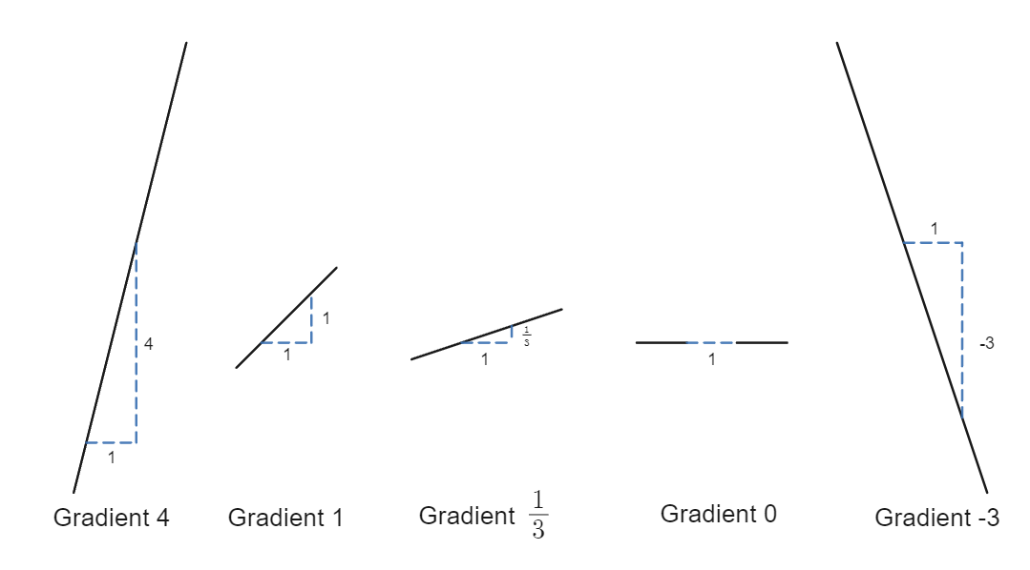
- Check that the green line has a gradient of 2.
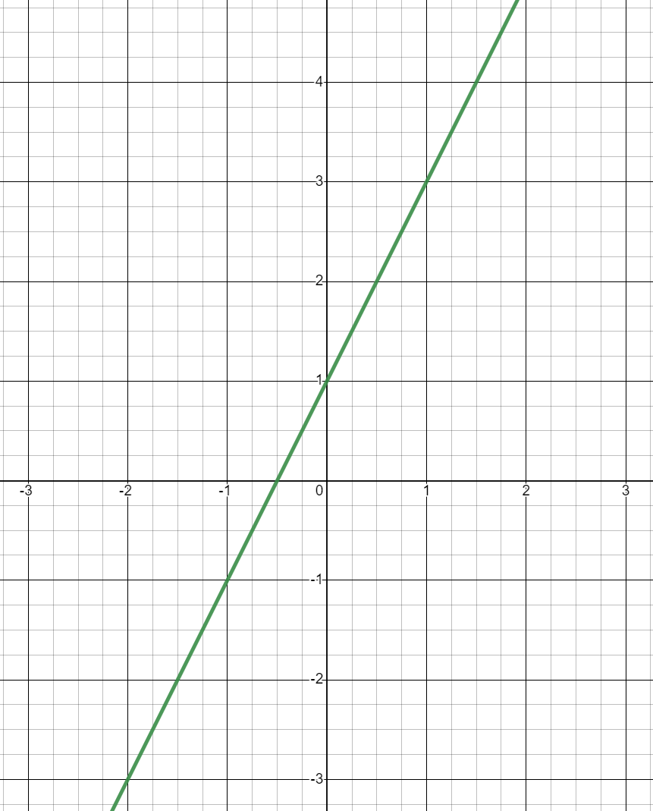
- Can you draw other lines on the graph above that also have a gradient of 2?
- Draw some more lines with different gradients.
- How many different gradients can you draw? Can you find them all?
- Arrange your gradients in order of steepness and list the points each line passes through.
This activity has been modified from the NRICH activity ‘How steep is the slope?’ (https://nrich.maths.org/6603).

Appendix B

Put them in order
The equation of a line in gradient intercept form is given as:
$$y=mx+c$$
Where m is the gradient.
The table below contains many different straight-line equations.
- $y = \frac{2}{3}x + 4$ | - $y = 2x - 2$
- $y =-\frac{7}{5}x + 1$ | - $y =\frac{3}{2}x - 5$
- $y = -5x + 3$ | - $y = -7x + 6$
- $y =\frac{9}{2}x + 2$ | - $y =-\frac{10}{11}x + 9$
- $y = -9x - 7$ | - $y = -3x + 5$
- $y =-\frac{3}{4}x - 1$ | - $y = 4x + 8$
- $y=-5$ | - $x=2$
- Arrange the equations in ascending order according to the numerical value of the gradients?
- Arrange the equations in ascending order according to their steepness?
- Explain why the lists differ.

Appendix C

Card sort
0 | 1.45
Infinite | -6
$$y=5.2$$ | $$y=1.45x+3$$
$$x=500$$ | $$y=2034-6x$$
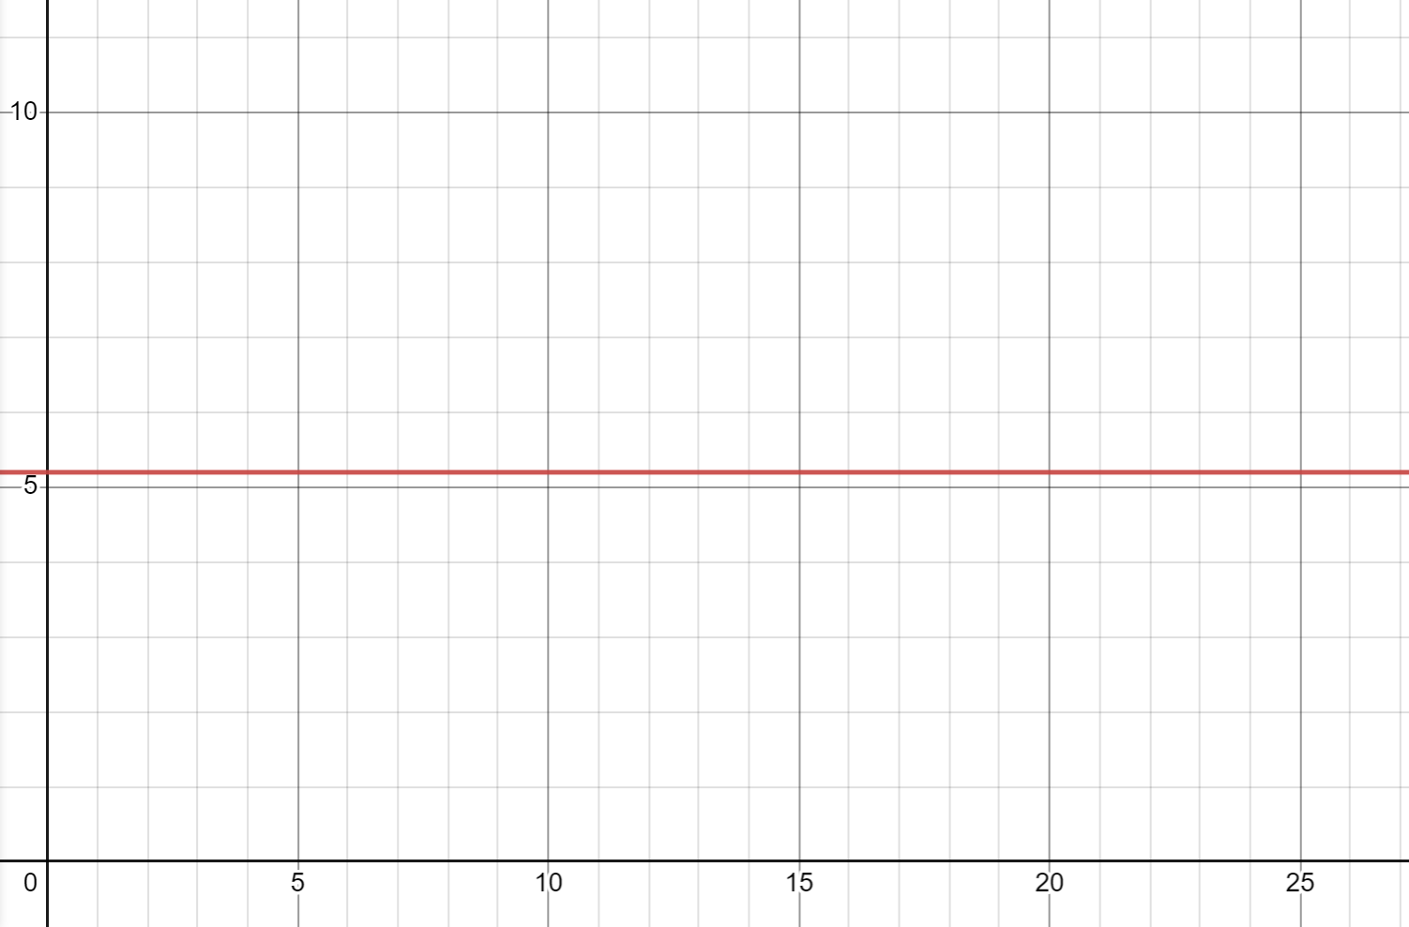
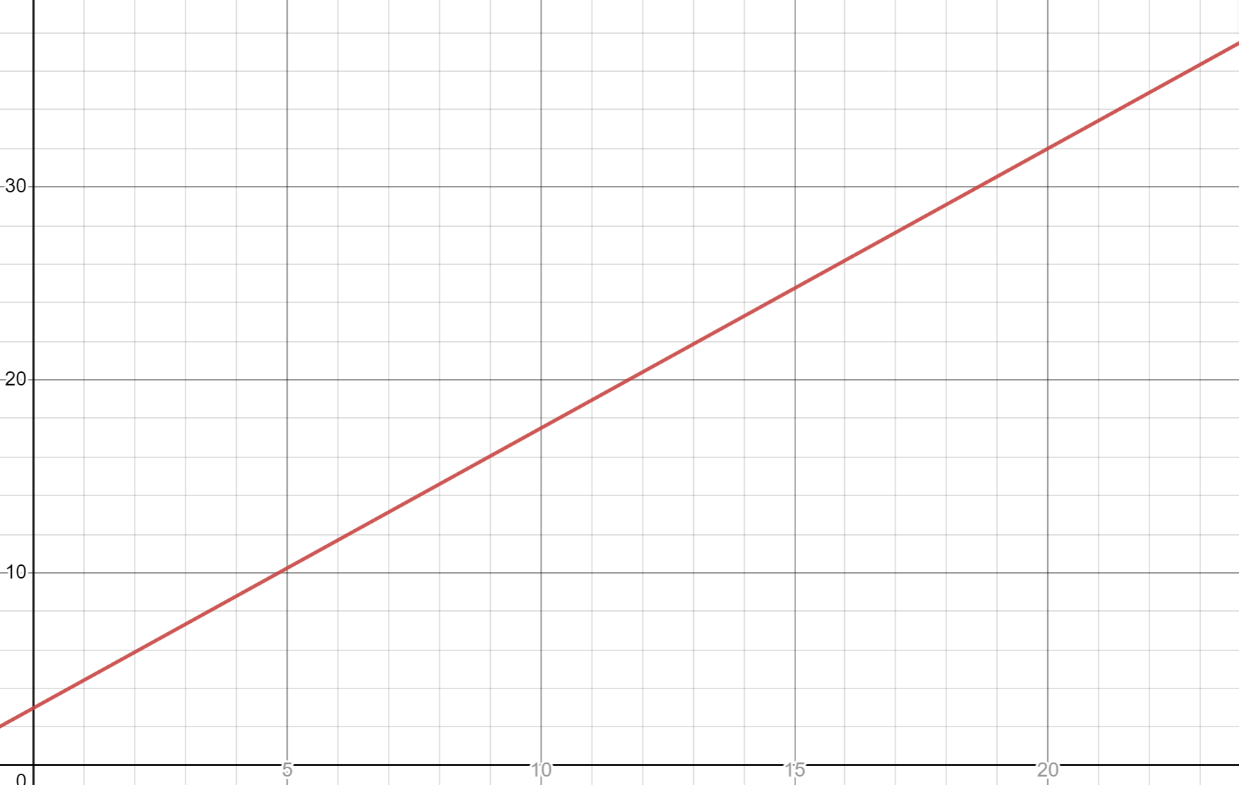 | 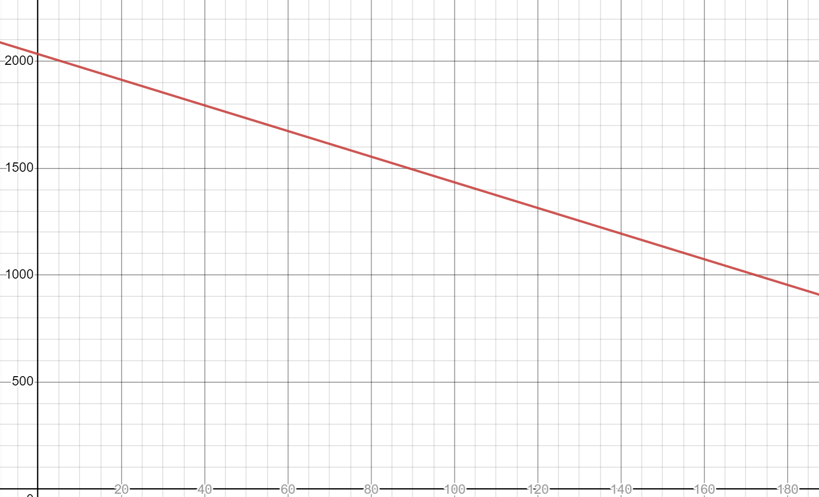

The y value increases as the $x$ value increases. | The$y$ value remains constant as the $x$ value changes.
The y value decreases as the $x$ value increases. | The $y$ values changes as the $x$ value remains constant.
The maximum weight limit of a lift and the amount of people. | The cost of a taxi and the distance it has to travel.
The interest rate over the time of a fixed rate loan. | The altitude of a skier going down a hill.

Appendix D

Roller coaster
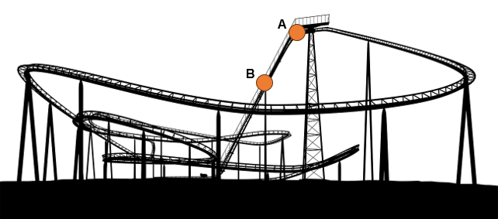 ‘Roller Coaster png sticker silhouette’ by Rawpixel is licensed under CC0 1.0.
- Label points on the roller coaster with A–J so each pair of letters creates a line that follows the roller coaster track. AB is completed in the table.
- Complete the following table.
Line | Estimated Gradient | Actual gradient | Potential equation
AB | 3 | 2 | $$y=2x$$
CD
EF
GH
IJ

Sample solutions

Appendix A – How steep is the slope?
All 24 possible gradients, listed in descending order:
$∞$, 4, 3, 2, 1.5, $1\frac{1}{3}$, 1, 0.75, $\frac{2}{3}$, 0.5, $\frac{1}{3}$, 0.25, 0, −0.25, $-\frac{1}{3}$, −0.5, $-\frac{2}{3}$, −0.75, −1, $-1\frac{1}{3}$, −1.5, −2, −3 and −4.

Appendix B – put them in order
- Ascending order: i, f, e, j, c, h, k, m, a, d, g, b, l, n
- Steepness: m, a, k, h, c, d, b, j, l, g, e, I, n
- The order changes as the negative sign only tells the direction of the line (whether it is increasing or decreasing).

Appendix C – card sort
The card sort groups are as follows:
Positive line | Negative line | Vertical line | Horizontal line
The y value increases as the x value increases. | The y value decreases as the x value increases. | The y values changes as the x value remains constant. | The y value remains constant as the x value changes.
Positive gradient | Negative gradient | Infinite gradient | Zero gradient
1.45 | -6 | Infinite | 0
The cost of a taxi and the distance it has to travel. | The altitude of a skier going down a hill. | The maximum weight limit of a lift and the number of people. | The interest rate over the time of a fixed rate loan.
$$y=1.45x+3$$ | $$y=2034-6x$$ | $$x=500$$ | $$y=5.2$$

Positive | Vertical
Negative | Horizontal

Appendix C – roller coaster
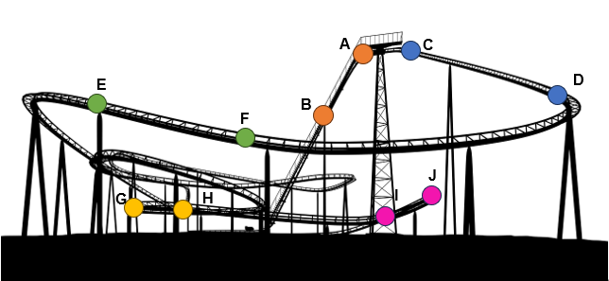‘Roller Coaster png sticker silhouette’ by Rawpixel is licensed under CC0 1.0.
Label points on the roller coaster with A–J so each pair of letters creates a line that follows the roller coaster track. AB is completed in the table.
- Complete the following table.
Line | Estimated Gradient | Actual gradient | Potential equation
AB | 3 | 2 | $$y=2x$$
CD | -1 | $$-\frac{1}{2}$$ | $$y=-\frac{1}{2}x$$
EF | $$-\frac{1}{2}$$ | $$-\frac{1}{4}$$ | $$y=-\frac{1}{4}x$$
GH | 0 | 0 | $$y=c$$
IJ | 1 | $$\frac{1}{2}$$ | $$y=\frac{1}{2}x$$

References
This resource contains NSW Curriculum and syllabus content. The NSW Curriculum is developed by the NSW Education Standards Authority. This content is prepared by NESA for and on behalf of the Crown in right of the State of New South Wales. The material is protected by Crown copyright.
Please refer to the NESA Copyright Disclaimer for more information https://educationstandards.nsw.edu.au/wps/portal/nesa/mini-footer/copyright.
NESA holds the only official and up-to-date versions of the NSW Curriculum and syllabus documents. Please visit the NSW Education Standards Authority (NESA) website https://educationstandards.nsw.edu.au/ and the NSW Curriculum website https://curriculum.nsw.edu.au/home.
Mathematics K–10 Syllabus © NSW Education Standards Authority (NESA) for and on behalf of the Crown in right of the State of New South Wales, 2022.

© State of New South Wales (Department of Education), 2023
The copyright material published in this resource is subject to the Copyright Act 1968 (Cth) and is owned by the NSW Department of Education or, where indicated, by a party other than the NSW Department of Education (third-party material).
Copyright material available in this resource and owned by the NSW Department of Education is licensed under a Creative Commons Attribution 4.0 International (CC BY 4.0) license.
This license allows you to share and adapt the material for any purpose, even commercially.
Attribution should be given to © State of New South Wales (Department of Education), 2023.
Material in this resource not available under a Creative Commons license:
- the NSW Department of Education logo, other logos and trademark-protected material
- material owned by a third party that has been reproduced with permission. You will need to obtain permission from the third party to reuse its material.
Links to third-party material and websites
Please note that the provided (reading/viewing material/list/links/texts) are a suggestion only and implies no endorsement, by the New South Wales Department of Education, of any author, publisher, or book title. School principals and teachers are best placed to assess the suitability of resources that would complement the curriculum and reflect the needs and interests of their students.
If you use the links provided in this document to access a third-party's website, you acknowledge that the terms of use, including licence terms set out on the third-party's website apply to the use which may be made of the materials on that third-party website or where permitted by the Copyright Act 1968 (Cth). The department accepts no responsibility for content on third-party websites.

