Journey to linearity
Students explore different ways to identify and represent linear relationships. They do this through exploring the relationships between the lengths of leaves and examples and non-examples.

Visible learning

Learning intention
- To be able to identify linear relationships in a variety of forms.

Success criteria
- I can identify a linear relationship when represented as a graph.
- I can identify a linear relationship when represented as an equation.
- I can identify a linear relationship when represented as a table of values.
- I can explain the characteristics of a linear relationship.

Syllabus outcomes
A student:
- develops understanding and fluency in mathematics through exploring and connecting mathematical concepts, choosing and applying mathematical techniques to solve problems, and communicating their thinking and reasoning coherently and clearly MAO-WM-01
- graphs and interprets linear relationships using the gradient/slope-intercept form
MA5-LIN-C-02
Mathematics K–10 Syllabus © NSW Education Standards Authority (NESA) for and on behalf of the Crown in right of the State of New South Wales, 2022.

Activity structure

Launch

Equipment
- Appendix A
- Rulers

Method
- Tell students they are to each collect 5 leaves from a single tree. Challenge them to collect varying sizes.
- With a ruler, students are to measure the length and width of their leaves, recording their results in the table in Appendix A ‘Leaf exploration’.
- Using a Think-Pair-Share (bit.ly/thinkpairsharestrategy), ask students if they think there is a relationship between the length and width of their leaves. What do they think it is? How could we tell for certain?
This is an opportunity to revisit the concept of scale factor with students. Students could use either the length or width to find the scale factor between the leaves they collected.
- Ask students to plot the length and width of each leaf on the Cartesian plane in Appendix A.
- Students are to do a gallery walk (bit.ly/DLSgallerywalk) of the graphs. Ask them to think about the graphs and if they show there is a relationship between the leaves. Do the leaves from some trees show a relationship while those from other trees do not?

Explore
- During this section, students will work in visibly random groups of 3 (bit.ly/visiblegroups) on vertical non-permanent surfaces (bit.ly/VNPSstrategy).
- Hand out Appendix B ‘Linear and non-linear graphs’. This appendix contains a variety of linear and non-linear graphs for students to compare.
- Ask students if the graphs they just saw on their gallery walk look like any of the graphs displayed.
- Tell students that the graphs on the left are linear relationships. Ask students to create a definition for linear relationships from this representation.
Students may identify characteristics such as:
- linear graphs contain a single, straight-line segment
- non-linear graphs are often made up of curves
- non-linear graphs may have more than one curve.
- Hand out Appendix C ‘Linear and non-linear equations’. This appendix shows a collection of linear and non-linear equations. Students are to compare the equations and determine what characteristics make an equation linear or non-linear.
- Combine 2 groups and ask them to compare their lists of characteristics. They should justify why they have included each characteristic and add to their own list if necessary.
Students may identify characteristics such as:
- $x$ and $y$ have no powers in a linear equation
- no more than an $x$ and $y$ variable in a linear equation
- $x$ and/or$y$ cannot be on the bottom of a fraction in a linear equation.

- Distribute Appendix D ‘Linear and non-linear tables of values’ to each group. This appendix shows a collection of linear and non-linear relationships represented as tables of values. Students should again compare the tables and determine characteristics for linear and non-linear relationships.
- Combine 2 groups and ask them to compare their lists of characteristics. They should justify why they have included each characteristic and add to their own list if necessary.
This will be more difficult for students. Students may identify characteristics such as:
- $x$ values go up by a constant amount, but y values don’t in a non-linear relationship.
- Initiate a sharing of ideas and reasoning using the Pose-Pause-Pounce-Bounce question strategy [PDF 200KB] (bit.ly/pausepouncebounce), to highlight what is important and what isn’t when identifying linear relationships.

Summarise
- Display or draw the Frayer diagram from Appendix E on the board. Explain to students that they are going to summarise all of the characteristics they have discovered of linear relationships.
- Explain to students what needs to be written in each different quadrant of the diagram.
- Students are to complete Appendix E ‘Frayer diagram’ (bit.ly/frayerdiagram) by filling in examples and non-examples from the Appendix worksheets, and characteristics they listed as a group.
The Frayer diagram uses the strategy of examples and non-examples [PDF 68.8 KB] (bit.ly/nonexamplesstrategy) to build the concept of a linear relationship for students.

Apply
- Ask students to return to their table of values and graph from the ‘leaves’ launch activity.
- Using the characteristics of linear relationships they have listed in their Frayer diagram, they should justify to a partner whether the length and width of their leaves form a linear relationship.
- Ask students who believe that their leaves form a linear relationship to place their graph and table of values on one side of the room, and those that don’t form a linear relationship on the other side of the room.
- Ask students to complete a Gallery walk to compare the graphs.
- Discuss with students whether there are some leaves that formed a stronger linear relationship than others? Were there any that formed a perfect linear relationship?
- Using a Think-Pair-Share (bit.ly/thinkpairsharestrategy) ask students what is the minimum amount of information they would need to prove if a relationship is linear in each representation.
- Join pairs and encourage them to test each other’s theories by creating non-examples.
The purpose of this activity is to highlight to students that 3 consecutive points are needed to identify if you have a linear relationship.

Two truths and a lie
- Still working in their groups of 3, students are to create 2 truths and a lie (bit.ly/Two_Truths_One_Lie) about linear relationships.
- Have groups conduct a gallery walk, determining the lie for each set of statements.
- As a group, they need to determine which set of statements is their favourite and vote by placing a sticker to select their favourite.
- Discuss the set of statements with the most stickers. Ask students why they thought this one was the best.

Assessment and differentiation

Suggested opportunities for differentiation
Explore
- Students can graph tables of values to help identify characteristics between the points.
- Working in groups will provide support to students who are still developing their algebra skills.
- Teachers can challenge students by modifying the equations in the table, so they aren’t in gradient-intercept form.

Suggested opportunities for assessment
Apply
- Look at the 2 truths and a lie students produce to check if they are linear relationships or not. Ask students how they created their truths and lies.

Appendix A

Leaf exploration
- Find 5 leaves. Complete the table with the lengths and widths of each leaf.
Leaf | Length (cm) | Width (cm)
1
2
3
4
5
- Graph the length versus width of your leaves on the Cartesian plane.
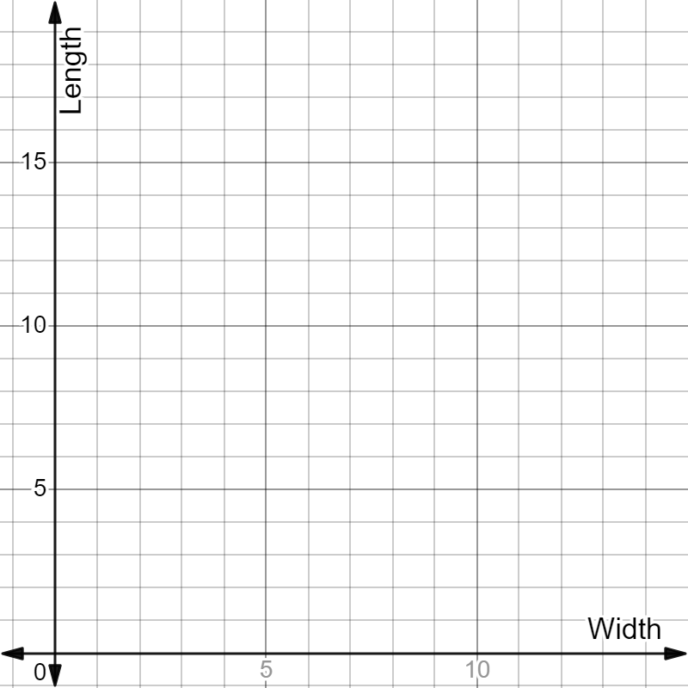

Appendix B

Linear and non-linear graphs
Linear graphs | Non-linear graphs
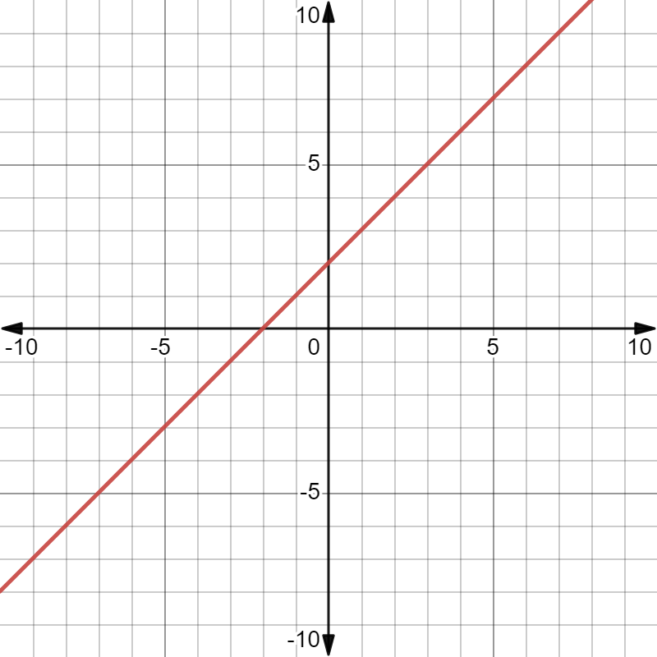 | 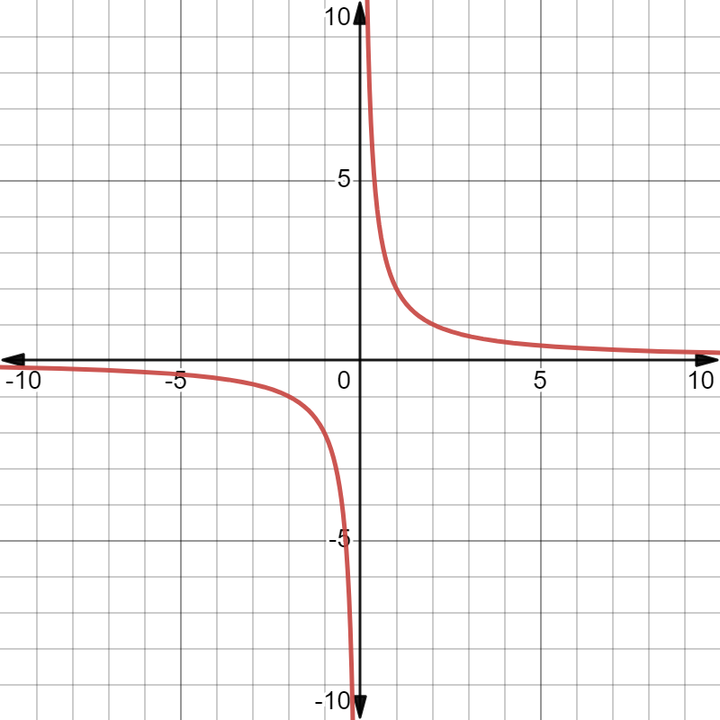
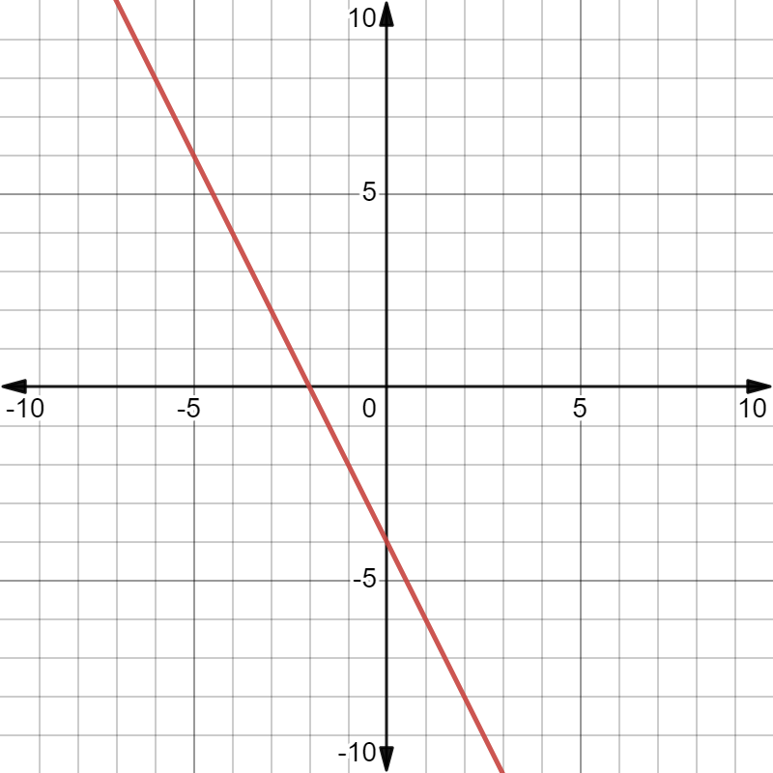 | 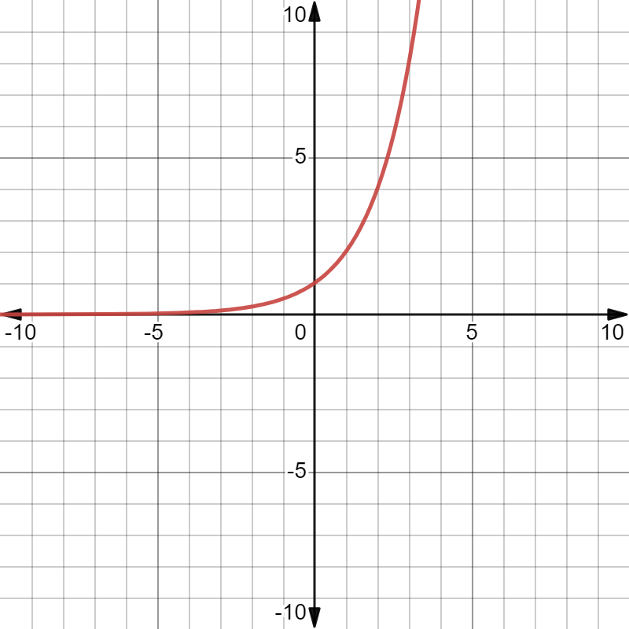
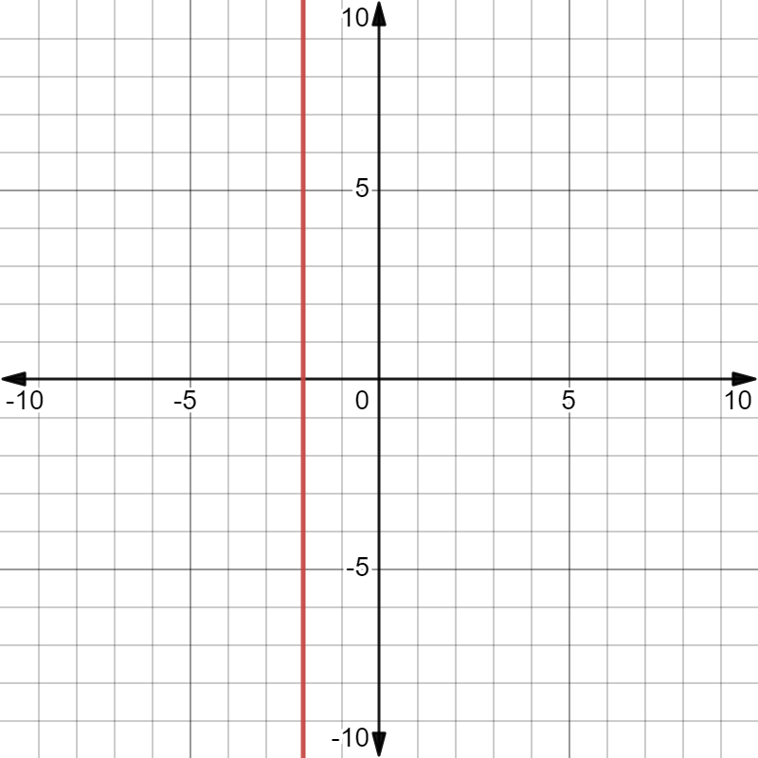 | 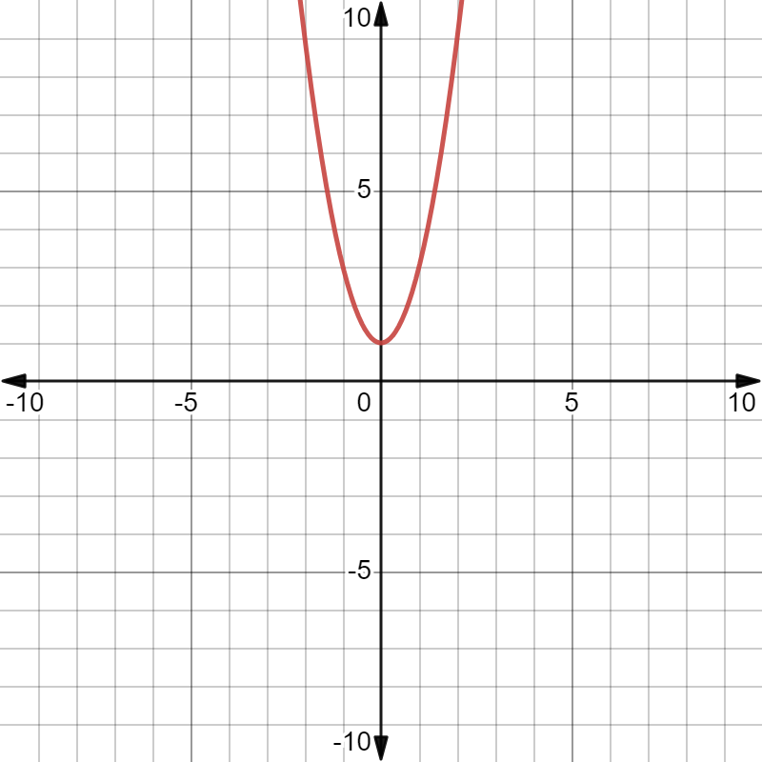
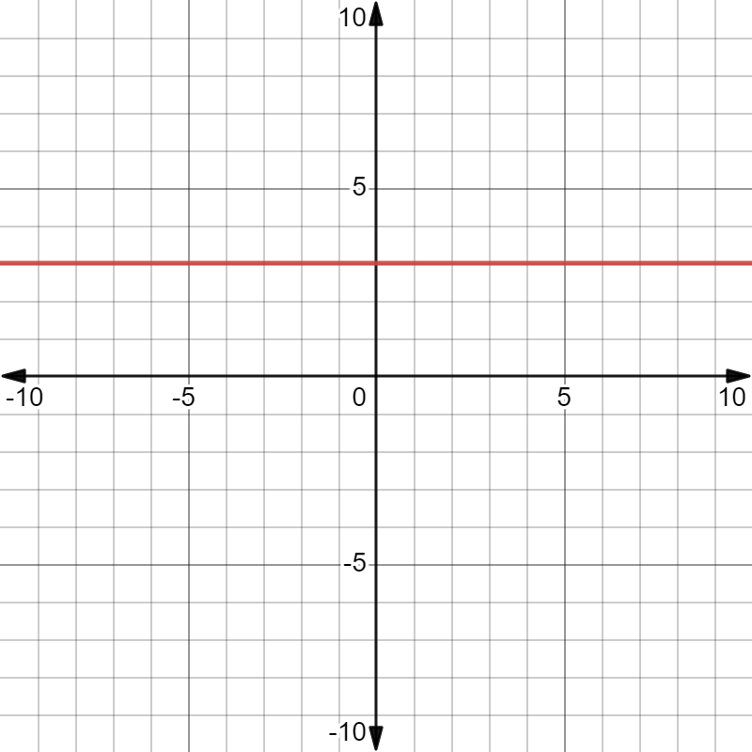 | 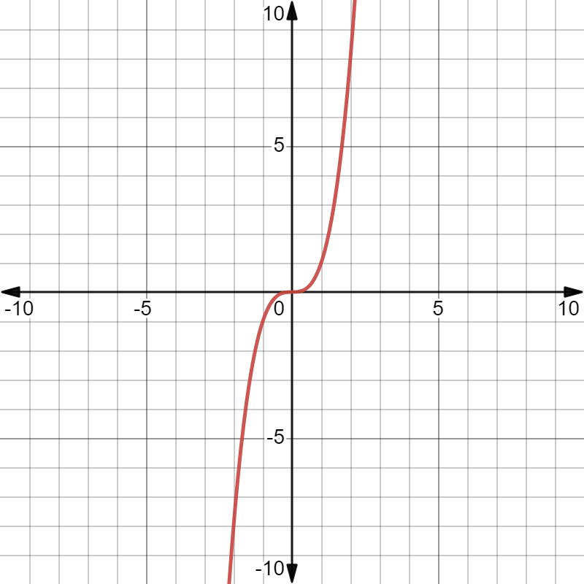
- List the characteristics of linear graphs that differ to non-linear graphs.
- In your own words, how would you identify a linear relationship given its graph?

Appendix C

Linear and non-linear equations
Linear | Non-Linear
$$y=x$$ | $$y=x^{2}$$
$$y=2x+4$$ | $$y^{2}=2x+4$$
$$\frac{x}{6}=y$$ | $$\frac{6}{x}=y$$
$$\frac{1}{7}x-4=y$$ | $$y=\frac{1}{7}x^{3}-4$$
$$y=-7x+4$$ | $$y=-7^{x}+4$$
$$y=5$$ | $$x^{2}+y^{2}=0$$
$$x=-2$$ | $$y=x+z+2$$
- List the characteristics of linear equations that differ to non-linear equations.
- In your own words, how would you identify a linear relationship given its equation?
- Do equations of linear relationships follow the same format? If so, what is it?

Appendix D

Linear and non-linear tables of values
Linear | Non-Linear
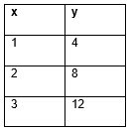  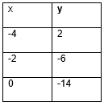  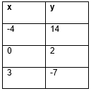 | 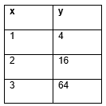  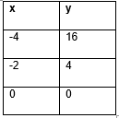  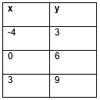
- List the characteristics of linear graphs that differ to non-linear tables of values.
- In your own words, how would you identify a linear relationship given its equation?

Appendix E

Frayer diagram
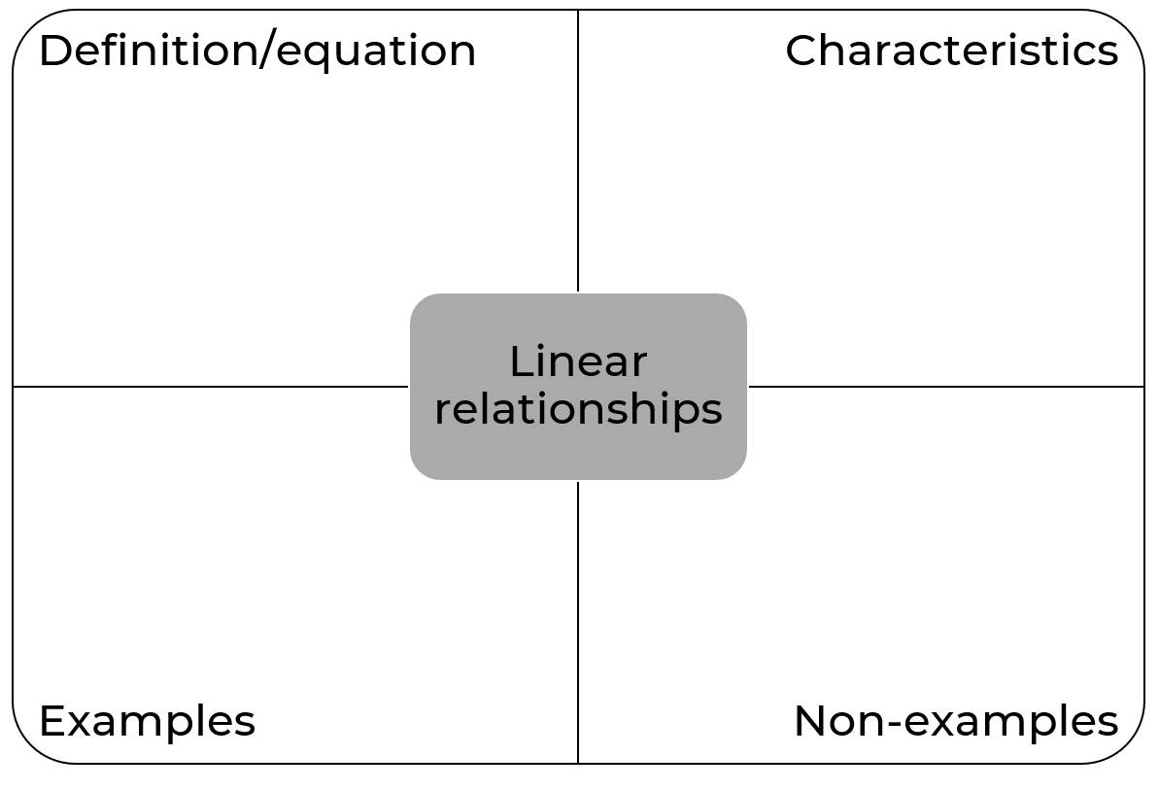

Sample solutions

Appendix A – leaf exploration
- Find 5 leaves. Complete the table with the lengths and widths of each leaf.
Leaf | Width (cm) | Length (cm)
1 | 2 | 10
2 | 4 | 12
3 | 5 | 14
4 | 5 | 15
5 | 6 | 16
- Graph your leaves on the Cartesian plane.
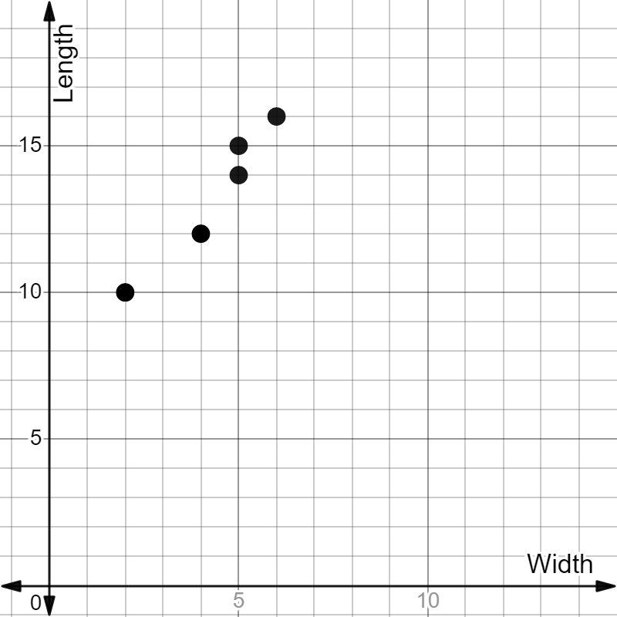

Appendix E – Frayer diagram
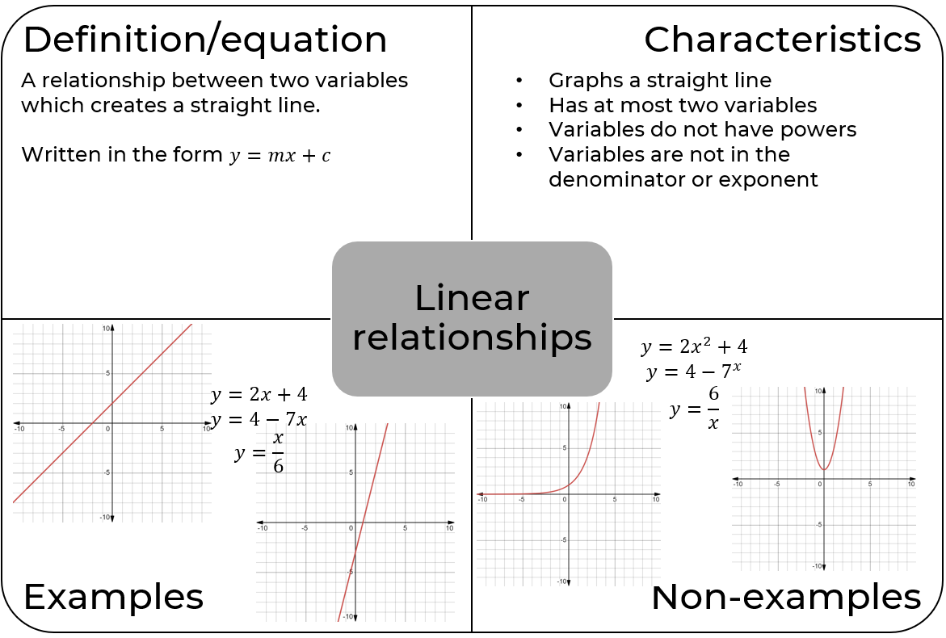

References
This resource contains NSW Curriculum and syllabus content. The NSW Curriculum is developed by the NSW Education Standards Authority. This content is prepared by NESA for and on behalf of the Crown in right of the State of New South Wales. The material is protected by Crown copyright.
Please refer to the NESA Copyright Disclaimer for more information https://educationstandards.nsw.edu.au/wps/portal/nesa/mini-footer/copyright.
NESA holds the only official and up-to-date versions of the NSW Curriculum and syllabus documents. Please visit the NSW Education Standards Authority (NESA) website https://educationstandards.nsw.edu.au/ and the NSW Curriculum website https://curriculum.nsw.edu.au/home.
Mathematics K–10 Syllabus © NSW Education Standards Authority (NESA) for and on behalf of the Crown in right of the State of New South Wales, 2022.
© State of New South Wales (Department of Education), 2023
The copyright material published in this resource is subject to the Copyright Act 1968 (Cth) and is owned by the NSW Department of Education or, where indicated, by a party other than the NSW Department of Education (third-party material).
Copyright material available in this resource and owned by the NSW Department of Education is licensed under a Creative Commons Attribution 4.0 International (CC BY 4.0) license.
This license allows you to share and adapt the material for any purpose, even commercially.
Attribution should be given to © State of New South Wales (Department of Education), 2023.
Material in this resource not available under a Creative Commons license:
- the NSW Department of Education logo, other logos and trademark-protected material
- material owned by a third party that has been reproduced with permission. You will need to obtain permission from the third party to reuse its material.
Links to third-party material and websites
Please note that the provided (reading/viewing material/list/links/texts) are a suggestion only and implies no endorsement, by the New South Wales Department of Education, of any author, publisher, or book title. School principals and teachers are best placed to assess the suitability of resources that would complement the curriculum and reflect the needs and interests of their students.
If you use the links provided in this document to access a third-party's website, you acknowledge that the terms of use, including licence terms set out on the third-party's website apply to the use which may be made of the materials on that third-party website or where permitted by the Copyright Act 1968 (Cth). The department accepts no responsibility for content on third-party websites.

