Watch money grow
Students explore how money can increase through simple interest by looking at an investment scenario. Students then use online simple interest calculators to consider the different variables and what happens as one is altered.
Students will need at least one digital device per pair to interact with online simple interest calculators during this lesson.

Visible learning

Learning intentions
- To be able to solve problems involving simple interest calculations.

Success criteria
- I can explain what simple interest is.
- I can compare different investments with varying interest rates and time periods.
- I can use the simple interest formula to solve problems.
- I can interpret simple interest graphs to solve problems.

Syllabus outcomes
A student:
- develops understanding and fluency in mathematics through exploring and connecting mathematical concepts, choosing and applying mathematical techniques to solve problems, and communicating their thinking and reasoning coherently and clearly MAO-WM-01
- solves financial problems involving simple interest, earning money and spending money MA5-FIN-C-01
- solves linear equations of up to 3 steps, limited to one algebraic fraction
MA5-EQU-C-01
Mathematics K–10 Syllabus © NSW Education Standards Authority (NESA) for and on behalf of the Crown in right of the State of New South Wales, 2022.
Please use the associated PowerPoint Watching Money Grow to display images in this lesson.

Activity structure

Launch
- Pose the following scenario to students and have them Think-Pair-Share (bit.ly/thinkpairsharestrategy) what they notice and what they wonder (bit.ly/noticewonderstrategy).
‘Corinne had $450 in her savings account and when she looked at the start of the next month, she suddenly had $452.65. How could this be?’
- Pose the second scenario to students and have them Think-Pair-Share what they notice and what they wonder.
‘Carlos had $450 in his savings account and when he looked at the start of the next month, he suddenly had $452. How could this be?’
- In their pairs, have students to compare the 2 scenarios. Ask students to consider why each final amount might be different. Students should be encouraged to share their thoughts and reasoning within their pair.
- Using the Pause-Pose-Pounce-Bounce question strategy (bit.ly/pausepouncebounce), allow students to share their reasoning for each scenario. By using prompting questions such as the ones listed below, the term interest should be mentioned and a brief definition should be supplied, interest rates may even be brought up within the discussion.
- How are the scenarios the same?
- How are the scenarios different?
- What is the increase amount called?
- Why might the first example have $450 increasing by $2.65 and the second have $450 increasing by on $2?

Explore
- Using the scenarios in the launch, ensure that students understand what interest is. Explain that for this lesson they will be focussing on interest gained when investing money and have a brief discussion on why banks give interest on investment accounts.
- Assign students into visibly random groups of 3 (bit.ly/visiblegroups). Each student will need a copy of Appendix A ‘Watching money grow’, as well as one device per group.
- Using Appendix A ‘Watching money grow’, students will enter differing amounts, interest rates and time periods into an online simple interest calculator (bit.ly/simpleinterestcalcgraph) to see the effect of altering each variable.
- Within their groups students will make predictions and discuss what they notice and what they wonder about the values and the graph displayed (bit.ly/noticewonderstrategy).
- Encourage students to look at and consider the calculations displayed on the online calculator, the graphical display of the investment and the table that outlines each year and the interest gained.
- Have a class discussion, using non volunteer students, on the results of each investment, with an emphasis on students providing their reasoning for each prediction they made as one variable was altered.
- Join 2 groups of 3 together to form groups of 6 in the class. Within these groups students will explore and debate the following using the Six Thinking Hats strategy (bit.ly/strategy6thinkinghats):
Is it best to increase the amount of money, the interest rate or the amount of time to get the most out of an investment?
- To assign students one of the 6 thinking hats you could have students place themselves in alphabetical order by first name and then assign as follows:
Table 1 – explanation of Six Thinking Hats
Order | Thinking hat | Lens of thinking | Description
1 | White | Logic | What do I know?  What do I need to find out?
2 | Red | Emotion | How do I feel about the impact of the decision?  What do I like/don’t like?
3 | Black | Caution | What are the negative aspects?
4 | Yellow | Optimism | What are the positive aspects?
5 | Green | Creativity | What new ideas are possible?  Can I create something new?
6 | Blue | Control | What thinking is needed?  What decision can be made?
- Use a questioning strategy such as Pause-Pose-Pounce-Bounce question strategy [PDF 200KB] (bit.ly/pausepouncebouncestrategy) to see how each group answered the question:
Is it best to increase the amount of money, the interest rate or the amount of time to get the most out of an investment?

Summarise
- Use slides 2–5 of the Watching money grow PowerPoint along with Appendix B ‘Frayer Model’ to step students through filling out their own Frayer model (http://bit.ly/frayerdiagram) for simple interest.
- Use slides 6–19 from the Watching money grow PowerPoint for explicit teaching of the simple interest formula and how to use it.
The explicit teaching technique used in the associated PowerPoint is ‘Your turn.’ The first slide is a worked example which should be displayed for the students and then use the following steps.
- Reveal the question to students and its solution.
- Students read in silence.
- Students individually think and explain to themselves what is happening in each step.
- Students hold up a thumbs up to the teacher when they have finished reading and have some sort of understanding.
- Think-Pair-Share. Students explain the solution to their partner.
- In pairs students then answer the self-explanation questions.
- Finally, randomly select students to share their answers with the whole class.
- Have students complete Appendix C ‘Simple interest practice’ These questions use variation theory (variationtheory.com/introduction/) as a strategy.
Students will use a method of trial and error for questions 4, 5 and 6.

Apply
- Assign students into new visibly random groups of 3 (bit.ly/visiblegroups) and explain that students will be investigating how they can save up to buy a new mobile phone.
- Students are to first explore, online, the average cost of a mobile phone of the group’s choosing and decide as a group how much money they think they need to have saved before affording it.
- By researching interest rates of savings accounts across different banks, students are to determine how they could save most efficiently. Students could be given different scenarios such as, wanting the new phone in 6 months, how much money do you need to put into a savings account now, to have the desired amount in 6 months’ time?

Assessment and differentiation

Suggested opportunities for differentiation
Explore
- Students may need to revise how to find a percentage of a quantity.
- To extend students, they could be encouraged to graph each of the scenarios for Appendix A ‘Watching money grow’, and then compare the steepness, that is the gradient, of each of the lines.
- When students discuss the question ‘Is it best to increase the amount of money, the interest rate or the amount of time to get the most out of an investment?’ encourage them to combine 2 of the options to see which will get the most out of their investment.
Summarise
- Students may need further practice questions to consolidate their understanding.
Apply
- Students can either complete the calculations using the formula and a calculator, or by using an online calculator.
- Students can be encouraged to investigate term deposits and compare these to the interest rates for savings accounts.

Suggested opportunities for assessment
- Monitor student discussions in group work to check for understanding and address any misconceptions.

Appendix A

Watching money grow
- $1500 is invested for 3 years at a simple interest rate of 2.5% per year. Using the online calculator (bit.ly/simpleinterestcalcgraph), calculate the future value of the investment.
- For each of the scenarios in the table, firstly consider what has been changed from question 1, then make a prediction on the effect this may have on the future value and then use the online calculator to determine the final amount.
Scenario | What has changed | Make a prediction | Future value
$1500 is invested for 4 years at a simple interest rate of 2.5% per year.
$1500 is invested for 2 years at a simple interest rate of 2.5% per year.
$1500 is invested for 2 years at a simple interest rate of 3% per year.
$1500 is invested for 3 years at a simple interest rate of 3% per year.
- What do you notice and wonder about the graph for each investment?

Appendix B

Frayer model
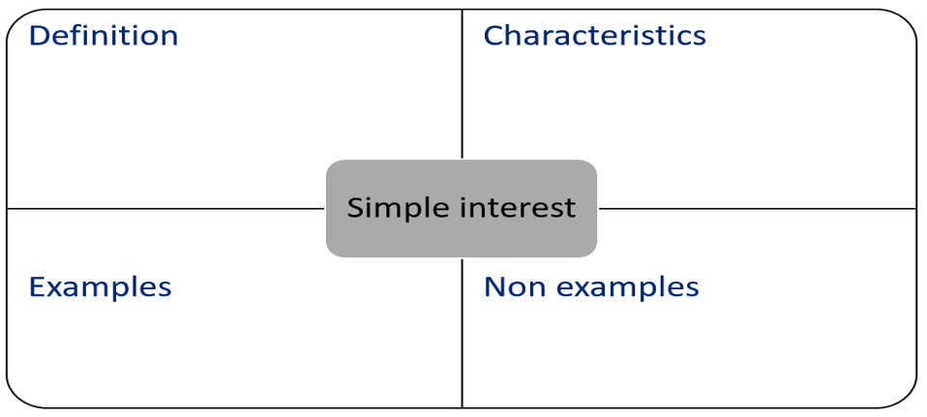

Appendix C

Simple interest practice
- $1000 is invested at 5% simple interest
- What is the value after 1 year?
- What is the value after 2 years?
- What is the value after 5 years?
- What is the value after 10 years?
- $2000 is invested at 5% simple interest
- What is the value after 1 year?
- What is the value after 2 years?
- What is the value after 5 years?
- What is the value after 10 years?
- $2000 is invested at 2.5% simple interest
- What is the value after 1 year?
- What is the value after 2 years?
- What is the value after 5 years?
- What is the value after 10 years?
- How much would I need to invest at 10% interest for 5 years, to have $1500?
- How much would I need to invest at 10% interest for 2.5 years, to have $1500?
- How much would I need to invest at 10% interest for 1 year, to have $1500?

Sample solutions

Appendix A – watching money grow
Scenario | What has changed | Make a prediction | Future value
$1500 is invested for 4 years at a simple interest rate of 2.5% per year. | The term of the investment has increased, from 3 to 4 years. | The future value will increase. | $1650
$1500 is invested for 2 years at a simple interest rate of 2.5% per year. | The term of the loan has now decreased to 2 years. | The future value will decrease. | $1575
$1500 is invested for 2 years at a simple interest rate of 3% per year. | The interest rate has increased. | The future value will increase. | $1590
$1500 is invested for 3 years at a simple interest rate of 3% per year. | The term of the investment has increased. | The future value will increase. | $1635

Appendix C – simple interest practice
- $1000 is invested at 5% simple interest
- What is the value after 1 year? $1050
- What is the value after 2 years? $1100
- What is the value after 5 years? $1250
- What is the value after 10 years? $1500
- $2000 is invested at 5% simple interest
- What is the value after 1 year? $1100
- What is the value after 2 years? $1200
- What is the value after 5 years? $1500
- What is the value after 10 years? $3000
- $2000 is invested at 2.5% simple interest
- What is the value after 1 year? $1050
- What is the value after 2 years? $1100
- What is the value after 5 years? $1250
- What is the value after 10 years? $1500
- How much would I need to invest at 10% interest for 5 years, to have $1500? $1000
- How much would I need to invest at 10% interest for 2.5 years, to have $1500? $1200
- How much would I need to invest at 10% interest for 1 year, to have $1500? $1363.64

References
This resource contains NSW Curriculum and syllabus content. The NSW Curriculum is developed by the NSW Education Standards Authority. This content is prepared by NESA for and on behalf of the Crown in right of the State of New South Wales. The material is protected by Crown copyright.
Please refer to the NESA Copyright Disclaimer for more information https://educationstandards.nsw.edu.au/wps/portal/nesa/mini-footer/copyright.
NESA holds the only official and up-to-date versions of the NSW Curriculum and syllabus documents. Please visit the NSW Education Standards Authority (NESA) website https://educationstandards.nsw.edu.au/ and the NSW Curriculum website https://curriculum.nsw.edu.au/home.
Mathematics K–10 Syllabus © NSW Education Standards Authority (NESA) for and on behalf of the Crown in right of the State of New South Wales, 2022.

© State of New South Wales (Department of Education), 2023
The copyright material published in this resource is subject to the Copyright Act 1968 (Cth) and is owned by the NSW Department of Education or, where indicated, by a party other than the NSW Department of Education (third-party material).
Copyright material available in this resource and owned by the NSW Department of Education is licensed under a Creative Commons Attribution 4.0 International (CC BY 4.0) licence.
This licence allows you to share and adapt the material for any purpose, even commercially.
Attribution should be given to © State of New South Wales (Department of Education), 2023.
Material in this resource not available under a Creative Commons licence:
- the NSW Department of Education logo, other logos and trademark-protected material
- material owned by a third party that has been reproduced with permission. You will need to obtain permission from the third party to reuse its material.
Links to third-party material and websites
Please note that the provided (reading/viewing material/list/links/texts) are a suggestion only and implies no endorsement, by the New South Wales Department of Education, of any author, publisher, or book title. School principals and teachers are best placed to assess the suitability of resources that would complement the curriculum and reflect the needs and interests of their students.
If you use the links provided in this document to access a third-party's website, you acknowledge that the terms of use, including licence terms set out on the third-party's website apply to the use which may be made of the materials on that third-party website or where permitted by the Copyright Act 1968 (Cth). The department accepts no responsibility for content on third-party websites.

