What? – more pay!
Students explore the different types of leave they are entitled to in Australia. They learn about the history of leave loading and how to calculate leave loading and total holiday pay.

Visible learning

Learning intentions
- To know that there are different types of leave.
- To be able to solve problems that involve leave loading.

Success criteria
- I can define leave loading.
- I can calculate leave loading.
- I can calculate the total pay for a period of leave.

Syllabus outcomes
A student:
- develops understanding and fluency in mathematics through exploring and connecting mathematical concepts, choosing and applying mathematical techniques to solve problems, and communicating their thinking and reasoning coherently and clearly MAO-WM-01
- solves financial problems involving simple interest, earning money and spending money MA5-FIN-C-01
Mathematics K–10 Syllabus © NSW Education Standards Authority (NESA) for and on behalf of the Crown in right of the State of New South Wales, 2022.

Activity structure
Please use the associated PowerPoint What? – more pay! to display images in this lesson.

Launch
- Display Figure 1 using slide 3 of the What? – more pay! PowerPoint. Explain that it shows the minimum number of paid vacation days employees receive in various parts of the world.
Figure 1 – minimum mandatory paid vacation days, normalised for a 5-day work week
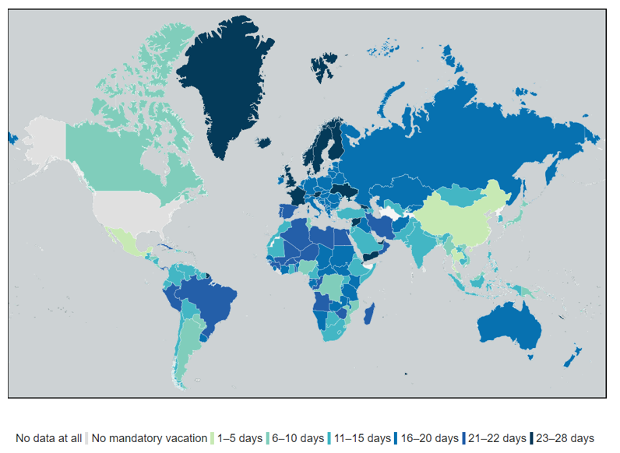
‘Map of Vacation Days Around the World’ by Guest2625 is licensed under CC BY-SA 4.0.
- Ask students to Think-Pair-Share (bit.ly/thinkpairsharestrategy) to discuss what they notice and what they wonder (bit.ly/noticewonderstrategy) about Figure 1.
Prompting questions could be:
- Where would you like to live and why?
- Do countries in the same areas have the same number of paid vacation days? If so, why would this be?
- How many paid vacation days does America get compared to Australia?
- What might be the average number across the world?

Explore
- Ask students if they know of any leave types that employees are entitled to in Australia. Allow students to Think-Pair-Share (bit.ly/thinkpairsharestrategy) the types of leave that they know of with a partner.
- Answers could be shared verbally by non-volunteer students or using an online word cloud such as Mentimeter (mentimeter.com/).
- Print approximately 5 sets of Appendix A ‘Types of leave fact sheets’. This appendix contains summary fact sheets of 6 different types of leave outlined on the Fair Work website (fairwork.gov.au/leave).
- Randomly hand out the fact sheets so that each student has one fact sheet and the class has a range of each of the fact sheets.
There is a fact sheet on Family and Domestic Violence Leave. This may be a sensitive issue with your students. Deleting this leave sheet will not have any impact on the activity.
- Allow students time to read the information presented, focusing on:
- What is it?
- Who can take it?
- When can you take it?
- Anything interesting?
- While students are reading, arrange the room so that students can participate in speed dating (bit.ly/strategyspeed).

Suggested steps for effective speed dating are:
- Set the room up in 2 circles, one inside the other with chairs facing. You could also use 2 straight lines or have the students stand facing each other.
- Arrange students so fact sheets are evenly spread throughout the circles.
- Give students a set time to talk to their partner about what they have learnt.
- Both partners share their knowledge before one circle of students moves one spot over.
- It is suggested to allow approximately 40 seconds to one minute for each person to talk and 3 minutes for students to process the information and ask any questions. Repeat this process as one group of students moves one spot until all students have heard each topic. It does not matter if they hear the same information more than once or if they hear their own information, as this will reinforce learning.
- At the conclusion of this activity students should understand the 6 different types of leave. Explain to students that the focus of this lesson is on annual leave and ask a non-volunteer student to explain what annual leave is.
- Show students the video ‘How annual leave works’ (1:26) (bit.ly/howannualleaveworks). This video is provided by the Fair Work Ombudsman (fairwork.gov.au) and explains what annual leave is, how it works and when it can be taken. It also introduces the concept of holiday leave loading which was not explained on the fact sheet during the speed dating activity.
- Use slides 5–10 of the What – more pay! PowerPoint to educate students about the history of leave and annual leave loading in Australia.

Summarise
- Use slides 12–23 of the What – more pay! PowerPoint for explicit teaching of the 3 most asked questions around calculating leave loading.
It is often the language that complicates this work for students. The scenarios have been kept the same to outline the difference between the questions.
- Issue students with Appendix B – holiday pay questions for students to complete. These questions use variation theory (variationtheory.com/introduction/), so students should be encouraged to make predictions of how the changes affect the answer, as they progress through the questions.

Apply
- Ask students to find a job advertisement that provides an annual amount of pay. Students could use newspapers or online searches such as I work for NSW (iworkfor.nsw.gov.au/).
- Instruct students to calculate the following for their chosen job advertisement:
- Weekly pay
- Holiday loading
- Amount of money received for a week’s holiday
- Amount of money received for a 2-week holiday
- The amount of money received for 4 weeks’ annual leave.

Assessment and differentiation

Suggested opportunities for differentiation
Explore
- Some of the fact sheets are quite lengthy and contain a lot of information. Students with low literacy skills may benefit from one of the shorter fact sheets such as sick, carer’s and compassionate leave.
- Students may need to revise how to calculate a percentage of a quantity.
- Students could research leave entitlements of other countries and compare to our own.
Summarise
- The practice questions used will differ depending on students’ needs.
Apply
- Students could be given a job advertisement if required, rather than finding their own.

Suggested opportunities for assessment
- Listen to student conversations during the Think-Pair-Share and speed dating activities to check for any misconceptions.
- Collect each student’s job advertisement and calculations to check their understanding.

Appendix A

Types of leave fact sheets
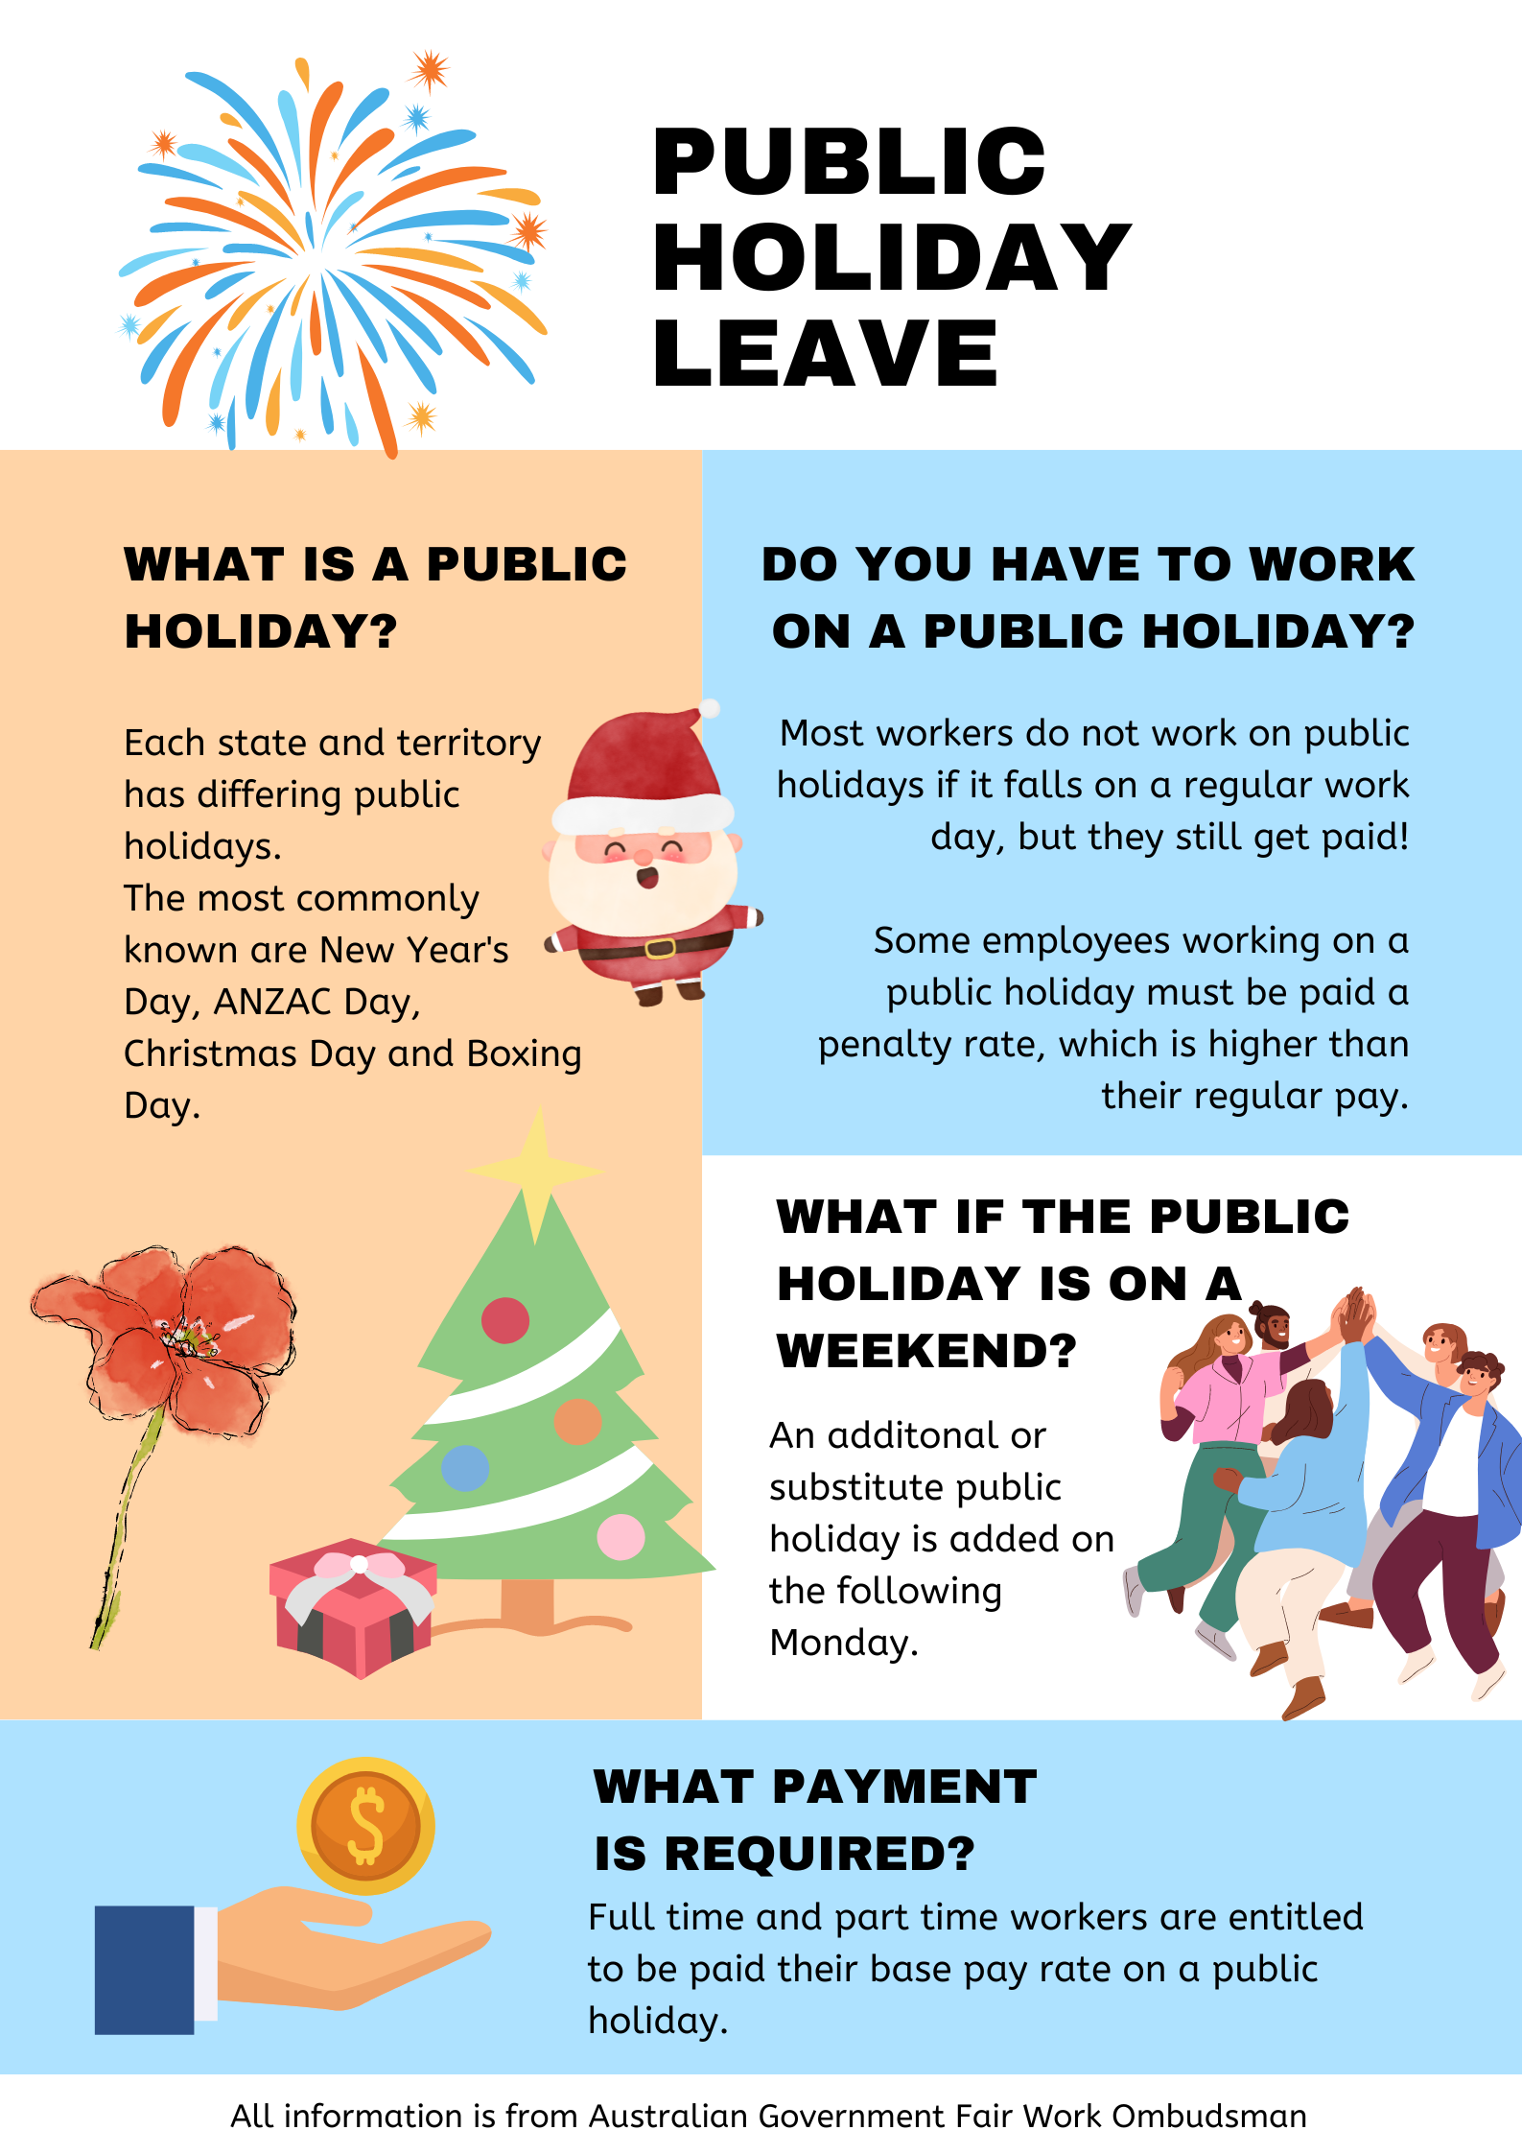

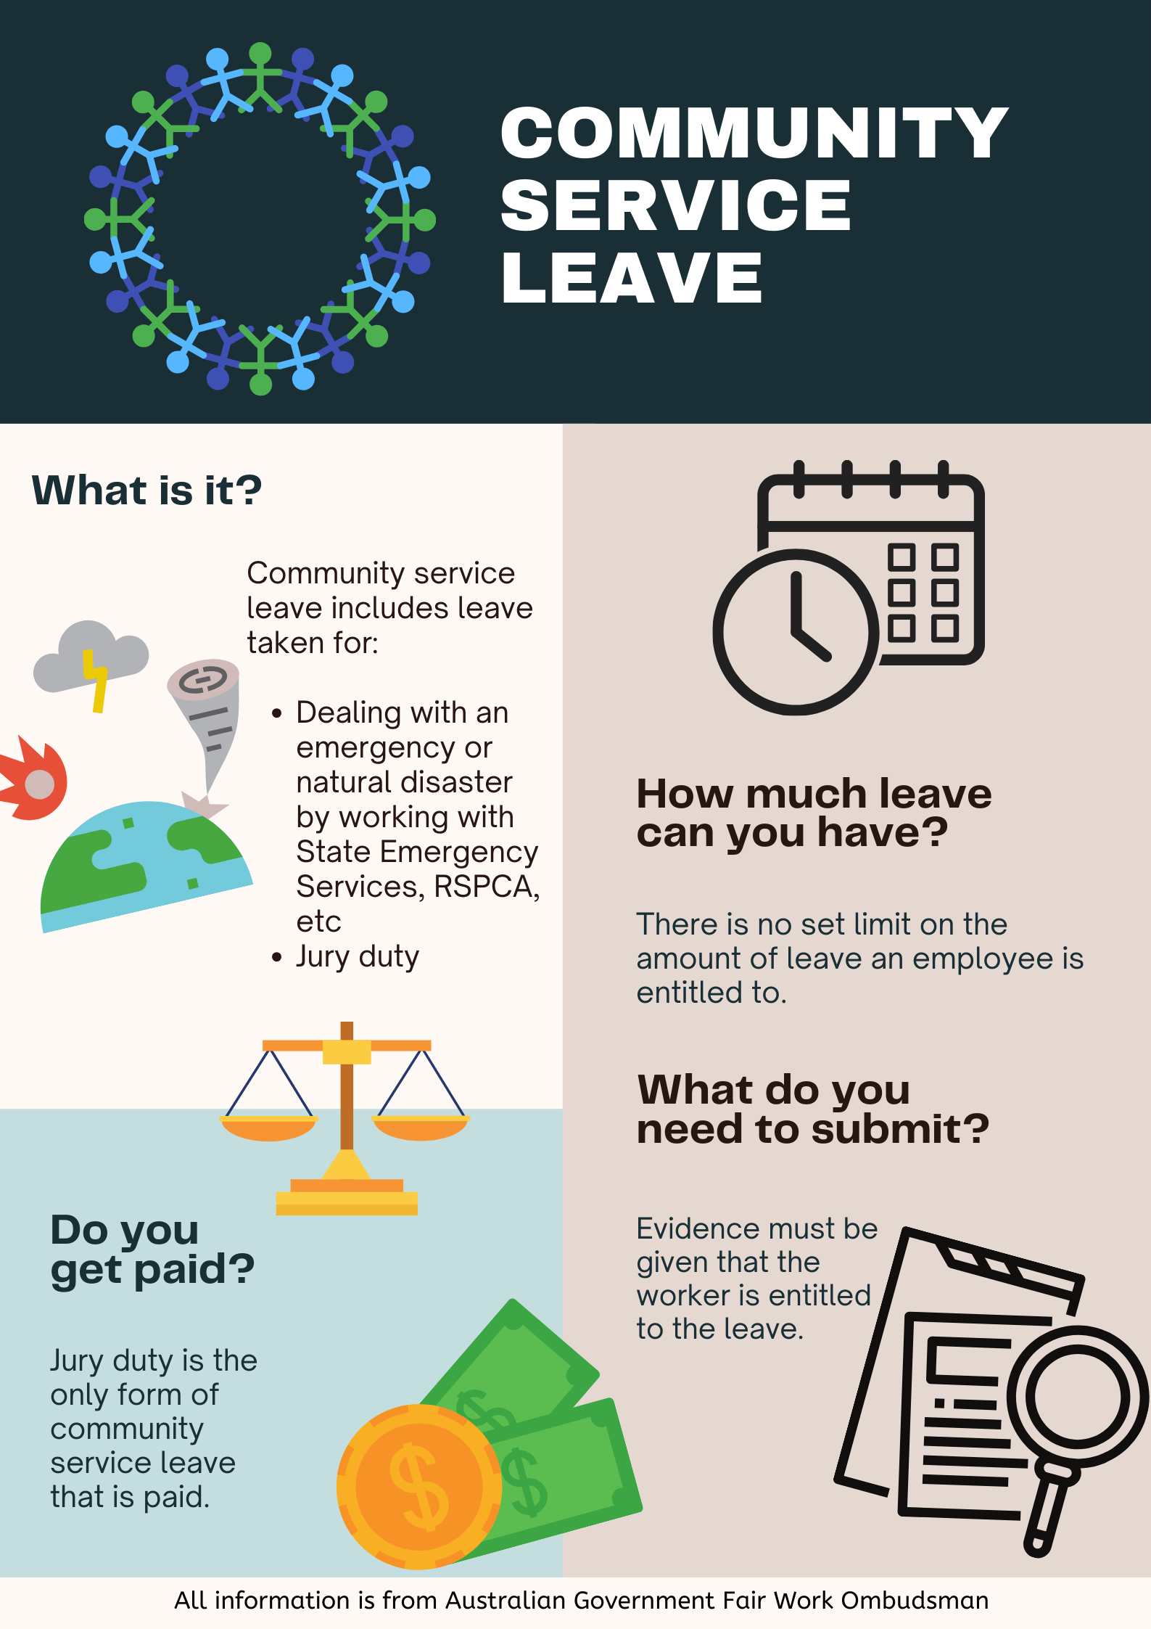

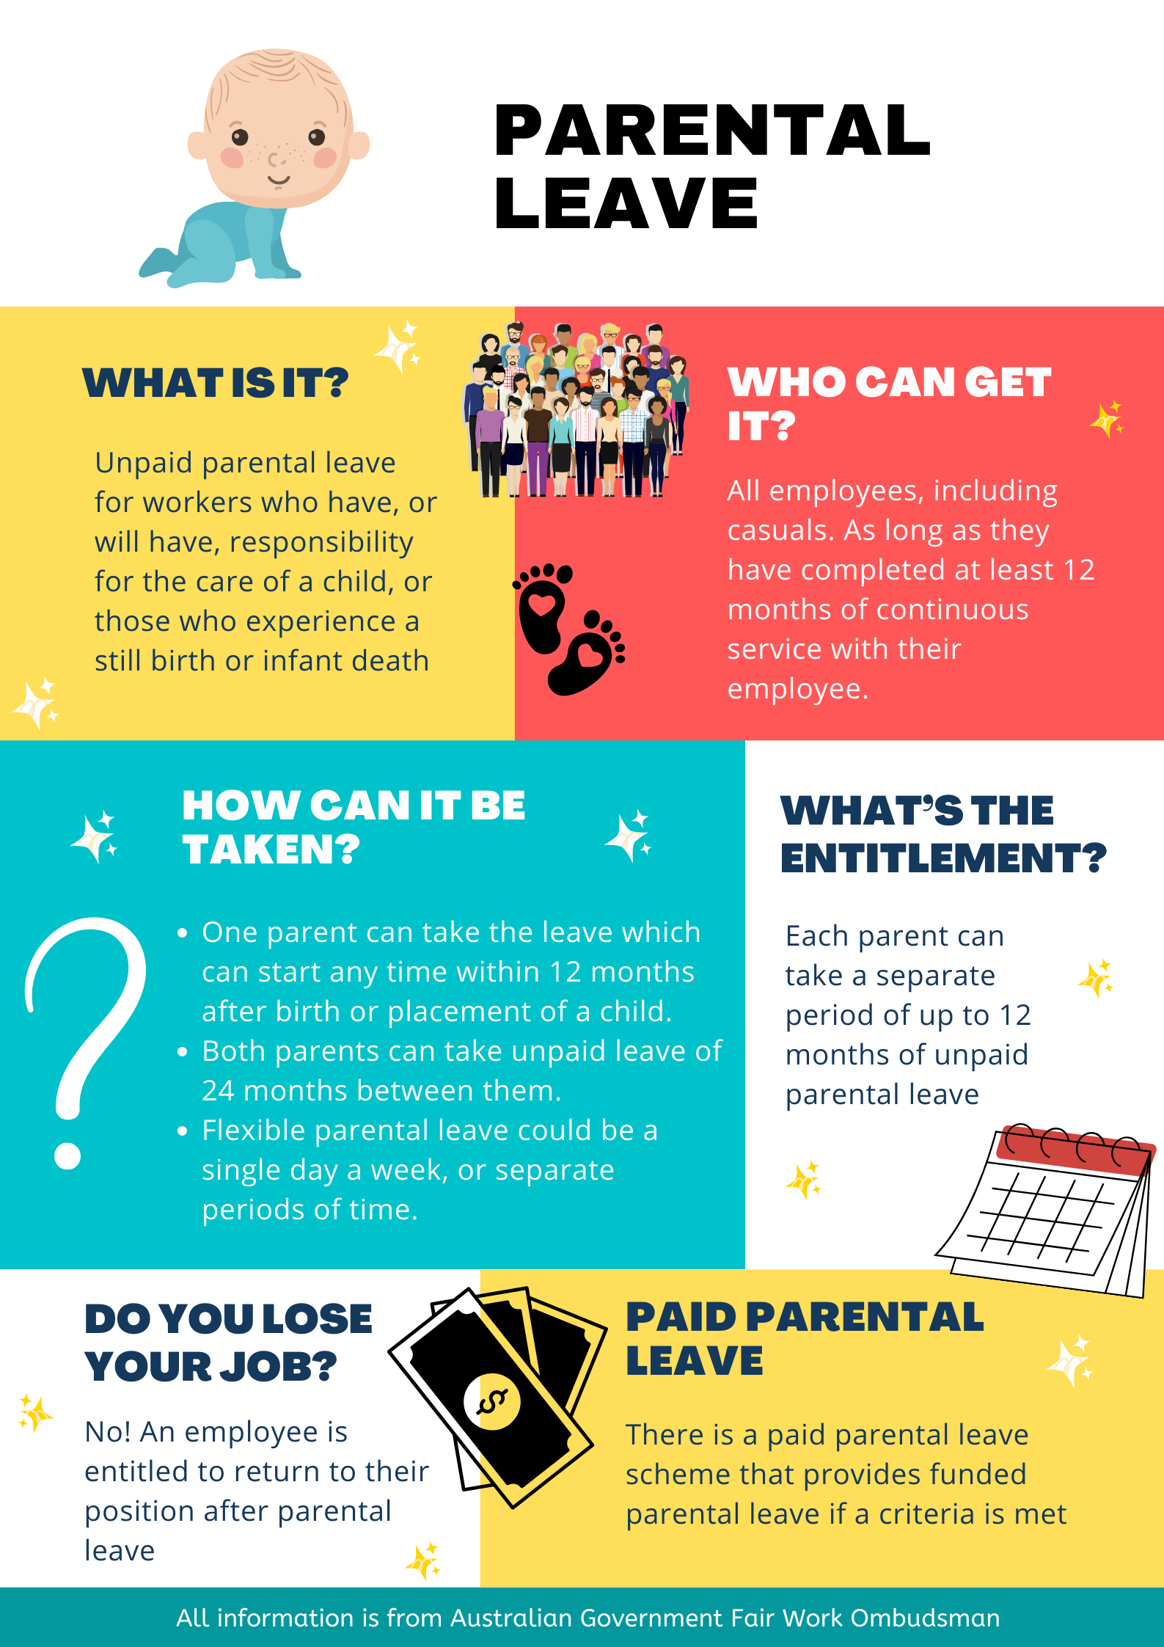
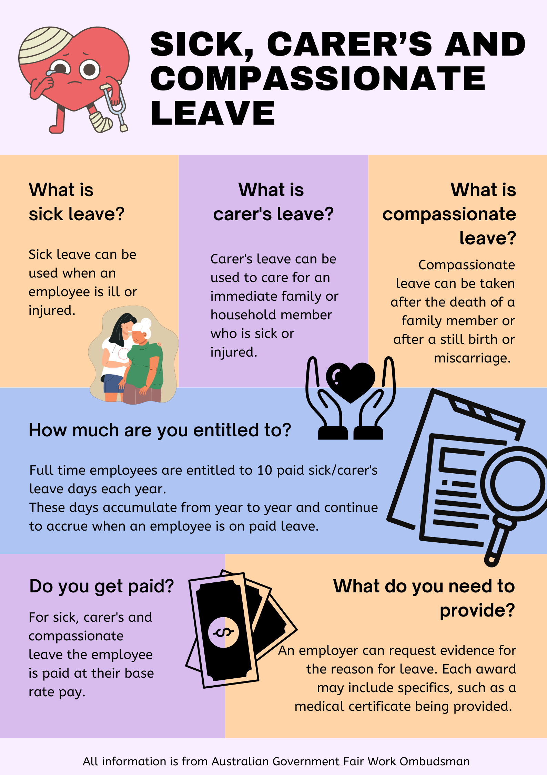

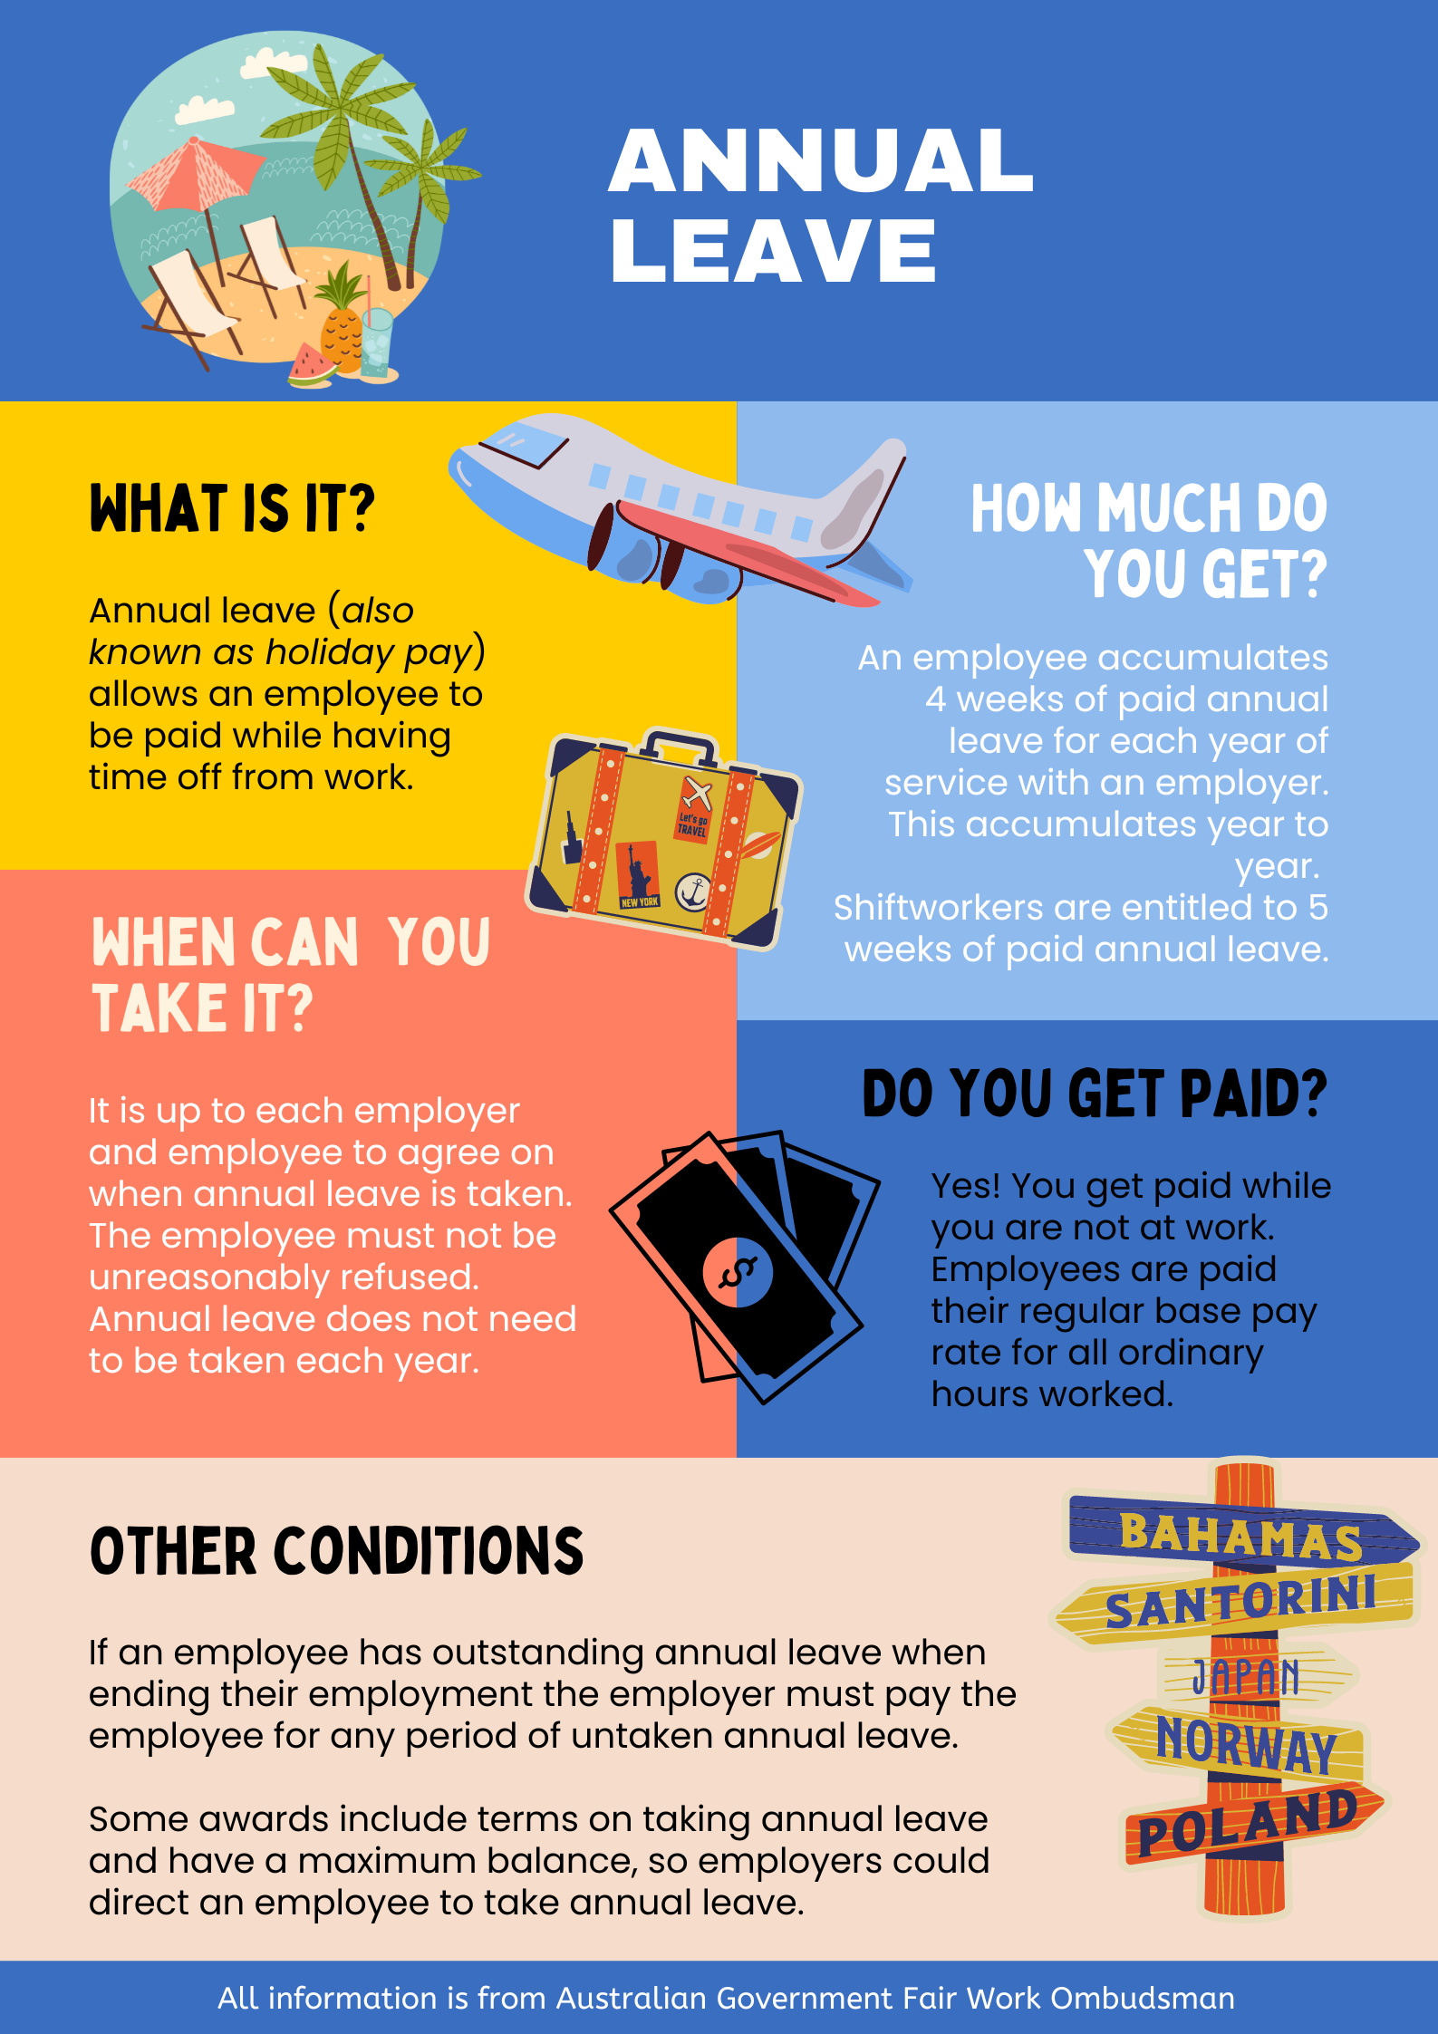
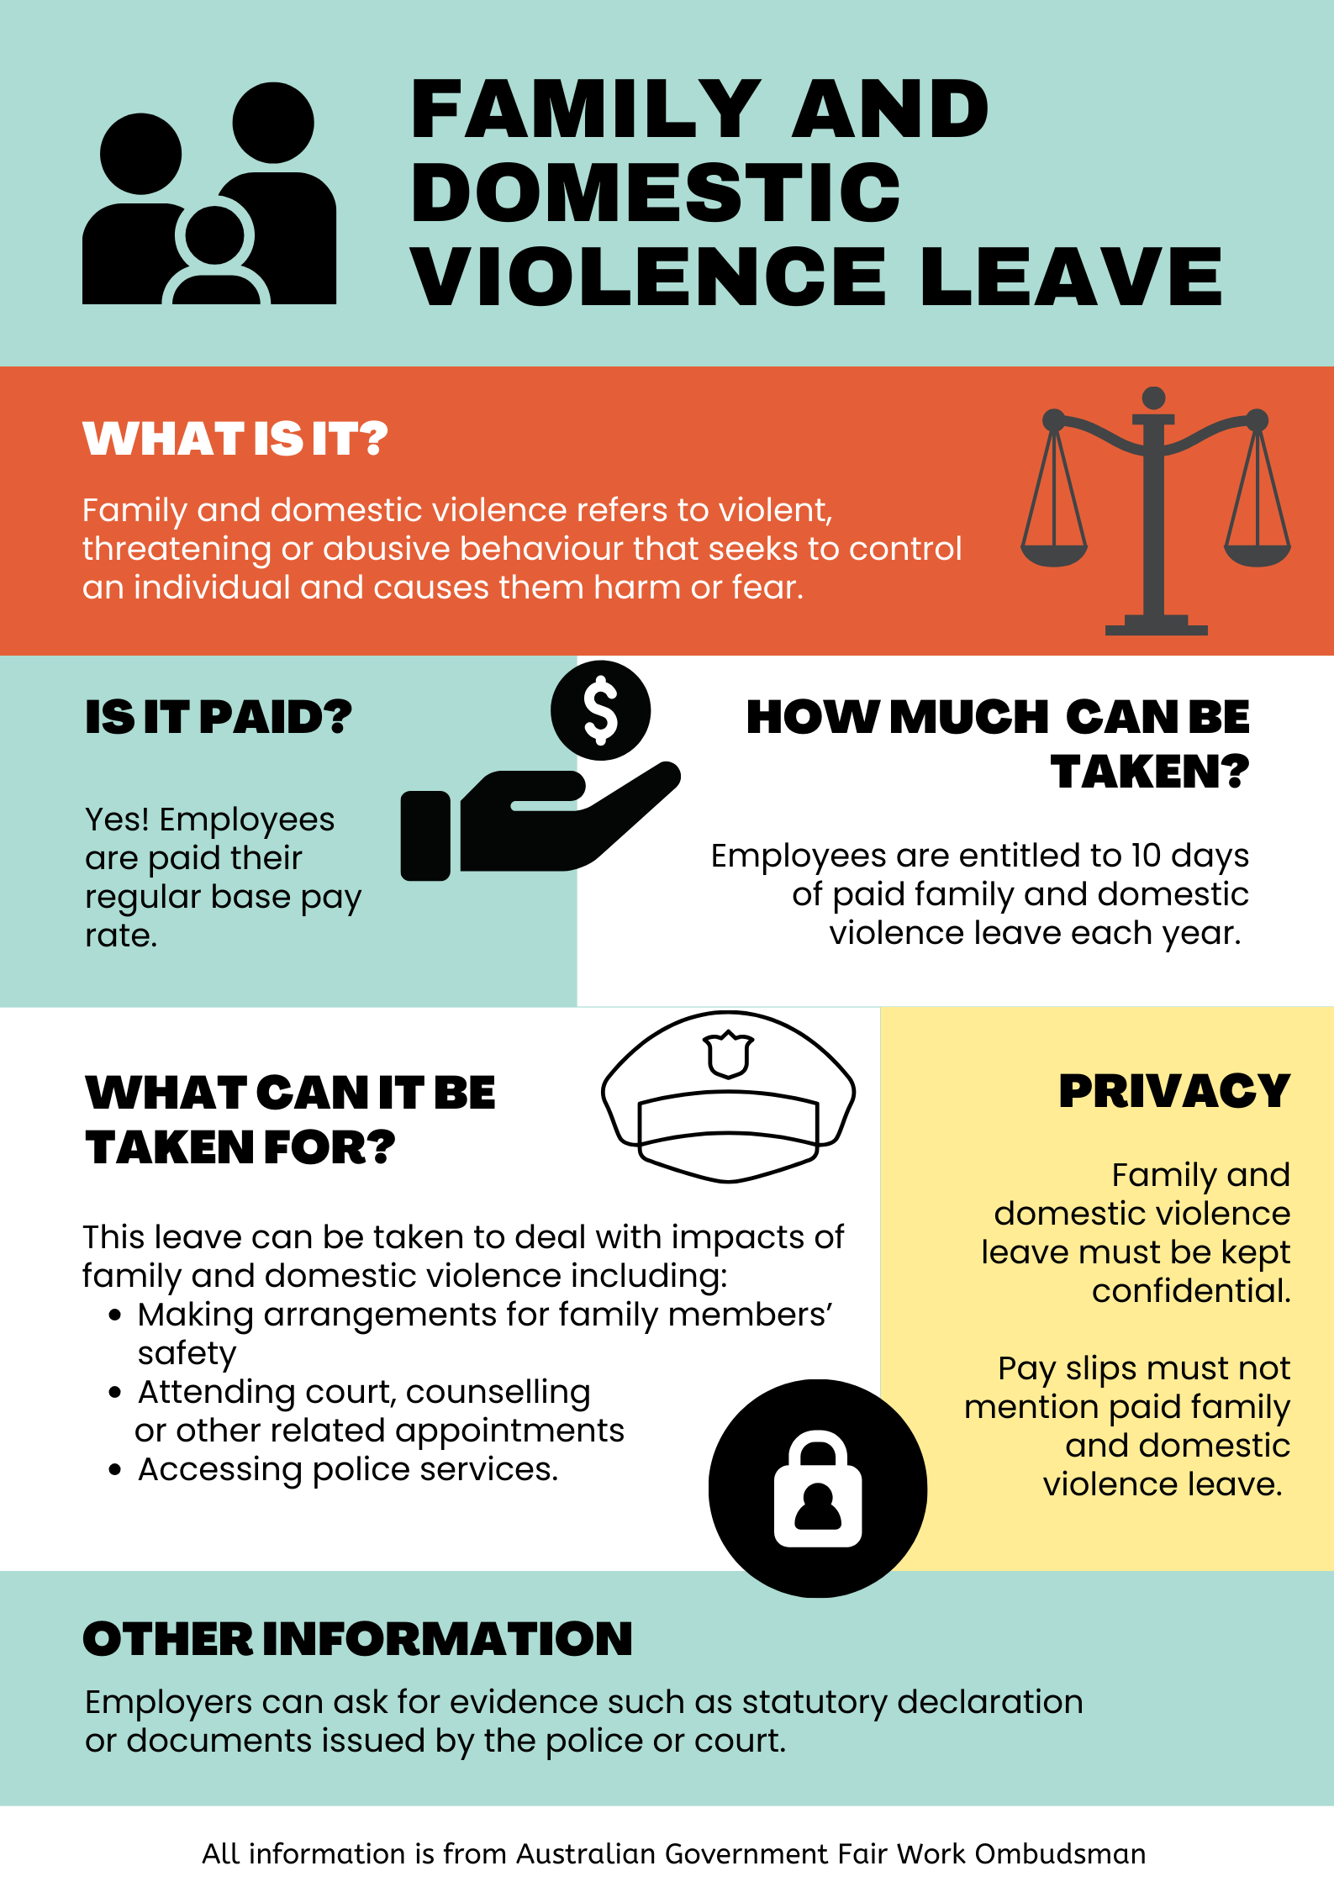

Appendix B

Holiday pay questions
- Alexandra earns a weekly income of $1400. Her work pays holiday loading at 17.5%. Calculate her holiday loading if she plans on taking 3 weeks’ leave.
- For each of the following questions, compare the scenario to the one in question 1. Explain what has changed, and make a prediction of what effect this change will have on the final answer.
Question | Changes and predictions | Calculate the answer
- Barton earns a weekly income of $1400. His work pays holiday loading at 17.5%. Calculate his holiday loading if he plans on taking 4 weeks’ leave.
- Candice earns a weekly income of $1400. Her work pays holiday loading at 17.5%. Calculate her holiday pay if she plans on taking 4 weeks’ leave.
- Dominic earns a weekly income of $960. His work pays holiday loading at 17.5%. Calculate his holiday pay if he plans on taking 4 weeks’ leave.

Sample solutions

Appendix B – holiday pay questions
- $1400×\frac{17.5}{100}=245$
$245×3=\$735$

Question | Changes and predictions | Calculate the answer
- Barton earns a weekly income of $1400. His work pays holiday loading at 17.5%. Calculate his holiday loading if he plans on taking 4 weeks’ leave. | The holiday loading is for 4 weeks rather than 3.  This will mean that the holiday loading will increase. | $1400×\frac{17.5}{100}=245$  $245×4=\$980$
- Candice earns a weekly income of $1400. Her work pays holiday loading at 17.5%. Calculate her holiday pay if she plans on taking 4 weeks’ leave. | Holiday pay is being calculated rather than just holiday loading.  This will make the answer increase by 4 weeks’ pay. | $$1400×4=5600$$  $$5600+980=\$6580$$
- Dominic earns a weekly income of $960. His work pays holiday loading at 17.5%. Calculate his holiday pay if he plans on taking 4 weeks’ leave. | The weekly income has decreased.  Therefore, the holiday pay will decrease. | $$960×4=3840$$  $$\frac{17.5}{100}×3840=672$$  $$3840+672=\$4512$$

References
This resource contains NSW Curriculum and syllabus content. The NSW Curriculum is developed by the NSW Education Standards Authority. This content is prepared by NESA for and on behalf of the Crown in right of the State of New South Wales. The material is protected by Crown copyright.
Please refer to the NESA Copyright Disclaimer for more information https://educationstandards.nsw.edu.au/wps/portal/nesa/mini-footer/copyright.
NESA holds the only official and up-to-date versions of the NSW Curriculum and syllabus documents. Please visit the NSW Education Standards Authority (NESA) website https://educationstandards.nsw.edu.au/ and the NSW Curriculum website https://curriculum.nsw.edu.au/home.
Mathematics K–10 Syllabus © NSW Education Standards Authority (NESA) for and on behalf of the Crown in right of the State of New South Wales, 2022.
Fair Work Ombudsman (n.d.) Leave, Fair Work Ombudsman website, accessed 8 September 2023.

© State of New South Wales (Department of Education), 2023
The copyright material published in this resource is subject to the Copyright Act 1968 (Cth) and is owned by the NSW Department of Education or, where indicated, by a party other than the NSW Department of Education (third-party material).
Copyright material available in this resource and owned by the NSW Department of Education is licensed under a Creative Commons Attribution 4.0 International (CC BY 4.0) license.
This license allows you to share and adapt the material for any purpose, even commercially.
Attribution should be given to © State of New South Wales (Department of Education), 2023.
Material in this resource not available under a Creative Commons license:
- the NSW Department of Education logo, other logos and trademark-protected material
- material owned by a third party that has been reproduced with permission. You will need to obtain permission from the third party to reuse its material.
Links to third-party material and websites
Please note that the provided (reading/viewing material/list/links/texts) are a suggestion only and implies no endorsement, by the New South Wales Department of Education, of any author, publisher, or book title. School principals and teachers are best placed to assess the suitability of resources that would complement the curriculum and reflect the needs and interests of their students.
If you use the links provided in this document to access a third-party's website, you acknowledge that the terms of use, including licence terms set out on the third-party's website apply to the use which may be made of the materials on that third-party website or where permitted by the Copyright Act 1968 (Cth). The department accepts no responsibility for content on third-party websites.

