How much will it cost?
Students will need at least one digital device with internet access, per pair, to interact with the Launch activity.
In this lesson students will use infographics to explore how much money they will need to spend on different needs and wants. Students will then plan a budget based on their research.

Visible learning

Learning intentions
- To understand the purpose and benefits of budgeting.
- To create a budget, categorising expenses and allocating funds accordingly.

Success criteria
- I can budget for weekly essentials.
- I can convert between weekly, monthly and yearly amounts.

Syllabus outcomes
A student:
- Solves financial problems involving simple interest, earning money and spending money MA5-FIN-C-01
- develops understanding and fluency in mathematics through exploring and connecting mathematical concepts, choosing and applying mathematical techniques to solve problems, and communicating their thinking and reasoning coherently and clearly MAO-WM-01
Mathematics K–10 Syllabus © NSW Education Standards Authority (NESA) for and on behalf of the Crown in right of the State of New South Wales, 2022.

Activity structure

Launch
- Allow students time to explore and play ‘Spent’ (playspent.org/html/).
During the game students make decisions regarding which job they will accept and what they will spend their money on. Playing the game more than once will allow students the opportunity to encounter different expenses and income opportunities.
- Discuss with students’ what expenses or earnings they could expect when they move out of home. Points to discuss include:
- What do you need to move out of home?
- How will you make money to move out of home?
- What expenses do you think you will encounter monthly?
- What happens if an emergency arises?
- Will you be renting or buying a house?
- How will you furnish your new home?
- Will you need to plan how you will spend your money?

Explore
- Each group will need an A3 copy of Appendix A ‘Money in/Money Out’ and something to attach the sheet to the wall. In randomly assigned groups of 3 (bit.ly/visiblegroups) allow students time to brainstorm and record in the table, their ideas on how they will make money and any expected expenses. To start with students are just using their own knowledge to do this.
Each section in the money out column has been broken into two sections; needs and wants. It is important that students understand the difference between needs and wants to budget effectively.
- Once students have had enough time in their groups to complete Appendix A, allow time for a gallery walk (bit.ly/DLSgallerywalk) so students can observe common themes and unique ideas.
To initiate discussion on the aspects of the unit, Appendix A has been completed in the sample solutions. This is to help prompt ideas that Year 9 students may not consider.
- Appendix B ‘Spending Infographics’ has been developed to display as A3 posters around the classroom.
There are four posters in total. Depending on the size of your class, more than one of each will need to be displayed so students can study the posters in small groups. These posters are best printed in colour.
- Allow time for students to do a gallery walk to look at the infographics, just reading and interpreting the graphs.
- Allocate students back to their original groups and allow groups time to share their insights into the graphs.
- Display the word ‘budget’ on the board and ask students what this word means to them. Foster a discussion on the purpose of a budget. Possible prompt questions could be:
- Think back to the ‘spent’ game you played. Did you have a budget? Do you think it would have helped you to get to the end of the month? Why / Why not?
- Does the school have a budget? What would be the school’s income? What would be the school’s expenditure? What happens if the school spends more money than it brings in?
- Why do governments create yearly budgets?
- Why would you or your family need a budget?
- Ask the question ‘What would you include in a budget?’ Use the Pause-Pose-Pounce-Bounce question strategy [PDF 200KB] (bit.ly/pausepouncebounce) to create a list of earnings and expenses.

Summarise
- Explain to students that they will be creating a budget using the information from the infographics previously explored. Students will select a job from Appendix C ‘Jobs in demand today’ or recall the job that they selected in the previous lesson ‘What should I do when I am older’ and use this income for their budget.
- Distribute Appendix D ‘My budget’ or the How much will it cost? spreadsheet if devices are available.
Appendix D is identical to the spreadsheet. The benefit of using the spreadsheet is that students can enter and practice using simple formulas, such as ‘SUM’ for adding columns. No formulas have been included in the spreadsheet although before issuing it to students some could be added to assist them.
- Students are to firstly complete the income section of the budget using a job that they selected from Appendix C ‘Jobs in demand today’. Students can select any amount within the given range of the job they select. They should also be encouraged to consider other forms of income. They can research the average amount of interest from a savings account that people earn, or money made from investment properties and add this as ‘other income’; this row is optional.
- Students will now consider expenses using the infographics that have been displayed around the room. They are to move around the room recording any information they can on their budget, such as transport, internet, utilities, food and rent.
- Explain that some expenses were not shown on the infographics although these are personal choices for everyone on how they spend their money. These categories include eating out/takeaway, entertainment, and personal items. Students are to assign amounts for each of these expenses to meet their budgeting needs by first deciding how much they would like to save. If needed, a set amount to be saved can be set for the class and they can adjust their budget accordingly to suit this amount.
- Have a class discussion about what they noticed and wondered (bit.ly/noticewonderstrategy) when filling in their personal budget in terms of overall expenses and how much money was left over to save.

Apply
- Display slide 2 from the PowerPoint How much will it cost? and ask students to compare their own percentages from their work in Appendix C, to that of the average Australian. What do they notice? What do they wonder? (bit.ly/noticewonderstrategy) about their spending compared to the average.
- To prompt deeper thinking, ask students to answer the following questions individually, on paper:
- Can you explain or justify why some of your categories are different than the data?
- How can you reduce your spending?
- How can you increase your savings?
Money is a sensitive issue so it is important to allow students personal reflection time independent of their peers.

Assessment and differentiation

Suggested opportunities for differentiation
Explore
- Students with good literacy and research skills may be given a copy of the budget from Appendix C and asked to find average costs for an individual, in each category.
- Students could find the value of their family utility bills to complete their budgets.
- Teachers could provide information such as where to live to help students who have difficulty researching.
Summarise
- A budget spreadsheet has been developed to support students of all levels. Students could develop their own formulas to convert between time periods, find percentages and calculate totals or they could be provided to students to assist their understanding of budgets without the complexity of converting between time periods.
- Converting between days, weeks, months and years and percentages may need to be revised.
Apply
- Students could be encouraged to create a sector graph of their own expenses.

Suggested opportunities for assessment
Explore
- The teacher could ask the students to explain and justify their thinking around their responses in Appendix A.
Summarise
- Appendix C could be collected and used as summative assessment for the unit of learning.
Apply
- Monitor student responses during the individual reflections, for working mathematically skills such as justification and reasoning.

Appendix A

Money in/money out
How will I make money? | What expenses will I have?
Short term: Whilst at school or studying? | Initial costs  Need:  Want:
Long term: Career options | Monthly costs  Need:  Want:

Appendix B

Spending infographics
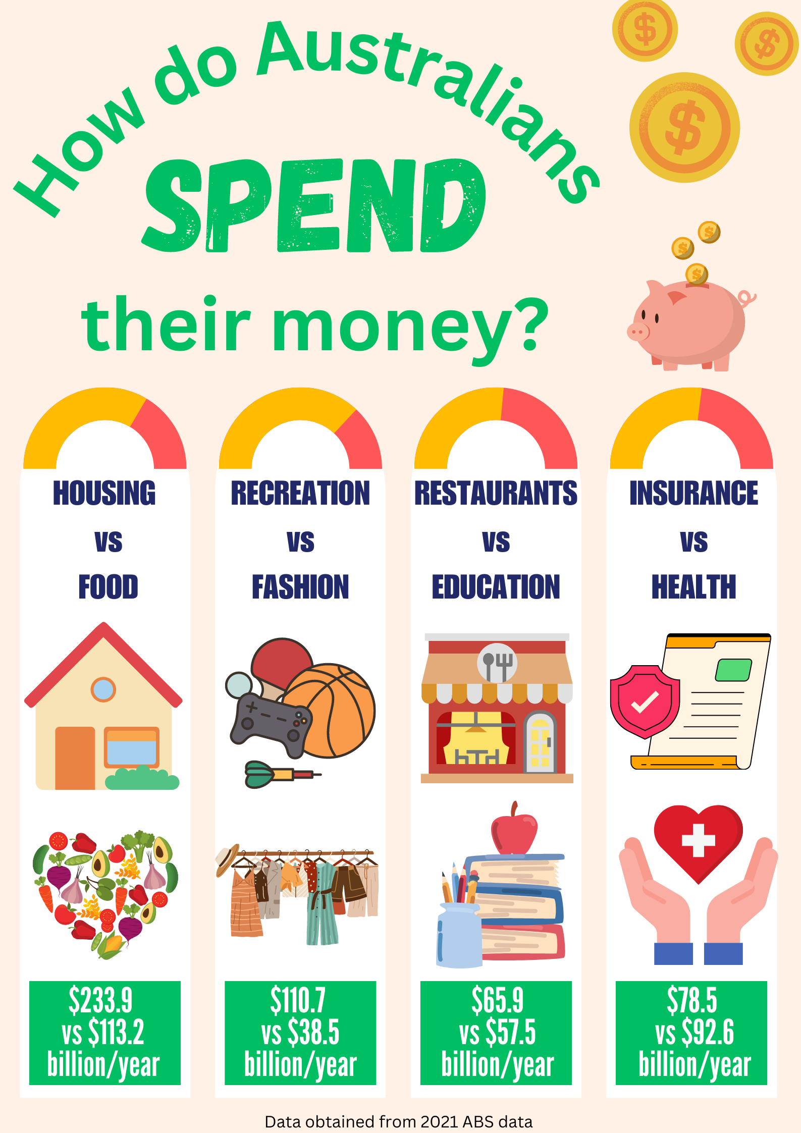
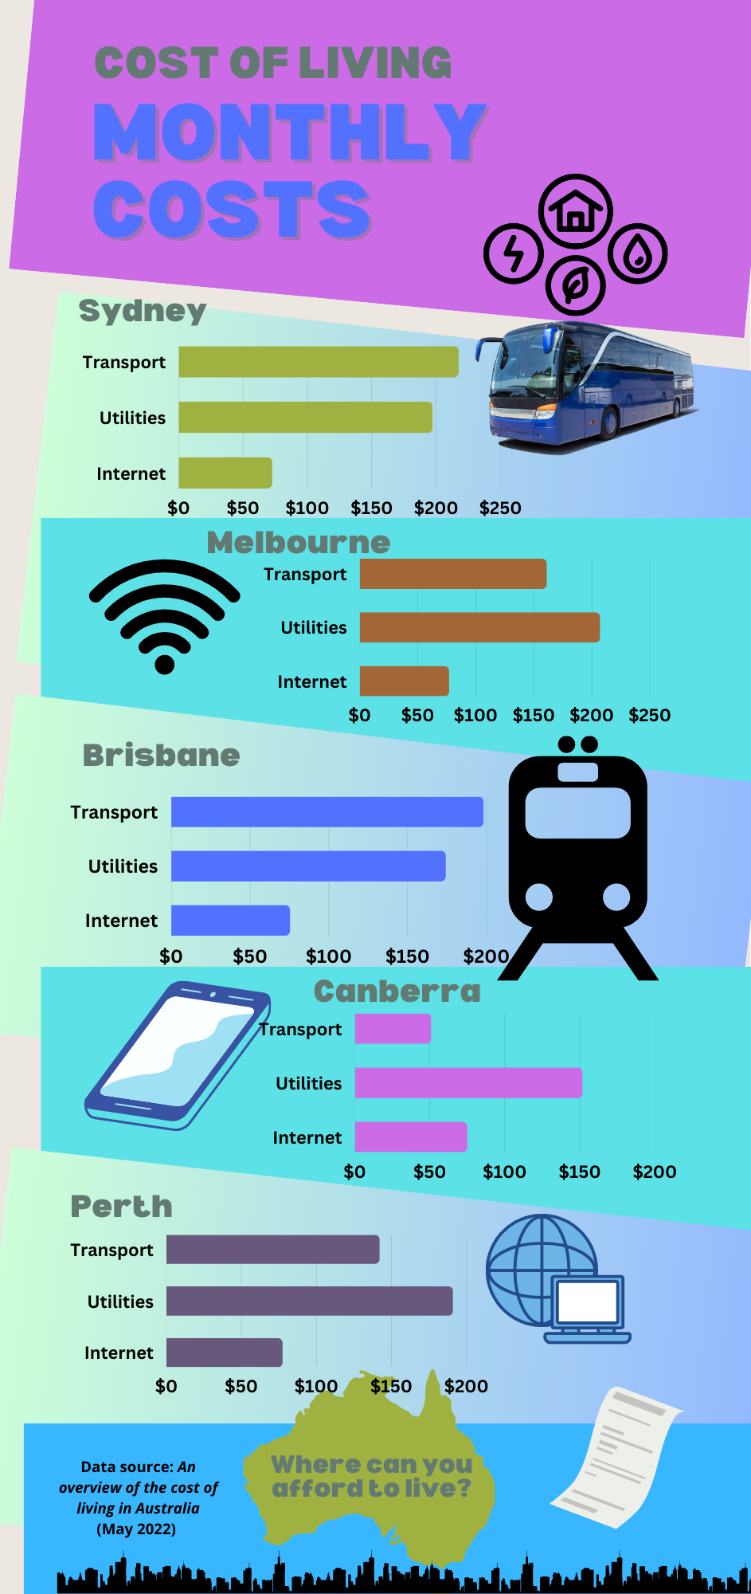
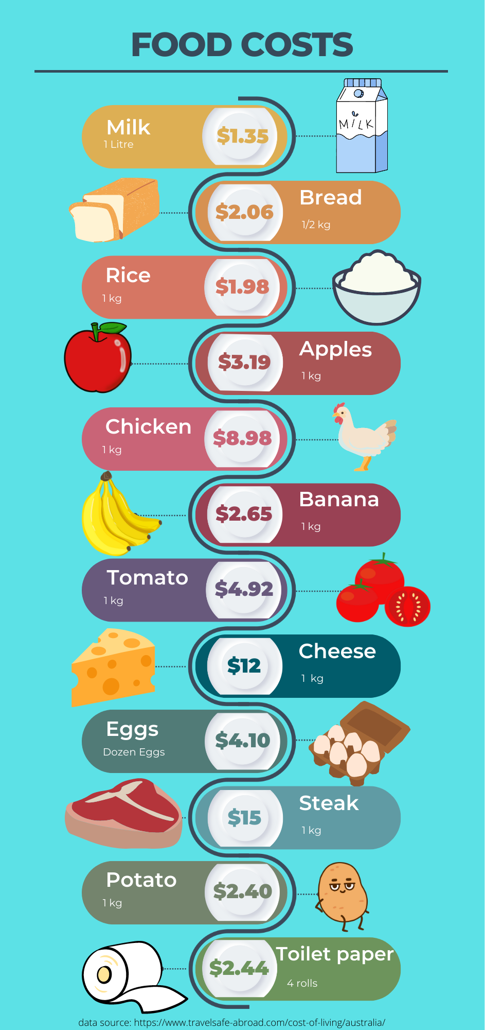
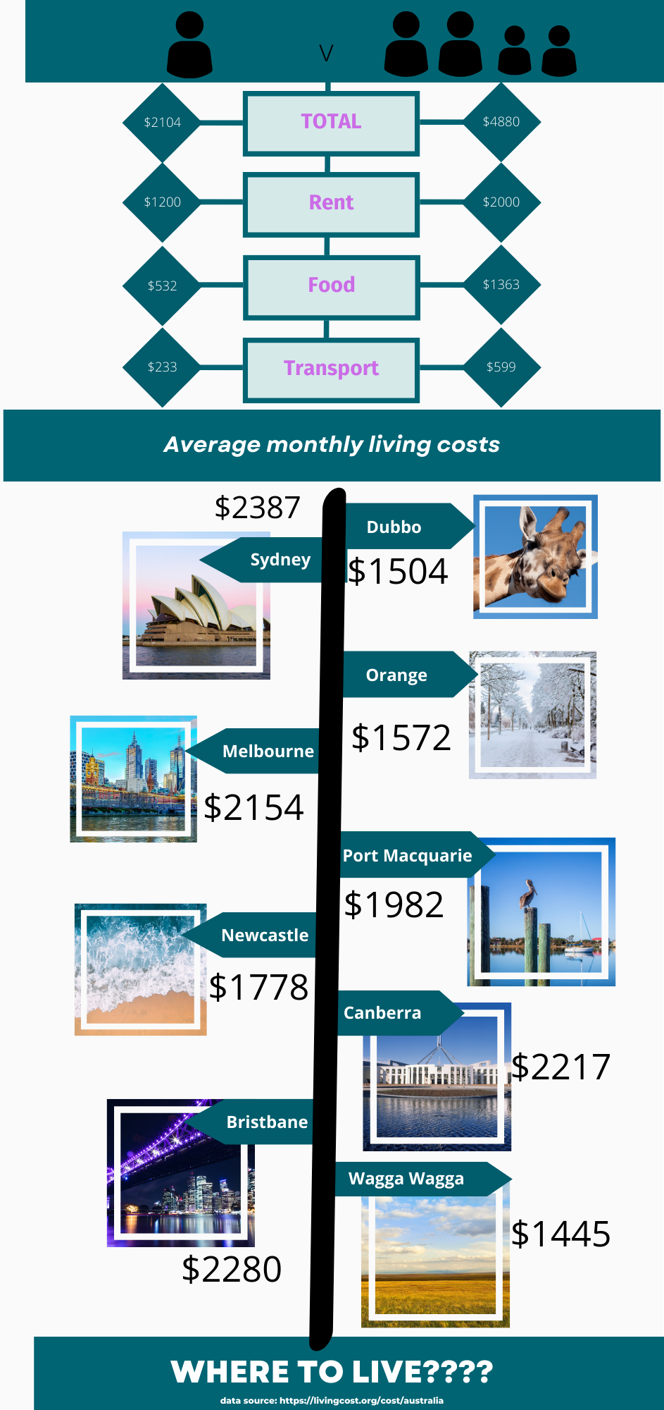

Appendix C

Jobs in demand today
 | Job | Bottom salary | Top salary | Average
1 | Civil Engineer | $58 000 | $102 000 | $80 000
2 | Plumber | $60 000 | $89 000 | $74 500
3 | IT Security Specialist | $98 000 | $160 000 | $129 000
4 | Logistics Manager | $62 000 | $150 000 | $106 000
5 | Welder | $55 000 | $72 000 | $63 500
6 | Registered Nurse | $88 000 | $129 000 | $108 500
7 | Childcare worker | $64 000 | $89 000 | $76 500
8 | Project Manager | $78 000 | $170 000 | $124 000
9 | Dentist | $74 000 | $200 000 | $137 000
10 | Hospitality Manager | $53 000 | $69 000 | $61 000
11 | Construction Manager | $67 000 | $180 000 | $123 500
12 | Heavy Vehicle Mechanic | $100 000 | $160 000 | $130 000
13 | Chef | $59 000 | $84 000 | $71 500
14 | Human Resource Manager | $72 000 | $170 000 | $121 000
15 | Aged and disability Care worker | $60 000 | $96 000 | $78 000
Data sourced from ‘Top 30 Most In-Demand Jobs in Australia in 2023’ by GRADJOBS.

Appendix D

My budget

Income
Calculate your total income by selecting a job from ‘Jobs in demand’ and considering any additional income you may earn, such as interest from savings accounts.
Income type | Yearly income | Monthly income | Weekly income
Income from job
Other income
Total income

Expenses
Calculate your total expenses using the infographics around the room. Enter each expense to either yearly, monthly or weekly and then complete the rest of the row.
Expense | Yearly cost | Monthly cost | Weekly cost
Mortgage or rent
Phone and Internet
Utilities
Transport
Food (Groceries)
Food (Eating out or takeaway)
Entertainment
Personal items
Total expenses

Savings
Calculate the total amount of money left over to save by comparing the total income to total expenses.
Totals | Yearly amount | Monthly amount | Weekly amount
Total income
Total expenses
Total savings

Sample solutions

Appendix A – money in/money out
How will I make money? | What expenses could I expect?
Short term: Whilst at school or studying?  Retail  Fast food  Fruit picking  Delivery driver  Baby sitting  Mowing lawns  This will lead into learning about wages, overtime and other forms of income. | Initial costs  Need:  Furniture/ kitchen equipment  Uni fees  Bond  Want:  Car  Big screen TV  This will lead to buying on term, payday loans and buy now, pay latter
Long term: Career options  Doctor, teacher, plumber, nurse etc.  This will lead into learning about salary and holiday loading. | Monthly costs  Need:  Electricity  Food  Water  Rent  Transport  Tax  Want:  Fashion clothing  Entertainment  Saving

References
This resource contains NSW Curriculum and syllabus content. The NSW Curriculum is developed by the NSW Education Standards Authority. This content is prepared by NESA for and on behalf of the Crown in right of the State of New South Wales. The material is protected by Crown copyright.
Please refer to the NESA Copyright Disclaimer for more information https://educationstandards.nsw.edu.au/wps/portal/nesa/mini-footer/copyright.
NESA holds the only official and up-to-date versions of the NSW Curriculum and syllabus documents. Please visit the NSW Education Standards Authority (NESA) website https://educationstandards.nsw.edu.au/ and the NSW Curriculum website https://curriculum.nsw.edu.au/home.
Mathematics K–10 Syllabus © NSW Education Standards Authority (NESA) for and on behalf of the Crown in right of the State of New South Wales, 2022.
Berard V (n.d.) ‘Top 30 Most In-Demand Jobs in Australia in 2023’, GRABJOBS, accessed 8 September 2023.

© State of New South Wales (Department of Education), 2023
The copyright material published in this resource is subject to the Copyright Act 1968 (Cth) and is owned by the NSW Department of Education or, where indicated, by a party other than the NSW Department of Education (third-party material).
Copyright material available in this resource and owned by the NSW Department of Education is licensed under a Creative Commons Attribution 4.0 International (CC BY 4.0) license.
This license allows you to share and adapt the material for any purpose, even commercially.
Attribution should be given to © State of New South Wales (Department of Education), 2023.
Material in this resource not available under a Creative Commons license:
- the NSW Department of Education logo, other logos and trademark-protected material
- material owned by a third party that has been reproduced with permission. You will need to obtain permission from the third party to reuse its material.
Links to third-party material and websites
Please note that the provided (reading/viewing material/list/links/texts) are a suggestion only and implies no endorsement, by the New South Wales Department of Education, of any author, publisher, or book title. School principals and teachers are best placed to assess the suitability of resources that would complement the curriculum and reflect the needs and interests of their students.
If you use the links provided in this document to access a third-party's website, you acknowledge that the terms of use, including licence terms set out on the third-party's website apply to the use which may be made of the materials on that third-party website or where permitted by the Copyright Act 1968 (Cth). The department accepts no responsibility for content on third-party websites.

