Half-life
Students investigate half-life to establish the need for and meaning of negative indices for numerical bases. Students also use the change from positive to negative indices to reinforce the zero index.

Visible learning
This lesson incorporates Path content.

Learning intention
- To understand the relationship between positive and negative indices.

Success criteria
- I can express terms with a negative power as a fraction.
- I can express fractions as a term with a negative power.
- I can simplify expressions with a zero index.
Learning intentions and success criteria should not be revealed until the start of the Summarise section of the lesson.

Syllabus outcomes
A student:
- develops understanding and fluency in mathematics through exploring and connecting mathematical concepts, choosing and applying mathematical techniques to solve problems, and communicating their thinking and reasoning coherently and clearly MAO-WM-01
- simplifies algebraic expressions involving positive-integer and zero indices, and establishes the meaning of negative indices for numerical bases MA5-IND-C-01
- applies the index laws to operate with algebraic expressions involving negative-integer indices MA5-IND-P-01
Mathematics K–10 Syllabus © NSW Education Standards Authority (NESA) for and on behalf of the Crown in right of the State of New South Wales, 2022.

Activity structure

Launch

Equipment
- Multi-coloured, candy-coated button shaped chocolates with a letter on one side (or counters with a mark on one side)
- Plastic cups
- Class set of Appendix A ‘Half-life experiment’

Method
- Students are given 20–30 of the candy-coated chocolates in a cup. Record this number in the table in Appendix A ‘Half-life experiment’.
- Students tip out the contents of the cup onto the desk and eliminate the chocolates that display a letter on the upper surface. Record the number remaining in the second row of the table.
- Repeat step 2, 10 times or until the students run out of chocolates.
- After the activity, ask students to graph their results (Appendix A) and record what they notice and what they wonder (bit.ly/noticewonderstrategy) about the graph.
- Ask students to Think-Pair-Share (bit.ly/thinkpairsharestrategy) to answer the following questions:
- How could you describe the shape of the graph?
- Would the graph ever give negative values?
- What would happen if we started with more chocolates in the cup?
- What is the greatest number of times you could tip out the cup before running out of chocolates?

Explore
- Introduce students to the concept of half-life by showing them the first one minute and 11 seconds of the video ‘Physics: Half-life’ (4:54) https://www.youtube.com/embed/IDkNlU7zKYU.
Half-life is the time it takes for a radioactive isotope to decay by half.
- Briefly discuss the function of Plutonium-238 with the students to give context to an application of half-life.
Plutonium-238 has a half-life of 88 years, which generates an excellent heat source as it decays. This heat source is used in spaceships and converted into electrical power to operate the hardware and computers on board. In a conventional nuclear reactor, one kilogram of Pu-239 can produce sufficient heat to generate nearly 8 million kilowatt-hours of electricity.
- Distribute Appendix B ‘Radioactive isotope decay’ to students and ask them to complete the table.
- Ask students to Think-Pair-Share (bit.ly/thinkpairsharestrategy) and discuss the following questions:
If I have 1000g of Plutonium-238:
- When will it be ½ its size?
- When will it be ¼ of its size?
- Can it ever be $\frac{1}{5}$ of its size?
- When will it be $\frac{1}{1024}$ of its original size?
Another half-life example is Technetium-99m. Technetium-99m is used by radiographers as a medical diagnostic tool. It is injected into people and has a half-life of 6 hours.
- Ask students to go to the Desmos graph ‘Investigating plutonium’ (bit.ly/DesmosInvestigatingPlutonium) and enter the numbers from their ‘Remaining value’ column in the table on their worksheet, into the table in the Desmos graph.
- Ask them to consider:
- How does the shape of this graph compare to your graph from the half-life activity you completed with the chocolates?
- What would happen if the graph kept going?
- What would change in the table if the half-life was a third-life or quarter-life?
- Why do you think scientists talk about ‘half-life’?
- Explain to students that we are now going to have a look at what this has to do with indices. We will start by considering only 8 grams of Plutonium.

Explicit Teaching
Use slides 1–9 of the Negative indices PowerPoint to explore the link between negative indices and fractions. There are comments in the notes section of each slide explaining what to focus on and what questions to ask.

Summarise
- Ask students to write a statement in their own words, explaining how they can write an expression with a negative index as a fraction.
- Challenge students to write their statement as an algebraic rule.
- Display slide 10 of the Negative indices PowerPoint showing the algebraic rule.
- Have students write notes to their future selves (bit.ly/notesstrategy). These should include the rule, where it comes from and some useful examples.
- Ask students to complete Appendix C ‘Multiple representations’.
This activity is designed to encourage students to be flexible in the way they think about negative indices.

Apply

Indices battles
This activity is a game where the students go into battle. To build an army each student will need to:
- Cut out the set of playing cards from Appendix D ‘Indices battles’ and use their set of cards to assemble the strongest set of 10 soldiers they can. Appendix E ‘Scorecard’ contains a scorecard to record the battles.
The rules:
- Two cards are used to create one soldier. One card will form the base and one will be the power.
- Each soldier will then be sent to battle with a solider from a rival army.
- The soldier with the highest total wins the battle.
- Each student will decide what order they are playing their soldiers before the battle begins.
- The army that wins the most battles, wins the war!
- Once the students have assembled their armies, get them to explain step-by-step and in detail how they constructed each soldier. The following questions could be used as a prompt:
- How did you start the task?
- What was the most difficult part?
- Did you ever change your mind? Why?
- What maths skills did you use?
- After one round, students are to Think-Pair-Share (bit.ly/thinkpairsharestrategy) the following questions:
- What were your first thoughts when putting together your army?
- What changes did you make as you assembled your army?
- What were the easier soldiers to assemble?
- How did you decide your order?
- What would make the game easier?

Negative exponents challenge
- Use the digits 0–9, at most one time each, and place a digit in each box to make a true statement.
Figure 1 – negative exponents scaffold
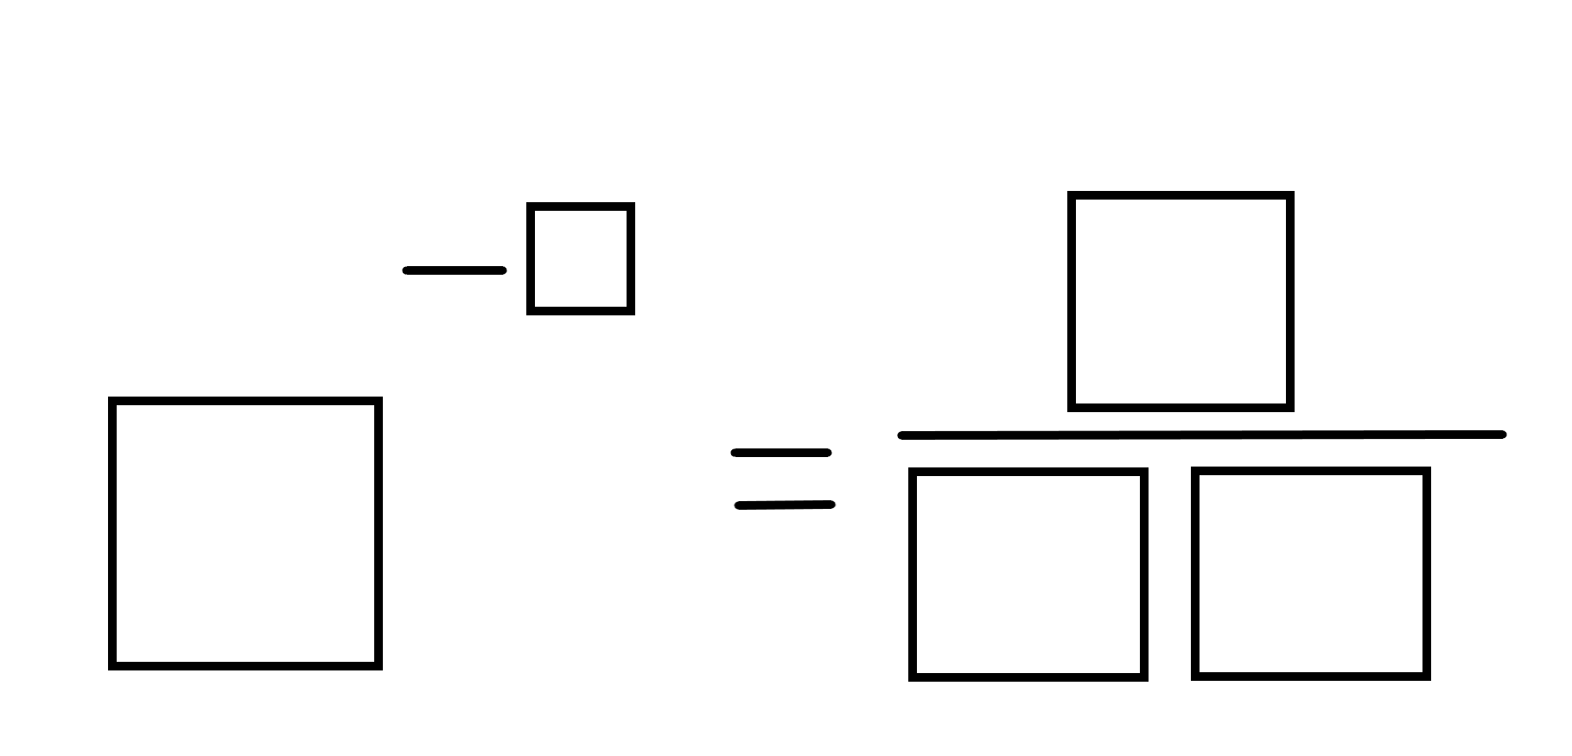
- Following the same rules as above, make a number that is closest to zero as possible.
Figure 2 – negative exponents scaffold
Adapted from Open Middle Partnership (2023) (https://www.openmiddle.com/negative-exponents/).

Assessment and differentiation

Suggested opportunities for differentiation
Launch
- Students could graph their results using a graphing program such as Desmos or spreadsheet software.
- Students could investigate further by starting with more or less chocolates and removing them at different rates. For instance, they could roll a number of dice and remove any die that lands with a 6 face up.
Explore
- Students could alternatively graph their results by hand or using a spreadsheet program rather than the Desmos graph.
- Students could also create a table of values and graph for third-life and quarter-life and compare the shapes of the graphs.
Summarise
- Students who are ready for more challenging applications of negative index values could work through the questions on the websites below which utilise the variation theory technique:
- Multiplying terms (bit.ly/VariationTheoryM).
- Dividing terms (bit.ly/VariationTheoryD).
Apply
- Change the game so the smallest total wins each battle.
- Challenge students to find the biggest or smallest overall total you can make from all 10 soldiers, and the biggest or smallest individual total you can make for one soldier.
- Have a calculator check token, reduce the cards to only have 5 soldiers or only have positive integers on the cards.
- For the open middle problem, challenge students to find the largest fraction possible.

Suggested opportunities for assessment
- Teachers should monitor student discussions for misconceptions.
Explore
- Observe students while they are completing Appendix A to check for understanding and justification.
- Teachers could collect Appendix B to check for student understanding.
Summarise
- Teachers could collect Appendix C to check for student understanding.
- Create an exit ticket where students need to express a term with a negative index as a fraction.

Appendix A

Half-life experiment
Number of tips | Lollies remaining
0
1
2
3
4
5
6
7
8
9
10
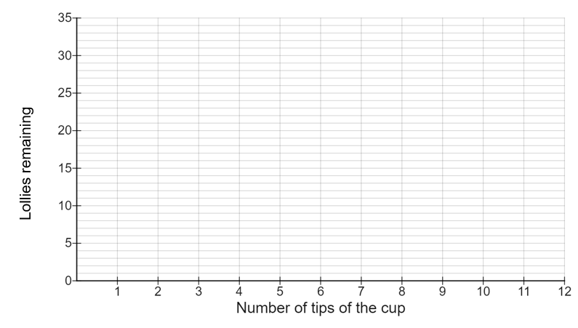

Appendix B

Radioactive isotope decay
- Complete the table below rounding your answer to 2 decimal places.
Time period (in years) | Remaining value (in grams) | Fraction of original amount remaining
0 | 1000 g | 1
88 |  | $$\frac{1}{2}$$
176 |  | $$\frac{1}{4}$$
 |  | $$\frac{1}{8}$$

- If I have 1000 g of Plutonium-238:
- When will it be ½ its size?
- When will it be ¼ of its size?
- Can it ever be $\frac{1}{5}$of its size?
- When will it be $\frac{1}{1024}$ of its original size?
- Go to the Desmos graph ‘Investigating plutonium’ (bit.ly/DesmosInvestigatingPlutonium) and enter the numbers from your ‘Remaining value’ column in the table on your worksheet, into the table in the Desmos graph (or alternatively, use graph paper).
- How does the shape of this graph compare to your graph from the half-life activity you completed with the chocolates?
- What would happen if the graph kept going?
- What would change in the table if the half-life was a third-life or quarter-life?

Appendix C

Multiple representations
Write each statement using multiple different representations. The first example has been completed for you.
$$5^{-2}$$ | $$\frac{1}{5^{2}}$$ | $$\frac{1}{25}$$ | $$25^{-1}$$ | $$\frac{1}{5}×\frac{1}{5}$$ | $$1÷5÷5$$
$$2^{-3}$$
 |  |  |  | $$\frac{1}{4}×\frac{1}{4}$$
 |  |  |  |  | $$1÷3÷3÷3$$
 |  | $$\frac{1}{64}$$
 | $$\frac{1}{x^{4}}$$

Appendix D

Indices battles
Cut out these cards.
0 | 1 | 2 | 3 | 4
9 | -1 | -1 | -2 | -3
8 | -8 | $$\frac{1}{3}$$ | $$-\frac{1}{2}$$ | 2
$$-\frac{3}{2}$$ | $$-\frac{2}{3}$$ | $$\frac{2}{3}$$ | $$\frac{1}{2}$$ | 4

Appendix E

Scorecard
War 1 War 2
Mine | Theirs | Battle winner |  | Mine | Theirs | Battle winner
Winner of War 1 _____________ Winner of War 2 _____________

References
This resource contains NSW Curriculum and syllabus content. The NSW Curriculum is developed by the NSW Education Standards Authority. This content is prepared by NESA for and on behalf of the Crown in right of the State of New South Wales. The material is protected by Crown copyright.
Please refer to the NESA Copyright Disclaimer for more information https://educationstandards.nsw.edu.au/wps/portal/nesa/mini-footer/copyright.
NESA holds the only official and up-to-date versions of the NSW Curriculum and syllabus documents. Please visit the NSW Education Standards Authority (NESA) website https://educationstandards.nsw.edu.au/ and the NSW Curriculum website https://curriculum.nsw.edu.au/home.
Mathematics K–10 Syllabus © NSW Education Standards Authority (NESA) for and on behalf of the Crown in right of the State of New South Wales, 2022.

© State of New South Wales (Department of Education), 2023
The copyright material published in this resource is subject to the Copyright Act 1968 (Cth) and is owned by the NSW Department of Education or, where indicated, by a party other than the NSW Department of Education (third-party material).
Copyright material available in this resource and owned by the NSW Department of Education is licensed under a Creative Commons Attribution 4.0 International (CC BY 4.0) licence.
This licence allows you to share and adapt the material for any purpose, even commercially.
Attribution should be given to © State of New South Wales (Department of Education), 2023.
Material in this resource not available under a Creative Commons licence:
- the NSW Department of Education logo, other logos and trademark-protected material
- material owned by a third party that has been reproduced with permission. You will need to obtain permission from the third party to reuse its material.
Links to third-party material and websites
Please note that the provided (reading/viewing material/list/links/texts) are a suggestion only and implies no endorsement, by the New South Wales Department of Education, of any author, publisher, or book title. School principals and teachers are best placed to assess the suitability of resources that would complement the curriculum and reflect the needs and interests of their students.
If you use the links provided in this document to access a third-party's website, you acknowledge that the terms of use, including licence terms set out on the third-party's website apply to the use which may be made of the materials on that third-party website or where permitted by the Copyright Act 1968 (Cth). The department accepts no responsibility for content on third-party websites.

