Reflecting on practice
This lesson contains a variety of activities that allow students to practise simplifying algebraic expressions using index laws.

Visible learning

Learning intentions
- To be able to consistently apply the index laws to simplify expressions.
- To understand how the index laws apply to a variety of situations.

Success criteria
- I can identify the index law(s) required to simplify an expression.
- I can explain why an expression simplifies in a particular way.

Syllabus outcomes
A student:
- develops understanding and fluency in mathematics through exploring and connecting mathematical concepts, choosing and applying mathematical techniques to solve problems, and communicating their thinking and reasoning coherently and clearly MAO-WM-01
- simplifies algebraic expressions involving positive-integer and zero indices, and establishes the meaning of negative indices for numerical bases MA5-IND-C-01
Mathematics K–10 Syllabus © NSW Education Standards Authority (NESA) for and on behalf of the Crown in right of the State of New South Wales, 2022.

Activity structure

Launch
- Using Figure 1, students are to use the digits 0 to 9 to create a result with the greatest exponent. The digits can only be used once.
Figure 1: Fill in the blanks indices
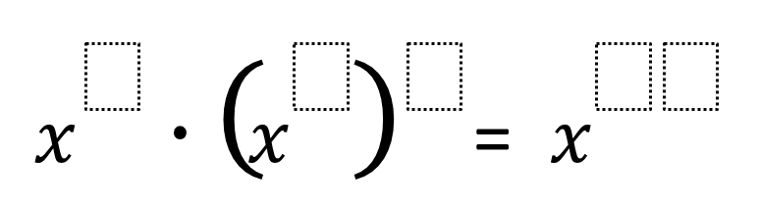
‘Exponential Powers’ by Open Middle is licensed under CC BY-NC-SA 4.0.
- Using vertical non-permanent surfaces (bit.ly/VNPSstrategy) will allow students to collaborate and experiment together.
This problem comes from Open Middle (openmiddle.com). These problems have a closed beginning and a closed end but have different ways of approaching the problem, hence the open middle.

Explore
This lesson has 3 different activities that students will perform in randomly selected groups of 3. There may be more than one group working on the same activity at the same time.

Activity 1 – index laws word web
- Hand groups a copy of Appendix A ‘Index law word web’.
- Instruct students to enter expressions, terms or operations into the empty boxes, following the arrows for directions.
- Make note that students are to:
- input answers into boxes with rounded corners
- input operations into boxes with arrows.

Activity 2 – tarsia puzzle
- Hand groups a copy of Appendix B ‘Index laws tarsia puzzle’, cut out into smaller triangles.
There are 2 tarsia puzzles in Appendix B ‘Index laws tarsia puzzle 1’ has easier examples than the second. Whilst it has a negative index, it is derived from subtracting the powers. No further understanding of negative indices is needed.
- Explain to students that the tarsia puzzle consists of triangles whose sides are either the question or the answer.
- Instruct students to match the question with the answer to form a bigger triangle.
- The solution is the original worksheet.
The resource was created using Tarsia software. You can download the free software using the following link: bit.ly/TarsiaSoftwareDownload.

Activity 3 – treasure hunt
- Appendix C ‘Treasure hunt’ contains the questions for a treasure hunt.
Students can work with the cards in their original size, or each card could be enlarged onto A4 paper, printed and randomly place around the room.
- Students need to simplify each expression and match it to the answer on another arrow.
Figure 2 – question card
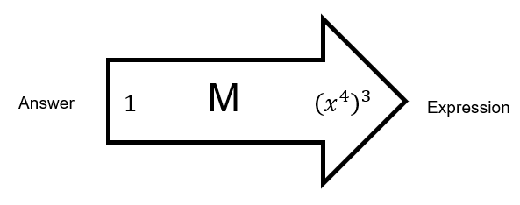
- When students have matched the expressions to all the answers, the letters in sequence form a message.

Summarise
- Have students engage in a Think-Pair-Share (bit.ly/thinkpairsharestrategy) to reflect on their work, focusing on the following discussion questions:
- Which operations did you get incorrect? How did you know it was a mistake?
- Can you identify any situation in the word web where 2 different operations could produce the same result?
- Can you make small changes to the expressions in the tarsia puzzle so that 2 triangle tiles swap places?
- Individually, students will need to write notes to their future forgetful self (bit.ly/notesstrategy). It is important that the students include misconceptions that they experienced whist completing the ‘Explore’ section of the lesson.

Apply
- Students can create their own questions and answers for other students to solve using Appendix D ‘Blank tarsia puzzle template’.

Assessment and differentiation

Suggested opportunities for differentiation
Launch
- Students could substitute in a value for $x$ such as 2 so that they can use the calculator to help complete the problem.
- Students could make up a similar puzzle using the division and power of a power rules and find the smallest answer.
Explore
- Teachers have been provided a link to create a tarsia puzzle. These can be adapted for different ability levels.
- Index laws tarsia puzzle 1 has easier examples than the second. Whilst it has a negative index it is derived from subtracting the powers. No further understanding of negative indices is needed.
- The message for the treasure hunt starts with an M. This could be given to students who are having difficulty finding the message.
Apply
- Students could make their own puzzles similar to any of the 3 activities from the ‘Explore’ section. Students could swap their puzzle with another pair of students for them to complete.

Suggested opportunities for assessment
Explore
- Students could be observed working in their group for participation, understanding, misconceptions or use of the index rules.
Summarise
- Teachers should take note of how students express identified misconceptions and whether they have methods to avoid similar mistakes.
Apply
- The ‘Apply’ section of the lesson could be collected to form the summative assessment for this topic.

Appendix A

Index law word web
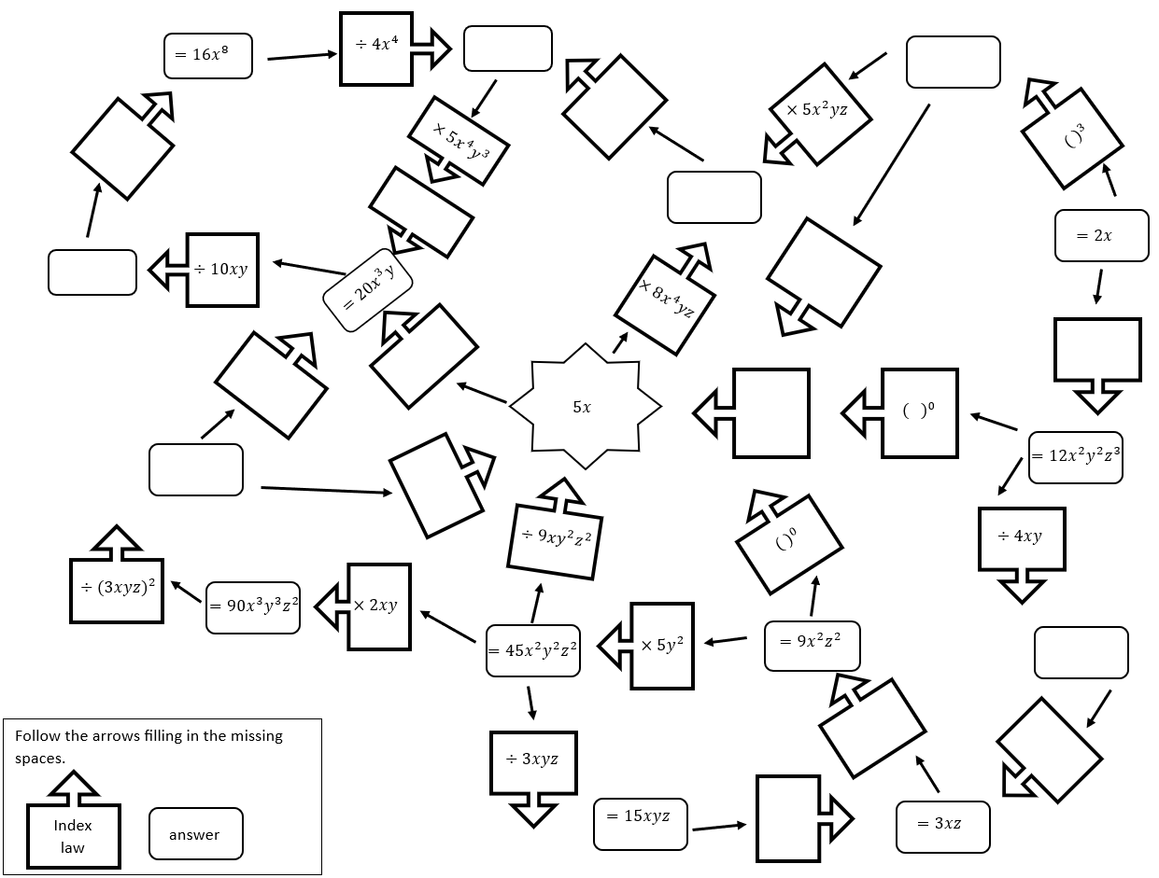

Appendix B

Index laws tarsia puzzle 1
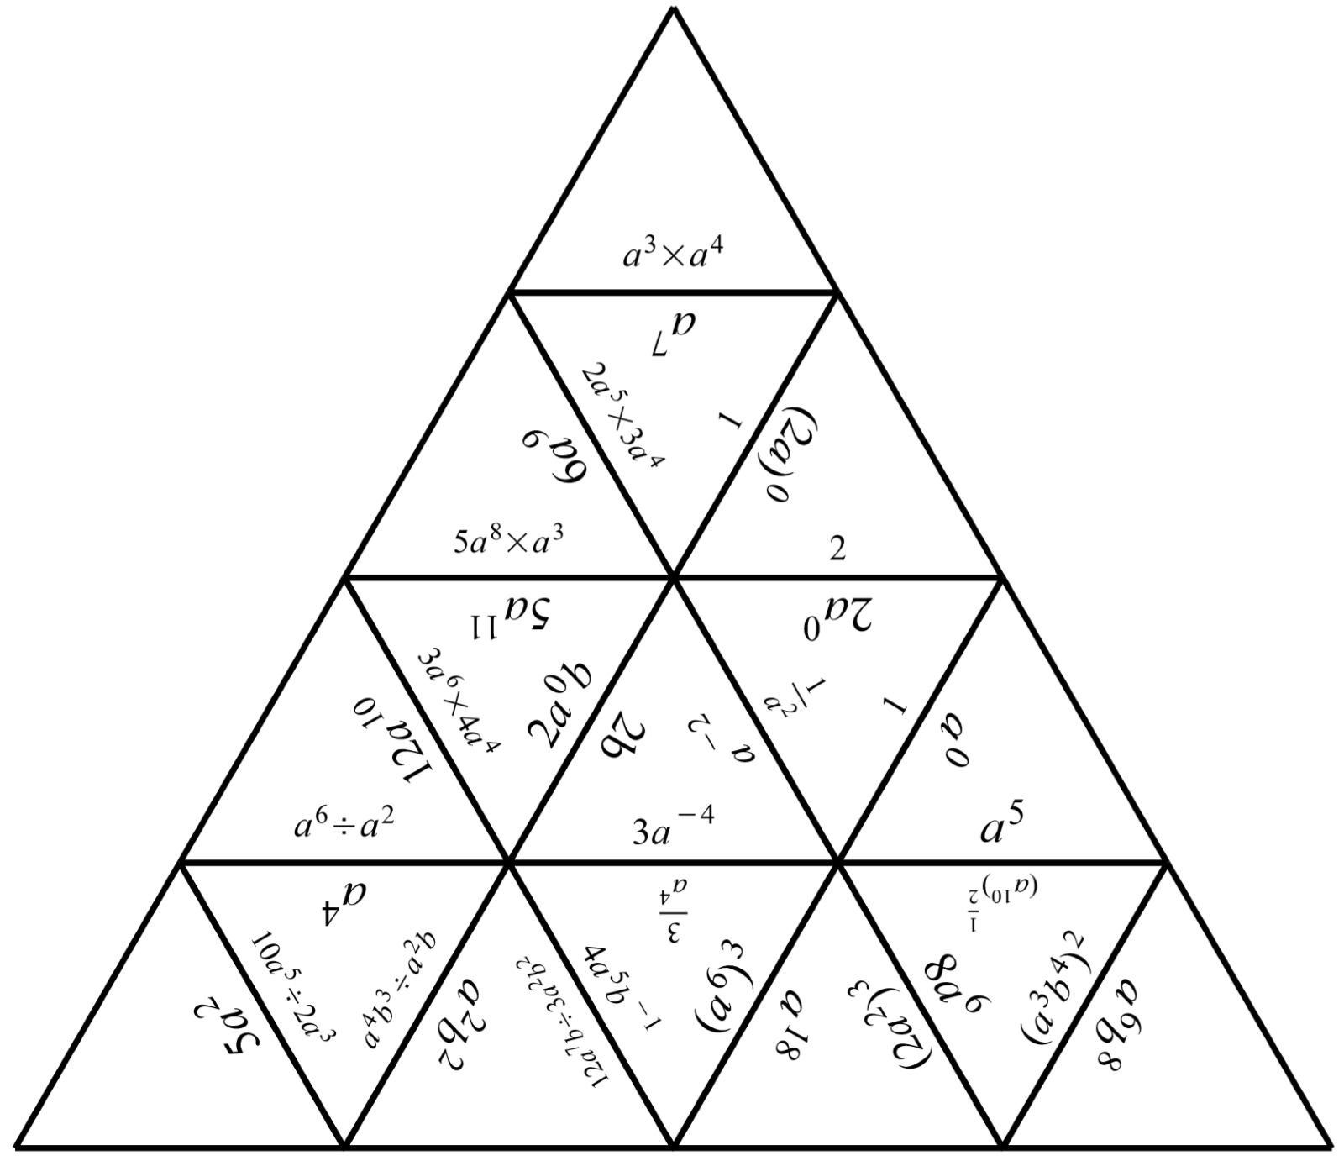Cut out each of the triangles. Shuffle the pieces and match the sides of the triangles using equivalent expressions.

Index laws tarsia puzzle 2
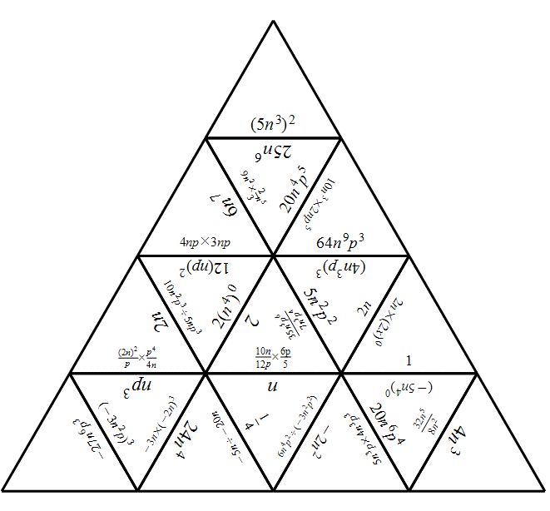

Appendix C

Treasure hunt
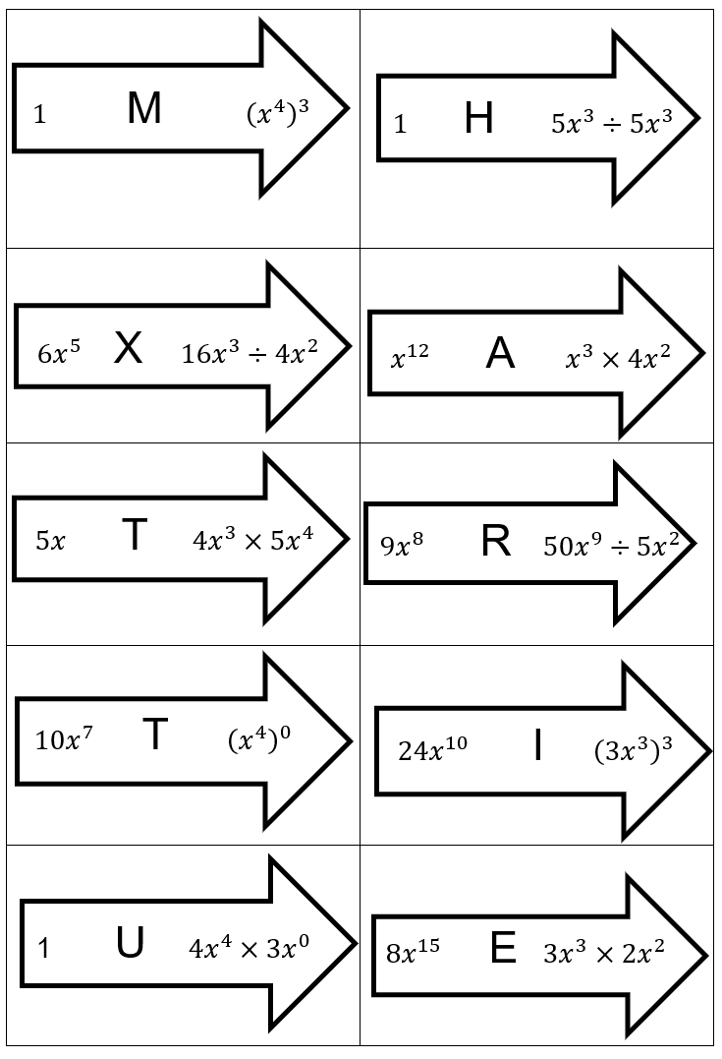
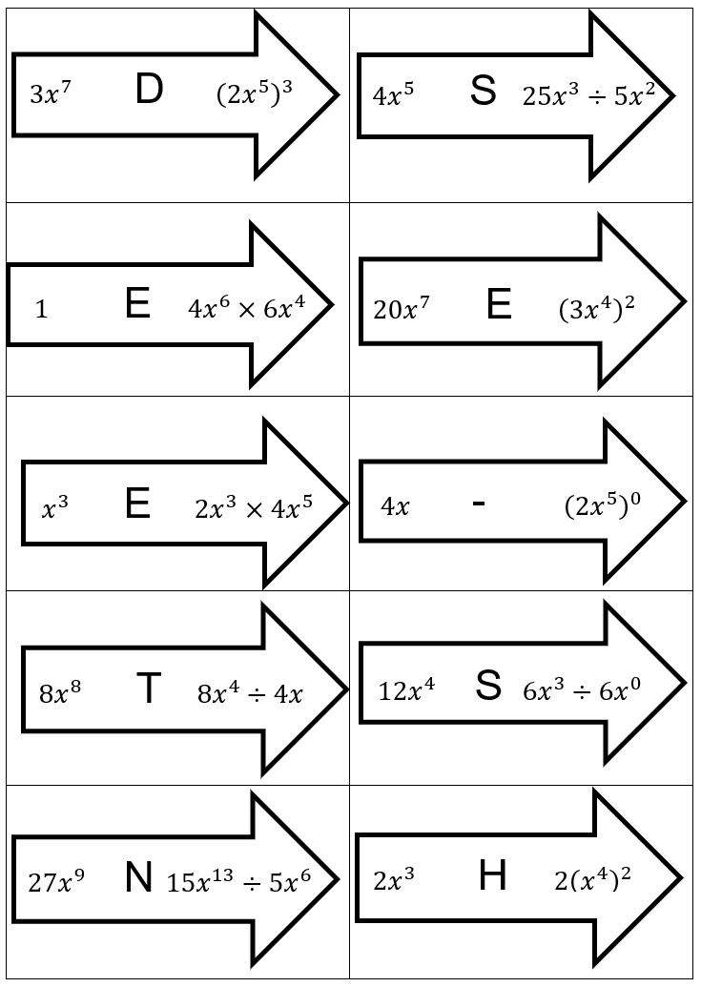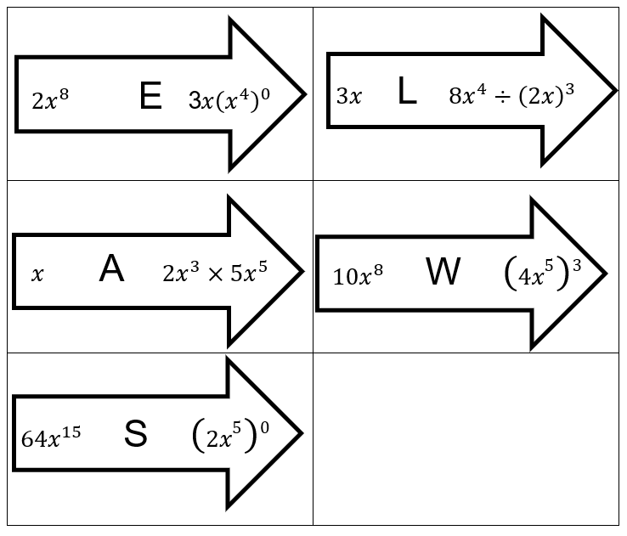

Appendix D

Blank Tarsia puzzle templates
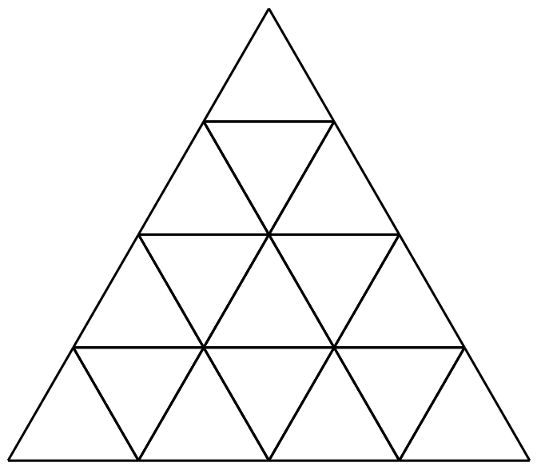
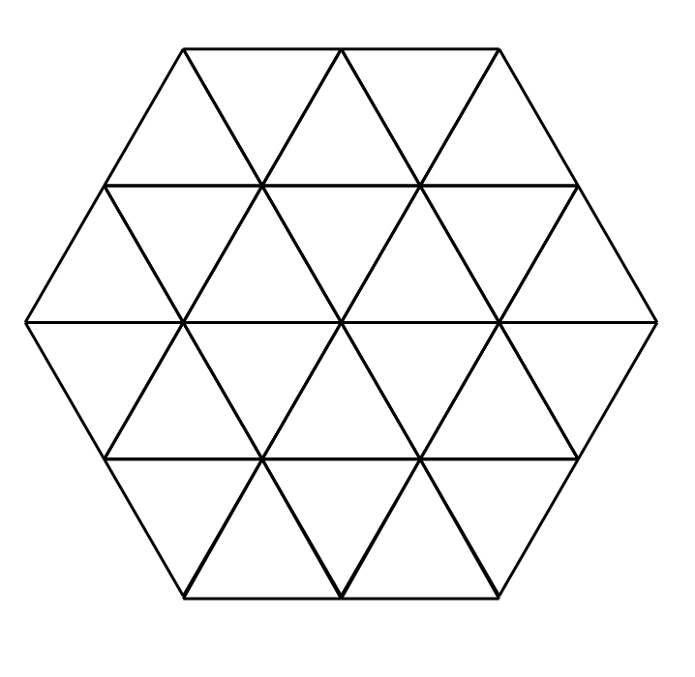

Sample solutions

Launch
The result with the greatest exponent is $x^{4}×{\left(x^{9}\right)}^{8}=x^{76}$

Appendix A – index laws word web
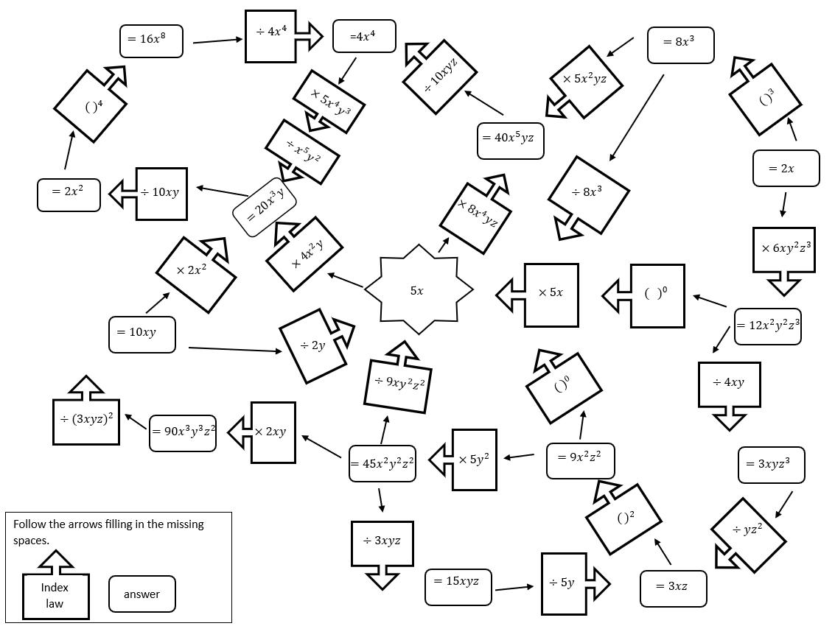

Appendix C – treasure Hunt
Treasure hunt riddle:
Master the index – use the laws.

References
This resource contains NSW Curriculum and syllabus content. The NSW Curriculum is developed by the NSW Education Standards Authority. This content is prepared by NESA for and on behalf of the Crown in right of the State of New South Wales. The material is protected by Crown copyright.
Please refer to the NESA Copyright Disclaimer for more information https://educationstandards.nsw.edu.au/wps/portal/nesa/mini-footer/copyright.
NESA holds the only official and up-to-date versions of the NSW Curriculum and syllabus documents. Please visit the NSW Education Standards Authority (NESA) website https://educationstandards.nsw.edu.au/ and the NSW Curriculum website https://curriculum.nsw.edu.au/home.
Mathematics K–10 Syllabus © NSW Education Standards Authority (NESA) for and on behalf of the Crown in right of the State of New South Wales, 2022.
© State of New South Wales (Department of Education), 2023
The copyright material published in this resource is subject to the Copyright Act 1968 (Cth) and is owned by the NSW Department of Education or, where indicated, by a party other than the NSW Department of Education (third-party material).
Copyright material available in this resource and owned by the NSW Department of Education is licensed under a Creative Commons Attribution 4.0 International (CC BY 4.0) licence.
This licence allows you to share and adapt the material for any purpose, even commercially.
Attribution should be given to © State of New South Wales (Department of Education), 2023.
Material in this resource not available under a Creative Commons licence:
- the NSW Department of Education logo, other logos and trademark-protected material
- material owned by a third party that has been reproduced with permission. You will need to obtain permission from the third party to reuse its material.
Links to third-party material and websites
Please note that the provided (reading/viewing material/list/links/texts) are a suggestion only and implies no endorsement, by the New South Wales Department of Education, of any author, publisher, or book title. School principals and teachers are best placed to assess the suitability of resources that would complement the curriculum and reflect the needs and interests of their students.
If you use the links provided in this document to access a third-party's website, you acknowledge that the terms of use, including licence terms set out on the third-party's website apply to the use which may be made of the materials on that third-party website or where permitted by the Copyright Act 1968 (Cth). The department accepts no responsibility for content on third-party websites.

