Invaluable indices
Students investigate and review the multiplication, division, power of a power and zero index laws and apply them to numerical bases. This lesson is designed to revisit the concepts covered in Stage 4.

Visible learning

Learning intentions
- To understand how to apply the index laws to simplify calculations.

Success criteria
- I can simplify numerical expressions using the multiplication index law.
- I can simplify numerical expressions using the division index law.
- I can simplify numerical expressions using the power of a power index law.
- I can simplify numerical expressions using the zero-index law.

Syllabus outcomes
A student:
- develops understanding and fluency in mathematics through exploring and connecting mathematical concepts, choosing and applying mathematical techniques to solve problems, and communicating their thinking and reasoning coherently and clearly MAO-WM-01
- simplifies algebraic expressions involving positive-integer and zero indices, and establishes the meaning of negative indices for numerical bases MA5-IND-C-01
Mathematics K–10 Syllabus © NSW Education Standards Authority (NESA) for and on behalf of the Crown in right of the State of New South Wales, 2022.

Activity structure
Please use the associated PowerPoint Invaluable indices to display images in this lesson.

Launch
- Use the PowerPoint slides 1–5 Invaluable indices to investigate how indices are used with binary code.
Table 1 ‘The binary code for the number 13’ shows that the number 13 is made up of the values $8+4+1$. It places a ‘0’ in the ‘2’ column, to show it is not included.
Table 1 – the binary code for the number 13
Number | 64 | $$32$$ | $$16$$ | $$8$$ | $$4$$ | $$2$$ | $$1$$ | = | Code
13 |  |  |  | 1 | 1 | 0 | 1 | = | 1101
Note, we would say ‘one, one, zero, one’, but the computer reads the code starting from the right side.
We do not say ‘one thousand, one hundred and one’.
- Hand out Appendix A ‘Using binary code to code numbers’ to each student and display slide 6 of the PowerPoint file for students to attempt writing numbers using binary code.
- Hand out Appendix B ‘Comparing strategies’ and use slides 7–15 of the PowerPoint file to compare the numbers used in binary code with base 2.
When investigating multiplication and division with numbers written in index form, allow students to investigate the algorithms rather than telling them what is happening. A formal approach will occur during the explore phase of the lesson.

Table 2 – a comparison of multiplying binary values written as integers and written in index form
Binary values | Binary values in index form
$$4×2=8$$ | $$2^{2}×2^{1}=2^{3}$$
$$8÷2=4$$ | $$2^{3}÷2^{1}=2^{2}$$

Explore
The Jigsaw strategy (bit.ly/jigsawgroupstrategy) asks a group of students to become ‘experts’ and then share that material with another group of students. This strategy offers a way to help students understand and retain information and to develop their collaboration skills.
- Divide the class into groups of 4. These groups will be the ‘home teams’ of the jigsaw.
- Explain the strategy and the topic of study: index laws.
- Tell students that they are going to be responsible for teaching one index law to the team they are sitting with now.
- Ask students to assign each member of their team with a number, 1, 2, 3 or 4.
- Students will leave their home team to sit with a group of students assigned to the same number. Indicate an area for groups of ‘number 1s’ to gather, another area for the ‘number 2s’ and so on. Note, the experts can be in groups of about 4 or 5.
- Distribute the following material to the students:
- Number 1 group(s) – Appendix C – ‘The multiplication index law’.
- Number 2 group(s) – Appendix D – ‘The division index law’.
- Number 3 group(s) – Appendix E – ‘The power of a power index law’.
- Number 4 group(s) – Appendix F – ‘The zero-index law’.
- Ask students to begin reading to themselves, or have them take turns reading aloud to their group. When students are finished reading, the group should discuss the law, fill out their direction sheet, and discuss what they should present to their home teams.
- After 5–10 minutes, or when you think they are ready, send the students back to their home team. Remind them that they are going back to their home team to teach them this law.

Summarise
Students will complete the second stage of the Jigsaw activity. In this stage, the ‘experts’ will take turns to explain their rule to the other members of their home team.
- Distribute Appendix G ‘Notes to my future self’ to all students.
- Tell the students they will be taking notes for their future forgetful self (bit.ly/notesstrategy), as the experts explain their law.
- Advise the experts that they will have approximately 5–10 minutes to explain their law and communicate their understanding of the law to the members of their home team. During this time, they will also need to be checking for understanding with their team members.
- Whilst the students are in their home teams, encourage them to ask each other questions, discuss the index laws and check that all members of their team understand how the laws work.
- In a class discussion, select random students to share their thoughts about the laws.

Apply
Students will apply the skills developed in the Jigsaw strategy to solving problems.
- Display or write the following on the board.
$$1 296×279 936=362 797 056$$
$$6^{4}×6^{7}=362 797 056$$
$$6^{4}×6^{7}=6^{11}$$
$$2^{3}=8$$
$$8^{15}=35 184 372 088 832$$
- In a Think-Pair-Share (bit.ly/thinkpairsharestrategy) students should discuss the question, ‘When is it useful to write a number showing all of its digits and when is it useful to write a number in index form?’
- Select random pairs to share their thoughts.
Explain to students that they will be working collaboratively to solve problems using the index laws.
- They will be asked to ‘simplify’ some numerical expressions.
- Some of the questions will have answers which students may believe would be easier to answer in numerical form. But, as the aim of the task is for them to apply the index laws, leaving the answers in index form will be more effective in demonstrating how the index laws have been used to simplify the expression.
- Working in visibly random groups of 3 (bit.ly/visiblegroups), at a vertical non-permanent surface bit.ly/VNPSstrategy, students can collaborate to solve the problems from Appendix H. Students should keep their completed Appendix G summary sheet with them to use as a reference.
- Lead a class discussion around the strategies used to simplify the expressions.

Assessment and differentiation

Suggested opportunities for differentiation
Launch
- Binary is a base 2 system, using only the digits 0 and 1. Students could be challenged to explore a base 3 system, which uses the symbols 0, 1 and 2 and the values of $3^{0}$, $3^{1}$ and so on.
- The ‘exploding dots’ website (https://www.explodingdots.org/) contains interactive activities that explore base 2, 3 and 10 number systems in more detail.
Explore
- ‘Experts’ may be assigned an assistant, allowing the opportunity to group students who need support with stronger students.
Apply
- Challenge students to create a question that relies on all 4 index laws to simplify the expression. If more than one group succeeds, then the groups may swap their questions to simplify.

Suggested opportunities for assessment
Explore
- Students can be asked to write questions they would like to have clarified from the discussions with their peers. These questions could assist teachers to quickly assess misconceptions that are arising from the discussions.
Apply
- Students can submit their answers in Appendix H for teachers to assess their ability to apply the index laws and act on misconceptions.

Appendix A

Using binary code to code numbers
Can you determine the binary code for these numbers?
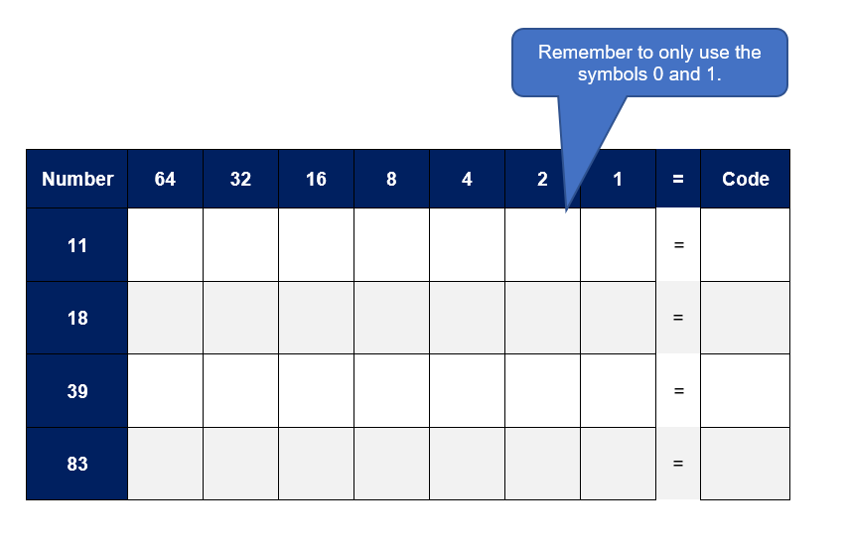

Appendix B

Comparing strategies
Binary value: | $$64$$ | $$32$$ | $$16$$ | $$8$$ | $$4$$ | $$2$$ | $$1$$
Index form: | $$2^{6}$$ | $$2^{5}$$ | $$2^{4}$$ | $$2^{3}$$ | $$2^{2}$$ | $$2^{1}$$ | $$2^{0}$$
Complete the questions in the table below by filling in the blanks with integer values in problems on the left, and values in index form on the right.
- Multiplication strategies
Binary values | Binary values in index form
$$4×8=__$$ | $$2^{2}×2^{3}=2^{?}$$
$$__×32=64$$ | $$__×2^{5}=2^{6}$$
$$4×__=16$$ | $$2^{2}×__=2^{4}$$
$$2×4×8=__$$ | $$2^{1}×__×2^{3}=2^{6}$$
$$8×1=__$$ | $$2^{3}×__=2^{3}$$
- Division strategies
Binary values | Binary values in index form
$$8÷4=__$$ | $$2^{3}÷2^{2}=2^{?}$$
$$64÷__=32$$ | $$2^{6}÷__=2^{5}$$
$$32÷4=__$$ | $$2^{5}÷2^{2}=__$$
$$__÷1=8$$ | $$__÷2^{0}=2^{3}$$
$$16÷16=__$$ | $$2^{4}÷2^{4}=__$$

Appendix C

Multiplication law
A term written in index form is a shorter way to write a term written in expanded form.
Complete the examples and discuss what is happening.
Example 1: | $4^{5}×4^{3}=(4×4×4×4×4)×(4×4×4$)  $$(4×4×4×4×4)×(4×4×4)=4^{8}$$
Example 2: | $$5^{6}×5^{4}=(5×5×5×5×5×5)×(5×5×5×5)$$  $$(5×5×5×5×5×5)×(5×5×5×5)=___$$
Example 3: | $6^{4}×6^{5}=$
- What do you notice about the powers?
- What do you notice about the bases?
Example 1: | $$5^{2}×5^{9}=5^{11}$$
Example 2: | $$3^{2}×3^{5}=3^{?}$$
Example 3: | $$4^{7}×4^{5}=$$
Can you write a sentence to explain how to answer these types of questions?
Practice questions:
$$5^{2}×5^{4}=$$ | $$2^{3}×2^{6}=$$ | $$4^{1}×4^{7}=$$
$${10}^{2}×{10}^{3}=$$ | $$3^{3}×3^{4}×3^{5}=$$ | $$4^{2}×3^{3}=$$

Appendix D

Division law
A term written in index form is a shorter way to write a term written in expanded form.
It’s useful to remember that a fraction is a division problem and when dividing a term by itself, the answer is 1. For example:
$$5÷5=\frac{5}{5}=1$$
Complete the examples and discuss what is happening.
Example 1: | $$4^{5}÷4^{3}=(4×4×4×4×4)÷(4×4×4)$$  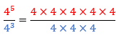  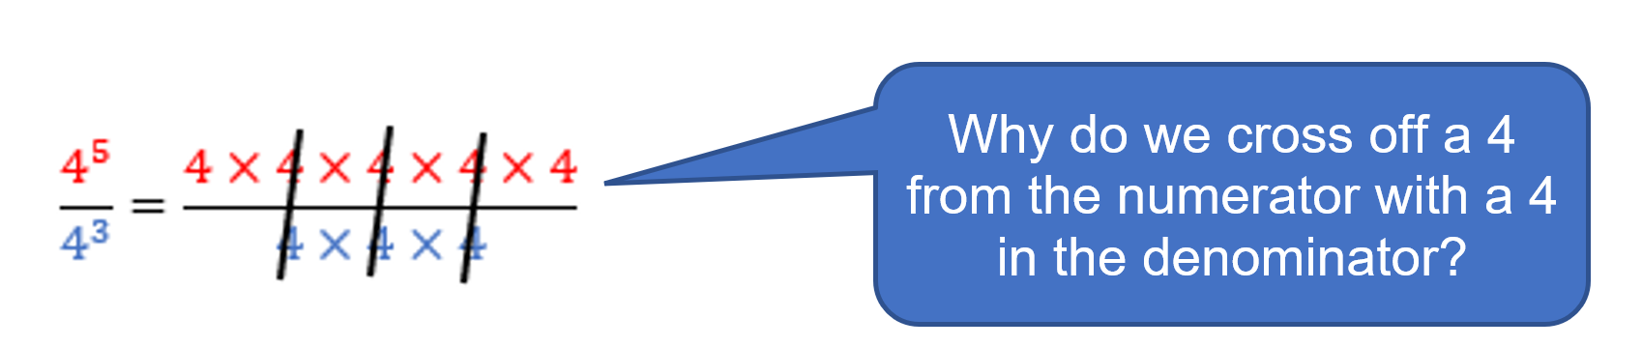  $$\frac{4^{5}}{4^{3}}=4^{2}$$
Example 2: | $$6^{9}÷6^{4}=(6×6×6×6×6×6×6×6×6)÷(6×6×6×6)$$  $$\frac{6^{9}}{6^{4}}=\frac{6×6×6×6×6×6×6×6×6}{6×6×6×6}$$  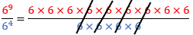  $$\frac{6^{9}}{6^{4}}=$$
Example 3: | $$5^{7}÷5^{4}=$$
- What do you notice about the powers?
- What do you notice about the bases?
Complete the examples and discuss what is happening.
Example 1: | $$5^{8}÷5^{4}=5^{4}$$
Example 2: | $$3^{7}÷3^{5}=3^{?}$$
Example 3: | $$4^{8}÷4^{3}=$$
Can you write a sentence to explain how to answer these types of questions?

Practice questions:
$$5^{8}÷5^{3}=$$ | $$2^{6}÷2^{3}=$$ | $$4^{5}÷4^{1}=$$
$${10}^{5}÷{10}^{3}=$$ | $$3^{5}÷3^{5}=$$ | $$4^{2}÷3^{3}=$$

Appendix E

Power of a power law
A term written in index form is a shorter way to write a term written in expanded form.
Complete the examples and discuss what is happening.
Example 1: | $${\left(2^{3}\right)}^{4}=2^{3}×2^{3}×2^{3}×2^{3}$$  $$2^{3}×2^{3}×2^{3}×2^{3}=(2×2×2)×(2×2×2)×(2×2×2)×(2×2×2)$$  $${\left(2^{3}\right)}^{4}=2^{12}$$
Example 2: | $${\left(3^{5}\right)}^{3}=3^{5}×3^{5}×3^{5}$$  $$3^{5}×3^{5}×3^{5}=3×3×3×3×3×3×3×3×3×3×3×3×3×3×3$$  $${\left(3^{5}\right)}^{3}=3^{?}$$
Example 3: | $${\left(5^{4}\right)}^{2}=5^{4}×5^{4}$$  $$5^{4}×5^{4}=$$
Example 4: | $${\left(4^{2}\right)}^{3}=$$
- What do you notice about the indices?
- What do you notice about the bases?
Example 1: | $${\left(3^{5}\right)}^{4}=3^{20}$$
Example 2: | $${\left(5^{3}\right)}^{5}=5^{?}$$
Example 3: | $${\left(4^{7}\right)}^{2}=$$
Can you write a sentence to explain how to answer these types of questions?

Practice questions:
$${\left(5^{3}\right)}^{5}=$$ | $${\left(2^{4}\right)}^{2}=2^{8}$$ | $${\left(4^{6}\right)}^{2}=$$
$${\left({10}^{2}\right)}^{2}=$$ | $${\left[{\left(3^{2}\right)}^{3}\right]}^{4}=$$ | $${\left(5^{4}\right)}^{\frac{1}{2}}=$$

Appendix F

Zero-index law
A term written in index form is a shorter way to write a term written in expanded form.
- The zero-index law refers to numbers with a power of zero.
Complete the examples and discuss what is happening.
Example 1: | $$5^{0}=1$$
Example 2: | $$6^{0}=1$$
Example 3: | $$4^{0}=$$
- What do you notice about the examples?
- What do you think the most common mistake is when simplifying a number written with an index of zero?
Example 1: | $$3×5^{0}=3×1$$
Example 2: | $$6-4^{0}=6-1$$  $$=?$$
Example 3: | $$2^{0}+7=$$
Can you write a sentence to explain how to answer these types of questions?
Practice questions:
$$7^{0}=$$ | $${287}^{0}=$$ | $${\left(-6\right)}^{0}=$$
$${3^{0}+4}^{0}=$$ | $${5×12}^{0}=$$ | $${\left(\frac{2}{3}\right)}^{0}=$$

Appendix G

Notes for my future self
Use the following table to write some notes, the rules and some examples that your future forgetful self might find useful.
Topic: index laws
How could I summarise what I know about the 4 laws?
What are some useful examples that show how the laws work?
Is there any other important information I should remember?

Appendix H

Apply the skills
Simplify the following expressions. Write the answers in index form.
$$4^{8}×4^{5}=$$
$$4×4^{5}=$$
$$4^{8}×4^{0}=$$
$$4^{8}×4^{5}×4^{6}=$$
$$4^{8}×4^{8}=$$
$${\left(4^{5}\right)}^{8}=$$
$$4^{8}+4^{5}=$$
$$4^{8}÷4^{5}=$$
$$4^{8}÷4^{8}=$$
$$\frac{4^{8}×4^{5}}{4^{3}}=$$
$$\frac{4^{8}×4^{5}}{4^{6}}=$$

Sample solutions

Appendix A – using binary code to code numbers
Number | 64 | 32 | 16 | 8 | 4 | 2 | 1 | = | Code
11 |  |  |  | 1 | 0 | 1 | 1 | = | 1011
18 |  |  | 1 | 0 | 0 | 1 | 0 | = | 10010
39 |  | 1 | 0 | 0 | 1 | 1 | 1 | = | 100111

Appendix B – comparing strategies
- Multiplication strategies
Binary values | Binary values in index form
$$4×8=32$$ | $$2^{2}×2^{3}=2^{5}$$
$$2×32=64$$ | $$2^{1}×2^{5}=2^{6}$$
$$4×4=16$$ | $$2^{2}×2^{2}=2^{4}$$
$$2×4×8=64$$ | $$2^{1}×2^{2}×2^{3}=2^{6}$$
$$8×1=8$$ | $$2^{3}×2^{0}=2^{3}$$
- Division strategies
Binary values | Binary values in index form
$$8÷4=2$$ | $$2^{3}÷2^{2}=2^{1}$$
$$64÷2=32$$ | $$2^{6}÷2^{1}=2^{5}$$
$$32÷4=8$$ | $$2^{5}÷2^{2}=2^{3}$$
$$8÷1=8$$ | $$2^{3}÷2^{0}=2^{3}$$
$$16÷16=1$$ | $$2^{4}÷2^{4}=1$$

Appendix H – apply the skills
$$4^{8}×4^{5}=4^{13}$$
$$4×4^{5}=4^{6}$$
$$4^{8}×4^{0}=4^{8}$$
$$4^{8}×4^{5}×4^{6}=4^{19}$$
$$4^{8}×4^{8}=4^{16}$$
$${\left(4^{5}\right)}^{8}=4^{40}$$
$$4^{8}+4^{5}=66560$$
$$4^{8}÷4^{5}=4^{3}$$
$$4^{8}÷4^{8}=4^{0}=1$$
$$\frac{4^{8}×4^{5}}{4^{3}}=4^{10}$$
$$\frac{4^{8}×4^{5}}{4^{6}}=4^{7}$$

References
This resource contains NSW Curriculum and syllabus content. The NSW Curriculum is developed by the NSW Education Standards Authority. This content is prepared by NESA for and on behalf of the Crown in right of the State of New South Wales. The material is protected by Crown copyright.
Please refer to the NESA Copyright Disclaimer for more information https://educationstandards.nsw.edu.au/wps/portal/nesa/mini-footer/copyright.
NESA holds the only official and up-to-date versions of the NSW Curriculum and syllabus documents. Please visit the NSW Education Standards Authority (NESA) website https://educationstandards.nsw.edu.au/ and the NSW Curriculum website https://curriculum.nsw.edu.au/home.
Mathematics K–10 Syllabus © NSW Education Standards Authority (NESA) for and on behalf of the Crown in right of the State of New South Wales, 2022.

© State of New South Wales (Department of Education), 2023
The copyright material published in this resource is subject to the Copyright Act 1968 (Cth) and is owned by the NSW Department of Education or, where indicated, by a party other than the NSW Department of Education (third-party material).
Copyright material available in this resource and owned by the NSW Department of Education is licensed under a Creative Commons Attribution 4.0 International (CC BY 4.0) licence.
This licence allows you to share and adapt the material for any purpose, even commercially.
Attribution should be given to © State of New South Wales (Department of Education), 2023.
Material in this resource not available under a Creative Commons licence:
- the NSW Department of Education logo, other logos and trademark-protected material
- material owned by a third party that has been reproduced with permission. You will need to obtain permission from the third party to reuse its material.
Links to third-party material and websites
Please note that the provided (reading/viewing material/list/links/texts) are a suggestion only and implies no endorsement, by the New South Wales Department of Education, of any author, publisher, or book title. School principals and teachers are best placed to assess the suitability of resources that would complement the curriculum and reflect the needs and interests of their students.
If you use the links provided in this document to access a third-party's website, you acknowledge that the terms of use, including licence terms set out on the third-party's website apply to the use which may be made of the materials on that third-party website or where permitted by the Copyright Act 1968 (Cth). The department accepts no responsibility for content on third-party websites.

