Tank it to the limit
Students explore a range of water tanks of differing shapes and sizes, as well as the best location on a block of land to place the tank. Students make connections between the tank size, the location and the required conditions for the water tank while applying their volume and surface area knowledge to make informed decisions.

Visible learning

Learning intentions
- To be able to solve problems involving volumes of composite solids consisting of right prisms and cylinders.
- To be able to solve problems involving surface area of composite solids consisting of right prisms and cylinders.

Success criteria
- I can identify and name the solids that make up a composite solid.
- I can calculate the volume of composite solids consisting of right prisms and cylinders.
- I can calculate the surface area of composite solids consisting of right prisms and cylinders.
- I can justify my decisions when solving surface area and volume problems.

Syllabus outcomes
A student:
- develops understanding and fluency in mathematics through exploring and connecting mathematical concepts, choosing and applying mathematical techniques to solve problems, and communicating their thinking and reasoning coherently and clearly MAO-WM-01
- solves problems involving the surface area of right prisms and practical problems involving the area of composite shapes and solids MA5-ARE-C-01
- solves problems involving the volume of composite solids consisting of right prisms and cylinders MA5-VOL-C-01
Mathematics K–10 Syllabus © NSW Education Standards Authority (NESA) for and on behalf of the Crown in right of the State of New South Wales, 2022.

Activity structure

Warm up
- Display the GeoGebra link (bit.ly/geogebracylinder) for students to view. Be sure that the box View a solution is unchecked so that the graphs are not showing, and that the height slider is set to $h=5$.
- Explain to students that they are viewing 5 different cylinders. The cylinders from A–E increase in diameter by one unit each time and decrease the height of the water each time. Ask students to consider which cylinder has the largest volume of water. No calculations should be performed.
- Conduct a finger vote for the cylinder they believe has the largest volume of water. That is, students hold up one finger for cylinder A, 2 fingers for cylinder B, and so on. Repeat the vote for the smallest volume of water. An alternate method to collect student responses is to do a Mentimeter poll (mentimeter.com/).
- Click the View a solution box to reveal the graphs showing the students that cylinder D contained the most water. Discuss the other results with students. For example, that the volume did not increase from smallest to largest despite the diameter increasing from smallest to largest, and anything else students noticed or found interesting.

Launch
- Ask students to consider the following questions and have a class discussion:
- Why do houses have sloping roofs?
- Where does rainwater go when it runs off a roof?
The purpose of these questions is to lead students to consider how rainwater runs from a downpipe into a rainwater tank. If the school has a water tank, take students to view it and investigate its placement in relation to a building. If there is no water tank at the school, explain to students that a rainwater tank should be placed close to a downpipe so that water can easily run into the tank.
- Issue each student with Appendix A ‘Block plan’ which shows an image of a block plan, including a house, driveway, deck and shed.
- Ask students to discuss with the person next to them what they notice and what they wonder (bit.ly/noticewonderstrategy), including the important features that they may recognise which could include:
- the scale
- circles representing downpipes
- rectangles on roof representing gutters
- arrows on roof representing direction of run off.
Explain each of these features to the class.
- Display Figure 1 and Figure 2 for students and ask them to consider which solid or which combination of solids make up each water tank, that is:
- The round water tank is a cylinder.
- The slim water tank looks as though it could be made up of a rectangular prism with 2 half-cylinders on each end.

Figure 1 – slim water tank  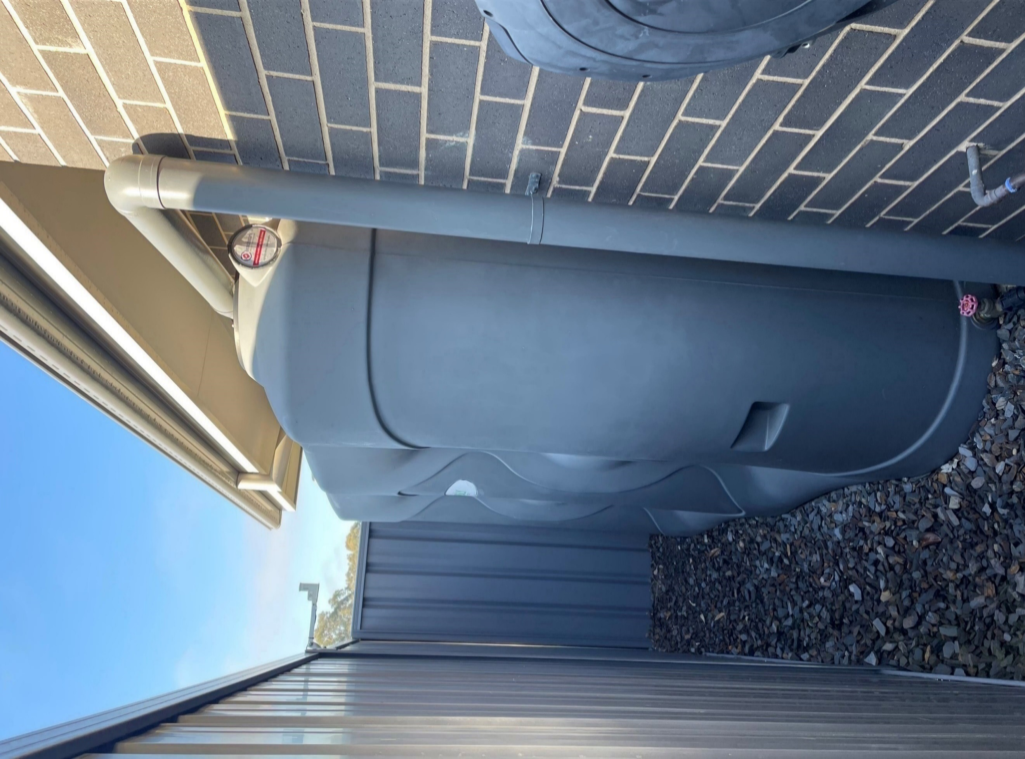 | Figure 2 – round water tank  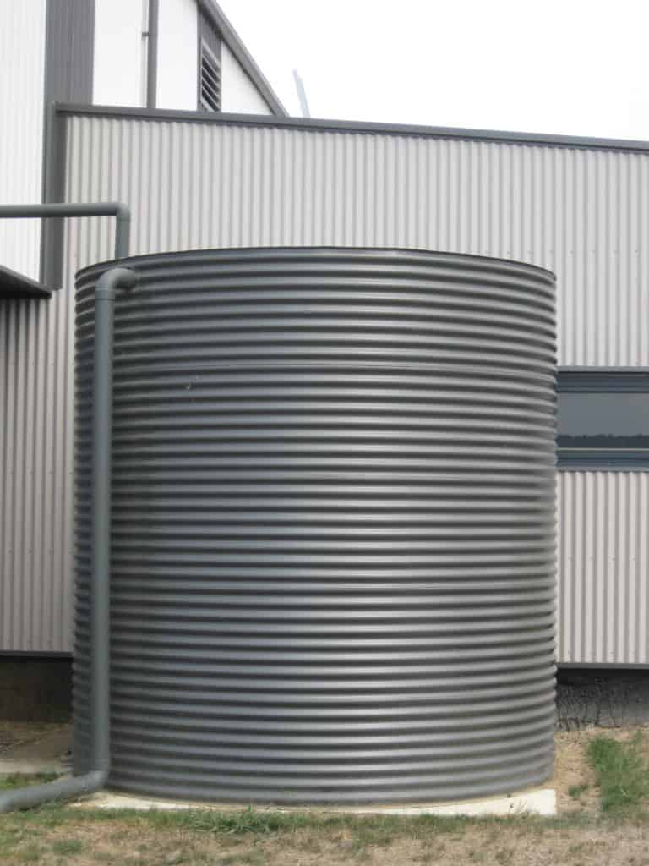  Image by unknown author is licensed under CC BY-NC-ND 4.0.

Explore
- Randomly assign students into groups of 3, to work at Vertical Non-Permanent Surfaces (VNPS) (bit.ly/VNPSstrategy) and explain that students will be working through a series of tasks to design a water tank for the given block plan. Issue Appendix B ‘Water tank design’ as a handout.
- Students will design their own water tank to meet the NSW requirements for an above ground water tank:
- the water tank must have capacity of at least 2 000 L
- the water tank must NOT exceed a capacity of 10 000 L
- the water tank must be at least 450 mm away from each boundary of the block, if the tank is more than 1.8 m in height.
- In their groups students will determine the dimensions of the water tank, the placement of the water tank on the block of land and the cost to build the water tank.

Summarise
- Students do a gallery walk to view other group’s designs before independently writing a brief overview, justifying the decisions they made during the task, including:
- where they placed the water tank
- which style of water tank they chose and why
- if they would do anything differently if they were to do the task again.

Apply
- Display Figure 3 and explain the investigation below.
Figure 3 – rectangular gutter
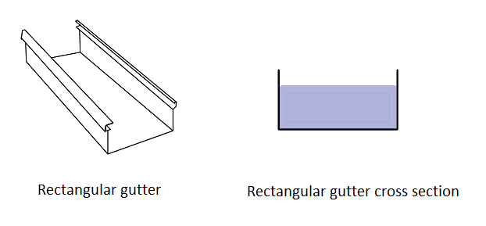
To optimise their business, manufacturers of gutters need to minimise the amount of material used to make their gutters while maximising the volume of water that can be drained.
Traditionally the gutters are rectangular as shown.
Your job is to investigate the optimal cross-section for a gutter.
This task is open-ended, and some students may require prompting to begin. Students could start by choosing a fixed length for the cross section and exploring rectangles of varying base lengths. Students might then progress to triangular or circular cross sections, such as semi-circles and quadrants. Students should be extended towards composite cross sections as well.
This task is based on the NRICH activity, ‘Gutter’ bit.ly/nrichgutters.
As of writing this, no student solutions have been submitted to this problem, so maybe your class could be the first.

Assessment and differentiation

Suggested opportunities for differentiation
Warm up
- The activity could be done multiple times for any values between zero and 5. They could be challenged to consider whether the order will always be the same regardless of the height.
Explore
- All students should be encouraged to calculate volume and surface area of the slim water tank, as it is composed of a right prism and cylinder. If students have chosen the round water tank, challenge them to compare it to a slim tank of the same capacity.
- In calculating the cost of poly for the water tank, the curved panel price can be removed to make the task easier.

Suggested opportunities for assessment
Warm up
- The warm up is an opportunity to assess students’ abilities to work with cylinders. If students are struggling with this activity, they may need additional support to engage in this lesson.
Explore
- Students’ drawings of their water tank on the block plan (Appendix A) will demonstrate if they are able to operate with ratio to produce scale drawings.
Summary
- If working on paper or in their books, students can submit each part as a folio for assessment.
- If working at NPVS students can take photos of their work and submit a folder with each part for assessment.

Appendix A

Block plan
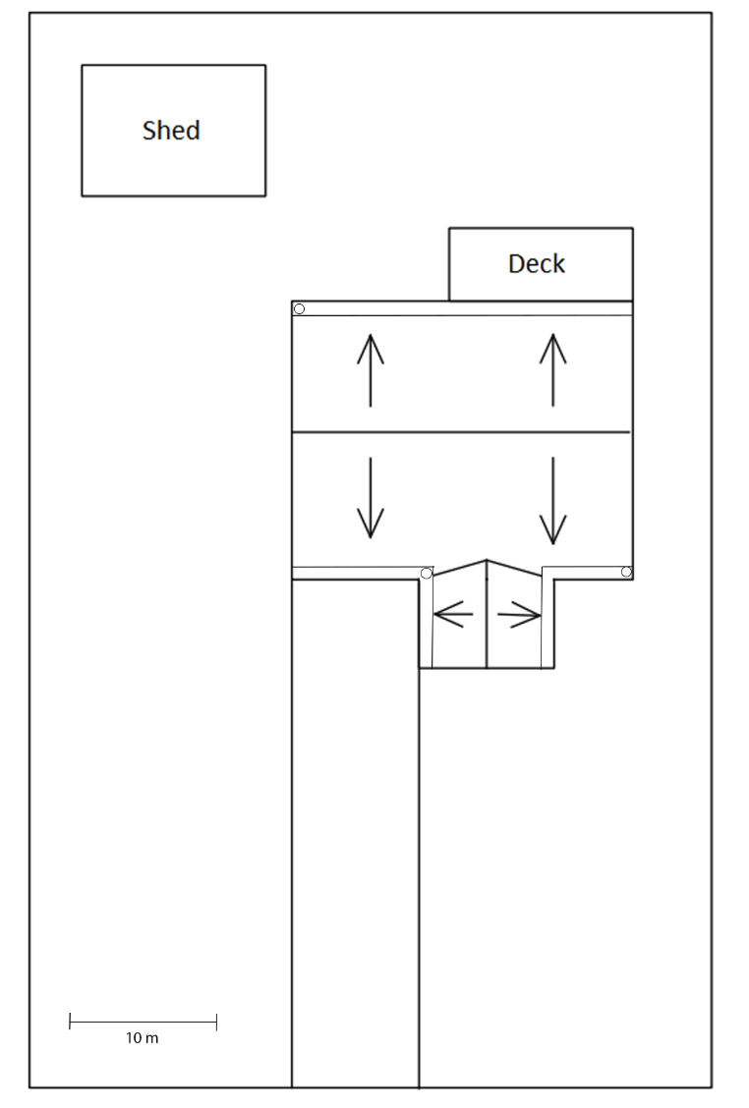

Appendix B

Water tank design
Here is a list of the above ground water tank requirements for NSW:
- The water tank must have a capacity of at least 25 000 L.
- The water tank must NOT exceed a capacity of 10 000 L.
- The water tank must be at least 450 mm away from each boundary of the block, if the tank is more than 1.8 meters in height.
- For the given block of land, design a water tank and decide on its location on the block of land.
- Decide which style of water tank will be used, slim or round.
- Considering the above requirements, determine the dimensions of your chosen water tank and provide a sketch of the water tank clearly showing the shape, it’s dimensions and the capacity in litres. Include all calculations.
- Determine the best location for the water tank, taking into consideration the existing down pipes. Using the provided scale drawing, draw the water tank to scale in the chosen location on the block of land provided.
A water tank manufacturer charges by the square metre for poly as follows:
- Straight panels of poly are priced at $13.20 per square metre.
- Curved panels of poly are priced at $15.40 per square metre.
- Calculate the total price to construct your water tank. Firstly, draw a net of your water tank design, indicate the areas that will require curved or straight panels and show all calculations to find the total cost of your water tank.

References
This resource contains NSW Curriculum and syllabus content. The NSW Curriculum is developed by the NSW Education Standards Authority. This content is prepared by NESA for and on behalf of the Crown in right of the State of New South Wales. The material is protected by Crown copyright.
Please refer to the NESA Copyright Disclaimer for more information https://educationstandards.nsw.edu.au/wps/portal/nesa/mini-footer/copyright.
NESA holds the only official and up-to-date versions of the NSW Curriculum and syllabus documents. Please visit the NSW Education Standards Authority (NESA) website https://educationstandards.nsw.edu.au/ and the NSW Curriculum website https://curriculum.nsw.edu.au/home.
Mathematics K–10 Syllabus © NSW Education Standards Authority (NESA) for and on behalf of the Crown in right of the State of New South Wales, 2022.
Team Poly (n.d.) NSW Development Code for Rainwater Tank Installations, Team Poly website, accessed 7 June 2023. https://teampoly.com.au/2018/06/15/nsw-development-code-for-rainwater-tank-installations/
© State of New South Wales (Department of Education), 2023
The copyright material published in this resource is subject to the Copyright Act 1968 (Cth) and is owned by the NSW Department of Education or, where indicated, by a party other than the NSW Department of Education (third-party material).
Copyright material available in this resource and owned by the NSW Department of Education is licensed under a Creative Commons Attribution 4.0 International (CC BY 4.0) licence.
This licence allows you to share and adapt the material for any purpose, even commercially.
Attribution should be given to © State of New South Wales (Department of Education), 2023.
Material in this resource not available under a Creative Commons licence:
- the NSW Department of Education logo, other logos and trademark-protected material
- material owned by a third party that has been reproduced with permission. You will need to obtain permission from the third party to reuse its material.
Links to third-party material and websites
Please note that the provided (reading/viewing material/list/links/texts) are a suggestion only and implies no endorsement, by the New South Wales Department of Education, of any author, publisher, or book title. School principals and teachers are best placed to assess the suitability of resources that would complement the curriculum and reflect the needs and interests of their students.
If you use the links provided in this document to access a third-party's website, you acknowledge that the terms of use, including licence terms set out on the third-party's website apply to the use which may be made of the materials on that third-party website or where permitted by the Copyright Act 1968 (Cth). The department accepts no responsibility for content on third-party websites.

