Perfect packaging
This lesson incorporates optional Path content in the ‘Apply’ section.
Students explore different ways to package 5 mineral water cans while investigating the differing surface area of the packaging and the volume taken up within each package.

Visible learning

Learning intention
- To be able to compare the surface area and volume of different prisms and composite solids.

Success criteria
- I can compare different packages containing the same contents.
- I can name the solids that make up a composite solid.
- I can determine the volume of a composite solid.
- I can determine the surface area of a composite solid.
- I can justify my decision on the best packaging.

Syllabus outcomes
A student:
- develops understanding and fluency in mathematics through exploring and connecting mathematical concepts, choosing and applying mathematical techniques to solve problems, and communicating their thinking and reasoning coherently and clearly MAO-WM-01
- solves problems involving the surface area of right prisms and practical problems involving the area of composite shapes and solids MA5-ARE-C-01
- solves problems involving the volume of composite solids consisting of right prisms and cylinders MA5-VOL-C-01
- applies knowledge of the surface area of right pyramids and cones, spheres and composite solids to solve problems MA5-ARE-P-01
- applies knowledge of the volume of right pyramids, cones and spheres to solve problems involving related composite solids MA5-VOL-P-01
Mathematics K–10 Syllabus © NSW Education Standards Authority (NESA) for and on behalf of the Crown in right of the State of New South Wales, 2022.

Activity structure

Launch
- Show students the clip, ‘Dandy Candies’ (1:00) (bit.ly/101dandycandies).
- Ask students to consider the cheapest way to package up the candies. Students’ initial thoughts could be collected using a Mentimeter word cloud (mentimeter.com/).
- Using the Dandy Candies site (bit.ly/101dandycandies), open the image ‘All Four Packages’ and ask students to work in pairs to rank the packages in order of which uses the most cardboard to the least.
- Compare student responses through a class discussion.
- Finally, ask students to consider which packaging uses the most ribbon, by ranking the packages in order of most ribbon used to the least. Ask students whether the ordering would be the same as the amount of cardboard used. Why? Why not?
- Explain to students that this lesson is about exploring how the same items can be packaged in a range of different ways, using more or less packaging material and therefore affecting the cost.

Explore
- Bring 5 identical cans to show and display the image below, explaining that:
- A company has decided to sell their mineral water cans in packs of 5.
- The company is trying to decide the best way to package the 5 cans and has come up with 2 designs.
Figure 1 – two packaging options
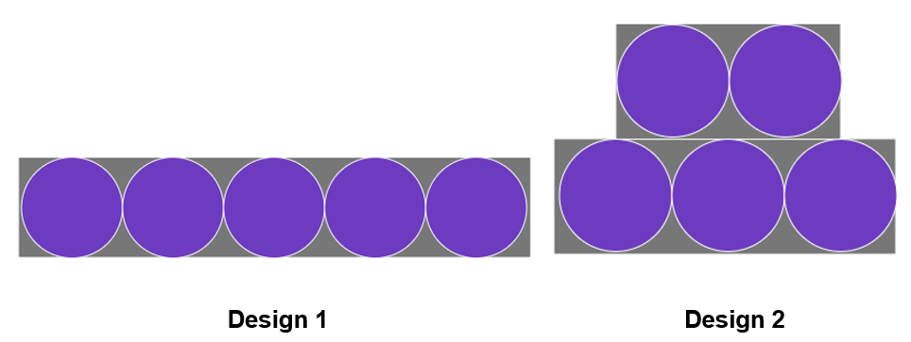
Image created using the free virtual manipulatives at Polypad.org.
- Ask students which design they think is the optimal way to package the cans and justify why. Answers can be collected using a poll such as Mentimeter (mentimeter.com/).
This task doesn’t require students to make calculations when making their decision. Students should simply consider each design and then validate their decision with a reason.
It is an important concept to define ‘optimal’ with students. In this case optimal would be the smallest surface area that will fit the 5 cans.

- Have a brief class discussion about some of the reasons provided by students. Further prompting may be required if the following are not mentioned:
- surface area of packaging
- comparison of volume of packaging compared to volume taken up by 5 cans (how much space is there around the cans)
- stacking into a bigger box for shipment.
- As a class explore the dimensions of the chosen can that you have brought in for the class. This should include the height and diameter.
If you don’t have cans available, you can use the example of a small kombucha can with diameter 5 cm and height 13 cm.
- In randomly assigned groups of 3, students will investigate the 2 designs the company has put forward for the 5 cans to be packaged. Students will also investigate one packaging design of their own. Students are trying to find the optimal packaging for the 5 cans. Students could use Vertical Non-Permanent Surfaces (VNPS) (bit.ly/VNPSstrategy) for their working and calculations.
In this investigation students will calculate and should examine:
- the surface area of the packaging
- the volume of the packaging
- the volume of the 5 cans
- the volume of the packaging compared to the volume taken up by the cans, that is the amount of left over space
- how effective the shape of the packaging is, that is how the packaging could be stacked into a bigger box for shipment and/or how the packaging could be stacked on the shelf of a supermarket.
Sample answers have been provided which include suggested options that may be explored when students are designing their own packaging, as well as solutions to both company’s packaging options, with a given can dimension.

Summarise
- Once students have worked through the 2 packaging options provided and any that they designed, each group is to share their conclusions with the class. Each group could discuss:
- Which packaging they thought was best.
- Which packaging had the most/least empty space.
- The calculations they used to come to this conclusion.
- The characteristics of good packaging.

Apply

Equipment
- Wrapping paper (a standard roll is 900 mm wide)
- Core and Path objects (such as packaging, balls, a set of solids)

Method
- Show Katie Steckles’ YouTube video ‘Mathematical Present Wrapping (4:27)’ (bit.ly/mathpresentwrapping). Specifically interesting moments include:
- wrapping a triangular prism (1:00)
- wrapping a cylinder (1:35)
- wrapping with algebra (2:30).
- Assign random groups of 3.
- Groups choose 3 objects to wrap.
- Students are tasked with using the least area of wrapping paper to wrap all 3 objects. They should draw the nets of each object on the wrapping paper before cutting.
The challenge is to wrap all 3 objects entirely, using the least area of wrapping paper. Only single pieces of paper should be used to wrap each object. Offcuts would be discarded.
Students could work with objects they otherwise could not find the surface area of, by considering a solid or composite solid they are familiar with that has approximately the same dimensions.

Assessment and differentiation

Suggested opportunities for differentiation
Launch
- Students may benefit from having a model of each of the packaging options to view. Centicubes could be used to create the 4 options.
Explore
- The surface area of each of the company’s packaging designs are quite challenging and may require calculating as a class.
- The nets of each packaging may be useful for some students when determining surface area.
- Students may need to revise how to find the volume of composite shapes.
Summarise
- A gallery walk (bit.ly/DLSgallerywalk) could be conducted rather than groups verbally sharing their findings.
- Students could be challenged to algebraically define the optimal dimensions for a rectangular prism and cylinder. The optimal solid will always be closest to a cube or sphere.
Apply
- Some students should only be issued core items, other students may be extended with both core and path items given they know each of the formulas required.

Suggested opportunities for assessment
Explore
- Monitor student discussions in their groups during the ‘Explore’ section of the activity to address any misconceptions or difficulties with calculations.

Sample solution

Explore – packaging options activity
Can used: small kombucha can with a diameter of 5 cm and a height of 13 cm.

Design 1
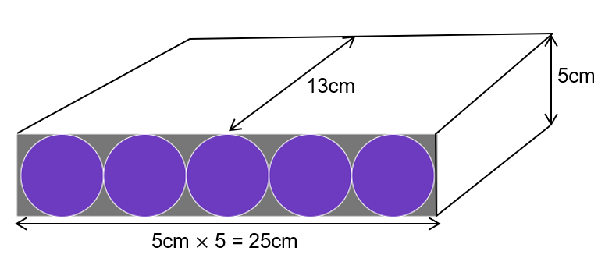
Image created using the free virtual manipulatives at Polypad.org.

Surface area of the packaging
$$SA=2\left(25 ×5+13×25+5×13\right) \\ =1030cm^{2}$$

Volume
The volume of the 5 cans
$$V=5 πr^{2}h \\ =5×π×{2.5}^{2}×13 \\ =1276.3cm^{3}$$
The volume of the packaging compared to the volume taken up by the cans
$$V=lbh \\ =5×25×13 \\ =1625cm^{3}$$
Remaining space in the packaging $=1625-1276.3=348.7cm^{3}$.

Effectiveness of the packaging
This box would be easy to stack on shelves as it is a rectangular prism, although it is quite long so it would depend on the depth of the shelf.

Design 2
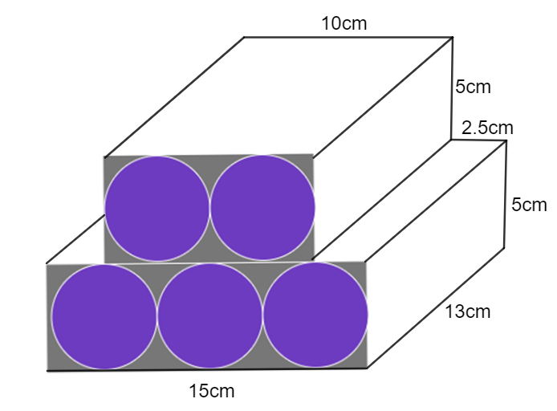
Image created using the free virtual manipulatives at Polypad.org.

Surface area of the packaging
$$A1=15×5=75cm^{2} \\ A2=13×5=65cm^{2} \\ A3=2.5×13=32.5cm^{2} \\ A4=10×13=130cm^{2} \\ A5=15×13=195cm^{2} \\ A6=10 ×5=50cm^{2}$$
$$Total SA=195+65×4+32.5×2+130+75×2+50×2 \\ =900cm^{2}$$

Volume
The volume of the 5 cans
$$V=5 πr^{2}h \\ =5×π×{2.5}^{2}×13 \\ =1276.3cm^{3}$$

The volume of the packaging compared to the volume taken up by the cans
$$V1=lbh \\ =15×13×5 \\ =975cm^{3}$$
$$V2=lbh \\ =10×13×5 \\ =650cm^{3}$$
Total volume $=1625cm^{3}$
The left-over space in the packaging is the same as in Design 1.
Effectiveness of the packaging
These will not be easy to stack as they do not stack on top of each other without spaces in between.

Comparing design 1 and 2
Design 1 and 2 have the same volume, although unequal surface areas. Design 1 has a greater surface area than design 2, meaning that more cardboard would need to be used per set of 5 cans. Although design 1 will more easily stack on shelves and in a larger box to ship or deliver to stores. So, despite design 1 packaging costing more to make it is the preferred design.

Other designs that could have been explored
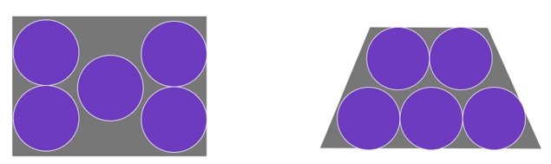
Images created using the free virtual manipulatives at Polypad.org.

References
This resource contains NSW Curriculum and syllabus content. The NSW Curriculum is developed by the NSW Education Standards Authority. This content is prepared by NESA for and on behalf of the Crown in right of the State of New South Wales. The material is protected by Crown copyright.
Please refer to the NESA Copyright Disclaimer for more information https://educationstandards.nsw.edu.au/wps/portal/nesa/mini-footer/copyright.
NESA holds the only official and up-to-date versions of the NSW Curriculum and syllabus documents. Please visit the NSW Education Standards Authority (NESA) website https://educationstandards.nsw.edu.au/ and the NSW Curriculum website https://curriculum.nsw.edu.au/home.
Mathematics K–10 Syllabus © NSW Education Standards Authority (NESA) for and on behalf of the Crown in right of the State of New South Wales, 2022
© State of New South Wales (Department of Education), 2023
The copyright material published in this resource is subject to the Copyright Act 1968 (Cth) and is owned by the NSW Department of Education or, where indicated, by a party other than the NSW Department of Education (third-party material).
Copyright material available in this resource and owned by the NSW Department of Education is licensed under a Creative Commons Attribution 4.0 International (CC BY 4.0) licence.
This licence allows you to share and adapt the material for any purpose, even commercially.
Attribution should be given to © State of New South Wales (Department of Education), 2023.
Material in this resource not available under a Creative Commons licence:
- the NSW Department of Education logo, other logos and trademark-protected material
- material owned by a third party that has been reproduced with permission. You will need to obtain permission from the third party to reuse its material.
Links to third-party material and websites
Please note that the provided (reading/viewing material/list/links/texts) are a suggestion only and implies no endorsement, by the New South Wales Department of Education, of any author, publisher, or book title. School principals and teachers are best placed to assess the suitability of resources that would complement the curriculum and reflect the needs and interests of their students.
If you use the links provided in this document to access a third-party's website, you acknowledge that the terms of use, including licence terms set out on the third-party's website apply to the use which may be made of the materials on that third-party website or where permitted by the Copyright Act 1968 (Cth). The department accepts no responsibility for content on third-party websites.

