The secrets of pyramids
This lesson incorporates Path content.
Students investigate the volume and surface area of pyramids through the construction of yangma nets. Students will derive the volume of a pyramid formula by joining 3 yangma, explore how the surface area of a pyramid is found and apply this knowledge to solve problems.

Visible learning

Learning intentions
- To be able to calculate the volume of a pyramid.
- To be able to calculate the surface area of a pyramid.

Success criteria
- I can describe how the volume of a pyramid formula is derived.
- I can calculate the volume of a pyramid using the formula.
- I can explain how to calculate the surface area of a pyramid.
- I can solve problems involving pyramids and composite solids.

Syllabus outcomes
A student:
- develops understanding and fluency in mathematics through exploring and connecting mathematical concepts, choosing and applying mathematical techniques to solve problems, and communicating their thinking and reasoning coherently and clearly MAO-WM-01
- applies knowledge of the surface area of right pyramids and cones, spheres and composite solids to solve problems MA5-ARE-P-01
- applies knowledge of the volume of right pyramids, cones and spheres to solve problems involving related composite solids MA5-VOL-P-01
Mathematics K–10 Syllabus © NSW Education Standards Authority (NESA) for and on behalf of the Crown in right of the State of New South Wales, 2022.

Activity structure

Launch
- Display Figure 1 for students to view.
Figure 1 – Which one doesn't belong?
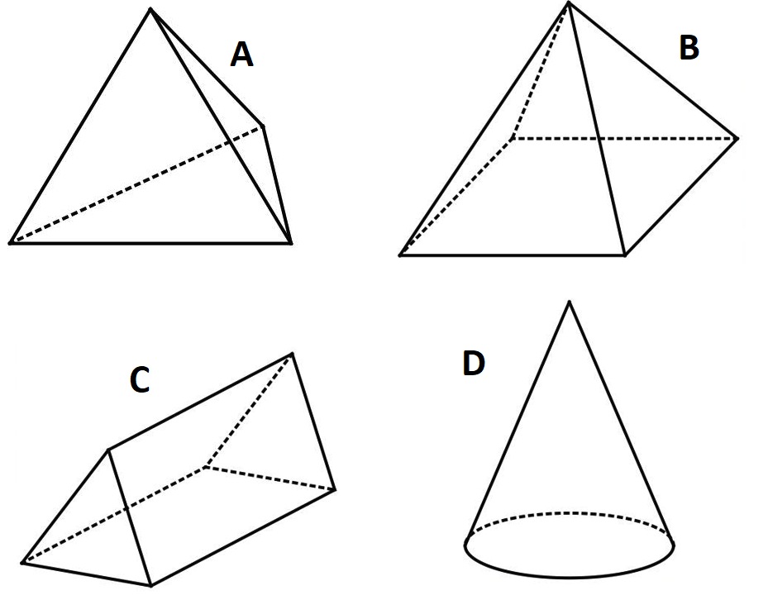
- Students, in a Think-Pair-Share (bit.ly/thinkpairsharestrategy) determine which, if any, of the solids don’t belong (bit.ly/wodbstrategy). While students are discussing in pairs, encourage them to use the correct language to describe the solids.
- Collect student responses through an online poll such as Mentimeter (mentimeter.com/) or by using a finger vote, that is students hold up one finger to vote for solid A, 2 fingers to vote for solid B, and so on.
- Have a class discussion by randomly selecting students to explain their reasoning as to which one doesn’t belong. Through these student responses, explicitly revise the correct terminology to describe each solid:
- Triangular-based pyramid
- Square-based pyramid
- Triangular prism
- Cone

Explore

Volume
- Share with students the story of a famous mathematician, Liu Hui:
Liu Hui is famous for writing a commentary of the book, Arithmetic in nine chapters. The book presented algorithms to solve practical problems although it did not explain how the algorithms were derived. Liu Hui went and provided an explanation for each algorithm, one of which was how to find the volume of a pyramid.
- Display the GeoGebra applet: Yangma (bit.ly/geogebrayangma) for students to view as a class or provide the link for students to view on their individual devices. Explain to students that the pyramid in view is called a Yangma which is the specific type of pyramid used by Liu Hui to explain the volume of a pyramid.
- Using the unfold and rotation tools on the applet, ask students to look at key features of the yangma, that is:
- What shapes make up the net of the yangma?
- Is the yangma a prism, pyramid or cone?
- What do you notice about the faces in relation to the base? (One face is perpendicular to the square base.)
- Distribute Appendix A ‘Yangma net’ to each student, which is the net of a yangma. Instruct students to cut out and construct the net.
- In pairs, students try to combine their yangmas together to see how they fit and if another known solid can be created. Students can then add to their Notice and Wonder list.
- Randomly assign groups of 3 and ask students to try to combine 3 yangmas together to see how they fit. Can they arrange the 3 yangmas to produce a solid with which they are familiar?

- Students should eventually discover that 3 yangmas fit together to form a rectangular prism.
Figure 2 – three Yangma fitted together
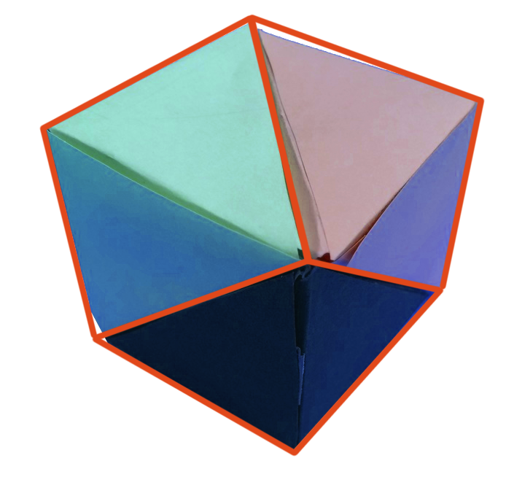
- Have students consider how they could find the volume of this rectangular prism. Students may benefit from labelling some of the sides of their yangmas as shown in the image below.
Figure 3 – labelled yangma
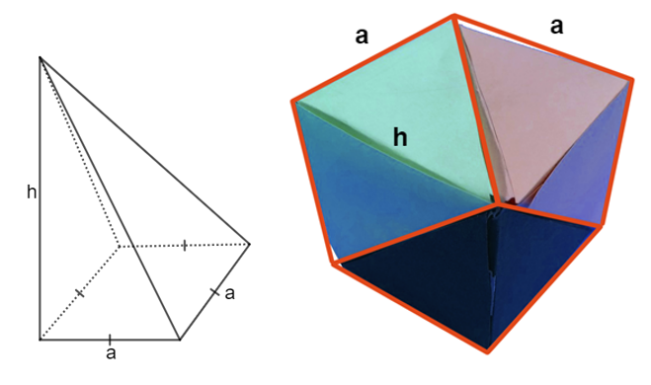
To avoid using algebra, another method is to have students measure the edges of the rectangular prism and then calculate the volume using these measurements.
- Once students have discovered that the rectangular prism has $Volume=a^{2}h$, ask them to consider a formula for the volume of one yangma, acknowledging that they do not yet know a formula or method to find the volume of a pyramid.
Students should recognise that the prism is made of 3 identical yangmas, therefore the volume of each yangma must be one third of the volume of the prism, which is $Volume=\frac{1}{3}a^{2}h$.
- Explain to students that they have just performed the same exploration that Liu Hui did to discover the volume of a pyramid.
- Generalise the formula for students that the volume of any pyramid is $V=\frac{1}{3}Ah$, where $A$ is the area of the base of the pyramid.

Surface Area
- Ask students to consider and Think-Pair-Share (bit.ly/thinkpairsharestrategy) whether the following statement is true or false:
‘The volume of one yangma is one third of the rectangular prism, therefore the surface area of one yangma is one third the surface area of the rectangular prism.’
A poll could then be conducted to tally their predictions of whether it is true or false.
- Students can explore their prediction by calculating the surface area of the rectangular prism formed with the 3 yangmas joined together and compare this to the surface area of the net of a yangma.
This is best done by measuring the sides of the prism and then measuring the faces of the yangma. Comparing algebraically becomes too complex.
- Once students have calculated both surface areas and reassessed whether the statement above is true or false, they can discuss their findings with a partner. Students should compare their results, prompting a discussion on errors in measurement.
- Students should have discovered that the statement was false. Clearly explain to students that, unlike the volume of a pyramid, there isn’t a satisfactory explanation for the surface area of a pyramid. The method is to simply find the area of each of the faces.

Summarise
- Display Figure 4 and ask students if there is sufficient information to find both the surface area and volume.
Figure 4 – pyramid
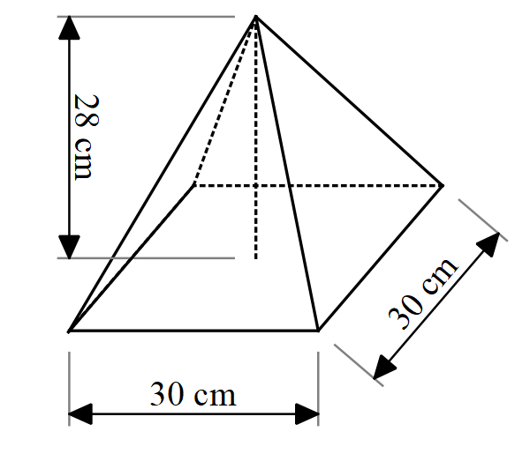
- Allow an opportunity for students to share their thoughts either verbally using a questioning technique such as Pause-Pose-Pounce-Bounce question strategy [PDF 200KB] (bit.ly/pausepouncebounce) or using an online poll such as Mentimeter (mentimeter.com/).
- Students should identify that there is sufficient information to find the volume, however by visualising the net of the pyramid, students should see that they need to know the height of each triangle to find the surface area. Explain to students that this height is known as the slant height of the pyramid.
Explicitly define the following terminology in relation to a pyramid with a diagram:
- Base
- Height
- Slant height
- Let students investigate Figure 4 to see if they can identify that Pythagoras’ theorem must be used to find the slant height before explicitly modelling how to use Pythagoras’ theorem to find the slant height for one of the faces.
- Allow students time to use this theory to calculate the surface area of the pyramid.
- Provide students with problems from the Variation Theory website (bit.ly/variationtheorypyramid), which consists of 6 pyramids of which students can independently find the volume and surface area.
- Students can then explore the questions in Appendix B ‘Pyramid problems’ in groups using Vertical Non-Permanent Surfaces (VNPS)(bit.ly/VNPSstrategy). This involves finding the volume and surface area of composite solids containing pyramids.

Apply
Assign randomly selected groups of 3.

The Great Egyptian Pyramids
In their groups, students go to The Great Egyptian pyramids site (https://bit.ly/greategyptianpyramids) and work through the given problem on 3 of the great pyramids.

Non-routine problem
Students can then attempt the ‘Non-routine problem’ in Appendix C from Open Middle (openmiddle.com/) either individually or in their assigned groups. This task could also be given as an exit ticket (bit.ly/exitticketstrategy).

Assessment and differentiation

Suggested opportunities for differentiation
- To extend students, they could investigate the slope from each of the corners of the base to the apex of the pyramid and compare this to the slope between the base and slant height of each of the faces. This would incorporate revision of previous concepts explored in Unit 3: Working with triangles.

Suggested opportunities for assessment
- Collect Appendix B and C to check for student understanding.
- Monitor student conversations to check for any misconceptions or concepts that may need to be revised.

Appendix A

Yangma net
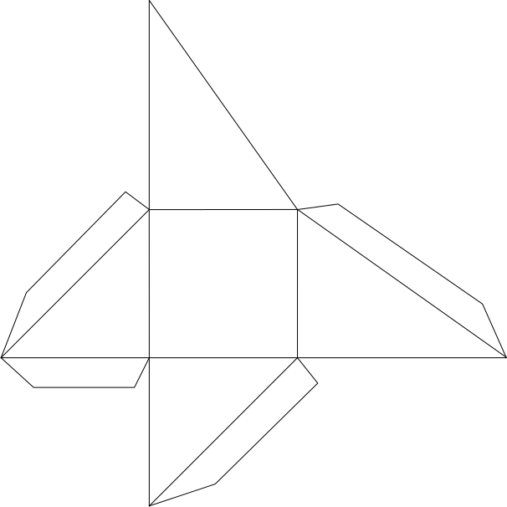

Appendix B

Pyramid problems
- The roof of a building is in the shape of a rectangular pyramid, as shown below:
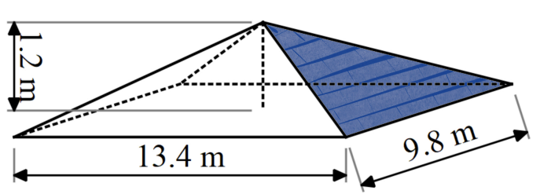
- Calculate the surface area of the roof, excluding the base of the pyramid.
- The roof tiles chosen have a covering capacity of 60 tiles per metre squared.
How many tiles will be needed to cover the roof?
- The solid shown below was obtained by cutting off a small square pyramid with a height of 5 cm from the top of a larger square pyramid with a height of 10 cm.
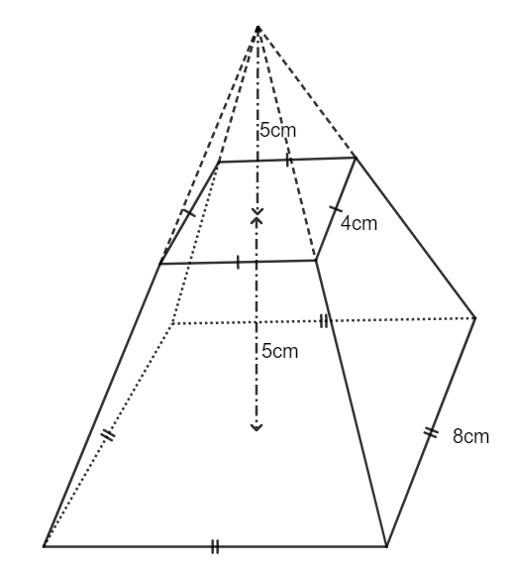
- Find the volume of the solid.
- Find the surface area of the solid.

- A sink has been designed by cutting a rectangular based pyramid from a rectangular prism shaped slab of marble, as shown below.
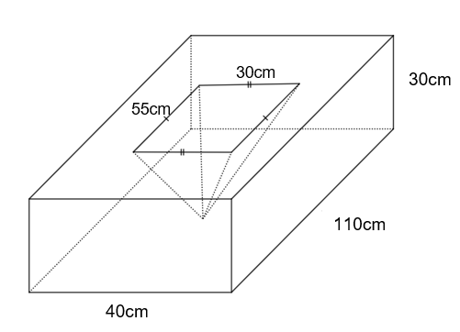
- Find the capacity of the sink.
- Find the volume of the marble slab.
- Find the surface area of the marble slab.
- An architect is designing a pyramid-shaped museum. The museum has a square base with a side length of 50 m and a height of 40 m.
The museum also has 4 triangular windows on each face of the pyramid, each with a base of 10 m and a height of 8 m.
The windows are placed symmetrically on each face, such that the distance from the centre of the window to the centre of the face is 5 m.
What is the total surface area of the museum that needs to be painted?

Appendix C

Non-routine problem
Using the digits 1 to 9 at most one time each, place a digit in each box to list the dimensions of a rectangular prism and rectangular pyramid so that both shapes have equal volumes.
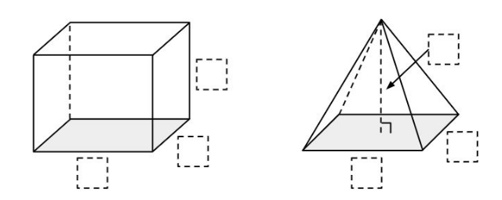
Image sourced from OPEN MIDDLE and used in accordance with the CC BY-NC-SA 4.0 license.

Sample solution

Appendix B – pyramid problems

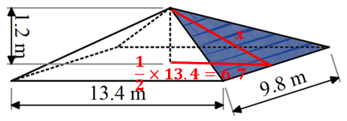
$$x^{2}={6.7}^{2}+{1.2}^{2} \\ x=\sqrt{46.33} \\ x=6.8$$
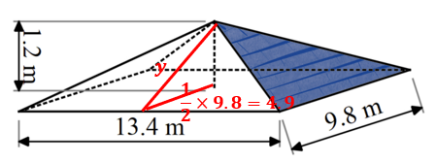
$$y^{2}={4.9}^{2}+{1.2}^{2} \\ y=\sqrt{25.45} \\ y=5.0$$
$$SA=2×\left(\frac{1}{2}×9.8×6.8\right)+2×\left(\frac{1}{2}×13.4×5\right)+\left(9.8×13.4\right) \\ =2×33.32+2×33.5+131.32 \\ =264.96m^{2} \\ =265m^{2}$$
- $\text{Roof tiles}=60×266 \text{(since 0.96}{\text{m}}^{\text{2}}\text{is also need to be covered)}$
$$=15 960 \text{tiles}$$

- $V=\frac{1}{3}Ah$
$$V=\left(\frac{1}{3}×8×8×10\right)-\left(\frac{1}{3}×4×4×5\right) \\ =186.\dot{6} cm^{3}$$

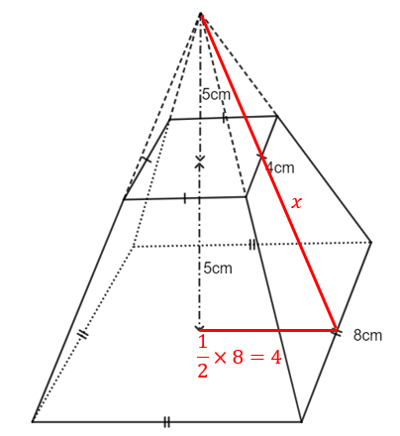
$$x^{2}={10}^{2}+4^{2} \\ x=\sqrt{116} \\ x=10.77$$
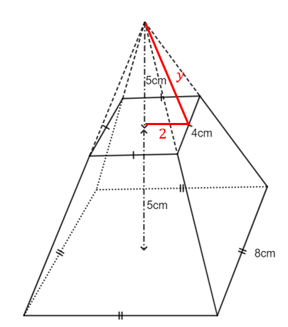
$$y^{2}=5^{2}+2^{2} \\ y=\sqrt{29} \\ y=5.39$$
$$Side slope face=big triangle-small triangle \\ =\left(\frac{1}{2}×8×10.77\right)-\left(\frac{1}{2}×4×5.39\right) \\ =32.3cm^{2}$$
$$SA=base square+top square+4×side slope face \\ =\left(8×8\right)+\left(4×4\right)+4×32.3 \\ =209.2 cm^{2}$$

- $V=\frac{1}{3}Ah$
$$V=\frac{1}{3}×\left(30×55\right)×30 \\ =16 500cm^{3}$$
$$Capacity:1cm^{3}=1mL$$
$$Capacity=16 500mL$$
$=16.5L$
- $V=rectangular prism-sink$
$$V=\left(40×110×30\right)-16500 \\ 115 500cm^{3}$$
- $SA=top+base+sides$
$$SA=\left(\left(40×110\right)-\left(30×55\right)\right)+\left(40×110\right)+2×\left(110×30\right)+2×(40×30)$$
$$=2750+4400+6600+2400 \\ =16 150cm^{2}$$
- Assume that the base of the pyramid does not need to be painted.
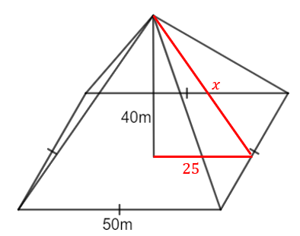
$$x=\sqrt{{25}^{2}+{40}^{2}} \\ =47.17$$
$$Area needing to be painted=4×(triangle face-area of window)$$
$$A=4×\left(\left(\frac{1}{2}×50×47.17\right)-\left(\frac{1}{2}×10×8\right)\right) \\ =4557m^{2}$$

Appendix C – non-routine problem
The rectangular pyramid could have a base with side lengths of 1 and 8, and a height of 9. The rectangular prism could have side lengths of 2, 4 and 3. The volume of both 3-dimensional shapes would be 24 cubic units.

References
This resource contains NSW Curriculum and syllabus content. The NSW Curriculum is developed by the NSW Education Standards Authority. This content is prepared by NESA for and on behalf of the Crown in right of the State of New South Wales. The material is protected by Crown copyright.
Please refer to the NESA Copyright Disclaimer for more information https://educationstandards.nsw.edu.au/wps/portal/nesa/mini-footer/copyright.
NESA holds the only official and up-to-date versions of the NSW Curriculum and syllabus documents. Please visit the NSW Education Standards Authority (NESA) website https://educationstandards.nsw.edu.au/ and the NSW Curriculum website https://curriculum.nsw.edu.au/home.
Mathematics K–10 Syllabus © NSW Education Standards Authority (NESA) for and on behalf of the Crown in right of the State of New South Wales, 2022.

© State of New South Wales (Department of Education), 2023
The copyright material published in this resource is subject to the Copyright Act 1968 (Cth) and is owned by the NSW Department of Education or, where indicated, by a party other than the NSW Department of Education (third-party material).
Copyright material available in this resource and owned by the NSW Department of Education is licensed under a Creative Commons Attribution 4.0 International (CC BY 4.0) licence.
This licence allows you to share and adapt the material for any purpose, even commercially.
Attribution should be given to © State of New South Wales (Department of Education), 2023.
Material in this resource not available under a Creative Commons licence:
- the NSW Department of Education logo, other logos and trademark-protected material
- material owned by a third party that has been reproduced with permission. You will need to obtain permission from the third party to reuse its material.
Links to third-party material and websites
Please note that the provided (reading/viewing material/list/links/texts) are a suggestion only and implies no endorsement, by the New South Wales Department of Education, of any author, publisher, or book title. School principals and teachers are best placed to assess the suitability of resources that would complement the curriculum and reflect the needs and interests of their students.
If you use the links provided in this document to access a third-party's website, you acknowledge that the terms of use, including licence terms set out on the third-party's website apply to the use which may be made of the materials on that third-party website or where permitted by the Copyright Act 1968 (Cth). The department accepts no responsibility for content on third-party websites.

