Exploring unknowns
This lesson incorporates Path content in the Apply section.
Students explore problems where they need to work backwards. They are given either the area, volume or surface area of a solid and they need to find a missing dimension. Students use their algebraic techniques by solving a range of linear equations.

Visible learning

Learning intentions
- To be able to use algebraic techniques to find the missing sides of a solid.

Success criteria
- I can determine the missing side of a solid by trial and error.
- I can determine the missing side of a solid using algebraic techniques.
- I can rearrange a formula to change the subject of the equation.

Syllabus outcomes
A student:
- develops understanding and fluency in mathematics through exploring and connecting mathematical concepts, choosing and applying mathematical techniques to solve problems, and communicating their thinking and reasoning coherently and clearly MAO-WM-01
- simplifies algebraic fractions with numerical denominators and expands algebraic expressions MA5-ALG-C-01
- solves linear equations of up to 3 steps, limited to one algebraic fraction MA5-EQU-C-01
- solves linear equations of more than 3 steps, monic and non-monic quadratic equations, and linear simultaneous equations MA5-EQU-P-02
Mathematics K–10 Syllabus © NSW Education Standards Authority (NESA) for and on behalf of the Crown in right of the State of New South Wales, 2022.

Activity structure

Launch
- Explain to the students that they are to imagine a rectangular prism that is:
- Twice as wide as it is high, and
- Three times as long as it is high.
- Ask students to draw what this rectangular prism could possibly look like.
- Next, ask students to see if they can find some dimensions that fit the above criteria for a rectangular prism.
- Students share their possible rectangular prism with a partner and compare their drawings. Encourage students to discuss reasons as to how they developed their dimensions.
- Share the class results through an online poll, such as Mentimeter word cloud (mentimeter.com/) where students can submit their dimensions such as 2x4x6, or by asking for student volunteers to verbally share their dimensions.
- Ask students to calculate the volume of the rectangular prism with their chosen dimensions. Collate the class results, using the same method as above. Ask students why the results vary.
- Tell students that it is known that the volume of the rectangular prism is $3072 unit^{3}$ and continue the class discussion by asking:
- Did any student get this result?
- If they didn’t, how could they find dimensions that work for this given volume?
- Are there multiple dimensions that would give this volume?
- What if the surface area was known instead of the volume, would multiple dimensions be possible?

Explore
- Randomly arrange students into groups of 3.
- Explain to students that they will be given a set of problems where they are either given some dimensions, the area, surface area or volume, and they need to find the unknown side.
- Appendix A ‘Exploring unknowns’ contains the problems that students will solve. These can be used as a handout for students or used in a relay activity where students are given the next problem after they have successfully solved the previous problem. Students should be encouraged to do their working on Vertical Non-Permanent Surfaces (VNPS) (bit.ly/VNPSstrategy).
- After students have had time to work through a few problems, have a class discussion of the strategies and techniques they are using to solve the problems, for example:
- Are they using the guess and check method?
- Are they discussing a range that the unknown could lie within based on the given information?
- Are they using algebra?
- Are they solving an equation?
- Depending on these results, a few demonstrations of how to use algebra and equations may be beneficial for students to continue with the rest of the problems. The Exploring unknowns PowerPoint slides 3–7 contains the algebraic solutions to each of the problems that can be used as explicit teaching worked examples. Alternatively allow students to continue to explore the remaining problems without any demonstration.

Summarise
- Using the Exploring unknowns PowerPoint slides 3–7, work through the solutions with students, demonstrating how algebraic techniques can be used to solve the problems.
- Whilst going through the solutions, students should be encouraged to notice the differences between the questions and predict how these changes will affect the solution. These questions are created using Variation Theory (variationtheory.com/introduction/).
- Students make notes to their future self (bit.ly/notesstrategy) on how to use algebraic techniques to solve questions that require them to work backwards from the answer.

Apply
These questions incorporate Path content; ‘solve linear equations involving more than 3 steps’ and ‘change the subject of a formula’. Solutions for this question are in the Exploring unknowns PowerPoint.
Students can attempt this question without doing Path content. For question 1b, students can guess and check rather than solving an equation that involves more than 3 steps or compare each length and width to predict how each height might be related. For question 2, remove the step to rearrange the equation and leave the height in terms of $π$.
- Students are to attempt the following 2 problems. They are to inspect what happens to the height if the lengths are half the size, and the widths, volume and surface area are equal.
- Two rectangular prisms hold the same volume. The first rectangular prism has a length of 10 cm, a width of 8 cm but the height is unknown. The second rectangular prism has a length of 5 cm, a width of 8 cm but the height is unknown. It is known that the second rectangular prism’s height is 2 cm more than the height of the first rectangular prism. By constructing an equation, find the height of each of the rectangular prisms.
- Two rectangular prisms hold the same volume. The first rectangular prism has a length of 10 cm, a width of 8cm but the height is unknown. The second rectangular prism has a length of 5 cm, a width of 8 cm but the height is unknown. It is known that the second rectangular prism's height is 2 cm more than the height of the first rectangular prism. By constructing an equation, find the height of each of the rectangular prisms.
- Students can attempt the following problem and explore working with an equation in terms of $π$.
- A company must create 1000 cylindrical money tins from a sheet of tin-coated steel that has dimensions 14 m by 15 m. If the diameter of the money tin must be 18 cm, calculate the height of each money tin, in terms of $π$, by firstly rearranging the equation for the surface area of a cylinder such that $h$ is the subject.

Assessment and differentiation

Suggested opportunities for differentiation
Launch
- It may be beneficial to allow students to use virtual manipulatives such as Mathigon Polypad (mathigon.org/polypad) or centicubes to construct prisms that meet the criteria.
Explore
- Some questions may need to be explored as a class.
Apply
- Despite these questions having Path content, they can easily be adapted to suit the needs of all students. For question 1 students can guess and check, rather than solving an equation that involves more than 3 steps, or compare each length and width to predict how each height might be related. For question 2, remove the step to rearrange the equation and leave the height in terms of $π$.

Suggested opportunities for assessment
- Collect student responses to check for understanding.
- Monitor student discussions during group work to check for understanding and any misconceptions that may need to be addressed.

Appendix A

Exploring unknowns

Area
- A rectangle has a base length of 8 cm and a perimeter of 20 cm. Determine the missing dimension of the rectangle.
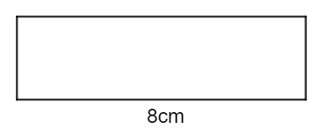

- A rectangle has a base length of 8 cm and an area of 20 cm². Determine the missing dimension of the rectangle.

- A triangle has a base length of 8 cm and an area of 20 cm². Determine the missing dimensions of the triangle.
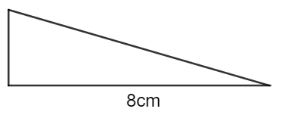

- A composite shape has measurements as shown below. Determine the missing dimensions if it is known that the area is 30 cm².
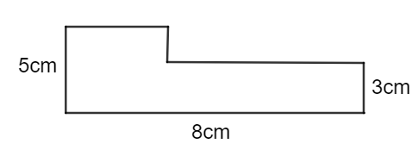

Volume
- A rectangular prism has a height of 6 cm, a width of 9 cm and a volume of 594 cm³. Determine the missing dimension of the prism.
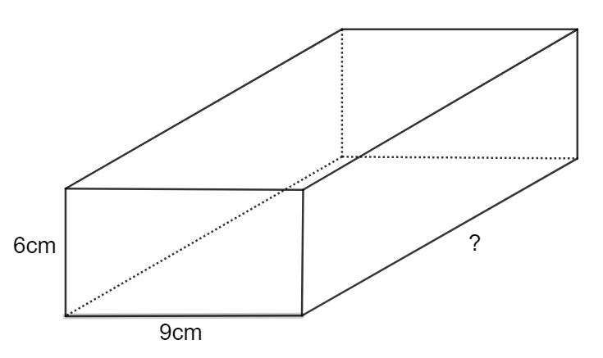

- A triangular prism has a height of 6 cm, a width of 9 cm and a volume of 594 cm³. Determine the missing dimension of the prism.
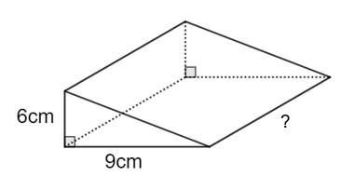

- A trapezoidal prism has a height of 6 cm, a width of 9 cm, a depth of 11 cm and a volume of 462 cm³. Determine the missing dimension.
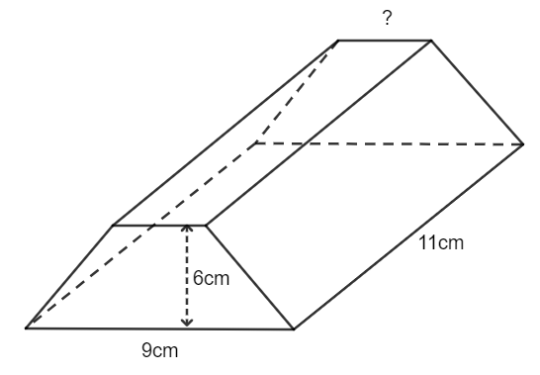

- A composite solid is shown below. It is known that the volume of the solid is 594 cm². Determine the missing dimension.
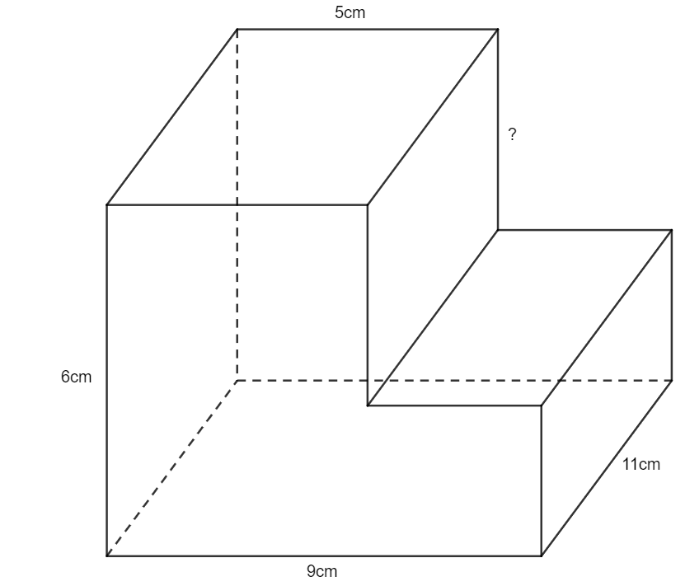

Surface area
- A rectangular prism has a height of 6 cm, a width of 8 cm and a surface area of 390 cm². Determine the missing dimension of the prism.
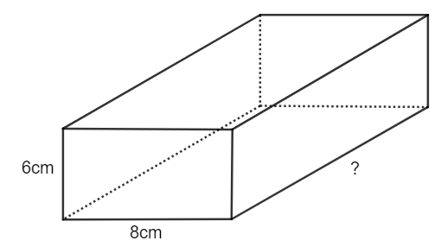
- A triangular prism has a height of 6 cm, a width of 8 cm and a surface area of 390 cm². Determine the missing dimension of the prism.
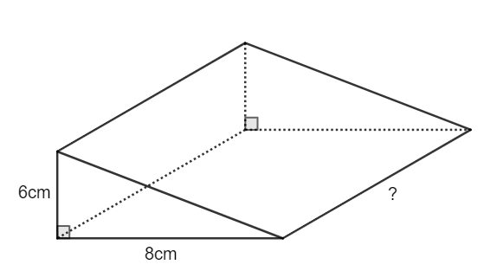
- Four cubes, each with a surface area of 24 cm² are placed together to make a cuboid as shown. What is the surface area of this cuboid?

References
This resource contains NSW Curriculum and syllabus content. The NSW Curriculum is developed by the NSW Education Standards Authority. This content is prepared by NESA for and on behalf of the Crown in right of the State of New South Wales. The material is protected by Crown copyright.
Please refer to the NESA Copyright Disclaimer for more information https://educationstandards.nsw.edu.au/wps/portal/nesa/mini-footer/copyright.
NESA holds the only official and up-to-date versions of the NSW Curriculum and syllabus documents. Please visit the NSW Education Standards Authority (NESA) website https://educationstandards.nsw.edu.au/ and the NSW Curriculum website https://curriculum.nsw.edu.au/home.
Mathematics K–10 Syllabus © NSW Education Standards Authority (NESA) for and on behalf of the Crown in right of the State of New South Wales, 2022.

© State of New South Wales (Department of Education), 2023
The copyright material published in this resource is subject to the Copyright Act 1968 (Cth) and is owned by the NSW Department of Education or, where indicated, by a party other than the NSW Department of Education (third-party material).
Copyright material available in this resource and owned by the NSW Department of Education is licensed under a Creative Commons Attribution 4.0 International (CC BY 4.0) licence.
This licence allows you to share and adapt the material for any purpose, even commercially.
Attribution should be given to © State of New South Wales (Department of Education), 2023.
Material in this resource not available under a Creative Commons licence:
- the NSW Department of Education logo, other logos and trademark-protected material
- material owned by a third party that has been reproduced with permission. You will need to obtain permission from the third party to reuse its material.
Links to third-party material and websites
Please note that the provided (reading/viewing material/list/links/texts) are a suggestion only and implies no endorsement, by the New South Wales Department of Education, of any author, publisher, or book title. School principals and teachers are best placed to assess the suitability of resources that would complement the curriculum and reflect the needs and interests of their students.
If you use the links provided in this document to access a third-party's website, you acknowledge that the terms of use, including licence terms set out on the third-party's website apply to the use which may be made of the materials on that third-party website or where permitted by the Copyright Act 1968 (Cth). The department accepts no responsibility for content on third-party websites.

