Deep dive
Students explore the design of a variety of pools with a range of depths. Each pool is a composite solid and students compare the pools in terms of volume, capacity and surface.

Visible learning

Learning intentions
- To be able to dissect a composite solid into known solids.
- To be able to calculate the volume of a composite solid.

Success criteria
- I can identify the solids that make up a composite solid.
- I can calculate the volume of a composite solid.
- I can calculate the capacity of a composite solid.

Syllabus outcomes
A student:
- develops understanding and fluency in mathematics through exploring and connecting mathematical concepts, choosing and applying mathematical techniques to solve problems, and communicating their thinking and reasoning coherently and clearly MAO-WM-01
- solves problems involving the surface area of right prisms and practical problems involving the area of composite shapes and solids MA5-ARE-C-01
- solves problems involving the volume of composite solids consisting of right prisms and cylinders MA5-VOL-C-01
Mathematics K–10 Syllabus © NSW Education Standards Authority (NESA) for and on behalf of the Crown in right of the State of New South Wales, 2022.

Activity structure

Launch
- Display Appendix A ‘Which pool holds the most amount of water?’ for students to view, or display slide 3 in the Deep dive PowerPoint. Ask students to consider which, of the 4 different pools, holds the most water and the reasons why.
- Students are to Think-Pair-Share (bit.ly/thinkpairsharestrategy) their thoughts on which pool they believe would hold the most water.
- Students’ thoughts should then be shared either through a class discussion or an online poll such as Mentimeter (mentimeter.com), where reasons should also be shared.
This activity is intended to get students considering what characteristics of a pool need to be considered when determining the amount of water it will hold. For example, shape, depth, size and so on.

Explore
Students will now explore the characteristics of 2 different pool designs, a local swimming pool and a resort pool.

Local swimming pool
- Ask students to consider their local swimming pool and whether it is the same depth throughout the pool or if it has a shallow end and a deep end.
For the purposes of this activity, the local pool needs to be rectangular and have a shallow end and a deep end. If the school’s local swimming pool is not like this, select another pool for students to consider.
- Using mini whiteboards (bit.ly/miniwhiteboards) or otherwise, ask students to individually draw the top view of the local swimming pool. Then ask students to display what they have drawn. This is an opportunity to look for student misconceptions. They should have drawn a rectangle.
- Next, ask students to draw a side view of the local swimming pool on their mini whiteboards. Allow them time to attempt this without any prompting. After allowing students some time, ask students to consider if they may have forgotten something and eventually remind them that there is a deep end and a shallow end. Ask students to display what they have drawn.
Students will have a range of images at this point. Depending on students’ understanding of the concept of volume and 3-dimensional figures, decide on which shape students will investigate further. Students will also need to know the dimensions of the pool. Most local pools are either 25 or 50 metres long, with 8–10 lanes. Some shape suggestions are in Appendix B ‘Local swimming pool designs’, which includes a trapezoidal prism and further composite solids.
- Prior to students exploring the local swimming pool, as a class discuss how the side view of the swimming pool can be split into rectangular and triangular prisms. Are there multiple ways to do this?
- Arrange students into random groups of 3. Students will work in groups with the chosen design of the local swimming pool and its dimensions to perform calculations of the volume and the amount of water it holds. Appendix C ‘Deep dive pool design’ has been supplied as a handout for students to work from.

Resort pool
- Students will now explore a resort pool that has a consistent depth, although its top view is made of composite solids. Display Figure 1, the image of the resort pool for students.
- Ask students to explain how they could break this 2-dimensional solid up into known shapes, that is rectangles and a semi-circle.
Figure 1 – image of a resort pool
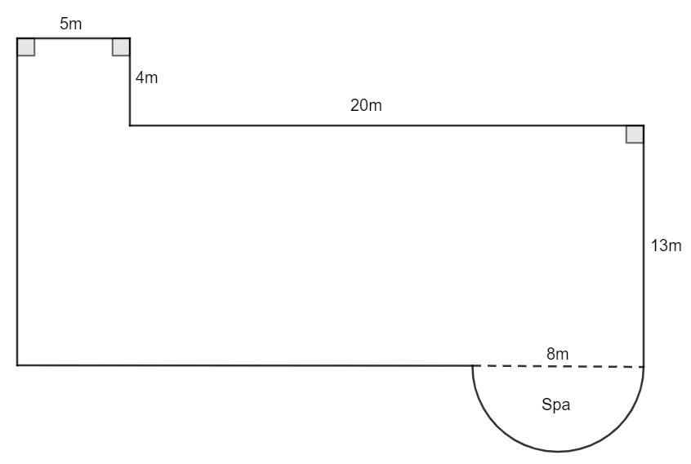
Image created using the free virtual manipulates at geogebra.org.
- Decide as a class on the depth of each section of the resort pool and have students record this on their Appendix C ‘Deep dive pool design’ handout.
The depth choice and the design will be dependent on the class and/or students’ ability. For example, the entire pool, including the spa could be the same depth, or the spa could be a different constant depth to the rest of the pool, or the small rectangle could go from shallow to deep.
- Students will now return to their groups to perform calculations for the resort pool including the volume and the amount of water it holds. Appendix C ‘Deep dive pool design’ can continue to be used.
- Students will then compare the 2 pools, as they are both 25 metres in length.
- After students have finished their calculations, conduct a class discussion to explore the findings of each pool investigated.

Summarise
- Use the Deep dive PowerPoint slides 5–11 for explicit teaching of calculating the volume of composite right prisms with uniform cross sections that can be dissected into triangles, quadrilaterals, sectors, semicircles and quadrants.

The explicit teaching technique used in the PowerPoint is ‘Your turn’. The first slide is a worked example which should be displayed for the students and then use the following steps.
- Reveal the question to the students and its solution.
- Students read in silence.
- Students individually think and explain to themselves what is happening in each step.
- Students hold a thumbs up to the teacher when they have finished reading and have some sort of understanding.
- Think-Pair-Share. Students explain the solution to their partner.
- In pairs, students then answer the self-explanation questions.
- Finally, randomly select students to share their answers with the whole class, using a technique such as Pause-Pose-Pounce-Bounce question strategy [PDF 200KB] (bit.ly/pausepouncebounce).
- Students should make notes to their future self (bit.ly/notesstrategy) and complete some practice questions.

Apply
- Students are to design their own pool to enter a pool design competition. The requirements of the competition state that the pool design:
- must fit within a 6 m by 10 m flat block of land
- have both straight and curved edges around its perimeter
- contain 55 kL to 65 kL.
- Students will need to submit a diagram of the top and side view of the pool as well as supporting calculations.

Assessment and differentiation

Suggested opportunities for differentiation
Explore
- To support the varying ability levels of students, a range of local pool designs have been supplied for the teacher to select the one that best meets the students’ needs.
- To support the varying ability levels of students, different depths could be considered for the resort pool to best meet the needs of every student.
- To extend students they could consider the tiles of the pool and calculate the surface area that would require tiling.
- To extend students they could consider the time it would take to fill the pool by researching the flow rate of a hose.
Apply
- To extend students, consider adding additional criteria for students to consider when designing their own pool. For example, the block of land may not be rectangular, they could be supplied with a house plan and design a pool that fits in a particular backyard.
- To support students, some criteria of the pool could be removed such as the amount of water that the pool must contain.

Suggested opportunities for assessment
- Monitor student discussions in group work to check for understanding.
- Collect Appendix C ‘Deep dive into pool design’ from each group to check calculations and reasons provided.
- Collect the pool designs from each student to use as summative assessment.

Appendix A

Which pool holds the most amount of water?

Figure 1 – resort pool area
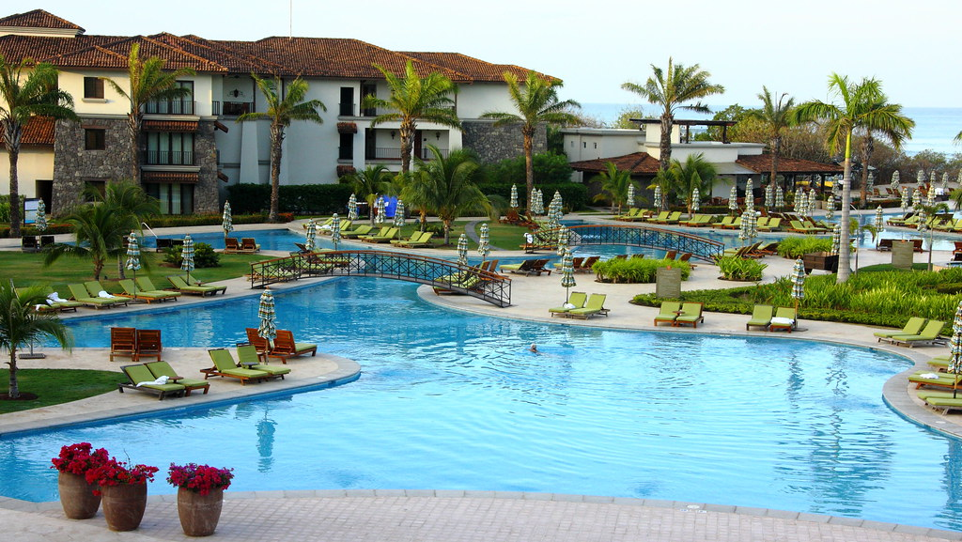
‘Costa Rica J W Marriott Resort Pool area’ by John Menard is licensed under CC BY-SA 2.0.
Figure 2 – backyard – pool before rebuild
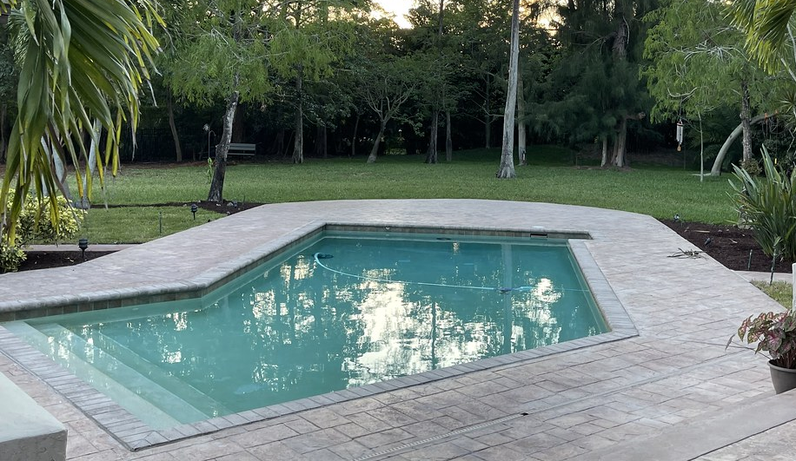
‘Backyard – pool before rebuild’ by Julie Corsi is licensed under CC BY 2.0.
Figure 3 – pool at Bondi Icebergs
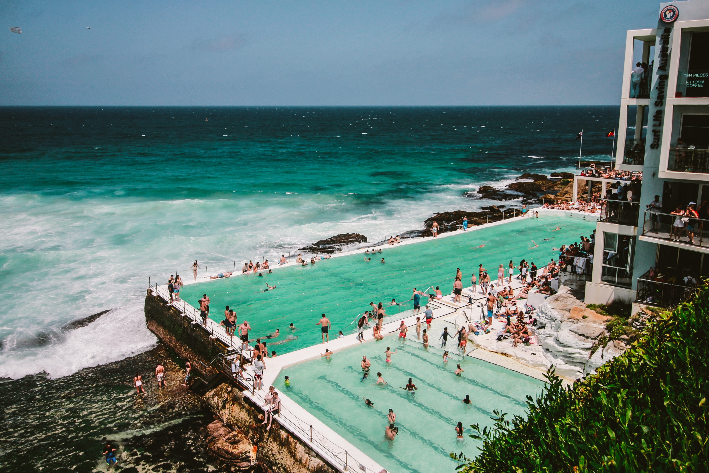
Image by Belle Co is licensed under Pexels License
Figure 4 – pool at the US Olympic swim team trials
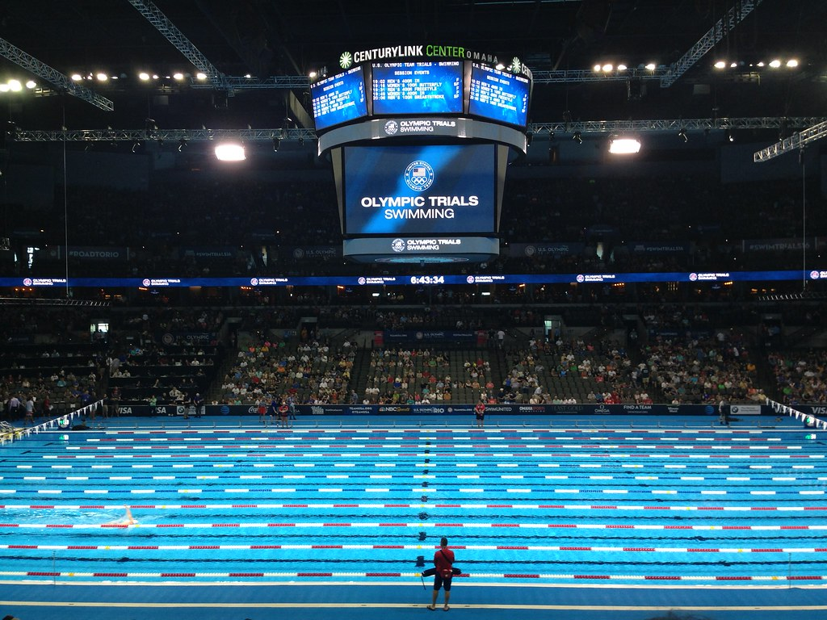
‘Pool Safely at the U.S. Olympic Swim Team Trials’ by PoolSafely is licensed under CC BY 2.0.

Appendix B

Local swimming pool designs
Depending on the class and/or student’s ability level, select one or more of the following side views of the local swimming pool for students to investigate. The width of the pool will also need to be supplied to the students.
Pool design | Side view and dimensions
Trapezoidal | 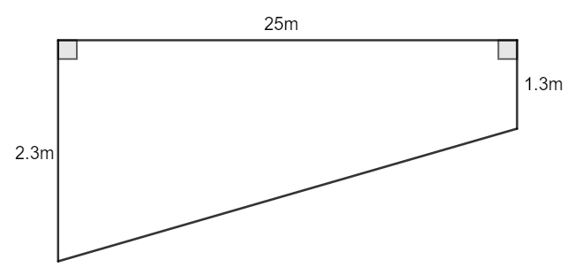
Sloped | 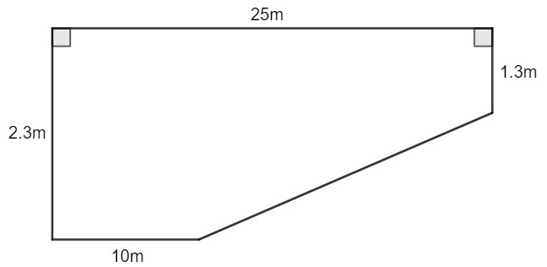
Spooned | 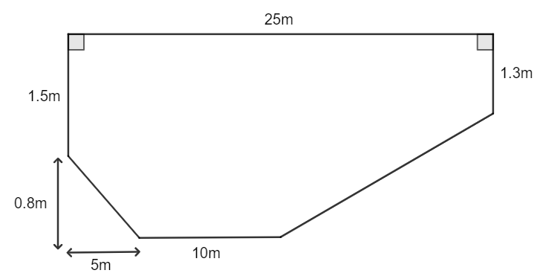
Images created using the free virtual manipulatives at geogebra.org/.

Appendix C

Deep dive into pool design

Local swimming pool
- Sketch the side view and the 3-dimensional solid, including dimensions, which represents the local swimming pool.
Side view | 3-dimensional solid
- Calculate the volume of the pool.
- A pool cover is to be purchased that needs to cover the entire pool’s surface with 1 metre extra around the perimeter. Calculate the dimensions of this cover.
- If the pool is only filled until it is 0.3 m from the surface, calculate the amount of water the pool holds in litres. Remember that $1cm^{3}=1mL$ and $1m^{3}=1000L$.
- Olympic swimming pools are much deeper than regular pools to decrease the change of waves forming and to increase the swimmers’ performance. In a deeper pool the splash and turbulence take longer to get down to the bottom of the pool, meaning that it doesn’t ricochet back up into the swimmers. Olympic pools also have a constant depth throughout the entire pool. If the local swimming pool’s depth was to be adjusted to a constant 3 metres throughout, by how much would the capacity of the pool change?

Resort pool
Figure 5 – image of a resort pool
Image created using the free virtual manipulates at geogebra.org.
- Split the resort pool into 3 different known shapes and record their dimensions.
- Record the depth of each section of the resort pool.
- Calculate the volume of the pool.
- If the pool is only filled until it is 0.3 m from the surface, calculate the amount of water the pool holds in litres. Remember that $1cm^{3}=1mL$ and $1m^{3}=1000L$.
- If a pool cover was to be purchased that needed to cover the entire pools surface with 1 metre extra around the perimeter, calculate the dimensions and area of this cover.
- This pool is the same length as the local swimming pool. Compare the 2 pools, in terms of volume, amount of water they both hold and the size and area of the pool cover.

References
This resource contains NSW Curriculum and syllabus content. The NSW Curriculum is developed by the NSW Education Standards Authority. This content is prepared by NESA for and on behalf of the Crown in right of the State of New South Wales. The material is protected by Crown copyright.
Please refer to the NESA Copyright Disclaimer for more information https://educationstandards.nsw.edu.au/wps/portal/nesa/mini-footer/copyright.
NESA holds the only official and up-to-date versions of the NSW Curriculum and syllabus documents. Please visit the NSW Education Standards Authority (NESA) website https://educationstandards.nsw.edu.au/ and the NSW Curriculum website https://curriculum.nsw.edu.au/home.
Mathematics K–10 Syllabus © NSW Education Standards Authority (NESA) for and on behalf of the Crown in right of the State of New South Wales, 2022.

© State of New South Wales (Department of Education), 2023
The copyright material published in this resource is subject to the Copyright Act 1968 (Cth) and is owned by the NSW Department of Education or, where indicated, by a party other than the NSW Department of Education (third-party material).
Copyright material available in this resource and owned by the NSW Department of Education is licensed under a Creative Commons Attribution 4.0 International (CC BY 4.0) licence.
This licence allows you to share and adapt the material for any purpose, even commercially.
Attribution should be given to © State of New South Wales (Department of Education), 2023.
Material in this resource not available under a Creative Commons licence:
- the NSW Department of Education logo, other logos and trademark-protected material
- material owned by a third party that has been reproduced with permission. You will need to obtain permission from the third party to reuse its material.
Links to third-party material and websites
Please note that the provided (reading/viewing material/list/links/texts) are a suggestion only and implies no endorsement, by the New South Wales Department of Education, of any author, publisher, or book title. School principals and teachers are best placed to assess the suitability of resources that would complement the curriculum and reflect the needs and interests of their students.
If you use the links provided in this document to access a third-party's website, you acknowledge that the terms of use, including licence terms set out on the third-party's website apply to the use which may be made of the materials on that third-party website or where permitted by the Copyright Act 1968 (Cth). The department accepts no responsibility for content on third-party websites.

