How do animals keep cool?
Students explore how the surface area and volume of an animal can affect how they lose heat from their bodies. Students firstly explore how different positions of an animal may determine if they are trying to warm up or cool down, before exploring the ratio of volume to surface area and how this affects heat loss in animals.

Visible learning

Learning intentions
- To understand the relationship between surface area and volume.
- To be able to compare and contrast the ratio of volume to surface area.

Success criteria
- I can identify the different shapes that make up a 3D object.
- I can calculate the surface area of cylinders and prisms.
- I can calculate the volume of cylinders and prisms.
- I can explain the relationship between the surface area and volume of solids.
- I can justify the most effective solid to model an animal.

Syllabus outcomes
A student:
- develops understanding and fluency in mathematics through exploring and connecting mathematical concepts, choosing and applying mathematical techniques to solve problems, and communicating their thinking and reasoning coherently and clearly MAO-WM-01
- solves problems involving the surface area of right prisms and practical problems involving the area of composite shapes and solids MA5-ARE-C-01
- solves problems involving the volume of composite solids consisting of right prisms and cylinders MA5-VOL-C-01
Mathematics K–10 Syllabus © NSW Education Standards Authority (NESA) for and on behalf of the Crown in right of the State of New South Wales, 2022

Activity structure

Launch
- Display the table below for students to view.
Figure 1 – mouse | Figure 2 – elephant
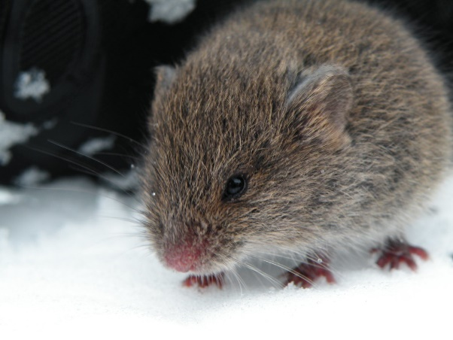  ‘Snow mouse’ by Nick Moise is licensed under CC BY 2.0. | 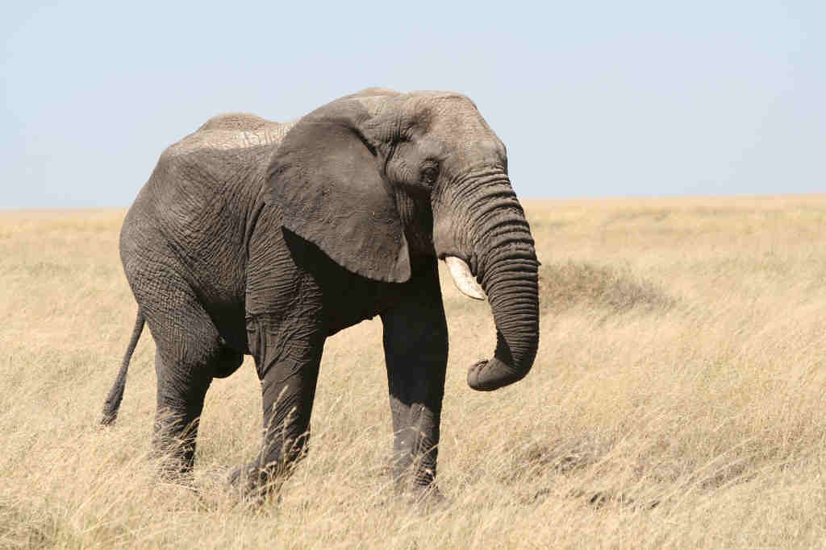  ‘Elephant’ by guido da rozze is licensed under CC BY 2.0.
- Pose the question, ‘Which animal is more likely to get cold in winter and hot in summer?’ Allow students time to ‘Think-Pair-Share’ (bit.ly/thinkpairsharestrategy) their thoughts, encouraging students to explain their reasoning to each other.
- Using a questioning technique such as Pose-Pause-Pounce-Bounce [PDF 200KB] (bit.ly/pausepouncebouncestrategy), ask a few pairs of students to share their thoughts and reasoning with the class.
- Display the table below for students to view and pose the question, ‘Why do dogs and cats curl up in a ball in winter and stretch out in summer?’
Figure 3 – dog curled up in a ball | Figure 4 – dog stretched out
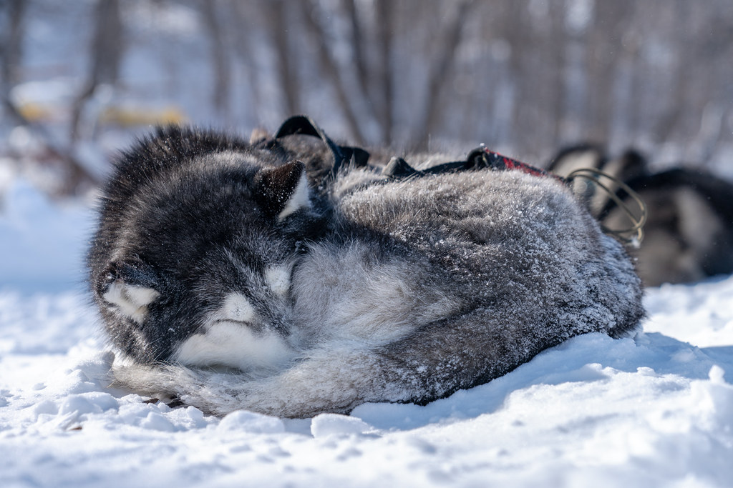  ‘A Siberian husky sled dog curled up in the snow at Birches on the Lake in Long Lake, Minnesota’ by Lorie Shaull is licensed under CC BY 2.0. | 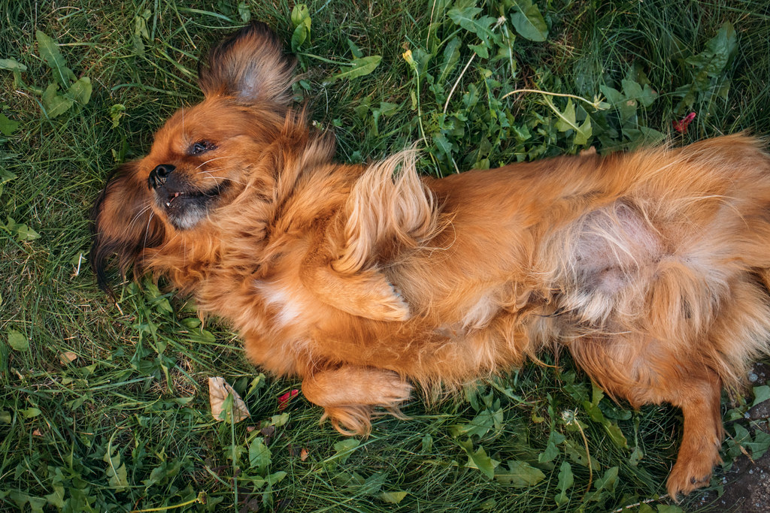  ‘Playful dog laying in the grass’ by Ivan Radic is licensed under CC BY 2.0.
- Allow students time to ‘Think-Pair-Share’ (bit.ly/thinkpairsharestrategy) their thoughts, encouraging students to explain their reasoning to each other.
- Again, use a questioning technique such as Pause-Pose-Pounce-Bounce [PDF 200KB] (bit.ly/pausepouncebounce) to ask a few pairs of students to share their thoughts and reasoning.

Explore
Students will now explore surface area to volume ratios and how it relates to heating an animal’s body. They will consider an extreme example of a dog which is curled up compared to a dog which is stretched out.
- Explain to students that they are going to assume a dog curled up is approximately the shape of a cube and that a dog stretched out is approximately the shape of a rectangular prism.
- Randomly assign students into small groups of 3 and hand out Appendix A which investigates heat loss of animals in the 2 positions. Students will work through an activity where they calculate the surface area and volume of each model for a curled-up and a stretched-out dog and consider the ratio between the 2 variables.
- Conduct a class discussion about the results and what each group concluded.

Modelling with rectangular prisms
Students will further investigate this by modelling a mouse, an elephant, and any other animals of their choosing, using rectangular prisms.
- For each animal, research approximate dimensions and then calculate the surface area, volume, and surface area to volume ratio. Example dimensions:
- A mouse is approximately 10 cm long, 3 cm high.
Figure 5 – dimensions of a mouse and its rectangular model
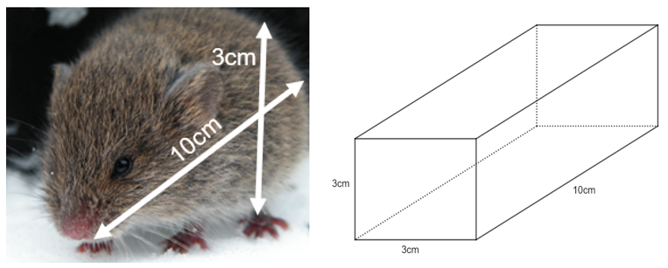
- A table has been provided in Appendix A for students to complete this task.
- Have a class discussion to see if any conclusions can be drawn by asking questions such as:
- Which animal, from the calculations, will lose body heat at the quickest rate?
- Can any generalisations be made about the size of the animal and how quickly they will lose body heat?

Modelling with cylinders
- Ask students whether they think a rectangular prism is the best solid to choose as a model for animals. Can they think of another solid that may be better suited?
- Students will now complete the same investigation using cylinders as a model. Explain to students that most animals are approximately 2.5 times longer than they are across their diameter. For example:

Figure 6 – dimensions of a mouse and its cylindrical model
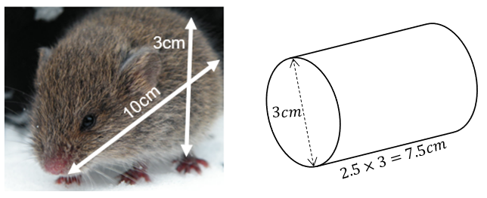
- A table has been provided in Appendix A for students to complete this task.
- Conduct a class discussion about how changing the shape of the model affected the results.
- To further investigate the relationship, graph the radius of the animals compared to their ratio either by hand or using a graphing calculator like Desmos (desmos.com/calculator).

Summarise
- Using the graph and all previous calculations and discoveries, ask students what the relationship is between the surface area and volume. How does this ratio relate to how quickly an animal loses heat?
If not already concluded in the class discussion, explain to students that a lower surface area to volume ratio means less heat loss per unit of body mass. Higher surface area to volume ratios means more heat loss per body mass.

Apply

Animal characteristics
Using mathematical models and calculations, students are to work in pairs and try to explain why animals have certain characteristics. A few animal characteristics include:
- elephants and rhinoceros have big ears and wrinkled skin
- smaller animals have more fur than most larger animals
- smaller animals tend to be shaped more like a sphere than larger animals.

Plant characteristics
Students are to transfer their knowledge of volume, surface area and heat to the leaves of different types of plants.
Using the below images, or similar, as a stimulus, students are to consider the design of each plant in relation to its environment and the reasoning behind its characteristics. Students may consider:
- the appearance of each plant
- the location and environment of each plant
- the volume of the plant
- the plant’s surface area that is exposed to the sun.
Figure 7 – plant 1 | Figure 8 – plant 2
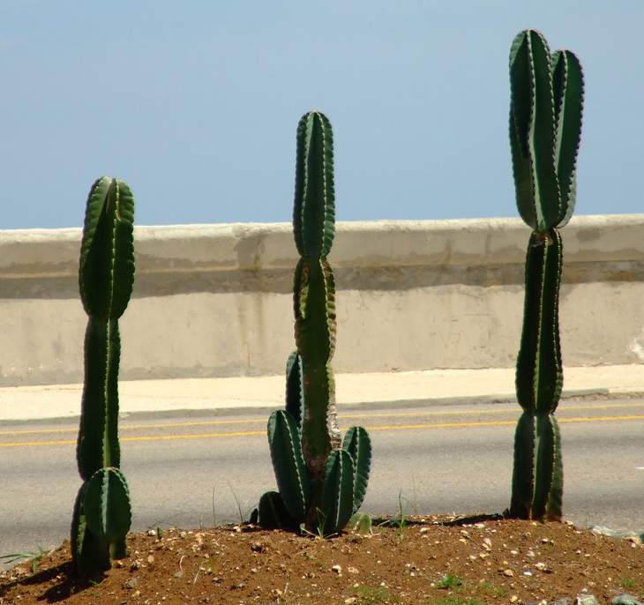  ‘Cactus sul Malecón - Havana, Cuba’ by danifeb is licensed under CC BY-SA 2.0. | 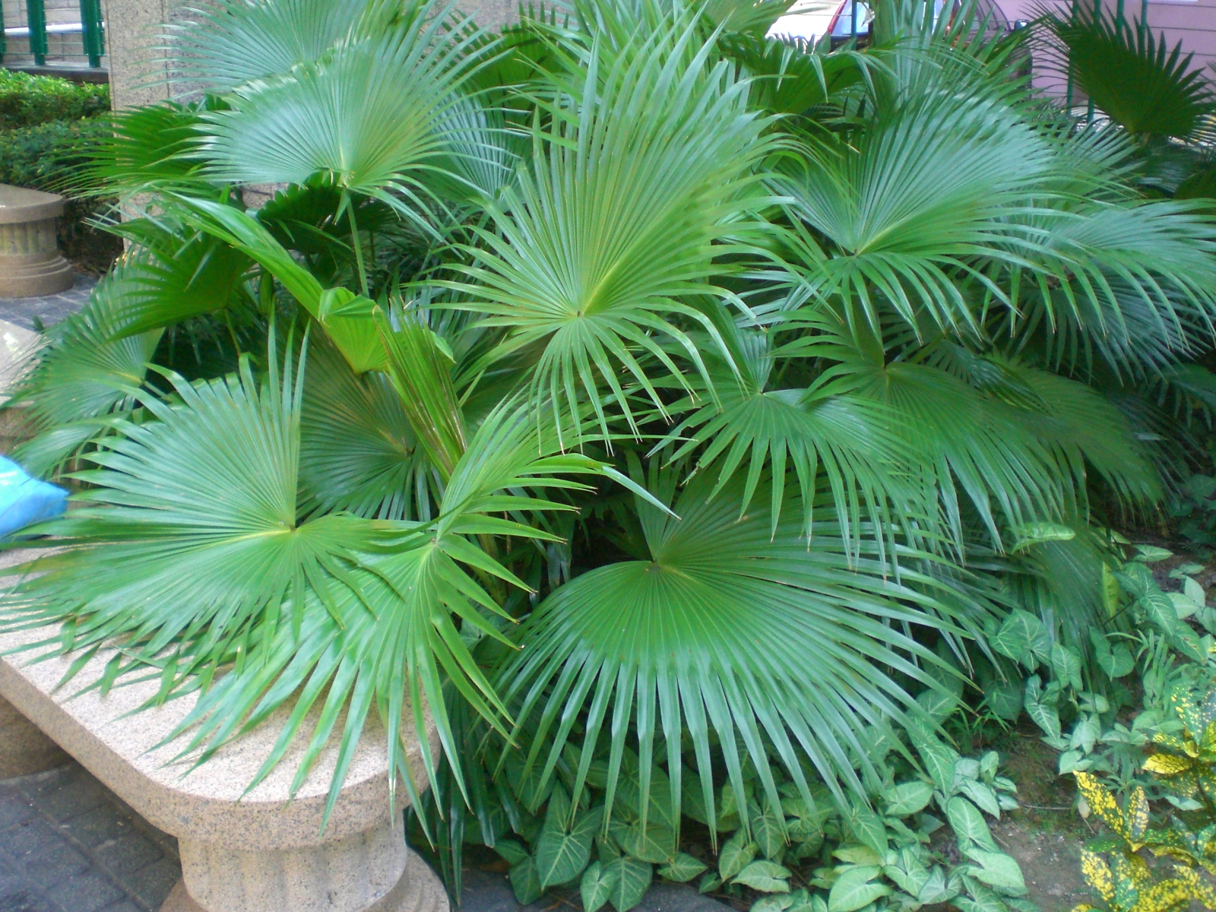  ‘HK CWB The Leighton Hill Public Big Leaves 6’ by PpYukShing is licensed under CC BY-SA 3.0.
Have a class discussion to summarise the student’s discoveries.

Assessment and Differentiation

Suggested opportunities for differentiation
Launch
- Some students may like to consider other animals, such as reptiles, in terms of heat loss.
Explore
- Students may need some assistance calculating and comparing surface area and volumes when their results are decimals. Students may find it easier to round their surface area and volumes to the nearest whole number.
- Students could be challenged to further separate the animal’s body into smaller parts. For instance, cylinders for each leg and arm. Students could also be extended into using a sphere to model the head.
Summarise
- Depending on the ability level of the class, the teacher may choose to determine the dimensions of the animals as a class.
- Some students may benefit from having a physical model in front of them, such as a cereal box as the rectangular prism and a can as the cylinder.
Apply
- Students could make a presentation of plant characteristics and their exposure to the sun that they could present back to the class.

Suggested opportunities for assessment
- Monitor student discussions during group work activities to check for understanding and to address any misconceptions.
- Collect students’ completed responses from Appendix A as either formative or summative assessment.
- This entire lesson could easily be turned into an investigation style assessment task.

Appendix A

Heat loss in animals
- Consider an extreme example of a dog curled up compared to a dog stretched out. Use a 10 cm cube to model the dog curled up and a 10 cm by 30 cm rectangle to model the same dog when it is stretched out.
Dog curled up in a ball | Dog stretched out
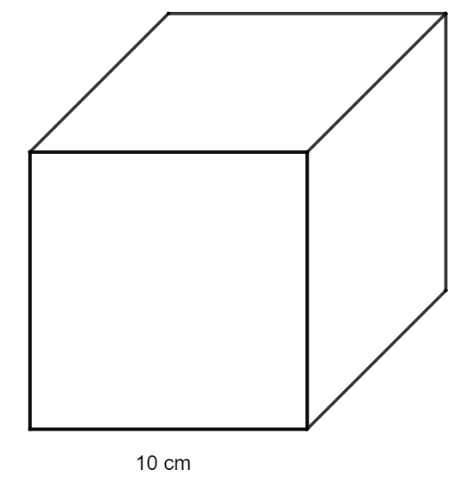 | 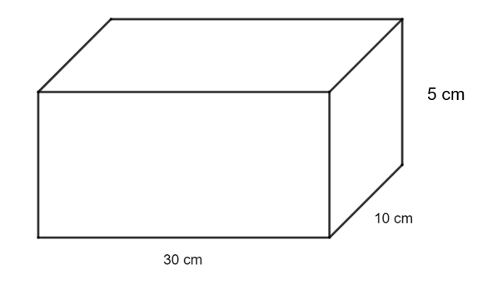

Surface area
- Calculate the surface area of each position of the dog, that is the surface area of the cube and the rectangular prism. Record your working in the table below.
Dog curled up in a ball | Dog stretched out
- Knowing the surface area of each position of the dog, which shape do you now think is more likely to lose heat at a quicker rate? Explain your reasoning.

Volume
- Next, calculate the volume of each position of the dog, that is the volume of the cube and the volume of the rectangular prism. Record your working in the table below.
Dog curled up in a ball | Dog stretched out
- Does the volume calculation support your initial thought on which shape is more likely to lose heat at a quicker rate? Explain your reasoning.

Ratio of surface area to volume
- Investigate the relationship between the surface area and volume using ratios for each of the positions. Compare the surface area to the volume for each shape by writing it as a ratio. It may be beneficial to simplify the ratio to find the surface area per $1 cm^{3}$ of volume, that is to calculate the surface area $÷$ volume. Record your working in the table below.
Dog curled up in a ball | Dog stretched out
- Reconsider your previous assumptions in terms of surface and volume by using the ratio calculated and how it affects the rate at which animals lose heat. Can any conclusions be formed?

Modelling with rectangular prisms
- Find approximate dimensions for the animals and calculate the surface area, volume, and ratio, recording your working in the table below. Example dimensions:
- A mouse is approximately 10 cm long, 3 cm high.
Calculations | Mouse | Elephant | Animal 1 | Animal 2
Surface area
Volume
Ratio
- Consider the following:
- Which animal, from the calculations, will lose body heat at the quickest rate?
- Can any generalisations be made about the size of the animal and how quickly they will lose body heat?

Modelling with cylinders
- Complete the same investigation using cylinders as a model. It is known that most animals are approximately 2.5 times longer than they are across their diameter. For example:
Calculations | Mouse | Elephant | Animal 1 | Animal 2
Radius
Surface area
Volume
Ratio
- How has changing the shape of the model affected your results when considering which animal loses heat the quickest?

Sample solutions

Appendix A – heat loss in animals

Dog curled up in a ball | Dog stretched out

Surface area

Dog curled up in a ball | Dog stretched out
Area of front face  $$A=10×10$$  $=100cm^{2}$  Total surface area  $$A=100×6$$  $=600cm^{2}$ | Area of front face  $$A=30×5 \\ =150cm^{2}$$  Area of side face  $$A=10×5 \\ =50cm^{2}$$  Area of top face  $$A=10×30 \\ =300 cm^{2}$$  Total surface area  $$A=150×2+50×2+300×2 \\ =1000cm^{2}$$

Volume

Dog curled up in a ball | Dog stretched out
$$V=s^{3}$$  $$={10}^{3}$$  $$=1000cm^{3}$$ | $$V=lbh$$  $$=10 ×30×5$$  $$=1500 cm^{3}$$

Ratio of surface area to volume

Dog curled up in a ball | Dog stretched out
$$\frac{SA}{V}=\frac{600}{1000} \\ =\frac{3}{5} \\ =0.6$$ | $$\frac{SA}{V}=\frac{1000}{1500} \\ =0.67$$
- The dog that is stretched out has a larger surface area (SA) to volume ratio meaning they will cool down quicker than the dog curled in a ball.

Modelling with rectangular prisms
- Find approximate dimensions for the animals and calculate the surface area, volume, and ratio, recording your working in the table below. Example dimensions:
- A mouse is approximately 10 cm long, 3 cm high.
Calculations | Mouse | Elephant | Animal 1 | Animal 2
Dimensions |  | 3.3 m wide  4 m long  1.7 m high
Surface area | Front face$:$  $$A=3×3=9$$  Side face:  $$A=3×10=30$$  Total SA  $$=2×9+4×30$$  $$=138 cm^{2}$$ | $$A=3.3×4$$  $$=13.2m^{2}$$  $$A=3.3×1.7$$  $$=5.61m^{2}$$  $$A=4×1.7$$  $$=6.8m^{2}$$  Total SA  $$=2×(13.2+5.61+6.8)$$  $$=51.22m^{2}$$
Volume | $$V=lbh$$  $$=3×3×10$$  $$=90 cm^{3}$$ | $$V=lbh$$  $$=3.3×4×1.7$$  $$=22.44 m^{3}$$
Ratio | $$\frac{SA}{V}=\frac{138}{90}$$  $$=1.53$$ | $$\frac{SA}{V}=\frac{51.22}{22.44}$$  $$=2.28$$

Modelling with cylinders
- Complete the same investigation using cylinders as a model. It is known that most animals are approximately 2.5 times longer than they are across their diameter. For example:
Calculations | Mouse | Elephant | Animal 1 | Animal 2
Radius | $$1.5cm$$ | $$1.5m$$
Surface area | $$SA=2πr^{2} +2πrh$$  $$=2 ×π×{1.5}^{2}+2 ×π×1.5 ×7.5$$  $$=84.82cm^{2}$$ | $$SA=2πr^{2} +2πrh$$  $$=2 ×π×{1.5}^{2}+2 ×π×1.5 ×4$$  $$=51.84m^{2}$$
Volume | $$V=πr^{2}h$$  $$= π×{1.5}^{2}×7.5$$  $$=53.01cm^{3}$$ | $$V=πr^{2}h$$  $$= π×{1.5}^{2}×4$$  $$=28.27m^{3}$$
Ratio | $$\frac{SA}{V}=\frac{84.82}{53.01}$$  $$=1.6$$ | $$\frac{SA}{V}=\frac{51.84}{28.27}$$  $$=1.83$$

References
This resource contains NSW Curriculum and syllabus content. The NSW Curriculum is developed by the NSW Education Standards Authority. This content is prepared by NESA for and on behalf of the Crown in right of the State of New South Wales. The material is protected by Crown copyright.
Please refer to the NESA Copyright Disclaimer for more information https://educationstandards.nsw.edu.au/wps/portal/nesa/mini-footer/copyright.
NESA holds the only official and up-to-date versions of the NSW Curriculum and syllabus documents. Please visit the NSW Education Standards Authority (NESA) website https://educationstandards.nsw.edu.au/ and the NSW Curriculum website https://curriculum.nsw.edu.au/home.
Mathematics K–10 Syllabus © NSW Education Standards Authority (NESA) for and on behalf of the Crown in right of the State of New South Wales, 2022.

© State of New South Wales (Department of Education), 2023
The copyright material published in this resource is subject to the Copyright Act 1968 (Cth) and is owned by the NSW Department of Education or, where indicated, by a party other than the NSW Department of Education (third-party material).
Copyright material available in this resource and owned by the NSW Department of Education is licensed under a Creative Commons Attribution 4.0 International (CC BY 4.0) licence.
This licence allows you to share and adapt the material for any purpose, even commercially.
Attribution should be given to © State of New South Wales (Department of Education), 2023.
Material in this resource not available under a Creative Commons licence:
- the NSW Department of Education logo, other logos and trademark-protected material
- material owned by a third party that has been reproduced with permission. You will need to obtain permission from the third party to reuse its material.
Links to third-party material and websites
Please note that the provided (reading/viewing material/list/links/texts) are a suggestion only and implies no endorsement, by the New South Wales Department of Education, of any author, publisher, or book title. School principals and teachers are best placed to assess the suitability of resources that would complement the curriculum and reflect the needs and interests of their students.
If you use the links provided in this document to access a third-party's website, you acknowledge that the terms of use, including licence terms set out on the third-party's website apply to the use which may be made of the materials on that third-party website or where permitted by the Copyright Act 1968 (Cth). The department accepts no responsibility for content on third-party websites.

