Under pressure
Students explore the shape and dimension of columns through an investigation. This lesson allows for a highly differentiated exploration. Students could be extended into engineering basics such as buckling and critical load.

Visible learning

Learning intentions
- To be able to test a hypothesis by conducting an experiment.
- To be able to examine the relationships between surface area, volume and strength.

Success criteria
- I can substitute into the formula for surface area of a cylinder.
- I can solve problems involving surface areas of cylinders.
- I can identify the individual solids that make up a composite solid.
- I can identify the cross-section or base of a right prism or cylinder.
- I can calculate volumes of composite solids consisting of right prisms and cylinders.

Syllabus outcomes
A student:
- develops understanding and fluency in mathematics through exploring and connecting mathematical concepts, choosing and applying mathematical techniques to solve problems, and communicating their thinking and reasoning coherently and clearly MAO-WM-01
- solves measurement problems by using scientific notation to represent numbers and rounding to a given number of significant figures MA5-MAG-C-01
- solves problems involving the surface area of right prisms and practical problems involving the area of composite shapes and solids MA5-ARE-C-01
- solves problems involving the volume of composite solids consisting of right prisms and cylinders MA5-VOL-C-01
Mathematics K–10 Syllabus © NSW Education Standards Authority (NESA) for and on behalf of the Crown in right of the State of New South Wales, 2022.

Activity structure

Launch
- Display the following images.
Figure 1 – pillars inside Tirumal Naicker Palace
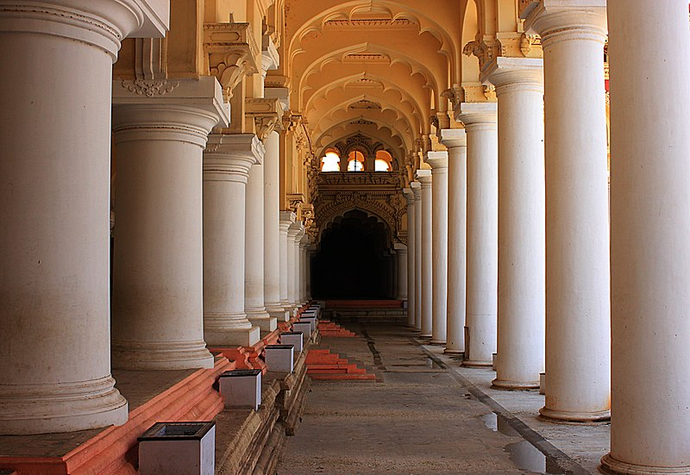
‘The Pillars inside the Palace’ by Vanilabalaji is licensed under CC-BY-SA-3.0.
Figure 2 – modern pillars in London Wall
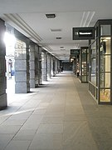
‘Modern pillars in London Wall’ by Basher Eyre is licensed under CC BY-SA 2.0.
Figure 3 – pillars at the Veerabhadra Temple, Lepakshi
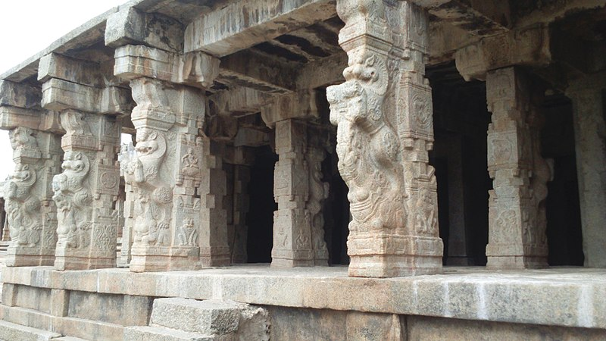
‘Pillars at the Veerabhadra Temple, Lepakshi’ by Manuspanicker is licensed under CC0 1.0.
- Ask students to discuss what they notice and what they wonder (bit.ly/noticewonderstrategy) with respect to the pillars in each diagram.
- Following this, have a class discussion about what they noticed and wondered, ensuring that there is some discussion about the different shape of the pillars and possibly about which one looks the strongest.
- Next, draw a square and a circle on the board and ask students to suggest which shape is stronger and to explain their answer. A simple finger vote could be done to start with where students hold up one finger if they believe the square is the stronger shape and 2 fingers if they believe the circle is the stronger shape.
- A question strategy such as the Pause-Pose-Pounce-Bounce question strategy [PDF 200KB] (bit.ly/pausepouncebounce) can then be used to discuss students’ reasoning.
During the discussion, students could be prompted to consider characters, structures in video games, or features in buildings around the school that use circles.
- Show students an A4 sheet of paper and ask students to do a Think-Pair-Share (bit.ly/thinkpairsharestrategy) with the following question:
- If we were to roll the sheet of paper as opposed to folding it into a rectangular prism, would it have the same or different strength?
- Another poll that can be referred to later should be conducted, such as a Mentimeter (mentimeter.com/), finger vote or a simple tally on the board where students vote on which shape they believe is stronger, cylinders or rectangular prisms.
- To build on students’ responses, ask students to consider whether it would make a difference depending on how the A4 sheet of paper was rolled or folded to form the prism or cylinder? For instance, landscape or portrait.

Explore
- Assign the students into random groups of 3.
- Following on from the ‘Launch’ discussions, groups are to develop a hypothesis. Their hypothesis should be a simple and concise sentence that predicts the method of folding or rolling the sheet of paper that will hold the maximum weight. For example:
- A tall cylinder is the optimal way of folding or rolling paper to hold the most weight.
- A short rectangular prism is the optimal way of folding or rolling paper to hold the most weight.

Equipment
- Weights (could use books instead)
- Paper (a lot of scrap paper)
- Thin book or piece of carboard
- Tape
- Devices with camera (optional)

Method
- Using the provided paper and tape, groups construct 4 identical columns for their hypothesised shape. If a group predicted cylinders would be stronger, they should only build cylinders and vice versa.
- Each group will then measure the dimensions that are required to calculate the surface area and volume of their columns. Each group should make their own decision as to the units of measurement and rounding.
- Students are to then calculate and record the surface area and volume of their columns on a Vertical Non-Permanent Surface (VNPS) (bit.ly/VNPSstrategy), assuming that they are closed solids even though their constructed solids may be open at both ends.

A shared online spreadsheet could be used so that students’ results are automatically collated. A potential template is set out below which you would need to set up for each column type.
Figure 4 – template displaying each column type
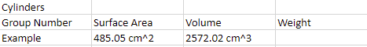
- Students are then to use a light book or piece of carboard to go over their four columns. Slowly place weights on the four columns, one at a time, as per the diagram below.
Figure 5 – four columns with an added weight
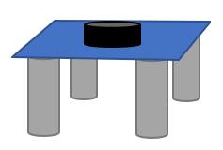
Setting up a camera to film the columns as weight is being added will allow students to observe the point of failure for their columns.
Students could make some generalisations about the shape and point of failure of various columns. An example would be slender and short columns buckle and compress.
- Students are then to record the weight that their column held on their VNPS (bit.ly/VNPSstrategy) (and in the spreadsheet if being used) with the aim being to hold the most amount of weight as possible.
- Each group should then repeat this experiment with various sized columns. Students should be encouraged to compare:
- cylinders with rectangular prisms
- short wide columns with tall wide columns
- short wide columns with tall narrow columns.
- Each group should form a conclusion, based off their experiment as to which column design is the strongest.

Summarise
If you can, collate the groups’ data into one spreadsheet. This can be done whilst groups are discussing the investigation.
- Have adjacent groups take turns presenting their hypothesis, the experiments they conducted, calculations and results to one another. Groups should discuss commonalities and differences they found in their investigations.
- Students return to their seats and independently write responses to the reflection prompts:
- Describe what you could change to make the experiment fairer.
- At which stages could errors have affected the data obtained?
- Reflect on your group’s hypothesis. What do you think makes a strong column?

Apply

Equipment
- Weights (could use books instead)
- Paper (a lot of scrap paper)
- Tape
- Devices (optional)
- Straw
- Soft drink can
If using cameras to record the method of failure for each cylinder, students can use their footage and data to inform their conclusion, instead of the straws and cans demonstration.

Method
- Stand a straw upright on a desk where students can see. By pushing down on the top of the straw, the straw will bend around the midpoint. This is called ‘buckling’.
- Stand a can upright where students can see. Ask students to predict what will happen when you step on the can. Step on the can slowly, it will compress down to a disk. This is called ‘compression’ and it is another method of failure for columns.
- Students will explore what causes a column to buckle or compress by constructing cylinders of varying dimensions. Students should be encouraged to establish a rule, for example, when the height is 5 cm longer than the diameter, the column will buckle.
- In their groups, students construct single cylinders of varying dimensions, once again recording the surface area and volume. Groups also record the method of failure: buckle or compression.
- Once everyone has had an opportunity to try various dimensions of cylinders, have groups conduct a gallery walk (bit.ly/DLSgallerywalk) to observe what other groups found in their trials.
- Bring the class back together and ask groups to share what they found.
Students should come close to determining:
- If the height of the cylinder is more than 15 times the diameter, we consider that a slender beam or a long column will always buckle.
- If it is not a slender beam, then it is referred to as a short column which will always compress.
This is also an opportunity to revisit volume and surface area of the cylinders and how they might impact the ability of a cylinder to be an effective column.

Assessment and differentiation

Suggested opportunities for differentiation
Launch
- A more accessible launch might include going for a walk around the neighbourhood and noticing where cylinders are used in structures.
Explore
- Depending on your class, you might like to allow for a broader range of hypotheses. For example, have some students explore materials used, others might look at other column shapes.
- Students could be prompted to calculate the maximum volume possible from a sheet of A4 paper. This could provide an opportunity to work with equations.

Suggested opportunities for assessment
Summary
- Students could submit their calculations of surface area and volume to check for understanding.
- Teacher should monitor student responses in group and whole-class discussions to ensure they are using appropriate terminology and aren’t harbouring misconceptions.
- Teacher can observe Working mathematically skills such as communication, reasoning, justification and strategies to solve non-routine problems.

References
This resource contains NSW Curriculum and syllabus content. The NSW Curriculum is developed by the NSW Education Standards Authority. This content is prepared by NESA for and on behalf of the Crown in right of the State of New South Wales. The material is protected by Crown copyright.
Please refer to the NESA Copyright Disclaimer for more information https://educationstandards.nsw.edu.au/wps/portal/nesa/mini-footer/copyright.
NESA holds the only official and up-to-date versions of the NSW Curriculum and syllabus documents. Please visit the NSW Education Standards Authority (NESA) website https://educationstandards.nsw.edu.au/ and the NSW Curriculum website https://curriculum.nsw.edu.au/home.
Mathematics K–10 Syllabus © NSW Education Standards Authority (NESA) for and on behalf of the Crown in right of the State of New South Wales, 2022.

© State of New South Wales (Department of Education), 2023
The copyright material published in this resource is subject to the Copyright Act 1968 (Cth) and is owned by the NSW Department of Education or, where indicated, by a party other than the NSW Department of Education (third-party material).
Copyright material available in this resource and owned by the NSW Department of Education is licensed under a Creative Commons Attribution 4.0 International (CC BY 4.0) licence.
This licence allows you to share and adapt the material for any purpose, even commercially.
Attribution should be given to © State of New South Wales (Department of Education), 2023.
Material in this resource not available under a Creative Commons licence:
- the NSW Department of Education logo, other logos and trademark-protected material
- material owned by a third party that has been reproduced with permission. You will need to obtain permission from the third party to reuse its material.
Links to third-party material and websites
Please note that the provided (reading/viewing material/list/links/texts) are a suggestion only and implies no endorsement, by the New South Wales Department of Education, of any author, publisher, or book title. School principals and teachers are best placed to assess the suitability of resources that would complement the curriculum and reflect the needs and interests of their students.
If you use the links provided in this document to access a third-party's website, you acknowledge that the terms of use, including licence terms set out on the third-party's website apply to the use which may be made of the materials on that third-party website or where permitted by the Copyright Act 1968 (Cth). The department accepts no responsibility for content on third-party websites.

