Margin for error
Students explore errors that can occur when different measuring instruments are used, and values are rounded. Students use a variety of measuring instruments to calculate the dimensions of a space. They compare their results and observe the effect that rounding a value or an error with a value will have when further calculations are performed.

Visible learning

Learning intentions
- To be aware of the different types of errors present in measurements.
- To be able to calculate the absolute and percentage error.
- To understand the effect that truncating or rounding during calculations has on the accuracy of the results.

Success criteria
- I can explain why errors in measurements occur.
- I can determine the precision of a measuring instrument.
- I can calculate the percentage error of a given measurement.
- I can explain the effect that rounding initial measurements may have on the accuracy of further calculations.
- I can explain when errors in values do or do not have an impact.

Syllabus outcomes
A student:
- develops understanding and fluency in mathematics through exploring and connecting mathematical concepts, choosing and applying mathematical techniques to solve problems, and communicating their thinking and reasoning coherently and clearly MAO-WM-01
- solves measurement problems by using scientific notation to represent numbers and rounding to a given number of significant figures MA5-MAG-C-01
- solves problems involving the surface area of right prisms and practical problems involving the area of composite shapes and solids MA5-ARE-C-01
- solves problems involving the volume of composite solids consisting of right prisms and cylinders MA5-VOL-C-01
Mathematics K–10 Syllabus © NSW Education Standards Authority (NESA) for and on behalf of the Crown in right of the State of New South Wales, 2022.

Activity structure

Launch
- Show students that the capacity of the Melbourne Cricket Ground (MCG) is 100 000, by following the link bit.ly/mcgcapacity.
- Display Figure 1and explain to students that this is an image of the crowd at the 2022 AFL Grand Final.
Figure 1 – the crowd at the MCG at the 2022 AFL Grand Final
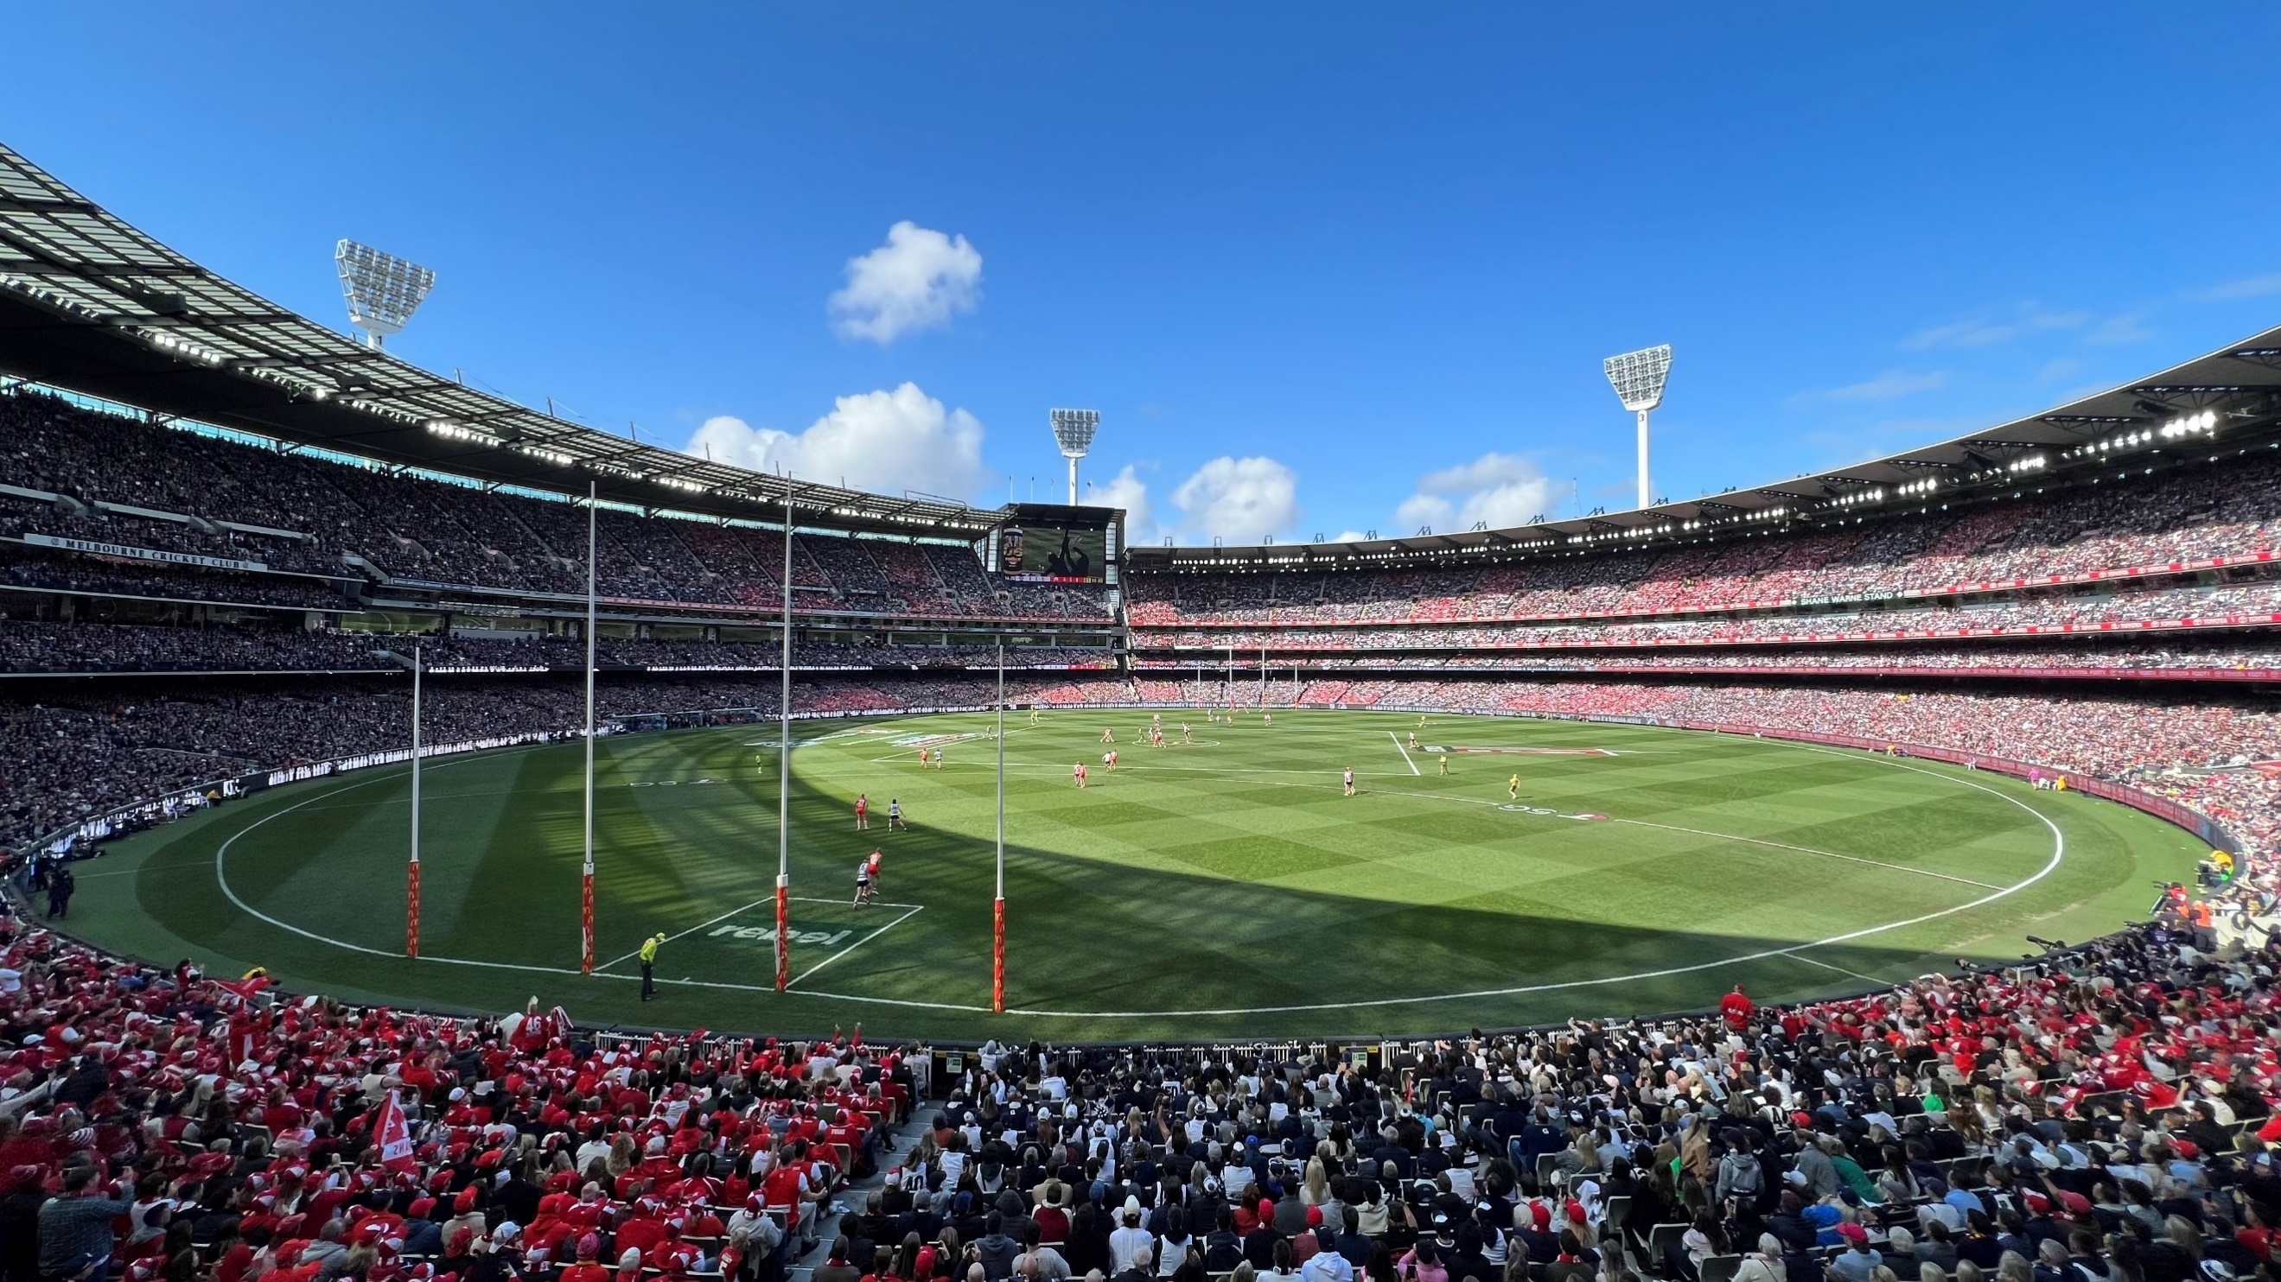
‘MCG 2022 AFL Grand Final’ by Storm machine is licensed under CC BY-SA 4.0
- Ask students to estimate how many people are in the crowd. Collect the results in a Mentimeter poll or word cloud (mentimeter.com/).
- Conduct a class discussion about issues students had when making their predictions. This may include some discussion on:
- the fact that they couldn’t see specific seats
- not knowing if someone had left early
- not knowing if people had bought a ticket but didn’t attend.
- Continue the class discussion on how students chose to estimate the crowd. Did they round to the nearest hundred, thousand, tens of thousands? Discuss the implications of each of these.
- Reveal that there were 100 024 people at the 2022 AFL Grand Final, by showing the link bit.ly/2022AFLGFcrowd. Ask students to consider why most websites state that the MCG holds a crowd capacity of 100 000.
This task is intended to facilitate discission about error and rounding in mathematics. At times, values can be rounded to make calculations or communicating easier. For example, the number of people at the MCG. But other times, rounding values can change the outcome significantly. For example, a scientist needs to be precise when measuring the temperature of a chemical reaction, since a slight change could have a severe effect on the outcome.

Explore

Equipment
A range of measuring instruments that could include:
- Trundle wheel
- 1 m ruler
- Measuring tape
- 30 cm ruler

Method
- Select an area within the school that students can measure, for example:
- a soccer field
- the quadrangle
- the classroom.
- Randomly arrange students into groups of 3, issuing each group with a range of different measuring instruments. Assign at least one group no measuring tool and ask them to use their steps as measuring tools.
- Students measure the dimensions of the chosen area and calculate its area.
No guidance should be given to students about rounding when completing this activity.
- Give students time to find the dimensions and area and collate the class data in a spreadsheet or similar, using headings such as ‘Length’, ‘Width’, ‘Area’.
- Display the class data for students. It may easiest to display this in the form of a graph. For example, 3 graphs for length, width, and area. Alternatively, each column could be ordered from lowest to highest to see the range of results.
This is a fantastic opportunity to revisit Stage 4: Unit 2 – making decisions. Students could calculate the mean, median and mode for each set of measurements and comment on which is an outlier, or on the distribution of the measurements.
- Ask students within their groups to discuss what they notice and what they wonder (bit.ly/noticewonderstrategy).
- Students calculate volume within the area chosen with the measurements that they recorded. For example:
- Calculate the volume of soil that is needed to top dress the oval 15 cm thick.
- Calculate the volume of concrete needed to make a basketball court 12 cm in depth.
- Collate all student results for volume by adding another column to their table or spreadsheet. Display this by either a graph or ordering each column from lowest to highest.
- Ask students within their groups to discuss what they notice and what they wonder (bit.ly/noticewonderstrategy). Are the results more varied than they were with dimensions and/or area?
- Have a class discussion about why the results varied so much. Students should identify and discuss some of the following:
- Were errors created from the equipment itself or from the people using the equipment? (Rounding errors and so on)
- What happened as these errors were multiplied to calculate area and volume?
- Will error always exist?
- Do some measurements have smaller or larger errors than others?
- Which instrument was the most accurate? Why?
- How could we make our measurements with these tools more accurate?

Summarise
- Use the Margin for error PowerPoint slides 10–20 for explicit teaching of absolute and percentage error.
The explicit teaching technique used in the PowerPoint is ‘Your turn’. The first slide is a worked example which should be displayed for the students and then use the following steps.
- Reveal the question to the students and its solution.
- Students read in silence.
- Students individually think and explain to themselves what is happening in each step.
- Students hold a thumbs up to the teacher when they have finished reading and have some sort of understanding.
- Think-Pair-Share. Students explain the solution to their partner.
- In pairs, students then answer the self-explanation questions.
- Finally, randomly select students to share their answers with the whole class, using a technique such as Pause-Pose-Pounce-Bounce question strategy [PDF 200KB] (bit.ly/pausepouncebounce).
- Students are then to complete the examples in Appendix A ‘Margin for error’.

Apply

When does error matter most?
- Display Figure 2for students. Ask students to consider if it would have an impact on the baby if an error of 0.1 mL occurred when issuing the baby medicine. For example, a 3-month-old was given 1 mL of medicine by mistake.
Figure 2 – medicine dosage for babies
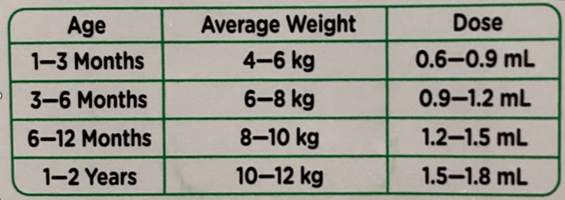
- Display Figure 3 for students. Ask students to consider if it would have an impact on their day if the weather on this day was in fact $17℃, 17.6℃$ or $18.34℃$.
Figure 3 – Weather forecast
- Use a questioning technique such as Pose-Pause-Pounce-Bounce question strategy [PDF 200KB] (bit.ly/pausepouncebounce) and have a class discussion to hear some students’ responses.
- Students are to brainstorm when making errors in measurements really matters in the real world. Students can then share their discussions with the class.
- Allow students time to explore the following news article https://bit.ly/11actualerrors where 11 errors were made in real life, and their impact.

Assessment and differentiation

Suggested opportunities for differentiation
Explore
- Some students may need revision on how to read measuring instruments.
- You may need to be selective on which measuring instruments are given to which students depending on their ability level.
- Some students may need revision on measurement conversions, for instance millimetres to centimetres and centimetres to metres.

Suggested opportunities for assessment
Explore
- Monitor how students are using their measuring instruments to check for misconceptions.
- Monitor how students are rounding their measurements.
Summarise
- Collect Appendix A ‘Margin for error’ to check for student understanding.
Apply
- Monitor student discussion and their examples to check for any misconceptions.

Appendix A

Margin for error
Image 1 – measuring cylinder  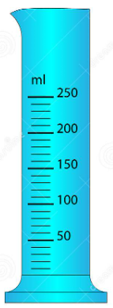 | Image 2 – tape measure 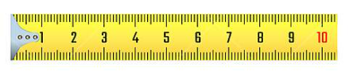
Image 3 – thermometer  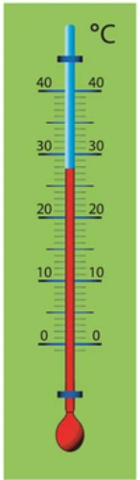 | Image 4 – thermometer  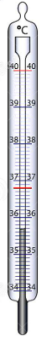
Image 5 – pressure gauge (Pa)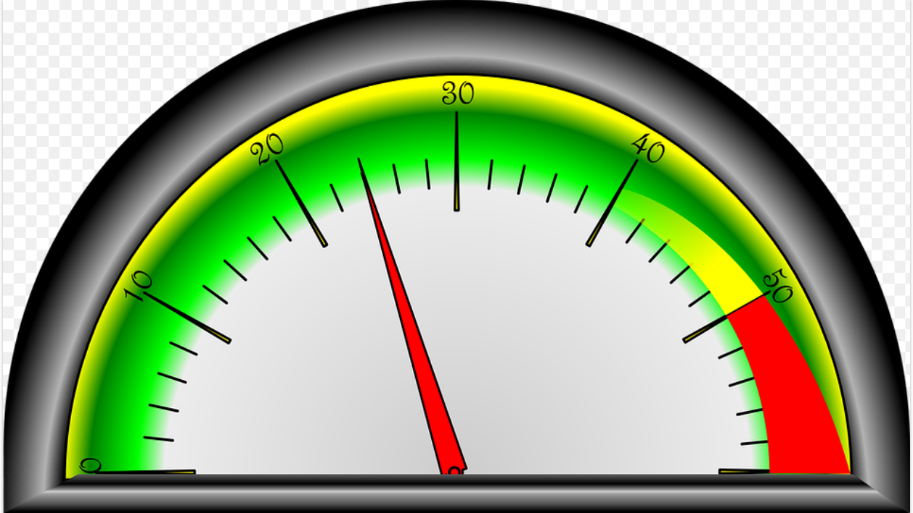 | Image 6 – digital clock 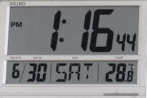
Images by Kuno Toming is licensed under Shutterstock License Agreement(s), Image 5 by OpenClipart-Vectors from Pixabay and Image 6 licensed under the Creative Commons Attribution-Share Alike 3.0 Unported license.

Image | Precision | Absolute error | Actual measurement | Percentage error (2 d.p)
1.
2.
3
4.
5.
6.

Sample solution

Appendix A – margin for error activity
Image | Precision | Absolute error | Actual measurement | Percentage error (2 d.p.)
1. | 10 mL | 5 mL | 180 mL | 2.78%
2. | 1 mm | 0.5mm | 62 mm | 0.81%
3 | $$1^{o}$$ | $${0.5}^{o}$$ | $${28}^{o}$$ | 1.79%
4. | $${0.1}^{o}$$ | $${0.05}^{o}$$ | $${36.8}^{o}$$ | 0.14%
5. | 2 Pa | 1 Pa | 24 Pa | 4.17%
6. | 1 second | 0.5 s | 76.44 s | 0.65%

References
This resource contains NSW Curriculum and syllabus content. The NSW Curriculum is developed by the NSW Education Standards Authority. This content is prepared by NESA for and on behalf of the Crown in right of the State of New South Wales. The material is protected by Crown copyright.
Please refer to the NESA Copyright Disclaimer for more information https://educationstandards.nsw.edu.au/wps/portal/nesa/mini-footer/copyright.
NESA holds the only official and up-to-date versions of the NSW Curriculum and syllabus documents. Please visit the NSW Education Standards Authority (NESA) website https://educationstandards.nsw.edu.au/ and the NSW Curriculum website https://curriculum.nsw.edu.au/home.
Mathematics K–10 Syllabus © NSW Education Standards Authority (NESA) for and on behalf of the Crown in right of the State of New South Wales, 2022.

© State of New South Wales (Department of Education), 2023
The copyright material published in this resource is subject to the Copyright Act 1968 (Cth) and is owned by the NSW Department of Education or, where indicated, by a party other than the NSW Department of Education (third-party material).
Copyright material available in this resource and owned by the NSW Department of Education is licensed under a Creative Commons Attribution 4.0 International (CC BY 4.0) licence.
This licence allows you to share and adapt the material for any purpose, even commercially.
Attribution should be given to © State of New South Wales (Department of Education), 2023.
Material in this resource not available under a Creative Commons licence:
- the NSW Department of Education logo, other logos and trademark-protected material
- material owned by a third party that has been reproduced with permission. You will need to obtain permission from the third party to reuse its material.
Links to third-party material and websites
Please note that the provided (reading/viewing material/list/links/texts) are a suggestion only and implies no endorsement, by the New South Wales Department of Education, of any author, publisher, or book title. School principals and teachers are best placed to assess the suitability of resources that would complement the curriculum and reflect the needs and interests of their students.
If you use the links provided in this document to access a third-party's website, you acknowledge that the terms of use, including licence terms set out on the third-party's website apply to the use which may be made of the materials on that third-party website or where permitted by the Copyright Act 1968 (Cth). The department accepts no responsibility for content on third-party websites.

