Beyond the surface
In the previous lesson it was determined that solids can have the same volume but a different surface area. In this lesson, students discover that some solids can have the same surface area but a different volume by constructing solids with centicubes.

Visible learning

Learning intention
- To understand the relationship between volume and surface area.

Success criteria
- I can compare and create 2 objects that have an equal surface area and different volume.
- I can compare and create 2 objects that have an equal volume and different surface area.

Syllabus outcomes
A student:
- develops understanding and fluency in mathematics through exploring and connecting mathematical concepts, choosing and applying mathematical techniques to solve problems, and communicating their thinking and reasoning coherently and clearly MAO-WM-01
- solves problems involving the surface area of right prisms and practical problems involving the area of composite shapes and solids MA5-ARE-C-01
- solves problems involving the volume of composite solids consisting of right prisms and cylinders MA5-VOL-C-01
Mathematics K–10 Syllabus © NSW Education Standards Authority (NESA) for and on behalf of the Crown in right of the State of New South Wales, 2022.

Activity structure

Launch
- Give each student 2 sheets of A4 paper and display Figure 1. Instruct the students to fold each sheet of paper as shown.
Figure 1 – two A4 sheets of paper folded differently.
- Ask students to construct a square prism with each sheet of paper. They could use sticky tape to hold it together. The prisms will be open with no ends.
- With each prism in front of students, ask them to hold up one, both or neither of their prisms to answer each question:
- Which prism has the greater surface area?
- Imagine each prism is solid, which would have the greater volume?
Students should recognise that the surface area is equal because both prisms are made from the same sheet of paper, although the volume of each prism will not be as obvious.

Explore
- Students will now further explore the relationship between volume and surface area by constructing solids using centicubes.
- Randomly assign students into pairs and issue each student with at least 6 centicubes.
If centicubes aren’t available, virtual manipulatives can be used (https://toytheater.com/cube/).
- Explain to students that you will be calling out different prisms to be formed that each have different characteristics. Each pair that successfully creates the prisms required will win a point. The pair with the most points will win the game.
- Below is a list of the different solids you could ask students to construct. Please note that some may be impossible, and this should be discussed with the students.
- Two different solids each made from 4 cubes that have equal volumes but different surface areas.
- Two solids made from 3 cubes that have different surface areas.
- One solid made from 4 cubes with the greatest surface area.
- One solid made from 5 cubes with the least surface area.
- Two solids, one with 5 cubes and the other with 6 cubes that have the same surface area.
Possible solids for this can be found at the conclusion of this document in the Sample solution section.
- Have a class discussion as to whether there is a pattern or a technique that they used to construct each of the solids. For example, no matter the number of blocks how does having them in a row compare to having them in more of a cluster.

Summarise
The purpose of this lesson is for students to deepen their understanding of surface area and volume by exploring the relationship between the 2 properties. By referring to the activities within this lesson, the following conclusions should be drawn:
- Two objects can have an equal surface area and different volume.
- Two objects can have equal volume and different surface area.
- Refer students back to the initial problem with the A4 sheet of paper, considering which A4 prism would have the greater volume. Ask students to again make a prediction. Has their prediction changed?
- By measuring the sides of the constructed prisms or using the dimensions of an A4 sheet of paper (a4-size.com), as a class, calculate the volume of each prism formed by folding the paper differently, and discover which has the greater volume.
- Discuss with students when it may be important to maximise volume while maintaining the same surface. For example, companies want to fit as many products as possible into a box for shipping with the least amount of cardboard packaging to minimise cost.
Worked solutions for this can be found at the conclusion of this document in Sample solution.

Apply
Continuing with the prisms formed from the A4 sheet of paper, students will now investigate what happens to the volume if the surface area is halved.
- Ask students to Think-Pair-Share (bit.ly/thinkpairsharestrategy) what they think would happen to the surface area and the volume of 2 rectangular prisms if half a sheet of paper was used.
- Give each student one A4 sheet of paper. In pairs, one student cuts their A4 sheet of paper in half perpendicular to the longer side. This is now the size of an A5 sheet of paper. The other student is to cut their A4 sheet of paper in half perpendicular to the shorter side. See Figure 2 for an explanation.
Figure 2 – two A4 sheets of paper cut in half differently.
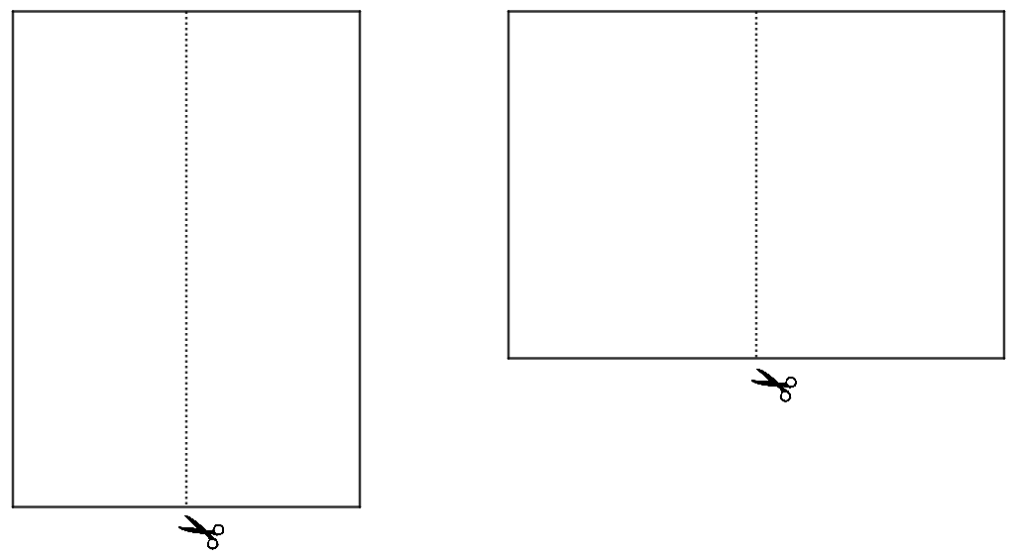
- Ask students to make a prediction: Which half of the A4 sheet of paper will create a prism with the greatest volume?
- Each student is to calculate the volume of a prism formed by folding it in 2 different ways as they did in the launch, see Figure 3. This should create 4 different prisms, with each student calculating the volume of 2 prisms.
Figure 3 – A4 sheet cut in half to form 4 prisms
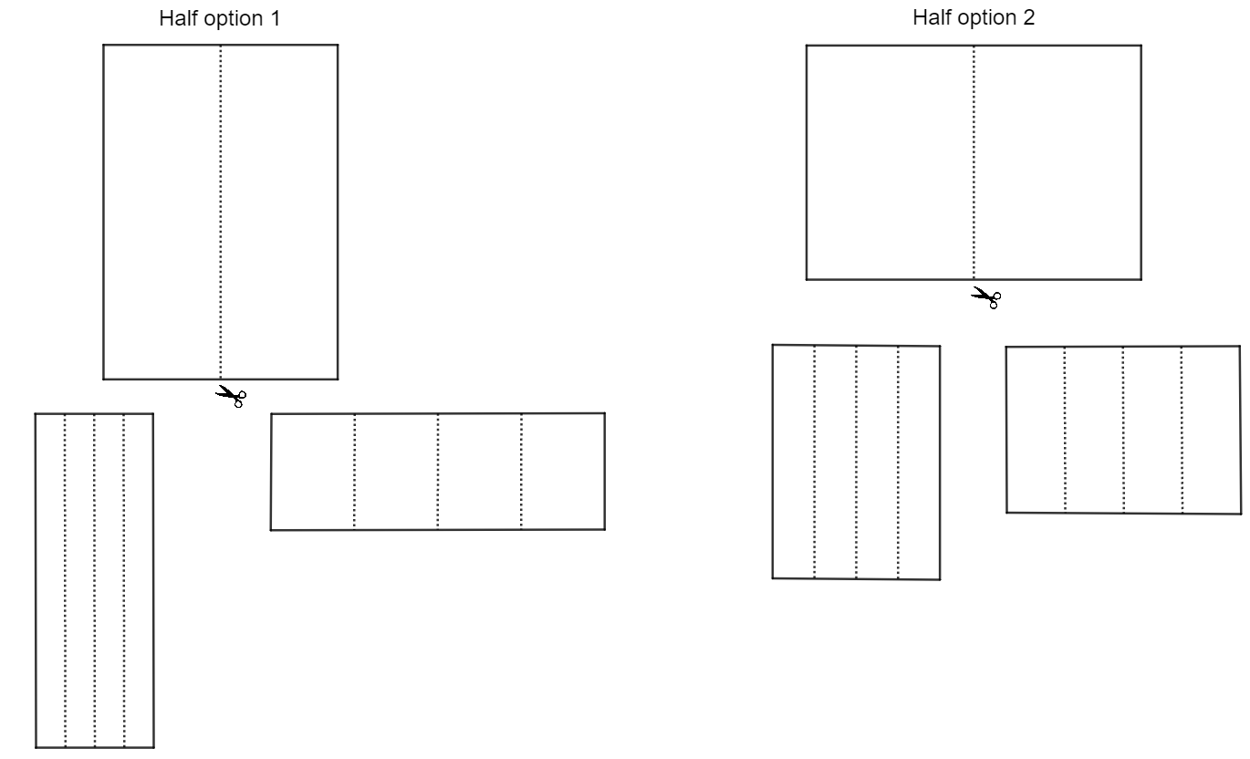
- Students are to compare answers to determine which half created the prism with the greatest volume.
- As a class, discuss what happened to the volume when the surface area was halved. Did the volume also half?
Worked solutions for this activity can be found at the conclusion of this document in Sample solution.

Assessment and differentiation

Suggested opportunities for differentiation
Launch
- Students may need to revise the difference between surface area and volume.
Explore
- Students may need a few demonstrations with simplified criteria before they commence the game, for example constructing 2 different solids with a volume of 3 units³.
Summarise
- The impact of error in measurement could be discussed here by allowing each pair to calculate the dimensions of the A4 sheet of paper and the volume and then compare the results.
Apply
- Students could be extended to consider other possibilities such as: If the paper was cut into quarters, what would happen with the volume of each prism? What if the paper was an A3 sheet?

Suggested opportunities for assessment
Launch
- Monitor student selections of which prism they believe to have the greater volume, to check for initial understanding. Do they believe they are both the same or acknowledge that they are different?
Explore
- Monitor the solids that students are constructing to check for misconceptions. Check to see if they are confusing volume and surface area.
Summarise
- Monitor students’ problem-solving skills in finding the volume when the dimensions aren’t explicitly given, to check for understanding.
Apply
- Monitor student discussions and predictions to check for understanding.
Sample solution

Explore – creating solids game
- Two different solids, each made from 4 cubes that have equal volumes but different surface areas.
Figure 4 – two solids made of 4 cubes.
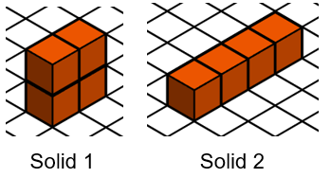
Solid 1 has volume = 4 units³ and surface area = 16 units² and solid 2 has volume = 4 units³ and surface area = 18 units².
- Two different solids made from 3 cubes that have different surface areas.
Figure 5 – two solids made of 3 cubes.
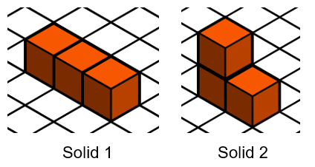
Solid one has volume = 3 units³ and surface area = 14 units², and solid 2 has volume = 3 units³ and surface area = 14 units².
This criteria is impossible because no other arrangement of cubes is possible.
- A solid made from 4 cubes that has the greatest surface area.
Figure 6 – one solid made of 4 cubes.
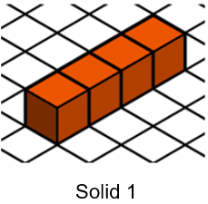
Solid one has volume = 4 units³ and surface area = 18 units².
- A solid made from 5 cubes that has the least surface area.
Figure 7 – one solid made of 5 cubes.
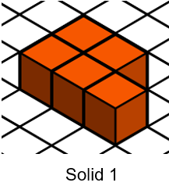
Solid one has volume = 5 units³ and surface area = 20 units².
- Two solids, one with 5 cubes and the other with 6 cubes that have the same surface area.
Figure 8 – two solids, one made of 5 cubes, the other made of 6 cubes.
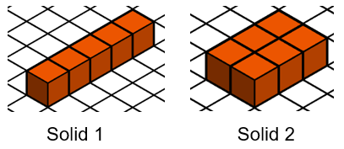
Solid one has volume = 5 units³ and surface area = 22 units², and solid 2 has volume = 6 units³ and surface area = 22 units².

Summarise – folding paper activity
Dimensions of an A4 sheet of paper
- 210 mm × 297 mm
Volume of prism formed by folding A4 sheet along the longest side
Side length of top square = $\frac{297}{4}=74.25$mm
$$V=lbh \\ =74.25×74.25×210 \\ =1 157 743.125 mm^{3}$$
Volume of prism formed by folding A4 sheet along the shortest side
Side length of top square = $\frac{210}{4}=52.5$ mm
$$V=lbh \\ =52.5×52.5×297 \\ =818 606.25 mm^{3}$$

Apply – halving the paper activity

Student 1
Dimensions of an A5 sheet of paper = 210 mm×148.5 mm
Volume of prism formed by folding A5 sheet along the longest side
Side length of top square = $\frac{210}{4}=52.5$mm
$$V=lbh \\ =52.5×52.5×148.5 \\ =409 303.125 mm^{3}$$
Volume of prism formed by folding A5 sheet along the shortest side
Side length of top square = $\frac{148.5}{4}=37.125$mm
$$V=lbh \\ =37.125×37.125×210 \\ =289 435.7813 mm^{3}$$

Student 2
Dimensions = 105 mm × 297 mm
Volume of prism formed by folding sheet along the longest side
Side length of top square = $\frac{297}{4}=74.25$mm
$$V=lbh \\ =74.25×74.25×105 \\ =578 871.56 mm^{3}$$
Volume of prism formed by folding sheet along the shortest side
Side length of top square = $\frac{105}{4}=26.25$mm
$$V=lbh$$
$$=26.25×26.25×297$$
$=204 651.56 mm^{3}$

References
This resource contains NSW Curriculum and syllabus content. The NSW Curriculum is developed by the NSW Education Standards Authority. This content is prepared by NESA for and on behalf of the Crown in right of the State of New South Wales. The material is protected by Crown copyright.
Please refer to the NESA Copyright Disclaimer for more information https://educationstandards.nsw.edu.au/wps/portal/nesa/mini-footer/copyright.
NESA holds the only official and up-to-date versions of the NSW Curriculum and syllabus documents. Please visit the NSW Education Standards Authority (NESA) website https://educationstandards.nsw.edu.au/ and the NSW Curriculum website https://curriculum.nsw.edu.au/home.
Mathematics K–10 Syllabus © NSW Education Standards Authority (NESA) for and on behalf of the Crown in right of the State of New South Wales, 2022.
© State of New South Wales (Department of Education), 2023
The copyright material published in this resource is subject to the Copyright Act 1968 (Cth) and is owned by the NSW Department of Education or, where indicated, by a party other than the NSW Department of Education (third-party material).
Copyright material available in this resource and owned by the NSW Department of Education is licensed under a Creative Commons Attribution 4.0 International (CC BY 4.0) licence.
This licence allows you to share and adapt the material for any purpose, even commercially.
Attribution should be given to © State of New South Wales (Department of Education), 2023.
Material in this resource not available under a Creative Commons licence:
- the NSW Department of Education logo, other logos and trademark-protected material
- material owned by a third party that has been reproduced with permission. You will need to obtain permission from the third party to reuse its material.
Links to third-party material and websites
Please note that the provided (reading/viewing material/list/links/texts) are a suggestion only and implies no endorsement, by the New South Wales Department of Education, of any author, publisher, or book title. School principals and teachers are best placed to assess the suitability of resources that would complement the curriculum and reflect the needs and interests of their students.
If you use the links provided in this document to access a third-party's website, you acknowledge that the terms of use, including licence terms set out on the third-party's website apply to the use which may be made of the materials on that third-party website or where permitted by the Copyright Act 1968 (Cth). The department accepts no responsibility for content on third-party websites.

