Cube houses
Students investigate the surface area of prisms by comparing different house designs made from 4 cubes.

Visible learning

Learning intention
- To be able to calculate the surface area of prisms.

Success criteria
- I can compare the size and shape of 2 prisms.
- I can determine the area of the faces of a prism.
- I can calculate the surface area of a rectangular prism.
- I can calculate the surface area of a triangular prism.

Syllabus outcomes
A student:
- develops understanding and fluency in mathematics through exploring and connecting mathematical concepts, choosing and applying mathematical techniques to solve problems, and communicating their thinking and reasoning coherently and clearly MAO-WM-01
- simplifies algebraic fractions with numerical denominators and expands algebraic expressions MA5-ALG-C-01
- solves problems involving the surface area of right prisms and practical problems involving the area of composite shapes and solids MA5-ARE-C-01
Mathematics K–10 Syllabus © NSW Education Standards Authority (NESA) for and on behalf of the Crown in right of the State of New South Wales, 2022.

Activity structure

Launch
- Explain to students that in Holland there is a famous architectural structure called ‘The Cube Houses’. The structure is composed of cubes and the houses are located close to the city centre of Rotterdam.
- Ask students to explain what they imagine the houses might look like (do not show them any pictures at this point). Can they draw what they are imagining?
- Have a few students explain what they are imagining and share some of the students’ drawings.
- Following this, show students images of Rotterdam’s Cube Houses and compare with the images they have drawn.
Figure 1 – The Cube Houses
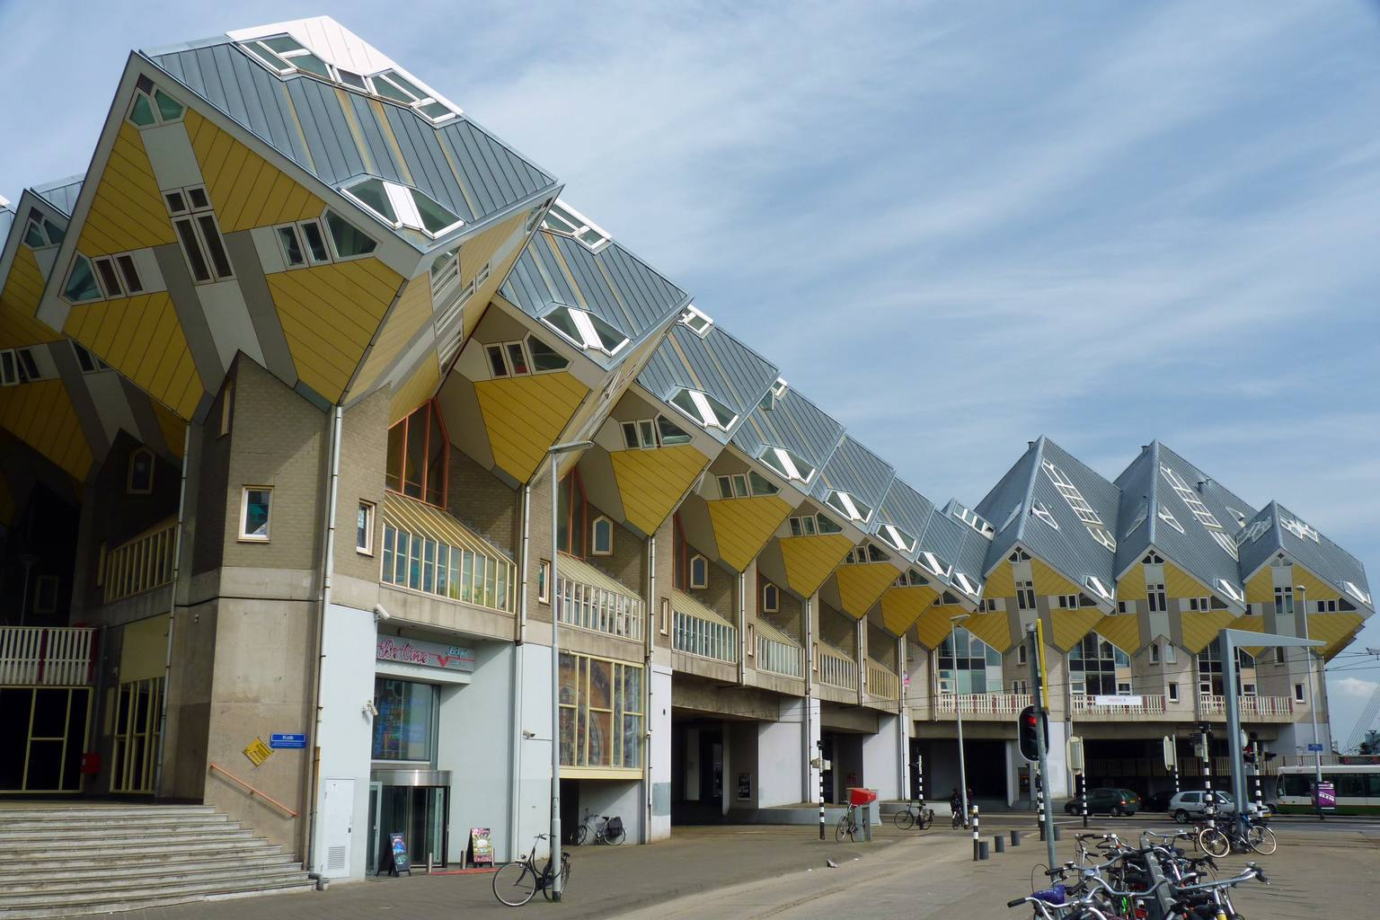
‘File:Rotterdam Cube House street view’ by Raul Ayres is licensed under CC BY-SA 3.0.

Explore

Equipment
- Centicubes (4 per student).
- Isometric paper.
- Appendix B ‘Cube houses investigation’.
If cubes and/or isometric paper is not available, students can use virtual manipulatives using toytheater.com/cube/.

Method
- Pose the following questions to students:
- What if we had a street of houses made from cubes?
- What might this look like?
- Would all the houses look the same?
- What design considerations would we need to consider?
- The students are going to become architects, with a challenge to build as many different houses as possible from 4 cubes. The orientation of the house on the ‘block of land’ determines if 2 houses are the same. For example, the 2 houses below are considered different house designs.
Figure 2 – four cube houses
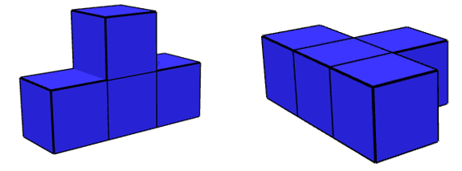
Images created using the free virtual manipulatives at toytheater.com/cube/.
- In randomly assigned pairs or groups of 3, students will use 4 centicubes to explore the different house designs, recording their designs on the isometric paper.
- Ask each group to share a design until all 15 designs are shared with the class. All design options can be found in Appendix A ’Cube house solutions’.
- Once students have discovered all possible house designs, ask them to consider:
- What is the same about each of the houses formed?
- What is different about each of the houses formed?
Students may discuss that some houses are single storey whilst others are 2, 3 or 4 storeys, or that some houses take up more land space than others. However, this task is leading students to discover that the volume is the same for each prism formed, $4 cm^{3}$, but the surface area is different for each prism.
- The architects now need to consider the most cost-efficient houses, by investigating the cost to build each of the houses. Below is a list of the costs to build each section of the house.
Section | Cost per square
Floor | $6 000
External wall | $3 000
Roof | $5 000
Ask the class to consider and discuss: Will all houses cost the same, since they are all made from 4 cubes?
- In their groups, students are to select their favourite 3–5 houses and determine the cost to build each of them. They can then select their favourite design, by considering the visual design of the house, as well as the cost to build the house.
- Following this, select a few groups to share their findings with the class.
This discussion should then lead into how they found the cost to build, that is they were finding the surface area of the house. Clearly define surface area of solids to students as the measure of the total area of the surface(s) of a 3-dimensional shape or object.

Summarise
- Use the Cube Houses PowerPoint for explicit teaching of calculating the surface area of rectangular and triangular prisms.
The explicit teaching technique used in the PowerPoint is ‘Your turn’. The first slide is a worked example which should be displayed for the students and then use the following steps.
- Reveal the question to the students and its solution.
- Students read in silence.
- Students individually think and explain to themselves what is happening in each step.
- Students hold a thumbs up to the teacher when they have finished reading and have some sort of understanding.
- Think-Pair-Share. Students explain the solution to their partner.
- In pairs, students then answer the self-explanation questions.
- Finally, randomly select students to share their answers with the whole class, using a technique such as Pause-Pose-Pounce-Bounce question strategy [PDF 200KB] (bit.ly/pausepouncebounce).
- Students are then to complete the faded worked examples in Appendix C ‘faded worked examples’.

Apply

Home office space renovation
- Explain to students that they have been given a double garage that is being converted into an office space. Students will be given an image of the space, see Appendix D ‘Home office space renovation’. The image shows the measurements for a door and a window, and they will need to determine the amount of paint required if the walls and ceiling need to be painted.
Teachers are to note that this is the first time students have been asked to calculate the surface area of a composite solid. This task is for students to investigate and challenge themselves. Surface area of composite solids will be explored in more detail in future lessons.
- Following this, students will investigate 2 different styles of roof replacements to determine the most cost-effective design.

Assessment and differentiation

Suggested opportunities for differentiation
Launch
- Students may struggle to draw in 3-dimensions. Some may benefit from isometric paper, others may benefit from just explaining their visualisations.
Explore
- Some students may need assistance with drawing their house designs on the isometric paper. These students may benefit from using the suggested virtual manipulatives.
- Encourage students to re-construct their house designs to assist with calculating the cost of building. Some students may struggle to visualise which faces represent the floor, and how many external walls there are.
Summarise
- Having physical nets and 3-dimensional objects can assist students with visualisation when calculating the surface area.
- Some students may need to revise calculating the hypotenuse using Pythagoras’ theorem.
Apply
- Some students could be extended to explore different styles of roof designs. They could then calculate the cost of painting the door and window frames. Discuss the addition of a bathroom in one corner and how this would affect the amount of paint needed for the internal walls.
- Students could be challenged by renovating a room with various shaped surfaces.

Suggested opportunities for assessment
- Monitor reasons provided for students’ choice of a favourite house design to clarify any misconceptions.
- Monitor conversations occurring in group work for formative assessment.
- Teachers could collect the faded worked examples to check for understanding.
- The activity in the ‘Apply’ section could be turned into a summative assessment task.

Appendix A

Cube house solutions
Below are the 15 possible house designs.
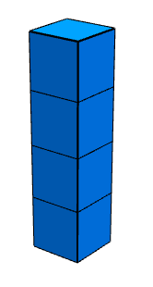 | 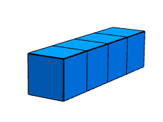 | 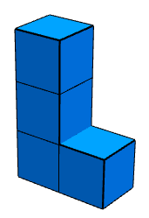
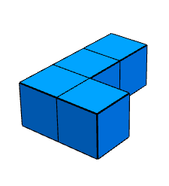 | 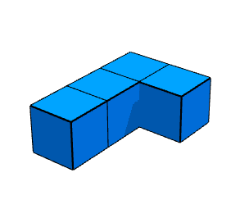 | 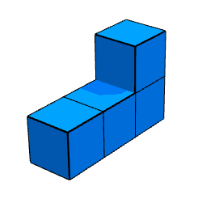
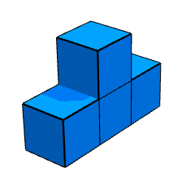 | 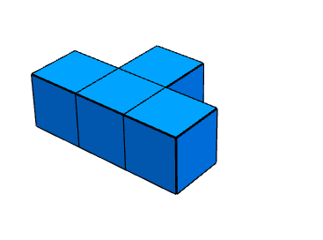 | 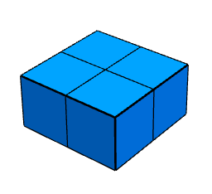
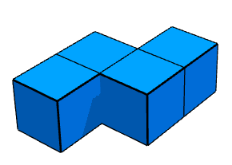 | 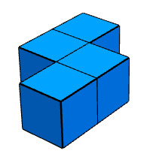 | 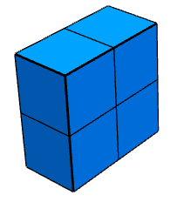
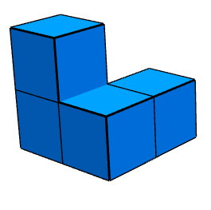 | 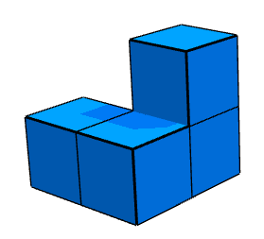 | 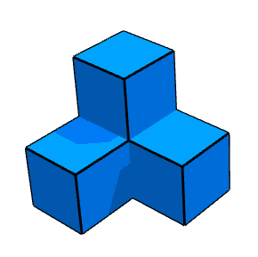
Images created using the free virtual manipulatives at toytheater.com/cube/

Appendix B

Cube houses investigation
- You have become an architect, with a challenge to build as many different houses as possible from 4 cubes.
The orientation of the house on the ‘block of land’ determines if 2 houses are the same. For example, the 2 houses below are considered different house designs.
Figure 3 – 4-cube houses
Images created using the free virtual manipulatives at toytheater.com/cube/
- In your group use 4 centicubes to explore as many different house designs as possible, recording your designs on the isometric paper provided.
- Consider the following:
- What is the same about each of the houses formed?
- What is different about each of the houses formed?
- You, as the architect now need to consider the most cost-efficient houses, by investigating the cost to build each of the houses. Below is a list of the costs to build each section of the house.
Section | Cost per square
Floor | $6 000
External wall | $3 000
Roof | $5 000
Will all houses cost the same, since they are all made from 4 cubes?
- In your group, select your favourite 3–5 houses and determine the cost to build each of them. Be sure to consider the visual design of the house, as well as the cost to build the house. Justify your decision with mathematical reasoning.

Appendix C

Faded worked examples – rectangular prisms 1
Calculate the surface area of each rectangular prism.
Question 1 | Question 2 | Question 3
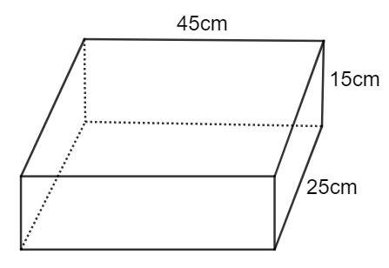 | 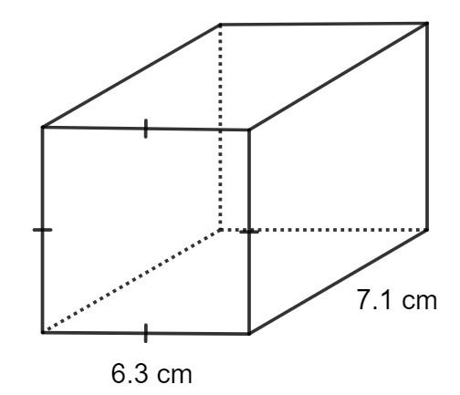 | 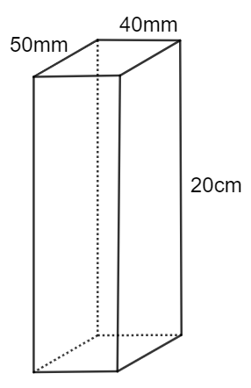
Front face  $$=45×15 \\ =675 cm^{2}$$ | Front face  $$=6.3 ×6.3$$$=$ | Front face  $$=$$
Back face  $$=45×15 \\ =675 cm^{2}$$ | Back face  $$=$$ | Back face  $$=$$
Right face  $$=25×15 \\ =375 cm^{2}$$ | Right face  $$=7.1×6.3 \\ =$$ | Right face  $$=$$
Left face  $$=25×15 \\ =375 cm^{2}$$ | Left face  $$=$$ | Left face  $$=$$
Bottom face  $$=45×25 \\ =1125 cm^{2}$$ | Bottom face  $$=$$ | Bottom face  $$=$$
Top face  $$=45×25 \\ =1125 cm^{2}$$ | Top face  $$=$$  $$=44.73 cm^{2}$$ | top face  $$=$$
Surface area  $$=675+675+375+375+1125+1125 \\ =4350 cm^{2}$$ | Surface area  $=$ $2×39.69+4×44.73$  $$=$$ | Surface area  $$=$$

Faded worked examples – rectangular prisms 2
Calculate the surface area of each rectangular prism.
Question 1 | Question 2 | Question 3
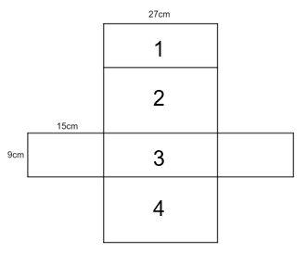 | 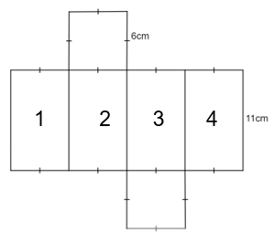 | 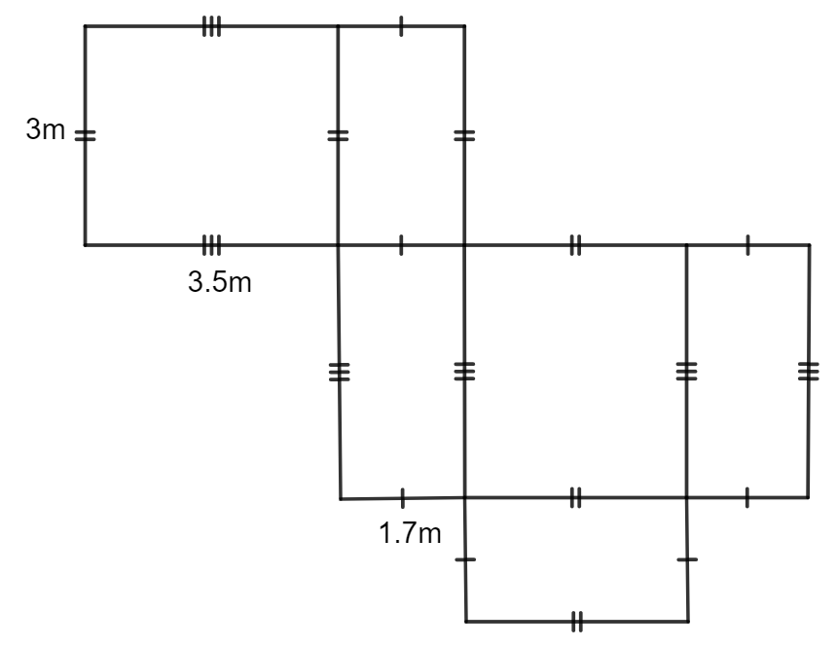
Small rectangle left  $$=9×15 \\ =135 cm^{2}$$ | Square face top  $$=$$$=36 cm^{2}$ | Big rectangle top left  $$=$$
Small rectangle right  $=135 cm^{2}$ (same as the other small rectangle) | Square face bottom  $$=$$ | Big rectangle middle right  $$=$$
Rectangle 1  $$=27×9 \\ =243 cm^{2}$$ | Rectangle 1  $$=6×11 \\ =$$ | Rectangle 1  $$=$$
Rectangle 2  $$=27×15 \\ =405 cm^{2}$$ | Rectangle 2  $$=$$ | Rectangle 2  $$=$$
Rectangle 3  $=243 cm^{2}$ (same as rectangle 1) | Rectangle 3$$=$$ | Rectangle 3  $$=$$
Rectangle 4  $=405 cm^{2}$ (same as rectangle 2) | Rectangle 4  $$=$$ | Rectangle 4  $$=$$
Surface area  $$=2×135+2×243+2×405 \\ =1566 cm^{2}$$ | Surface area  $=$  $$=336cm^{2}$$ | Surface area  $$=$$

Faded worked examples – triangular prisms 1
Calculate the surface area of each triangular prism.
Question 1 | Question 2 | Question 3
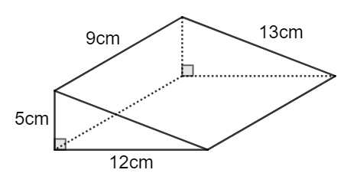 | 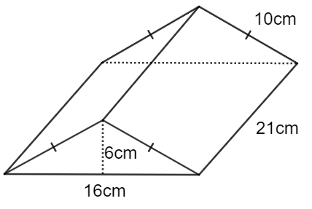 | 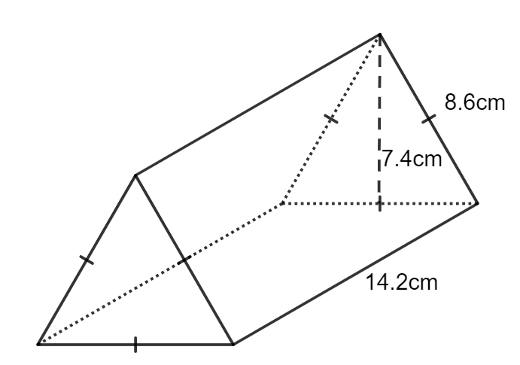
Front triangular face  $$=\frac{1}{2}×12×5 \\ =30 cm^{2}$$ | Front triangular face  $$=\frac{1}{2}×16×6 \\ =$$ | Front triangular face  $$=$$
Back triangular face  $$=\frac{1}{2}×12×5$$$=30 cm^{2}$ (same as front) | Back triangular face  $$=$$ | Back triangular face  $$=$$
Right/slope rectangle face  $$=9×13$$$=117 cm^{2}$ | Right/slope rectangle face  $$=10×21 \\ =$$ | Right/slope rectangle face  $$=$$
Left rectangle face  $$=9×5$$$=45 cm^{2}$ | Left /slope rectangle face  $$=$$ | Left/slope rectangle face  $$=$$
Bottom rectangle face  $$=9×12 \\ =108 cm^{2}$$ | Bottom rectangle face  $$=$$ | Bottom rectangle face  $$=$$
Surface area  $$=30+30+117$$  $$+45+108$$  $$=330cm^{2}$$ | Surface area  $$=2 ×48+$$ | Surface area  $$=$$

Faded worked examples – triangular prisms 2
Calculate the surface area of each triangular prism.
Question 1 | Question 2 | Question 3
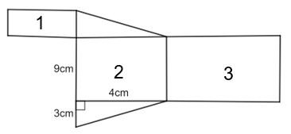 | 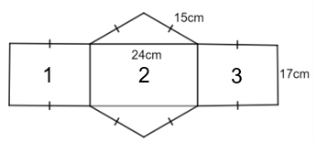 | 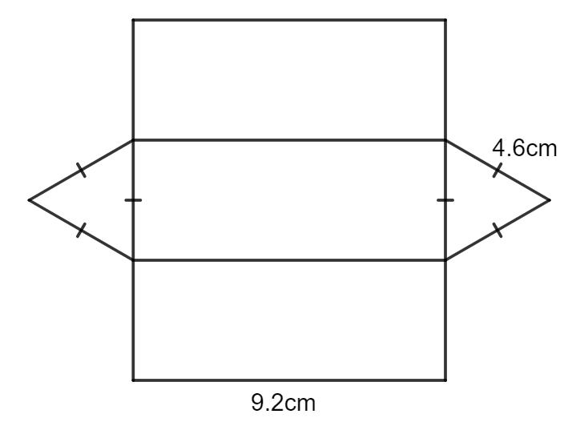
Pythagoras theorem  $$c^{2}=a^{2}+b^{2} \\ c^{2}=3^{2}+4^{2}$$$c =5cm$ (hypotenuse) | Pythagoras theorem  $$c^{2}=a^{2}+b^{2} \\ {15}^{2}={12}^{2}+b^{2} \\ b^{2}=81$$  $b=9cm$ (height of triangle) | Pythagoras theorem  $$c^{2}=a^{2}+b^{2}$$
Triangular face  $$=\frac{1}{2}×3×4 \\ =6 cm^{2}$$ | Triangular face  $$=\frac{1}{2}×9×24 \\ =$$ | Triangular face  $$=$$
Rectangle 1  $$=3×9 \\ =27 cm^{2}$$ | Rectangle 1  $$= \\ =255cm^{2}$$ | Rectangle 1  $$=$$
Rectangle 2  $$=4×9 \\ =36 cm^{2}$$ | Rectangle 2  $$=$$ | Rectangle 2  $$=$$
Rectangle 3  $$=5×9 \\ =45 cm^{2}$$ | Rectangle 3  $$=$$ | Rectangle 3  $$=$$
Surface area  $$=2 ×6+27+36+45$$  $$=120cm^{2}$$ | Surface area  $$=$$  $$=1134cm^{2}$$ | Surface area  $$=$$

Appendix D

Home office space renovation
Below is an image of a double garage that has been converted into a home office space. Measurements are shown for the room, door, and window.
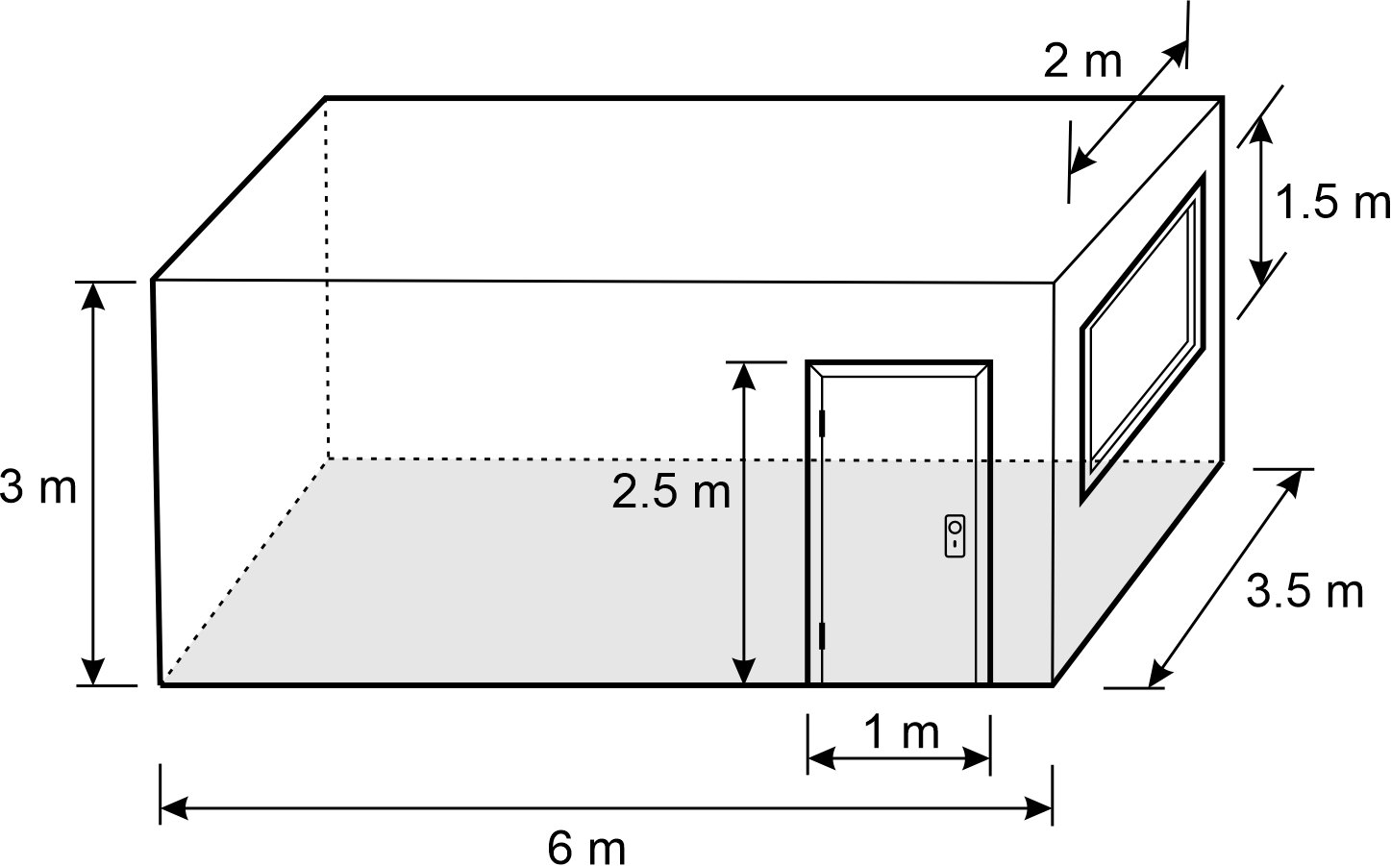
- Determine the amount of paint required if the walls and ceiling need to be painted. Assume that 1 litre of paint covers 15 square metres.
- The roof of the new home office space needs replacing. Below are 2 different designs that the owner needs to choose between. The cost of replacing a roof is $210 per square metre. Using mathematical calculations, decide which roof design is the most cost effective.
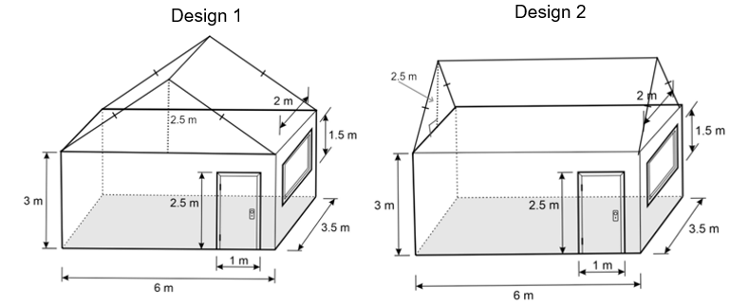

Sample solution

Appendix C – faded worked examples

Faded worked examples – Rectangular prism 1
Question 1 | Question 2 | Question 3
Front face  $$=45×15 \\ =675 cm^{2}$$ | Front face  $$=6.3 ×6.3$$$=39.69 cm^{2}$ | Front face  $$= 40 × 200$$  $$= 8000 mm^{2}$$
Back face  $$=45×15 \\ =675 cm^{2}$$ | Back face  $$=6.3×6.3 \\ =39.69 cm^{2}$$ | Back face  $$= 40 × 200$$  $$= 8000 mm^{2}$$
Right face  $$=25×15 \\ =375 cm^{2}$$ | Right face  $$=7.1×6.3 \\ =44.73 cm^{2}$$ | Right face  $$= 50 × 200$$  $$= 10 000 mm^{2}$$
Left face  $$=25×15 \\ =375 cm^{2}$$ | Left face  $$=7.1×6.3 \\ =44.73 cm^{2}$$ | Left face  $$= 50 × 200$$  $$= 10 000 mm^{2}$$
Bottom face  $$=45×25 \\ =1125 cm^{2}$$ | Bottom face  $$=44.73 cm^{2}$$ | Bottom face  $$= 50 × 40$$  $$= 2000 mm^{2}$$
Top face  $$=45×25 \\ =1125 cm^{2}$$ | Top face  $$=44.73 cm^{2}$$ | top face  $$= 50 × 40$$  $$= 2000 mm^{2}$$
Surface area  $=675×2+375×2+1125×2$  $$=4350 cm^{2}$$ | Surface area  $=$ $2×39.69+4×44.73$  $$=258.3 cm^{2}$$ | Surface area  $=2×10 000+2 ×8000+2×2000$  $$=40 000mm^{2}$$

Faded worked examples – rectangular prism 2
Question 1 | Question 2 | Question 3
 |  | 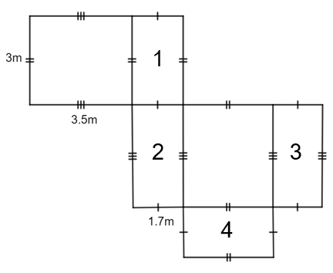
Small rectangle left  $$=9×15 \\ =135 cm^{2}$$ | Square face top  $$=6 ×6$$$=36 cm^{2}$ | Big rectangle top left  $$=3×3.5$$  $$= 10.5 m^{2}$$
Small rectangle right  $=135 cm^{2}$ (same as the other small rectangle) | Square face bottom  $$=36 cm^{2}$$ | Big rectangle middle right  $$=10.5 m^{2}$$
Rectangle 1  $$=27×9 \\ =243 cm^{2}$$ | Rectangle 1  $$=6×11 \\ =66 cm^{2}$$ | Rectangle 1  $$=3×1.7$$  $$=5.1 m^{2}$$
Rectangle 2  $$=27×15 \\ =405 cm^{2}$$ | Rectangle 2  $=66 cm^{2}$ (same as rectangle 1) | Rectangle 2  $$=3.5×1.7$$  $$=5.95 m^{2}$$
Rectangle 3  $=243 cm^{2}$ (same as rectangle 1) | Rectangle 3$$=66 cm^{2}$$ | Rectangle 3  $$=5.95 m^{2}$$
Rectangle 4  $=405 cm^{2}$ (same as rectangle 2) | Rectangle 4  $$=66 cm^{2}$$ | Rectangle 4  $$=5.1 m^{2}$$
Surface area  $=2×135+2×243+2×405$  $$=1566 cm^{2}$$ | Surface area  $=$ $2×36+4×66$  $$=336cm^{2}$$ | Surface area  $=2×10.5+2×5.1+2×5.95$  $$=43.1 m^{2}$$

Faded worked examples – triangular prism 1
Question 1 | Question 2 | Question 3
Front triangular face  $$=\frac{1}{2}×12×5 \\ =30 cm^{2}$$ | Front triangular face  $$=\frac{1}{2}×16×6 \\ =48 cm^{2}$$ | Front triangular face  $$=\frac{1}{2}×8.6×7.4 \\ =31.82cm^{2}$$
Back triangular face  $$=\frac{1}{2}×12×5$$$=30 cm^{2}$ (same as front) | Back triangular face  $$=48 cm^{2}$$ | Back triangular face  $$=31.82cm^{2}$$
Right/slope rectangle face  $$=9×13$$$=117 cm^{2}$ | Right/slope rectangle face  $$=10×21 \\ =210 cm^{2}$$ | Right/slope rectangle face  $$=8.6×14.2 \\ =122.12cm^{2}$$
Left rectangle face  $$=9×5$$$=45 cm^{2}$ | Left /slope rectangle face  $$=210 cm^{2}$$ | Left/slope rectangle face  $$=122.12cm^{2}$$
Bottom rectangle face  $$=9×12 \\ =108 cm^{2}$$ | Bottom rectangle face  $$=16×21 \\ =336 cm^{2}$$ | Bottom rectangle face  $$=122.12cm^{2}$$
Surface area  $$=30+30+117$$  $$+45+108$$  $$=330cm^{2}$$ | Surface area  $$=2 ×48+2×210$$  $$+336$$  $$=852cm^{2}$$ | Surface area  $$=430cm^{2}$$

Faded worked examples – triangular prism 2
Question 1 | Question 2 | Question 3
 |  | 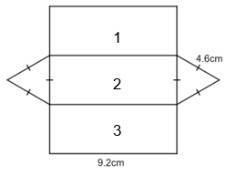
Pythagoras theorem  $$c^{2}=a^{2}+b^{2} \\ c^{2}=3^{2}+4^{2}$$$c =5cm$ (hypotenuse) | Pythagoras theorem  $$c^{2}=a^{2}+b^{2} \\ {15}^{2}={12}^{2}+b^{2} \\ b^{2}=81$$  $b=9cm$ (height of triangle) | Pythagoras theorem  $$c^{2}=a^{2}+b^{2} \\ {4.6}^{2}={2.3}^{2}+b^{2} \\ b^{2}=15.87$$  $b=3.98cm$ (height of triangle)
Triangular face  $$=\frac{1}{2}×3×4 \\ =6 cm^{2}$$ | Triangular face  $$=\frac{1}{2}×9×24 \\ =108cm^{2}$$ | Triangular face  $$\frac{1}{2}×4.6×3.98 \\ =9.154cm^{2}$$
Rectangle 1  $$=3×9 \\ =27 cm^{2}$$ | Rectangle 1  $$=17×15 \\ =255cm^{2}$$ | Rectangle 1  $$=9.2×4.6 \\ =42.32cm^{2}$$
Rectangle 2  $$=4×9 \\ =36 cm^{2}$$ | Rectangle 2  $$=24×17 \\ =408cm^{2}$$ | Rectangle 2  $=42.32cm^{2}$ (same as rectangle 1)
Rectangle 3  $$=5×9 \\ =45 cm^{2}$$ | Rectangle 3  $=255cm^{2}$ (same as rectangle 1) | Rectangle 3  $=42.32cm^{2}$ (same as rectangle 1)
Surface area  $$=2 ×6+27+36+45$$  $$=120cm^{2}$$ | Surface area  $$=2×108+2×255+408$$  $$=1134cm^{2}$$ | Surface area  $$=2×9.154+3×42.32$$  $$=145.268cm^{2}$$

Appendix D – home office space renovation
- Walls:
$$Front=6×3-1×2.5=15.5 m^{2} \\ Back=6×3=18 m^{2} \\ Left=3×3.5=10.5 m^{2} \\ Right=3.5×3-2×1.5=7.5 m^{2}$$
$$Total wall surface area=15.5+18+10.5+7.5 \\ =51.5 m^{2}$$
Ceiling:
$$Top=6×3.5=21 m^{2}$$
Paint needed:
$$Total surface area of paint needed=51.5+21 \\ =72.5 m^{2}$$
$$Litres of paint needed=72.5÷15 \\ =4.8\dot{3}$$
$∴$ 5 L of paint will be required.

- New roof
Design 1
$$Length of slope=\sqrt{{2.5}^{2}+3^{2}} \\ =3.9 m \left(1 decimal place\right)$$
$$Left=3.9×3.5 \\ =13.65 m^{2}$$
$$Front=\frac{1}{2}×6×2.5 \\ =7.5 m^{2}$$
$$Total area of design 1=13.65×2+7.5×2 \\ =42.3 m^{2}$$
$$Cost of design 1=210×42.3 \\ =\$8883$$
Design 2
$$Length of slope=\sqrt{{2.5}^{2}+{1.75}^{2}} \\ =3.1 m \left(1 decimal place\right)$$
$$Front=3.1×6 \\ =18.6 m^{2}$$
$$Left=\frac{1}{2}×3.5×2.5 \\ =4.375 m^{2}$$
$$Total area of design 2=18.6×2+4.375×2 \\ =45.95 m^{2}$$
$$Cost of design 2=210×45.95 \\ =\$9649.50$$

Therefore, roof design 1 is more cost effective.

References
This resource contains NSW Curriculum and syllabus content. The NSW Curriculum is developed by the NSW Education Standards Authority. This content is prepared by NESA for and on behalf of the Crown in right of the State of New South Wales. The material is protected by Crown copyright.
Please refer to the NESA Copyright Disclaimer for more information https://educationstandards.nsw.edu.au/wps/portal/nesa/mini-footer/copyright.
NESA holds the only official and up-to-date versions of the NSW Curriculum and syllabus documents. Please visit the NSW Education Standards Authority (NESA) website https://educationstandards.nsw.edu.au/ and the NSW Curriculum website https://curriculum.nsw.edu.au/home.
Mathematics K–10 Syllabus © NSW Education Standards Authority (NESA) for and on behalf of the Crown in right of the State of New South Wales, 2022.

© State of New South Wales (Department of Education), 2023
The copyright material published in this resource is subject to the Copyright Act 1968 (Cth) and is owned by the NSW Department of Education or, where indicated, by a party other than the NSW Department of Education (third-party material).
Copyright material available in this resource and owned by the NSW Department of Education is licensed under a Creative Commons Attribution 4.0 International (CC BY 4.0) licence.
This licence allows you to share and adapt the material for any purpose, even commercially.
Attribution should be given to © State of New South Wales (Department of Education), 2023.
Material in this resource not available under a Creative Commons licence:
- the NSW Department of Education logo, other logos and trademark-protected material
- material owned by a third party that has been reproduced with permission. You will need to obtain permission from the third party to reuse its material.
Links to third-party material and websites
Please note that the provided (reading/viewing material/list/links/texts) are a suggestion only and implies no endorsement, by the New South Wales Department of Education, of any author, publisher, or book title. School principals and teachers are best placed to assess the suitability of resources that would complement the curriculum and reflect the needs and interests of their students.
If you use the links provided in this document to access a third-party's website, you acknowledge that the terms of use, including licence terms set out on the third-party's website apply to the use which may be made of the materials on that third-party website or where permitted by the Copyright Act 1968 (Cth). The department accepts no responsibility for content on third-party websites.

