Visualising nets
Students explore nets by both visualising and constructing 3D shapes to establish which face would become the base, as well as determining which nets become open cubes.

Visible learning

Learning intentions
- To be able to visualise open cubes from nets.
- To be able to determine if a net represents a given prism.

Success criteria
- I can visualise an open cube from its net.
- I can justify whether a diagram represents the net of a prism.
- I can determine which face of an open cube net will become the base.
- I can identify nets that will not form prisms.

Syllabus outcomes
A student:
- develops understanding and fluency in mathematics through exploring and connecting mathematical concepts, choosing and applying mathematical techniques to solve problems, and communicating their thinking and reasoning coherently and clearly MAO-WM-01
- solves problems involving the surface area of right prisms and practical problems involving the area of composite shapes and solids MA5-ARE-C-01
Mathematics K–10 Syllabus © NSW Education Standards Authority (NESA) for and on behalf of the Crown in right of the State of New South Wales, 2022.

The PowerPoint Visualising nets has been created to use throughout this activity.

Activity structure

Launch
- Display Figure 1 for students and ask whether they think the net will fold to make the pictured cube.

Figure 1 – net of an open cube
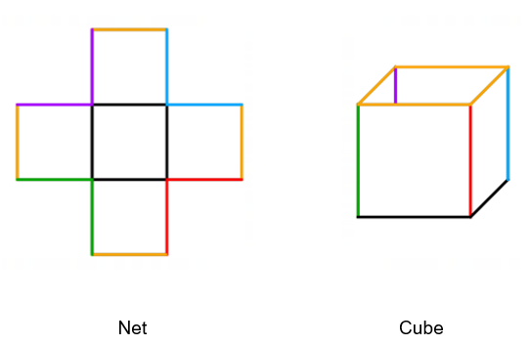
- Results could be collected using a Mentimeter (mentimeter.com) or a simple thumbs up for yes or thumbs down for no.
- Using the Pause-Pose-Pounce-Bounce question strategy [PDF 200KB] (bit.ly/pausepouncebouncestrategy)ask students at random to explain their answer using mathematical reasoning.
This allows an opportunity to build on responses by explicitly teaching and revising vocabulary including net, face, edge and vertices.

- In pairs, students will then work through a Which One Doesn’t Belong? (bit.ly/wodbstrategy) activity by analysing each of the 4 nets below to determine which nets will make the given open cube. There is more than one net that doesn’t belong. Advise students that they need to make sure the colour of the edges are in the correct order.
Figure 2 – which nets don't belong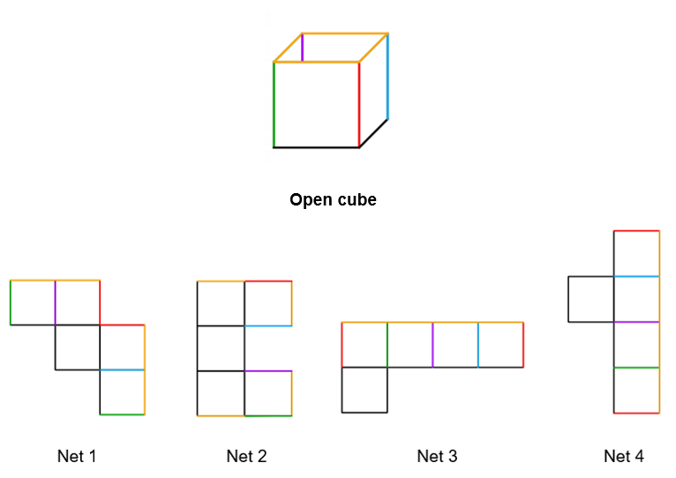
- Once students have had sufficient time to explore the nets, select pairs at random to discuss their strategy in determining which nets make the open cube. For example, they may discuss aligning the edges with corresponding colours, or they may discuss visualising folding up the net in their mind as a three-dimensional solid.
- At this point it may be beneficial to demonstrate how each of the cubes fold to make an open cube (or do not fold to make an open cube). This could be done by physically having the nets above enlarged on A3 paper and demonstrating. Alternatively, Polypad (mathigon.org/polypad) can be used. This ‘create your own nets in #polypad #mathigon to fold and unfold (1:11)’ video demonstrates how to use the fold and unfold button on Mathigon Polypad (bit.ly/netfoldpolypad).
Be sure to use and reinforce the correct terminology for face, edge and so on.

Explore
- Explain to students that they will be investigating pentominoes in pairs.
- Clearly define that a pentomino is a polygon made of 5 equal-sized squares connected edge-to-edge. The nets that they have previously explored are all examples of pentominoes. Figure 3 below may assist with the explanation.
Figure 3 – examples and non-example of pentominoes
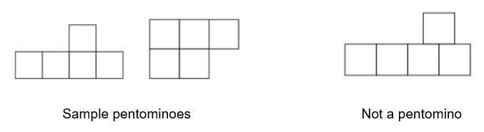
- Explain to students that some pentominoes look different but are actually the same. For example, Figure 4 shows the same pentomino 3 times. Ask students if they can explain how the pentominoes below are the same.

Figure 4 – the same pentomino 3 times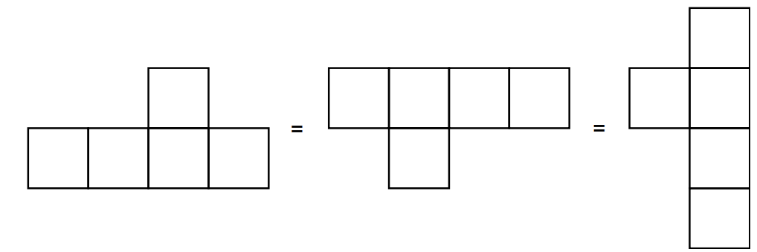

- In pairs students are challenged to discover every possible pentomino arrangement. Students will record their results using Appendix A and can explore using any one of the following:
- 5 squares from a tangram set
- 5 flats from a base 10 block set
- 5 plastic squares
- virtual manipulatives such as Mathigon Polypad using the polygons and shapes function (mathigon.org/polypad#polygons).
Mathigon Polypad has in-built pentominoes in the Geometry section under the Polyominoes sub-section (mathigon.org/polypad#polyominoes). Allowing students to access this too early will hinder discovery and investigation. This is also where you will find the solutions to Appendix A ‘Pentominoes’.
- Ask students to reveal how many arrangements they discovered, before revealing that there are 12 pentominoes. As a class these can be viewed using the link, ‘The Set of Pentominoes’ (bit.ly/setofpentominoes).
- Explain that the 12 pentominoes can be used to form a rectangle. Students can explore this by cutting out their pentominoes and arranging them on the grid provided in Appendix B. Alternatively, students can be shown this using the polyominoes function on Mathigon Polypad (mathigon.org/polypad#polyominoes).
- Conduct a class discussion referring to the 12 pentominoes and ask the following questions:
- Which pentomino has the greatest area? Justify why.
- Which pentomino has the greatest perimeter? Justify why.
- Students will explore which pentominoes form nets of an open cube. In pairs they will analyse each of their 12 pentominoes and determine:
- Does this pentomino represent a net of an open cube?
- If yes, which of the 5 faces represents the base face of the cube?
- Students should firstly visualise folding the net in their minds and then they can check their answer by cutting up their pentomino and folding it to form a net or using virtual manipulatives such as Mathigon polypad (mathigon.org/polypad).
- Once students have determined which pentominoes represent the net of an open cube, use the pre-made Mathigon Polypad page (https://mathigon.org/polypad/hu4mXz1rW4NxEA) to demonstrate to students which of the 12 pentominoes can be folded to form an open cube. Change the colour of the face that they predict to be the base and test their theory using the fold net function.
- Conduct a class discussion to consider which pentominoes represented open cubes and which face formed the base in each. Students should be encouraged to explain their thinking and how they visualised the open cube. For example:
- Did they visually fold the net in their mind before or after selecting the face that would be the base?
- Were some nets easier to visualise folding into an open cube than others, why?

Summarise
- Explain to students that now they can visually fold the net of an open cube, they will be exploring a range of different prisms while using their nets to be able to:
- Identify the edge lengths.
- Identify the faces that make up a prism.
- Recognise if a net represents a given prism.
- Use the provided Visualising nets PowerPoint for explicit teaching and worked examples of the above content.
- Students are then to complete the Cube Nets activity (bit.ly/cubenetsnctmactivity) which shows students 24 potential nets of cubes. Students need to determine which ones will make a cube.

Apply
- Using Appendix C, students will create their own Which One Doesn’t Belong? activity (bit.ly/wodbstrategy).
- Each student will create nets for 4 given right prisms. For one of their nets, they will construct a net that looks as if it represents the prisms, but it does not.
- They will then swap sheets with a partner who needs to determine which net does not represent the given prism.
- The aim is to attempt to trick their partner by being as creative as possible when designing and arranging the nets.
- Their partner will need to justify why they believe a particular net does not represent the given prism.

Assessment and differentiation

Suggested opportunities for differentiation
Launch
- Instead of displaying the image, it may help students if they are given a copy of it so they can physically move and fold it.
Explore/Summarise/Apply
- Mathigon Polypad (mathigon.org/polypad) can be used as a tool to assist students when considering nets and their 3D form.
- Support students to use the correct terminology to help them communicate what they are imagining. For example, face, edge and base may help students explain what they are thinking to their partner, or to the class.
Apply
- Students may find grid paper helpful when creating the nets.

Suggested opportunities for assessment
- Monitor student conversations when discussing techniques and what they are imagining in their minds to check for understanding.
- Collect Appendix C to determine if students can create nets of right prisms as well as recognise and justify whether a diagram represents a net of a right prism.

Appendix A

Pentominoes
Record every possible pentomino on the grid below. Two have been drawn for you.
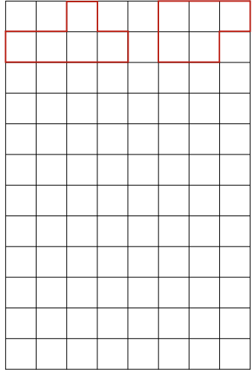

Appendix B

Arranging pentominoes

Appendix C

Which net doesn’t belong?
For 3 of the 4 given right prisms, create a net that corresponds to the prism. For the fourth right prism, create a net that doesn’t fold to form the given prism.
Swap with a partner after you have created your nets and ask them to determine which net doesn’t correspond to the given prism and justify why.
Right prism | Net of right prism
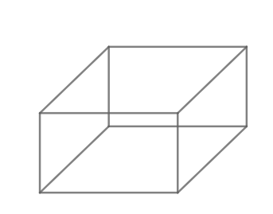
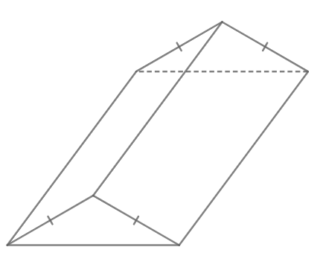
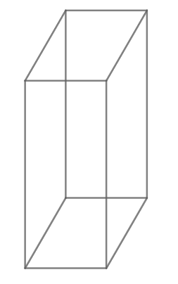
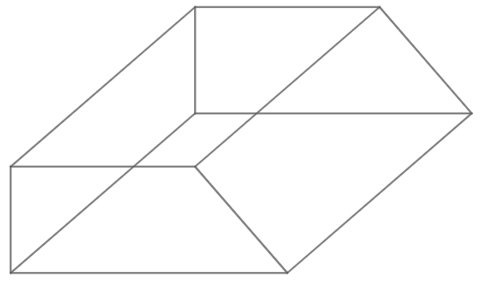

References
This resource contains NSW Curriculum and syllabus content. The NSW Curriculum is developed by the NSW Education Standards Authority. This content is prepared by NESA for and on behalf of the Crown in right of the State of New South Wales. The material is protected by Crown copyright.
Please refer to the NESA Copyright Disclaimer for more information https://educationstandards.nsw.edu.au/wps/portal/nesa/mini-footer/copyright.
NESA holds the only official and up-to-date versions of the NSW Curriculum and syllabus documents. Please visit the NSW Education Standards Authority (NESA) website https://educationstandards.nsw.edu.au/ and the NSW Curriculum website https://curriculum.nsw.edu.au/home.
Mathematics K–10 Syllabus © NSW Education Standards Authority (NESA) for and on behalf of the Crown in right of the State of New South Wales, 2022.
© State of New South Wales (Department of Education), 2023
The copyright material published in this resource is subject to the Copyright Act 1968 (Cth) and is owned by the NSW Department of Education or, where indicated, by a party other than the NSW Department of Education (third-party material).
Copyright material available in this resource and owned by the NSW Department of Education is licensed under a Creative Commons Attribution 4.0 International (CC BY 4.0) licence.
This licence allows you to share and adapt the material for any purpose, even commercially.
Attribution should be given to © State of New South Wales (Department of Education), 2023.
Material in this resource not available under a Creative Commons licence:
- the NSW Department of Education logo, other logos and trademark-protected material
- material owned by a third party that has been reproduced with permission. You will need to obtain permission from the third party to reuse its material.
Links to third-party material and websites
Please note that the provided (reading/viewing material/list/links/texts) are a suggestion only and implies no endorsement, by the New South Wales Department of Education, of any author, publisher, or book title. School principals and teachers are best placed to assess the suitability of resources that would complement the curriculum and reflect the needs and interests of their students.
If you use the links provided in this document to access a third-party's website, you acknowledge that the terms of use, including licence terms set out on the third-party's website apply to the use which may be made of the materials on that third-party website or where permitted by the Copyright Act 1968 (Cth). The department accepts no responsibility for content on third-party websites.

