Mathematics Stage 5 – stage based – sample scope and sequence
This resource has been designed to support teachers by providing an approach to organising syllabus content and can be modified to suit individual school contexts and procedures as required.
The approach used in this resource is designed to support schools working with stage-based classes that work on an even/odd year rotation.
High quality formative and summative assessment should form an integral part of all teaching and learning programs. For more information please visit NESA’s Advice on assessment page.

7-10 Core–Paths structure

Intention
The following excerpt from the Mathematics K–10 Syllabus course overview describes the intentions behind the Core–Paths structure in 7-10 and has guided decisions around the organisation of this scope and sequence.
The Core–Paths structure is designed to encourage aspiration in students and provide the flexibility needed to enable teachers to create pathways for students working towards Stage 6. The structure is intended to extend students as far along the continuum of learning as possible and provide solid foundations for the highest levels of student achievement.
The aim for most students is to demonstrate achievement of the Core and as many Path outcomes as possible by the end of Stage 5 and this should guide teacher planning.
This scope and sequence provides multiple options for schools and teachers to consider when making decisions about delivering curriculum in a manner true to the intention of the syllabus. Schools and teachers can choose to engage with either or both approaches described below, which are supported with units and lessons.

Path outcomes related to core topics
For the majority of units in this scope and sequence, specific elements of related Path outcomes have been identified and activities included that support teachers to expose students to these Paths as they become relevant. This empowers schools to cover these Path concepts naturally, and as a result of school-based decisions around what is achievable for individual students and cohorts.
Units and assessments are developed so that teachers and schools choosing to only cover core content in these units, are supported.

Optional electives
The optional electives units in Term 4 of each year are an acknowledgement that all school contexts and student cohorts are different. Schools using this scope and sequence will need to decide how to engage with this time based on a range of factors, including staffing, student cohort characteristics, timetabling and available resources.
The intention of this time in the scope and sequence is for students to be given some choice and say in what units, and hence which Path outcomes, they engage with. Alternatively, the decisions about which students are exposed to which further units, and to what depth, during this time can be made by schools and teachers.
Optional elective units developed to support this time focus on logical connections between Core and Path outcomes, and applications of knowledge and skills. These could include units such as:
- Planning a trip
- Being an entrepreneur
- Maths in science
- Creating your own space
- Maths in engineering and physics.
These units are designed with a student's path towards specific Stage 6 Mathematics courses in mind, but also to be accessible to as wide a range of students as possible. This is in line with the Core-Path structure intention that ‘most students … demonstrate achievement of … as many Path outcomes as possible by the end of Stage 5’.
Table 1 – even year, Term 1
2D Spatial relations  Unit title: Geometrical representations  Weeks 1 to 5 | 2D Spatial relations  Unit title: Working with triangles  Weeks 6 to 10
MAO-WM-01, MA5-GEO-C-01  (Related Life Skills outcomes: MALS-GEO-01)  - Identify and describe the properties of similar figures  - Solve problems using ratio and scale factors in similar figures | MAO-WM-01, MA5-TRG-C-01, MA5-LIN-C-01, MA5-MAG-C-01 (Related Life Skills outcomes: MALS-POS-01)  - Demonstrate and explain the constancy of trigonometric ratios for a given angle in right-angled triangles  - Apply trigonometry to solve right-angled triangle problems  - Find the midpoint and gradient of a line segment (interval) and the distance between 2 points on a Cartesian plane  - Estimate and round numbers to a specified degree of accuracy
Related Path content: MA5-GEO-P-01, MA5-NET-P-01  - Develop and apply the minimum conditions for triangles to be similar  - Establish and apply properties of similar shapes and solids  - Examine and describe a graph/network | Related Path content: MA5-LIN-P-01, MA5-IND-P-02  - Apply formulas to find the midpoint and gradient/slope of an interval and the distance between 2 points located on the Cartesian plane  - Describe surds
Table 2 – even year, Term 2
3D Spatial relations  Unit title: Prisms and cylinders  Weeks 1 to 7 | Linear relationships  Unit title: Financial mathematics  Weeks 8 to 10
MAO-WM-01, MA5-ARE-C-01, MA5-VOL-C-01, MA5-ALG-C-01, MA5-EQU-C-01,  MA5-MAG-C-01  (Related Life Skills outcomes: MALS-ADS-01, MALS-MDI-01, MALS-PAT-01,  MALS-VOL-01, MALS-ARE-01)  - Solve problems involving areas and surface areas  - Develop and apply the formula for surface areas of cylinders  - Solve problems involving surface areas of cylinders and related composite solids  - Solve problems involving composite solids consisting of right prisms and cylinders  - Apply the distributive law to the expansion of algebraic expressions  - Solve linear equations involving up to 3 steps  - Solve linear equations arising from word problems and substitution into formulas  - Identify and describe very small and very large measurements  - Find absolute and percentage error  - Estimate and round numbers to a specific degree of accuracy | MAO-WM-01, MA5-FIN-C-01,  MA5-EQU-C-01  (Related Life Skills outcomes:  MALS-FIN-01, MALS-FIN-02)  - Solve problems involving earning money, simple interest and spending money  - Solve linear equations involving up to 3 steps  - Solve linear equations arising from word problems and substitution into formulas
Related Path content: MA5-ARE-P-01, MA5-VOL-P-01, MA5-EQU-P-02  - Solve problems involving surface areas  - Solve problems involving volumes  - Solve linear equations involving algebraic fractions and equations of more than 3 steps  - Rearrange literal equations | - No Path content included

Table 3 – even year, Term 3
Uncertainty  Unit title: Making predictions  Weeks 1 to 5 | Non-linear relationships  Unit title: Investigating parabolas  Weeks 6 to 10
MAO-WM-01, MA5-PRO-C-01  (Related Life Skills outcomes: MALS-PRO-01)  - Describe multistage chance experiments involving independent and dependent events  - Solve problems for multistage chance experiments  - Design and use simulations to model and examine situations involving probability | MAO-WM-01, MA5-ALG-C-01, MA5-NLI-C-01, MA5-NLI-C-02 (Related Life Skills outcomes: MALS-PAT-01)  - Apply the distributive law to the expansion of algebraic expressions, and collect like terms where appropriate  - Examine the connection between algebraic and graphical representations of quadratics and exponentials  - Graph and examine quadratic relationships
Related Path content: MA5-PRO-P-01  - Solve problems involving Venn diagrams and 2-way tables  - Use the language, ‘if…then’, ‘given’, ‘of’ and ‘knowing that’, to examine conditional statements and identify common mistakes in interpreting the language  - Describe mutually and non-mutually exclusive events using specific language and calculate related probabilities | Related Path content: MA5-ALG-P-01, MA5-ALG-P-02,  MA5-EQU-P-01, MA5-EQU-P-02, MA5-NLI-P-01  - Expand binomial products and factorise monic quadratic expressions  - Expand, factorise and simplify algebraic expressions including special products  - Solve monic quadratic equations  - Solve quadratic equations using a variety of methods  - Graph parabolas and describe their features and transformations  - Distinguish between different types of graphs by examining their algebraic and graphical representations and solve problems

Table 4 – even year, Term 4
Optional elective  Unit title:  Weeks 1 to 5 | Optional elective  Unit title:  Weeks 6 to 10
MAO-WM-01, [school to enter outcomes]  (Related Life Skills outcomes: [school to enter outcomes])  - [School to enter content dot points] | MAO-WM-01, [school to enter outcomes]  (Related Life Skills outcomes: [school to enter outcomes])  - [School to enter content dot points]
Related Path content: [School to enter Path outcomes]  - [School to enter content dot points] | Related Path content: [School to enter Path outcomes]  [School to enter content dot points]

Even year overview
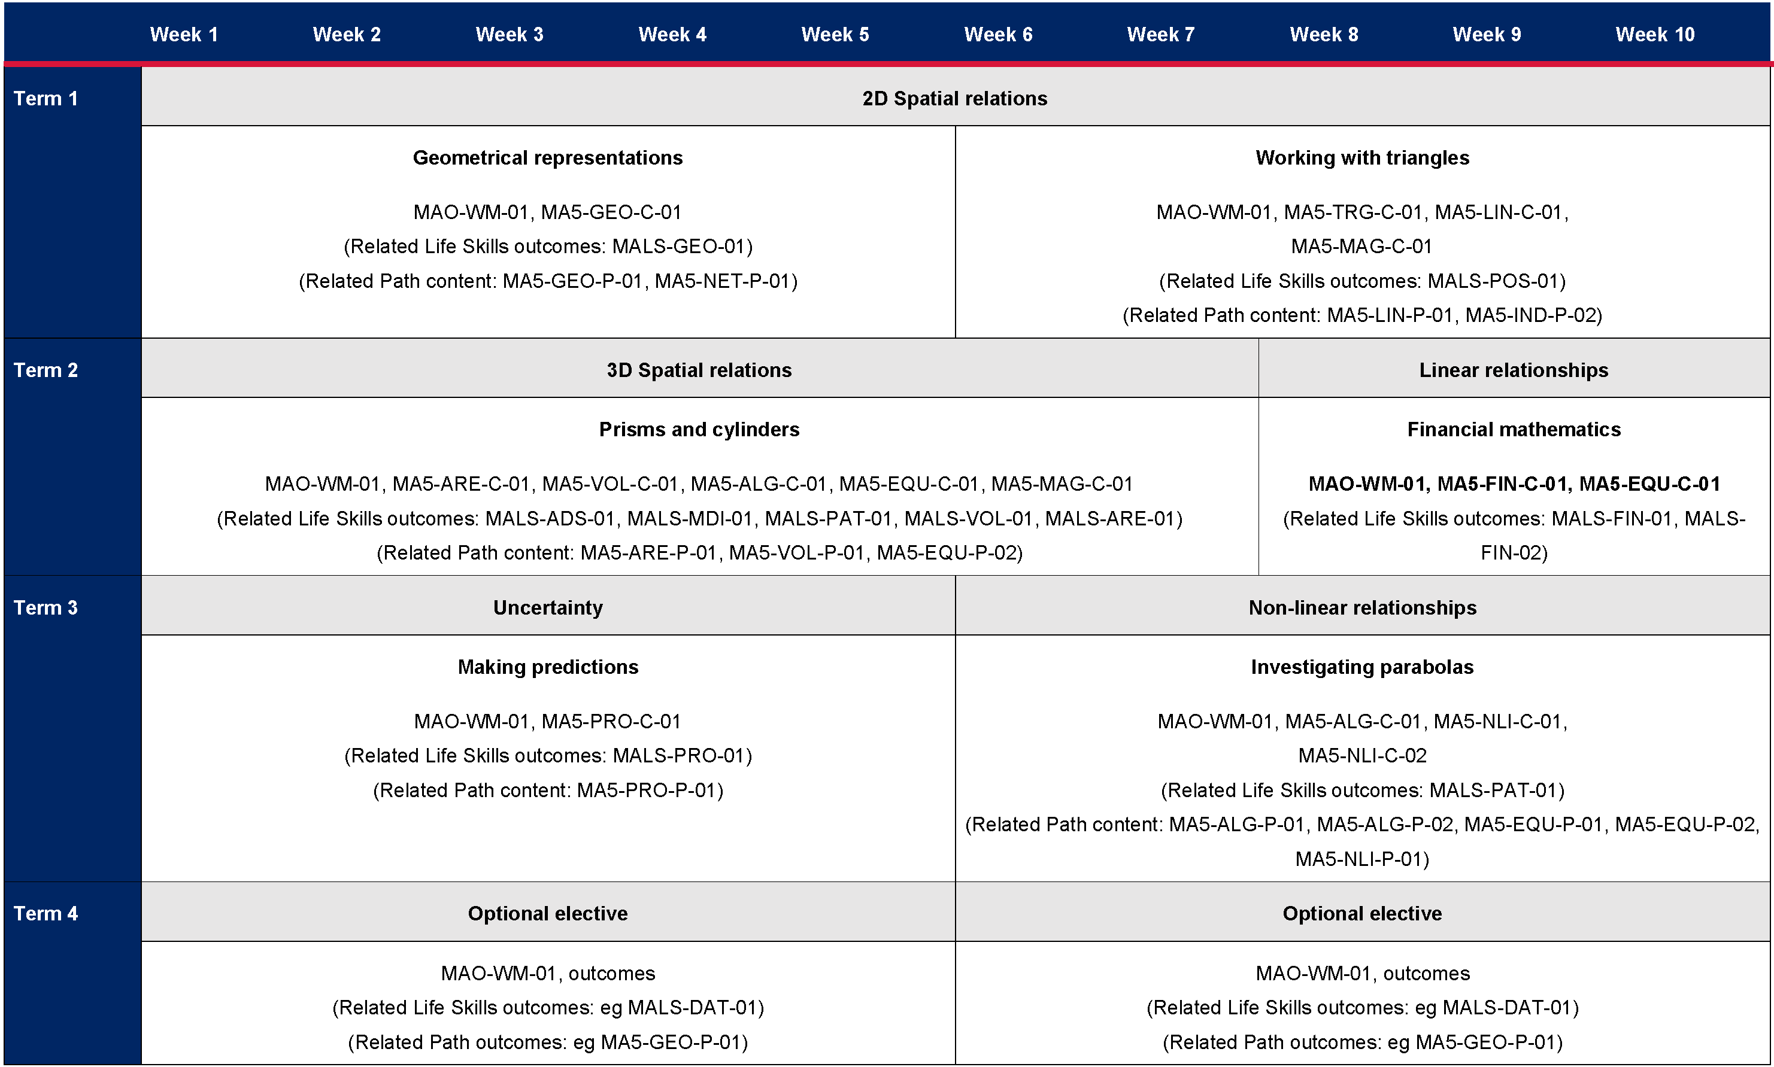

Table 5 – odd year, Term 1
Non-linear relationships  Unit title: Applying exponentials  Weeks 1 to 6 | Multiplicative relationships  Unit title: Index laws  Weeks 7 to 10
MAO-WM-01, MA5-FIN-C-02, MA5-NLI-C-01, MA5-NLI-C-02  (Related Life Skills outcomes: MALS-FIN-01, MALS-FIN-02)  - Solve problems involving compound interest and depreciation  - Examine the connection between algebraic and graphical representations of quadratics and exponentials  - Graph and examine exponential relationships  - Distinguish between linear, quadratic and exponential relationships by examining their graphical representations | MAO-WM-01, MA5-IND-C-01, MA5-MAG-C-01  (Related Life Skills outcomes: MALS-MDI-01,  MALS-PAT-01)  - Extend and apply the index laws to variables, using positive-integer indices and the zero index  - Simplify algebraic products and quotients using index laws  - Apply index laws to numerical expressions with negative-integer indices  - Express numbers in scientific notation
Related Path content: MA5-NLI-P-01  - Graph exponentials and describe their features and transformations  - Distinguish between different types of graphs by examining their algebraic and graphical representations and solve problems | Related Path content: MA5-IND-P-01, MA5-IND-P-02  - Apply index laws to algebraic expressions involving negative-integer indices  - Describe and use fractional indices
Table 6 – odd year, Term 2
Algebraic relations  Unit title: Expressions and equations  Weeks 1 to 3 | Linear relationships  Unit title: Constant rates of change  Weeks 4 to 10
MAO-WM-01, MA5-ALG-C-01,  MA5-EQU-C-01  (Related Life Skills outcomes:  MALS-ADS-01, MALS-MDI-01,  MALS-PAT-01)  - Apply the 4 operations to simplify algebraic fractions with numerical denominators  - Apply the distributive law to the expansion of algebraic expressions, and collect like terms where appropriate  - Solve linear equations involving up to 3 steps  - Solve linear equations involving one algebraic fraction | MAO-WM-01, MA5-EQU-C-01, MA5-LIN-C-01, MA5-LIN-C-02  (Related Life Skills outcomes: MALS-ADS-01, MALS-MDI-01, MALS-POS-01)  - Solve linear equations arising from word problems and substitution into formulas  - Recognise and graph equations  - Examine parallel, horizontal and vertical lines  - Examine the gradient/slope-intercept form  - Find the equations of parallel and perpendicular lines
Related Path content: MA5-ALG-P-01,  MA5-ALG-P-02, MA5-EQU-P-02  - Apply the 4 operations involving algebraic fractions with pronumerals in the denominator  - Factorise algebraic expressions by taking out a common algebraic factor  - Operate with algebraic fractions involving binomial numerators and numerical denominators  - Solve linear equations involving algebraic fractions and equations of more than 3 steps | Related Path content: MA5-LIN-P-01, MA5-EQU-P-02, MA5-RAT-P-01  - Use various forms of the equation of a straight line  - Solve linear simultaneous equations, both algebraically and graphically  - Identify and describe problems and graphs involving direct variation  - Solve problems involving direct variation

Table 7 – odd year, Term 3
Spatial relations  Unit title: Surveying  Weeks 1 to 6 | Uncertainty  Unit title: Making decisions  Weeks 7 to 10
MAO-WM-01, MA5-TRG-C-02  (Related Life Skills outcomes: MALS-LEN-01, MALS-GEO-01, MALS-POS-01)  - Solve right-angled triangle problems involving angles of elevation and depression  - Solve right-angled triangle problems involving bearings | MAO-WM-01, MA5-DAT-C-01  (Related Life Skills outcomes: MALS-DAT-02)  - Standard deviation as a measure of spread  - Determine quartiles and interquartile range  - Represent datasets using box plots and use them to compare datasets
Related Path content: MA5-TRG-P-01, MA5-EQU-P-02  - Solve 3-dimensional problems involving right-angled triangles  - Apply the sine, cosine and area rules to any triangle and solve related problems  - Rearrange literal equations | - No Path content included

Table 8 – odd year, Term 4
Uncertainty  Unit title: Correlation  Weeks 1 to 5 | Optional elective  Unit title:  Weeks 6 to 10
MAO-WM-01, MA5-DAT-C-02, MA5-LIN-C-02  (Related Life Skills outcomes: MALS-DAT-02)  - Identify and describe numerical datasets involving 2 variables  - Represent datasets involving 2 numerical variables, using a scatter plot and a line of best fit, by eye  - Interpret data involving 2 numerical variables, using graphical representation  - Examine the gradient/slope-intercept form | MAO-WM-01, [school to enter outcomes]  (Related Life Skills outcomes: [school to enter outcomes])  - [School to enter content dot points]
Related Path content: MA5-DAT-P-01  - Plan and conduct a statistical inquiry into a question of interest  - Examine reports of studies in digital media and elsewhere for information on their planning and implementation | Related Path content: [School to enter Path outcomes]  - [School to enter content dot points]

Odd year overview
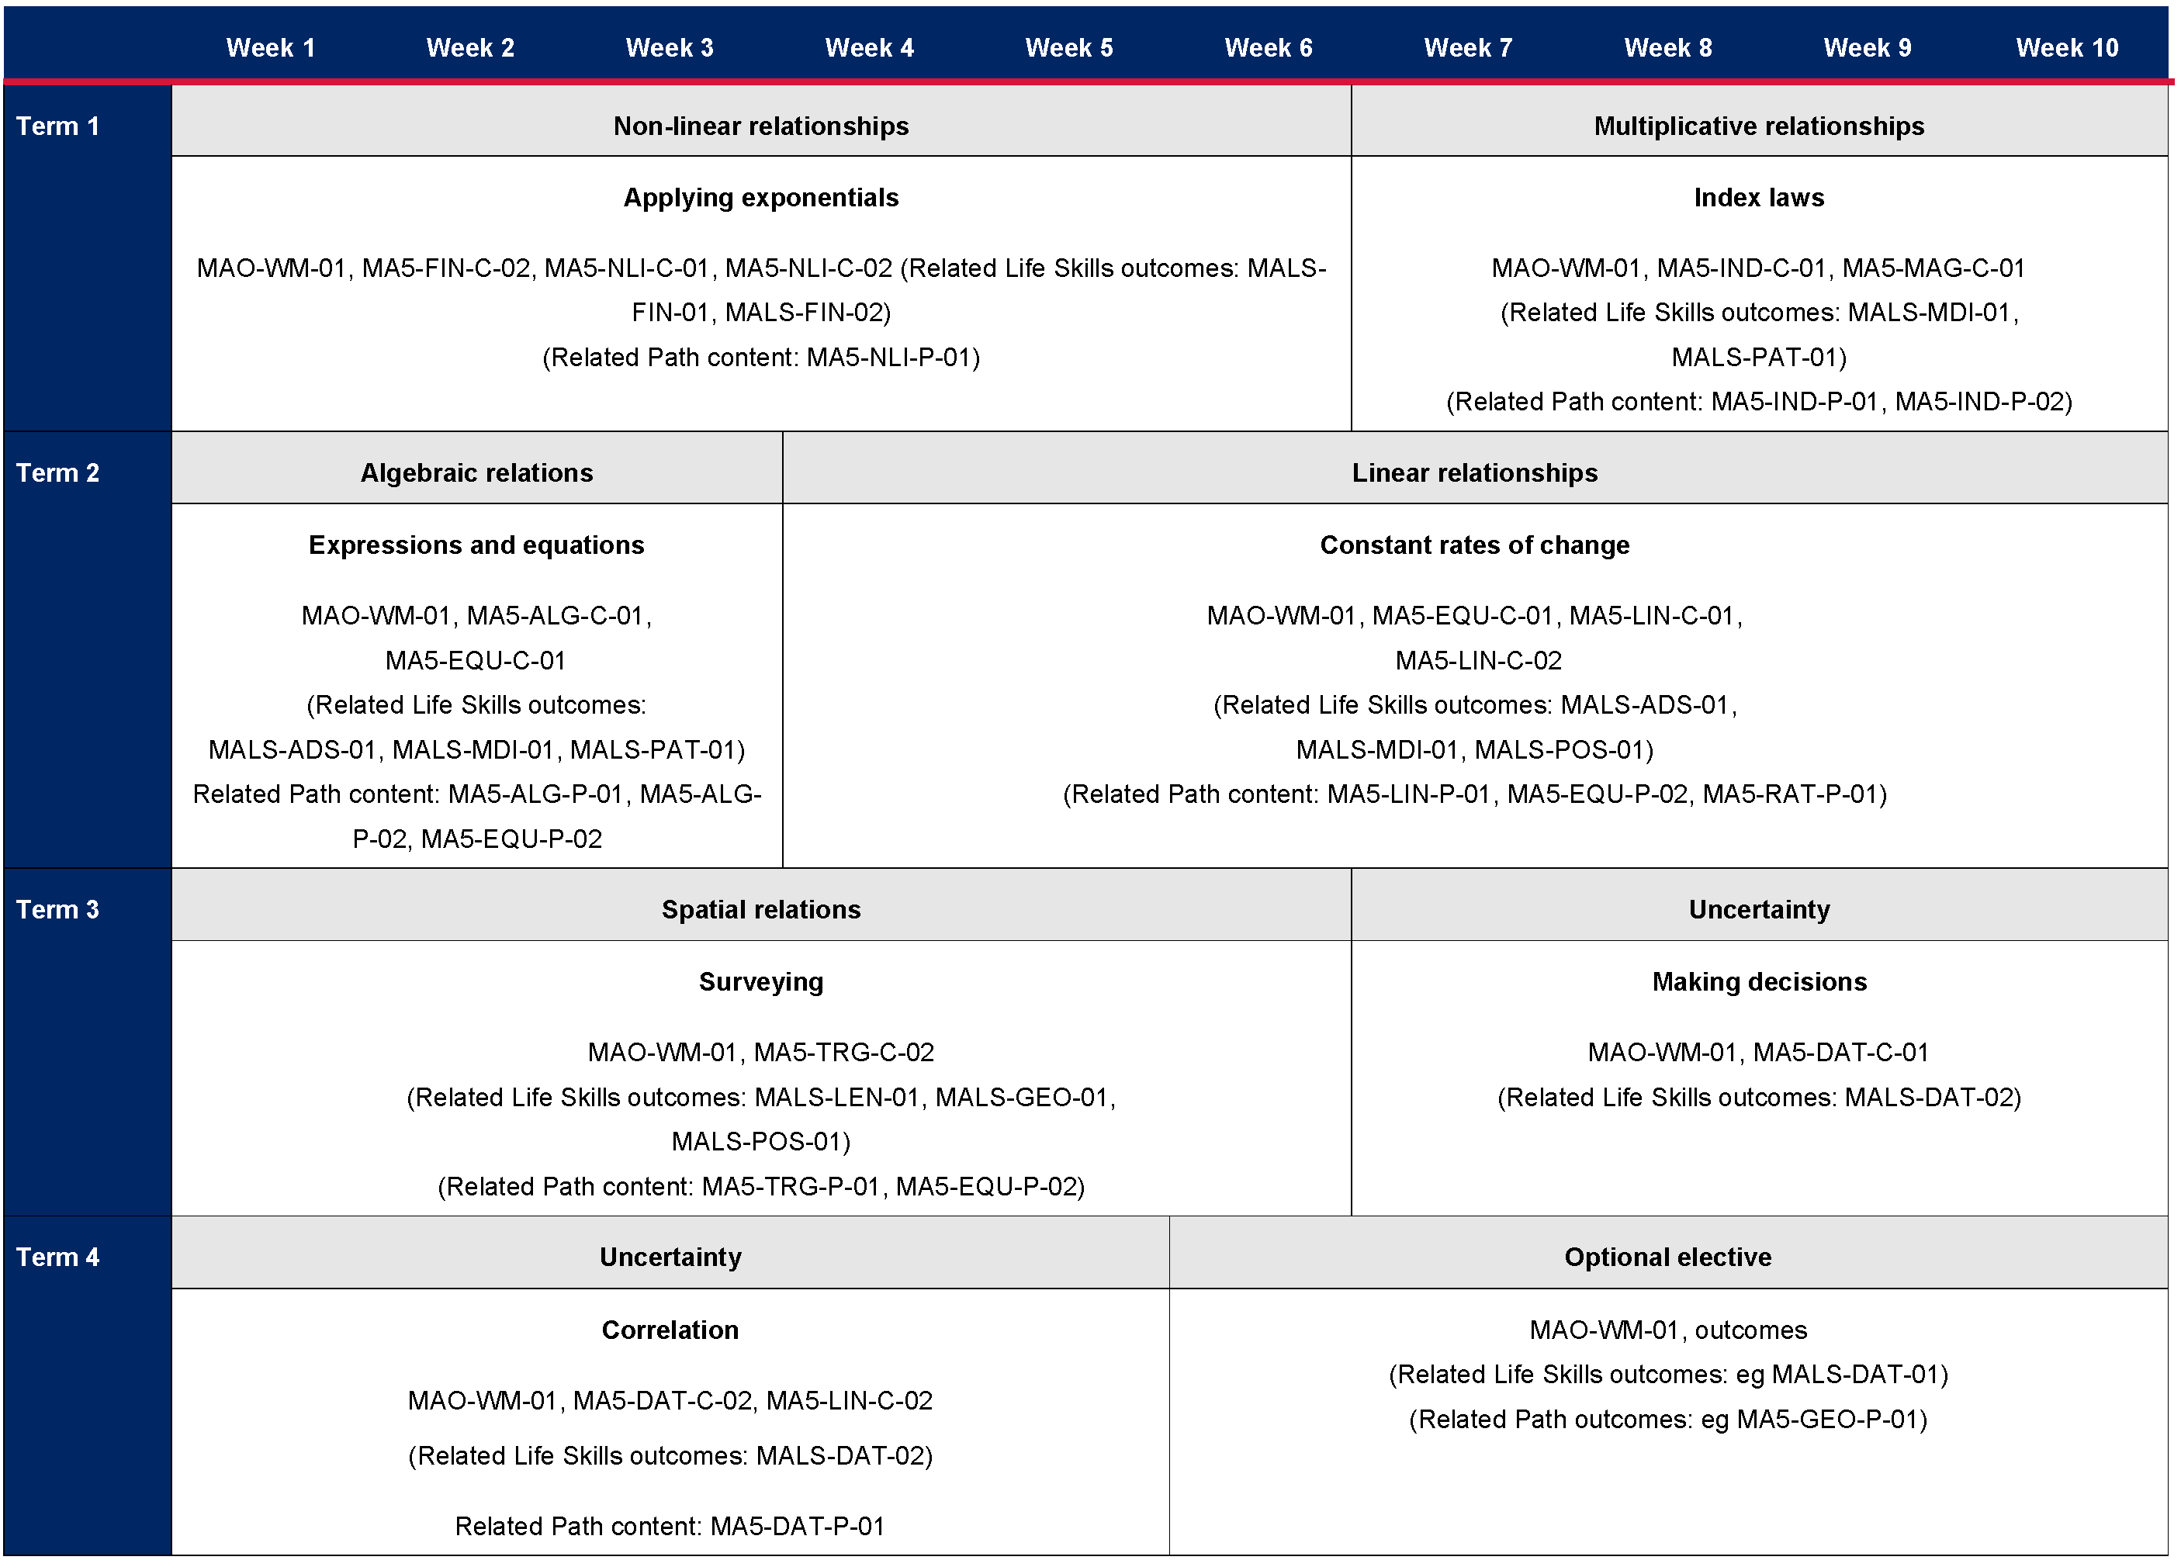

Example optional electives
Table 9 – two examples of optional electives that could be taught during Term 4 in both even and odd years
Optional elective  Unit title: Being an entrepreneur  Weeks 1 to 5 | Optional elective  Unit title: Maths in Science  Weeks 6 to 10
MAO-WM-01, MA5-FIN-C-01, MA5-FIN-C-02, MA5-LIN-C-01, MA5-LIN-C-02  (Related Life Skills outcomes: MALS-FIN-01, MALS-FIN-02, MALS-PAT-01)  - Solve problems involving spending money  - Solve problems involving compound interest and depreciation  - Recognise and graph equations  - Examine the gradient/slope-intercept form | MAO-WM-01, MA5-GEO-C-01, MA5-DAT-C-02, MA5-PRO-C-01  (Related Life Skills outcomes: MALS-DAT-01, MALS-DAT-02, MALS-PRO-01, MALS-MDI-01, MALS-GEO-01)  - Solve problems using ratio and scale factors in similar figures  - Identify and describe numerical datasets involving 2 variables  - Represent datasets involving 2 numerical variables, using a scatter plot and a line of best fit, by eye  - Interpret data involving 2 numerical variables, using graphical representation  - Design and use simulations to model and examine situations involving probability
Related Path content: MA5-LIN-P-01, MA5-EQU-P-02,  MA5-NET-P-01, MA5-RAT-P-01  - Solve linear simultaneous equations, both algebraically and graphically  - Identify and describe graphs involving direct and inverse variation  - Solve problems involving direct and inverse variation and examine the relationship between graphs and equations corresponding to proportionality  - Examine and describe a graph/network  - Define a planar graph and apply Euler’s formula for planar graphs  - Explain the concept of Eulerian trails and circuits in the context of the Königsberg bridges problem | Related Path content: MA5-GEO-P-01, MA5-LOG-P-01,  MA5-IND-P-02, MA5-RAT-P-01, MA5-EQU-P-01,  MA5-EQU-P-02, MA5-PRO-P-01  - Identify and describe problems and graphs involving direct and inverse variation  - Solve problems involving direct and inverse variation and examine the relationship between graphs and equations corresponding to proportion  - Establish and apply properties of similar shapes and solids  - Examine logarithms both numerically and graphically  - Establish and apply the laws of logarithms to solve problems  - Solve linear inequalities and graph their solutions on a number line  - Solve linear simultaneous equations, both algebraically and graphically  - Solves problems involving Venn diagrams and 2-way tables

References
This resource contains NSW Curriculum and syllabus content. The NSW Curriculum is developed by the NSW Education Standards Authority. This content is prepared by NESA for and on behalf of the Crown in right of the State of New South Wales. The material is protected by Crown copyright.
Please refer to the NESA Copyright Disclaimer for more information https://educationstandards.nsw.edu.au/wps/portal/nesa/mini-footer/copyright.
NESA holds the only official and up-to-date versions of the NSW Curriculum and syllabus documents. Please visit the NSW Education Standards Authority (NESA) website https://educationstandards.nsw.edu.au/ and the NSW Curriculum website https://curriculum.nsw.edu.au/home.
Mathematics K–10 Syllabus © NSW Education Standards Authority (NESA) for and on behalf of the Crown in right of the State of New South Wales, 2022.
© State of New South Wales (Department of Education), 2023
The copyright material published in this resource is subject to the Copyright Act 1968 (Cth) and is owned by the NSW Department of Education or, where indicated, by a party other than the NSW Department of Education (third-party material).
Copyright material available in this resource and owned by the NSW Department of Education is licensed under a Creative Commons Attribution 4.0 International (CC BY 4.0) licence.
This licence allows you to share and adapt the material for any purpose, even commercially.
Attribution should be given to © State of New South Wales (Department of Education), 2023.
Material in this resource not available under a Creative Commons licence:
- the NSW Department of Education logo, other logos and trademark-protected material
- material owned by a third party that has been reproduced with permission. You will need to obtain permission from the third party to reuse its material.
Links to third-party material and websites
Please note that the provided (reading/viewing material/list/links/texts) are a suggestion only and implies no endorsement, by the New South Wales Department of Education, of any author, publisher, or book title. School principals and teachers are best placed to assess the suitability of resources that would complement the curriculum and reflect the needs and interests of their students.
If you use the links provided in this document to access a third-party's website, you acknowledge that the terms of use, including licence terms set out on the third-party's website apply to the use which may be made of the materials on that third-party website or where permitted by the Copyright Act 1968 (Cth). The department accepts no responsibility for content on third-party websites.

