Mathematics Stage 5 (Year 9) – summative assessment package – question bank

Contents
Outcomes to be assessed 2
Question bank 3
Prisms and cylinders 4
Working with triangles 14
References 23

This document is part 1 of 3 of a summative assessment package designed to assess the outcomes from Units 3 and 4 of the Department of Education’s Stage 5 (Year 9) sample scope and sequence [DOCX 258KB].
- Part 1: Question bank
- Part 2: Sample class test [DOCX 338KB]
- Part 3: Annotated sample responses [DOCX 2.3MB]

Outcomes to be assessed
Core outcomes being assessed:
- develops understanding and fluency in mathematics through exploring and connecting mathematical concepts, choosing and applying mathematical techniques to solve problems, and communicating their thinking and reasoning coherently and clearly MAO-WM-01
- determines the midpoint, gradient and length of an interval, and graphs linear relationships, with and without digital tools MA5-LIN-C-01
- applies trigonometric ratios to solve right-angled triangle problems MA5-TRG-C-01
- solves problems involving the surface area of right prisms and practical problems involving the area of composite shapes and solids MA5-ARE-C-01
- solves problems involving the volume of composite solids consisting of right prisms and cylinders MA5-VOL-C-01
Path outcomes being assessed:
- describes and applies transformations, the midpoint, gradient/slope and distance formulas, and equations of lines to solve problems MA5-LIN-P-01
- applies knowledge of the surface area of right pyramids and cones, spheres and composite solids to solve problems MA5-ARE-P-01
- applies knowledge of the volume of right pyramids, cones and spheres to solve problems involving related composite solids MA5-VOL-P-01
Mathematics K–10 Syllabus © NSW Education Standards Authority (NESA) for and on behalf of the Crown in right of the State of New South Wales, 2022.
The outcomes chosen are based on this assessment being implemented during Term 2 of the Department of Education’s Stage 5 (Year 9) sample scope and sequence [DOCX 258KB], after the unit ‘Prisms and cylinders’.

Question bank
The questions in this ‘Question bank’ are designed to support the development of a class test, such as the ‘sample class test’. The test will provide opportunities for students to demonstrate their knowledge of the content points related to the included outcomes.
Sample answers with marking guidelines have been provided in the file ‘Annotated sample responses’ and give examples of how to interpret responses against the Common Grade Scale (bit.ly/commongradescale).

Prisms and cylinders

Core
Question 1 (MA5-ARE-C-01)
Eli is 3D printing a ramp to ride his scooter over. His first design is below.
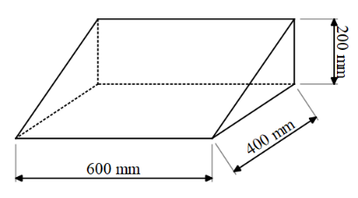
- What is the volume of material Eli will need to 3D print the ramp?
- Eli decides he wants the ramp to be twice as steep. Suggest one change he can make to the plan to achieve this and explain why you suggested that change.

Question 2 (MA5-ARE-C-01)
Consider the enclosed rectangular prism below, with width of 2 cm.
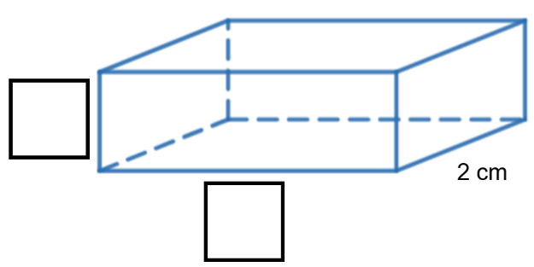
- Label the indicated length and height edges such that the volume of the prism is 24 cm³.
- Calculate the surface area of the solid.
- Are there any dimensions you could have chosen in part a where the volume would remain as 24 cm³, but the surface area would be smaller than your answer in part b? Give reasons for your answer.
Question 3 (MA5-ARE-C-01 and MA5-VOL-C-01)
A cube with a side length of 4 cm is painted blue on all 6 faces. It is cut into 64 smaller cubes with a side length of 1 cm each.
How many of these smaller cubes have exactly 2 blue faces?
Question 4 (MA5-VOL-C-01)
The local council is designing ‘bee bricks’ to help support the local bee population. A bee brick is a brick with small cavities where bees can nest, as shown below. The brick itself is a rectangular prism with dimensions 20 cm long, 10 cm wide, and 6 cm high. Each cavity is a cylinder with a diameter of 1 cm and a depth of 5 cm.
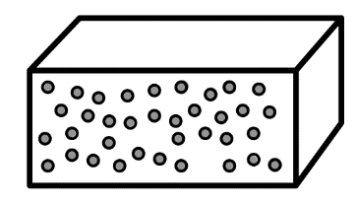
The council wants to maximize the number of cavities in each brick, but they also need to ensure that at least 85% of the brick's volume remains solid to maintain structural integrity.
Determine the maximum number of cavities they can include in each brick while maintaining the required structural integrity.

Question 5 (MA5-ARE-C-01 and MA5-VOL-C-01)
A company is designing new cylindrical packaging for their product. The packaging consists of a cylindrical body and 2 circular ends. The company has a budget that allows for a maximum of 400 cm² of material for the surface area of the packaging and a requirement that the packaging must hold a product volume of at least 500 cm³.
The design team has proposed a packaging design with a radius of 5 centimetres for the cylindrical body, but they are unsure of the height that they should choose.
Suggest a height for the packaging and explain why you suggested that height.
Question 6 (MA5-ARE-C-01 and MA5-VOL-C-01)
The pool shown below from a top and side view is to be built at a resort.
Figure 1 – top view
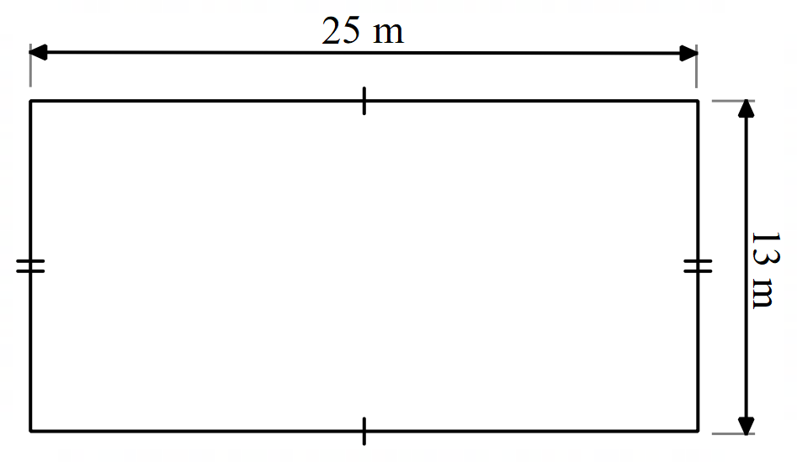
Figure 2 – side view
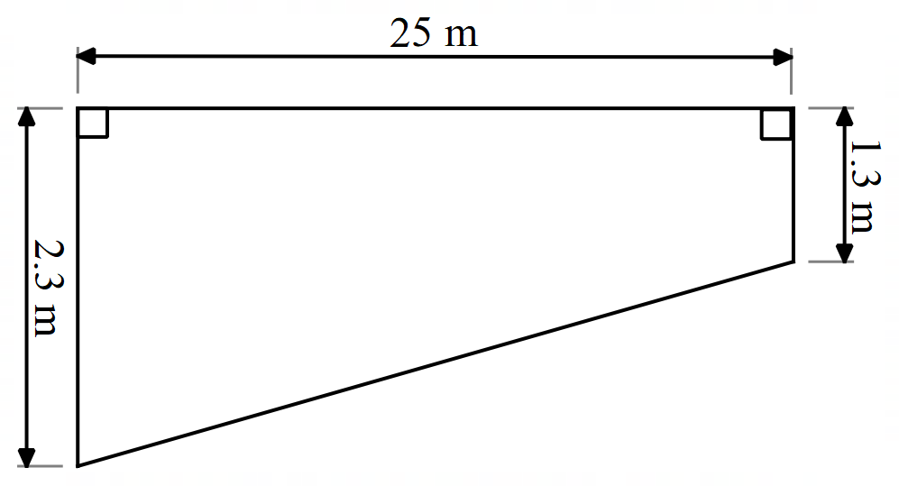
Find the capacity of the pool in litres.

Question 7 (MA5-ARE-C-01 and MA5-VOL-C-01)
Four small cubes, each with a surface area of 54 ${cm}^{2}$ are placed together to make the solid shown. What is the volume of the solid created?
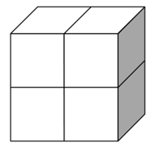
Question 8 (MA5-ARE-C-01)
A marquee tent is constructed to the dimensions below.
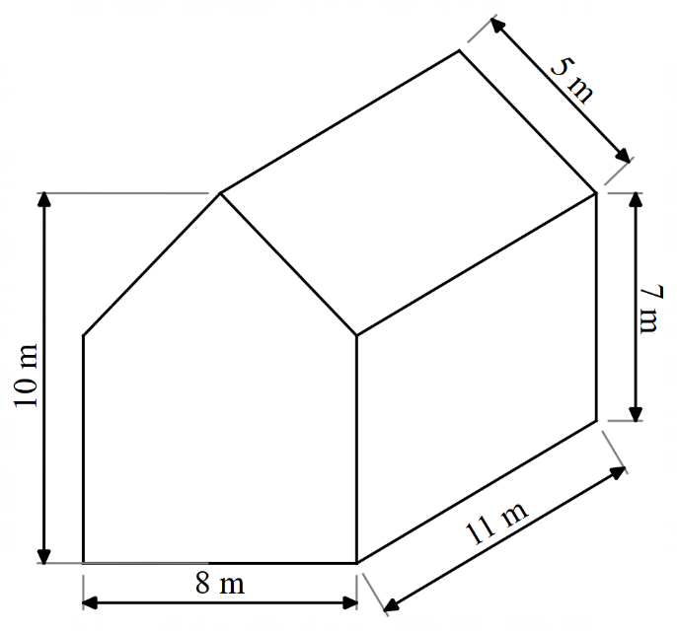
The material for the marquee costs $45 per $m^{2}$. How much will the construction of this marquee cost, without a floor?

Path
Question 9 (MA5-ARE-C-01 and MA5-VOL-C-01)
A company produces spherical chocolates, each with a volume of 4.5 $π$ $cm^{3}$. The company has 2 potential packaging options:
- Option 1: four chocolates are arranged in a square, with edges touching and no space between each chocolate.
- Option 2: four chocolates are arranged in a row, with edges touching and no space between each chocolate.
Both options will be packaged in a cardboard rectangular prism. Which packaging option would you recommend the company uses? Give reasons for your answer.
Question 10 (MA5-ARE-P-01)
Tennis balls are sold in cylinders of 3 balls that fit perfectly inside so that the height of the 3 spheres is equal to the height of the cylinder, and each ball touches the cylinder wall.
Will the height of a cylinder that holds 3 tennis balls be greater than or less than its circumference?
Question 11 (MA5-ARE-P-01 and MA5-VOL-P-01)
Two identical spherical balls fit exactly inside a cylinder as shown below.
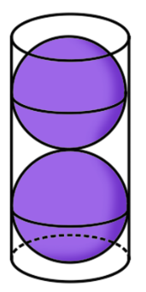
Given that the circumference of the cylinder is 30 cm:
- Find the surface area of the cylinder, rounding your answer to 2 decimal places.
- Find the percentage of empty space in the cylinder.
Question 12 (MA5-ARE-P-01 and MA5-VOL-P-01)
A sink has been designed by cutting a rectangular-based pyramid from a rectangular prism, with equal depth.
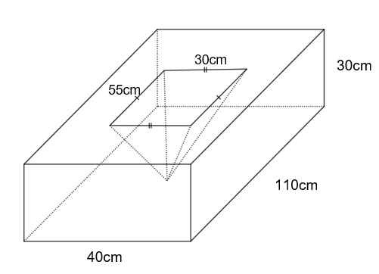
- Find the capacity of the sink. Round your answer to the nearest litre.
- Find the volume of the marble slab.
Question 13 (MA5-ARE-P-01 and MA5-VOL-P-01)
The solid shown below was obtained by cutting off a small square pyramid with a height of 5 cm from the top of a larger square pyramid with a height of 10 cm.
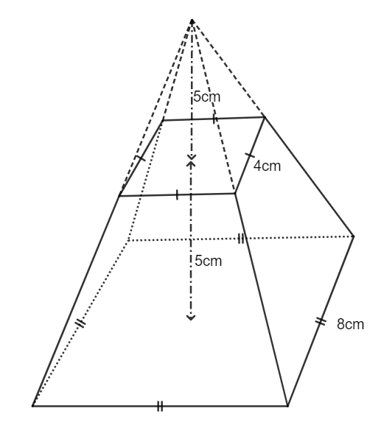
- Find the volume of the solid.
- Find the surface area of the solid.
Question 14 (MA5-ARE-P-01 and MA5-VOL-P-01)
- Using the digits 1 to 9 at most one time each, place a digit in each box to show the dimensions of a rectangular prism and rectangular pyramid so that both shapes have equal volumes.
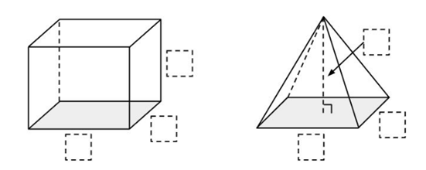
- Explain the strategy you used to solve or attempt this problem.

Question 15 (MA5-ARE-P-01 and MA5-VOL-P-01)
An open ice cream cone is modelled on the cone below.
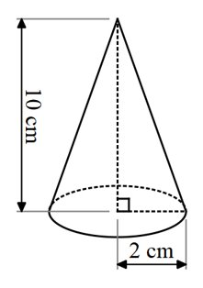
Find the surface area of the ice cream cone.

Question 16 (MA5-ARE-P-01 and MA5-VOL-P-01)
Jim says that if a cone has twice the height of a smaller cone, as shown below, it will also have double the volume and surface area.
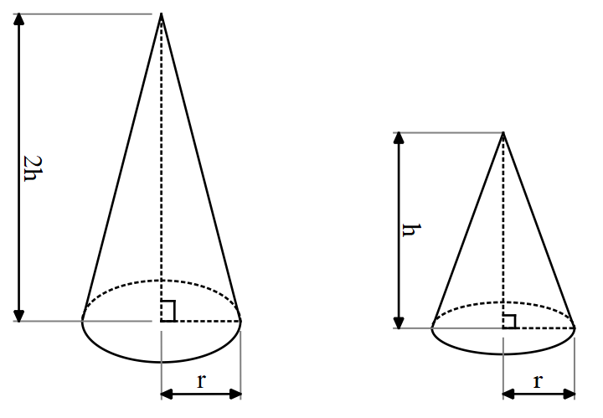
Is Jim correct? Give reasons to support your answer.

Working with triangles

Core
Question 1 (MA5-TRG-C-01)
Consider the statement below.
‘Every right-angled triangle with a ${45}^{o}$ angle will have 2 equal sides.’
Is this statement true? Explain why or why not.

Question 2 (MA5-TRG-C-01)
Find the value of $\sin{{37}^{o}}$ using $⊿ABC$.
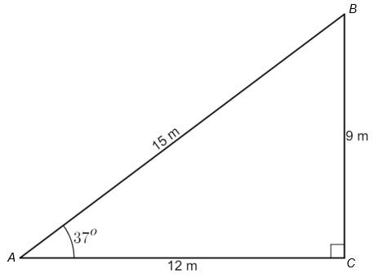

Question 3 (MA5-TRG-C-01)
By completing the right-angled triangle and measuring side lengths, find an approximation for the value of $\sin{{20}^{o}}$.
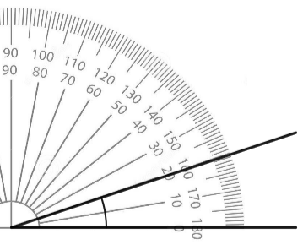
Question 4 (MA5-TRG-C-01)
Zoe can see a plane flying and knows that it cruises approximately 10 km above ground level. She measures the angle between the ground and her line of sight to the plane to be ${25}^{o}13'$, as shown in the image below.
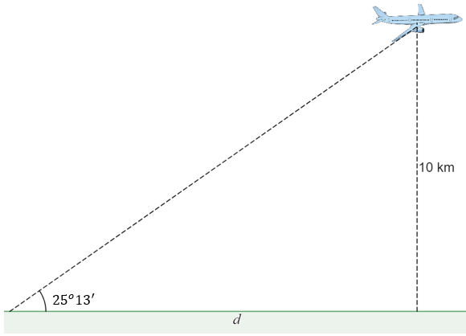
What is the distance of the plane from Zoe, measured along the ground, $d$?
Question 5 (MA5-LIN-C-01)
Consider the map below of a local park. The numbers in the Cartesian plane on the map represent metres.
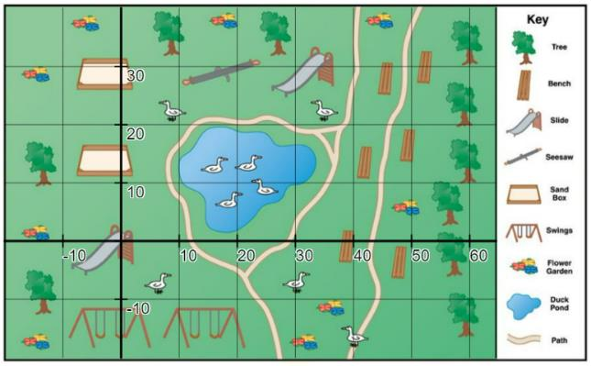
‘Map’ by Unknown is licensed under CC BY-NC-SA 4.0.
- You are standing at the slide at point (0,0) and you walk to the closest bench. How many metres have you walked?
- Draw a straight interval on the map joining the 2 slides. How far apart are the 2 slides? Express your answer rounded to three significant figures.
- What is the midpoint of the interval between the 2 slides, expressed as a coordinate? Describe what is at this location.

Question 6 (MA5-TRG-C-01)
Eva has attempted to find the value of $d$ in the diagram below. Her working is shown beneath the diagram.
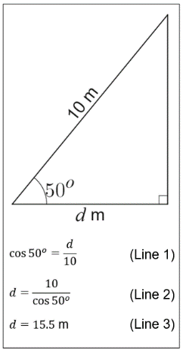
- Explain how Eva could know immediately that her answer is incorrect?
- Describe where Eva has made her mistake. What is the correct value of $d$, rounded to one decimal place?

Question 7 (MA5-LIN-C-01)
Consider the Cartesian plane below, with the line $l$ displayed.
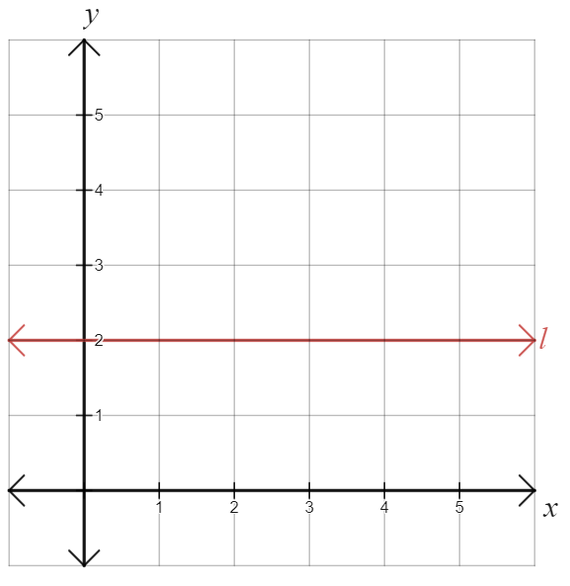
- Explain why the line $l$ has a gradient of 0.
- Explain why all horizontal lines will have a gradient of 0.

Question 8 (MA5-TRG-C-01)
To meet safety regulations, a ramp must rise at an angle no greater than $4^{o}$. A school needs to build a ramp to reach a classroom that is 2 metres off the ground, as shown in the diagram below.
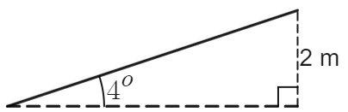
How long should the ramp be to meet the regulations?
Question 9 (MA5-TRG-C-01 and MA5-LIN-C-01)
The straight line $l$ shown on the Cartesian plane below has a gradient of 2.
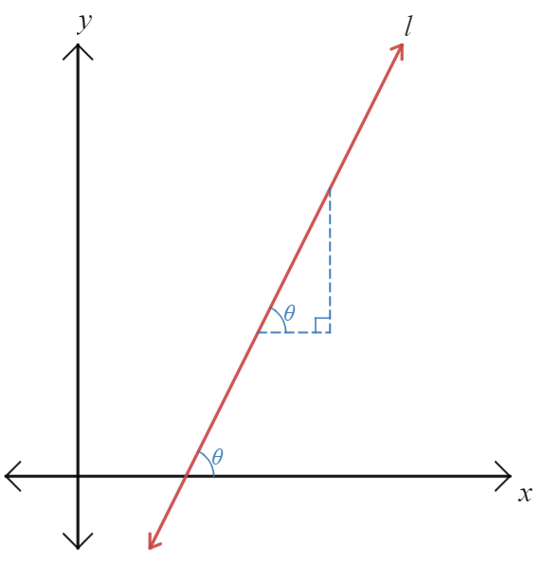
By writing values on the triangle and applying trigonometry, find the size of the angle that $l$ makes with the positive $x$-axis, $θ$, correct to the nearest minute.
Question 10 (MA5-TRG-C-01)
Find and record everything you can about the diagram below.
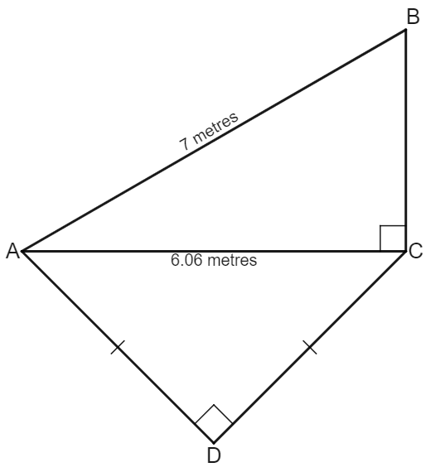

Question 11 (MA5-LIN-C-01 and MA5-LIN-P-01)
Three points are labelled on a Cartesian plane: $A(-1, 2)$, $B(-3, -6)$ and $C(3, 0)$. Which of the gradients $m_{AB}, m_{AC}$ or $m_{BC}$ is negative?

Path
Question 12 (MA5-TRG-C-01 and MA5-LIN-P-01)
The diagram below shows the line $l$ on the Cartesian plane, with the coordinates $A(2,4)$ and $B(4, b)$ shown. The gradient of the line $l$ is known to be $m_{AB}=\frac{1}{2}$. Find the value of $b$, giving reasons for your answer.
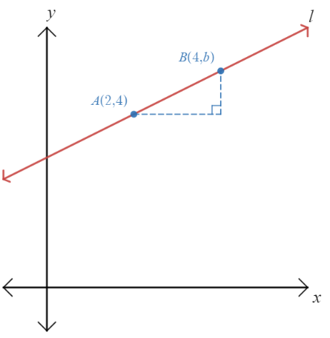

Question 13 (MA5-LIN-P-01)
Consider the Cartesian plane below, where the points $A(-3,0)$, $B(2,2)$, $C(4,-3)$ and $D(-1,-5)$ are displayed and connected, forming a square.
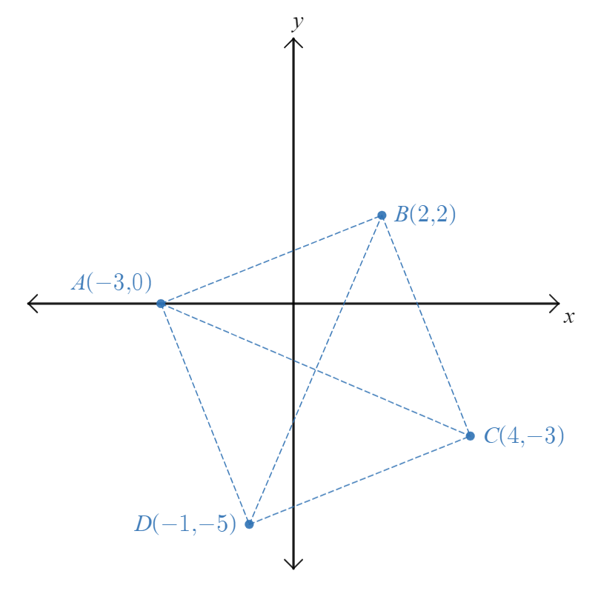
- What evidence do you have that this is a square?
- Find the coordinates of the midpoint $M(x,y)$ of the interval $AC$ and show that this is the same as the midpoint of the interval $BD$.
- You are standing at $M$ and need to travel from the point to visit each of the other points, $A$, $B$, $C$ and $D$ at least once. What is the shortest distance you can travel to visit each destination once, returning to $M$ at the end.

References
This resource contains NSW Curriculum and syllabus content. The NSW Curriculum is developed by the NSW Education Standards Authority. This content is prepared by NESA for and on behalf of the Crown in right of the State of New South Wales. The material is protected by Crown copyright.
Please refer to the NESA Copyright Disclaimer for more information https://educationstandards.nsw.edu.au/wps/portal/nesa/mini-footer/copyright.
NESA holds the only official and up-to-date versions of the NSW Curriculum and syllabus documents. Please visit the NSW Education Standards Authority (NESA) website https://educationstandards.nsw.edu.au/ and the NSW Curriculum website https://curriculum.nsw.edu.au/home.
Mathematics K–10 Syllabus © NSW Education Standards Authority (NESA) for and on behalf of the Crown in right of the State of New South Wales, 2022.

© State of New South Wales (Department of Education), 2023
The copyright material published in this resource is subject to the Copyright Act 1968 (Cth) and is owned by the NSW Department of Education or, where indicated, by a party other than the NSW Department of Education (third-party material).
Copyright material available in this resource and owned by the NSW Department of Education is licensed under a Creative Commons Attribution 4.0 International (CC BY 4.0) license.
This license allows you to share and adapt the material for any purpose, even commercially.
Attribution should be given to © State of New South Wales (Department of Education), 2023.
Material in this resource not available under a Creative Commons license:
- the NSW Department of Education logo, other logos and trademark-protected material
- material owned by a third party that has been reproduced with permission. You will need to obtain permission from the third party to reuse its material.
Links to third-party material and websites
Please note that the provided (reading/viewing material/list/links/texts) are a suggestion only and implies no endorsement, by the New South Wales Department of Education, of any author, publisher, or book title. School principals and teachers are best placed to assess the suitability of resources that would complement the curriculum and reflect the needs and interests of their students.
If you use the links provided in this document to access a third-party's website, you acknowledge that the terms of use, including licence terms set out on the third-party's website apply to the use which may be made of the materials on that third-party website or where permitted by the Copyright Act 1968 (Cth). The department accepts no responsibility for content on third-party websites.

