Mathematics Stage 5 (Year 9) – summative assessment package – annotated sample responses
Contents
Outcomes to be assessed 2
Marking guidelines 3
Approach to marking 3
Student marking sheet 5
Annotated sample responses 7
Prisms and cylinders 7
Working with triangles 41
References 69

This document is part 3 of 3 of a summative assessment package designed to assess the outcomes from Units 3 and 4 of the Department of Education’s Stage 5 (Year 9) sample scope and sequence [DOCX 258KB].
- Part 1: Question bank [DOCX 809KB]
- Part 2: Sample class test [DOCX 338KB]
- Part 3: Annotated sample responses

Outcomes to be assessed
Core outcomes being assessed:
- develops understanding and fluency in mathematics through exploring and connecting mathematical concepts, choosing and applying mathematical techniques to solve problems, and communicating their thinking and reasoning coherently and clearly MAO-WM-01
- determines the midpoint, gradient and length of an interval, and graphs linear relationships, with and without digital tools MA5-LIN-C-01
- applies trigonometric ratios to solve right-angled triangle problems MA5-TRG-C-01
- solves problems involving the surface area of right prisms and practical problems involving the area of composite shapes and solids MA5-ARE-C-01
- solves problems involving the volume of composite solids consisting of right prisms and cylinders MA5-VOL-C-01
Path outcomes being assessed:
- describes and applies transformations, the midpoint, gradient/slope and distance formulas, and equations of lines to solve problems MA5-LIN-P-01
- applies knowledge of the surface area of right pyramids and cones, spheres and composite solids to solve problems MA5-ARE-P-01
- applies knowledge of the volume of right pyramids, cones and spheres to solve problems involving related composite solids MA5-VOL-P-01
Mathematics K–10 Syllabus © NSW Education Standards Authority (NESA) for and on behalf of the Crown in right of the State of New South Wales, 2022.
The outcomes chosen are based on this assessment being implemented during Term 2 of the Department of Education’s Stage 5 (Year 9) sample scope and sequence [DOCX 258KB], after the unit ‘Prisms and cylinders’.

Marking guidelines
These annotated sample responses have been provided to support consistent and accurate teacher judgement.

Approach to marking
- Sample answers with marking guidelines have been provided on pages 7–68 and give examples of how to interpret responses against the Common Grade Scale (bit.ly/commongradescale).
- The annotations for each sample response determine a grade that has been demonstrated based on the Common Grade Scale (bit.ly/commongradescale). Justification for this determination is made by referencing the content points for the relevant outcome(s) and the Course performance descriptors (bit.ly/CoursePerformanceDescriptors).
- Not all questions provide an opportunity for students to demonstrate every grade level. The first sample response for each question, titled ‘Sample exemplar response’, is an example of the highest level of student response that could be predicted at the time of creating this assessment task. It is unlikely that a higher grade could be demonstrated in response to the question.
- It is intended that teachers review each student’s responses to all questions before determining the grade they have demonstrated in a particular outcome. In each outcome, students should be awarded the highest grade level at which they have demonstrated knowledge and skills.
- A ‘Student marking sheet’ has been provided on pages 5–6 to record the determined grades and give overall feedback to students.
- Opportunities to demonstrate skills with working mathematically processes are embedded in content focused questions. Some student responses will provide more evidence of a student’s aptitude with the working mathematically processes than their knowledge and skills with the mathematics content of the question.
- Versions of the working mathematically outcome MAO-WM-01 have been included on the student marking sheet so these responses can be assessed and possibly reported on.
Students frequently seek ways to reduce their written working without ‘losing marks’. While efficiency should be valued, students need to be empowered to make good decisions about what to include in their responses. The suggested marking guidelines acknowledge students providing relevant representations and elaborations that enhance the clarity or depth of their response. Students should be encouraged to use effective communication techniques to support and improve their answers.

Student marking sheet
Assign each student a grade from A–E based on their demonstrated ability as shown in the annotated sample responses.
Table 1 – assessment marking recording sheet
Grade | E | D | C | B | A
Core
develops understanding and fluency in mathematics through exploring and connecting mathematical concepts MAO-WM-01
develops understanding and fluency in mathematics through choosing and applying mathematical techniques to solve problems MAO-WM-01
develops understanding and fluency in mathematics through communicating their thinking and reasoning coherently and clearly MAO-WM-01
determines the midpoint, gradient and length of an interval, and graphs linear relationships, with and without digital tools MA5-LIN-C-01
applies trigonometric ratios to solve right-angled triangle problems MA5-TRG-C-01
solves problems involving the surface area of right prisms and practical problems involving the area of composite shapes and solids MA5-ARE-C-01
solves problems involving the volume of composite solids consisting of right prisms and cylinders MA5-VOL-C-01
Paths
describes and applies transformations, the midpoint, gradient/slope and distance formulas, and equations of lines to solve problems MA5-LIN-P-01
applies knowledge of the surface area of right pyramids and cones, spheres and composite solids to solve problems MA5-ARE-P-01
applies knowledge of the volume of right pyramids, cones and spheres to solve problems involving related composite solids MA5-VOL-P-01
Comments:

Annotated sample responses

Prisms and cylinders

Core
Question 1 (MA5-ARE-C-01)
Eli is 3D printing a ramp to ride his scooter over. His first design is below.
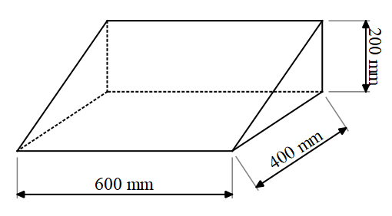
- What is the volume of material Eli will need to 3D print the ramp?
Sample exemplar response:
$$V=\frac{1}{2}×600×400×200 \\ V=24 000 000 mm^{3}$$
This student is demonstrating a sound knowledge of the content and is performing at a C grade level. The student has solved a routine problem of up to 3 steps by finding the volume of a triangular prism. They have effectively used symbols and working to represent the information in the diagram.

Sample response 2:
$$48 000 000$$
This student is demonstrating a limited knowledge of the content and is performing at an E grade level. The student has attempted to find the volume of the triangular prism; however, they have not recognised that the volume of a triangular prism would be half that of a rectangular prism. The student has not communicated their result using working, symbols, or units.
- Eli decides he wants the ramp to be twice as steep. Suggest one change he can make to the plan to achieve this and explain why you suggest that change.
Sample exemplar response:
Eli could either make the ramp shorter or taller. I would recommend making the ramp taller because if you made the ramp shorter it would be too short for him to ride his scooter up.
So, the new ramp would have dimensions 600 mm, 400 mm and 400 mm.
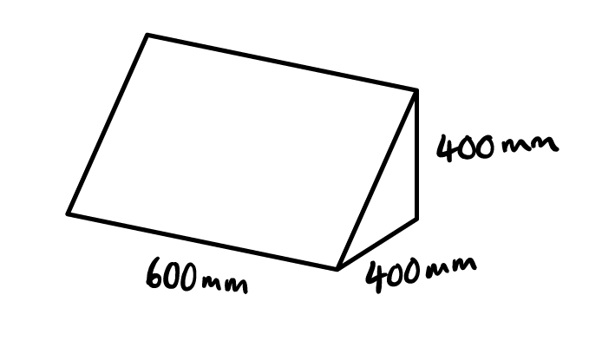
This student is demonstrating a thorough knowledge of the content and is performing at a B grade level. The student has solved a routine problem in an unfamiliar situation, requiring effective communication using appropriate mathematical language to communicate their reasoning and explain their solution.

Sample response 2:
Eli could double the height or the length because it would make it twice as steep.
This student is demonstrating a limited knowledge of the content and is performing at an E grade level. The student has suggested 2 possible changes, including doubling the height will make the ramp twice as steep. However, doubling the length would either decrease the steepness of the ramp or keep it the same which is not the desired result.

Question 2 (MA5-ARE-C-01 and MA5-VOL-C-01)
Consider the enclosed rectangular prism below, with width of 2 cm.
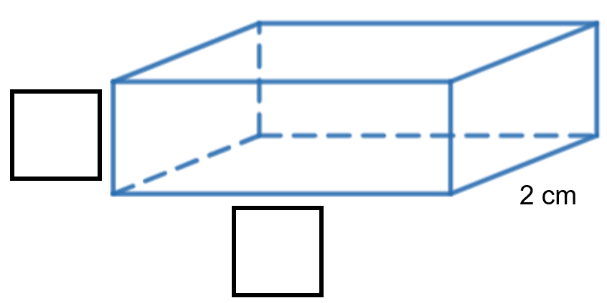
- Label the indicated length and height edges such that the volume of the prism is 24 cm³.
Sample exemplar response:
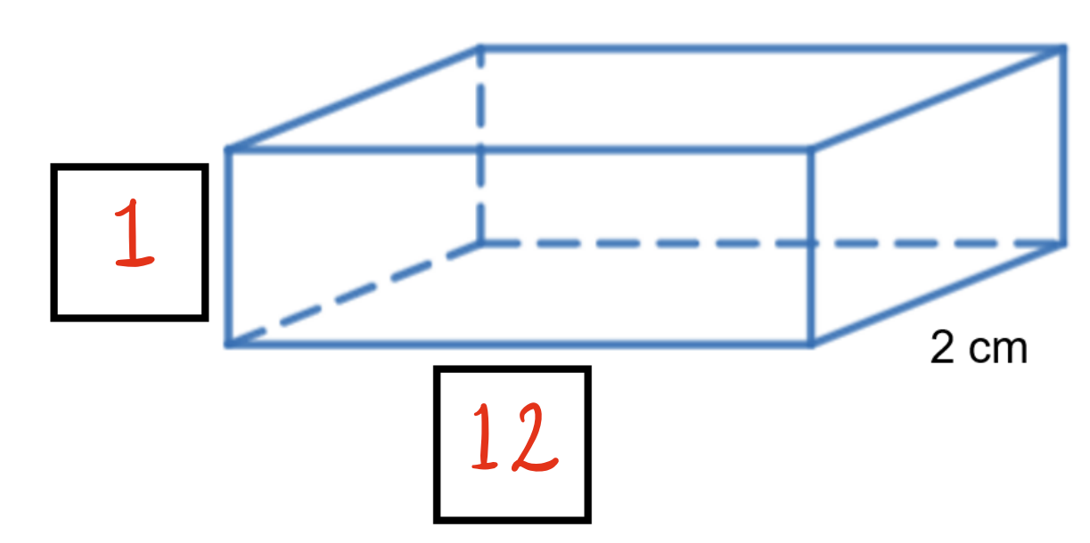
$$V=1×12×2 \\ V=24 cm^{3}$$
The student is demonstrating a sound knowledge of the content outcome MA5-VOL-C-01 and is performing at a C grade level. They have identified the connection between dimension and volume to solve an unfamiliar problem.
Sample response 2:
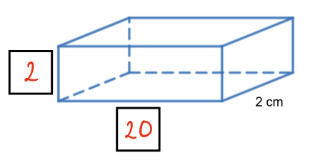
This student is demonstrating an elementary knowledge of the content outcome
MA5-VOL-C-01 and is performing at an E grade level. The student has labelled the length and height edges somewhat logically, identifying that one edge appears significantly longer. They have, however, incorrectly labelled numbers that will add to 24 cm, indicating a limited understanding of the multiplicative properties of volume.
- Calculate the surface area of the solid.
Sample exemplar response:
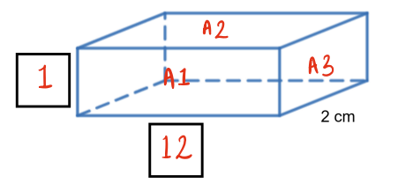
$$A1=1×12 \\ A1=12 \\ A2=2×12 \\ A2=24 \\ A3=2×1 \\ A3=2 \\ SA=2×12+2×24+2×2 \\ SA=76 cm^{2}$$
The student is demonstrating a thorough knowledge of the content outcome
MA5-ARE-C-01 and is performing at a B grade level. The student has used the labelled diagram as a representation before moving to written calculations. They have referred to these labels to help structure their response to correctly solve a routine problem of up to 3 steps. The student has effectively communicated their process through thorough working and reference to the diagram.
Sample response 2:
$$12, 24, 2 \\ SA=76 cm^{2}$$
The student is demonstrating a sound knowledge of the content outcome MA5-ARE-C-01 and is performing at a C grade level. They have correctly solved a routine problem of up to 3 steps. The student has communicated their thinking through some working and correct use of symbols and units.
- Are there any dimensions you could have chosen in part a where the volume would remain as 24 cm³, but the surface area would be smaller than your answer in part b? Give reasons for your answer.
Sample exemplar response:
3 and 4
$$A1=3×4 \\ A1=12 \\ A2=2×4 \\ A2=8 \\ A3=2×3 \\ A3=6 \\ SA=2×12+2×8+2×6 \\ SA=52 cm^{2}$$
A cube will always have a smaller surface area than a rectangular prism with the same volume, so I chose lengths closer together than in part a.
This student is demonstrating an extensive knowledge of the content and is performing at an A grade level. They have solved a routine problem of multiple steps when finding the surface area of a rectangular prism. The student has considered the connection between surface area and volume to guide their thinking. They have applied deductive reasoning to justify the side lengths chosen.
Sample response 2:
No because the surface area will be the same.
This student is demonstrating an elementary knowledge of the content and is performing at an E grade level. They have incorrectly assumed that 2 solids with the same volume must have the same surface area. The student has attempted to use informal mathematical reasoning to explain their answer.

Question 3 (MA5-ARE-C-01 and MA5-VOL-C-01)
A cube with a side length of 4 cm is painted blue on all 6 faces. It is cut into 64 smaller cubes with a side length of 1 cm each.
How many of these smaller cubes have exactly 2 blue faces?
Sample exemplar response:
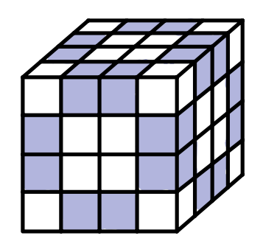

There will be 16 cubes on each face of the larger cube. Eight cubes on each face will have exactly 2 blue faces. All these faces will be shared with an adjacent face of the larger cube. By drawing a 3D cube cut into 64 smaller cubes, I was able to count 8 cubes on the top layer, 8 cubes in the middle 2 layers, and another 8 cubes on the bottom layer, which is a total of 24 cubes.
The student is demonstrating a thorough knowledge of the content and is performing at a B grade level. The student uses some connections between surface area and volume to correctly solve the non-routine problem. They have created and used a representation to support their reasoning, by considering the net of a cube, faces and edges. They use appropriate mathematical language effectively to communicate reasoning, explain solutions and justify results.

Sample response 2:
8 cubes with 2 blue faces on each face of the larger cube.
$$8×6=48$$
The student is demonstrating a sound knowledge of the content and is performing at a C grade level. The student identifies some connections between surface area of a solid and its net, in their attempt to solve a non-routine problem. They have used informal mathematical reasoning to justify their result. However, they have double counted cubes that are shared between 2 faces of the larger cube.

Question 4 (MA5-VOL-C-01)
The local council is designing ‘bee bricks’ to help support the local bee population. A bee brick is a brick with small cavities where bees can nest, as shown below. The brick itself is a rectangular prism with dimensions 20 cm long, 10 cm wide, and 6 cm high. Each cavity is a cylinder with a diameter of 1 cm and a depth of 5 cm.
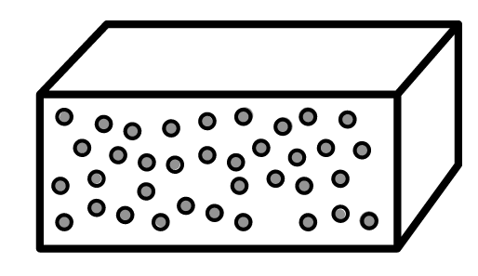
The council wants to maximize the number of cavities in each brick, but they also need to ensure that at least 85% of the brick's volume remains solid to maintain structural integrity.
Determine the maximum number of cavities they can include in each brick while maintaining the required structural integrity.
Sample exemplar response:
Brick volume:
$$V=20×10×6 \\ V=1200 cm^{3}$$
Cavity volume:
$$V=π×{0.5}^{2}×5 \\ V=\frac{5}{4}π cm^{3}$$
The volume of the brick needs to be at least 85%, which is $1020 cm^{3}$.
Cavities in 12$0 cm^{3}:$$$=180÷\frac{5}{4}π \\ =45.83662…$$Assuming they only use whole cavities, the maximum number of cavities in one brick is 45.

The student is demonstrating an extensive knowledge of the content and is performing at an A grade level. The student has demonstrated extensive understanding of composite solids involving prisms and cylinders. They have applied deductive reasoning to correctly solve a non-routine problem involving multiple steps. Their solutions and written explanations effectively communicate their thinking and justify their results, including when to round answers and why.

Sample response 2:
$$V_{rectangular prism}=1200 cm^{3} \\ V_{cylinder}=3.9 cm^{3}$$
Minimum brick volume
$$=1020 cm^{3}$$
$$\frac{Minimum volume}{Cylinder volume}$$
$$\frac{1020}{3.9}$$
$261.53846…$ cylinders.
This student is demonstrating a sound knowledge of the content and is performing at a C grade level. The student has demonstrated a sound understanding of composite solids involving prisms and cylinders to calculate the volume of the rectangular prism and cylinder. The student has used appropriate mathematical language to show their working. Their answer does not make logical sense given the context of the problem.

Question 5 (MA5-ARE-C-01 and MA5-VOL-C-01)
A company is designing new cylindrical packaging for their product. The packaging consists of a cylindrical body and 2 circular ends. The company has a budget that allows for a maximum of 400 cm² of material for the surface area of the packaging and a requirement that the packaging must hold a product volume of at least 500 cm³.
The design team has proposed a packaging design with a radius of 5 cm for the cylindrical body, but they are unsure of the height that they should choose.
Suggest a height for the packaging and explain why you suggested that height.
Sample exemplar response:
Max SA = 400 $cm^{2}$
Min V = 500 $cm^{3}$
$$r=5 cm$$
$h$ is unknown.
$$V=π×5^{2}×h \\ SA=2×π×5^{2}+2×π×5×h$$
$h$ required for minimum volume:
$$500=π×5^{2}×h \\ h=\frac{500}{π×5^{2}} \\ h=6.36620 cm$$Assuming they want to use the least amount of packaging, the company should use the smallest height possible while still having more than $500 cm^{3}$ volume. Which means $h≥6.36620 cm$ (rounded to 5 decimal places).
$$SA\left(6.36620\right)=2×π×5^{2}+2×π×5×6.36620 \\ SA\left(6.36620\right)=357.07970 cm^{2}$$
A height of $6.36620 cm$ will result in a volume of $500 cm^{3}$ and a surface area of approximately $357 cm^{2}$, which is the optimal height for the packaging.
This student is demonstrating an extensive knowledge of the content and is performing at an A grade level. They have demonstrated extensive understanding of the relationship between surface area and volume, using multiple connections between the 2 to solve a non-routine problem. The student has used precise mathematical language to communicate reasoning, explain solutions and justify results.

Sample response 2:
$$V=π×5^{2}×h \\ SA=2×π×5^{2}+2×π×5×h$$
If $h=5$, $V=392.69908$ which isn’t big enough.
If $h=10,$ $V=785.39816$ which is $>500$.
If $h=10,$ $SA=471.23890$which is $>400$, so $h$ needs to be less than 10 but greater than 5.
If $h=7,$ $V=549.77871$ which is $>500$.
If $h=10,$ $SA=376.991112$ which is $<400$.
So $h=7$ works for volume and surface area.
This student is demonstrating a thorough knowledge of the content and is performing at a B grade level. They have applied relevant formulas to test values and used informal mathematical reasoning to justify their results. They have identified and used connections between surface area and volume to identify a value that meets the requirements provided.

Question 6 (MA5-ARE-C-01 and MA5-VOL-C-01)
The pool shown below from a top and side view is to be built at a resort.
Figure 1 – top view
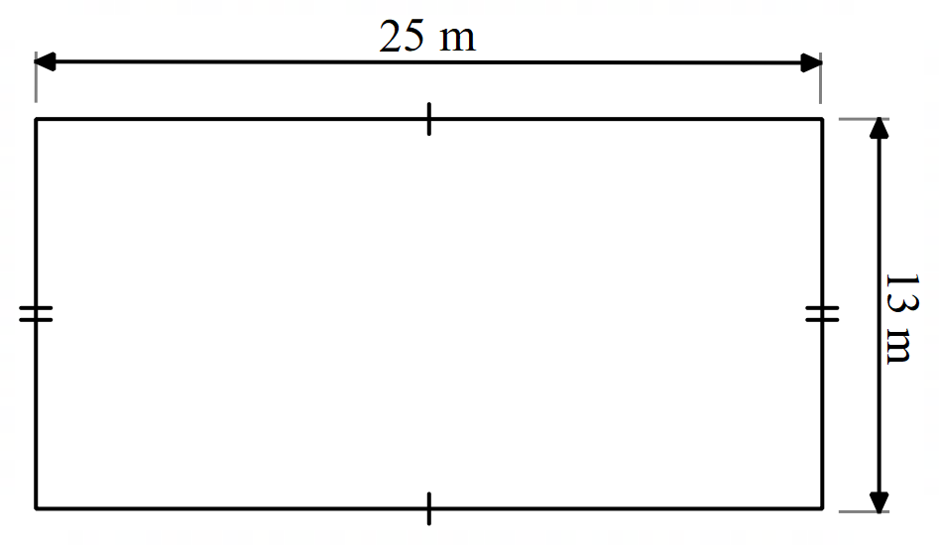
Figure 2 – side view
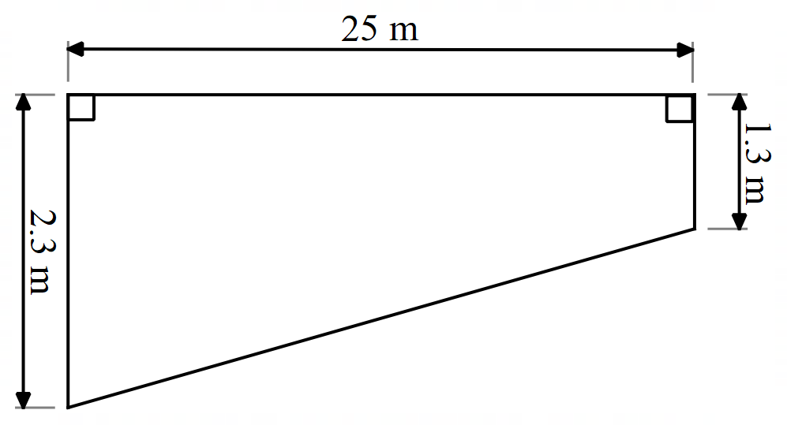
Find the capacity of the pool in litres.
Sample exemplar response:
$$Area=25×13 \\ Area=325 m^{2}$$
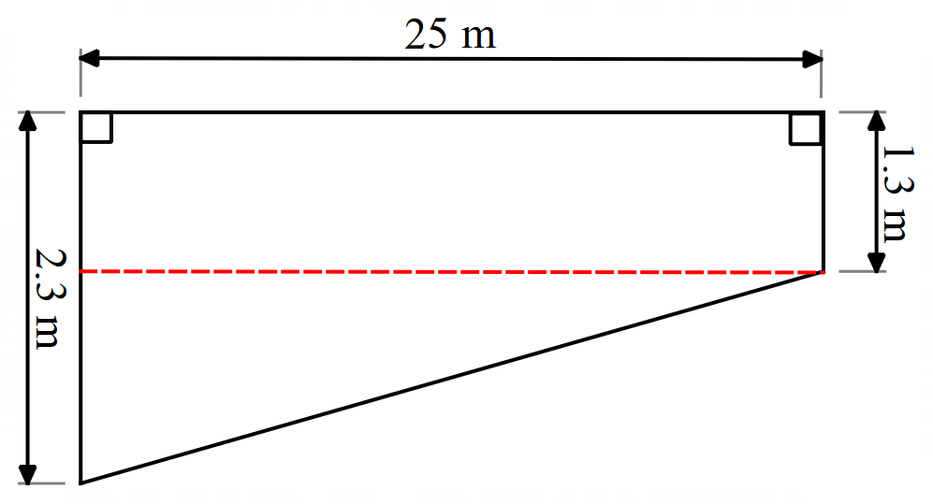
The pool depth is split into 2 parts, the rectangular prism and the triangular prism.
Capacity of 1.3 m depth:
$$=1.3×325 \\ =422.5 m^{3}$$
Capacity of 1.3 m to 2.3 m depth is a triangle, so we can find the capacity as if the depth was 1 m, then halve the answer.
$$=1×325 ×\frac{1}{2} \\ =162.5 m^{3}$$
So, the total capacity of the pool is $422.5+162.5$
$$=585 m^{3} \\ =585 kL$$
This student is demonstrating an extensive level of knowledge of the content and is performing at an A grade level. They have used, manipulated, and moved between visual and abstract representations to solve a routine problem involving multiple steps. Their working and mathematical language effectively communicates their reasoning and explains the solution obtained.

Sample response 2:
$$Area=325 m^{2}$$
$$V=325×2.3 \\ V=747.5 m^{3}$$
This student is demonstrating a basic knowledge of the content and is performing at a D grade level. They have correctly calculated the base area of the composite solid. They have incorrectly applied a consistent depth of the pool when calculating volume which demonstrates some understanding of the processes, but the student has struggled to use the visual representation. The student has left their answer as cubic metres, which is not the formal units of measurement used to describe capacity.

Question 7 (MA5-ARE-C-01 and MA5-VOL-C-01)
Four small cubes, each with a surface area of 54 cm² are placed together to make the solid shown. What is the volume of the solid created?
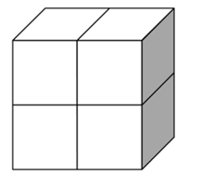
Sample exemplar response:
Each smaller cube has 6 faces, so each face has area: $\frac{54}{6}=9{cm}^{2}$.
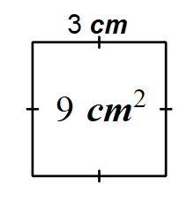
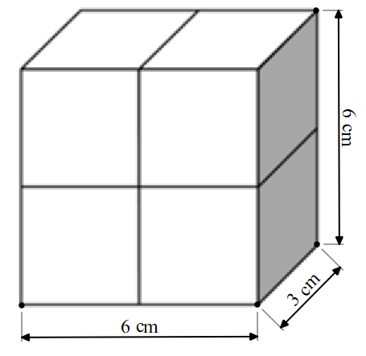
$$V=6×3×6 \\ V=108 cm^{3}$$
This student is demonstrating an extensive level of knowledge of the content and is performing at an A grade level. They have used, manipulated, and moved between visual and abstract representations to solve a non-routine problem. They have demonstrated an extensive understanding of the relationships between surface area and volume. They have used correct mathematical language such as edges and faces to explain their solution.
Sample response 2:
$$s=6 \\ V=6^{3} \\ V=216 cm^{3}$$
This student is demonstrating a sound level of knowledge of the content and is performing at a C grade level. The student has attempted a non-routine problem that requires understanding of the connections between surface area and volume. They have used appropriate working to effectively communicate their reasoning. The student could have further utilised the visual representation to verify that the created solid is not a cube.

Question 8 (MA5-ARE-C-01)
A marquee tent is constructed to the dimensions below.
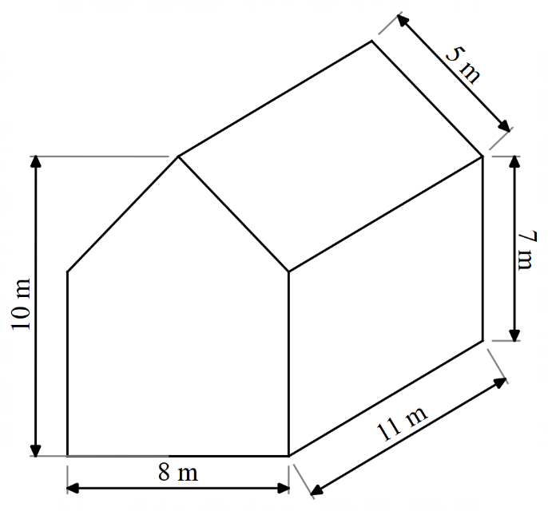
The material for the marquee costs $45 per $m^{2}$. How much will the construction of this marquee cost, without a floor.
Sample exemplar response:
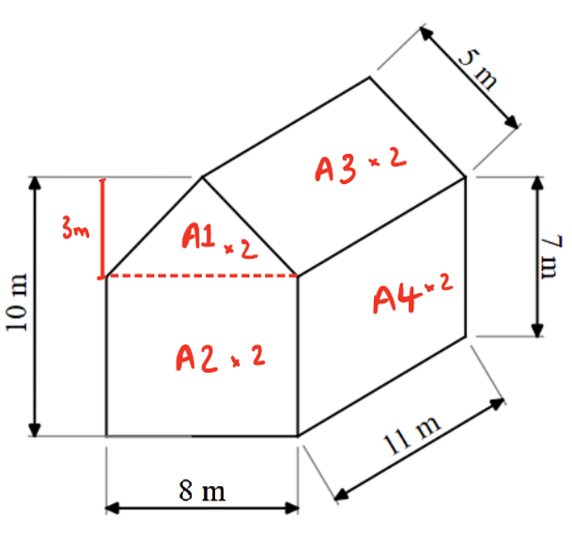
$$SA=2\left(\frac{1}{2}×8×3+8×7+11×7+5×11\right) \\ SA=400 m^{2} \\ Cost=400 ×45 \\ Cost=\$18 000$$

This student is demonstrating a thorough level of knowledge of the content and is performing at a B grade level. They have created, used, and moved between visual and abstract representations to communicate their reasoning. Their working clearly communicates the process they undertook.
Sample response 2:
$$SA=400$$
$$=18 000$$
This student is demonstrating a sound level of knowledge of the content and is performing at a C grade level. They have correctly used the visual representation to solve a routine problem of multiple steps. The student has not demonstrated use of mathematical language or symbols to communicate their reasoning or explain their solution.

Path
Question 9 (MA5-ARE-C-01 and MA5-VOL-C-01)
A company produces spherical chocolates, each with a volume of $4.5π$ $cm^{3}$. The company has 2 potential packaging options:
- Option 1: Four chocolates are arranged in a square, with edges touching and no space between each chocolate.
- Option 2: Four chocolates are arranged in a row, with edges touching and no space between each chocolate.
Both options will be packaged in a cardboard rectangular prism. Which packaging option would you recommend the company uses? Give reasons for your answer.
Sample exemplar response:
$$V=\frac{4}{3}×π×r^{3} \\ 4.5π=\frac{4}{3}×π×r^{3} \\ r^{3}=4.5×\frac{3}{4} \\ r=\sqrt[3]{4.5×\frac{3}{4}} \\ r=1.5 cm$$
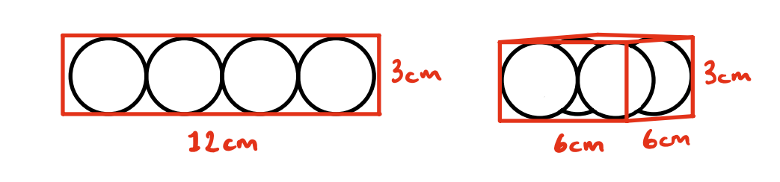
$${SA}_{1}=4×12×3+2×3×3 \\ {SA}_{1}=162 cm^{2} \\ {SA}_{2}=4×6×3+2×6×6 \\ {SA}_{2}=144 cm^{2}$$
The company should go with packaging option 2 as it uses less material (surface area) to hold the same number of chocolates.
This student is demonstrating an extensive level of knowledge of the content and is performing at an A grade level. They have created, used, and moved between visual and abstract representations to communicate their reasoning. They have demonstrated extensive understanding of the relationship between surface area and volume, using multiple connections between the 2 to solve a non-routine problem. The student has used precise mathematical language to communicate reasoning, explain solutions and justify results.

Sample response 2:
The company should choose the square option because the width of the box would be closer to the height as opposed to the row option. A square will always have the optimal volume for a right prism with the least surface area, so getting the shape as close to a square as possible will be the best option.
This student is demonstrating a sound knowledge of the content and is performing at a C grade level. They have informally provided reasoning to justify their solution, which indicates a sound understanding of the relationship between surface area and volume. The student has used informal mathematical language to communicate reasoning and explain their solution.

Question 10 (MA5-ARE-P-01)
Tennis balls are sold in cylinders of 3 balls that fit perfectly inside so that the height of the 3 spheres is equal to the height of the cylinder, and each ball touches the cylinder wall.
Will the height of a cylinder that holds 3 tennis balls be greater than or less than its circumference?
Sample exemplar response:
The height of the cylinder is equal to 3 diameters of the balls.
The circumference of the cylinder is equal to $π$ times the diameter of the balls.
$π≈3.14$
$$∴π>3$$
So, the height of the cylinder (3 diameters) will be less than its circumference ($π$diameters).
This student is demonstrating an extensive level of knowledge of the content and is performing at an A grade level. The student uses multiple connections between spheres and cylinders to solve a non-routine problem. They have used precise mathematical language and symbols to communicate reasoning and explain their solution.

Sample response 2:
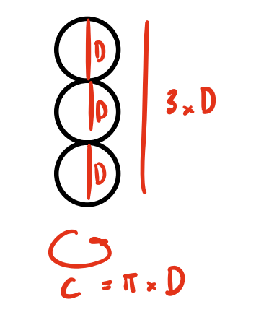
$π=3.14….$ which is bigger than 3.
This student is demonstrating a thorough level of knowledge of the content and is performing at a B grade level. The student uses multiple connections between spheres and cylinders to solve a non-routine problem. They have created and used a visual representation to communicate their reasoning and applied language to explain their solution but they have not used effective communication to clearly state that height will be less than the circumference.

Question 11 (MA5-ARE-P-01 and MA5-VOL-P-01)
Two identical spherical balls fit exactly inside a cylinder as shown below.
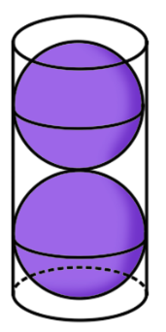
Given that the circumference of the cylinder is 30 cm:

- Find the surface area of the cylinder, rounding your answer to 2 decimal places.
Sample exemplar response:
$$C=π×D \\ 30=π×D \\ D=\frac{30}{π} \\ D=9.54930 \\ r=4.77465 \\ SA=2πrh+2πr^{2} \\ h=2D \\ h=19.09859 \\ SA=716.19746 \\ SA=716.20 cm^{2}$$
This student is demonstrating an extensive level of knowledge of the content and is performing at an A grade level. The student uses multiple connections between spheres and cylinders to solve a non-routine problem. They have demonstrated understanding of the relationships between cylinders and spheres to recognise the values required to find the surface area of the cylinder. They have shown their reasoning through logical steps of working that explain their solution.
Sample response 2:
$$r=15 cm$$
$$h=60 cm$$
$$SA=7068.58 cm^{2}$$
This student is demonstrating a basic level of knowledge of the content and is performing at a D grade level. The student has incorrectly identified the radius as half of the circumference and has similarly identified the height to be double the circumference. They have shown some understanding of the connections between spheres and cylinders, however, their solution shows limited reasoning.
- Find the percentage of empty space in the cylinder.
Sample exemplar response:
Each ball:
$$V=\frac{4}{3}πr^{3} \\ V=\frac{4}{3}×π×{4.77465}^{3} \\ V=455.94582 cm^{3}$$
Cylinder:
$$V=πr^{2}h \\ V=π×{4.77465}^{2}×19.09859 \\ V=1367.83673 cm^{3}$$
Empty space:
$$=1367.83673-2×455.94582$$
$$=455.94509 cm^{3}$$
This makes sense because the volume of a cylinder = 3 spheres with the same radius.
Percentage:
$$Empty= \frac{455.94509}{1367.83673} \\ Empty=0.33333 \\ Empty=33.33\%$$
This student is demonstrating an extensive level of knowledge of the content and is performing at an A grade level. They have solved a routine problem of multiple steps. Their working is clearly constructed to communicate their reasoning and demonstrates a strong understanding of the connection between volume and empty space.

Sample response 2:
Empty space = Cylinder – 2 × balls
$$716.20-2×455.94582 \\ 195.69164$$
$$\frac{195.69164}{716.20}$$
$$0.27324$$
$$27.32\%$$
This student is demonstrating a basic level of knowledge of the content and is performing at a D grade level. The student has demonstrated some capacity to solve routine problems involving surface area and volume. In this instance, they have used the surface area calculated in part a to calculate empty space, demonstrating a lack of reasoning.

Question 12 (MA5-ARE-P-01 and MA5-VOL-P-01)
A sink has been designed by cutting a rectangular-based pyramid from a rectangular prism, with equal depth.
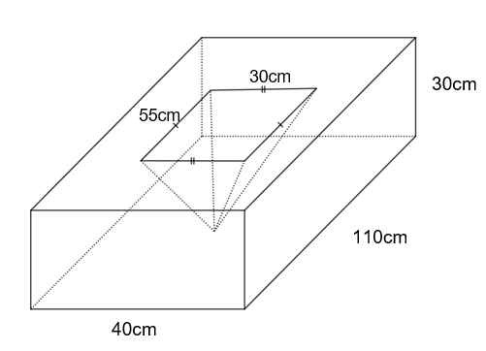
- Find the capacity of the sink. Round your answer to the nearest litre.
Sample exemplar response:
$$V=\frac{1}{3}×55×30×30 \\ V=16 500 cm^{3} \\ V=16.5 L$$
This student is demonstrating a sound level of knowledge of the content and is performing at a C grade level. The student has solved a routine problem of up to 3 steps in a familiar situation. Their working clearly communicates their reasoning and how they reached their solution.
Sample response 2:
Capacity is $16 500$
This student is demonstrating a basic level of knowledge of the content and is performing at a D grade level. The student has likely correctly calculated volume but does not know how to convert from cubic metres to litres. 16500 litres is an unreasonable capacity for a sink and thus shows a lack of reasoning.
- Find the volume of the marble slab.
Sample exemplar response:
$$V=40×110×30-16500 \\ V=115500 cm^{3}$$
This student is demonstrating a sound level of knowledge of the content and is performing at a C grade level. The student has solved a routine problem involving composite solids, of up to 3 steps. Their working communicates their reasoning and explains their solution.
Sample response 2:
$$V=40×110×30$$
$$V=132000 cm^{3}$$

This student is demonstrating a basic level of knowledge of the content and is performing at a D grade level. The student has attempted a routine problem of up to 3 steps. They have calculated the volume of the rectangular prism but have not considered the pyramid which is cut from the rectangular prism.
Question 13 (MA5-ARE-P-01 and MA5-VOL-P-01)
The solid shown below was obtained by cutting off a small square pyramid with a height of 5 cm from the top of a larger square pyramid with a height of 10 cm.
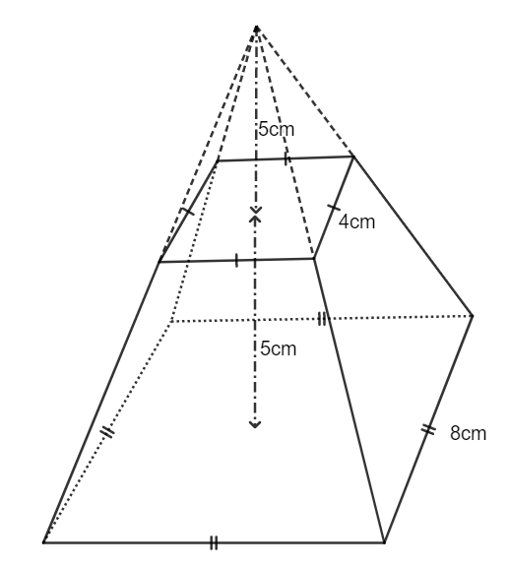
- Find the volume of the solid.

Sample exemplar response:
Frustum = Big pyramid – smaller pyramid
$$V=\frac{1}{3}×8^{2}×10 \\ V=213.33333$$
$$V=\frac{1}{3}×4^{2}×5 \\ V=26.66667$$
$$V=213.33333-26.66667 \\ V=186.66667 \\ V=186.67 cm^{3}$$
This student is demonstrating a thorough knowledge of the content and is performing at a B grade level. The student has solved a routine problem involving multiple steps. They have identified the significant properties of a pyramid to find the volume of the frustrum. Their working effectively communicates their reasoning and explains their solution.
Sample response 2:
$$V=\frac{1}{3}×8^{2}×5$$
$$V=106.67 cm^{3}$$
This student is demonstrating a limited knowledge of the content and is performing at an E grade level. The student has recognised the significant properties required to find the volume of a pyramid. However, they have incorrectly applied the formula and have used very limited working to explain their solution.

- Find the surface area of the solid.
Sample exemplar response:
Need lateral heights
Big lateral height:
$$h=\sqrt{4^{2}+{10}^{2}}$$
$$h=10.77033$$
Small lateral height:
$$h=\sqrt{2^{2}+5^{2}} \\ h=5.38516$$
Triangle area:
$$A=\frac{1}{2}×8×10.77033-\frac{1}{2}×4×5.38516 \\ A=32.311 \\ SA=32.311×4+8^{2}+4^{2} \\ SA=112.31 cm^{2}$$
This student is demonstrating an extensive knowledge of the content and is performing at an A grade level. The student has solved a routine problem involving multiple steps. They have identified the significant properties of a pyramid to find the surface area of the frustrum. Their working effectively communicates their reasoning and explains their solution.
Sample response 2:
$$SA=\frac{1}{2}×5×8×4+8^{2}+4^{2} \\ SA=160 cm^{2}$$
This student is demonstrating a basic knowledge of the content and is performing at a D grade level. They have attempted a routine problem of up to 3 steps, requiring them to find the area of both squares and the triangular faces. The student has attempted to use the surface area formula for a pyramid; however, they have not identified the need to calculate the slant height of the triangular faces. Their working provides limited communication or reasoning.

Question 14 (MA5-ARE-P-01 and MA5-VOL-P-01)
- Using the digits 1 to 9 at most one time each, place a digit in each box to list the dimensions of a rectangular prism and rectangular pyramid so that both shapes have equal volumes.
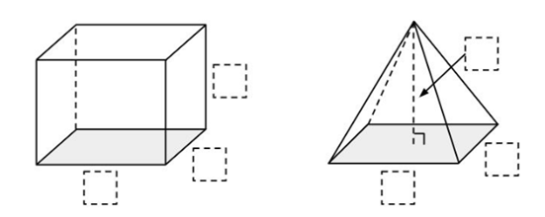
Sample exemplar response:
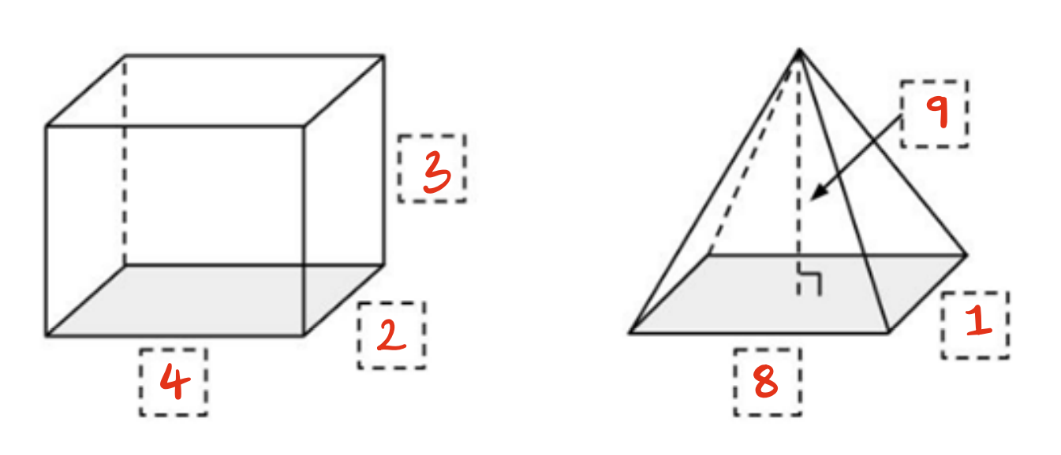
Both solids have a volume of 24 cubic units.

Sample response 2:
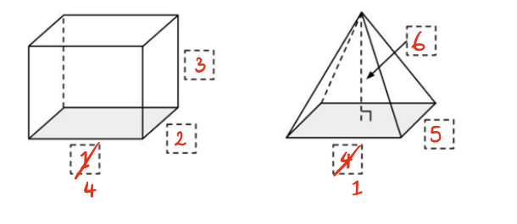
A grade has not been assigned to part a. Responses are assessed in part b.

- Explain the strategy you used to solve or attempt this problem.
Sample exemplar response:
Because the volume of a pyramid is $V=\frac{1}{3}Ah$ I knew that one of the numbers in the pyramid must be a multiple of 3 to avoid decimals. I chose 9 so that I could use 3 for the rectangular prism, meaning that the 2 numbers left for each solid would be equal.
This student is demonstrating a thorough knowledge of the content and is performing at a B grade level. The student has solved a non-routine problem requiring a strong understanding of the connection between volumes of a rectangular prism and a pyramid.
Sample response 2:
I started with 1, 2, 3 and 4, 5, 6 which got 6 and 40. So I swapped 4 and 1 to try and balance it out and got 24 and 10. Then I gave up.
This student is demonstrating a limited knowledge of the content and is performing at an E grade level. The student has attempted to use informal mathematical reasoning and limited language to explain their reasoning.

Question 15 (MA5-ARE-P-01 and MA5-VOL-P-01)
An open ice cream cone is modelled on the cone below.
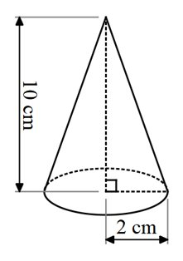
Find the surface area of the ice cream cone.
Sample exemplar response:
$$SA=πrl \\ l=\sqrt{2^{2}+{10}^{2}}$$
$$l=10.19804 cm$$
$$SA=64.07618$$
$$SA=64.08 cm^{2}$$
This student is demonstrating a thorough knowledge of the content and is performing at a B grade level. The student has solved a routine problem involving up to 3 steps, in an unfamiliar situation. The student identified the need to find the slant height in order to find the surface area of the cone. The student recognised that the base of the cone would not be included in the surface area. Their working clearly communicates their reasoning and the steps taken to reach their solution.
Sample response 2:
$$SA=πr^{2}+πrl \\ l=\sqrt{2^{2}+{10}^{2}}$$
$$l=10.19804 cm$$
$$SA=76.64255$$
$$SA=76.64 cm^{2}$$
This student is demonstrating a thorough knowledge of the content and is performing at a C grade level. The student has solved a routine problem but has not accounted for the unfamiliar situation. They found the surface area for the cone, including its base which would not make sense given the context.

Question 16 (MA5-ARE-P-01 and MA5-VOL-P-01)
Jim says that if one cone has twice the height of a smaller cone, as shown below, it will also have double the volume and surface area.
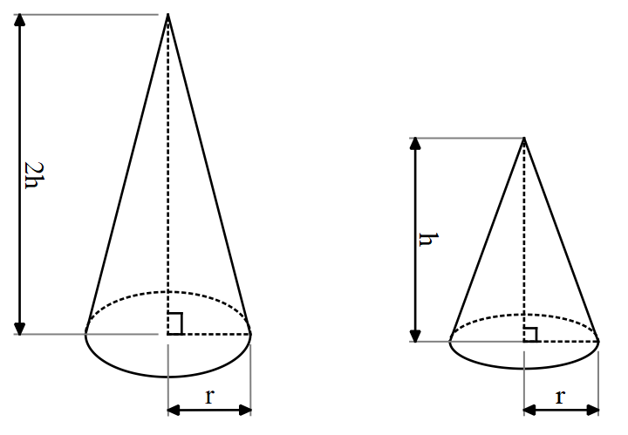
Is Jim correct? Give reasons to support your answer.

Sample exemplar response:
$V=\frac{1}{3}×π×r×2h$ is equal to $2(\frac{1}{3}×π×r×h)$ so it will have double the volume.
$πr^{2}$ doesn’t change for either cone, so $SA=πrl$ is the only thing that matters.
For $2h$ cone:
$$l=\sqrt{{\left(2h\right)}^{2}+r^{2}}$$
$$SA=πr^{2}+πr\left(\sqrt{{\left(2h\right)}^{2}+r^{2}}\right)$$
For $h$ cone:
$$l=\sqrt{h^{2}+r^{2}}$$
$$SA=πr^{2}+πr\left(\sqrt{h^{2}+r^{2}}\right)$$
$$\sqrt{{\left(2h\right)}^{2}+r^{2}}≠2(\sqrt{h^{2}+r^{2}})$$
$∴$ Jim is incorrect, a cone with double the height of another cone will have double the volume but not double the surface area.
This student is demonstrating an extensive knowledge of the content and is performing at an A grade level. The student has clearly communicated their reasoning and justified their solution to solve a non-routine problem. The student has applied deductive reasoning and concise, formal mathematical arguments to prove and justify why Jim is incorrect.

Sample response 2:
When $r=1$ and $h=1$,
$$V\left(2h\right)=\frac{1}{3}×1×1×2=\frac{2}{3}$$
$$V=\left(h\right)=\frac{1}{3}×1×1=\frac{1}{3}$$
$$SA\left(2h\right)=π×1\left(1+\sqrt{2^{2}+1^{2}}\right)=10.166407$$
$$SA\left(h\right)=π×1\left(1+\sqrt{1^{2}+1^{2}}\right)=7.58448$$
No, Jim is incorrect.
This student is demonstrating a sound knowledge of the content and is performing at a C grade level. The student has attempted to solve a non-routine problem by considering specific values for surface area and volume. The student has used informal mathematical reasoning to justify their solution, but has not generalised the result.

Working with triangles

Core
Question 1 (MA5-TRG-C-01)
Consider the statement below.
‘Every right-angled triangle with a ${45}^{o}$ angle will have 2 equal sides.’
Is this statement true? Explain why or why not.
Sample exemplar response:
The statement is true. If the triangle is right-angled, it has a ${90}^{o}$ angle in addition to the ${45}^{o}$ angle. The third angle will then be equal to ${180}^{o}-{90}^{o}-{45}^{o}={45}^{o}$, as the angle sum of a triangle is ${180}^{o}$.
Triangles with exactly 2 equal angles will have exactly 2 equal sides. In this case, the hypotenuse is the side that is not equal to the other 2 sides.
This student is demonstrating a thorough knowledge of the content and is performing at a B grade level. The student has used appropriate mathematical language effectively to explain the rule and provides reasoning as to why it is always true, citing relevant rules.
Sample response 2:
The statement is true. Every right-angled triangle with a ${45}^{o}$ angle will have one side different and the other 2 equal.
This student is demonstrating a sound knowledge of the content and is performing at a C grade level. The student has used adequate mathematical language and states correct facts about the nature of the triangles in question, but does not provide any reasons, formal or informal, for this result.

Question 2 (MA5-TRG-C-01)
Find the value of $\sin{{37}^{o}}$ using $⊿ABC.$
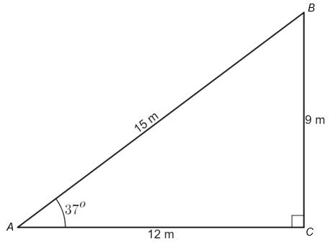
Sample exemplar response:
$$\sin{θ}=\frac{opposite}{hypotenuse}$$
$$\sin{{37}^{o}}=\frac{9}{15}$$
This student is demonstrating a sound knowledge of the content and is performing at a C grade level. The student has solved a routine problem of less than 3 steps, correctly identifying the sine ratio and using the right-angled triangle to find an approximation to the ratio.
Sample response 2:
$$\sin{{37}^{o}}=\frac{15}{9}$$
This student is demonstrating a basic knowledge of the content and is performing at a D grade level. The student has attempted to solve a routine problem of less than 3 steps, incorrectly identifying the sine ratio.

Question 3 (MA5-TRG-C-01)
By completing the right-angled triangle and measuring side lengths, find an approximation for the value of $\sin{{20}^{o}}$.
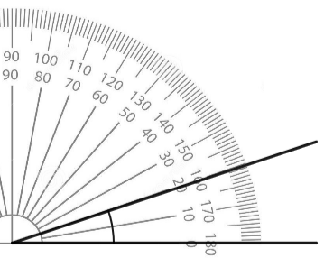
Sample exemplar response:
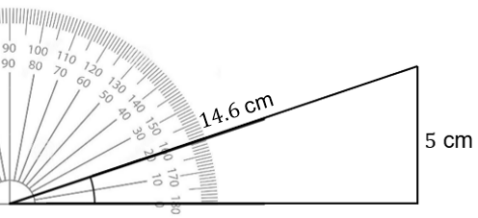
$$\sin{{20}^{o}}=\frac{5}{14.6} \\ =\frac{50}{146} \\ =\frac{25}{73}$$
This student is demonstrating a thorough knowledge of the content and is performing at a B grade level. They have solved a potentially routine problem of less than 3 steps in correctly finding an approximation to a trigonometric ratio for a given angle. They have used mathematical notation effectively to communicate their working.

Sample response 2:
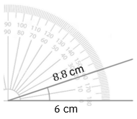
$$\sin{{20}^{o}}=\frac{6}{8.8}$$
This student is demonstrating an elementary knowledge of the content and is performing at an E grade level. They have attempted a potentially routine problem and recognised some features of trigonometric concepts, such as how trigonometric ratios use angles and give fractions as results.
Question 4 (MA5-TRG-C-01)
Zoe can see a plane flying and knows that it cruises approximately 10 km above ground level. She measures the angle between the ground and her line of sight to the plane to be ${25}^{o}13'$, as shown in the image below.
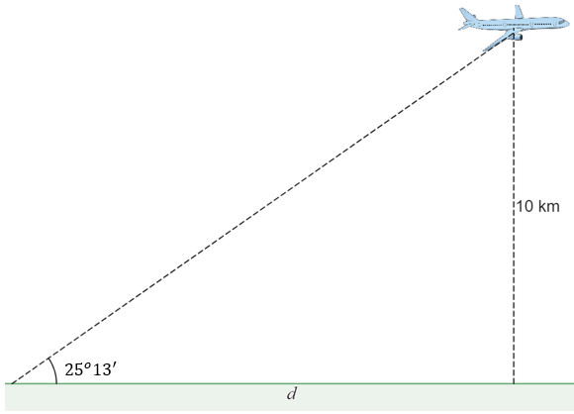
What is the distance of the plane from Zoe, measured along the ground, $d$?
Sample exemplar response:
$$\tan{θ}=\frac{opposite}{adjacent}$$
$$\tan{{25}^{o}{13}^{'}}=\frac{10}{d}$$
$$d=\frac{10}{\tan{{25}^{o}13'}}$$
$d=21.24$ km
This student is demonstrating a sound knowledge of the content and is performing at a C grade level. They have solved a routine problem of multiple steps when finding a missing side in a right-angled triangle using trigonometry. The student’s work should be monitored for the consistency with which they have been able to successfully solve related problems in any of questions 8, 9 and 10, as well as through performance in class.

Sample response 2:
$$\tan{{25}^{o}{13}^{'}}=\frac{10}{d}$$
$$d=10\tan{{25}^{o}13'}$$
$d=4.7$ km
This student is demonstrating a basic knowledge of the content and is performing at a D grade level. The student has attempted this routine problem with some success, correctly identifying and writing the trigonometric ratio and taking steps to solve.

Question 5 (MA5-LIN-C-01)
Consider the map below of a local park. The numbers in the Cartesian plane on the map represent metres.
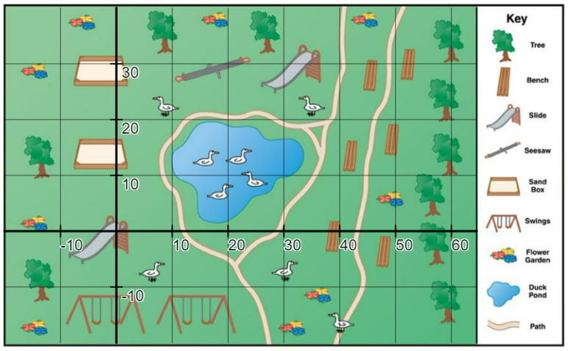
‘Map’ by Unknown is licensed under CC BY-NC-SA 4.0.
- You are standing at the slide at point (0,0) and you walk to the closest bench. How many metres have you walked?
Sample exemplar response:
From (0,0) to (39,0) is $39-0=39$ metres.
This student is demonstrating a sound knowledge of the content and is performing at a C grade level. The student uses mathematical language and notation when referring to coordinates in the Cartesian plane.

Sample response 2:
From $\left(0,0\right)$ to $(0,12)$ is $12-0=12$ metres.

This student is demonstrating an elementary knowledge of the content and is performing at an E grade level. They have referred to coordinates appropriately but have had difficulty identifying locations in a Cartesian plane correctly. This response provides limited evidence of aptitude in the outcome MA5-LIN-C-01.
- Draw a straight interval on the map joining the 2 slides. How far apart are the 2 slides? Express your answer rounded to 3 significant figures.
Sample exemplar response:
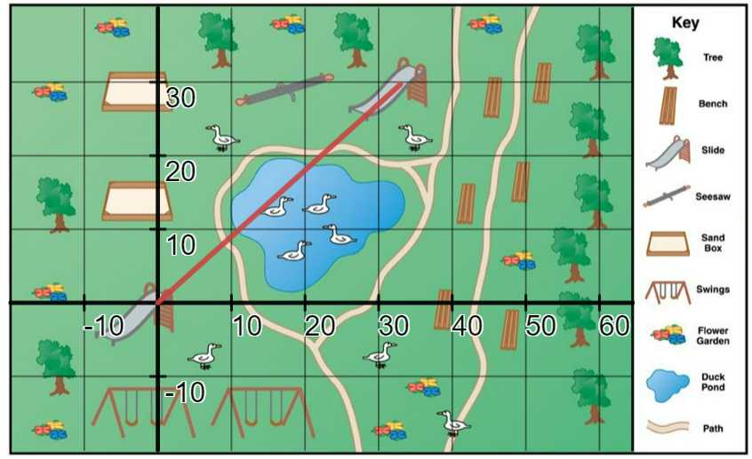
The 2 slides are at points $\left(0,0\right)$ and $(33, 30)$.
Let the distance between the 2 slides be $d$.
$$d^{2}={33}^{2}+{30}^{2} \\ =1089+900 \\ =1989$$
$$d=\sqrt{1989} \\ =44.5982$$$=44.6$ metres
This student is demonstrating a thorough knowledge of the content and is performing at a B grade level. They have successfully solved a routine problem of multiple steps in a potentially unfamiliar situation, forming a right-angled triangle and applying Pythagoras’ theorem to determine the length of the interval between 2 locations.
Sample response 2:
$$d=33+30$$
$=63$ metres
This student is demonstrating an elementary knowledge of the content and is performing at an E grade level. The student may have recognised the concept of distance and is attempting to describe the distance of a way around the pond to the slide.
- What is the midpoint of the interval between the 2 slides, expressed as a coordinate? Describe what is at this location.
Sample exemplar response:
$$M=\left(\frac{33}{2},\frac{30}{2}\right) \\ =(16.5,15)$$
This location is right in the middle of the duck pond.
This student is demonstrating a thorough knowledge of the content and is performing at a B grade level. They have solved a routine problem of less than 3 steps in a potentially unfamiliar situation, using a basic calculation for the mean to locate and describe a midpoint.
Sample response 2:
The midpoint of the interval lands in the duck pond.
This student is demonstrating a basic knowledge of the content and is performing at a D grade level. While it is possible they have successfully located the midpoint and understand this concept, they have used limited mathematical language to describe the location of the midpoint.
Question 6 (MA5-TRG-C-01)
Eva has attempted to find the value of $d$ in the diagram below. Her working is shown beneath the diagram.
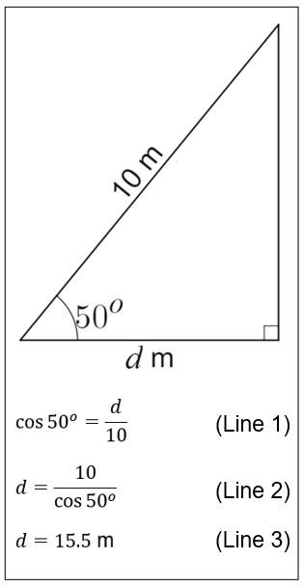
- Explain how Eva could know immediately that her answer is incorrect?
Sample exemplar response:
$d$ cannot be longer than the hypotenuse of the triangle, which is 10 metres. The value of 15.5 metres is too long.
This student is demonstrating a sound knowledge of the content and is performing at a C grade level. They have identified connections between Pythagoras’ theorem and the trigonometric working displayed in the worked example. This response provides limited evidence of aptitude in the outcome MA5-TRG-C-01.
Sample response 2:
The length $d$ is too long.
This student is demonstrating a basic knowledge of the content and is performing at a D grade level. The student has correctly identified the relevant features of right-angled triangles. They have used limited mathematical language to give reasoning to support their response. This response provides limited evidence of aptitude in the outcome
MA5-TRG-C-01.
- Describe where Eva has made her mistake. What is the correct value of $d$, rounded to one decimal place?
Sample exemplar response:
In Line 2, Eva has rearranged the equation incorrectly. It should be $d=10\cos{{50}^{o}}$.
The solution should then be $d=6.427876$, or $d=6.4$ metres, correct to one decimal place.
This student is demonstrating a thorough knowledge of the content and is performing at a B grade level. The student has used appropriate mathematical language effectively to explain their solution and solve a problem of less than 3 steps, finding a missing side in a right-angled triangle through application of trigonometry.
Sample response 2:
Line 1 is incorrect, it should be ‘sin’.
The solution should be $d=\frac{10}{\sin{{50}^{o}}}$, or $d=13.1$ metres.
This student is demonstrating an elementary knowledge of the content and is performing at an E grade level. The student has used limited mathematical language, using only the language already in the question, with the addition of the concept of ‘sin’.
Question 7 (MA5-LIN-C-01)
Consider the Cartesian plane below, with the line $l$ displayed.
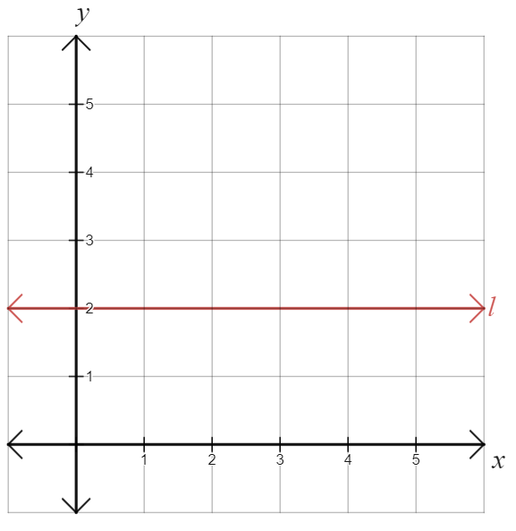
- Explain why the line $l$ has a gradient of 0.
Sample exemplar response:
The ‘rise’ of the line is equal to 0, no matter what ‘run’ we choose. For example, the line travels from coordinate $(0,2)$ to $(3,2)$ where $rise=0$ and $run=3$.
The gradient is $m=\frac{0}{3}=0$.
This student is demonstrating a thorough knowledge of the content and is performing at a B grade level. They have used appropriate mathematical language to communicate reasoning of why this horizontal line has a gradient of 0.
Sample response 2:
The gradient is equal to 0 because the line does not go up or down.
This student is demonstrating a basic knowledge of the content and is performing at a D grade level. The student has used informal mathematical reasoning and limited mathematical language to explain why this horizontal line has a gradient of 0.
- Explain why all horizontal lines will have a gradient of 0.
Sample exemplar response:
For any 2 points on a horizontal line, the $y$ values will be the same, and the distance between them will be zero. Every horizontal line will have a ‘rise’ of 0, no matter what ‘run’ we choose, and so $m=\frac{rise}{run}=\frac{0}{run}=0$.
This student is demonstrating a thorough knowledge of the content and is performing at a B grade level. They have used somewhat formal mathematical reasoning and appropriate mathematical language to prove that every horizontal line has a gradient of 0.
Sample response 2:
Every horizontal line does not go up or down, so will have a gradient of 0.
This student is demonstrating a basic knowledge of the content and is performing at a D grade level. The student has used informal mathematical reasoning and limited mathematical language to explain why every horizontal line has a gradient of 0.

Question 8 (MA5-TRG-C-01)
To meet safety regulations, a ramp must rise at an angle no greater than $4^{o}$. A school needs to build a ramp to reach a classroom that is 2 metres above the ground, as shown in the diagram below.
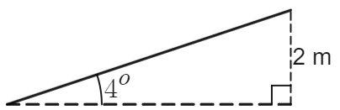
How long should the ramp be to meet the regulations?
Sample exemplar response:
Let the length of the ramp be $d$.
$$\sin{4^{o}}=\frac{2}{d}$$
$$d=\frac{2}{\sin{4^{o}}}$$
$d=28.671174$ metres
$d=28.7$ metres, correct to 3 significant figures.
This student is demonstrating a sound knowledge of the content and is performing at a C grade level. They have solved a routine problem of multiple steps when finding a missing side in a right-angled triangle using trigonometry. The student’s work should be monitored for the consistency with which they have been able to successfully solve related problems in any of questions 4, 9 and 10, as well as through performance in class.

Sample response 2:
$$\tan{4^{o}}=\frac{2}{d}$$
$$d=\frac{2}{\tan{4^{o}}}$$
$d= 28.6$ metres
This student is demonstrating a basic knowledge of the content and is performing at a D grade level. They have attempted to solve a routine problem of more than 3 steps by applying trigonometry to find a missing side in a right-angled triangle. They have incorrectly interpreted the question and found the wrong side length, or else have applied trigonometry incorrectly by using ‘tan’ instead of ‘sin’, leading to limited success.
Question 9 (MA5-TRG-C-01 and MA5-LIN-C-01)
The straight line $l$ shown on the Cartesian plane below has a gradient of 2.
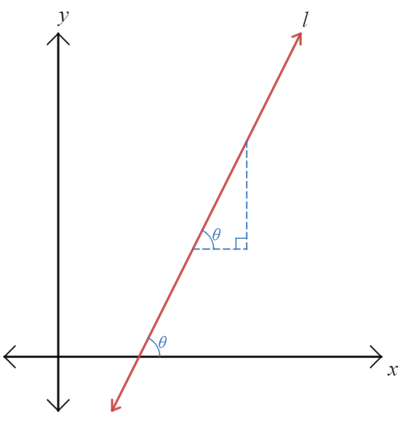
By writing values on the triangle and applying trigonometry, find the size of the angle that $l$ makes with the positive $x$-axis, $θ$, correct to the nearest minute.

Sample exemplar response:
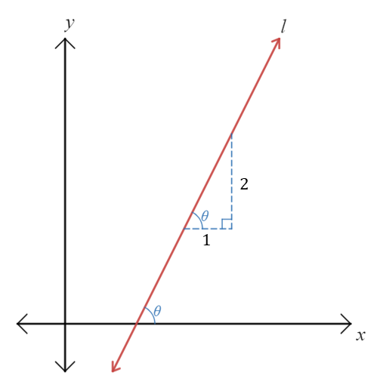
$$\tan{θ}=\frac{2}{1}$$
$$θ=\tan^{-1}{(2)} \\ ={63.435}^{o} \\ ={63}^{o}26'$$
This student is demonstrating a thorough knowledge of the content outcome
MA5-TRG-C-01 and is performing at a B grade level. They have moved between visual and abstract representations (their working) and in doing so have expressed extensive understanding of the connections between gradients, linear graphs, angles and trigonometry. They have successfully solved a problem of more than 3 steps, applying trigonometry to find a missing angle in a right-angled triangle to solve a non-routine problem. The student’s work should be monitored for the consistency with which they have been able to successfully solve related problems in any of questions 4, 8 and 10, as well as through performance in class.
The student is also demonstrating a sound knowledge of the content outcome
MA5-LIN-C-01 and is performing at a C grade level. They have identified connections between the value of gradients and linear graphs, illustrating this concept in a visual representation.

Sample response 2:
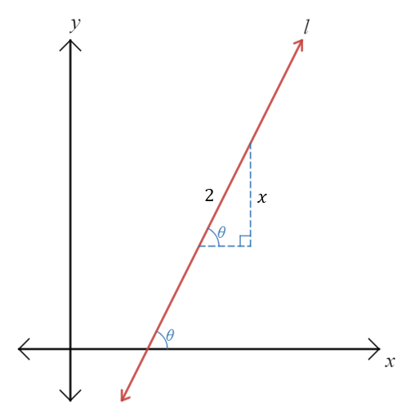
$$\sin{θ}=\frac{x}{2}$$
$$x=2\sin{θ}$$
This student is demonstrating a basic knowledge of the content outcome MA5-TRG-C-01 and is performing at a D grade level. They have correctly identified a trigonometric ratio from the information in their diagram, using appropriate mathematical conventions and symbols to express this relationship. They have attempted to apply algebra to solve this problem.
The student is also demonstrating an elementary knowledge of the content outcome
MA5-LIN-C-01 and is performing at an E grade level. They have attempted to express a gradient of 2 in a visual representation with limited success.

Question 10 (MA5-TRG-C-01)
Find and record everything you can about the diagram below.
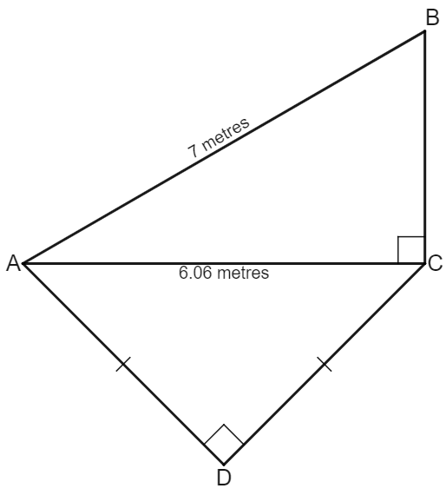
Sample exemplar response:
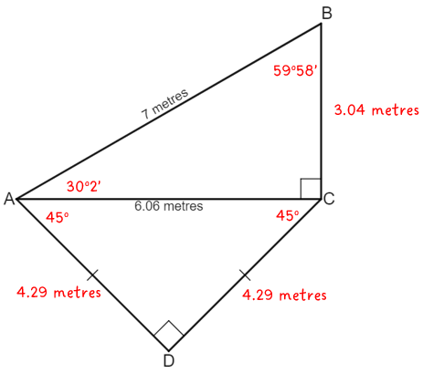
- $AB^{2}=BC^{2}+AC^{2}$
$$BC^{2}=AB^{2}-AC^{2}$$
$$BC=\sqrt{7^{2}-{6.06}^{2}}$$
$BC=3.04$ metres
- $\cos{(∠BAC)}=\frac{AC}{AB}$
$$\cos{(∠BAC)}=\frac{6.06}{7}$$
$$∠BAC=\cos^{-1}\left(\frac{6.06}{7}\right)$$
$$∠BAC={30}^{o}2'$$
- $∠ABC={180}^{o}-{90}^{o}-{30}^{o}2'$
$${=59}^{o}58'$$
- $∠DAC=∠DCA$ because $⊿ACD$ is isosceles and isosceles triangles have 2 equal angles.
- $∠ADC+∠DAC+∠DCA={180}^{o}$
$${90}^{o}+∠DAC+∠DAC={180}^{o}$$
$$2×∠DAC={90}^{o}$$
$$∠DAC={45}^{o}$$
$$∠DCA={45}^{o}$$
- $\sin{∠DCA}=\frac{AD}{AC}$
$$\sin{{45}^{o}}=\frac{AD}{6.06}$$
$$AD=6.06\sin{{45}^{o}}$$
$AD=4.29$ metres
- $AD=CD=4.29$ metres

This student is demonstrating an extensive knowledge of the content and is performing at an A grade level. They have solved a problem involving multiple steps consistently throughout their working, including applying trigonometry to find missing sides and angles. The student has also moved interchangeably between the diagram and abstract working.
Sample response 2:
$$BC=\sqrt{7^{2}-{6.06}^{2}}$$
$BC=3.04$ metres
$⊿ADC$ is isosceles.
$${6.06}^{2}=AD^{2}+DC^{2}$$
This student is demonstrating a basic knowledge of the content and is performing at a D grade level. They have identified some relationships between mathematical concepts that relate to trigonometry, including the nature of triangles and Pythagoras’ theorem. They have attempted routine problems with some success.
Question 11 (MA5-LIN-C-01 and MA5-LIN-P-01)
Three points are labelled in a Cartesian plane: $A(-1, 2)$, $B(-3, -6)$ and $C(3, 0)$. Which of the gradients $m_{AB}, m_{AC}$ or $m_{BC}$ is negative?
Sample exemplar response:
$$m=\frac{y_{2}-y_{1}}{x_{2}-x_{1}}$$
$$m_{AB}=\frac{2--6}{-1--3} \\ =\frac{8}{2} \\ =4$$

$$m_{AC}=\frac{2-0}{-1-3} \\ =\frac{2}{-4} \\ =-\frac{1}{2}$$
$$m_{BC}=\frac{-6-0}{-3-3} \\ =\frac{-6}{-6} \\ =1$$
$m_{AC}<0$ and is a negative gradient.
This student is demonstrating a sound knowledge of the content and is performing at a C grade level. They have solved routine problems involving multiple steps consistently, applying the formula for the gradient repeatedly with success. The student has also correctly interpreted the gradients in terms of being positive or negative and conveyed this effectively using appropriate mathematical language and symbols.
Sample response 2:
$$m_{AB}=\frac{2--6}{-3--1} \\ =\frac{8}{-2} \\ =-4$$
$$m_{AC}=\frac{2-0}{-1-3} \\ =\frac{2}{-4} \\ =-\frac{1}{2}$$

$$m_{BC}=\frac{-6-0}{3--3} \\ =\frac{-6}{6} \\ =-1$$
$m_{AB}<0$, $m_{AC}<0$ and $m_{BC}<0$. All 3 gradients are negative gradient.
This student is demonstrating a basic knowledge of the content and is performing at a D grade level. The student has solved problems with 3 steps successfully, correctly finding the gradient of the interval $AC$. They have been unable to apply this consistently, making mistakes with the order of the values in the formula and being unable to identify the negative error that has occurred when finding the gradients of the intervals $AB$ and $BC$.

Path
Question 12 (MA5-TRG-C-01 and MA5-LIN-P-01)
The diagram below shows the line $l$ in the Cartesian plane, with the coordinates $A(2,4)$ and $B(4, b)$ shown. The gradient of the line $l$ is known to be $m_{l}=\frac{1}{2}$. Find the value of $b$, giving reasons for your answer.
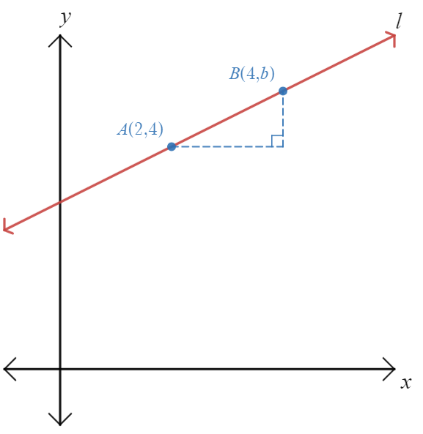
Sample exemplar response:
$$m_{l}=\frac{y_{2}-y_{1}}{x_{2}-x_{1}}$$
$$\frac{1}{2}=\frac{b-4}{4-2}$$
$$\frac{1}{2}=\frac{b-4}{2}$$
$$1=b-4$$
$$b=5$$
This student is demonstrating an extensive knowledge of the content and is performing at an A grade level. They have applied the formula for the gradient of an interval to solve a non-routine problem involving multiple steps.
Sample response 2:
$$m_{l}=\frac{y_{2}-y_{1}}{x_{2}-x_{1}}$$
$$\frac{1}{2}=\frac{b-4}{4-2}$$
$$\frac{1}{2}=\frac{b}{2}$$
$$b=1$$
This student is demonstrating a sound knowledge of the content and is performing at a C grade level. They have applied algebraic techniques to solve a problem involving gradients with some success.

Question 13 (MA5-LIN-P-01)
Consider the Cartesian plane below, where the points $A(-3,0)$, $B(2,2)$, $C(4,-3)$ and $D(-1,-5)$ are displayed and connected, forming a square.
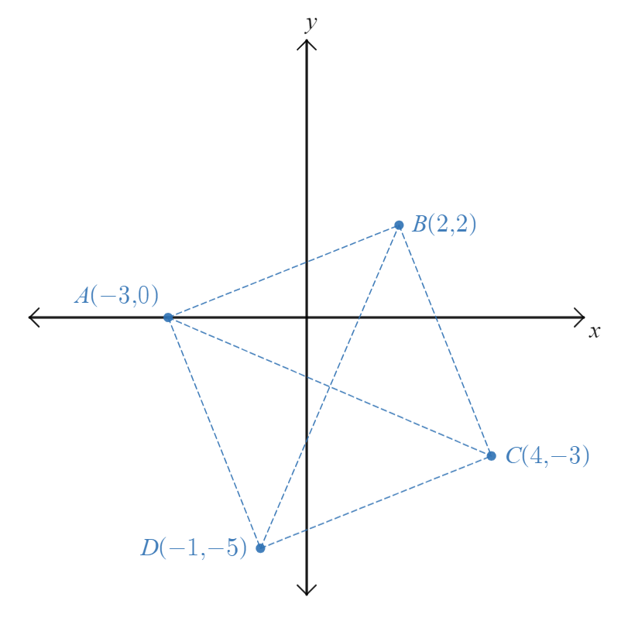
- What evidence do you have that this is a square?
Sample exemplar response:
$$d_{AB}=\sqrt{{\left(2--3\right)}^{2}+{\left(2-0\right)}^{2}} \\ =\sqrt{5^{2}+2^{2}} \\ =\sqrt{29}$$
$$d_{BC}=\sqrt{{\left(4-2\right)}^{2}+{\left(-3-2\right)}^{2}} \\ =\sqrt{2^{2}+{\left(-5\right)}^{2}} \\ =\sqrt{29}$$

$$d_{CD}=\sqrt{{\left(-1-4\right)}^{2}+{\left(-5--3\right)}^{2}} \\ =\sqrt{{\left(-5\right)}^{2}+{\left(-2\right)}^{2}} \\ =\sqrt{29}$$
$$d_{AD}=\sqrt{{\left(-1--3\right)}^{2}+{\left(-5-0\right)}^{2}} \\ =\sqrt{2^{2}+{\left(-5\right)}^{2}} \\ =\sqrt{29}$$
All 4 sides are equal in length, which is true in a square.
Lines are perpendicular if product of gradients is -1.
$$m_{AB}×m_{BC}=\frac{2}{5}×-\frac{5}{2} \\ m_{AB}×m_{BC}=-1$$
$$m_{AD}×m_{DC}=-\frac{5}{2}×\frac{2}{5} \\ m_{AD}×m_{DC}=-1$$
Lines AB and BC are perpendicular, lines AD and DC are perpendicular which is true in a square.
This student is demonstrating an extensive knowledge of the content and is performing at an A grade level. They have consistently solved routine problems involving multiple steps by calculating the distance between 2 points in the Cartesian plane. The student has also shown an extensive understanding of the relationship between distances in the Cartesian plane and the properties of quadrilaterals, specifically squares. The student has used the property of perpendicular gradients to further justify their argument.

Sample response 2:
All 4 sides, AB, BC, CD and AD, are all equal in length.
$$d_{AB}=\sqrt{{\left(2--3\right)}^{2}+{\left(2-0\right)}^{2}} \\ =\sqrt{5^{2}+2^{2}} \\ =\sqrt{29}$$
They will all be $\sqrt{29}$ unit long.
All 4 angles, $∠DAB$, $∠ABC$, $∠BCD$ and $∠CDA$ are right angles.

This student is demonstrating a thorough knowledge of the content and is performing at a B grade level. They have successfully solved a routine problem of up to 3 steps when using the distance formula to find the length of an interval. The student has also used appropriate mathematical language and symbols to effectively communicate their solution.
- Find the coordinates of the midpoint $M(x,y)$ of the interval $AC$ and show that this is the same as the midpoint of the interval $BD$.
Sample exemplar response:
$$M=\left(\frac{x_{1}+x_{2}}{2},\frac{y_{1}+y_{2}}{2}\right)$$
$$M_{AC}=\left(\frac{-3+4}{2},\frac{0+\left(-3\right)}{2}\right)$$
$$M_{AC}=\left(\frac{1}{2}, -\frac{3}{2}\right)$$
$$M_{BD}=\left(\frac{2+(-1)}{2},\frac{2+(-5)}{2}\right)$$
$$M_{BD}=\left(\frac{1}{2}, -\frac{3}{2}\right)$$
Therefore, $M_{AC}=M_{BD}$.
This student is demonstrating a thorough knowledge of the content and is performing at a B grade level. They have consistently solved routine problems involving multiple steps by calculating the midpoint of an interval between 2 points in the Cartesian plane. They have used precise mathematical language and notation to communicate a result.
Sample response 2:
$$M_{BD}=\left(\frac{2+(-1)}{2},\frac{2+(-5)}{2}\right)$$
$$M_{BD}=\left(\frac{1}{2}, -\frac{3}{2}\right)$$
This student is demonstrating a sound knowledge of the content and is performing at a C grade level. They have solved a routine problem involving less than 3 steps when calculating the midpoint of an interval between 2 points in the Cartesian plane. In doing so, they have attempted a larger problem, found 2 midpoints and compared them, but have not completely solved this problem.
- You are standing at $M$ and need to travel from this point to visit each of the other points, $A$, $B$, $C$ and $D$ at least once. What is the shortest distance you can travel to visit each destination once, returning to $M$ at the end?
Sample exemplar response:
$$d_{AC}=\sqrt{{\left(-3-4\right)}^{2}+{\left(0--3\right)}^{2}} \\ =\sqrt{{(-7)}^{2}+3^{2}} \\ =\sqrt{58} \\ =7.61577…$$
$=7.62$ units, correct to 3 significant figures.
$d_{MA}=\frac{d_{AC}}{2}=7.62÷2=3.81$ units.
$d_{AB}=d_{BC}=d_{CD}=d_{AD}=\sqrt{29}=5.39$ correct to 3 significant figures, which is shorter than $d_{AC}$ and $d_{BD}$.
Therefore, the shortest path includes sides of the square wherever possible and avoids diagonals of the square. This would be from $M→A→B→C→D$, which is $d_{MA}+d_{AB}+d_{BC}+d_{CD}$ units long.
$$d_{MA}+d_{AB}+d_{BC}+d_{CD}=3.81+5.39+5.39+5.39$$
$=19.98$ units
This student is demonstrating an extensive knowledge of the content and is performing at an A grade level. The student has solved routine problems involving multiple steps consistently, calculating and manipulating distances between points in the number plane. They have used precise mathematical language consistently and effectively to explain their solution and communicate reasoning as to why their chosen path is the shortest distance.
Sample response 2:
$$d_{AC}=\sqrt{{\left(-3-4\right)}^{2}+{\left(0--3\right)}^{2}} \\ =\sqrt{{(-7)}^{2}+3^{2}} \\ =\sqrt{58} \\ =7.61577…$$
$=7.62$ units, correct to 3 significant figures.
The distance from M to a point on the outside of square, and back to M is $7.62$ units.
This will be repeated 4 times to each corner and back, making this path
$$2MA+2MB+2MC+2MD=7.62+7.62+7.62+7.62$$
$=30.48$ units

This student is demonstrating a thorough knowledge of the content and is performing at a B grade level. The student has solved routine problems involving multiple steps by calculating and manipulating distances between points in the number plane. They have used precise mathematical language consistently and effectively to explain their solution. They have identified only some connections between concepts when attempting the non-routine problem of finding the shortest path, failing to compare the lengths of the sides of the square with the lengths of the diagonals of the square.

References
This resource contains NSW Curriculum and syllabus content. The NSW Curriculum is developed by the NSW Education Standards Authority. This content is prepared by NESA for and on behalf of the Crown in right of the State of New South Wales. The material is protected by Crown copyright.
Please refer to the NESA Copyright Disclaimer for more information https://educationstandards.nsw.edu.au/wps/portal/nesa/mini-footer/copyright.
NESA holds the only official and up-to-date versions of the NSW Curriculum and syllabus documents. Please visit the NSW Education Standards Authority (NESA) website https://educationstandards.nsw.edu.au/ and the NSW Curriculum website https://curriculum.nsw.edu.au/home.
Mathematics K–10 Syllabus © NSW Education Standards Authority (NESA) for and on behalf of the Crown in right of the State of New South Wales, 2022.

© State of New South Wales (Department of Education), 2023
The copyright material published in this resource is subject to the Copyright Act 1968 (Cth) and is owned by the NSW Department of Education or, where indicated, by a party other than the NSW Department of Education (third-party material).
Copyright material available in this resource and owned by the NSW Department of Education is licensed under a Creative Commons Attribution 4.0 International (CC BY 4.0) license.
This license allows you to share and adapt the material for any purpose, even commercially.
Attribution should be given to © State of New South Wales (Department of Education), 2023.
Material in this resource not available under a Creative Commons license:
- the NSW Department of Education logo, other logos and trademark-protected material
- material owned by a third party that has been reproduced with permission. You will need to obtain permission from the third party to reuse its material.
Links to third-party material and websites
Please note that the provided (reading/viewing material/list/links/texts) are a suggestion only and implies no endorsement, by the New South Wales Department of Education, of any author, publisher, or book title. School principals and teachers are best placed to assess the suitability of resources that would complement the curriculum and reflect the needs and interests of their students.
If you use the links provided in this document to access a third-party's website, you acknowledge that the terms of use, including licence terms set out on the third-party's website apply to the use which may be made of the materials on that third-party website or where permitted by the Copyright Act 1968 (Cth). The department accepts no responsibility for content on third-party websites.

