Quadrilateral quest
Students review the properties of the 6 special quadrilaterals: square, rectangle, parallelogram, trapezium, kite and rhombus through a variety of activities. The lesson concludes with a visual overview of the hierarchy of different types of quadrilaterals.

Visible learning

Learning intention
- To be able to compare quadrilaterals using their properties.

Success criteria
- I can identify different types of quadrilaterals.
- I can compare quadrilaterals using their properties.
- I can justify why a shape is a particular quadrilateral.

Syllabus outcomes
A student:
- develops understanding and fluency in mathematics through exploring and connecting mathematical concepts, choosing and applying mathematical techniques to solve problems, and communicating their thinking and reasoning coherently and clearly MAO-WM-01
- Identifies and applies the properties of triangles and quadrilaterals to solve problems
MA4-GEO-C-01
Mathematics K–10 Syllabus © NSW Education Standards Authority (NESA) for and on behalf of the Crown in right of the State of New South Wales, 2022.

Activity structure
Please use the associated PowerPoint Quadrilateral quest to display images in this lesson.

Launch
- Randomly assign students in groups of 3 (bit.ly/visiblegroups).
- Verbally state each of the following scenarios below, one at a time. Use slides 2 and 3 of the Quadrilateral quest PowerPoint to display a brief summary for students to discuss in their groups of 3.
Jenna has a shape that she claims must be a rectangle. It has 4 straight sides and the opposite sides are the same length. Is she right? Explain your reasoning.
On his quadrilateral George measured one right angle and found that all 4 sides were straight and had the same length. George decided his shape must be a square. Do you think George is correct? Explain your reasoning.
These questions should spark students’ prior knowledge of each of the quadrilateral’s properties. Some prompting questions may be required for students to consider the possibilities.
- After allowing time for students to discuss their reasoning in their groups of 3, use a questioning technique such as Pose-Pause-Pounce-Bounce [PDF 200KB] (bit.ly/pausepouncebouncestrategy) for students to share their answers and reasoning for each of the scenarios.

Explore
For the following 3 activities students need to recall the properties of each of the quadrilaterals previously explored in this unit: square, rectangle, parallelogram, trapezium, rhombus, and kite. A brief review may be required before commencing these activities.

Constructing quadrilaterals
- Issue students with mini whiteboards (bit.ly/miniwhiteboards).
If mini whiteboards aren’t available students can use one sheet of laminated A4 paper, or a sheet of paper in a plastic sleeve.
- Challenge students to draw the following one at a time:
- a square that is not a rectangle
- a parallelogram that is not a trapezium
- a rhombus that is not a parallelogram.
- After each instruction, allow students time to draw. Ask students to display their image for you and the class to view.
- Conduct a class discussion about what students noticed and wondered (bit.ly/noticewonderstrategy) when trying to draw the above shapes. Use a questioning strategy such as Pose-Pause-Pounce-Bounce question strategy [PDF 200KB] (bit.ly/pausepouncebouncestrategy) for students to share their thoughts. Students should be prompted to discuss if a drawing was impossible to construct, or to explain the strategy they used to complete the instruction.

Classifying quadrilaterals
- Keep students in their previous groups of 3.
- Issue each group with Appendix A ‘Classifying quadrilaterals’ which contains a table comparing the number of parallel and equal sides. Students need to consider if any of the 6 quadrilaterals fit into each of the cells of the table. This activity is best completed at vertical non-permanent surfaces (bit.ly/VNPSstrategy) where students can easily remove errors if needed.
- Once students complete the task, encourage students to go on a gallery walk (bit.ly/DLSgallerywalk) to compare other group’s responses with their own.
- A class discussion may be held after this for students to share if they would make changes to their own work, or to give reasons why a quadrilateral should or should not be placed in a particular cell of the table. The discussion should also explore what students noticed and wondered when they finished their table. For example, no quadrilateral had one pair of equal sides (unless an isosceles trapezium was listed, which is a trapezium where the sides that are not parallel are equal in length).

What quadrilateral am I?
- Hand out Appendix B ‘What quadrilateral am I?’ to each group of 3. This contains a page of quadrilaterals that have not been drawn to scale but have geometrical notations that explain the properties of the quadrilateral. Students need to determine what the best name is for each quadrilateral.
For each group, Appendix B could be enlarged onto A3 paper and attached to a vertical surface for the group to work from.
- Have each group combine with another group to compare answers, encouraging students to discuss their reasoning.

Summarise
- Issue students with Appendix C ‘Table of quadrilateral properties’.
- Have students work independently to tick the relevant cells that correspond to the properties of each of the 6 special quadrilaterals.
- Once completed, develop the solutions as a class, through a class discussion using the Pose-Pause-Pounce-Bounce question strategy [PDF 200KB] (bit.ly/pausepouncebouncestrategy) questioning technique. The solutions can be found in the sample solutions at the conclusion of this document.
- Using the completed Appendix C, as a class, create a hierarchy of the six quadrilaterals as a Venn diagram and/or a flow chart. Completed Venn diagrams and flow charts can be found on slides 5 and 6 of the Quadrilateral quest PowerPoint.

Apply
Students are to complete these two activities in visibly random groups of 3.

Activity 1 – quadrilateral statements
- At vertical non-permanent surfaces, each group of 3 completes statements about quadrilaterals using Appendix D ‘Quadrilateral statements’.
- Students can complete a gallery walk to view other group’s responses, followed by a class discussion.

Activity 2 – properties of quadrilaterals Venn diagrams
- At vertical non-permanent surfaces, students complete the ‘Properties of quadrilaterals Venn diagrams’ activity in Appendix E.
- Students select a quadrilateral that could belong in each of the regions of the Venn diagram. If they believe a section is impossible to fill, they need to justify their reasoning.
- Two versions of this task have been created, a double and a triple Venn diagram.
- Students could be challenged to create their own Venn diagram task using criteria of their choice. They should also complete sample solutions for their activity.
- Students may like to do a gallery walk to compare their Venn diagrams with other groups.

Assessment and differentiation

Suggested opportunities for differentiation
Launch
- The scenarios provided should spark students’ prior knowledge of each of the quadrilateral’s properties. Some prompting questions may be required for students to consider the possibilities and a review of some of the properties of quadrilaterals may be required.
Explore
- Students may struggle to construct the quadrilaterals with its restrictions and this activity may be best done as a class or in pairs.
- Students could be challenged to create another table in Appendix A that compares properties of the 6 quadrilaterals, such as one that includes the properties of diagonals.
- Students may need some assistance interpreting Appendix B, as each quadrilateral appears the same but has different notations marked on it which indicate which quadrilateral it is.
Summarise
- Students could be encouraged to create their own hierarchy of the six quadrilaterals as a Venn diagram and/or a flow chart independently or in pairs, rather than as a class.
Apply
- Two Venn diagrams have been provided, one a double and the other a triple. Choose the appropriate one for your students.
- Students could be challenged to create their own criteria for properties of quadrilaterals Venn, complete with sample solutions.

Suggested opportunities for assessment
- Monitor student conversations and responses during class discussions to check for any misconceptions or to address further learning that may be required.
- Appendix A, B and C can be collected as evidence of student learning.

Appendix A

Classifying quadrilaterals
Determine where each of the 6 quadrilaterals fit within the table below by considering if the shape has equal and/or parallel sides.
- Square
- Rectangle
- Parallelogram
- Trapezium
- Rhombus
- Kite
 | No parallel sides | One pair of parallel sides | Two pairs of parallel sides
No equal sides
One pair equal sides
Two pairs of equal sides
All sides equal

Appendix B

What quadrilateral am I?
The following quadrilaterals have not been drawn to scale but contain geometry conventions to indicate their properties.
Write the best name for each of the quadrilaterals using the choices: quadrilateral, square, rectangle, parallelogram, trapezium, rhombus, and kite.
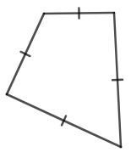 | 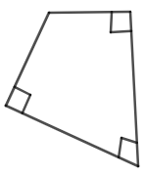 | 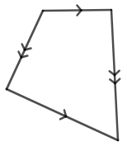
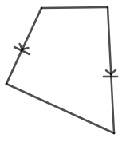 | 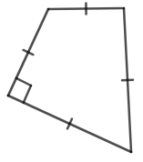 | 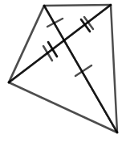
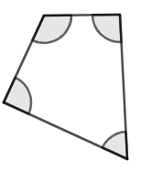 | 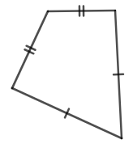 | 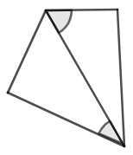
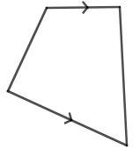 | 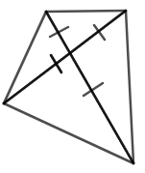 | 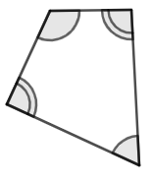
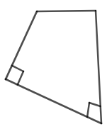 | 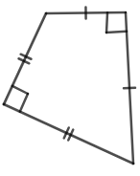 | 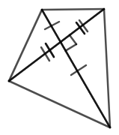
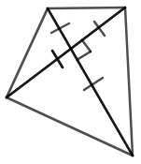 | 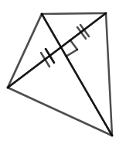 | 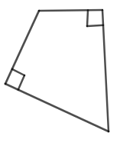

Appendix C

Table of quadrilateral properties
Tick each of the cells to make this table represent all the properties of each quadrilateral.
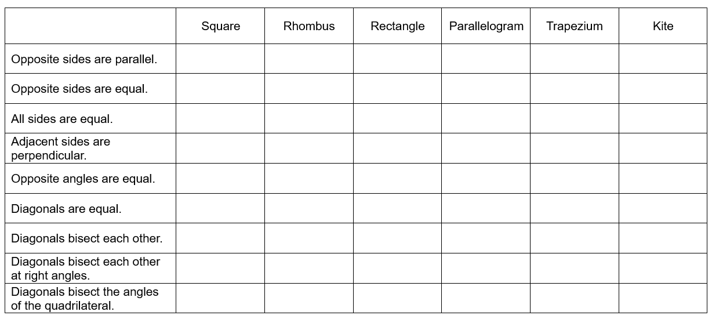

Appendix D

Quadrilateral statements

Part 1
Directions: Use the terms: always, never, sometimes, square, rectangle, parallelogram, trapezium, rhombus, and kite to complete the 2 sentences.
- Every rectangle is also a ____________, and every ____________ is also a kite.
- A rhombus is ____________ a square and a rectangle is ____________ a trapezium.

Part 2
Directions: Use the terms square, rhombus, kite, parallelogram, trapezium, rectangle, irregular quadrilateral at most one time each to complete the 2 sentences.
- A ______________ is a ______________ but not a ______________.
- A ______________ is a ______________ but not a ______________.

Appendix E

Properties of quadrilaterals Venn diagrams

Double Venn diagram
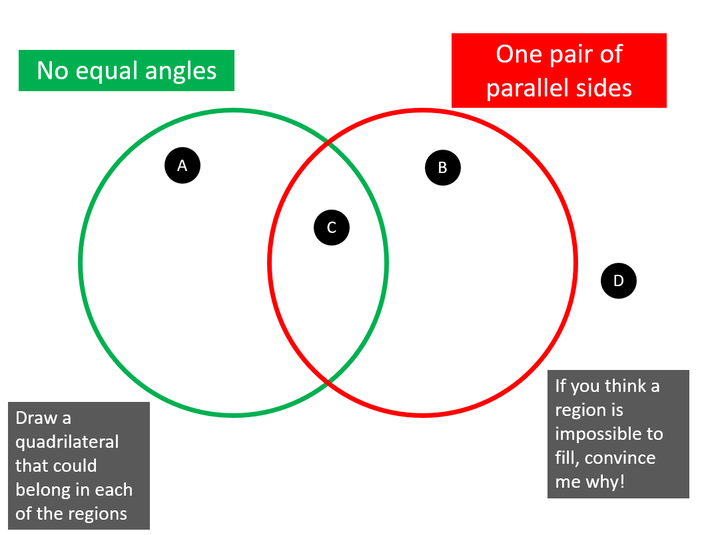

Triple Venn diagram
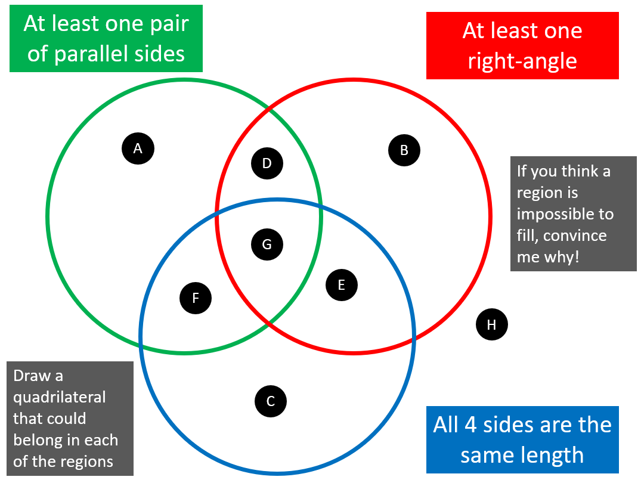

Sample solutions

Appendix A – classifying quadrilaterals
 | No parallel sides | One pair of parallel sides | Two pairs of parallel sides
No equal sides |  | Trapezium
One pair equal sides
Two pairs of equal sides | Kite |  | Parallelogram  Rectangle
All sides equal |  |  | Square  Rhombus

Appendix B – What quadrilateral am I?
- Rhombus
- Rectangle
- Parallelogram
- Parallelogram
- Square
- Parallelogram
- Rectangle
- Kite
- Trapezium
- Trapezium
- Rectangle
- Parallelogram
- Trapezium
- Kite
- Rhombus
- Square
- Kite
- Rectangle

Appendix C – table of quadrilateral properties
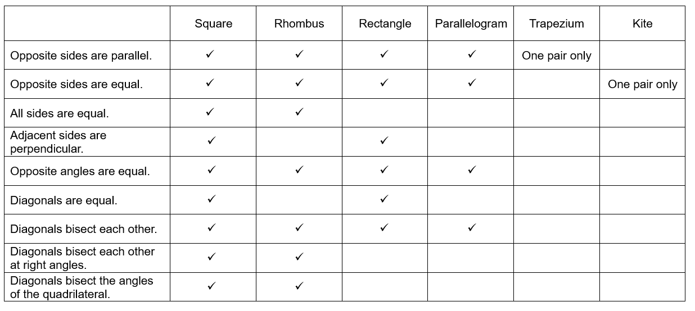

Appendix D – quadrilateral statements

Part 1
Every rectangle is also a parallelogram, and every rhombus is also a kite.
A rhombus is sometimes a square and a rectangle is always a trapezium.

Part 2
A square is a rectangle but not a kite.
A rhombus is a parallelogram but not a trapezium.
Please note that the final 2 statements are sample answers, other options could be explored. These questions are from Open Middle (openmiddle.com/what-is-it-not/).

Appendix E – properties of quadrilaterals Venn diagrams

Double Venn diagram
- Section A: Quadrilateral
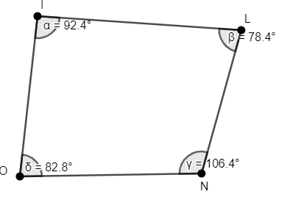
- Section B: Trapezium
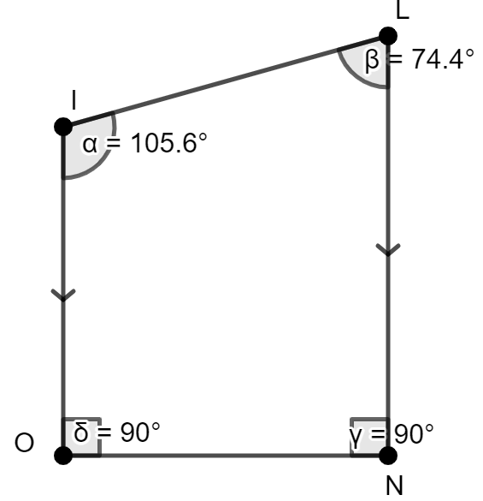
- Section C: Trapezium
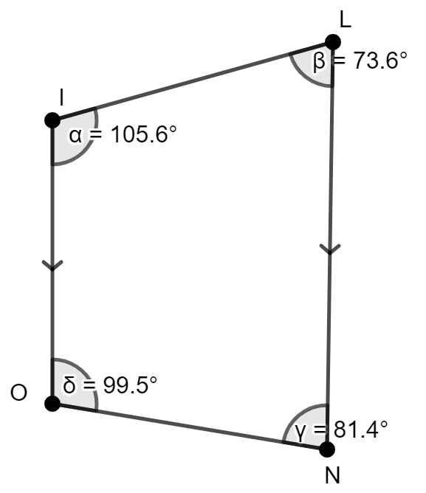
- Section D: Square
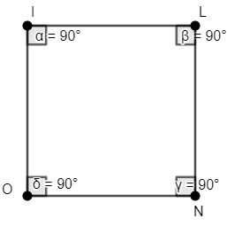

Triple Venn diagram
- Section A: Trapezium
- Section B: Quadrilateral
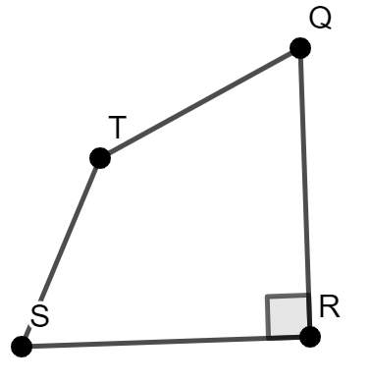
- Section C: empty as you can only make a rhombus or square which both have parallel sides.
- Section D: Trapezium
- Section E: empty as you can only make a rhombus or square which both have parallel sides.
- Section F: Rhombus
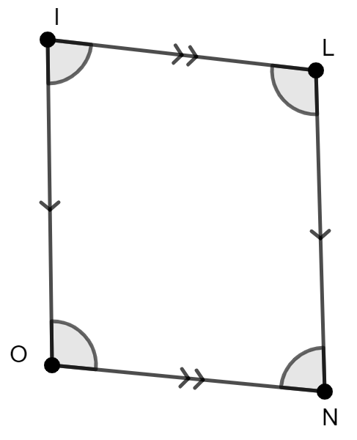
- Section G: Square
- Section H: Quadrilateral

References
This resource contains NSW Curriculum and syllabus content. The NSW Curriculum is developed by the NSW Education Standards Authority. This content is prepared by NESA for and on behalf of the Crown in right of the State of New South Wales. The material is protected by Crown copyright.
Please refer to the NESA Copyright Disclaimer for more information https://educationstandards.nsw.edu.au/wps/portal/nesa/mini-footer/copyright.
NESA holds the only official and up-to-date versions of the NSW Curriculum and syllabus documents. Please visit the NSW Education Standards Authority (NESA) website https://educationstandards.nsw.edu.au/ and the NSW Curriculum website https://curriculum.nsw.edu.au/home.
Mathematics K–10 Syllabus © NSW Education Standards Authority (NESA) for and on behalf of the Crown in right of the State of New South Wales, 2022.

© State of New South Wales (Department of Education), 2023
The copyright material published in this resource is subject to the Copyright Act 1968 (Cth) and is owned by the NSW Department of Education or, where indicated, by a party other than the NSW Department of Education (third-party material).
Copyright material available in this resource and owned by the NSW Department of Education is licensed under a Creative Commons Attribution 4.0 International (CC BY 4.0) license.
This license allows you to share and adapt the material for any purpose, even commercially.
Attribution should be given to © State of New South Wales (Department of Education), 2023.
Material in this resource not available under a Creative Commons license:
- the NSW Department of Education logo, other logos and trademark-protected material
- material owned by a third party that has been reproduced with permission. You will need to obtain permission from the third party to reuse its material.
Links to third-party material and websites
Please note that the provided (reading/viewing material/list/links/texts) are a suggestion only and implies no endorsement, by the New South Wales Department of Education, of any author, publisher, or book title. School principals and teachers are best placed to assess the suitability of resources that would complement the curriculum and reflect the needs and interests of their students.
If you use the links provided in this document to access a third-party's website, you acknowledge that the terms of use, including licence terms set out on the third-party's website apply to the use which may be made of the materials on that third-party website or where permitted by the Copyright Act 1968 (Cth). The department accepts no responsibility for content on third-party websites.

