Let’s go fly a kite
Students explore the properties of a kite by comparing the shape to previously explored special quadrilaterals. The lesson finishes in a kite flying experiment.

Visible learning

Learning intention
- To know the properties of a kite.

Success criteria
- I can identify the properties of a kite.
- I can compare the properties of a kite, rhombus and parallelogram.
- I can justify why a quadrilateral can be classified as a kite.

Syllabus outcomes
A student:
- develops understanding and fluency in mathematics through exploring and connecting mathematical concepts, choosing and applying mathematical techniques to solve problems, and communicating their thinking and reasoning coherently and clearly MAO-WM-01
- identifies and applies the properties of triangles and quadrilaterals to solve problems
MA4-GEO-C-01
Mathematics K–10 Syllabus © NSW Education Standards Authority (NESA) for and on behalf of the Crown in right of the State of New South Wales, 2022.

Activity structure
Please use the associated PowerPoint Let’s go fly a kite to display images in this lesson.

Launch
- Provide students with one mini whiteboard (bit.ly/miniwhiteboards) each.
If mini whiteboards aren’t available students can use a laminated sheet of paper or a blank sheet of paper inside an A4 plastic sleeve.
- Explain that the class will be playing a game of ‘What am I?’. The teacher will read 6 clues aloud, while students write what they think the mystery object is on their mini whiteboards. Students should be encouraged to erase and write another answer as many times as they like. Ensure students understand that answers won’t be shared with the class until all 6 clues have been given.
- Clue 1: In my earliest form, I was just leaves attached to spider webs, cunningly used as bait to lure fish.
- Clue 2: In ancient China and other parts of Asia, I evolved, symbolizing not only fun but also warding off evil spirits and communicating with deities.
- Clue 3: Made initially of silk and bamboo, explorers and traders carried tales of me and my designs to European shores by the 16th and 17th centuries.
- Clue 4: Not just a playful object in the sky, brilliant minds like Benjamin Franklin tapped into my potential for groundbreaking experiments.
- Clue 5: During festive moments in India or in competitive arenas worldwide, I rise as a symbol of joy, artistry, and sometimes, a true test of skill.
- Clue 6: Modern-day variants of me might be crafted from nylon, and you'll find me in an array of shapes, sizes, and vibrant designs, dancing in the wind.
- Have students hold up their mini whiteboards to share answers.
- Use a questioning strategy such as Pose-Pause-Pounce-Bounce [PDF 200KB] (bit.ly/pausepouncebouncestrategy) to ask students, when and how they knew the object was a kite.

Explore
- Display Figure 1. This can be found on slide 2 of the PowerPoint Let’s go fly a kite.
Figure 1 – Which one doesn't belong?
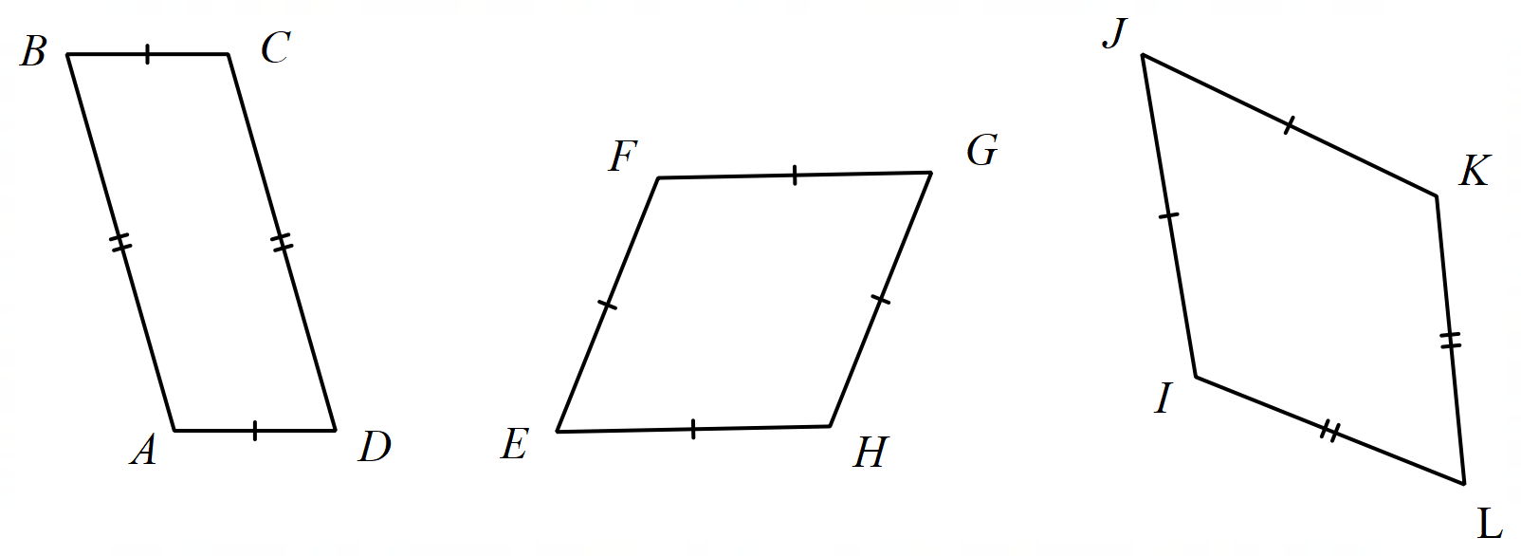
- In pairs, students are to discuss which shape they believe doesn’t belong (bit.ly/wodb).
In a which one doesn’t belong style problem there is typically no correct answer. The focus is instead on students justifying their answer.
- Ask students to draw the shape they believe doesn’t belong on their mini whiteboard and label all relevant information.
- Have each pair combine with an adjacent pair of students to compare and discuss their answers. Ensure that students are discussing their reasoning. It may be beneficial for each pair to find a pair with a different answer to encourage conversations involving mathematical reasoning.
- Use a questioning strategy such as Pose-Pause-Pounce-Bounce to hear responses from different groups. Students should be using the correct terminology and be encouraged to name quadrilaterals using naming conventions.
Students should recognise the first shape, $ABCD$, as a parallelogram and the second shape, $EFGH$, as a rhombus. Students can build on their prior knowledge to establish that the kite, $IJKL$, is a quadrilateral that has two sets of adjacent, equal sides.
- Display Figure 2. This can be found on slide 3 of the PowerPoint Let’s go fly a kite.
Figure 2 – cut into triangles
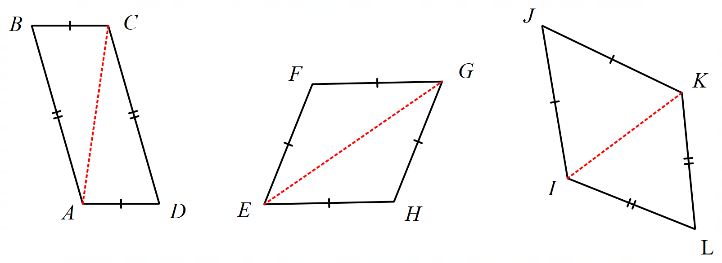
- In their pairs, have students discuss what they notice and wonder about the image (bit.ly/noticewonderstrategy).
- Conduct a class discussion by selecting non-volunteer students to share what they noticed and wondered.
Students might notice that each quadrilateral has been cut to make 2 triangles. Students might wonder what triangles would be created by drawing the second diagonals.

A parallelogram, a rhombus, and a kite

Equipment
- Appendix A ‘A parallelogram, a rhombus, and a kite’ printed A3 (1 per group)
- Appendix B ‘Table’ printed A3. Place in plastic pockets and stick to walls around the room using adhesive putty
- Whiteboard marker (1 per group)
- Paper towel or whiteboard eraser (1 per group)
- Protractor (1 per group)
- Ruler (1 per group)

Method
- Assign students to visibly random groups of 3 (bit.ly/visiblegroups) and assign each group Appendix B that has been placed on the walls around the room. Each group will also need Appendix A, a whiteboard marker, a protractor and a ruler.
- Groups will use the ruler and protractor to measure and discover as much as they can about the 3 quadrilaterals printed on Appendix A.
- Each group will record any information they find on Appendix B ‘Table’. There are 3 columns, one column for each of the quadrilateral’s properties.
To enable students, prompt them to consider:
- parallel sides
- diagonals
- opposite angles
- triangles that can be made by drawing diagonals
- Once groups think they have completed their lists, have them complete a gallery walk (bit.ly/DLSgallerywalk) to observe what their peers discovered. Encourage them to return to their own work to see if they can add any more information.
- A brief class discussion can be conducted on the properties discovered for the kite using a questioning technique such as Pose-Pause-Pounce-Bounce.
Students should conclude that a kite is a special quadrilateral that has two sets of equal and adjacent sides. The diagonals of a kite bisect each other at right angles.

Summarise

Venn diagram task
- Print Appendix C ‘Comparing shapes Venn’ on A3 paper and place in the plastic pockets already set up around the room, removing Appendix B. Position Appendix B next to or underneath each plastic pocket as students will need to refer to their previous work for this activity.
- Have groups return to where they were positioned and using their list from Appendix B, they are to fill in the relevant sections of Appendix C. Appendix C is a triple Venn diagram where students are comparing the properties of a parallelogram, rhombus and kite to observe similarities and differences. If students believe a section cannot be filled, they must be able to justify why that is the case.
- When groups think they have finished, encourage them to take a gallery walk to see if they can add any extra properties or challenge other groups.

Thinking notes
- Print Appendix D ‘Thinking notes’ on A3 paper and place in plastic pockets already around the room. Existing worksheets should be visible and/or accessible to students, as they may like to refer to them when completing this task.
- Assign new random groups of 3, provide one whiteboard marker per group, and direct students to stand at one of the plastic pockets.
The reason for assigning new groups of 3 is so students come from different conversations from around the room.
- Students work in their groups of 3 to fill in the 4 quadrants of the thinking notes, starting with the worked example then moving in a clockwise direction.

Thinking notes divide a page into 4 quadrants.
- The first quadrant completed is the top left which is a fill in the blanks example, created by the teacher.
- Groups then move in a clockwise direction, around the sheet, to complete each quadrant.
- The next quadrant, top right is example 1, which is a question given to the students without the solution completed.
- Following this, bottom right, is a second example that is more open than the previous one and at times asks students to create their own example.
- The final quadrant, bottom left, is where students write their notes their future forgetful self (bit.ly/notesstrategy), that is ‘things to remember’.
- When students are finished, they return to their seats and recreate the ‘Thinking notes’ quadrants in their workbooks. Allow students to move around the classroom as they complete their own ‘Thinking notes’, so they can take examples from any of the groups’ work, not just their own.

Apply

Fly a kite

Equipment
- Skewers or similar
- Various sized sheets of paper
- Stopwatches
- Rulers
- Protractors
- Sticky tape
- Scissors

Method
- Assign students to visibly random groups of 3 (bit.ly/visiblegroups). Explain to them that, using their knowledge of the properties of a kite, they will be constructing kites with the aim to have the one that can float for the longest time.
- Students will need to construct a range of kites, ideally at least 3 to trial. Their designs must maintain the properties of a kite. Students should trial different designs by exploring different sizes, interior angles, and side lengths.
- Students measure the side lengths and interior angles of their kites, drawing a representation of each kite in their workbooks, with important information labelled.
- To construct their kites, students will use the skewers to form perpendicular diagonals of the kite, sticking these to a sheet of paper.
Students should be encouraged to colour and draw on their kites to pay homage to the significance of kites in many cultures. Students could be asked to research traditional kite patterns and their meanings.
- To trial how well their kite flies, a location within the school grounds will need to be selected that is at least one floor high. Students will drop their kite from this height and time how long it takes to reach the ground.
- Students record the time taken for each kite next to their drawings from step 3.
- Have groups identify which of their kites took the longest to land and discuss what properties this kite had.
- Conduct a class discussion using a questioning technique such as Pose-Pause-Pounce-Bounce to compare the properties of each of these kites to see if there is a common feature that each of the kites have.
There may or may not be common features of the top 3 or 4 kites. The aim of this discussion is for students to consider the characteristics of a kite in general. The only characteristic that they are yet to discover is that there is one pair of equal opposite angles

Assessment and differentiation

Suggested opportunities for differentiation
Launch
- When discussing the cultural significance of kites, ensure students have opportunities to share their stories and experiences.
Explore
- Students could be extended in the ‘Which one doesn’t belong?’ activity to come up with multiple reasons why each shape may not belong, by recalling properties of parallelograms and rectangles.
Summarise
- Students may need some prompts when completing the Venn diagram tasks. These prompts should be given to the whole group and before students have time to ask further clarification questions, you should walk away from the group. An example of a prompt could be, draw a convex kite.
- When students are completing their thinking notes they can use either formal or informal language and notation. These notes should make sense to them.
- Students can be challenged in the thinking notes task to draw a non-convex kite for example 2.
Apply
- Students could be challenged to explore the different properties of a kite and then only change one variable to see if it improves the flight of the kite. For example, they could start with the restriction that the equal opposite angles must be $90°$, groups could then explore the types of angles that make the kite fly the best.

Suggested opportunities for assessment
- Monitor student conversations during the group work activities to check for any misconceptions of prior learning.
- Collect or take photos of students work to use as formative assessment.
- View each students thinking notes to check for understanding.

Appendix A

A parallelogram, a rhombus and a kite
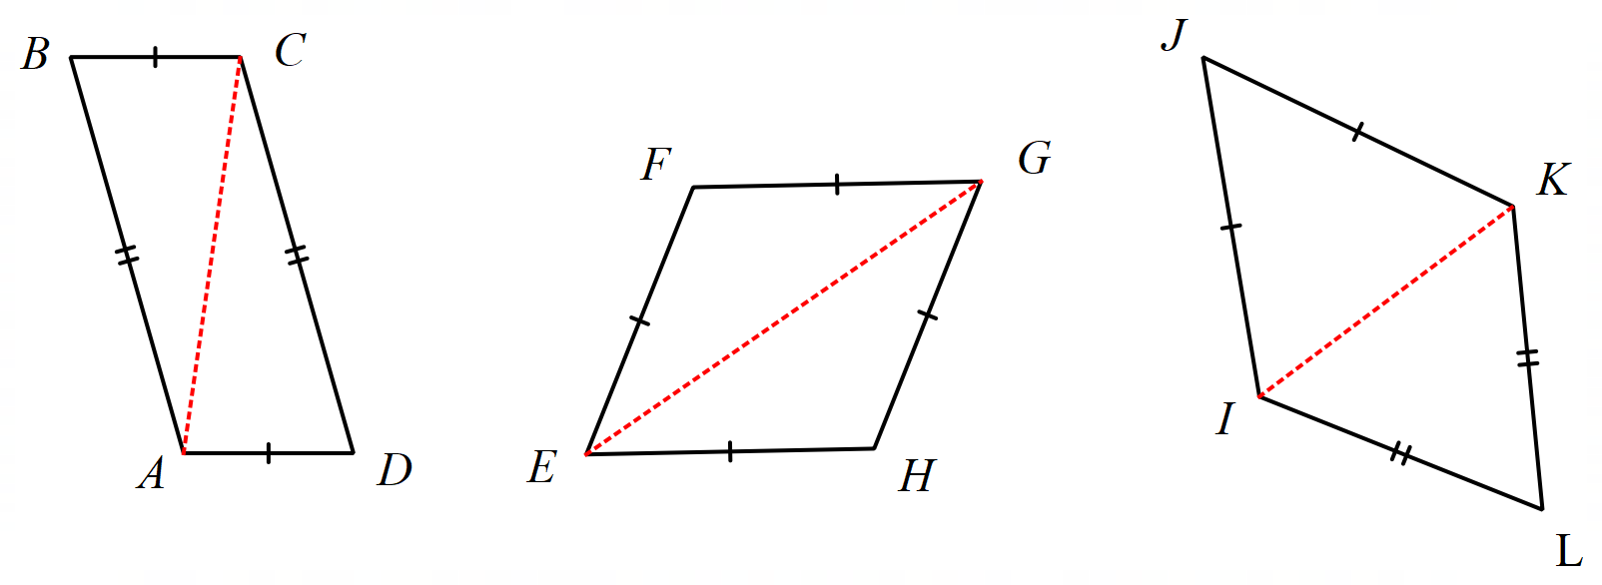

Appendix B

Table
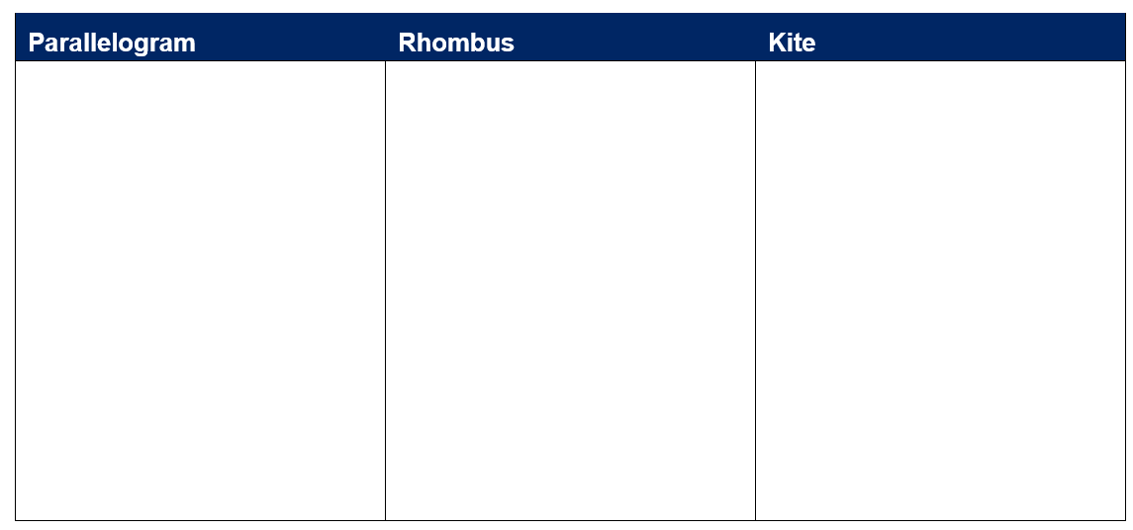

Appendix C

Comparing shapes Venn
List the properties of the 3 quadrilaterals in the relevant section of the Venn diagram. If there is a section you can’t fill, justify why.
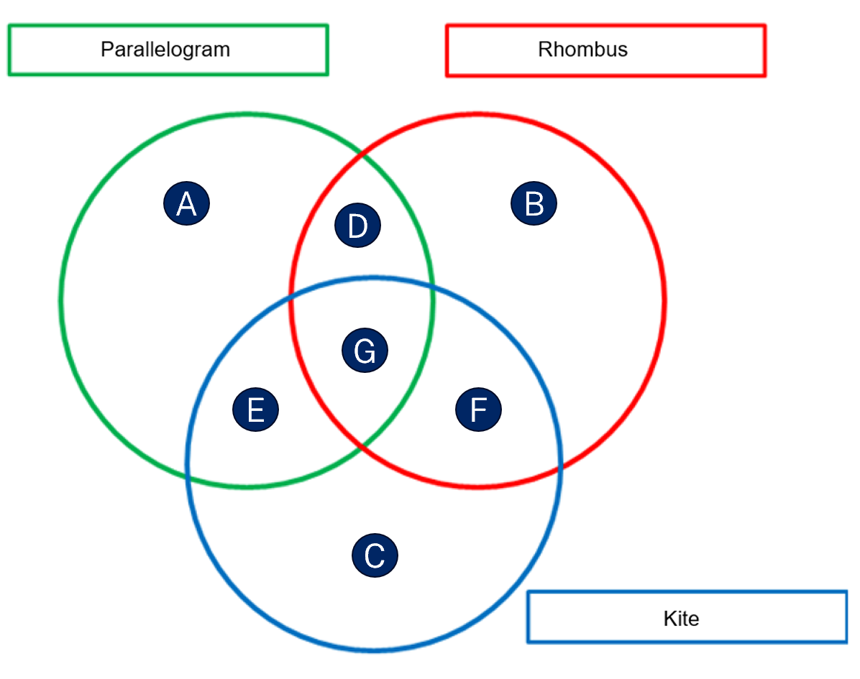

Appendix D

Thinking notes
Worked example  State why ABCD is a kite  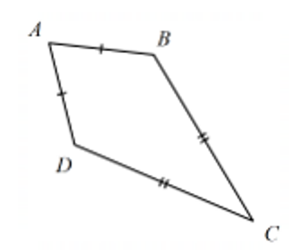  ABCD is a kite because:  - It has two sets of adjacent and equal sides.  _____=_____  _____=_____ | Example 1  State why EFGH is a kite  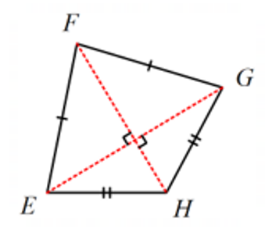
Things to remember | Example 2  - Draw a kite  - Label the vertices  - Label any additional information  - State why it is a kite

Sample solutions

Appendix B – table
Parallelogram | Rhombus | Kite
- Opposite sides equal  - Opposite angles equal  - Opposite sides parallel  - Diagonals cut each other in half | - All sides equal  - Opposite angles equal  - Opposite sides parallel  - Diagonals cut each other in half  - Diagonals meet at right angles | - One pair of opposite angles are equal.  - 2 pairs of adjacent sides are equal  - Diagonals meet at right angles

Appendix C – comparing shapes Venn
- Section A: empty
- Section B: All sides are equal.
- Section C: empty
- Section D: Opposite sides are equal, opposite angles are equal, opposite sides are parallel, diagonals cut each other in half.
- Section E: empty
- Section F: Diagonals meet at right angles, 2 pairs of adjacent sides are equal
- Section G: One pair of opposite angles are equal, have 4 sides
Section A is left empty as a rhombus satisfies all the characteristics of a parallelogram.
Section C is left empty as a rhombus satisfies all the characteristics of a kite.
Section E is left empty as there are no characteristics that only a parallelogram and kite share as a rhombus has all the characteristics of both.

Appendix D – thinking notes
Worked example  State why ABCD is a kite  ABCD is a kite because:  - It has two sets of adjacent and equal sides.  $$AB = AD$$  $$DC = BC$$  Students could add more detail such as angles and diagonals. | Example 1  State why EFGH is a kite  EFGH is a kite because:  - It has two sets of adjacent and equal sides.  $$FE = FG$$  $$HE = HG$$
Things to remember  - A kite is a quadrilateral  - It has 2 sets of adjacent and equal sides  - A kite is symmetrical about its main diagonal  - In a convex kite, diagonals will bisect at right angles | Example 2  - Draw a kite  - Label the vertices  - Label any additional information  - State why it is a kite  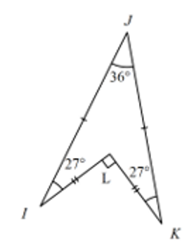  IJKL is a kite because:  - It has two sets of adjacent and equal sides.  $$JI = JK$$  $$LI = LK$$

References
This resource contains NSW Curriculum and syllabus content. The NSW Curriculum is developed by the NSW Education Standards Authority. This content is prepared by NESA for and on behalf of the Crown in right of the State of New South Wales. The material is protected by Crown copyright.
Please refer to the NESA Copyright Disclaimer for more information https://educationstandards.nsw.edu.au/wps/portal/nesa/mini-footer/copyright.
NESA holds the only official and up-to-date versions of the NSW Curriculum and syllabus documents. Please visit the NSW Education Standards Authority (NESA) website https://educationstandards.nsw.edu.au/ and the NSW Curriculum website https://curriculum.nsw.edu.au/home.
Mathematics K–10 Syllabus © NSW Education Standards Authority (NESA) for and on behalf of the Crown in right of the State of New South Wales, 2022.

© State of New South Wales (Department of Education), 2023
The copyright material published in this resource is subject to the Copyright Act 1968 (Cth) and is owned by the NSW Department of Education or, where indicated, by a party other than the NSW Department of Education (third-party material).
Copyright material available in this resource and owned by the NSW Department of Education is licensed under a Creative Commons Attribution 4.0 International (CC BY 4.0) license.
This license allows you to share and adapt the material for any purpose, even commercially.
Attribution should be given to © State of New South Wales (Department of Education), 2023.
Material in this resource not available under a Creative Commons license:
- the NSW Department of Education logo, other logos and trademark-protected material
- material owned by a third party that has been reproduced with permission. You will need to obtain permission from the third party to reuse its material.
Links to third-party material and websites
Please note that the provided (reading/viewing material/list/links/texts) are a suggestion only and implies no endorsement, by the New South Wales Department of Education, of any author, publisher, or book title. School principals and teachers are best placed to assess the suitability of resources that would complement the curriculum and reflect the needs and interests of their students.
If you use the links provided in this document to access a third-party's website, you acknowledge that the terms of use, including licence terms set out on the third-party's website apply to the use which may be made of the materials on that third-party website or where permitted by the Copyright Act 1968 (Cth). The department accepts no responsibility for content on third-party websites.

