Tackling trapeziums
Students explore the properties of a trapezium by examining its relationship to the properties of other quadrilaterals. Students will be able to verify and describe the properties of trapeziums.
Students will need at least one digital device per pair to interact with Desmos for the launch activity.

Visible learning

Learning intentions
- To know the properties of a trapezium.

Success criteria
- I can identify the properties of a trapezium.
- I can compare the properties of a trapezium and a parallelogram.
- I can justify why a quadrilateral can be classified as a trapezium.

Syllabus outcomes
- develops understanding and fluency in mathematics through exploring and connecting mathematical concepts, choosing and applying mathematical techniques to solve problems, and communicating their thinking and reasoning coherently and clearly MAO-WM-01
- identifies and applies the properties of triangles and quadrilaterals to solve problems
MA4-GEO-C-01
Mathematics K–10 Syllabus © NSW Education Standards Authority (NESA) for and on behalf of the Crown in right of the State of New South Wales, 2022.

Activity structure

Launch
- Provide each student with a device and direct them to the Desmos Polygraph ‘Polygon Polygraph’ (bit.ly/poly-graph).
Desmos Polygraph is a partnered guessing game where each student selects an activity card and they take turns asking a random partner yes or no questions to discover the other person’s activity card (bit.ly/desmospolygraph). In this activity students have a variety of polygon activity cards to select from. See Figure 1 below for reference.
- Stop students after they have played 2 rounds of the Polygraph.
- Display Figure 1 using slide 2 from the Tackling trapeziums PowerPoint. Use the Pose-Pause-Pounce-Bounce question strategy ([PDF 200KB] bit.ly/pausepouncebounce) to have students identify a shape that was difficult to name or describe and elaborate on what made naming or describing the shape difficult.
Figure 1 – polygon polygraph
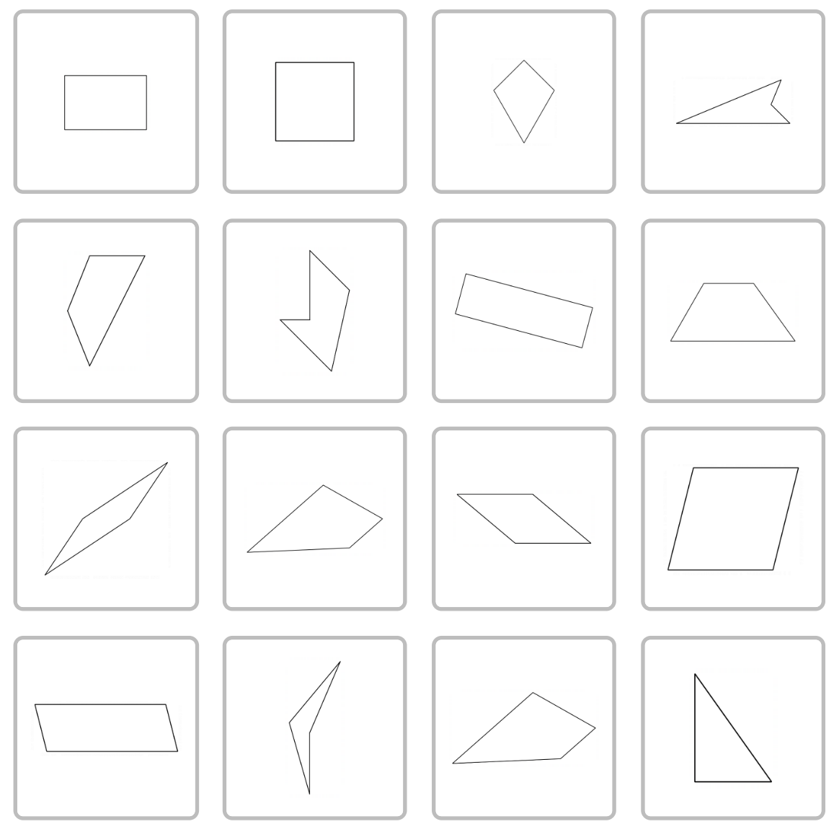
Image created using Desmos and is licensed under the Desmos Terms of Service.
This class discussion should highlight any misconceptions students may have. It can also be used as formative assessment of students’ prior knowledge of naming shapes and specific properties of squares, rhombuses, rectangles and parallelograms which have been explored in previous lessons.
- Display Figure 2 using slide 3 of the Tackling trapeziums PowerPoint. If students have not already identified this shape as difficult to describe, ask students to engage in a Think-Pair-Share (bit.ly/thinkpairsharestrategy) to discuss how they would describe the shape to someone that can’t see it.
Figure 2 – trapezium
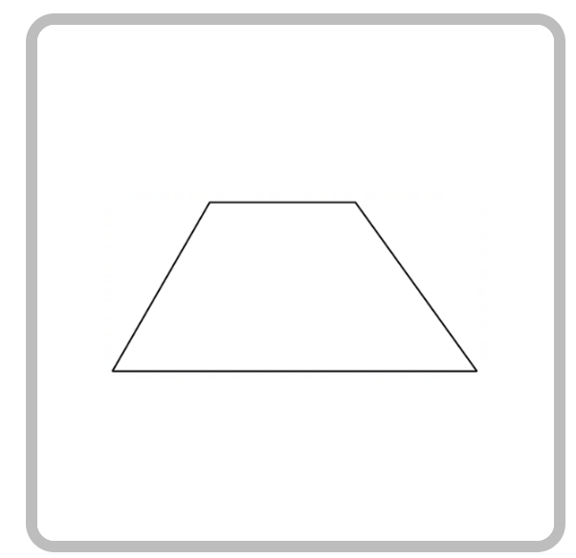
Image created using Desmos and is licensed under the Desmos Terms of Service.
Encourage students to share their own descriptions without providing any formal properties. This allows students to assign meaning to the shape and possibly relate the shape to their own lives.
- Record student answers, creating a visible class list of descriptions.

Explore

Categories
- Print Appendix A ‘Categories’ on A3 paper and place in plastic pockets. Use adhesive putty to position plastic pockets on walls around the room.
By printing Appendices A and B back-to-back on A3 paper, students can quickly move from the Categories task to the Venn diagram task by flipping their plastic pocket.
- Display Figure 3 which is in Appendix A, or slide 4 of the Tackling trapeziums PowerPoint. Explain to students that there are lots of shapes shown and the aim of the activity is to come up with some categories to summarise what the shapes have in common.
Figure 3 – categories
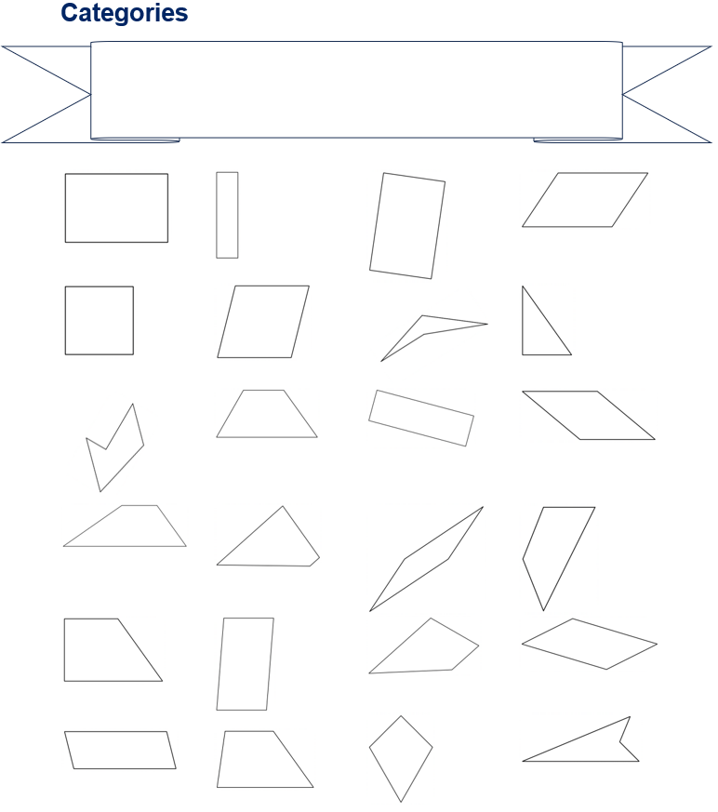

- Model an example of how the shapes could be categorised for students by using the categories ‘Q’ for quadrilateral and ‘N’ for not quadrilateral. Write ‘Q = quadrilateral’ and ‘N = not quadrilateral’ in the banner at the top of the sheet.
- Mark each shape with a Q or an N, encouraging students to call out Q or N as you hover the marker over each shape.
- Use a questioning strategy such as the Pose-Pause-Pounce-Bounce question strategy [PDF 200KB] (bit.ly/pausepouncebounce) to discuss if quadrilateral or not quadrilateral is the best way to categorise these shapes.
- Ask students if they can think of categories that would be more specific, creating smaller groups of shapes. Ask a few students to provide some examples.
- Assign random groups of 3 (bit.ly/visiblegroups) and position groups at the plastic pockets around the room, with one whiteboard marker per group. Students are to work in groups to decide on their categories. They should write their categories and a key in the banner at the top of their page. They are to mark each shape with a letter, indicating its category.
- As students complete their own categories, encourage them to look around the room and steal categories from other team’s banners.
- If students believe they are finished, challenge them to be more specific with their categories. If students don’t believe they can be more specific, try to draw an extra shape that either belongs to more than one of their categories or doesn’t belong to any of their categories.
- Have students engage in a gallery walk (bit.ly/DLSgallerywalk) to compare categories used by their peers. It may be beneficial to draw the entire class’s attention to 2 groups’ categories and discuss the similarities and differences.
- Use a questioning strategy such as the Pose-Pause-Pounce-Bounce question strategy [PDF 200KB] (bit.ly/pausepouncebounce) to discuss as a class which shapes were difficult to categorise.
- Conclude by asking students to consider what makes a trapezium different to the other shapes on the sheet. Students can Think-Pair-Share their thoughts.

Venn diagram task
- Print Appendix B ‘Venn diagram task’ on A3 paper and place in plastic pockets. Assign new random groups of 3 and position groups at plastic pockets, with one whiteboard marker per group.
- Groups will work together to fill in the Venn diagram, by recording any features of parallelograms and trapeziums that are common and/or unique.
Students shouldn’t be limited to special properties such as diagonals bisect at right angles but should be encouraged to describe any features they notice, such as both have 4 sides.
- If groups feel they have exhausted all options for their Venn diagram, encourage them to engage in a gallery walk to observe the features recorded by other groups.
- Groups return to their position and add or change any features recorded in their Venn diagram, based on what they observed in the gallery walk.
- Display Figure 4 using slide 5 of the Tackling trapeziums PowerPoint. Use a questioning strategy such as Pose-Pause-Pounce-Bounce to collect and discuss student responses. Once a statement is agreed upon, record it on Figure 4.
Figure 4 – Venn diagram task
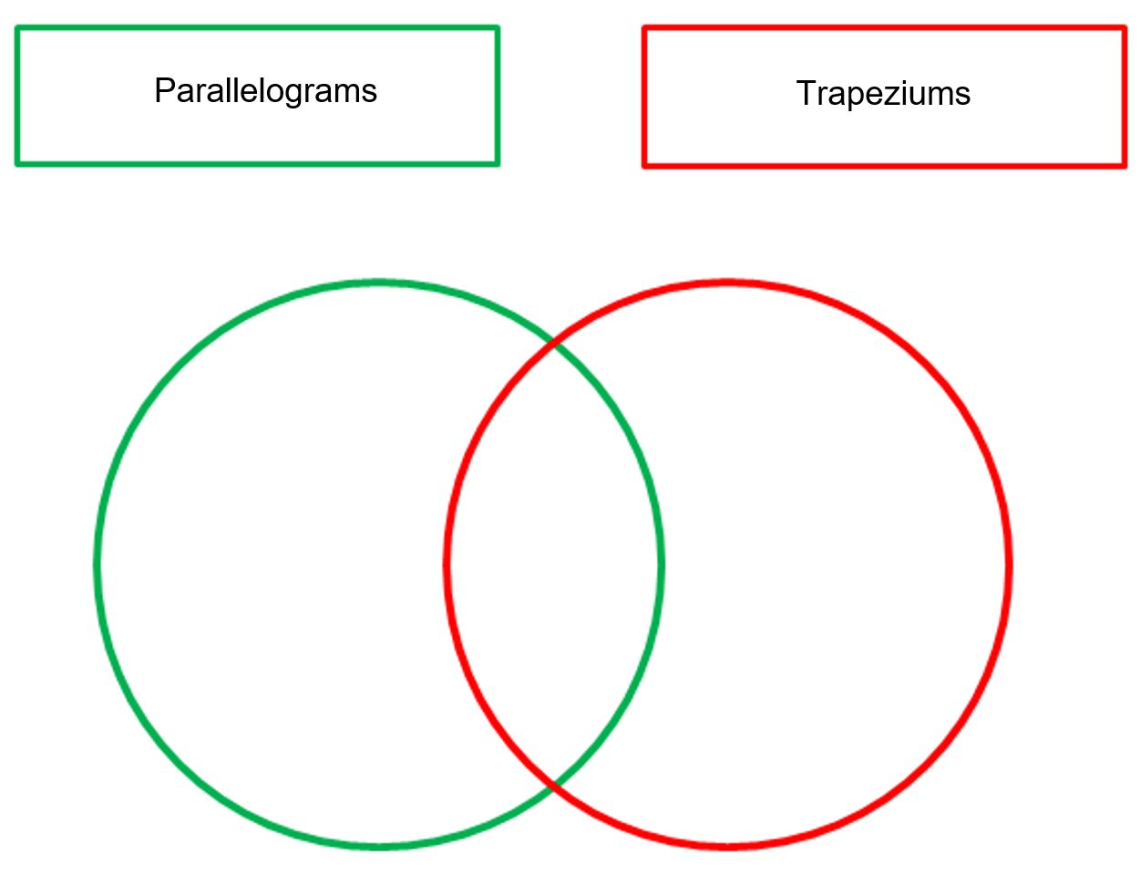

Summarise
- Print Appendix C ‘Thinking notes’ on A3 paper and place in plastic pockets.
- Students work in their previous groups of 3 to fill in the 4 quadrants of the thinking notes, starting with the worked example and then moving in a clockwise direction.
Thinking notes divide a page into 4 quadrants.
- The first quadrant completed is the top left which is a fill in the blanks example, created by the teacher.
- Groups then move in a clockwise direction, around the sheet, to complete each quadrant.
- The next quadrant, top right is example 1, which is a question given to the students without the solution completed.
- Following this, bottom right, is a second example that is more open than the previous one and at times asks students to create their own example.
- The final quadrant, bottom left, is where students write notes to their future forgetful selves (bit.ly/notesstrategy), that is ‘things to remember’.
- When students are finished, they return to their seats and recreate the ‘Thinking notes’ quadrants in their workbooks. Allow students to move around the classroom as they complete their own ‘Thinking notes’, so they can take examples from any of the groups’ work not just their own.
Students should summarise that a trapezium is a special quadrilateral that has exactly one set of parallel sides.

Apply
- Print and distribute Appendix D ‘Trapeziums’ to each student. Draw 3 trapeziums on the board similar to those in Appendix D.
- Ask 3 randomly selected students to draw a line cutting each of the 3 trapeziums into 2 parts. Explain to students that they could start and end anywhere when making their cut.
- Ask each student to identify which 2 shapes they have created by making that cut. Refer to Figure 5 on slide 6 of the Tackling trapeziums PowerPoint, as an example cut that creates a triangle and a parallelogram.
Figure 5 – example cut
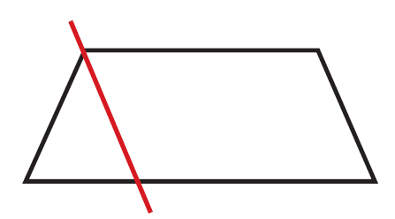
- Challenge students, in pairs, to investigate what shapes can be created by cutting a trapezium into 2 pieces.
- Students may need some prompting questions, such as:
- Have you considered making a cut between 2 opposite sides?
- Have you considered making a cut between 2 opposite vertices?
- Have you considered making a cut between a vertex and an opposite side?
- Are all your lines horizontal and/or vertical?
- Extend students to consider the following, sharing their thinking and reasoning with their partner:
- Describe the shapes that you have made and explain how you did this.
- What sort of trapezium is needed to make a rectangle? How should it be cut?
- How should you cut the trapezium to make a parallelogram?
- Can you make 2 triangles?
- How many ways can you make 2 triangles?
- Conduct a class discussion so students can share some of their cuts, and the shapes that they created.

Assessment and differentiation

Suggested opportunities for differentiation
Launch
- Students may struggle to remember key words used in this activity, such as the 6 special quadrilaterals and convex and non-convex quadrilaterals. Allow students to describe the shapes in any way that they can without focusing on formal mathematical language.
Explore
- The Categories activity is an example of a low floor, high ceiling task. Students could have broad categories such as convex and non-convex or be specific such as having each of the 6 special quadrilaterals as the categories. In this activity students could also be challenged to measure angles and/or draw and measure diagonals to use specific properties of the shapes.
- For the Venn diagram task, students could be challenged to add a third circle to look at the similarities and differences with a quadrilateral previously explored.
- For the Venn diagram task, students may benefit from having a variety of parallelograms and trapeziums drawn to compare.
Apply
- To challenge students, once they have created a list of possible shapes based on the trapeziums provided, ask them if their list applies to all trapeziums or if by cutting a different trapezium, they could create more shapes.

Suggested opportunities for assessment
- Assessing questions could be used in the Categories and Venn diagram task, such as, ‘Could you write a rule that is always true for a trapezium?’
- Monitor student conversations during the group work activities to check for understanding, encouraging groups to look at each other’s work and communicate.
- Be sure to check each of the thinking notes to check for any misconceptions.

Appendix A

Categories
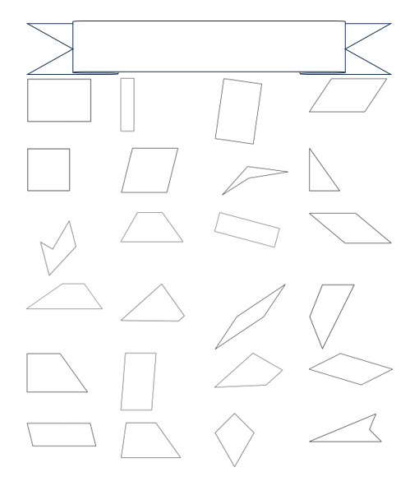

Appendix B

Venn diagram task

Appendix C

Thinking notes
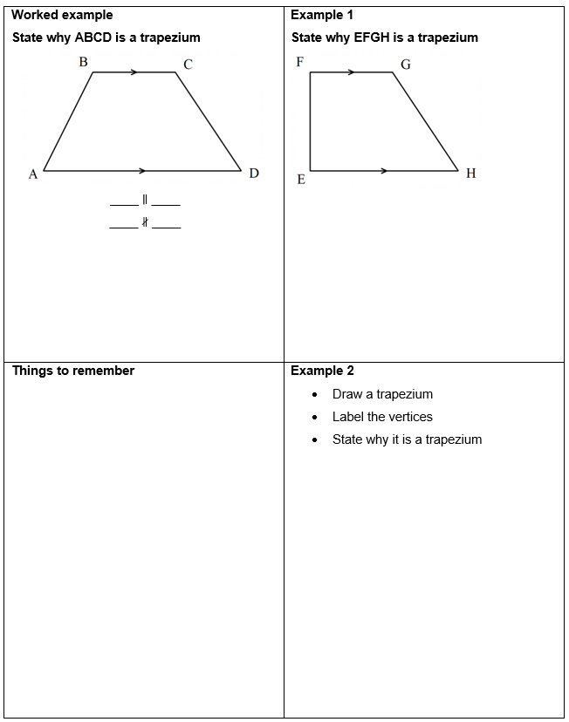

Appendix D

Trapeziums
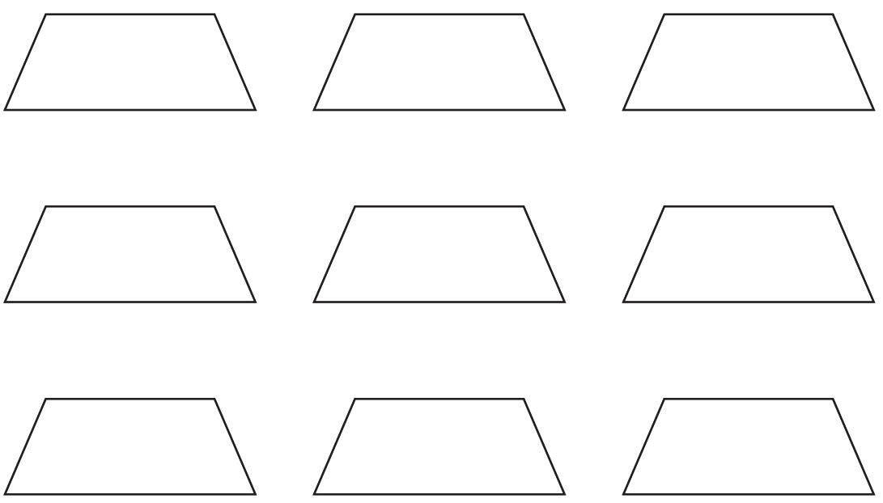

Sample solutions

Appendix C – thinking notes
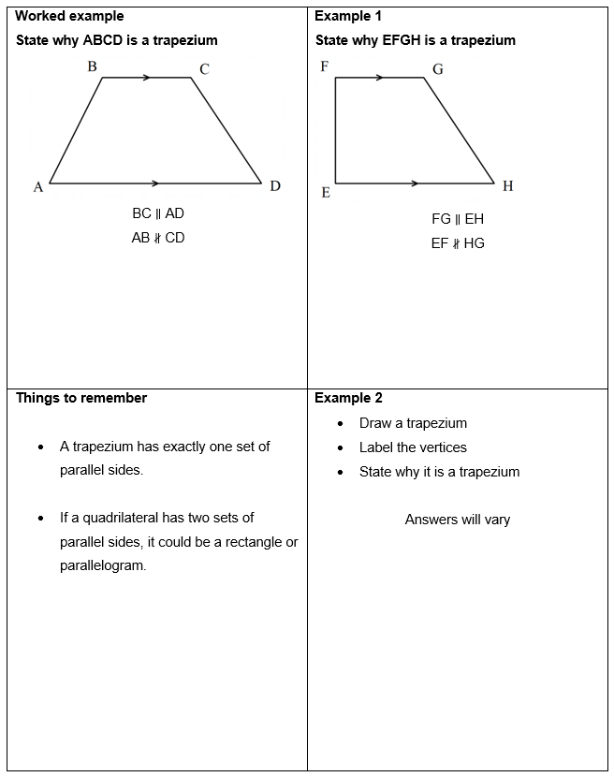

References
This resource contains NSW Curriculum and syllabus content. The NSW Curriculum is developed by the NSW Education Standards Authority. This content is prepared by NESA for and on behalf of the Crown in right of the State of New South Wales. The material is protected by Crown copyright.
Please refer to the NESA Copyright Disclaimer for more information https://educationstandards.nsw.edu.au/wps/portal/nesa/mini-footer/copyright.
NESA holds the only official and up-to-date versions of the NSW Curriculum and syllabus documents. Please visit the NSW Education Standards Authority (NESA) website https://educationstandards.nsw.edu.au/ and the NSW Curriculum website https://curriculum.nsw.edu.au/home.
Mathematics K–10 Syllabus © NSW Education Standards Authority (NESA) for and on behalf of the Crown in right of the State of New South Wales, 2022.

© State of New South Wales (Department of Education), 2023
The copyright material published in this resource is subject to the Copyright Act 1968 (Cth) and is owned by the NSW Department of Education or, where indicated, by a party other than the NSW Department of Education (third-party material).
Copyright material available in this resource and owned by the NSW Department of Education is licensed under a Creative Commons Attribution 4.0 International (CC BY 4.0) license.
This license allows you to share and adapt the material for any purpose, even commercially.
Attribution should be given to © State of New South Wales (Department of Education), 2023.
Material in this resource not available under a Creative Commons license:
- the NSW Department of Education logo, other logos and trademark-protected material
- material owned by a third party that has been reproduced with permission. You will need to obtain permission from the third party to reuse its material.
Links to third-party material and websites
Please note that the provided (reading/viewing material/list/links/texts) are a suggestion only and implies no endorsement, by the New South Wales Department of Education, of any author, publisher, or book title. School principals and teachers are best placed to assess the suitability of resources that would complement the curriculum and reflect the needs and interests of their students.
If you use the links provided in this document to access a third-party's website, you acknowledge that the terms of use, including licence terms set out on the third-party's website apply to the use which may be made of the materials on that third-party website or where permitted by the Copyright Act 1968 (Cth). The department accepts no responsibility for content on third-party websites.

