Two of a kind
Students explore the properties of a rectangle and parallelogram by comparing them to a square and a rhombus. Students will use their prior knowledge of triangles, squares and rhombuses in this lesson.

Visible learning

Learning intentions
- To know the properties of a rectangle.
- To know the properties of a parallelogram.

Success criteria
- I can identify properties of a rectangle and a parallelogram.
- I can compare the properties of a rectangle and a parallelogram.
- I can justify why a quadrilateral can be classified as a rectangle or a parallelogram.

Syllabus outcomes
A student:
- develops understanding and fluency in mathematics through exploring and connecting mathematical concepts, choosing and applying mathematical techniques to solve problems, and communicating their thinking and reasoning coherently and clearly MAO-WM-01
- identifies and applies the properties of triangles and quadrilaterals to solve problems
MA4-GEO-C-01
Mathematics K–10 Syllabus © NSW Education Standards Authority (NESA) for and on behalf of the Crown in right of the State of New South Wales, 2022.

Activity structure

Launch
- Assign students to visibly random groups of 3 (bit.ly/visiblegroups) and issue each group with manipulatives like those in Figure 1. This could be strips of paper, popsicle sticks, actual sticks, and so on. Each group needs 2 short and 2 long sticks.
Figure 1 – sticks
Image created using the free virtual manipulatives at Polypad.org.
- Explain to each group that their task is to make as many unique quadrilaterals as possible using the 4 sticks provided as side lengths. Groups will then need to name each of the shapes that they have created.
- Conduct a class discussion by asking groups to name the shapes they created. As each group names a shape, encourage the other groups to create the shape named with their manipulatives. Students could have created the following shapes:
- rectangle
- parallelogram
- kite
- non-convex quadrilateral.
The aim of this activity is for students to start to consider which special quadrilaterals have 2 pairs of equal sides.

Explore

Square vs rectangle
- Arrange students into visibly random groups of 3 (bit.ly/visiblegroups).
- Issue students with Appendix A ‘Exploring the properties of quadrilaterals’.
- In their groups, students recall the properties of a square using their prior knowledge. They should tick these properties in the first column of the table, as well as mark them on their diagram using common conventions.
- Issue each student with either a sheet of A4 or A5 paper (A4 sheet cut in half), so that each group has a variety of sizes.
- Groups will use their knowledge of triangles, as well as rulers and protractors to test if each property of a square is maintained in a rectangle. They will further investigate any other properties that rectangles may have that a square does not.
- Conduct a class discussion using a questioning technique such as Pose-Pause-Pounce-Bounce [PDF 200KB] (bit.ly/pausepouncebounce) to share the properties that each group listed for a rectangle. Allow the discussion to cover the fact that no matter what size their rectangle was, all had the same properties.
- Students then determine which of the following statements is true:
- Every square is a rectangle.
- Every rectangle is a square.
Every square is a special kind of rectangle where all the sides have the same length.

Rhombus vs parallelogram
- Students are to recall the properties of a rhombus and mark these on their diagram from Appendix A using common conventions, as well as record the features by ticking the column for rhombus.
- Issue students with either parallelogram A or B from Appendix B ‘Parallelograms’ so that each group has a variety of parallelograms.
- Firstly, have groups use their knowledge of triangles to fill in any missing angles and sides that they know.
- Distribute rulers and protractors for groups to test each property of a rhombus on a parallelogram. Students should be encouraged to draw on each diagonal to analyse. They will further investigate any other properties that parallelograms may have that a rhombus does not.
- Conduct a class discussion using a questioning technique such as Pose-Pause-Pounce-Bounce [PDF 200KB] (bit.ly/pausepouncebounce) to share the properties that each group listed for a parallelogram. Allow the discussion to cover the fact that no matter what size their parallelogram, all had the same properties.
- Students then determine which of the following statements is true:
- Every parallelogram is a rhombus.
- Every rhombus is a parallelogram.
Every rhombus is a special kind of parallelogram where all 4 sides are equal in length.
- Students have so far compared squares to rectangles and rhombuses to parallelograms. Students will now see how the 2 new shapes, rectangles and parallelograms, are related by continuing to use Appendix A in their groups of 3.
- Groups will complete a Venn diagram to compare the properties of a rectangle with the properties of a parallelogram, at vertical non-permanent surfaces.
- Following this, in their groups, students will compare all 4 shapes by completing the sentence below using the words squares, rectangles, parallelograms and rhombuses.
The answer to this is: Squares, rhombuses and rectangles are all parallelograms.

Summarise

Thinking notes
- Print Appendix C ‘Thinking notes’ on A3 paper and place in plastic pockets already around the room. Existing worksheets should be visible and/or accessible to students, as they may like to refer to them when completing this task.
- Assign new random groups of 3, provide one whiteboard marker per group, and direct students to stand at one of the plastic pockets.
The reason for assigning new groups of 3 is so students come from different conversations from around the room.
- Students work in their groups of 3 to fill in the 4 quadrants of the thinking notes, starting with the worked example and then moving in a clockwise direction.

Thinking notes divide a page into 4 quadrants.
- The first quadrant completed is the top left which is a fill in the blanks example, created by the teacher.
- Groups then move in a clockwise direction, around the sheet, to complete each quadrant.
- The next quadrant, top right is example 1, which is a question given to the students without the solution completed.
- Following this, bottom right, is a second example that is more open than the previous one and at times asks students to create their own example.
- The final quadrant, bottom left, is where students write their notes their future forgetful selves (bit.ly/notesstrategy), that is ‘things to remember’.
- When students are finished, they return to their seats and recreate the ‘Thinking notes’ quadrants in their workbooks. Allow students to move around the classroom as they complete their own ‘Thinking notes’, so they can take examples from any of the groups work not just their own.

Apply
- Arrange students into pairs and hand out Appendix D ‘Which shape am I?’ to each student.
- Inform students they will be playing a game of ‘Which shape am I?’
- Students will choose a shape from the ones provided in Appendix D, without telling their partner.
- They then take turns to ask one question about the shape their partner has chosen. Their partner can only reply with ‘Yes’ or ‘No’. Questions that they ask should be aligned to the properties of each of the shapes, that is, the number of sides, equal sides, equal angles, and so on.
- Once one round has been played, challenge students to consider the following:
- How many questions do you need to ask to guarantee you know which shape your partner has chosen?
- What could you ask first to increase your odds of guessing the correct shape in the least number of questions?

Assessment and differentiation

Suggested opportunities for differentiation
Launch
- The type of material can be varied to suit the needs of the students. For example, 4 equal sticks can be given at first to limit the options, followed by 2 pairs of equal sticks. Or 3–4 different length sticks could be given to students for more of a challenge.
Explore
- Students may need to revise the properties of triangles, squares and rhombuses before beginning this activity.
- Some students may need the list of properties filled in, rather than having to recall them individually.
- To extend students they could be provided with the table completed with ticks and they then need to determine the property that was listed.
- To extend the Venn diagram activity, a triple Venn could be created that compares squares, rectangles and parallelograms or rhombuses, rectangles and parallelograms.
Summarise
- Students may need to have the list of properties for a rectangle and parallelogram summarised for them, using a diagram.
Apply
- Students may need to list what each shape is before commencing.
- Students could be challenged to add more shapes that they know and to complete another round.

Suggested opportunities for assessment
- Monitor student conversations during the group activity to check for understanding and to address any misconceptions.
- Collect Appendix A from students to check for understanding.

Appendix A

Exploring the properties of quadrilaterals
- Mark the properties of a square on the square diagram below and then use the first column of the table to tick which properties apply to a square. One property has already been completed for you.
Properties | Square | Rectangle
All sides are equal | ü
Opposite sides are parallel
Adjacent sides are perpendicular
Diagonals are equal
Diagonals bisect each other
Diagonals bisect each other at right angles
Diagonals bisect the angles of the quadrilateral
Opposite sides are equal
- Use a sheet of paper to analyse the properties of a rectangle. Use the second column of the table to tick off any properties related to a rectangle.
- Mark the properties of a rectangle on the rectangle diagram at the top of the page.

- In your group decide which statement is correct:
- Every square is a rectangle.
- Every rectangle is a square.
- Mark the properties of a rhombus on the rhombus diagram below and then use the first column to tick which properties apply to a rhombus. One property has already been completed for you.
Properties | Rhombus | Parallelogram
All sides are equal | ü
Opposite sides are parallel
Opposite angles are equal
Diagonals bisect each other
Diagonals bisect each other at right angles
Diagonals bisect the angles of the quadrilateral
Opposite sides are equal
- Use the parallelogram above to analyse the properties of a parallelogram. Use the second column to tick any properties that relate to a parallelogram.
- Show these properties on the parallelogram diagram, using common conventions.

- In your group decide which statement is correct:
- Every rhombus is a parallelogram.
- Every parallelogram is a rhombus.
- It is now time to compare rectangles to parallelograms. Use the Venn diagram to list the properties that belong in each region. If you think a region is impossible to fill, convince me why!
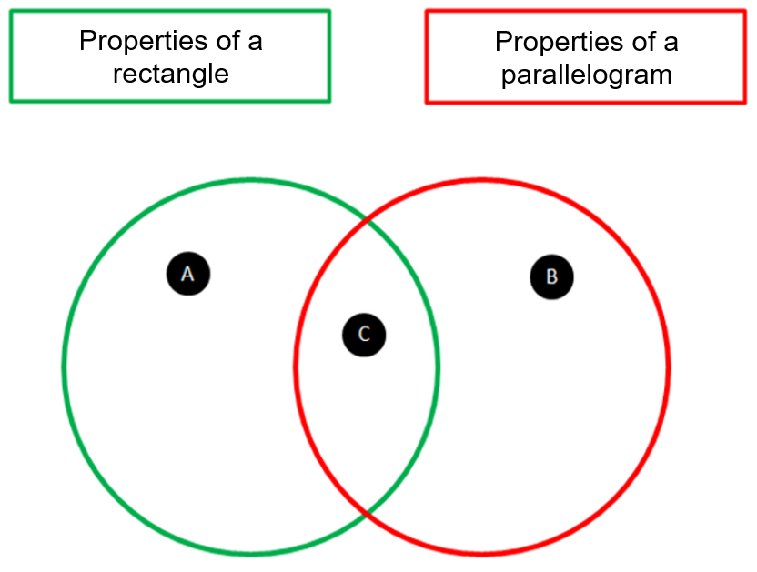
- Complete the sentence below using the words squares, rectangles, parallelograms and rhombuses.

Appendix B

Parallelograms

Parallelogram A
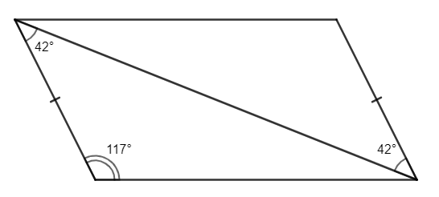

Parallelogram B
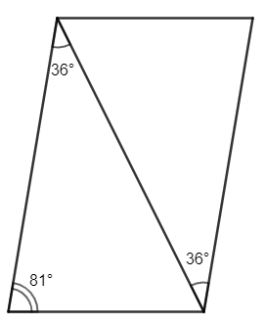

Appendix C

Thinking notes
Worked example  State why $ABCD$ is a parallelogram.  $ABCD$ is a parallelogram because: | Example 1  State why $EFGH$ is a rectangle.
Things to remember | Example 2  - Draw a parallelogram.  - Label any additional information.  - State why it is a parallelogram.

Appendix D

Which shape am I?
- Choose one of the shapes below, but don’t tell your partner.
- Take it in turns to ask a question about the shape that your partner has chosen. Each person can only reply with ‘Yes’ or ‘No’.
- Use the shapes below to help you identify your partner’s shape.
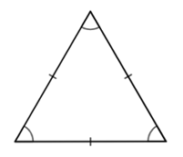 | 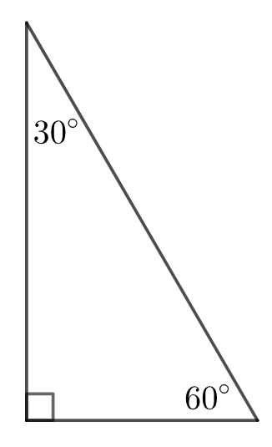
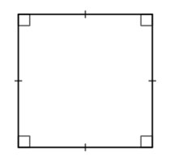 |  | 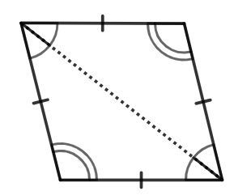
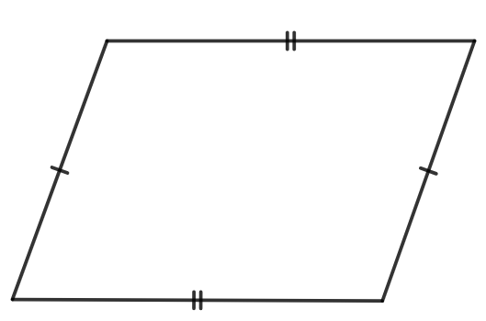

Sample solutions

Appendix A – exploring the properties of quadrilaterals

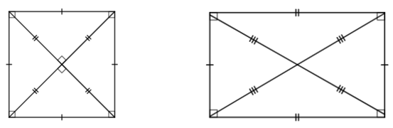
Properties | Square | Rectangle
All sides are equal | ü
Opposite sides are parallel | ü | ü
Adjacent sides are perpendicular | ü | ü
Diagonals are equal | ü | ü
Diagonals bisect each other | ü | ü
Diagonals bisect each other at right angles | ü
Diagonals bisect the angles of the quadrilateral | ü
Opposite sides are equal |  | ü
- In your group decide which statement is correct:
- Every square is a rectangle.

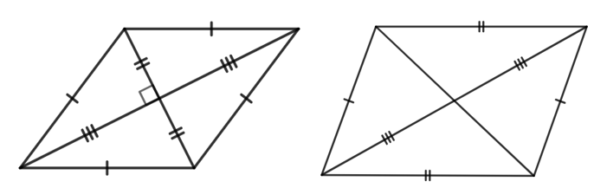
Properties | Rhombus | Parallelogram
All sides are equal | ü
Opposite sides are parallel | ü | ü
Opposite angles are equal | ü | ü
Diagonals bisect each other | ü | ü
Diagonals bisect each other at right angles | ü
Diagonals bisect the angles of the quadrilateral | ü
Opposite sides are equal |  | ü
- Every rhombus is a parallelogram.
- Region A: All angles are equal, diagonals are equal.
Region B: Opposite sides are parallel, diagonals bisect each other, opposite sides are equal.
Region C: Opposite angles are equal.
- Squares, rhombuses and rectangles are all parallelograms.

References
This resource contains NSW Curriculum and syllabus content. The NSW Curriculum is developed by the NSW Education Standards Authority. This content is prepared by NESA for and on behalf of the Crown in right of the State of New South Wales. The material is protected by Crown copyright.
Please refer to the NESA Copyright Disclaimer for more information https://educationstandards.nsw.edu.au/wps/portal/nesa/mini-footer/copyright.
NESA holds the only official and up-to-date versions of the NSW Curriculum and syllabus documents. Please visit the NSW Education Standards Authority (NESA) website https://educationstandards.nsw.edu.au/ and the NSW Curriculum website https://curriculum.nsw.edu.au/home.
Mathematics K–10 Syllabus © NSW Education Standards Authority (NESA) for and on behalf of the Crown in right of the State of New South Wales, 2022.

© State of New South Wales (Department of Education), 2023
The copyright material published in this resource is subject to the Copyright Act 1968 (Cth) and is owned by the NSW Department of Education or, where indicated, by a party other than the NSW Department of Education (third-party material).
Copyright material available in this resource and owned by the NSW Department of Education is licensed under a Creative Commons Attribution 4.0 International (CC BY 4.0) license.
This license allows you to share and adapt the material for any purpose, even commercially.
Attribution should be given to © State of New South Wales (Department of Education), 2023.
Material in this resource not available under a Creative Commons license:
- the NSW Department of Education logo, other logos and trademark-protected material
- material owned by a third party that has been reproduced with permission. You will need to obtain permission from the third party to reuse its material.
Links to third-party material and websites
Please note that the provided (reading/viewing material/list/links/texts) are a suggestion only and implies no endorsement, by the New South Wales Department of Education, of any author, publisher, or book title. School principals and teachers are best placed to assess the suitability of resources that would complement the curriculum and reflect the needs and interests of their students.
If you use the links provided in this document to access a third-party's website, you acknowledge that the terms of use, including licence terms set out on the third-party's website apply to the use which may be made of the materials on that third-party website or where permitted by the Copyright Act 1968 (Cth). The department accepts no responsibility for content on third-party websites.

