Diamonds of geometry
Students explore the properties of a rhombus by joining 2 equilateral triangles and then 2 isosceles triangles.

Visible learning

Learning intentions
- To know the properties of a rhombus.

Success criteria
- I can compare the properties of 2 quadrilaterals.
- I can describe the properties of a rhombus.
- I can justify why a quadrilateral can be classified as a rhombus.

Syllabus outcomes
A student:
- develops understanding and fluency in mathematics through exploring and connecting mathematical concepts, choosing and applying mathematical techniques to solve problems, and communicating their thinking and reasoning coherently and clearly MAO-WM-01
- identifies and applies the properties of triangles and quadrilaterals to solve problems
MA4-GEO-C-01
Mathematics K–10 Syllabus © NSW Education Standards Authority (NESA) for and on behalf of the Crown in right of the State of New South Wales, 2022.

Activity structure
Please use the associated PowerPoint Diamonds of geometry to display images in this lesson.

Launch
- Display Figure 1. This can be found on slide 2 of the Diamonds of geometry PowerPoint. Ask students to consider what they notice and what they wonder (bit.ly/noticewonderstrategy) about the image.
Figure 1 – car jack
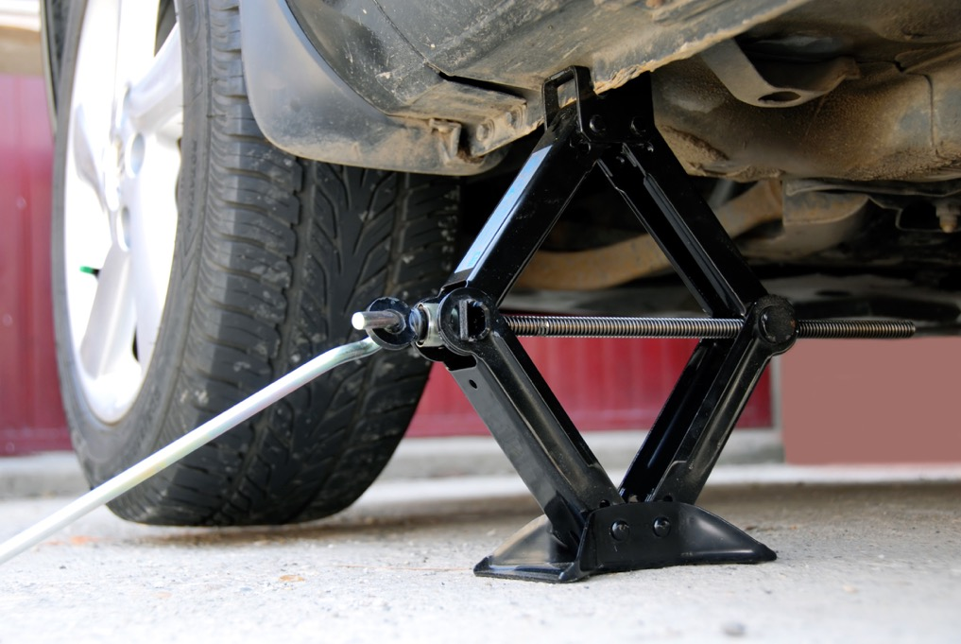
'Mechanical Linkages: Quadrilaterals' by reSolve is licensed under CC BY-NC-SA 4.0.
Some prompting questions could include:
- What shapes can you see?
- What do you notice/wonder about the design of the car jack?
- Students may consider that the car jack is in the shape of a diamond, some may suggest that it is a rhombus. Ask students ‘How do you know this is a diamond/rhombus?’
The aim of this activity is to get students to consider the properties of a rhombus that will be explored during the lesson. This can be a formative assessment activity to explore students’ prior knowledge.
- Ask students to brainstorm where else they may have seen this shape in the real world, explaining that they will explore its properties to determine why it is used. Figure 2, also found on slide 3 of the Diamonds of geometry PowerPoint, can be displayed to show other examples.
Figure 2 – other examples
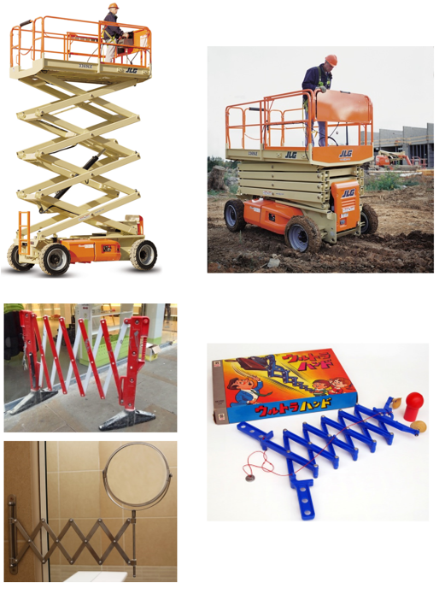
'Mechanical Linkages: Quadrilaterals' by reSolve is licensed under CC BY-NC-SA 4.0.

Explore
- In a Think-Pair-Share (bit.ly/thinkpairsharestrategy), have students create a list of everything they know about equilateral and isosceles triangles, including the properties that they can recall.
- Conduct a class discussion to create a list of all the properties of equilateral and isosceles triangles.
- Explain to students that they will be using equilateral and isosceles triangles to analyse the properties of a rhombus.
Students have identified different types of quadrilaterals in previous lessons without going into all the properties. At this point of the lesson, the aim is that students can recognise a rhombus as having all sides equal and may have an informal definition as to why it is different from a square.
- Pose the following scenario to the class:
Marlow joins 2 identical equilateral triangles and believes she has created a rhombus.
Nakul joins 2 identical isosceles triangles and believes he has created a rhombus.
The terminology ‘congruent’ can be used rather than ‘identical’ in the scenario.
- Explain to students that they will be analysing the 2 statements from above using their knowledge of the properties of equilateral and isosceles triangles.
- Assign students into visibly random groups of 3 (bit.ly/visiblegroups) at vertical non-permanent surfaces (bit.ly/VNPSstrategy).
- Provide each group with a copy of Appendix A ‘Joining 2 triangles’ which has images of 2 equilateral triangles and 2 isosceles triangles joined, as shown in Figure 3, and some questions for students to further investigate the scenario. Students will complete Appendix A at their vertical non-permanent surfaces.
Figure 3 – two triangles joined
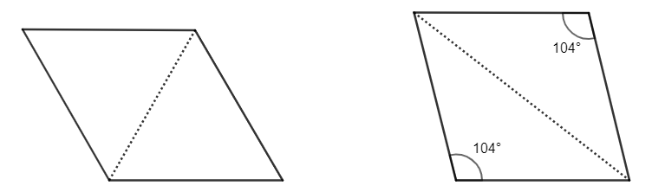
Images created using GeoGebra.
In Figure 3 common conventions have not been used to indicate properties. For example, that all sides of the equilateral triangle are equal or that each angle is $60°.$ This is to allow students to recall their prior knowledge.
- Encourage groups to take a gallery walk (bit.ly/DLSgallerywalk) to see how other groups have labelled their diagrams.
- Monitor student conversations when they are working in their groups. A completed diagram can be found in the Sample solutions section of this document. Some prompting questions might be required such as:
- What is the angle sum of all triangles?
- Can you think of any other properties of an isosceles triangle?
- After students have completed the activity in Appendix A ‘Joining 2 triangles’, conduct a class vote and ask groups which person from the scenario they believe is correct. Continue the discussion asking students to share the similarities and differences they listed for each quadrilateral.
- If it wasn’t already discussed, reveal to students that both Marlow and Nakul were correct and that both quadrilaterals formed are rhombuses.

Summarise
- Conduct a class discussion to see what students now know about rhombuses using the Pose-Pause-Pounce-Bounce question strategy [PDF 200KB] (bit.ly/pausepouncebounce).
- Display the GeoGebra applet ‘Rhombus properties’ (bit.ly/geogebrarhombusproperties) for the class to see. Slowly select each of the options to reveal all the properties of a rhombus.
- Move the points on the rhombus to show that the properties stay consistent no matter what size and shape the rhombus is.
The properties of a rhombus are listed below:
- All sides are equal.
- Opposite angles are equal.
- Opposite sides are parallel.
- Diagonals bisect each other at right angles.
- Diagonals bisect the interior angles of the quadrilateral.

Thinking notes
- Keep students in their previous groups of 3 and print Appendix B ‘Thinking notes’ on A3 paper. Place them in plastic pockets around the room. Provide one whiteboard marker per group. Existing worksheets should be visible and/or accessible to students, as they may like to refer to them when completing this task.
- Students work in their groups of 3 to fill in the 4 quadrants of the thinking notes, starting with the worked example and then moving in a clockwise direction.

Thinking notes divide a page into 4 quadrants.
- The first quadrant completed is the top left which is a fill in the blanks example, created by the teacher.
- Groups then move in a clockwise direction, around the sheet, to complete each quadrant.
- The next quadrant, top right is example 1, which is a question given to the students without a completed solution.
- Following this, bottom right, is a second example that is more open than the previous one and at times asks students to create their own example.
- The final quadrant, bottom left, is where students write notes to their future forgetful selves (bit.ly/notesstrategy), that is ‘things to remember’.
- When students are finished, they return to their seats and recreate the ‘Thinking notes’ quadrants in their workbooks. Allow students to move around the classroom as they complete their own ‘Thinking notes’, so they can take examples from any of the group’s work not just their own.

Car jack
- Have students recall the image of the car jack from the Launch section of this lesson. Ask students to Think-Pair-Share why a car jack may form rhombuses, reflecting on the properties they just discovered.
- Conduct a class discussion where students share some of their thoughts. Some examples of why a car jack forms rhombuses could include:
- Since the diagonals are perpendicular the car attachment point moves vertically.
- All sides being equal means that it folds neatly and compactly.

Apply

Squares versus rhombuses
- Challenge students to complete the sentence using the words square and rhombus:
- Hand out Appendix C ‘Venn diagram’. Students can return to their groups of 3 at vertical non-permanent surfaces to complete the double Venn diagram comparing the properties of a square and a rhombus.

Paper folding
- Distribute an A4 sheet of paper to each student. Students can work in pairs for this activity.
- Show students the video ‘How to fold a RHOMBUS from A4’ (bit.ly/rhombuspaperfolding) and have them follow the steps with their own sheet of paper.
- Once students have completed the paper folding activity, explain to them that they are to determine whether the shape they have formed is a rhombus, giving reasons. Students should be encouraged to refer to the list of properties that they established.
- Have students share their reasonings with other pairs once they complete their investigations.

Assessment and differentiation

Suggested opportunities for differentiation
Launch
- To extend students encourage them to consider what might happen if the car jack contained a different shape. For instance, a parallelogram, or even a hexagon.
Explore
- If students are struggling to recall the properties of equilateral and isosceles triangles, more information can be added to Appendix A, such as adding in a few more angle sizes. Alternatively, properties could be slowly revealed for students to add to their own diagrams before more time is given for them to fill in some more information.
- Students could be extended to think if there is a way to join 2 identical isosceles triangles to form another special quadrilateral (that is, a parallelogram).
Summarise
- Students may need this activity to be teacher-led if they are struggling to make connections between the diagrams in Appendix A and a rhombus. Adding in the diagonal lines could also assist students.
Apply
- To extend students, they could be encouraged to unfold the paper and to find the value of as many angles as they can between crease lines without the use of a protractor.

Suggested opportunities for assessment
Launch
- Monitor student conversations and discussion to address any misconceptions regarding the properties of the shapes presented.
Explore
- Monitor student conversations and analyse the markings that they add to their diagrams to determine their knowledge of equilateral and isosceles triangles.
Summarise
- View the properties students first listed in their groups as well as their notes to future forgetful self to check for understanding.

Appendix A

Joining 2 triangles
Marlow joins 2 identical equilateral triangles and believes she has created a rhombus.
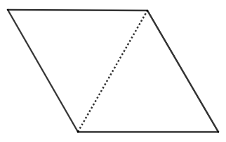
Nakul joins 2 identical isosceles triangles and believes he has created a rhombus.
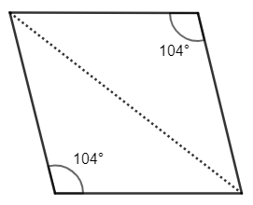
Images created using GeoGebra.

Activity
- Use your knowledge of the properties of each of the triangles to record as much information as possible on each diagram.
- Compare each diagram’s properties by listing the similarities and differences of each quadrilateral.
- Decide which person might be correct, Marlow or Nakul, giving reasons.

Appendix B

Thinking notes
Worked example  State why $ABCD$ is a rhombus.  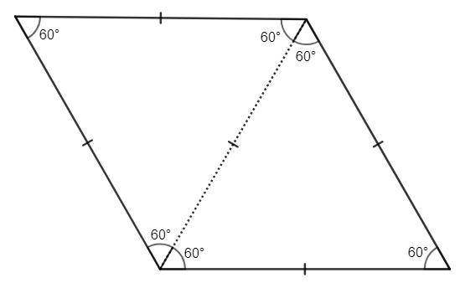  $ABCD$ is a rhombus because: | Example 1  State why $EFGH$ is a rhombus.  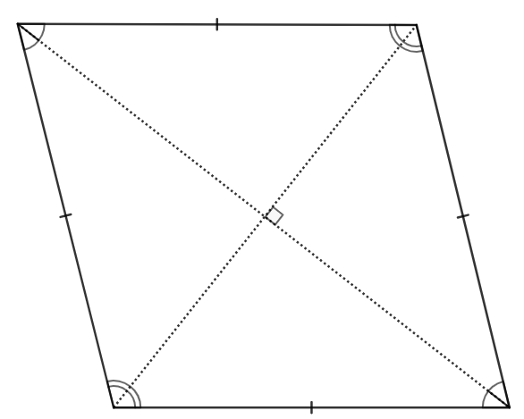
Things to remember | Example 2  - Draw a rhombus.  - Label any additional information.  - State why it is a rhombus.

Appendix C

Venn diagram
List the properties that belong in each region. If you think a region is impossible to fill, convince me why!
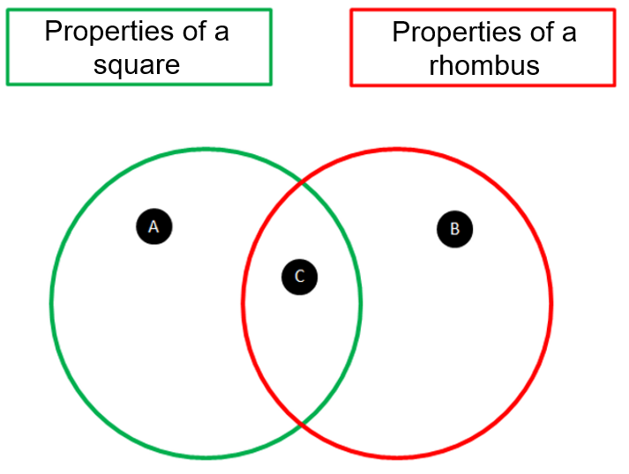

Sample solutions

Appendix A – joining 2 triangles
- Marlow
Nakul
- Similarities between the quadrilaterals could include:
- All sides are equal.
- Opposite angles are equal.
- Adjacent angles add to $180°$.
- Diagonals bisect the interior angles of the quadrilateral.

Appendix C – Venn diagram
- Section A: All corners right angles, diagonals are same length and 4 lines of symmetry.
- Section B: Diagonals can be different lengths.
- Section C: Two pairs of opposite parallel sides, all sides equal, opposite angles are equal, 2 lines of symmetry, have 4 sides, diagonals meet at right angles, angle sum of $360°$.

References
This resource contains NSW Curriculum and syllabus content. The NSW Curriculum is developed by the NSW Education Standards Authority. This content is prepared by NESA for and on behalf of the Crown in right of the State of New South Wales. The material is protected by Crown copyright.
Please refer to the NESA Copyright Disclaimer for more information https://educationstandards.nsw.edu.au/wps/portal/nesa/mini-footer/copyright.
NESA holds the only official and up-to-date versions of the NSW Curriculum and syllabus documents. Please visit the NSW Education Standards Authority (NESA) website https://educationstandards.nsw.edu.au/ and the NSW Curriculum website https://curriculum.nsw.edu.au/home.
Mathematics K–10 Syllabus © NSW Education Standards Authority (NESA) for and on behalf of the Crown in right of the State of New South Wales, 2022.

© State of New South Wales (Department of Education), 2023
The copyright material published in this resource is subject to the Copyright Act 1968 (Cth) and is owned by the NSW Department of Education or, where indicated, by a party other than the NSW Department of Education (third-party material).
Copyright material available in this resource and owned by the NSW Department of Education is licensed under a Creative Commons Attribution 4.0 International (CC BY 4.0) license.
This license allows you to share and adapt the material for any purpose, even commercially.
Attribution should be given to © State of New South Wales (Department of Education), 2023.
Material in this resource not available under a Creative Commons license:
- the NSW Department of Education logo, other logos and trademark-protected material
- material owned by a third party that has been reproduced with permission. You will need to obtain permission from the third party to reuse its material.
Links to third-party material and websites
Please note that the provided (reading/viewing material/list/links/texts) are a suggestion only and implies no endorsement, by the New South Wales Department of Education, of any author, publisher, or book title. School principals and teachers are best placed to assess the suitability of resources that would complement the curriculum and reflect the needs and interests of their students.
If you use the links provided in this document to access a third-party's website, you acknowledge that the terms of use, including licence terms set out on the third-party's website apply to the use which may be made of the materials on that third-party website or where permitted by the Copyright Act 1968 (Cth). The department accepts no responsibility for content on third-party websites.

