Sides and angles united
Students explore the properties of a square by relating them to equilateral and isosceles triangles.

Visible learning

Learning intentions
- To know the properties of a square.

Success criteria
- I can compare the properties of a triangle to a square.
- I can describe the properties of a square.
- I can justify why a quadrilateral can be classified as square.

Syllabus outcomes
A student:
- develops understanding and fluency in mathematics through exploring and connecting mathematical concepts, choosing and applying mathematical techniques to solve problems, and communicating their thinking and reasoning coherently and clearly MAO-WM-01
- identifies and applies the properties of triangles and quadrilaterals to solve problems
MA4-GEO-C-01
Mathematics K–10 Syllabus © NSW Education Standards Authority (NESA) for and on behalf of the Crown in right of the State of New South Wales, 2022.

Activity structure
Please use the associated PowerPoint Sides and angles united to display images in this lesson.

Launch
- Use slide 3 from the Sides and angles united PowerPoint to display the ‘Which one doesn’t belong?’ image. This slide shows 3 shapes, as seen in Figure 1 – Which one doesn’t belong?
- An equilateral triangle
- A square
- A right-angled isosceles triangle
Figure 1 – Which one doesn't belong?
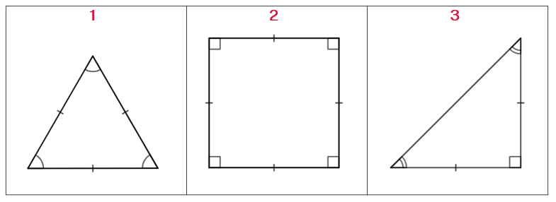
- Students are to consider which one doesn’t belong through a Think-Pair-Share (bit.ly/thinkpairsharestrategy) where they can discuss the reasons for their selection.
There is no correct answer for this activity, so student reasoning is important. Students could select that the equilateral triangle doesn’t belong since the others have at least one right angle, or the square since the other 2 shapes have 3 sides and it has 4, or the isosceles triangle since the others have all sides equal.
The aim of this activity is for students to recognise the shapes, name the shapes, list their properties and review common conventions.
- Once students have had sufficient time to discuss their choice and reasons with their partner, ask the class by either a show of hands or an online poll (such as mentimeter.com) to indicate the number of the shape which they think does not belong.
- By selecting non-volunteer students, conduct a class discussion to highlight the reasons why students selected each of the 3 shapes. Ensure that students can name the shape and explain what the conventions indicate when they are discussing their reasoning. A questioning technique such as Pose-Pause-Pounce-Bounce question strategy [PDF 200KB] (bit.ly/pausepouncebounce) could be used.

Explore

Averaging angles
- Arrange students into visibly random groups of 3 (bit.ly/visiblegroups) and issue each student with Appendix A ‘Averaging angles’. This worksheet asks students to calculate the mean of angles within isosceles and scalene triangles, and then the mean of angles within different types of quadrilaterals.
- Students discuss, within their group, what they notice and what they wonder about their results.
Students should discover that for the triangles the mean angle was $60°$ and for quadrilaterals the mean angle was $90°$.
- Once students have completed the activity, ask non-volunteer students to share their notice/wonders with the class as a discussion.

The aim of this task is to highlight that it is not the area taken up by a shape that influences its properties but rather how the shape is formed. Interior angles and side lengths are key to determining the classification of shapes and can be used efficiently to define and describe shapes and their properties. The discussion could also lead to defining regular polygons, specifically equilateral triangles, and squares.

Squaring up

Equipment
- Paper for students (any size) or their workbooks
- Rulers
- Protractors

Method
- Arrange students into pairs and have each student draw a square. Give no other instruction besides this at this point.
- Have students swap with the student next to them and have them critique their partner’s square, giving feedback as to why it is not a square. Students are to use rulers and protractors to assist with this process.
At this point, students may only know that all angles are $90°$ in a square and that each side is equal. Most students will only comment on these 2 properties. Some students may need direction here, but the aim is for them to find something that signifies that their peer’s square is not a perfect square.
- Instruct pairs to return their partner’s square with the feedback listed and conduct a brief class discussion where students can share the fault with their square.
- Continue the class discussion to see if students know any other properties of a square that could help them to draw a perfect square.
- Students are then to attempt to recreate their perfect square using the feedback provided by their partner and a ruler and protractor.
- Encourage students to swap with their partner again to receive more peer feedback on why this square might be better than the previous.
- Through a class discussion, ask pairs which one of them had the most perfect square. Ask students to share their strategies.
- Slowly reveal a few more properties of a square for the pairs to test. Challenge students to see if any pair drew a square that met all of the properties listed below.
- All sides are equal.
- Adjacent sides are perpendicular.
- Diagonals bisect each other at right angles.
- Diagonals bisect the angles of the quadrilateral.
There is no need to explore all these properties in this activity, as this extensive list is covered in the Summarise section of this lesson. Some properties revealed will need to be explained to students or an alternative wording could be provided.
- Conclude with the class that despite the square looking like a simple shape, it is the hardest to draw due to its wealth of properties.
- An optional task is to show students the construction of a square using Math Open Reference ‘Constructing a square’ (mathopenref.com/constsquare.html) which contains step-by-step annotations using a ruler and a compass. This website also has a printable step-by-step instruction sheet.

Summarise

Explicit teaching
- Use slides 5–10 from the Sides and angles united PowerPoint for a slow reveal of each of the properties of a square listed below.
- All sides are equal.
- Adjacent sides are perpendicular.
- Diagonals bisect each other at right angles.
- Diagonals are equal.
- Diagonals bisect the angles of the quadrilateral.
See the teaching notes within the PowerPoint as a guide to how each of these properties is to be marked on a diagram. The teaching notes also demonstrate how key terminology may be defined such as the words adjacent and bisect.

Thinking notes
- Print Appendix B ‘Thinking notes’ on A3 paper and place in plastic pockets already around the room. Existing worksheets should be visible and/or accessible to students, as they may like to refer to them when completing this task.
- Assign new random groups of 3, provide one whiteboard marker per group and direct students to stand at one of the plastic pockets.
The reason for assigning new groups of 3 is so students come from different conversations from around the room.
- Students work in their groups of 3 to fill in the 4 quadrants of the thinking notes, starting with the worked example and then moving in a clockwise direction.

Thinking notes divide a page into 4 quadrants.
- The first quadrant completed is the top left which is a fill in the blanks example, created by the teacher.
- Groups then move in a clockwise direction, on the page, to complete each quadrant.
The next quadrant, top right is example 1, which is a question given to the students without a completed solution.
- Following this, bottom right, is a second example that is more open than the previous one and at times asks students to create their own example.
- The final quadrant, bottom left, is where students write notes to their future forgetful self (bit.ly/notesstrategy), that is ‘things to remember’.
- When students are finished, they return to their seats and recreate the ‘Thinking notes’ quadrants in their workbooks. Allow students to move around the classroom as they complete their own ‘Thinking notes’, so they can take examples from any of the groups’ work not just their own.

Apply

What is a square most like?
- Display the scenario below to the class. This is also on slide 11 of the Sides and angles united PowerPoint.
Luana: Squares are most like equilateral triangles because they both have all sides equal.
Ashvin: No, squares are most like isosceles triangles because the diagonal splits a square into 2 identical isosceles triangles.
- Ask students to consider which statement they agree with the most and conduct a quick class vote by raising hands. No reasons should be given at this stage, as students will be investigating this.
- Have students return to their groups of 3 to discuss which statement they agreed with most and the reasons why.
- After allowing sufficient time, issue each student with Appendix C ‘What is a square most like?’ to complete as a group.
This is a worksheet with 2 different versions. One has 2 sets of double Venn diagrams and the other has a triple Venn diagram, which is used to compare the properties of a square with equilateral and isosceles triangles. Instead of completing this on the sheet, students are encouraged to complete this at vertical non-permanent surfaces (bit.ly/VNPSstrategy).
- Encourage students to go on a gallery walk (bit.ly/DLSgallerywalk) if they struggle at any point.
Students will likely find that the equilateral triangle and square had some properties that were similar, although they may have struggled to find any similarities between the square and an isosceles triangle.
- Conduct a brief class discussion on the results, comparing each of their Venn diagrams to reveal which type of triangle had the most in common with a square.

Square it
This game is based on an NRICH activity (nrich.maths.org/2526).
- Students will need to be in pairs to play the game.
- Issue each pair with dot paper, which can be printed from Appendix D ‘Dot paper’ or students can play online using the interactive game (nrich.maths.org/2526).
- Players may need different coloured pens to make this game easier.
- Players take it in turns to choose a dot on the grid. The winner is the first to have chosen 4 dots that can be joined to form a square. Squares can be anywhere and any size.
- After students have played a few times, a class discussion could be had on their strategies and whether they could find a winning strategy.
Student strategies have been submitted to NRICH and can be viewed using this link (nrich.maths.org/squareit/solution).

Turning a triangle into a square
This activity is based on a Cut Out Fold Up task (bit.ly/triangletoasquare).
- Explain to students that in this activity they will be dissecting an equilateral triangle into 4 pieces. If these 4 pieces are dissected in a particular way the pieces can be rearranged to form a square.
- Issue students with the equilateral triangle that is already dissected from Appendix E ‘Turning a triangle into a square’. Instruct students to cut out the shape and along the interior lines within the triangle, so they have 4 individual pieces.
An optional starting task is to issue students with a few copies of the blank equilateral triangle from Appendix E and allow them time to explore how the shape could be dissected.
- Students can then spend some time rearranging these 4 pieces to form a square.
- If students succeed in creating a square, ask them to consider any strategies that they used: that is they looked for right angles to form the 4 interior angles or they measured sides to form equal sides.
- Students can then consider why this might only work for an equilateral triangle and not all types of triangles.
- A further challenge is to dissect the triangle into more pieces to try and form a square which can be seen using the link Cut Out Fold Up ‘Turn an Equilateral Triangle into a Square II’ (bit.ly/triangletoasquare2).

Assessment and differentiation

Suggested opportunities for differentiation
Launch
- Students may need to review what each of the markings on the shapes mean, that is how equal sides and angles are shown using common conventions.
Explore
- Students may need to revise how to find the mean. This was previously taught in the unit ‘Making decisions’.
- Students may need assistance when using a protractor to measure angles.
- A class discussion could be had about errors in measurements and the implications of them in the real world.
Summarise
- Students may need support recalling the properties of triangles that have previously been explored in this unit.
- Rather than providing students with each of the properties, students could be told that the diagonal of a square cuts the square into 2 identical isosceles triangles. From here students could discover some of the properties of a square.
- Two different Venn diagrams have been created to allow for differentiation.
Apply
- To extend students, have them develop a winning strategy for the Square it game.
- To extend students they should investigate the strategy they took to form a square from the pieces and why the pieces create a square.

Suggested opportunities for assessment
- Appendix A and Appendix B can be collected to check for student understanding.
- Monitor student conversations when they are completing the Venn diagram activity to check for any misconceptions.

Appendix A

Averaging angles

Triangles
- Classify each of the triangles shown below.
Triangle 1 | Triangle 2 | Triangle 3
- Find the mean angle size for each of the triangles and record your results in the table below.
 | Triangle 1 | Triangle 2 | Triangle 3
Mean
- Find the mean of all 9 angles given in the triangles.
- What do you notice? What do you wonder?

Quadrilaterals
- Identify each of the quadrilaterals shown below, in whichever way you can.
Quadrilateral 1 | Quadrilateral 2 | Quadrilateral 3
 | 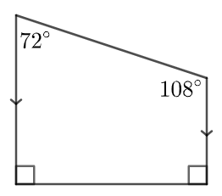
- Find the mean angle size for each of the quadrilaterals and record your results in the table below.
 | Quadrilateral 1 | Quadrilateral 2 | Quadrilateral 3
Mean
- Find the mean of all 12 angles given in the quadrilaterals.
- What do you notice? What do you wonder?

Appendix B

Thinking notes
Worked example  State why ABCD is a square.  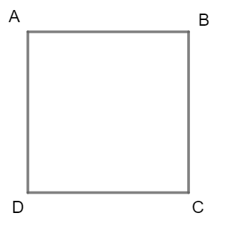  $ABCD$ is a square because: | Example 1  State why this is a square.  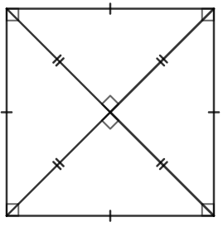
Things to remember | Example 2  - Draw a square  - Label any additional information  - State why it is a square

Appendix C

What is a square most like?

Triple Venn diagram
List the properties that belong in each region. If you think a region is impossible to fill, convince me why!
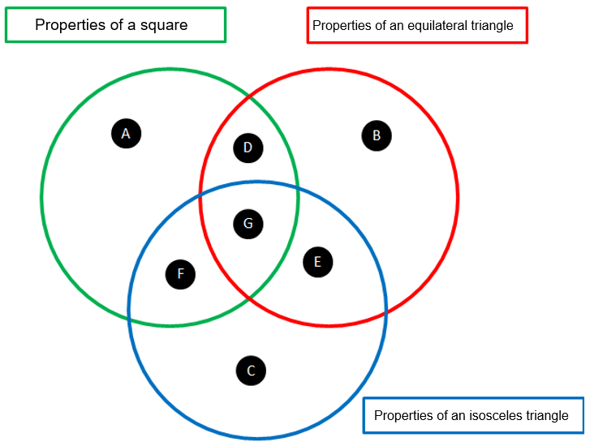

Double Venn diagrams
List the properties that belong in each region. If you think a region is impossible to fill, convince me why!

Venn diagram 1
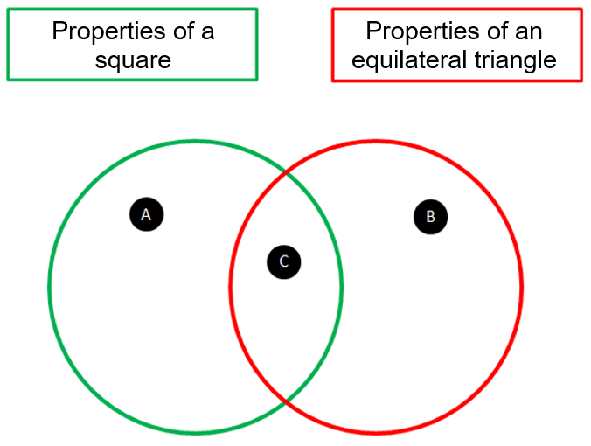

Venn diagram 2
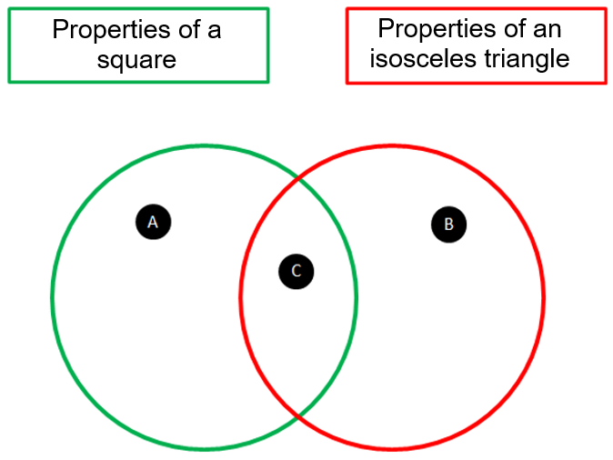

Appendix D

Dot paper

Appendix E

Turning a triangle into a square

Blank equilateral triangle
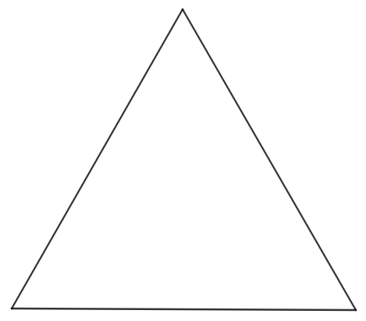

Dissected equilateral triangle
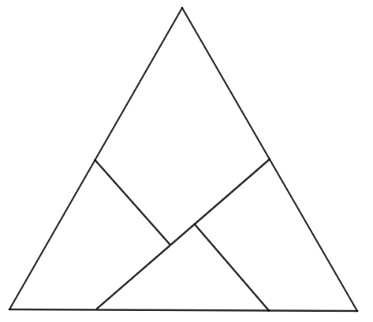

Sample solutions

Appendix A – averaging angles

Triangles

Triangle 1 | Triangle 2 | Triangle 3
Scalene triangle | Isosceles triangle | Right-angled scalene triangle

 | Triangle 1 | Triangle 2 | Triangle 3
Mean | $$56+78+46=180$$  $$180÷3=60°$$ | $$29×2+122=180$$  $$180÷3=60°$$ | $$90+30+60=180$$  $$180÷3=60°$$

$$56+78+46+29+29+122+90+30+60=540$$
$$540÷9=60°$$

Quadrilaterals

Quadrilateral 1 | Quadrilateral 2 | Quadrilateral 3
Quadrilateral | Trapezium | Non-convex quadrilateral

 | Quadrilateral 1 | Quadrilateral 2 | Quadrilateral 3
Mean | $$126+100+63+71=360$$  $$360÷4=90°$$ | $$90+108+90+72=360$$  $$360÷4=90°$$ | $$231+31+28+70=360$$  $$360÷4=90°$$

$$126+100+63+71+90+108+90+72+231+31+28+70=1080$$
$$1080÷12=90°$$

Appendix C – What is a square most like?

Triple Venn diagram
Please note that this is not an extensive list.
Region | Properties
A | - Diagonals bisect at right angles  - Adjacent sides are perpendicular
B | - All angles are $60°$
C | - Two equal sides  - Two equal angles
D | - All sides are equal  - All angles are equal  - A regular polygon
E | - 3-sided polygon
F | - At least one interior right angle (right-angled isosceles only)
G | - All sides are straight

Double Venn diagrams

Venn diagram 1
Please note that this is not an extensive list.
Region | Properties
A | - Diagonals bisect at right angles  - Adjacent sides are perpendicular  - 4-sided polygon
B | - All angles are $60°$  - 3-sided polygon
C | - All sides are equal  - All angles are equal  - A regular polygon

Venn diagram 2
Please note that this is not an extensive list.
Region | Properties
A | - Diagonals bisect at right angles  - Adjacent sides are perpendicular  - 4-sided polygon
B | - Two equal sides  - Two equal angles
C | - At least one interior right angle (right-angled isosceles only)

Appendix E – turning a triangle into a square
Solutions can be found on the Cut Out Fold Up website (bit.ly/triangletoasquare).

References
This resource contains NSW Curriculum and syllabus content. The NSW Curriculum is developed by the NSW Education Standards Authority. This content is prepared by NESA for and on behalf of the Crown in right of the State of New South Wales. The material is protected by Crown copyright.
Please refer to the NESA Copyright Disclaimer for more information https://educationstandards.nsw.edu.au/wps/portal/nesa/mini-footer/copyright.
NESA holds the only official and up-to-date versions of the NSW Curriculum and syllabus documents. Please visit the NSW Education Standards Authority (NESA) website https://educationstandards.nsw.edu.au/ and the NSW Curriculum website https://curriculum.nsw.edu.au/home.
Mathematics K–10 Syllabus © NSW Education Standards Authority (NESA) for and on behalf of the Crown in right of the State of New South Wales, 2022.

© State of New South Wales (Department of Education), 2023
The copyright material published in this resource is subject to the Copyright Act 1968 (Cth) and is owned by the NSW Department of Education or, where indicated, by a party other than the NSW Department of Education (third-party material).
Copyright material available in this resource and owned by the NSW Department of Education is licensed under a Creative Commons Attribution 4.0 International (CC BY 4.0) license.
This license allows you to share and adapt the material for any purpose, even commercially.
Attribution should be given to © State of New South Wales (Department of Education), 2023.
Material in this resource not available under a Creative Commons license:
- the NSW Department of Education logo, other logos and trademark-protected material
- material owned by a third party that has been reproduced with permission. You will need to obtain permission from the third party to reuse its material.
Links to third-party material and websites
Please note that the provided (reading/viewing material/list/links/texts) are a suggestion only and implies no endorsement, by the New South Wales Department of Education, of any author, publisher, or book title. School principals and teachers are best placed to assess the suitability of resources that would complement the curriculum and reflect the needs and interests of their students.
If you use the links provided in this document to access a third-party's website, you acknowledge that the terms of use, including licence terms set out on the third-party's website apply to the use which may be made of the materials on that third-party website or where permitted by the Copyright Act 1968 (Cth). The department accepts no responsibility for content on third-party websites.

