Unravelling tessellations
Students identify quadrilaterals by exploring and designing tessellations. Students distinguish between convex and non-convex quadrilaterals within this process.

Visible learning

Learning intentions
- To be able to identify special quadrilaterals.
- To be able to distinguish between convex and non-convex quadrilaterals.

Success criteria
- I can recognise special quadrilaterals using basic properties.
- I can draw convex and non-convex quadrilaterals.
- I can explain the difference between convex and non-convex quadrilaterals.

Syllabus outcomes
A student:
- develops understanding and fluency in mathematics through exploring and connecting mathematical concepts, choosing and applying mathematical techniques to solve problems, and communicating their thinking and reasoning coherently and clearly MAO-WM-01
- identifies and applies the properties of triangles and quadrilaterals to solve problems
MA4-GEO-C-01
Mathematics K–10 Syllabus © NSW Education Standards Authority (NESA) for and on behalf of the Crown in right of the State of New South Wales, 2022.

Activity structure

Warm up
Please use the associated PowerPoint Unravelling tessellations to display images in this lesson.
The purpose of this activity is for students to revise the angle sum of a quadrilateral and finding unknown angles in quadrilaterals, which has previously been explored in the unit.
- Display slide 2 of the associated PowerPoint Unravelling tessellations or draw Figure 1 on the board prior to students entering the classroom.
Figure 1 – quadrilaterals with missing angles
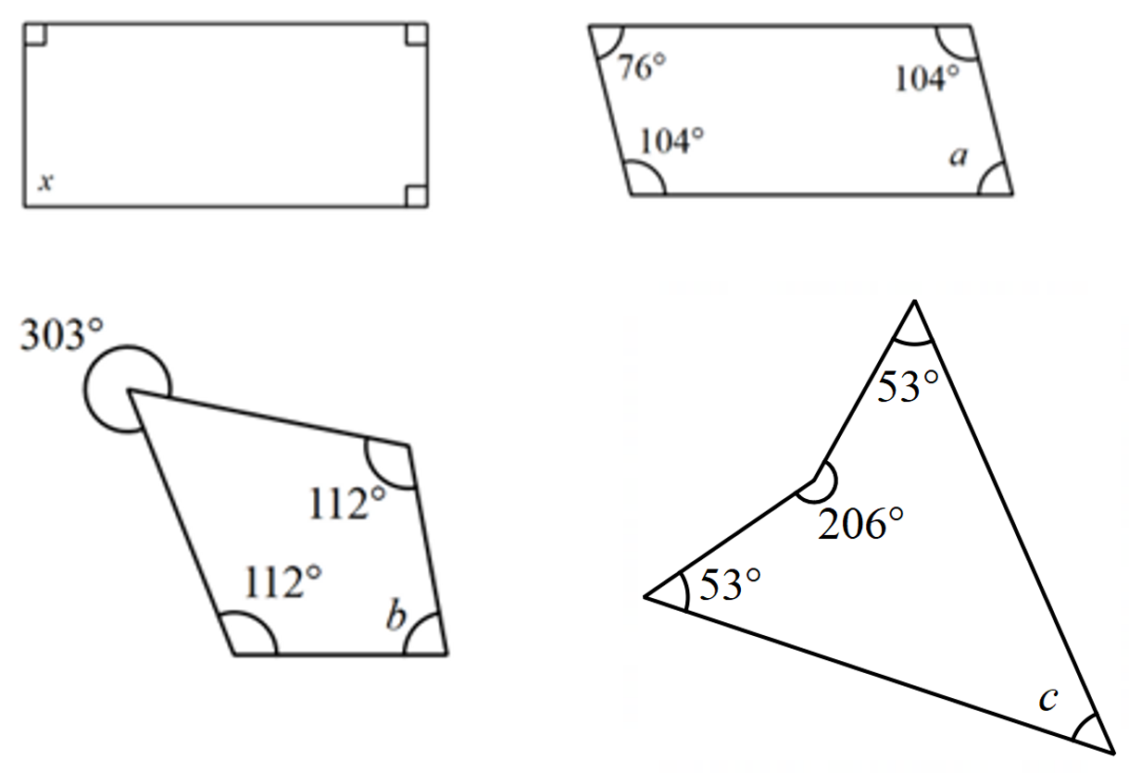
- As students enter the room, they are to begin finding the value of each pronumeral, showing their working in their workbooks or at vertical non-permanent surfaces (bit.ly/VNPSstrategy).
- Randomly select students to share their answers and strategies, suggesting that students name the quadrilateral if they can.

Launch
This activity can be displayed on slide 3 of the associated PowerPoint Unravelling tessellations. The following link can also be used to model the activity using Mathigon’s Polypad (bit.ly/polypadpolyominoes).
- Print, cut up and distribute the polyominoes from Appendix A ‘Polyomino tiles’, one set between pairs.
Students need to be able to distinguish between the 2 t-shaped tiles. Students may use a highlighter or similar to colour both sides of their shapes.
- Students are to use the polyomino tiles to fill a 4 × 4 grid. Challenge them to find as many ways as possible to fill the grid.
Figure 2 – 4 × 4 grid
Images created using the free virtual manipulatives at Polypad.org.
- Students should draw any solutions that they find.
- When students don’t believe any more solutions are possible, or the class is ready to move on, have students consider if each of their answers is unique.
You could use the term ‘congruent’ to describe solutions that are rotations of one another.
There are 8 unique solutions, which can be found in the ‘Sample solutions’ section.
- Have pairs check in with a nearby pair to count how many unique solutions they have between them.
- Explain to students that by rotating and translating their polyomino tiles, they have created a square tessellation.
- Display the Polypad canvas ‘Rectangular tessellations’ (bit.ly/polypadrectangulartessellations).
- Use the zoom and pan tools, on the right side of the screen, to show students the various rectangular tessellations. Figure 3 shows some examples of what is on the Polypad canvas. These images are also on slide 4 of the PowerPoint.
Figure 3 – rectangular tessellations
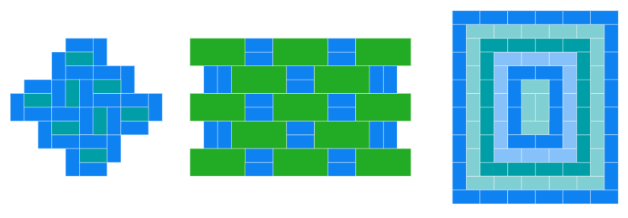
Images created using the free virtual manipulatives at Polypad.org.
- Ask students:
- How would you define a tessellation?
- Have you seen any tessellations around the school or elsewhere?
You can define a tessellation as shapes fitted together closely without gaps or overlapping.
Students might recognise rectangular tessellations as: the way bricks are laid, the structure of a block of chocolate, the tiles in their bathroom or the tiles in a pool.

Explore
- Write the following statement on the board: ‘All quadrilaterals tessellate’.
- In a Think-Pair-Share (bit.ly/thinkpairsharestrategy), have students consider which quadrilaterals always, sometimes and never tessellate in relation to the statement.
- Have a brief class discussion to gather some of the students’ thoughts from their Think-Pair-Share activity.
- Using Appendix B ‘Quadrilateral recall’, students complete a table where they draw a quadrilateral, state its name and then write anything they know about the shape in terms of sides and angles. The finalised list may include, but is not limited to, square, rectangle, parallelogram, rhombus, kite and trapezium. Students may also know of non-convex (concave) quadrilaterals.
The purpose of this activity is for students to recognise each of the special quadrilaterals, but not to explicitly go into the details of each of their properties. For example, with a square, students should know that there are equal sides and all angles are 90 degrees. The more advanced properties are explored in depth in the lessons that follow.
- Model for students each of the special quadrilaterals that will be explored in this unit and how there are a variety of ways to draw each quadrilateral. That is, they could be varied sizes and convex or non-convex. Demonstrate to students the difference between convex and non-convex.
Non-convex (also called concave) quadrilaterals can be defined as having one internal reflex angle, as per the diagram below.
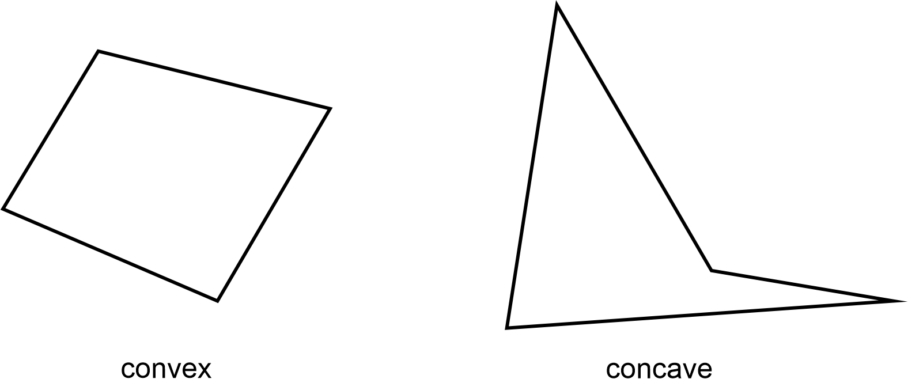
- Explain that in the following activities students will be exploring the properties of convex and non-convex quadrilaterals by constructing tessellations.

Activity 1 – convex quadrilaterals

Equipment
Each student should have access to the following equipment:
- Card or paper
- Appendix C ‘A page of quadrilaterals’, one quadrilateral per student
- Protractor
- Scissors
- Colour pencils or markers

Method
- Assign each student one type of convex quadrilateral from Appendix C ‘A page of quadrilaterals’. Ensure there is an approximately equal proportion of students working on each shape.
- Students label each angle of their quadrilateral using letters such as $A, B, C, D$, as shown in Figure 4, which is on slide 5 of the PowerPoint.
Figure 4 – labelled quadrilateral
By labelling vertices using letters, students can refer to angle properties using correct terminology. Ensure students are using capital letters.
- Students cut out their quadrilateral and place it on a sheet of card or paper and trace around it. They then keep one point of their quadrilateral fixed and rotate it so that one side is perfectly aligned with another.
Students may need a demonstration of this. The clip ‘Tessellations with Quadrilaterals (6:57)’ (bit.ly/tessellationwithquads) can be used if needed, although this uses an irregular quadrilateral rather than the special quadrilaterals. The tessellation process is still explained.
- Students continue rotating and tracing their quadrilateral to create a tessellation.
Students could do this activity on a sheet of cardboard, canvas or wood, to then be painted and create pieces of art that can be displayed around the classroom and the school. If working on sheets of paper, these sheets can be joined together to create a class ‘quilt’ that could be displayed on the classroom door.
- Challenge students to think about how they can verify their tessellation has no gaps between each quadrilateral.
- Model for students that if the vertices meet at a point the angle sum is $360°$ and if this occurs within their tessellation then we would know that there must be no gaps between shapes.
- Allow students time to then use a protractor to measure the angles at a point and label these on their drawings.
- Students then calculate the angle sum at each point. As shown in Figure 5, which is on slide 6 of the PowerPoint.
Figure 5 – angles at a point
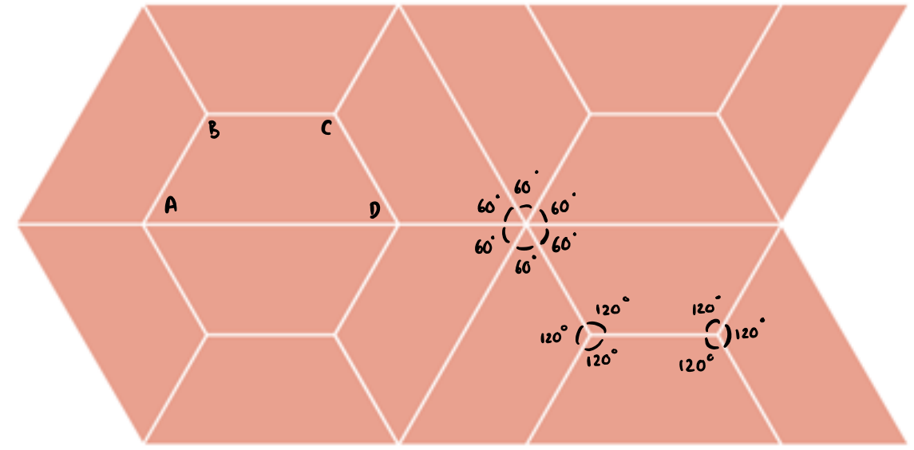
- Conduct a gallery walk (bit.ly/DLSgallerywalk) for students to move about the room and view their peers’ tessellations. Students should be looking to see whether all shapes created tessellations and considering reasons for this.
- Facilitate a group discussion using a questioning strategy such as the Pose-Pause-Pounce-Bounce [PDF 200KB] (bit.ly/pausepouncebounce), to discuss the features of each quadrilateral.
For example:
Who worked with a kite? What did you notice when tessellating a kite?
Someone else who also worked with a kite, did you notice that as well, or something different?

Activity 2 – non-convex quadrilaterals
- Explain that for this activity, students will construct a non-convex quadrilateral to tessellate.
- Have students discuss in a Think-Pair-Share, what might be the same or different about tessellations created with non-convex quadrilaterals.
- Two examples of non-convex quadrilateral tessellations can be shown to students using Figure 6, which is on slide 7 of the PowerPoint.
Figure 6 – non-convex quadrilateral tessellations
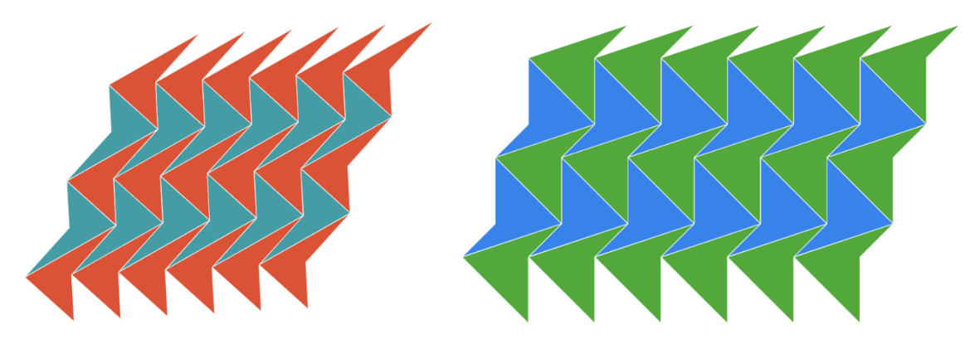
Images created using the free virtual manipulatives at Polypad.org.
- Students can now repeat the process of Activity 1, using their own non-convex quadrilateral that they create.

Summarise
- Ask students to move into groups such that each group contains a student who worked with a different quadrilateral (bit.ly/jigsawgroupstrategy).
- Refer back to the prompt ‘All quadrilaterals tessellate’.
- Ask students to take turns speaking for 2 minutes (display a timer on the board) to share with their group what shape they worked with, the properties of their shape, what they noticed by constructing their convex tessellation, and what they noticed when constructing their non-convex tessellation.
- Have each group reach a consensus as to whether they agree or disagree with the prompt ‘All quadrilaterals tessellate’.
- Randomly select a student from each group to share whether they agree or disagree and why.
- Students can add to their table from Appendix B by adding any of the special quadrilaterals that they hadn’t previously considered as well as an example of a non-convex quadrilateral, and recording any additional properties or features they believe are important.
- Refer to Figure 7 below or slide 8 of the PowerPoint Unravelling tessellations and explain to students that you will model one last example of a quadrilateral tessellation, and encourage them to try and determine a reason why all quadrilaterals will tessellate:
- In this example, we start by drawing a quadrilateral and labelling the vertices as A, B, C, and D in a clockwise direction, starting from any vertex.
- Then we rotate the tile in a clockwise direction (Rotation 1). Notice that we can label the vertices differently but still have the same shape, called congruence. For example, if we start at vertex C and label in a clockwise direction, we have quadrilateral CDAB. Even though the labels are different, the shape and properties of the quadrilateral remain the same.
- If we were to continue rotating and tracing copies of the quadrilateral, we could end up with the tessellation shown.
- Ask students if they notice anything interesting about the tessellation, now that each vertex is labelled with a letter?
Students should notice that at each point there are vertices A, B, C, and D which are all the interior angles of the original quadrilateral which we know will sum to $360°.$
- The tessellation can continue indefinitely because the interior angles of any quadrilateral, regardless of the labelling of vertices, always sum to $360°$. This ensures that they can fit together without gaps or overlaps.
Figure 7 – explaining tessellation.
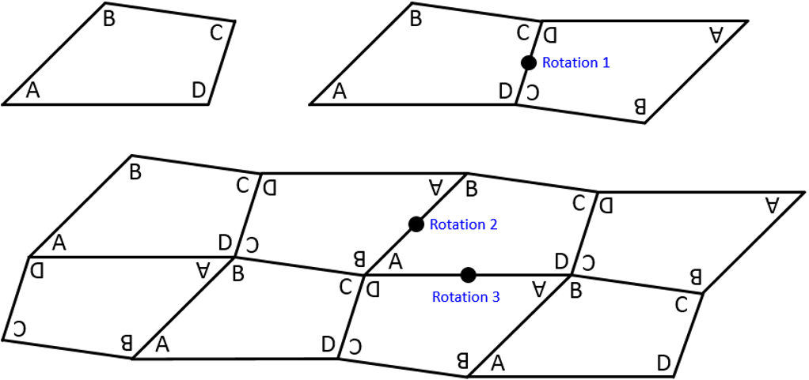

Apply
- With one device between each pair of students, direct students to the Polypad canvas ‘Regular Tessellation’ (bit.ly/polypadregulartessellation). Alternatively, students can be issued with Appendix D ‘Regular tessellation’.
- Explain to students that in a regular tessellation, all the shapes are the same regular polygon, and all the angles and sides are equal.
- For this activity student will need to find the interior angle of regular polygons. A class discussion will be needed prior to commencing this activity, using prompting questions that could include:
- A regular triangle is a triangle where all sides and angles are equal, what is this triangle called?
- What size are the angles in an equilateral triangle? How do you know?
- What is the name of a regular 4-sided shape and what facts do you know about this?
- What size are the angles in a square? How do you know?
- What might the angle sum of a regular pentagon be? How do you know?
- How could the interior angle of a regular pentagon be found?
- After this discussion, in pairs, students attempt to fill in the remaining rows of the table. They may need help defining polygons like heptagon.
- As a conclusion to this activity, students should be able to verify that the only regular polygons that tessellate are triangles, squares, and hexagons because each of their interior angles are factors of $360°$.

Assessment and differentiation

Suggested opportunities for differentiation
Explore
- If students struggle drawing, rotating, and tracing their quadrilaterals, provide concrete manipulatives such as physical tiles or Mathigon’s Polypad.
- Students could be challenged to choose 2 types of quadrilaterals to tessellate rather than one.
- Students could be challenged to construct regular quadrilaterals, requiring the accurate use of a ruler and protractor.
Summarise
- If there are students who require assistance communicating with their peers, provide a template for the Jigsaw conversation that everyone may use.

Suggested opportunities for assessment
- There are opportunities for formative assessment throughout the lesson, by asking assessing questions and observing student conversations, students will demonstrate their understanding of quadrilateral properties.
Explore
- Collect Appendix B to use as formative assessment of students’ prior knowledge of special quadrilaterals.
Summarise
- Students could write notes to their future forgetful self to assess what they have taken away from the lesson and address any misconceptions.

Appendix A

Polyomino tiles
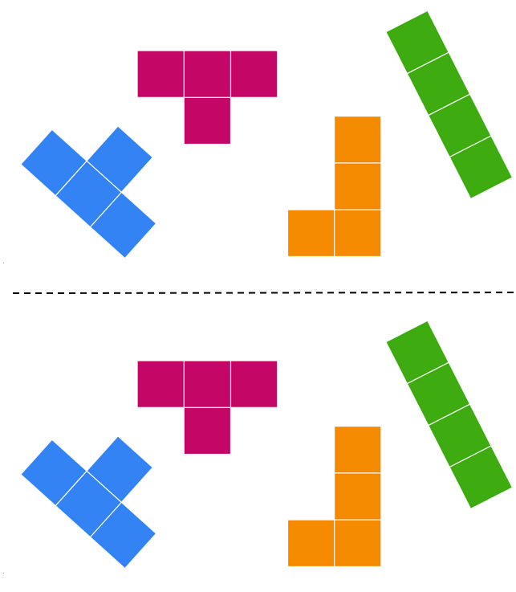
Images created using the free virtual manipulatives at Polypad.org.

Appendix B

Quadrilateral recall
Complete the table by drawing quadrilaterals that you know, then name it and list anything you know about it.
Draw the shape | Name the shape | List anything you know about the shape

Appendix C

A page of quadrilaterals
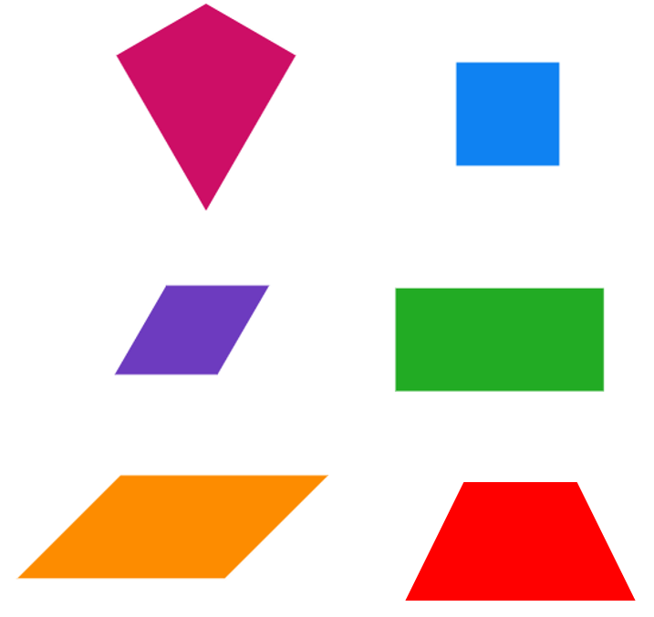
Images created using the free virtual manipulatives at Polypad.org.

Appendix D

Regular tessellation
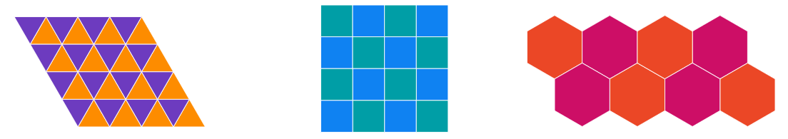
Images created using the free virtual manipulatives at Polypad.org.
Regular polygons | Each interior angle | 2 vertices | 3 vertices |  | 4 vertices | 5 vertices | 6 vertices
Triangle | $$60°$$ | $$120°$$ | $$180°$$ |  | $$240°$$ | $$300°$$ | $$360°$$
Square | $$90°$$ | $$180°$$ | $$270°$$ |  | $$360°$$
Pentagon
Hexagon
Heptagon
Octagon
Nonagon
Decagon
12- gon
15- gon
20- gon
30 - gon

Sample solutions

Warm up
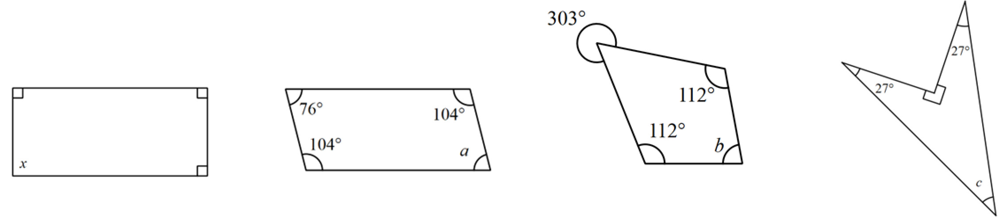
$$x=90°$$
$$a=76°$$
$$b=79°$$
$$c=36°$$

Launch – Polyomino 4 × 4 grid
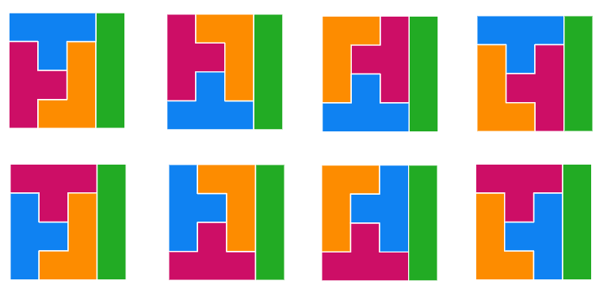
Image created using the free virtual manipulatives at Polypad.org.

References
This resource contains NSW Curriculum and syllabus content. The NSW Curriculum is developed by the NSW Education Standards Authority. This content is prepared by NESA for and on behalf of the Crown in right of the State of New South Wales. The material is protected by Crown copyright.
Please refer to the NESA Copyright Disclaimer for more information https://educationstandards.nsw.edu.au/wps/portal/nesa/mini-footer/copyright.
NESA holds the only official and up-to-date versions of the NSW Curriculum and syllabus documents. Please visit the NSW Education Standards Authority (NESA) website https://educationstandards.nsw.edu.au/ and the NSW Curriculum website https://curriculum.nsw.edu.au/home.
Mathematics K–10 Syllabus © NSW Education Standards Authority (NESA) for and on behalf of the Crown in right of the State of New South Wales, 2022.

© State of New South Wales (Department of Education), 2023
The copyright material published in this resource is subject to the Copyright Act 1968 (Cth) and is owned by the NSW Department of Education or, where indicated, by a party other than the NSW Department of Education (third-party material).
Copyright material available in this resource and owned by the NSW Department of Education is licensed under a Creative Commons Attribution 4.0 International (CC BY 4.0) license.
This license allows you to share and adapt the material for any purpose, even commercially.
Attribution should be given to © State of New South Wales (Department of Education), 2023.
Material in this resource not available under a Creative Commons license:
- the NSW Department of Education logo, other logos and trademark-protected material
- material owned by a third party that has been reproduced with permission. You will need to obtain permission from the third party to reuse its material.
Links to third-party material and websites
Please note that the provided (reading/viewing material/list/links/texts) are a suggestion only and implies no endorsement, by the New South Wales Department of Education, of any author, publisher, or book title. School principals and teachers are best placed to assess the suitability of resources that would complement the curriculum and reflect the needs and interests of their students.
If you use the links provided in this document to access a third-party's website, you acknowledge that the terms of use, including licence terms set out on the third-party's website apply to the use which may be made of the materials on that third-party website or where permitted by the Copyright Act 1968 (Cth). The department accepts no responsibility for content on third-party websites.

