Throwing light on the exteriors
Students investigate the relationship between interior and exterior angles of a triangle and use it to solve problems.

Visible learning

Learning intention
- To understand the relationship between the interior angles and exterior angles of a triangle.

Success criteria
- I can explain the relationship between the interior and exterior angles of a triangle.
- I can prove the relationship between the interior and exterior angles of a triangle.
- I can calculate unknown angles in a triangle.

Syllabus outcomes
A student
- develops understanding and fluency in mathematics through exploring and connecting mathematical concepts, choosing and applying mathematical techniques to solve problems, and communicating their thinking and reasoning coherently and clearly MAO-WM-01
- identifies and applies the properties of triangles and quadrilaterals to solve problems
MA4-GEO-C-01
Mathematics K–10 Syllabus © NSW Education Standards Authority (NESA) for and on behalf of the Crown in right of the State of New South Wales, 2022.

Activity structure
Please use the associated Throwing light on the exteriors PowerPoint to display images in this lesson.

Launch
- Display slide 2 of the PowerPoint.
- Verbally present the scenario below to students.
You are preparing an oval for the throwing events at an athletics carnival. You need to continue the foul lines on to the grass. You know the angle at the origin of the circle is $34.92°$ and the centre line is at right angles with the grass. Do you have enough information to find the angle of the line to continue the foul line in the upper corner? Can you find what it is?
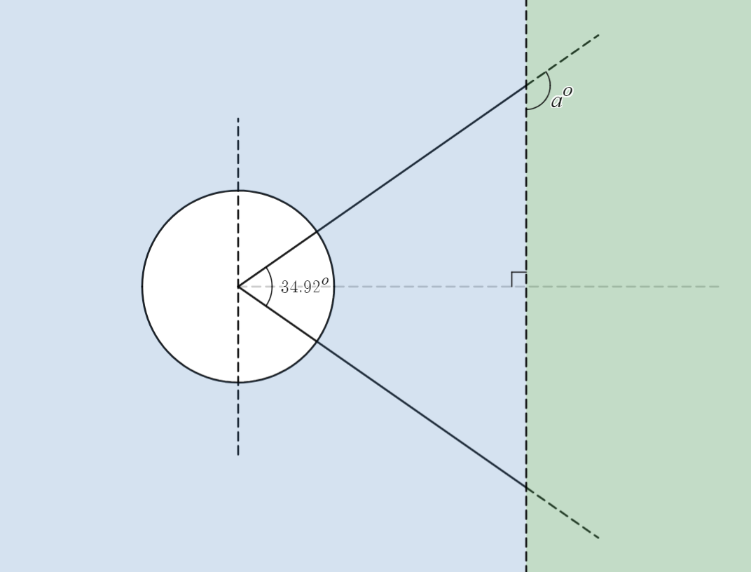
Students are yet to see decimal degrees. Teachers can either discuss what ${34.92}^{o}$ means, or round the angle to 35 degrees. Students could be challenged to consider how much of a difference if would make to round the angle, or the practicalities of measuring an angle to this degree of accuracy.
- In a Think-Pair-Share (bit.ly/thinkpairsharestrategy), ask students to discuss how they would determine the angle needed to continue the foul line onto the grass.

Explore
In this activity, students will investigate the relationship between the exterior angle of a triangle and the sum of the interior opposite angles.
- Display slide 3 of the PowerPoint. In a Think-Pair-Share, ask students to discuss the meaning of the terms ‘interior opposite angles’ and ‘exterior angle’.
- Ask students the hinge point question (bit.ly/hingepointstrategy), ‘How many exterior angles does a triangle have?’ Ensure students are given wait time (bit.ly/classroomtalkmoves) before initiating the sharing of responses using their fingers.
To enable students to attempt the question, prompt them to draw a diagram.
If clarity is still needed for the definition of exterior angles, use the examples and non-examples on slide 4 of the PowerPoint, to aid their understanding.
- Display slide 5 from the PowerPoint Throwing light on the exteriors and ask students what they notice or wonder (bit.ly/noticewonderstrategy).
- Distribute Appendix A ‘Visual proof’ where students explore the exterior angle theorem of a triangle.

Summarise
- Display the GeoGebra applet ‘Exterior angle of a triangle’ (bit.ly/geogebraexteriorangle) for the class to view. Do not move either slider yet.
- Have students Think-Pair-Share the following prompting questions:
- What might the exterior angle be equal to?
- How might you find the exterior angle?
- Can you think of two different ways to find the exterior angle?
- Use the Pose-Pause-Pounce-Bounce question strategy [PDF 200KB] (bit.ly/pausepouncebouncestrategy) with the prompting questions to have a class discussion.
- Drag both sliders, ‘drag me right’ and ‘pull me down’ in the GeoGebra applet to conclude to students that the exterior angle of a triangle is equal to the sum of 2 opposite interior angles.

Explicit teaching
- Use slides 6–13 from the Throwing light on the exteriors PowerPoint for explicit teaching of the exterior angle of a triangle.
The explicit teaching technique used in the associated PowerPoint is ‘Your turn.’ The first slide is a worked example which should be displayed for the students and then use the following steps.
- Reveal the question to students and its solution.
- Students read in silence.
- Students individually think and explain to themselves what is happening in each step.
- Students hold up a thumbs up to the teacher when they have finished reading and have some sort of understanding.
- Think-Pair-Share. Students explain the solution to their partner.
- In pairs students then answer the self-explanation questions.
- Finally, randomly select students to share their answers with the whole class.
- Direct students to create notes for their future forgetful self (bit.ly/notesstrategy), explaining how the exterior angle of a triangle is connected to the sum of the interior opposite angles. Encourage students to write an explanation in words for what is happening using the new terms ‘interior opposite angles’ and ‘exterior angles’, as well as a mathematical statement.

Apply
- Arrange students in visibly random groups of 3, at a vertical non-permanent surface (bit.ly/VNPSstrategy).
- Using Appendix B ‘Rugged exteriors’, give students one question at a time.
This requires the use of a banner – a section marked off by a horizontal line drawn approximately 10–15 cm from the top of the VNPS.
- On one of the groups' VNPS banner, write out the first question.
- Inform students they will need to steal questions from other groups' banners if they have no question or have completed their question. These are the only things allowed to be written in the banner and only one question at a time can exist on their groups' banner.
- Allow time for students to steal the question and work through a solution.
- Once you have noticed a group has finished working through the question and you are satisfied with their work, erase the question from the banner and write the next question. If several groups finish at or around the same time, write alternative questions in their banners.
- Try not to have more than 2 or 3 different questions available for students to work through at any one time.
- Encourage students to continue looking for questions to steal.
- When students complete a question, ask them to steal a different one from another team’s VNPS.
- If students have completed all visible questions, provide them with a new question from the list provided in Appendix B ‘Rugged exteriors’.

Make note of the different strategies students use to solve the problems. You can pair up groups when:
- they have differing solutions. State ‘at least one of you are wrong’ and let the 2 groups discuss to find the correct solution.
- they have different strategies to solve the same problem. Ask them to explain their solutions to each other and ask which is more efficient and why.
- Bring the class back together in the centre of the room.
- Once gathered, draw attention to various VNPS around the room to discuss the strategies and mathematical concepts utilised in working through the problems.
The emphasis of the discussion and conversation should focus on the processes, reasoning and strategies evident, rather than the solution achieved or the students involved.

Assessment and differentiation

Suggested opportunities for differentiation
Launch
- The angle could be rounded to ${35}^{o}$ or even ${30}^{o}$for low readiness students.
Explore
- To aid understanding show the class examples and non-examples of exterior angles.
- To support students with Appendix A, you could provide students with a piece of paper which has a triangle drawn on it, with the vertices labelled and lines showing students where to cut.
- You can further extend students by having them write a formal proof.
Summarise
- The GeoGebra applet allows teachers to demonstrate that the rule works for all triangle types and angles.
Apply
- Students are working in groups to answer questions to support each other’s thinking.

Suggested opportunities for assessment
Explore
- Use the hinge question to gauge student understanding of the terminology of exterior angles of triangles.
Summarise
- Monitor student responses in the ‘Your turn’ section to check for understanding.
- Review students’ notes to future selves.
Apply
- Students will demonstrate their working mathematically skills in discussions and justifications.

Appendix A

Visual proof

Equipment
- Ruler
- Paper
- Scissors
- Protractor

Method
An exterior angle of a triangle can be created by extending one of the sides of a triangle.
- Draw any triangle and label each vertex with A, B and C.
- Extend the side AC to some point D, to create the exterior angle $∠BCD$. An example is displayed below.
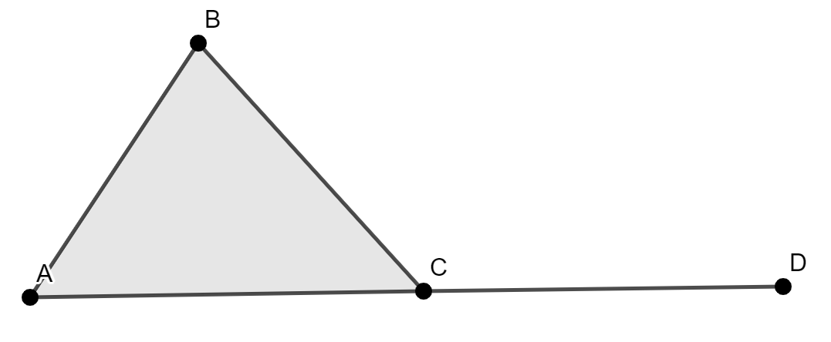
- Cut off the angles $A$ and $B$, and place them in $∠BCD$.
- State what you notice. Write a statement to explain this.
- Can you create a triangle that doesn’t meet the statement you created above? Try it. If you cannot, explain why.
- Draw another triangle. Measure the size of the exterior angle and the 2 interior angles. Does your statement remain true.
- Repeat for an obtuse triangle.
- Write a statement about the relationship between the exterior angle and the 2 opposite interior angles.
- Explain why this is true for all triangles.

Appendix B

Rugged exteriors
Find the value of the pronumerals.
- 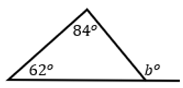
- 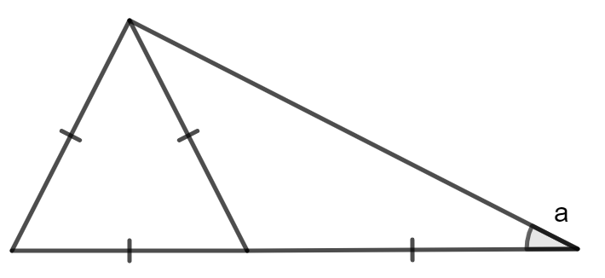
- 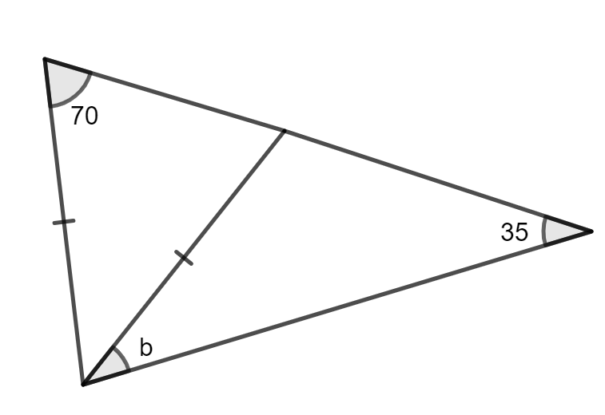
- 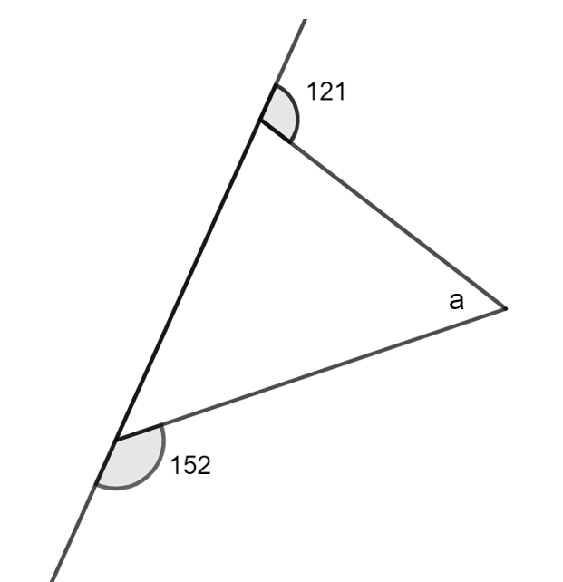
- 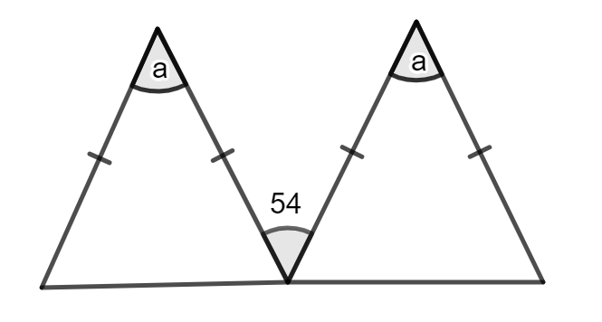
- 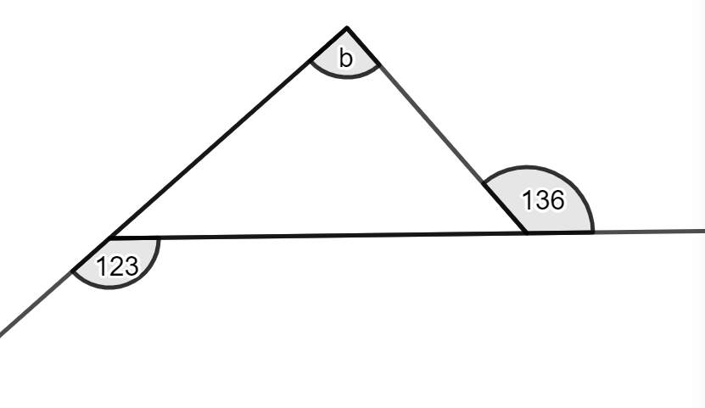
- 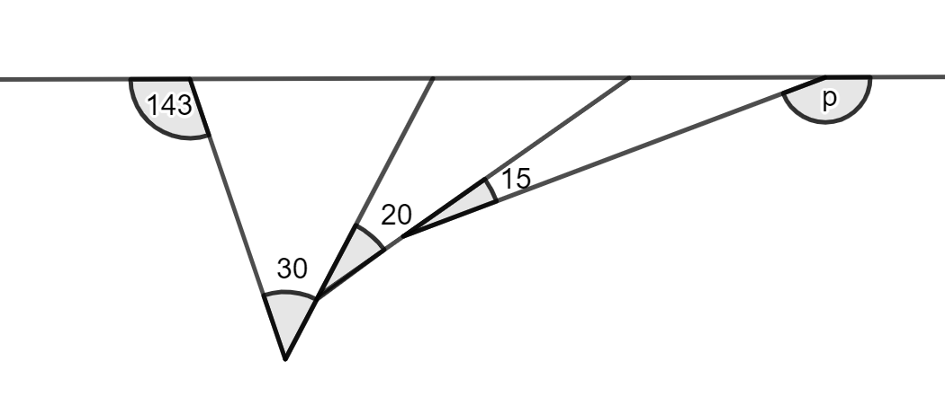

Sample solutions

Appendix B – rugged exteriors
- $b=146$
- $a=30$
- $b=35$
- $a=93$
- $a=54$
- $b=79$
- $p=102$

References
This resource contains NSW Curriculum and syllabus content. The NSW Curriculum is developed by the NSW Education Standards Authority. This content is prepared by NESA for and on behalf of the Crown in right of the State of New South Wales. The material is protected by Crown copyright.
Please refer to the NESA Copyright Disclaimer for more information https://educationstandards.nsw.edu.au/wps/portal/nesa/mini-footer/copyright.
NESA holds the only official and up-to-date versions of the NSW Curriculum and syllabus documents. Please visit the NSW Education Standards Authority (NESA) website https://educationstandards.nsw.edu.au/ and the NSW Curriculum website https://curriculum.nsw.edu.au/home.
Mathematics K–10 Syllabus © NSW Education Standards Authority (NESA) for and on behalf of the Crown in right of the State of New South Wales, 2022.

© State of New South Wales (Department of Education), 2023
The copyright material published in this resource is subject to the Copyright Act 1968 (Cth) and is owned by the NSW Department of Education or, where indicated, by a party other than the NSW Department of Education (third-party material).
Copyright material available in this resource and owned by the NSW Department of Education is licensed under a Creative Commons Attribution 4.0 International (CC BY 4.0) license.
This license allows you to share and adapt the material for any purpose, even commercially.
Attribution should be given to © State of New South Wales (Department of Education), 2023.
Material in this resource not available under a Creative Commons license:
- the NSW Department of Education logo, other logos and trademark-protected material
- material owned by a third party that has been reproduced with permission. You will need to obtain permission from the third party to reuse its material.
Links to third-party material and websites
Please note that the provided (reading/viewing material/list/links/texts) are a suggestion only and implies no endorsement, by the New South Wales Department of Education, of any author, publisher, or book title. School principals and teachers are best placed to assess the suitability of resources that would complement the curriculum and reflect the needs and interests of their students.
If you use the links provided in this document to access a third-party's website, you acknowledge that the terms of use, including licence terms set out on the third-party's website apply to the use which may be made of the materials on that third-party website or where permitted by the Copyright Act 1968 (Cth). The department accepts no responsibility for content on third-party websites.

