I see triangles
Students will use their knowledge of angle sizes to investigate the angle sum of a triangle. They will build on this result to investigate the angle sum of a quadrilateral.

Visible learning

Learning intention
- To know the angle sum of a triangle and quadrilateral.

Success criteria
- I can explain why the angle sum of a triangle is $180°$.
- I can explain why the angle sum of a quadrilateral is $360°$.
- I can use angle sums of shapes to calculate unknown values.

Syllabus outcomes
A student:
- develops understanding and fluency in mathematics through exploring and connecting mathematical concepts, choosing and applying mathematical techniques to solve problems, and communicating their thinking and reasoning coherently and clearly MAO-WM-01
- identifies and applies the properties of triangles and quadrilaterals to solve problems
MA4-GEO-C-01
Mathematics K–10 Syllabus © NSW Education Standards Authority (NESA) for and on behalf of the Crown in right of the State of New South Wales, 2022.

Activity structure
Please use the associated I see triangles PowerPoint to display images in this lesson.

Launch
- Display slide 3 of the I see triangles PowerPoint which asks students to count the number of triangles they can see in the image. Allow students time to do this individually.
- Collect the responses either using an online poll such as Mentimeter (mentimeter.com) or through a class discussion, asking students how many triangles they counted.
- Ask the student who identified the most triangles to show the class their method for counting the triangles.
- In a Think-Pair-Share (bit.ly/thinkpairsharestrategy), ask students to discuss if they could find the value of the angles in the diagram.

Explore

I see triangles

Equipment
- A4 blank sheets of paper (2 per student)
- 1 ruler per student
- 1 pencil per student
- Scissors

Method
- Without giving students too much direction, ask students to use their ruler and pencil to draw a triangle on an A4 piece of paper. Their triangle should fill up at least half of the A4 piece of paper. Suggest they can be a little creative with the type of triangle they draw.
- Once students have drawn their triangle, ask students to sit back-to-back with another student, facing away from each other. One student is to describe their triangle for their partner to try and draw as closely as possible.
- Select non-volunteer students to share the instructions they gave to their partner. Discuss how the instructions could be improved by encouraging them to use formal mathematical language in their instructions.
Highlight the different types of triangles students have drawn, including acute-angled, obtuse-angled, equilateral, isosceles or right-angled, to revise prior knowledge. The aim is for students to recognise that people are completing the activity with different types of triangles.
- Display slide 5 of the PowerPoint and ask students to label the vertices of their triangle in the same way as displayed on the image, with $a^{o}$ in one vertex, $b^{o}$ in another vertex and $c^{o}$ in the third vertex.
- Ask students to cut the triangle out by carefully cutting along the lines of the triangle they have drawn. Strongly encourage them to take their time when cutting to make the edges as straight as they can.
- Once students have cut out their triangle, display slide 6 of the PowerPoint and ask the students to cut their triangle into 3 pieces, following the guide on the slide.
Monitor the step of cutting the triangles into 3 pieces. Some students may find this procedure challenging. It is important that the students do not cut the triangle into 3 pieces until after they have labelled their vertices.
- Ask the students to arrange the pieces of their triangle so that all the vertices meet at one point and the edges of the pieces do not overlap.
- In a Think-Pair-Share, ask students what they notice and wonder about the labelled angles in the triangle.
Advancing prompts include:
- What do you each notice about your labelled angles when they are all lined up?
- Is it the same as your partner’s?
- How might the ruler be useful?
- Encourage the students to rearrange the pieces and see if they still notice the same things.
Students should be able to see the connection between the labelled angles meeting at a point and a straight angle that is equal to ${180}^{o}$. They may need further discussion to recognise that the three angles represent the vertices of their triangle and that the three angles will always add to a sum of ${180}^{o}$.
It is important for students to note, that this works no matter what type of triangle they started with.
This is an opportunity to revisit associative and commutative law with students as the order in which the angles are added does not affect the outcome.
- Using a second piece of A4 paper, ask students to use a pencil and ruler to draw a quadrilateral that fills up at least half of the page. Encourage them to be creative with the type of quadrilateral they draw.
- Repeat the same process used with the triangle:
- Students sit back-to-back and describe the quadrilateral to each other.
- Students label the vertices of the quadrilateral $a^{o}$, $b^{o}$, $c^{o}$ and $d^{o}$.
- Students cut their quadrilateral out.
- Students then cut the quadrilateral into four pieces, with one labelled vertex in each piece.
- Students arrange the vertices to all meet at one point.
- Ask the students what they notice about the angles this time.
The angles should be arranged so that they all meet at a point and form a revolution. Students should be able to see the connection between the labelled angles meeting at a point and that a revolution is equal to ${360}^{o}$. They may need further discussion to recognise that the four angles represent the vertices of their quadrilateral and that the 4 angles will always add to a sum of ${360}^{o}$.
It is important for students to note that this works for any type of quadrilateral.

More proof using triangles
In this activity, students will use the angle sum of a triangle to develop their understanding of the angle sum of a quadrilateral.

Equipment
- 1 A4 blank sheet paper per student
- 1 ruler per student
- 1 pencil per student

Method
- Ask students to use their ruler and pencil to draw another quadrilateral that takes up at least half a page of a new piece of A4 paper.
- Once students have drawn their quadrilateral, ask students to describe their quadrilateral to a partner. Use prompting questions, such as:
- Are there any parallel sides in your quadrilateral?
- Are there equal sides in your quadrilateral?
- Are there any right-angles in the quadrilateral?

The aim is for students to recognise that people are completing the activity with different types of quadrilaterals.
In Stage 2 students are asked to describe and compare 2-dimensional shapes, including parallelograms, rectangles, rhombuses, squares, trapeziums and kites, to identify and describe polygons that have and do not have parallel sides and to consider the lengths of sides and the size of angles in polygons.
- Direct students to draw a diagonal line, from one corner of their quadrilateral to an opposite corner of the quadrilateral. Discuss with students why some students will have a choice of where to draw their diagonal, whilst other students may only have one option.
A non-convex quadrilateral has only one internal diagonal.
- Using a Think-Pair-Share strategy, ask students the following:
“How can we know what the angle sum of a quadrilateral is?”
- After two minutes, use a Pose-Pause-Pounce-Bounce question strategy ([PDF 200KB] bit.ly/pausepouncebounce) to discuss student answers.
Students should be able to recognise that the diagonal will always cut the quadrilateral into 2 triangles.
Students should be able to deduce, during this part of the explore stage, that the angle sum of a quadrilateral is ${360}^{o}$.
Students may also recognise that only sometimes does the diagonal cut the quadrilateral in half.

Summarise
- Students are to draw a straight line in their books and glue the pieces of their triangle along the line, with the labelled vertices meeting at a point.
- Students should also glue their two quadrilaterals into their book showing their angles forming an angle of revolution.
- Use slides 8–15 from the I see triangles PowerPoint for explicit teaching of the angle sum of a triangle and the angle sum of a quadrilateral.
The explicit teaching technique used in the associated PowerPoint is ‘Your turn.’ The first slide is a worked example which should be displayed for the students and then use the following steps.
- Reveal the question to students and its solution.
- Students read in silence.
- Students individually think and explain to themselves what is happening in each step.
- Students hold up a thumbs up to the teacher when they have finished reading and have some sort of understanding.
- Think-Pair-Share. Students explain the solution to their partner.
- In pairs students then answer the self-explanation questions.
- Finally, randomly select students to share their answers with the whole class.
- Students can then complete the questions in Appendix A ‘Angle relationships’, which uses variation theory (variationtheory.com/introduction/). Students will need to determine what feature has changed from the previous question and then make a prediction as to what effect this will have on the answer.
- Direct students to create notes for their future forgetful self (bit.ly/notesstrategy) about the angle sum of triangles and quadrilaterals.

Apply
In this activity, students will use information about the angle sum of a triangle and quadrilateral to solve problems. Students will be working in visibly random groups of 3, at a vertical non-permanent surface (bit.ly/VNPSstrategy).
- Distribute a copy of Appendix B ‘Angle size’ to each of the groups for them to attach to the vertical non-permanent surface.
- Ask students to determine the value of each of the pronumerals. Tell students they need to show the calculations used for each answer.
- Walk around the room and note solutions that have utilised different strategies.
- Ask groups to talk to each other if they have differing values for a pronumeral, stating that at least one of them is incorrect.
- Take students on a gallery walk (bit.ly/DLSgallerywalk) to highlight different strategies that gave the correct solution.

Assessment and differentiation

Suggested opportunities for differentiation
Launch
- Challenge students by giving them a copy of the image and asking them to label the points of intersection with a letter and to identify each triangle using naming conventions.
Explore
- Support students by providing them with a piece of paper which has a triangle drawn on it, with the vertices labelled and lines showing students where to cut.
- Challenge students to conduct their own investigation of the angle sum of polygons with more than 4 sides.
Summarise
- Challenge students to write an explanation of how they know the angle size of a triangle and a quadrilateral.
Apply
- Encourage students who are having difficulty to ask nearby groups for assistance.

Suggested opportunities for assessment
Launch
- Check that students know what a triangle is.
Explore
- Monitor that students know how to draw a triangle and a quadrilateral.
- Monitor student discussions to determine if students can recall properties of quadrilaterals.
Summarise
- Review student notes to ensure students have recognised the angle sum of a triangle is ${180}^{o}$ and a quadrilateral ${360}^{o}$.
- Monitor student responses in the ‘Your turn’ section to check for understanding.
Apply
- Students will demonstrate their working mathematically skills in discussions and justifications.

Appendix A

Angle relationships
For each question, compare it to the previous question, explain what has changed, predict what effect the changes will have on the final answer and then find the missing angle.
Question: Find the value of the pronumeral | Changes and predictions | Calculate the missing angle
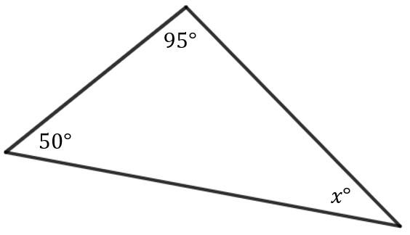
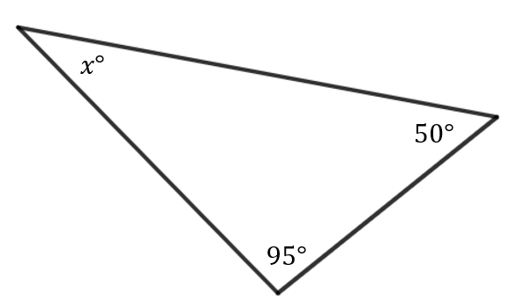
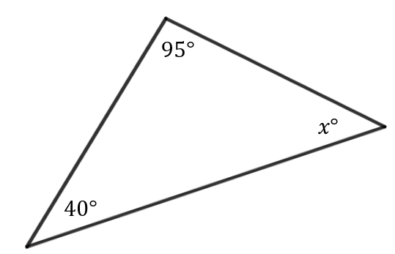
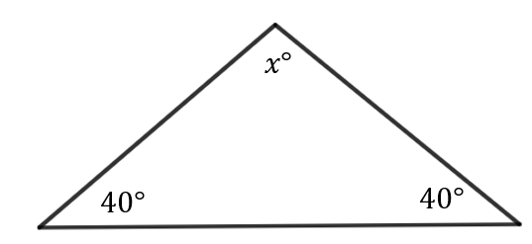
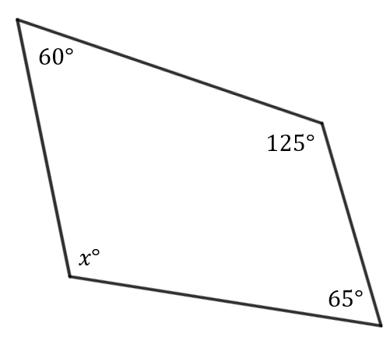
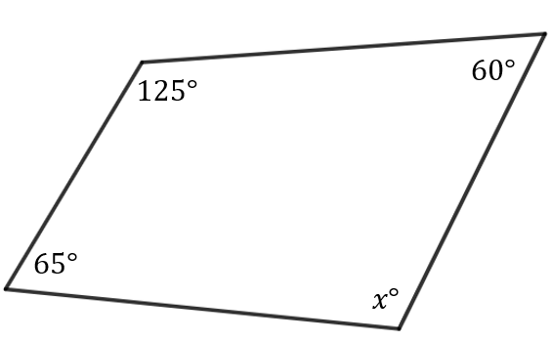
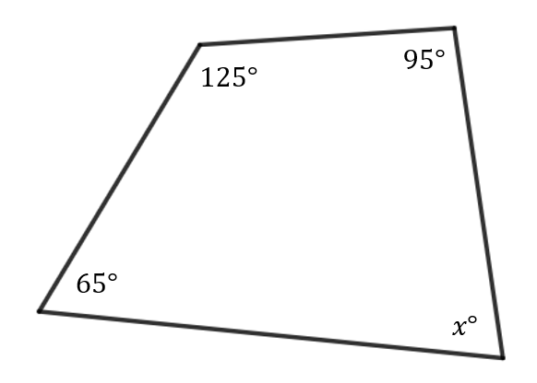
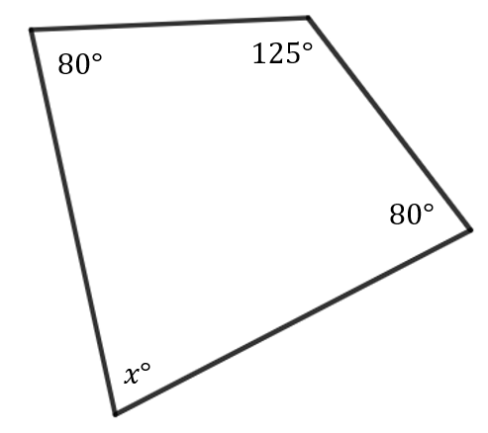

Appendix B

Angle size
Determine the size of as many unknown angles in the diagram as you can.
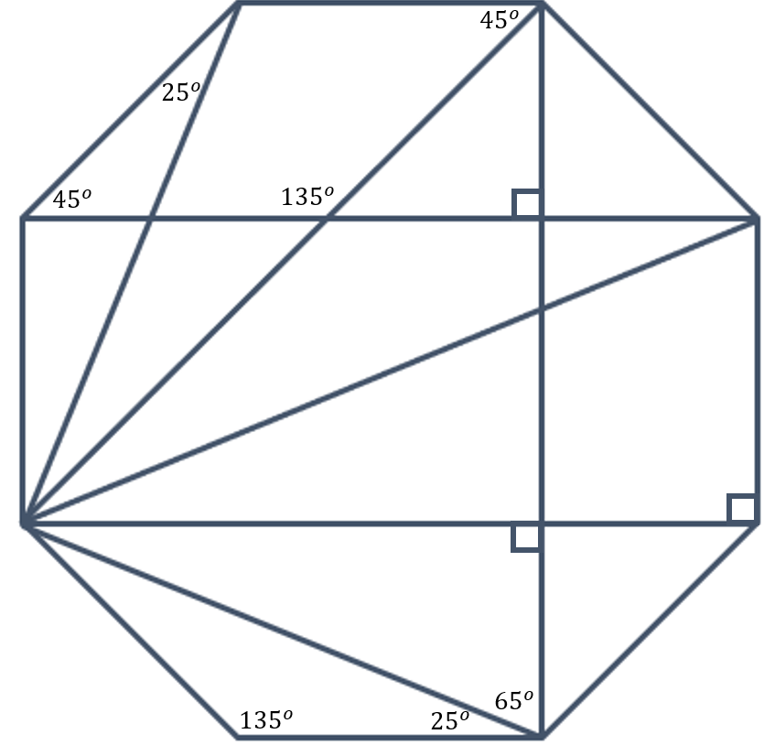

Sample solutions

Launch
32 triangles

Appendix A – angle relationships
Question: Find the value of the pronumeral | Changes and predictions | Calculate the missing angle
$$x+95+50=180$$
$$x=35°$$
 | The triangle has just been reflected and rotated; the angle sizes haven’t changed. The answer will remain the same. | $$x=35°$$
 | The angle that was initially $50°$ is now smaller, $40°$. This will mean that the value of $x$ will increase. | $$x+40+95=180$$  $$x=45°$$
 | The angle we are finding is now the largest angle. $x$ is now $5°$ less than previously so the largest angle will be larger than $95°$. | $$x+40+40=180$$  $$x=100°$$
 | The shape is now a quadrilateral, so angles will add to $360°$. | $$x+60+125+65=360$$  $$x=130°$$
 | The quadrilateral has just been reflected; the angle sizes haven’t changed. The answer will remain the same. | $$x=130°$$
 | The angle that was $60°$ has now increased to be $95°$. The unknown angle will decrease to an acute angle rather than an obtuse angle. | $$x+65+125+95=360$$  $$x=75°$$
 | The two angles that were previously $65°$ and $95°$ are now both $80°$. Despite the changes in angle the unknown angle will remain the same since the sum of these two angles is still $160°$. | $$x=75°$$

Appendix B – angle size
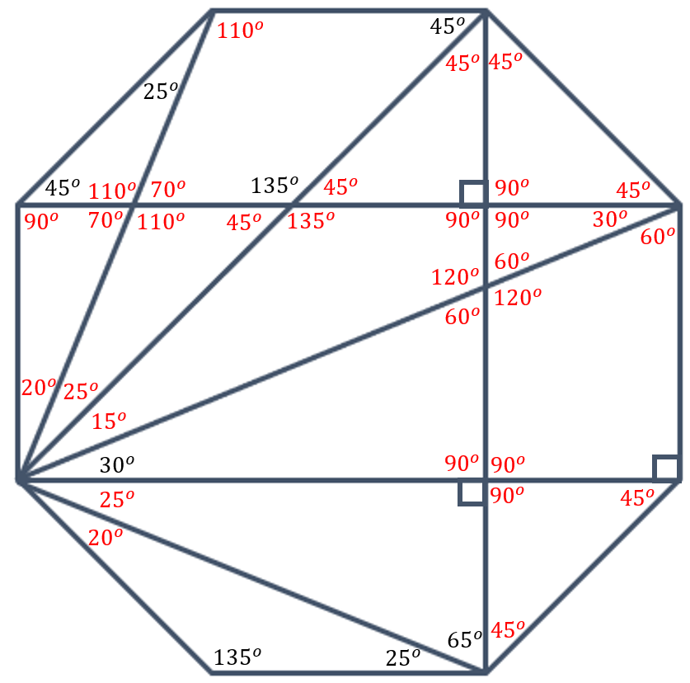

References
This resource contains NSW Curriculum and syllabus content. The NSW Curriculum is developed by the NSW Education Standards Authority. This content is prepared by NESA for and on behalf of the Crown in right of the State of New South Wales. The material is protected by Crown copyright.
Please refer to the NESA Copyright Disclaimer for more information https://educationstandards.nsw.edu.au/wps/portal/nesa/mini-footer/copyright.
NESA holds the only official and up-to-date versions of the NSW Curriculum and syllabus documents. Please visit the NSW Education Standards Authority (NESA) website https://educationstandards.nsw.edu.au/ and the NSW Curriculum website https://curriculum.nsw.edu.au/home.
Mathematics K–10 Syllabus © NSW Education Standards Authority (NESA) for and on behalf of the Crown in right of the State of New South Wales, 2022.

© State of New South Wales (Department of Education), 2023
The copyright material published in this resource is subject to the Copyright Act 1968 (Cth) and is owned by the NSW Department of Education or, where indicated, by a party other than the NSW Department of Education (third-party material).
Copyright material available in this resource and owned by the NSW Department of Education is licensed under a Creative Commons Attribution 4.0 International (CC BY 4.0) license.
This license allows you to share and adapt the material for any purpose, even commercially.
Attribution should be given to © State of New South Wales (Department of Education), 2023.
Material in this resource not available under a Creative Commons license:
- the NSW Department of Education logo, other logos and trademark-protected material
- material owned by a third party that has been reproduced with permission. You will need to obtain permission from the third party to reuse its material.
Links to third-party material and websites
Please note that the provided (reading/viewing material/list/links/texts) are a suggestion only and implies no endorsement, by the New South Wales Department of Education, of any author, publisher, or book title. School principals and teachers are best placed to assess the suitability of resources that would complement the curriculum and reflect the needs and interests of their students.
If you use the links provided in this document to access a third-party's website, you acknowledge that the terms of use, including licence terms set out on the third-party's website apply to the use which may be made of the materials on that third-party website or where permitted by the Copyright Act 1968 (Cth). The department accepts no responsibility for content on third-party websites.

