Is that a triangle?
Students will explore triangles, classify them based on their properties and use appropriate conventions to draw them.
Students will need at least one digital device per pair to interact with Desmos during this lesson.

Visible learning

Learning intention
- To be able to classify triangles.

Success criteria
- I can identify types of triangles based on angle size.
- I can identify types of triangles based on the lengths of the sides.
- I can apply reasoning skills to identify shapes that are triangles.

Syllabus outcomes
A student:
- develops understanding and fluency in mathematics through exploring and connecting mathematical concepts, choosing and applying mathematical techniques to solve problems, and communicating their thinking and reasoning coherently and clearly MAO-WM-01
- applies angle relationships to solve problems, including those related to transversals on sets of parallel lines MA4-ANG-C-01
- identifies and applies the properties of triangles and quadrilaterals to solve problems MA4-GEO-C-01
Mathematics K–10 Syllabus © NSW Education Standards Authority (NESA) for and on behalf of the Crown in right of the State of New South Wales, 2022.

Activity structure
Please use the associated PowerPoint Is that a triangle? to display images in this lesson.

Launch
- Play the video ‘Reuleaux wheels 1 (0:33)’ (bit.ly/Reuleauxwheels1).
- Use a Think-Pair-Share strategy (bit.ly/thinkpairsharestrategy) to discuss the following questions:
- What do you notice?
- What do you think?
- What do you wonder?
- What type of shape can you see?
- Display slide 2 of the Is that a triangle? PowerPoint. Ask students what other shape can rotate in the same way.
- Play the video ‘Who said wheels have to be round? (5:54)’ (bit.ly/notsoroundwheels) from 5:10 to 5:37 and discuss.
- Display slide 3 of the PowerPoint. Ask students to consider if the shape shown is a triangle by asking them how they would define a triangle. Questions you might pose include:
- What do you know about the sides of a triangle?
- What do you know about the angles of a triangle?
- Display slide 4 of the PowerPoint. Engage students in a discussion about the difference between how we describe a shape, such as a triangle, and how we use the properties of a shape to define it.
The shape is called the Reuleaux triangle, however, it is technically not a triangle. A triangle is a 3-sided polygon with straight edges. The Reuleaux triangle can be found in many places, including church windows, the centre of a 3 circle Venn diagram and on the end of large grip pencils.

Explore
- You will need to set up a Desmos classroom (bit.ly/desmosclassroomstrategy) and assign students the Desmos classroom activity ‘Classifying triangles Polygraph’ (bit.ly/trianglespolygraph) before students can complete the following Desmos Polygraph activity.
A Desmos Polygraph (bit.ly/desmospolygraph) is a partnered guessing game. Each round, players are matched into pairs, and assigned ‘Picker’ and ‘Guesser’ roles. The Picker selects a card; the Guesser asks yes/no questions for the Picker to answer in order to narrow the field of cards down to one.
- Students will each need a device or Appendix A ‘Triangles polygraph’ could be printed for students to play without devices.
- Display Appendix A which is also available on slide 5 of the associated PowerPoint.
- Explain how a Desmos Polygraph activity works, possibly by modelling an example game with a student.
- Students play 1–2 rounds of the Polygraph.
- Use a Think-Pair-Share strategy to discuss each question below:
- Which triangles were easier to describe, why?
- Does naming the triangles make them easier to discuss?
- What questions best narrowed down the triangle your partner chose?
- Did you notice any triangles that didn’t seem quite right? Which ones and why?
- Explain to students that the Desmos Polygraph was made by a class of Year 7 students and there are some mistakes with the triangles in the activity. Some of the triangles are impossible, meaning that the measurements must not be correct.
- By referring to the displayed Appendix A, students are to determine if each triangle is possible or impossible, recording their reasoning.
For all possible triangles, students should determine what, if any, additional details could be labelled. For example, could they determine any missing angles or sides, or could they mark sides with dashes to indicate equal lengths?
- Use a Pose-Pause-Pounce-Bounce question strategy [PDF 200KB] (bit.ly/pausepouncebouncestrategy) to discuss some of the triangles in Appendix A, emphasising the different classifications of triangles: scalene, isosceles, equilateral.

Summarise
- Display slide 7 from the PowerPoint. Use a Think-Pair-Share (bit.ly/thinkpairsharestrategy), to ask students to consider what types of triangles they can see and how they know.
- Repeat the process, displaying slide 8 from the PowerPoint and using a Think-Pair-Share for students to consider what types of triangles they can see and how they know.
The slides show triangles with measurements on some and geometrical notation on others. The aim is for students to recognise that whilst it is important to know which angles or sides are equal or unequal, they do not necessarily need to know the exact size of the angles or the length of the sides to be able to identify types of triangles.

Foldable
Students will create a foldable to organise information about triangles.

Equipment
- One blank piece of A4 paper for each student
- Scissors
- Ruler
- Pencil
Refer to the instructions in Appendix C ‘Triangles foldable instructions’ or display slide 9 of the PowerPoint to guide students through the process of creating a foldable.
Encourage students to use geometry notations in their diagrams to show equal angles and equal sides.
Encourage students to refer to acute, obtuse and right angles when describing the triangles.

Apply
Students will play 2 games to check their understanding of types of triangles.

Shapely Pairs
The first game ‘Shapely Pairs’ is based on a game which can be found on the NRICH website (nrich.maths.org/2925). The game is played in pairs.

Equipment
- Appendix B, ‘Shapely cards’, one set per pair.
- Paper
- Pencil
- Ruler

How to play
- Shuffle the cards and lay them face down on the table, arranged in rows.
- Players take turns to turn over 2 cards.
- If the player can draw a triangle with the 2 properties shown, then they take the cards. If not, once all the players have looked at the 2 cards, the cards are turned back over.
- It will help you if you can remember where the cards are! The game finishes when no matter which 2 cards are turned over, there is no triangle with both of those properties.
- The winner is the person with the most cards at the end of the game. Good luck!
- Once the game has been played, players can then attempt the challenge cards from Appendix B to further check their understanding.

Triangle Splat
The game ‘Triangle Splat’ is an online game for individuals.
Direct students to the game on the Sheppard Software website (bit.ly/geometrysplat).
There are 3 games and different game modes within each. Encourage students to play the different games and to try the different modes.

Assessment and differentiation

Suggested opportunities for differentiation
Launch
- Challenge students to draw a Reuleaux triangle.
- Challenge students to investigate if there are other shapes which could behave like a Reuleaux triangle, such as a Reuleaux square.
Explore
- Consider giving students a page of various types of triangles. Ask students to measure and compare the sides and the angles of the triangles.
- After completing the Desmos Polygraph activity, students could be tasked with drawing one of each type of triangle: scalene, isosceles, and equilateral, on a sheet of paper. Assign random groups of 3 and have students play the Polygraph game using their created triangles.

Suggested opportunities for assessment
Explore
- With Appendix A displayed, ask questions such as ‘How many isosceles triangles are in the first row?’ or ‘Which triangles are impossible?’. Students then hold up mini whiteboards with their answers.
Summarise
- Student foldables can be collected to check for understanding.
Apply
- Monitor students as they play the Shapely Pairs game, listening to their reasoning and formatively assessing their ability to draw the triangles or justifying why they are unable to draw the triangles.

Appendix A

Triangles polygraph
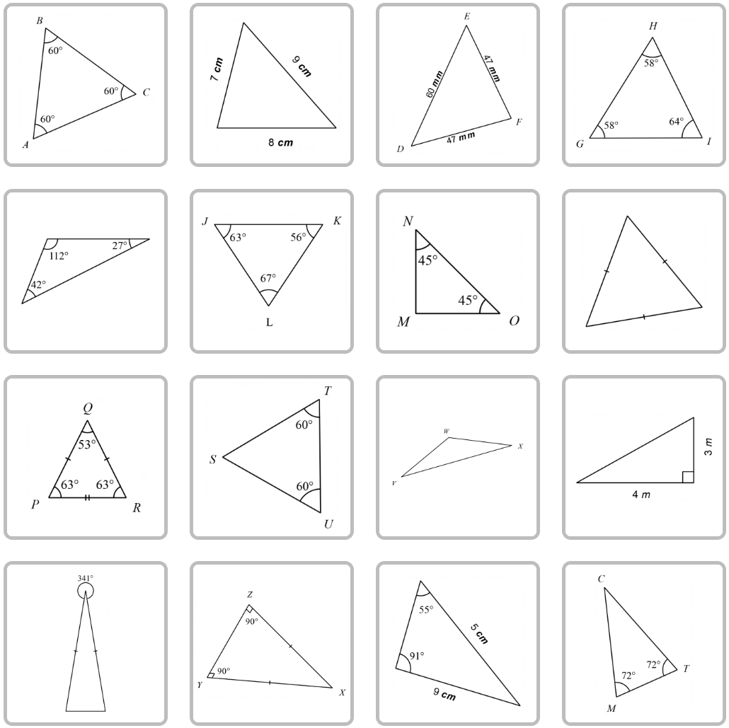
Image by Desmos is licensed under the Desmos Terms of Service.

Appendix B

Shapely Pairs
Contains a right angle and has just 2 equal angles | Contains a right angle and has all its sides of different lengths | Contains a right angle | All its angles are of different sizes
Has no line of symmetry | Does not contain a right angle | All its sides are of different lengths | Has just 2 equal angles
Contains a right angle and has just 2 equal sides | Does not contain a right angle and has just 2 equal sides | Contains a right angle but does not have a line of symmetry | Has only 1 line of symmetry
Has all its sides equal | Has just 2 equal sides | Has 3 lines of symmetry | Has all its angles equal
Challenge cards:
Challenge 1:
Classify each of the triangles that have been drawn as right, equilateral, isosceles, scalene, acute, obtuse.
Challenge 2:
Suppose instead of having the cards face down we have them all face up. If it's your turn first, and you want to take a pair of cards, how many possible pairs of cards could you choose? Can you list all the possible pairs?
Challenge 3:
At the end of the game, you might be left with some cards that can't be paired up. What is the largest number you could be left with like this? What is the smallest? Give examples for each.

Appendix C

Triangles foldable instructions
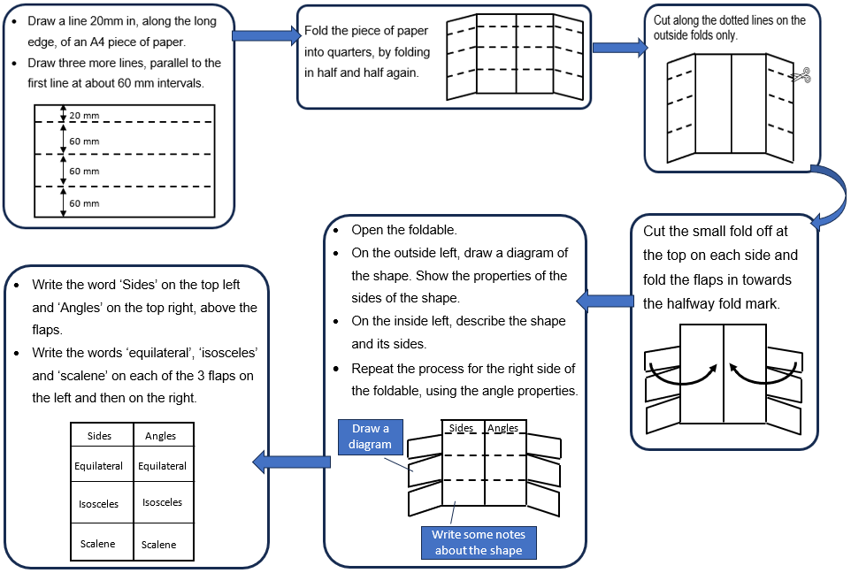

Sample solutions

Explore

Triangles polygraph
First row:
Possible – equilateral, could label all sides as equal.
Possible – scalene.
Possible – isosceles, could label 2 sides as equal.
Possible – isosceles, could label 2sides as equal.
Second row:
Impossible – angle sum is greater than 180 degrees.
Impossible – angle sum is greater than 180 degrees.
Possible – right-angled triangle and isosceles, could label missing 90-degree angle, could label 2 sides as equal.
Possible – equilateral, could label missing angles, each as 60 degrees.
Third row:
Impossible – angle sum is greater than 180 degrees.
Possible – equilateral, could label missing 60-degree angle, could label all sides as equal.
Possible – not enough information to determine the type of triangle.
Possible – right-angled triangle and scalene.
Fourth row:
Possible – isosceles, could find all 3 interior angles as 19, 80.5 and 80.5 degrees.
Impossible – angle sum is greater than 180 degrees.
Impossible – the longest side must always be opposite the largest angle.
Possible – isosceles, could find missing 36-degree angle, could label 2 sides as equal.

Apply

Shapely Pairs potential matches
First card selected | Cards it can match with to draw a triangle | Cards it cannot match with
Contains a right angle and has just 2 equal angles | - Contains a right angle and has just 2 equal sides  - Contains a right angle and has all its sides of different lengths  - Has just 2 equal sides  - Contains a right angle  - All its sides are of different lengths  - Contains a right angle but does not have a line of symmetry  - All its angles are of different sizes  - Has just 2 equal angles  - Has only 1 line of symmetry | - Has no line of symmetry  - Has all its sides equal  - Does not contain a right angle  - Does not contain a right angle and has just 2 equal sides  - Has 3 lines of symmetry  - Has all its angles equal
Has no line of symmetry | - Contains a right angle and has all its sides of different lengths  - Does not contain a right angle  - Contains a right angle  - All its sides are of different lengths  - Contains a right angle but does not have a line of symmetry  - All its angles are of different sizes | - Contains a right angle and has just 2 equal sides  - Has all its sides equal  - Does not contain a right angle and has just 2 equal sides  - Has just 2 equal sides  - Has 3 lines of symmetry  - Has just 2 equal angles  - Has only 1 line of symmetry  - Has all its angles equal  - Contains a right angle and has just 2 equal angles
Contains a right angle and has just 2 equal sides | - Contains a right angle and has just 2 equal angles  - Has just 2 equal sides  - Contains a right angle  - Has just 2 equal angles  - Has only 1 line of symmetry | - Has no line of symmetry  - Has all its sides equal  - Contains a right angle and has all its sides of different lengths  - Does not contain a right angle  - Does not contain a right angle and has just 2 equal sides  - All its sides are of different lengths  - Contains a right angle but does not have a line of symmetry  - Has 3 lines of symmetry  - All its angles are of different sizes  - Has all its angles equal
Has all its sides equal | - Does not contain a right angle  - Has 3 lines of symmetry  - Has all its angles equal | - Has no line of symmetry  - Contains a right angle and has just 2 equal angles  - Contains a right angle and has just 2 equal sides  - Contains a right angle and has all its sides of different lengths  - Does not contain a right angle and has just 2 equal sides  - Has just 2 equal sides  - Contains a right angle  - All its sides are of different lengths  - Contains a right angle but does not have a line of symmetry  - All its angles are of different sizes  - Has just 2 equal angles  - Has only 1 line of symmetry
Contains a right angle and has all its sides of different lengths | - Has no line of symmetry  - Contains a right angle  - All its sides are of different lengths  - Contains a right angle but does not have a line of symmetry  - All its angles are of different sizes | - Contains a right angle and has just 2 equal angles  - Contains a right angle and has just 2 equal sides  - Has all its sides equal  - Does not contain a right angle  - Does not contain a right angle and has just 2 equal sides  - Has just 2 equal sides  - Has 3 lines of symmetry  - Has just 2 equal angles  - Has only 1 line of symmetry  - Has all its angles equal
Does not contain a right angle | - Has no line of symmetry  - Has all its sides equal  - Does not contain a right angle and has just 2 equal sides  - Has just 2 equal sides  - All its sides are of different lengths  - Has 3 lines of symmetry  - All its angles are of different sizes  - Has just 2 equal angles  - Has only 1 line of symmetry  - Has all its angles equal | - Contains a right angle and has just 2 equal angles  - Contains a right angle and has just 2 equal sides  - Contains a right angle and has all its sides of different lengths  - Contains a right angle  - Contains a right angle but does not have a line of symmetry
Does not contain a right angle and has just 2 equal sides | - Does not contain a right angle  - Has just 2 equal sides  - Has just 2 equal angles  - Has only 1 line of symmetry | - Has no line of symmetry  - Contains a right angle and has just 2 equal angles  - Contains a right angle and has just 2 equal sides  - Has all its sides equal  - Contains a right angle and has all its sides of different lengths  - Contains a right angle  - All its sides are of different lengths  - Contains a right angle but does not have a line of symmetry  - Has 3 lines of symmetry  - All its angles are of different sizes  - Has all its angles equal
Has just 2 equal sides | - Contains a right angle and has just 2 equal angles  - Contains a right angle and has just 2 equal sides  - Does not contain a right angle  - Does not contain a right angle and has just 2 equal sides  - Contains a right angle  - Has just 2 equal angles  - Has only 1 line of symmetry | - Has no line of symmetry  - Has all its sides equal  - Contains a right angle and has all its sides of different lengths  - All its sides are of different lengths  - Contains a right angle but does not have a line of symmetry  - Has 3 lines of symmetry  - All its angles are of different sizes  - Has all its angles equal
Contains a right angle | - Has no line of symmetry  - Contains a right angle and has just 2 equal angles  - Contains a right angle and has just 2 equal sides  - Contains a right angle and has all its sides of different lengths  - Does not contain a right angle  - Has just 2 equal sides  - All its sides are of different lengths  - Contains a right angle but does not have a line of symmetry  - All its angles are of different sizes  - Has just 2 equal angles  - Has only 1 line of symmetry | - Has all its sides equal  - Does not contain a right angle and has just 2 equal sides  - Has 3 lines of symmetry  - Has all its angles equal
All its sides are of different lengths | - Has no line of symmetry  - Contains a right angle and has all its sides of different lengths  - Does not contain a right angle  - Contains a right angle  - Contains a right angle but does not have a line of symmetry  - All its angles are of different sizes | - Contains a right angle and has just 2 equal angles  - Contains a right angle and has just 2 equal sides  - Has all its sides equal  - Does not contain a right angle and has just 2 equal sides  - Has just 2 equal sides  - Has 3 lines of symmetry  - Has just 2 equal angles  - Has only 1 line of symmetry  - Has all its angles equal
Contains a right angle but does not have a line of symmetry | - Has no line of symmetry  - Contains a right angle and has all its sides of different lengths  - Contains a right angle  - All its sides are of different lengths  - All its angles are of different sizes | - Contains a right angle and has just 2 equal angles  - Contains a right angle and has just 2 equal sides  - Has all its sides equal  - Does not contain a right angle  - Does not contain a right angle and has just 2 equal sides  - Has just 2 equal sides  - Has 3 lines of symmetry  - Has just 2 equal angles  - Has only 1 line of symmetry  - Has all its angles equal
Has 3 lines of symmetry | - Has all its sides equal  - Does not contain a right angle  - Has all its angles equal | - Has no line of symmetry  - Contains a right angle and has just 2 equal angles  - Contains a right angle and has just 2 equal sides  - Contains a right angle and has all its sides of different lengths  - Does not contain a right angle and has just 2 equal sides  - Has just 2 equal sides  - Contains a right angle  - All its sides are of different lengths  - Contains a right angle but does not have a line of symmetry  - All its angles are of different sizes  - Has just 2 equal angles  - Has only 1 line of symmetry
All its angles are of different sizes | - Has no line of symmetry  - Contains a right angle and has all its sides of different lengths  - Does not contain a right angle  - Contains a right angle  - All its sides are of different lengths  - Contains a right angle but does not have a line of symmetry | - Contains a right angle and has just 2 equal angles  - Contains a right angle and has just 2 equal sides  - Has all its sides equal  - Does not contain a right angle and has just 2 equal sides  - Has just 2 equal sides  - Has 3 lines of symmetry  - Has just 2 equal angles  - Has only 1 line of symmetry  - Has all its angles equal
Has just 2 equal angles | - Contains a right angle and has just 2 equal angles  - Contains a right angle and has just 2 equal sides  - Does not contain a right angle  - Does not contain a right angle and has just 2 equal sides  - Has just 2 equal sides  - Contains a right angle  - Has only 1 line of symmetry | - Has no line of symmetry  - Has all its sides equal  - Contains a right angle and has all its sides of different lengths  - All its sides are of different lengths  - Contains a right angle but does not have a line of symmetry  - Has 3 lines of symmetry  - All its angles are of different sizes  - Has all its angles equal
Has only 1 line of symmetry | - Contains a right angle and has just 2 equal angles  - Contains a right angle and has just 2 equal sides  - Does not contain a right angle  - Does not contain a right angle and has just 2 equal sides  - Has just 2 equal sides  - Contains a right angle  - Has just 2 equal angles | - Has no line of symmetry  - Has all its sides equal  - Contains a right angle and has all its sides of different lengths  - All its sides are of different lengths  - Contains a right angle but does not have a line of symmetry  - Has 3 lines of symmetry  - All its angles are of different sizes  - Has all its angles equal
Has all its angles equal | - Has all its sides equal  - Does not contain a right angle  - Has 3 lines of symmetry | - Has no line of symmetry  - Contains a right angle and has just 2 equal angles  - Contains a right angle and has just 2 equal sides  - Contains a right angle and has all its sides of different lengths  - Does not contain a right angle and has just 2 equal sides  - Has just 2 equal sides  - Contains a right angle  - All its sides are of different lengths  - Contains a right angle but does not have a line of symmetry  - All its angles are of different sizes  - Has just 2 equal angles  - Has only 1 line of symmetry

References
This resource contains NSW Curriculum and syllabus content. The NSW Curriculum is developed by the NSW Education Standards Authority. This content is prepared by NESA for and on behalf of the Crown in right of the State of New South Wales. The material is protected by Crown copyright.
Please refer to the NESA Copyright Disclaimer for more information https://educationstandards.nsw.edu.au/wps/portal/nesa/mini-footer/copyright.
NESA holds the only official and up-to-date versions of the NSW Curriculum and syllabus documents. Please visit the NSW Education Standards Authority (NESA) website https://educationstandards.nsw.edu.au/ and the NSW Curriculum website https://curriculum.nsw.edu.au/home.
Mathematics K–10 Syllabus © NSW Education Standards Authority (NESA) for and on behalf of the Crown in right of the State of New South Wales, 2022.

© State of New South Wales (Department of Education), 2023
The copyright material published in this resource is subject to the Copyright Act 1968 (Cth) and is owned by the NSW Department of Education or, where indicated, by a party other than the NSW Department of Education (third-party material).
Copyright material available in this resource and owned by the NSW Department of Education is licensed under a Creative Commons Attribution 4.0 International (CC BY 4.0) license.
This license allows you to share and adapt the material for any purpose, even commercially.
Attribution should be given to © State of New South Wales (Department of Education), 2023.
Material in this resource not available under a Creative Commons license:
- the NSW Department of Education logo, other logos and trademark-protected material
- material owned by a third party that has been reproduced with permission. You will need to obtain permission from the third party to reuse its material.
Links to third-party material and websites
Please note that the provided (reading/viewing material/list/links/texts) are a suggestion only and implies no endorsement, by the New South Wales Department of Education, of any author, publisher, or book title. School principals and teachers are best placed to assess the suitability of resources that would complement the curriculum and reflect the needs and interests of their students.
If you use the links provided in this document to access a third-party's website, you acknowledge that the terms of use, including licence terms set out on the third-party's website apply to the use which may be made of the materials on that third-party website or where permitted by the Copyright Act 1968 (Cth). The department accepts no responsibility for content on third-party websites.

