Strike a pose
In this lesson students will locate angles in everyday life, estimate the size of angles, name the types of angles and use naming conventions for angles.

Visible learning

Learning intentions
- To be able to classify angles.
- To be able to apply the language, notation and conventions of geometry.

Success criteria
- I can estimate the size of angles.
- I can identify types of angles.
- I can use geometric conventions to name angles.

Syllabus outcomes
A student:
- develops understanding and fluency in mathematics through exploring and connecting mathematical concepts, choosing and applying mathematical techniques to solve problems, and communicating their thinking and reasoning coherently and clearly MAO-WM-01
- applies angle relationships to solve problems, including those related to transversals on sets of parallel lines MA4-ANG-C-01
Mathematics K–10 Syllabus © NSW Education Standards Authority (NESA) for and on behalf of the Crown in right of the State of New South Wales, 2022.

Activity structure
Please use the associated PowerPoint Strike a Pose to display images in this lesson.

Warm-up
- Direct students to the ‘Estimating Angles’ game (Estimating Angles (maths.org). Students are given an angle size. They click to stop the arm moving when they think that the size of the angle matches the given angle.
- Students should pick their difficulty level and change the slider to 2-players.
- Provide students with the opportunity to play the game several times.
- When most pairs have played at least 5 rounds, engage the class in a discussion to determine their scores, which angles were hardest to estimate and why they were harder to estimate.

Launch

Strike a pose
- Show slide 3 in the Strike a Pose PowerPoint. The slide shows 2 images of a dancer and a line sketch depicting each image.
- Using the notice-wonder strategy (bit.ly/noticewonderstrategy), ask the students what they notice and what they wonder. Allow them to share anything that pops into their mind.
At this point, students can share anything they notice and anything they wonder. It does not need to be maths related.
Encourage students to use both formal and informal mathematical language. Discuss with students how angles and lines can be used to communicate ideas and emotions.
- Show slide 4 from the Strike a Pose PowerPoint. This slide shows 2 more pictures of dancers. Tell students to choose one of the images from the slide and try to sketch the angles and lines that represent the image.
The sketches need only be small, taking a space approximately 5 cm by 5 cm. Encourage students to attempt the sketch a few times if they are not satisfied with their first attempt.
- In pairs, ask students to show each other their sketches and discuss their drawings. Encourage students to identify and describe to each other the different lines and angles they have used.
- Display slide 5 of the PowerPoint. Tell students that the image shows lots of different emotions that may be expressed through the way we pose. Students should think about how they might position themselves to communicate an idea and consider how changing the angles of their arms and legs changes the emotion.
- Arrange students in visibly random groups of 3 (bit.ly/visiblegroups). In each group, students will take turns to stand and pose whilst the other 2 students do a line sketch of the pose, showing the angles and lines. Students may use ideas from the word cloud on slide 5 or come up with their own idea. The students can either choose to tell their peers what emotion they are posing, or they might like to ask their peers to guess what they are posing.
Remind students that the activity is based on striking a pose and identifying the angles used by parts of their body. It is not about the emotion shown on their face.
- Continue to focus student discussion on describing the angles and lines, using formal and informal language. As the teacher visits the groups, they may prompt discussion with questions such as:
- How does the angle formed by our arms change when our hands are on our stomach compared to placing our hands on our heart?
- What message might we be sending when we hold one arm out, perpendicular to our body, compared to above our head and parallel to our body?
Teachers may introduce a discussion about how we read body language to help understand how a person might be feeling or how angles are integrated in cultural practices, such as bowing.
- Conduct a class discussion to consider how the angles of our bodies and limbs can communicate different messages.

Explore

Equipment
- Appendix A – The angles we see, printed in colour, single copy
- Adhesive putty

Method
- Post the colour, printed images contained in Appendix A on the walls around the classroom.
- Explain to the students that they will be moving around the classroom, in pairs, looking at the images posted on the walls.
- Ask them to discuss what they notice and what they think about the images and to write their ideas on the posters.
- The teacher should periodically pause the movement of students.
- Announce to the class that you will be pressing pause in thirty seconds to hear what some people are thinking.
- Ask 2 or 3 pairs to briefly describe the images in front of them and either describe something they see or something that they find interesting.
- Explain that the pause helps students to hear what others are seeing and thinking about the images. You may, if you think it is necessary, direct the students towards considering the angles they see with questions such as:
    - Can someone tell me something about the angles in their image?
    - Can someone recall and describe a type of angle?
The students do not need to visit all the images.
- After 10–15 minutes, stop the activity. Students can return to their seat.
- Use the Pose-Pause-Pounce-Bounce strategy [PDF 200KB] (bit.ly/pausepouncebounce) to discuss the images, directing the discussion towards the angles in the images.
Guide discussion towards defining the terms acute, obtuse, reflex, right-angle, straight-angle and revolution.
- Use slides 7–9 of the PowerPoint to conduct a discussion highlighting the difficulty of describing exactly what angle they are referring to when there are multiple angles shown.
Challenge students to consider if it is possible to use location identifiers such as ‘on the left of the photo’ or ‘at the top of the plane’ or descriptive phrases such as ‘the acute angle on his leg’. Students should be encouraged to consider perspective, that some images may not have a top or bottom, left or right, and that there is more than one acute angle in the person’s leg in the image displayed.
The photo of the bicycle should encourage students to further identify the problem with using general location identifiers. There are multiple angles visible, including reflex angles.

Summarise
- Guide the students through slides 11–13 of the PowerPoint. Use a class discussion to discuss how the angles are named and the types of angles they can see.
Use the discussion to promote recognition by students that angles are named using 3 letters and that the middle letter is always the letter located at the vertex of the angle. Encourage students to recognise that the naming conventions can be supported by identifying the type of angle, especially when distinguishing between an acute angle and a reflex angle with the same vertex.
- Ask students to write notes for their future forgetful self (bit.ly/notesstrategy).

Apply

Angles bingo

Equipment
- one bingo card per student, from the set in Appendix B ‘Bingo cards’
- a pen or pencil to mark their bingo card

Method
- Distribute the game cards to the students.
- Slide 15 of the PowerPoint can be used to explain how the game is played.
The game cards include names of angles, angle sizes, pictures of angles, stick figure drawings and an image.
Students look at the stick figure drawing and the image at the centre of the game card and identify some of the angle types they can see. Students should recognise that some of the drawings and images have more than one angle type. They will need to label the angle they are using on the photo and stick figure drawing.
- Display slide 16 of the PowerPoint. This slide contains 24 buttons. Each button links to one of the angle types.
- Ask a student to randomly select a number, from 1 to 24. Click on the number selected. The PowerPoint will show one of the angle types. Students should cross out that angle type or label that type of angle. Students can only cross out or label one angle for each spin.
- Explain to the students that the first person to cover all 9 squares on their game card needs to call ‘Bingo’. Remind students that there may be more than one person to fill their card at the same time.
When the first student calls Bingo, check the angles on the card match the angles called.

Assessment and differentiation

Suggested opportunities for differentiation
Throughout this lesson, low readiness students could be restricted to a small subset of angles such as ${90}^{o}, {180}^{o}, {360}^{o}, {45}^{o}$.
Launch
- Provide students with a set of drawn angles and a protractor to measure the angles.
- Challenge students to draw an angle produced by an arm that rotates more than ${360}^{o}$, such as ${460}^{o}$ or ${750}^{o}$.
Explore
- Discuss different types of angles before trying to identify them in the pictures. For instance, acute, obtuse, reflex.
Summarise
- Provide students with a scaffold to make their notes.
Apply
- Conduct a class discussion to assist students to identify the angles on their bingo card before playing the game.
- Students could play in pairs to assist each other with finding and marking angles.
- Have the students choose and mark out an angle on the stick figure drawing and the picture before they begin playing.

Suggested opportunities for assessment
Warm-up
- Monitor student understanding of angle size as they play the game.
Explore
- Monitor student discussions to determine student recall of angle types.
Summarise
- Scan student notes to their future forgetful self to check for understanding.
Apply
- Check that students can identify the types of angles on their bingo card.

Appendix A

The angles we see
The images in Appendix A are formatted to be printed one per page, with questions below the image and space for students to write multiple answers to the questions.
Figure 1 – ‘preying mantis...!‘ by S.o.L.e is licensed under CC BY 2.0.
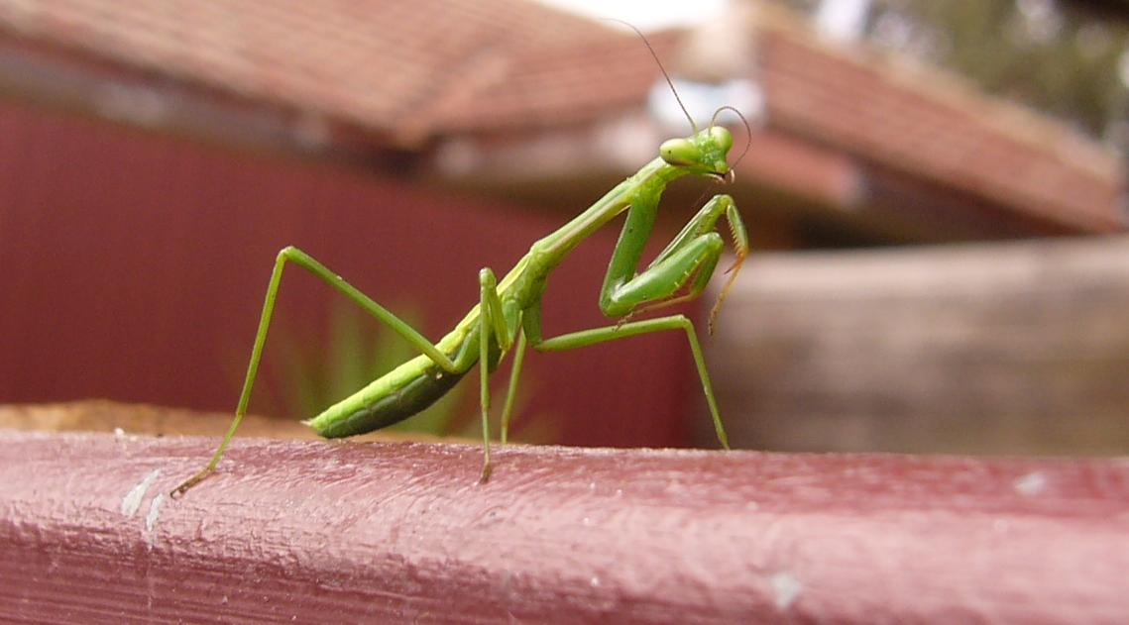
What can you see?
What do you notice?

Figure 2 – ‘Angles, lines, light, and shadows‘ by kevin dooley is licensed under CC BY 2.0.
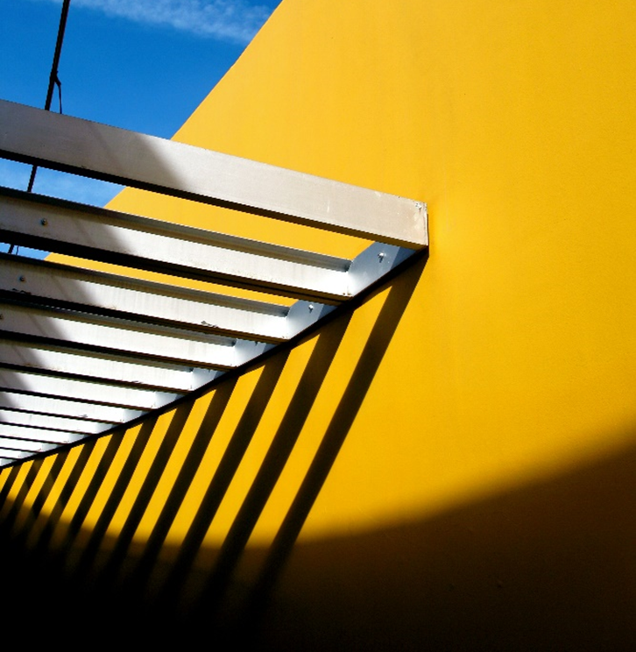
What can you see?

What do you notice?

Figure 3 – ‘The City Light Walking High Angle View Sunlight Steps And Staircases Outdoors Real People Day Architecture One Person Silhouette Shadows & Lights Pattern, Texture, Shape And Form PhotoNepal‘ by bmaharjan is licensed under CC BY-SA 2.0.

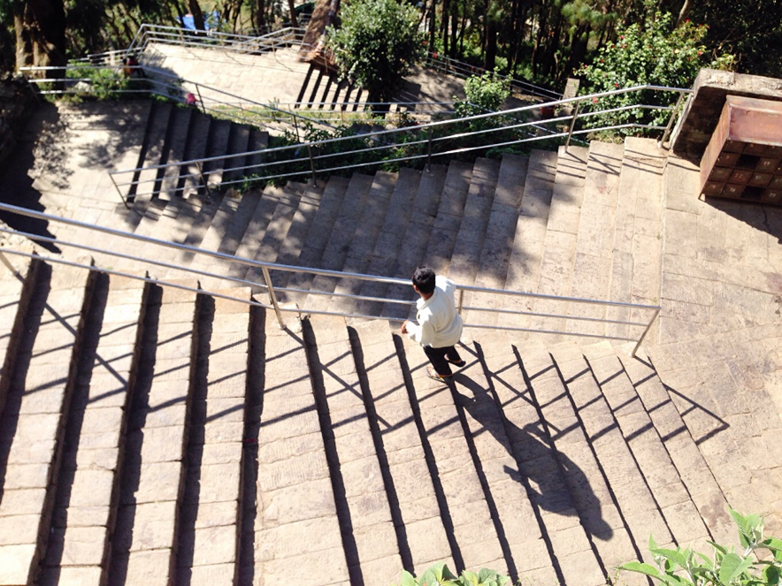
What can you see?

What do you notice?

Figure 4 – Waterloo station clock

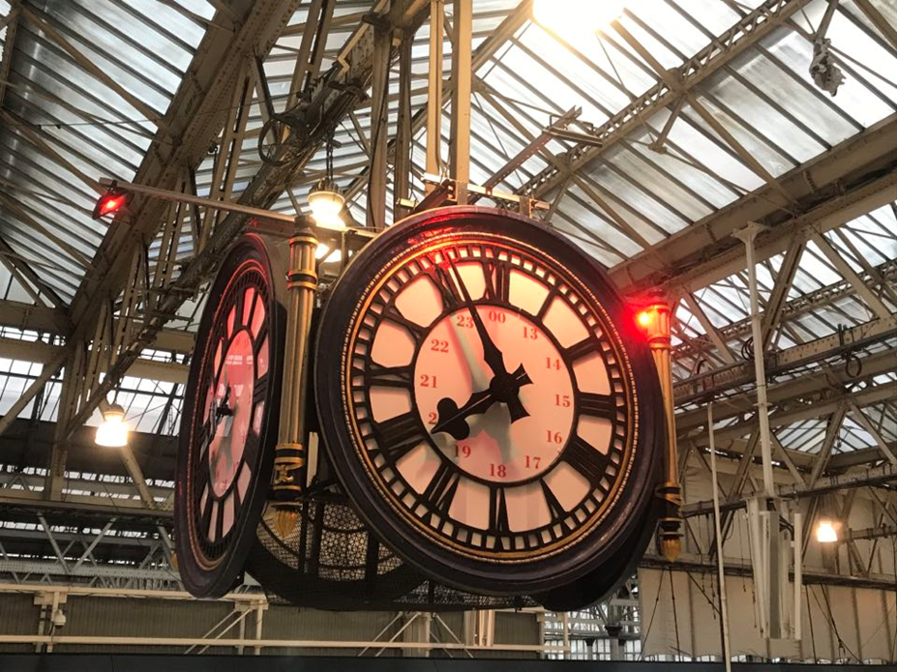
What can you see?

What do you notice?

Figure 5 – ‘Angles and shapes.‘ by Bernard Spragg is marked with Public Domain Mark 1.0.
What can you see?

What do you notice?

Figure 6 – ‘Sydney Harbour Bridge‘ by RaeAllen is licensed under CC BY 2.0.
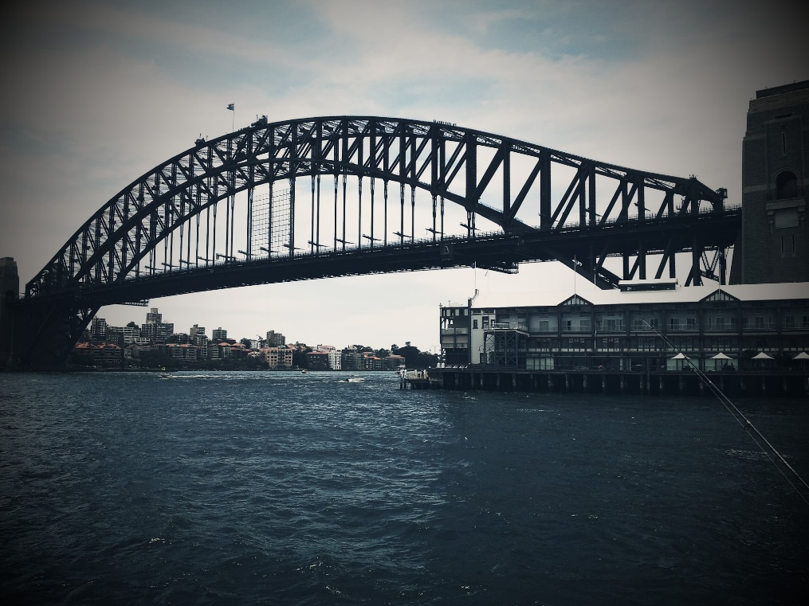
What can you see?

What do you notice?

Figure 7 – pole at Taronga Western Plains Zoo
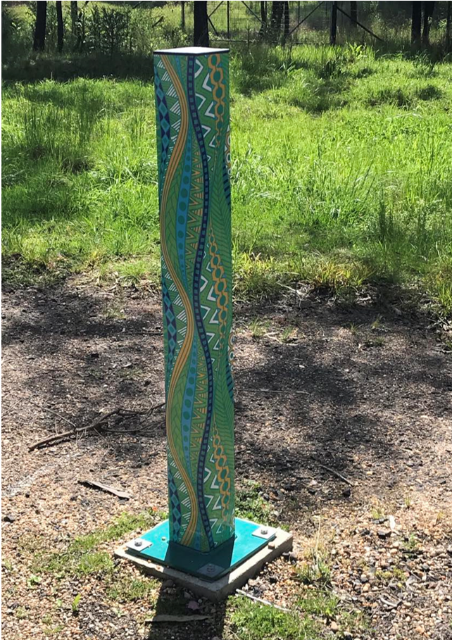
What can you see?

What do you notice?
Figure 8 – the Leaning Tower of Pisa

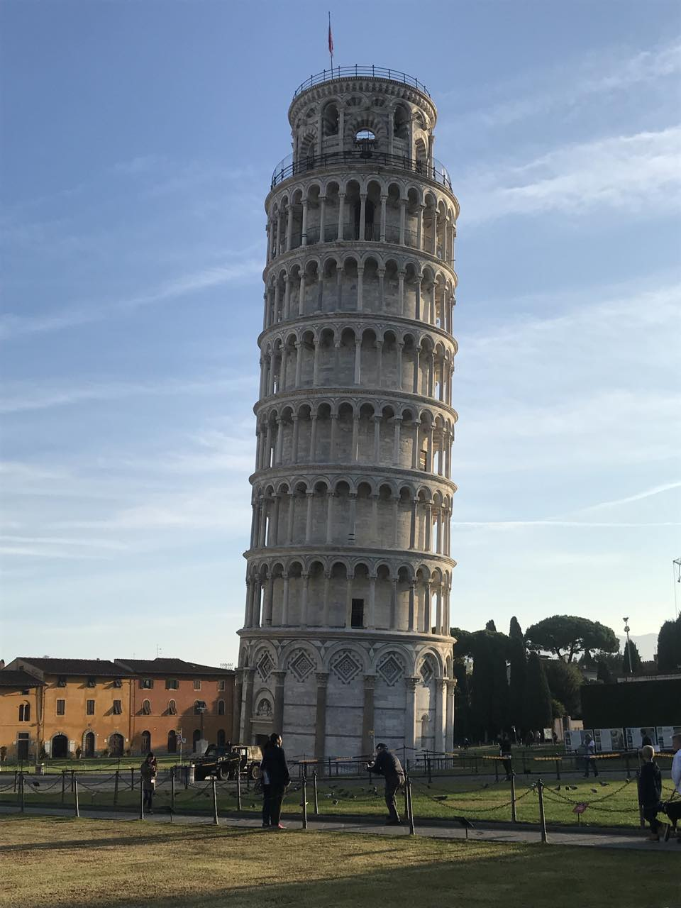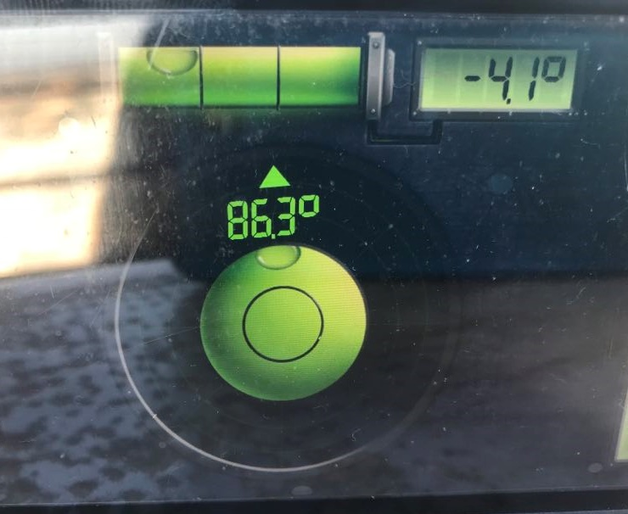
What can you see?

What do you notice?
Figure 9 – ‘Chocolate Cream Cake‘ by wuestenigel is licensed under CC BY 2.0.
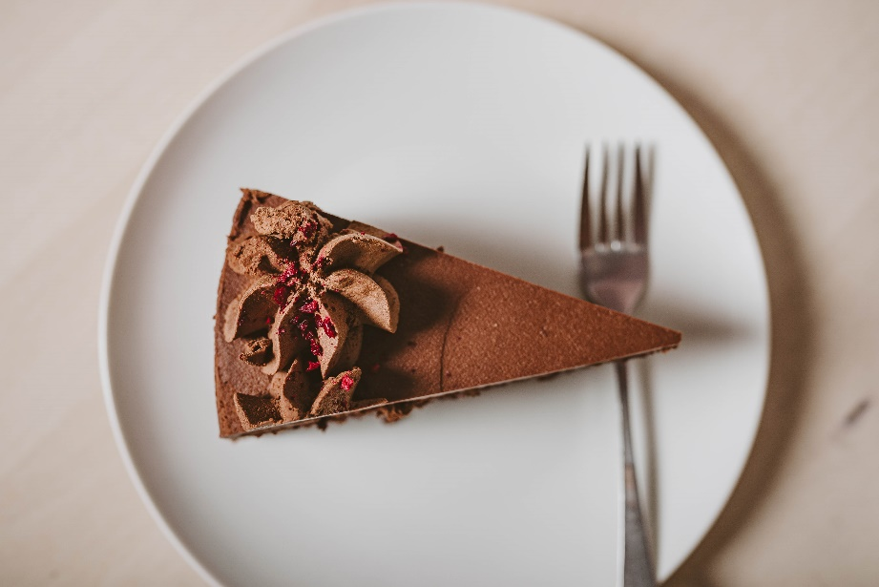
What can you see?

What do you notice?
Figure 10 – Mount Olympic at Perisher Valley Ski Resort
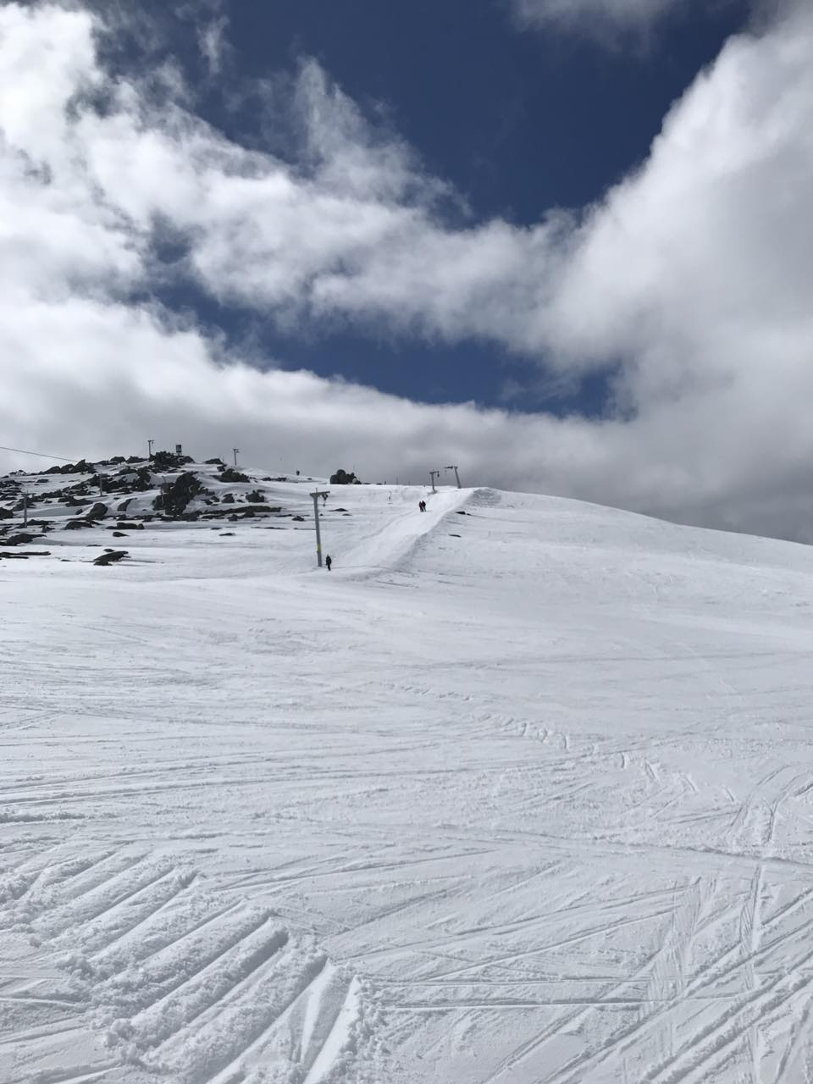
What can you see?

What do you notice?
Figure 11 – ‘Kandinsky/Klee Meisterhaus’ by Christian Stock is licensed under CC BY 2.0.
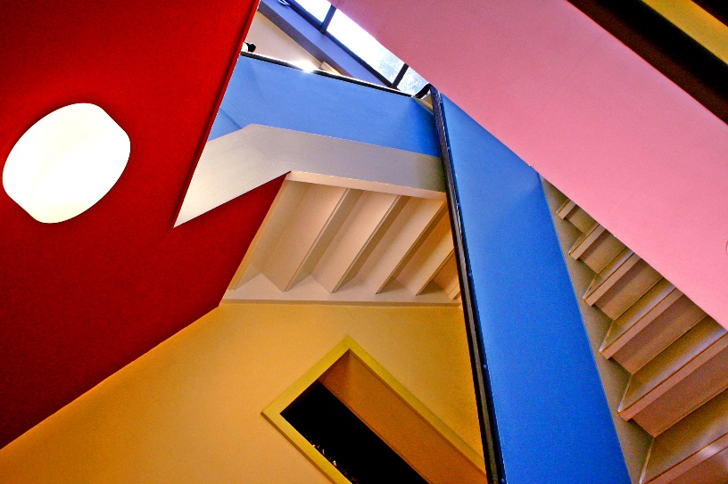
What can you see?

What do you notice?
Figure 12 – ‘[ K ] Vassily Kandinsky - Yellow - Blue - Red (1925)’ by Cea. is licensed under CC BY 2.0.
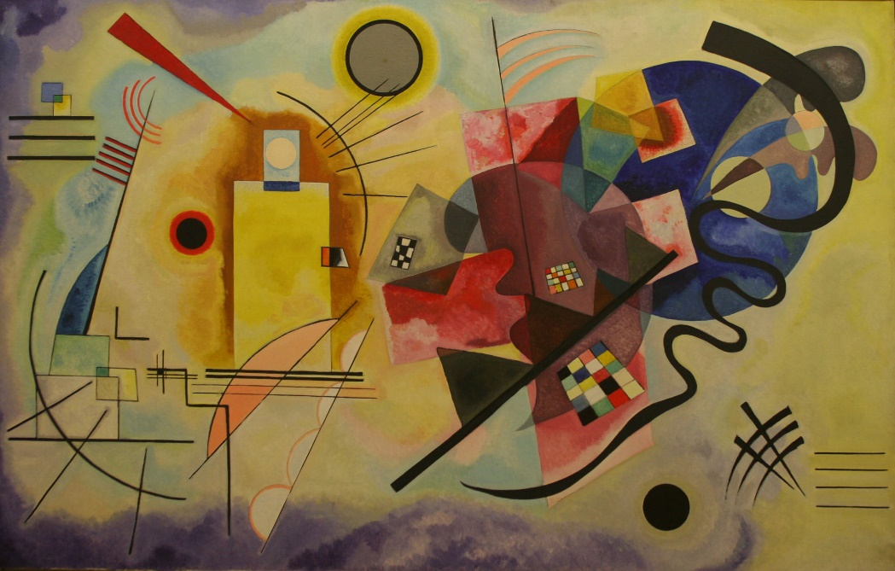
What can you see?

What do you notice?

Appendix B

Bingo cards
Straight | $${77}^{o}$$ | Acute
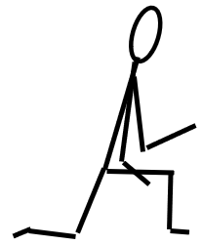 | 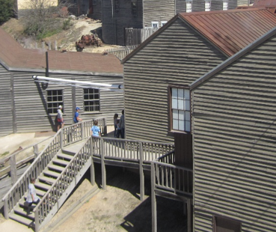 | 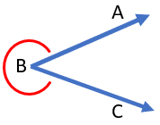
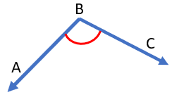 | $${360}^{o}$$ | 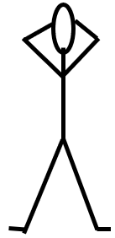

Straight | 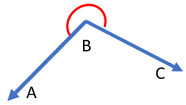 | $${89}^{o}$$
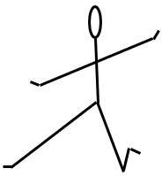 | 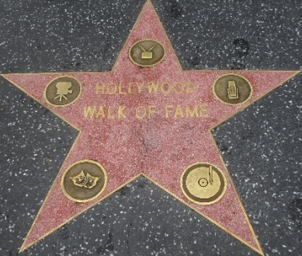
$${90}^{o}$$ | Reflex

Obtuse | $${51}^{o}$$ | 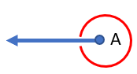
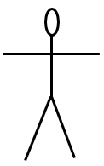 |  | $${17}^{o}$$
Revolution |  | Reflex

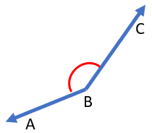 | $${342}^{o}$$ | $${15}^{o}$$
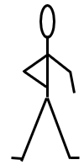 | 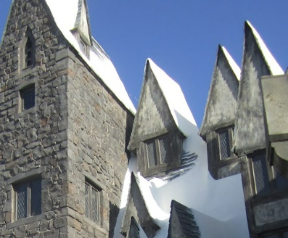 | Obtuse
Straight | $${77}^{o}$$ | 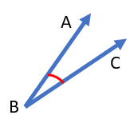

Reflex | 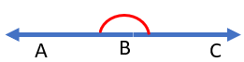 | $${199}^{o}$$
 | 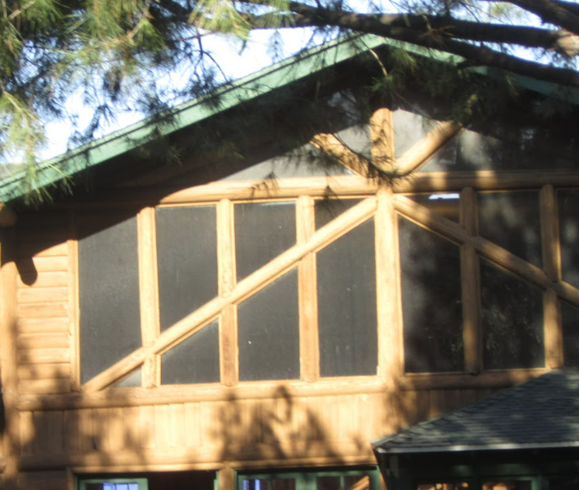
$${34}^{o}$$ | Obtuse | $${90}^{o}$$

Straight | $${17}^{o}$$ | $${284}^{o}$$
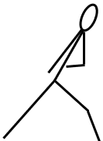 | 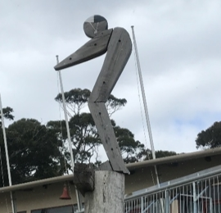
$${90}^{o}$$ | Acute

$${301}^{o}$$ |  | Obtuse
 | 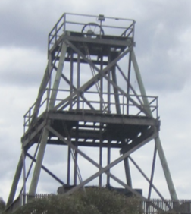 | $$8^{o}$$
$${90}^{o}$$ | Reflex

Right | $${318}^{o}$$ | 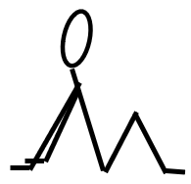
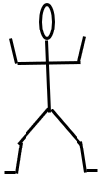 | 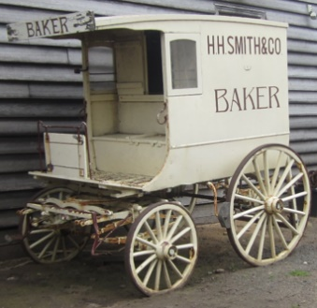
 | $${180}^{o}$$ | Obtuse

Revolution | $${70}^{o}$$ | 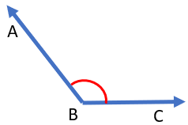
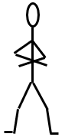 | 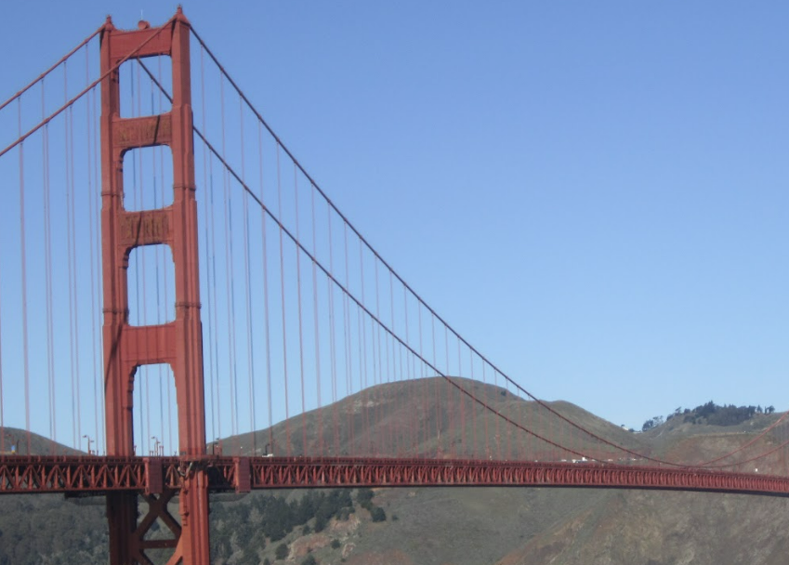 | $${305}^{o}$$
 | $${53}^{o}$$ | Reflex

Obtuse | $${109}^{o}$$
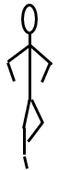 | 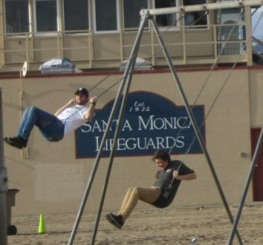 | $${70}^{o}$$
$${90}^{o}$$ | Right

 | $${180}^{o}$$
$${109}^{o}$$ | 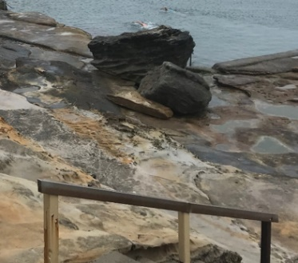 | Obtuse
Reflex | $${17}^{o}$$

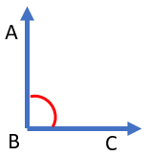 | $${90}^{o}$$ | $${342}^{o}$$
Revolution | 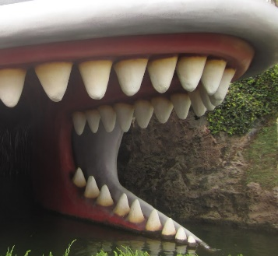 | $${109}^{o}$$
 | Acute

$${342}^{o}$$
Acute
 | Reflex | $${70}^{o}$$

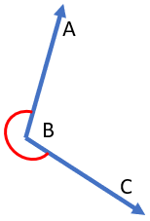 |  | $${180}^{o}$$
Reflex
$${56}^{o}$$ |  | Acute

 | Right | $${96}^{o}$$
 | 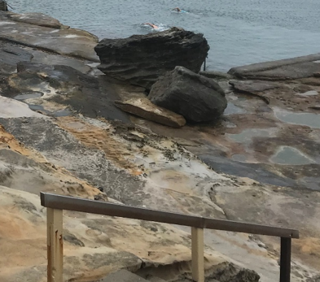 | Straight
$${180}^{o}$$ |  | $${210}^{o}$$

 | $${81}^{o}$$
Right
 | $${210}^{o}$$ | Reflex

Straight |  | $${123}^{o}$$
$${180}^{o}$$ |  | Obtuse
 | $${360}^{o}$$ | 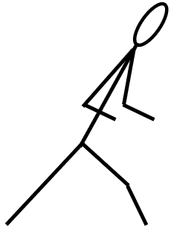

 | Straight | 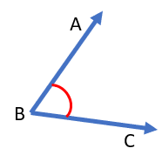
 |  | $${153}^{o}$$
$${180}^{o}$$ |  | Acute

 |  | Reflex
$${131}^{o}$$
Acute |  | $${360}^{o}$$

Right |  | $${120}^{o}$$
 |  | $${96}^{o}$$
$${45}^{o}$$ | Obtuse

 | Acute
$${135}^{o}$$ |  | $${180}^{o}$$
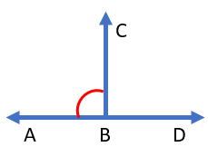 | Revolution | $${96}^{o}$$

 |  | $${180}^{o}$$
Reflex | 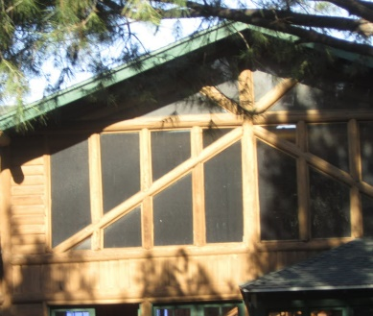
 | $${120}^{o}$$ | Acute

Right |  | $${135}^{o}$$
 |  | Acute
$${109}^{o}$$

Obtuse |  | $${147}^{o}$$
$${120}^{o}$$ | Straight

$${180}^{o}$$ | $${77}^{o}$$ | Right
Revolution |  | 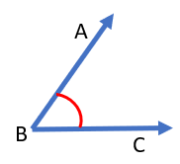
 |  | $${131}^{o}$$

$${77}^{o}$$ |  | Straight
Obtuse | $${153}^{o}$$

$${118}^{o}$$ | Straight
 |  | $${89}^{o}$$
 | Acute

Acute |  | $${96}^{o}$$
 |  | Right
$${51}^{o}$$

$${210}^{o}$$ |  | Straight
 |  | $${128}^{o}$$
Acute

$${62}^{o}$$ | Revolution | $${26}^{o}$$
Straight
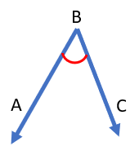 | $${234}^{o}$$

Sample solutions

Launch – Strike a pose
Examples of line drawings
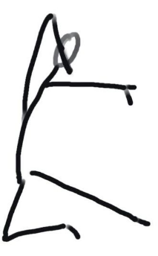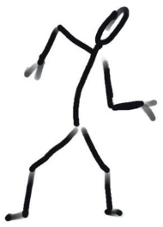

Apply – Angles bingo
Bingo buttons:
- Reflex
- Acute
- Obtuse
- Straight
- Revolution
- Right
- Straight
- Obtuse
- Right
- Revolution
- Acute
- Obtuse
- Reflex
- Revolution
- Straight
- reflex
- Right
- Obtuse
- Acute
- Revolution
- Reflex
- Straight
- Acute
- Right

References
This resource contains NSW Curriculum and syllabus content. The NSW Curriculum is developed by the NSW Education Standards Authority. This content is prepared by NESA for and on behalf of the Crown in right of the State of New South Wales. The material is protected by Crown copyright.
Please refer to the NESA Copyright Disclaimer for more information https://educationstandards.nsw.edu.au/wps/portal/nesa/mini-footer/copyright.
NESA holds the only official and up-to-date versions of the NSW Curriculum and syllabus documents. Please visit the NSW Education Standards Authority (NESA) website https://educationstandards.nsw.edu.au/ and the NSW Curriculum website https://curriculum.nsw.edu.au/home.
Mathematics K–10 Syllabus © NSW Education Standards Authority (NESA) for and on behalf of the Crown in right of the State of New South Wales, 2022.

© State of New South Wales (Department of Education), 2023
The copyright material published in this resource is subject to the Copyright Act 1968 (Cth) and is owned by the NSW Department of Education or, where indicated, by a party other than the NSW Department of Education (third-party material).
Copyright material available in this resource and owned by the NSW Department of Education is licensed under a Creative Commons Attribution 4.0 International (CC BY 4.0) license.
This license allows you to share and adapt the material for any purpose, even commercially.
Attribution should be given to © State of New South Wales (Department of Education), 2023.
Material in this resource not available under a Creative Commons license:
- the NSW Department of Education logo, other logos and trademark-protected material
- material owned by a third party that has been reproduced with permission. You will need to obtain permission from the third party to reuse its material.
Links to third-party material and websites
Please note that the provided (reading/viewing material/list/links/texts) are a suggestion only and implies no endorsement, by the New South Wales Department of Education, of any author, publisher, or book title. School principals and teachers are best placed to assess the suitability of resources that would complement the curriculum and reflect the needs and interests of their students.
If you use the links provided in this document to access a third-party's website, you acknowledge that the terms of use, including licence terms set out on the third-party's website apply to the use which may be made of the materials on that third-party website or where permitted by the Copyright Act 1968 (Cth). The department accepts no responsibility for content on third-party websites.

