Four 4’s
Students analyse expressions using the four operations and exactly four ‘4’s to identify errors. Students then use brackets to modify expressions to change the order of operations.
This lesson assumes that students have experience with foundational order of operation concepts.

Visible learning

Learning intention
- To understand how brackets impact the order of operations when evaluating an expression.

Success criteria
- I can explain the order that calculations need to be performed in an expression.
- I can add brackets to an expression to change the value.

Syllabus outcomes
A student:
- develops understanding and fluency in mathematics through exploring and connecting mathematical concepts, choosing and applying mathematical techniques to solve problems, and communicating their thinking and reasoning coherently and clearly MAO-WM-01
- compares, orders and calculates with integers to solve problems MA4-INT-C-01
- represents and operates with fractions, decimals and percentages to solve problems MA4-FRC-C-01
- operates with primes and roots, positive-integers and zero indices involving numerical bases and establishes the relevant index laws MA4-IND-C-01
Mathematics K–10 Syllabus © NSW Education Standards Authority (NESA) for and on behalf of the Crown in right of the State of New South Wales, 2022.
Please use the associated PowerPoint Four fours to display images in this lesson.

Activity structure

Launch
During this launch activity, teachers should allow time for productive struggle by students. One possible approach would be to devote one entire lesson to engaging in the launch activity and completing the explore, summarise and apply sections in the following lesson. Not all integers in the ‘Four fours’ task are achievable with the knowledge students will currently have. New ways of using the digit 4 are introduced throughout the activity, however some integers will remain empty at the end of the launch and will be considered later in the lesson.
- Hand students the first page of Appendix A ‘Four fours’ and organise them into visibly random groups of 3 (bit.ly/visiblegroups).
- Inform students that they are to write expressions that contain exactly four ‘4’s, using the operators ‘+’, ‘−’, ‘×’ and ‘$÷$’, to equal each of the numbers on Appendix A. Teachers could give the example of $4+4+4+4=16$.
If possible, have groups work at vertical, non-permanent surfaces (bit.ly/VNPSstrategy). Students should not use a calculator.
- Bring the class back together once they have had sufficient time to find some solutions. Collect solutions from each group and record it on the teacher’s whiteboard, asking for reasoning as students contribute their solution.
Encourage debate without concluding on correct ways to interpret an expression.

- Teachers can expand the toolkit of students by introducing the following options, one by one.
- Using two ‘4’s to make $44$ or $4.4$.
- $4^{2}$, giving $16$ but only using one ‘4’.
- $\sqrt{4}$, giving 2 but only using one ‘4’.
- Since $.4=0.4$, we will allow $0.4$ to count as a single 4. Its most obvious use being that $4÷0.4=10$.
- $4!=4×3×2×1=24$. This is an extension but allows access to some further answers.
These additions to the task may be introduced by the teacher, or acknowledged as students suggest them as possibilities.
- Give students the second page of Appendix A to complete.
Students may quickly discover that they can achieve negative results by copying their matching positive result, placing brackets around the whole expression and a negative symbol in front. For example, $4+4+4+4=16$, so $-\left(4+4+4+4\right)=-16$. Teachers may wish to announce that this approach can be used only 5 times.

Explore
- With students still in their groups of 3, hand each group a copy of Appendix B ‘Four fours errors’.
- Instruct students that they are to review the expressions and find 5 that are incorrect.
- Students need to discuss whether there is a way that the given incorrect expression could be completed in a different order to become correct.
Teachers can determine whether their students are proficient enough with the order of operations to begin inserting brackets to fix the incorrect expressions.

Summarise
- Use slides 2–5 from the Four fours PowerPoint for explicit teaching of using brackets to adjust expressions.
The explicit teaching technique used in the associated PowerPoint is ‘Your turn.’ The first slide is a worked example which should be displayed for the students and then use the following steps.
- Reveal the question to students and its solution.
- Students read in silence.
- Students individually think and explain to themselves what is happening in each step.
- Students hold up a thumbs up to the teacher when they have finished reading and have some sort of understanding.
- Think-Pair-Share. Students explain the solution to their partner.
- In pairs students then answer the self-explanation questions.
- Finally, randomly select students to share their answers with the whole class.
- Have students return to their work in Appendix B and add brackets to adjust the solutions.
- Use a Pose-Pause-Pounce-Bounce question strategy [PDF 200KB] (bit.ly/pausepouncebounce) to collect solutions.

Apply

Open middle problem
- Challenge students to complete the open middle problem displayed on slides 6 and 7 of the Four fours PowerPoint. This problem is also displayed in Figure 1 and printable as Appendix C ‘Open middle problem’. It is inspired by this problem at the ‘Open middle’ website (bit.ly/OMOoO2).
- Students are to fill each of the empty boxes with a digit from 0–9, so that all 3 expressions make an odd number. Each digit 0–9 can be used only once.
- Challenge students to see how many solutions they can find.
- Further open middle problems related to the order of operations can also be found at the ‘Open middle’ website (bit.ly/OMOoOALL).
Figure 1: Open middle problem
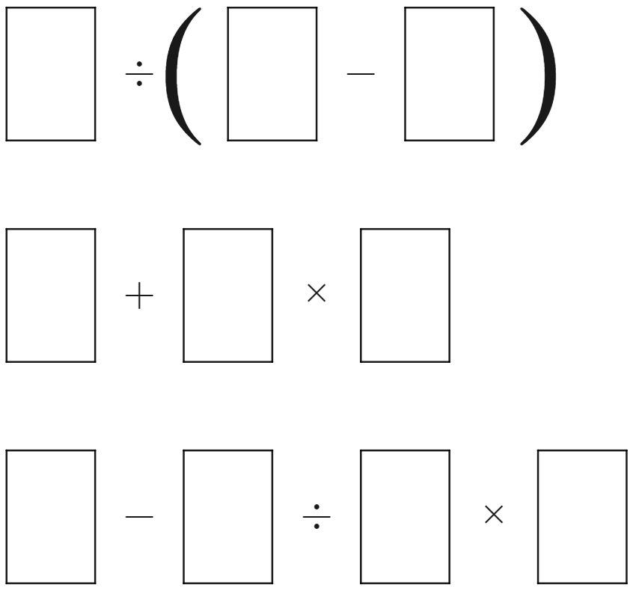
Image created using Desmos and is licensed under the Desmos Terms of Service.

Assessment and differentiation

Suggested opportunities for differentiation
Launch
- Teachers can edit Appendix A to either reduce the number of integers to be found, for example the integers 1–10, or else extend students to go all the way to 100.
- Students can be challenged to determine if the solutions provided by another group are correct. Especially if 2 groups discover different expressions for the same integer.
- This activity can also be modified to use the numbers 1, 2, 3, and 4 to create expressions for each integer. The challenge can be further increased by adding the criteria that the numbers need to be used in numeric order. For instance, 1 + 2 x 3 – 4 = 3
Explore
- Students enter this task knowing that exactly 5 of the problems are incorrect and that this incorrect solution is a common misconception, allowing them easier access to order of operation questions.
Apply
- Students can be given a single expression and asked to consider the number of possible ways you can make an odd number.
- Students who are excelling can attempt to explain the number of possible solutions to the entire open middle problem.

Suggested opportunities for assessment
Launch
- This activity acts as an opportunity for teachers to assess whether students are correctly applying the order of operations to evaluate simple expressions with and without brackets.
Explore and summarise
- Teachers can collect Appendix A and B to use as evidence of their ability to use the order of operations to obtain specific values from expressions.

Appendix A

Four fours
Write expressions using exactly four ‘4’s and the operators $+$, $-$, $×$, $÷$ that give each solution in the table below.
Result | Expression | Result | Expression
$$0$$ |  | $$16$$
$$1$$ |  | $$17$$
$$2$$ |  | $$18$$
$$3$$ |  | $$19$$
$$4$$ |  | $$20$$
$$5$$ |  | $$21$$
$$6$$ |  | $$22$$
$$7$$ |  | $$23$$
$$8$$ |  | $$24$$
$$9$$ |  | $$25$$
$$10$$ |  | $$26$$
$$11$$ |  | $$27$$
$$12$$ |  | $$28$$
$$13$$ |  | $$29$$
$$14$$ |  | $$30$$
$$15$$ |  | $$60$$
Write expressions using exactly four ‘4’s and the operators $+$, $-$, $×$, $÷$ to equal each solution in the table below.
Result | Expression | Result | Expression
$$-1$$ |  | $$-16$$
$$-2$$ |  | $$-17$$
$$-3$$ |  | $$-18$$
$$-4$$ |  | $$-19$$
$$-5$$ |  | $$-20$$
$$-6$$ |  | $$-21$$
$$-7$$ |  | $$-22$$
$$-8$$ |  | $$-23$$
$$-9$$ |  | $$-24$$
$$-10$$ |  | $$-25$$
$$-11$$ |  | $$-26$$
$$-12$$ |  | $$-27$$
$$-13$$ |  | $$-28$$
$$-14$$ |  | $$-29$$
$$-15$$ |  | $$-30$$

Appendix B

Four fours errors
The expressions below use exactly four ‘4’s to obtain the desired results. However, there are 5 expressions that are incorrect. Find the 5 incorrect expressions and place brackets to make them equal the desired result.
Result | Expression | Result | Expression
$$0$$ | $$4+4-4-4$$ | $$10$$ | $$44-4÷4$$
$$1$$ | $$44÷44$$ | $$11$$ | $$4÷0.4+4÷4$$
$$2$$ | $$4÷4+4÷4$$ | $$12$$ | $$4÷4+\sqrt{4}×4$$
$$3$$ | $$4+4+4÷4$$ | $$13$$ | $$44÷4+\sqrt{4}$$
$$4$$ | $$4-4+\sqrt{4}+\sqrt{4}$$ | $$14$$ | $$4+4+4+\sqrt{4}$$
$$5$$ | $$4÷4+\sqrt{4}+\sqrt{4}$$ | $$15$$ | $$4×4-4÷4$$
$$6$$ | $$4÷4+\sqrt{4}×\sqrt{4}$$ | $$16$$ | $$4-4+4×4$$
$$7$$ | $$4+4-4÷4$$ | $$17$$ | $$4×4+4÷4$$
$$8$$ | $$4^{2}+4-4÷\sqrt{4}$$ | $$18$$ | $$4-4+\sqrt{4}+(4^{2})$$
$$9$$ | $$4÷4+4+4$$ | $$20$$ | $$4×4+\sqrt{4}×\sqrt{4}$$

Appendix C

Open middle problem
Complete the expressions by filling each of the empty boxes with a digit from 0–9, so that all 3 expressions make an odd number. Each digit 0–9 can be used only once.
Image created using Desmos and is licensed under the Desmos Terms of Service.

Sample solutions

Appendix A – four fours
Result | Expression | Result | Expression
$$0$$ | $$4+4-4-4$$ | $$16$$ | $$4-4+4×4$$
$$1$$ | $$44÷44$$ | $$17$$ | $$4×4+4÷4$$
$$2$$ | $$4÷4+4÷4$$ | $$18$$ | $$4-4+\sqrt{4}+(4^{2})$$
$$3$$ | $$(4+4+4)÷4$$ | $$19$$ | $$4!-4-4÷4$$
$$4$$ | $$4-4+\sqrt{4}+\sqrt{4}$$ | $$20$$ | $$4+4-4+(4^{2})$$
$$5$$ | $$4÷4+\sqrt{4}+\sqrt{4}$$ | $$21$$ | $$\left(4.4+4\right)÷0.4$$
$$6$$ | $$4-4+4+\sqrt{4}$$ | $$22$$ | $$4×4+\sqrt{4}+4$$
$$7$$ | $$4+4-4÷4$$ | $$23$$ | $$4!+4÷4-\sqrt{4}$$
$$8$$ | $$\sqrt{4}+\sqrt{4}+\sqrt{4}+\sqrt{4}$$ | $$24$$ | $$4×4+4+4$$
$$9$$ | $$4÷4+4+4$$ | $$25$$ | $$\left(4×4!+4\right)÷4$$
$$10$$ | $$\left(44-4\right)÷4$$ | $$26$$ | $$4÷0.4+4×4$$
$$11$$ | $$4÷0.4+4÷4$$ | $$27$$ | $$4!+\sqrt{4}+4÷4$$
$$12$$ | $$4+4+\sqrt{4}+\sqrt{4}$$ | $$28$$ | $$4+4+4+(4^{2})$$
$$13$$ | $$\left(44÷4\right)+\sqrt{4}$$ | $$29$$ | $$4÷0.4÷0.4+4$$
$$14$$ | $$4+4+4+\sqrt{4}$$ | $$30$$ | $$\left(4+4+4\right)÷0.4$$
$$15$$ | $$4×4-4÷4$$ | $$60$$ | $$4×4×4-4$$
Result | Expression | Result | Expression
$$-1$$ | $$(-44)÷44$$ | $$-16$$ | $$4-4+4×(-4)$$
$$-2$$ | $$\left(-4\right)÷4+\left(-4\right)÷4$$ | $$-17$$ | $$4×\left(-4\right)-4÷4$$
$$-3$$ | $$\left(-4-4-4\right)÷4$$ | $$-18$$ | $$4-4-\sqrt{4}-(4^{2})$$
$$-4$$ | $$4-4-\sqrt{4}-\sqrt{4}$$ | $$-19$$ | $$-\left(4!\right)+4+4÷4$$
$$-5$$ | $$4÷4-\sqrt{4}-4$$ | $$-20$$ | $$4-4-4-(4^{2})$$
$$-6$$ | $$4-4-4-\sqrt{4}$$ | $$-21$$ | $$\left(\left(-4.4\right)-4\right)÷0.4$$
$$-7$$ | $$4÷4-4-4$$ | $$-22$$ | $$\left(-4\right)×4-\sqrt{4}-4$$
$$-8$$ | $$\left(-\sqrt{4}\right)-\sqrt{4}-\sqrt{4}-\sqrt{4}$$ | $$-23$$ | $$-\left(4!\right)+\sqrt{4}-4÷4$$
$$-9$$ | $$\left(-4\right)÷4-4-4$$ | $$-24$$ | $$\left(-4\right)×4-4-4$$
$$-10$$ | $$\left(\left(-44\right)+4\right)÷4$$ | $$-25$$ | $$\left(\left(-4\right)×4!-4\right)÷4$$
$$-11$$ | $$\left(-4\right)÷.4-4÷4$$ | $$-26$$ | $$\left(-4\right)÷0.4-4×4$$
$$-12$$ | $$-4-4-\sqrt{4}-\sqrt{4}$$ | $$-27$$ | $$-\left(4!\right)-\sqrt{4}-4÷4$$
$$-13$$ | $$\left(\left(-44\right)÷4\right)-\sqrt{4}$$ | $$-28$$ | $$-4-4-4-(4^{2})$$
$$-14$$ | $$-4-4-4-\sqrt{4}$$ | $$-29$$ | $$\left(-4\right)÷0.4÷0.4-4$$
$$-15$$ | $$4÷4-4×4$$ | $$-30$$ | $$\left(-4-4-4\right)÷0.4$$

Appendix B – four fours errors
Result | Expression | Result | Expression
$$0$$ | $$4+4-4-4$$ | $10$ - Modified | $$(44-4)÷4$$
$$1$$ | $$44÷44$$ | $$11$$ | $$4÷0.4+4÷4$$
$$2$$ | $$4÷4+4÷4$$ | $12$ - Modified | $$(4÷4+\sqrt{4})×4$$
$3$ - Modified | $$(4+4+4)÷4$$ | $$13$$ | $$44÷4+\sqrt{4}$$
$$4$$ | $$4-4+\sqrt{4}+\sqrt{4}$$ | $$14$$ | $$4+4+4+\sqrt{4}$$
$$5$$ | $$4÷4+\sqrt{4}+\sqrt{4}$$ | $$15$$ | $$4×4-4÷4$$
$6$ - Modified | $$(4÷4+\sqrt{4})×\sqrt{4}$$ | $$16$$ | $$4-4+4×4$$
$$7$$ | $$4+4-4÷4$$ | $$17$$ | $$4×4+4÷4$$
$8$ - Modified | $${(4}^{2}+4-4)÷\sqrt{4}$$ | $$18$$ | $$4-4+\sqrt{4}+(4^{2})$$
$$9$$ | $$4÷4+4+4$$ | $$20$$ | $$4×4+\sqrt{4}×\sqrt{4}$$

Appendix C – Open middle problem
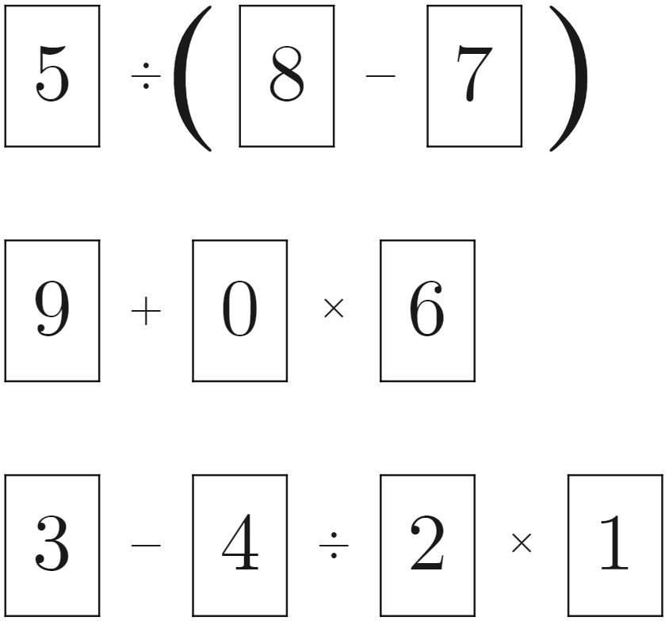
Image created using Desmos and is licensed under the Desmos Terms of Service.

References
This resource contains NSW Curriculum and syllabus content. The NSW Curriculum is developed by the NSW Education Standards Authority. This content is prepared by NESA for and on behalf of the Crown in right of the State of New South Wales. The material is protected by Crown copyright.
Please refer to the NESA Copyright Disclaimer for more information https://educationstandards.nsw.edu.au/wps/portal/nesa/mini-footer/copyright.
NESA holds the only official and up-to-date versions of the NSW Curriculum and syllabus documents. Please visit the NSW Education Standards Authority (NESA) website https://educationstandards.nsw.edu.au/ and the NSW Curriculum website https://curriculum.nsw.edu.au/home.
Mathematics K–10 Syllabus © NSW Education Standards Authority (NESA) for and on behalf of the Crown in right of the State of New South Wales, 2022.

© State of New South Wales (Department of Education), 2023
The copyright material published in this resource is subject to the Copyright Act 1968 (Cth) and is owned by the NSW Department of Education or, where indicated, by a party other than the NSW Department of Education (third-party material).
Copyright material available in this resource and owned by the NSW Department of Education is licensed under a Creative Commons Attribution 4.0 International (CC BY 4.0) license.
This license allows you to share and adapt the material for any purpose, even commercially.
Attribution should be given to © State of New South Wales (Department of Education), 2023.
Material in this resource not available under a Creative Commons license:
- the NSW Department of Education logo, other logos and trademark-protected material
- material owned by a third party that has been reproduced with permission. You will need to obtain permission from the third party to reuse its material.
Links to third-party material and websites
Please note that the provided (reading/viewing material/list/links/texts) are a suggestion only and implies no endorsement, by the New South Wales Department of Education, of any author, publisher, or book title. School principals and teachers are best placed to assess the suitability of resources that would complement the curriculum and reflect the needs and interests of their students.
If you use the links provided in this document to access a third-party's website, you acknowledge that the terms of use, including licence terms set out on the third-party's website apply to the use which may be made of the materials on that third-party website or where permitted by the Copyright Act 1968 (Cth). The department accepts no responsibility for content on third-party websites.

