Cooking for one
Students alter recipes, multiplying quantities by common fractions. They explore area models to represent fraction and decimal multiplication.

Visible learning

Learning intentions
- To be able to represent multiplication between fractions and decimals using area models.
- To be able to perform multiplication with fractions and decimals.

Success criteria
- I can divide rectangles into equal parts to represent fractions and decimals.
- I can create area models to represent fraction and decimal multiplication.
- I can explain why multiplication between fractions can be performed by multiplying numerators and multiplying denominators.

Syllabus outcomes
A student:
- develops understanding and fluency in mathematics through exploring and connecting mathematical concepts, choosing and applying mathematical techniques to solve problems, and communicating their thinking and reasoning coherently and clearly MAO-WM-01
- represents and operates with fractions, decimals and percentages to solve problems MA4-FRC-C-01
Mathematics K–10 Syllabus © NSW Education Standards Authority (NESA) for and on behalf of the Crown in right of the State of New South Wales, 2022.
Please use the associated PowerPoint Cooking for one to display images in this lesson.

Activity structure

Launch
- Explain to students that we are considering the situation of Andrew, a single person who wants to make a meal and dessert for himself.
- Hand out Appendix A ‘Dinner and dessert recipes’ and explain that Andrew is hoping to make both recipes. He wants to make 2 servings of the stir-fry, one for tonight and one to keep in the fridge for dinner tomorrow. He wants to make 4 cupcakes, as he knows that after 4 days the cakes will go stale.
- Have students engage in a Think-Pair-Share (bit.ly/thinkpairsharestrategy) to change the quantities of as many of the ingredients as possible to suit Andrew’s needs.
Teachers are advised to allow students to complete this without intervention, completing as much of the information as they know and allowing them to leave the measurements, they are unable to modify.

Explore

Paper folding to find fractions of fractions

Equipment
- Two A4 sheets of paper per student
- One copy of Appendix B ‘One quarter of everything’ per student

Method
- Acknowledge with students that to modify the stir-fry recipe to serve 2 people instead of 8 people, we need to find one quarter of the quantity of each ingredient.
- Display the Desmos graph ‘Cutting the cake’ (bit.ly/DesmosCake1) on the teacher screen. Inform students that the rectangle represents a chocolate cake.
- Have a student drag the point at the bottom of the screen $\frac{1}{4}$ of the way along the cake. The rest of the class can give their opinion of where the cut should be made.
- Drag the ‘Reveal four pieces’ switch to see the accuracy of the student’s estimate.
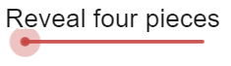
If technology is unavailable, steps 2–4 can be replicated by drawing a rectangle on a whiteboard and measuring with a metre ruler to determine how effectively a student estimated one quarter.
- Hand each student one sheet of A4 paper.
- Display Figure 1 and ask students to try to fold their paper $\frac{1}{4}$ of the way along the sheet.
Figure 1 – folding a sheet of paper one quarter of the way along the sheet
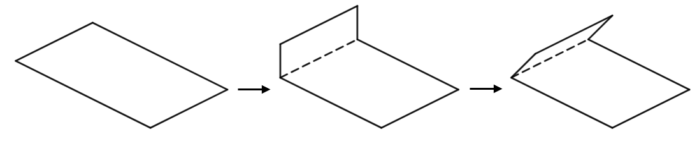
Image created using Desmos and is licensed under the Desmos Terms of Service.
- Display Figure 2 and ask students to continue folding until they can fold no further.
Figure 2 – folding a sheet of paper into quarters
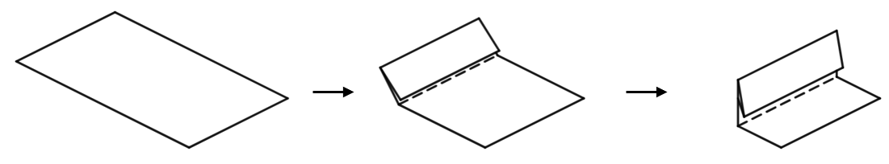
Image created using Desmos and is licensed under the Desmos Terms of Service.
- Have all students unfold their paper and review the results.
It is likely that students will have made inaccurate, unequal sections, as this approach is not precise. If students have made quite accurate quarters, consider asking them to share any additional methods they used.
- Display the Desmos graph ‘Cutting the cake 2’ (bit.ly/DesmosCake2) on the teacher screen.
- Have a student drag the point at the bottom of the screen $\frac{1}{2}$ of the way along the cake. The rest of the class can again give their opinion of where the cut should be made.
- Drag the switch to see the accuracy of the student estimate.
This method is far more likely to be accurate. If the first student does not improve upon the initial estimate with quarters, repeat step 9 with multiple students.
- Conclude that a good way to make quarters is to halve once and then to halve again, as halves are reasonable to approximate.
- Hand each student a new piece of A4 paper and display Figure 3. Have students halve their paper and then halve again to make quarters, shading one quarter when complete.
Figure 3 – folding a sheet of paper in half twice
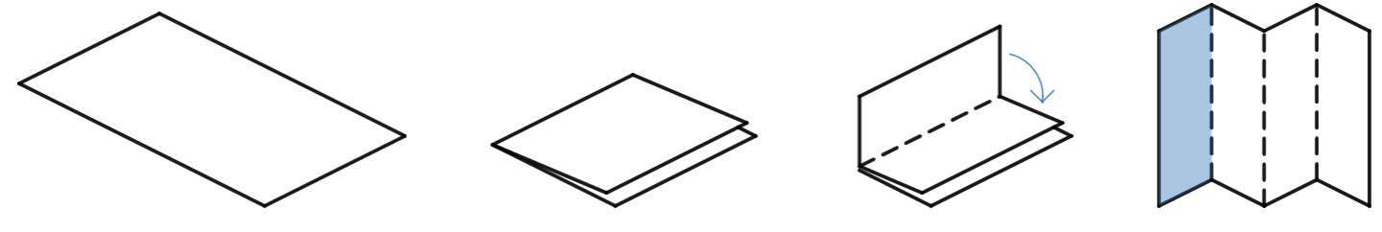
Image created using Desmos and is licensed under the Desmos Terms of Service.
- Have students engage in a Think-Pair-Share to consider how we would find $\frac{1}{4}$ of this $\frac{1}{4}$ sheet of paper.
- Demonstrate to students that folding the paper in the perpendicular direction to the original folds will help find $\frac{1}{4}$ of $\frac{1}{4}$, as shown in Figure 4.
Figure 4 – one quarter of one quarter
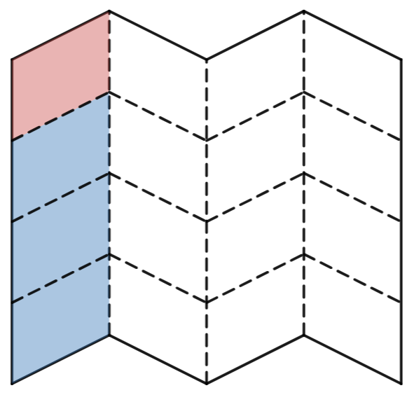
Image created using Desmos and is licensed under the Desmos Terms of Service.
- Conclude that $\frac{1}{4}$ of $\frac{1}{4}$ is the same as $\frac{1}{4}×\frac{1}{4}$ and is equal to $\frac{1}{16}$.

Quarters of ingredients
- Hand students copies of Appendix B ‘One quarter of everything’.
- Organise students into visibly random groups of 3 (bit.ly/visiblegroups).
- Have students read the first example on the worksheet before attempting to find and describe one quarter of each quantity.
- Use a Pause-Pose-Pounce-Bounce question strategy [PDF 200KB] (bit.ly/pausepouncebounce) to gather and review student responses.

Thirds of ingredients
- Hand students copies of Appendix C ‘One third of everything’.
- Have students read the first example on the worksheet before attempting to find and describe one third of each quantity, working in their groups from the previous activity.
- Use a Pause-Pose-Pounce-Bounce question strategy to gather and review student responses.

Summarise
- Use slides 6–17 from the Cooking for one PowerPoint for explicit teaching of multiplying fractions and decimals.
The explicit teaching technique used in the associated PowerPoint is ‘Your turn.’ The first slide is a worked example which should be displayed for the students and then use the following steps.
- Reveal the question to students and its solution.
- Students read in silence.
- Students individually think and explain to themselves what is happening in each step.
- Students hold up a thumbs up to the teacher when they have finished reading and have some sort of understanding.
- Think-Pair-Share. Students explain the solution to their partner.
- In pairs, students then answer the self-explanation questions.
- Finally, randomly select students to share their answers with the whole class.
- Have students complete Appendix D ‘Representing multiplication of fractions and decimals’ where they draw representations of each multiplication before solving.
- Students can use the Desmos graphs ‘Fraction multiplication’ (bit.ly/DesmosFracMult), ‘Decimal multiplication’ (bit.ly/DesmosDecMult) and ‘Fraction and decimal multiplication’ (bit.ly/DesmosFDMult) to assist their representations.
- Write the operation $\frac{8}{9}×\frac{6}{7}$ on the whiteboard. Have students engage in a Think-Pair-Share to discuss the following reflection questions.
- How can we predict the value of the numerator and denominator of the solution without drawing a representation?
- How does a representation explain these predictions?

When sharing, the teacher can establish rules for multiplying fractions, including that we can multiply the denominators to obtain the denominator of the solution. Such rules should be introduced by drawing connection to the representation and the reason these rules apply. For example, when evaluating $\frac{8}{9}×\frac{6}{7}$, the denominator of the solution will be $9 × 7 = 63$, because the result can be shown as a square divided horizontally into 7 equal parts and vertically into 9 equal parts, making a grid of 63 equal parts.
- Have students write notes to their future forgetful self (bit.ly/notesstrategy).

Apply

Open middle problem
- Challenge students to complete the open middle problem displayed on slides 18 and 19 of the Cooking for one PowerPoint. This problem is also displayed in Figure 5 and is inspired by the problem at the ‘Open middle’ website (bit.ly/OMFractionMult).
Figure 5 – open middle problem
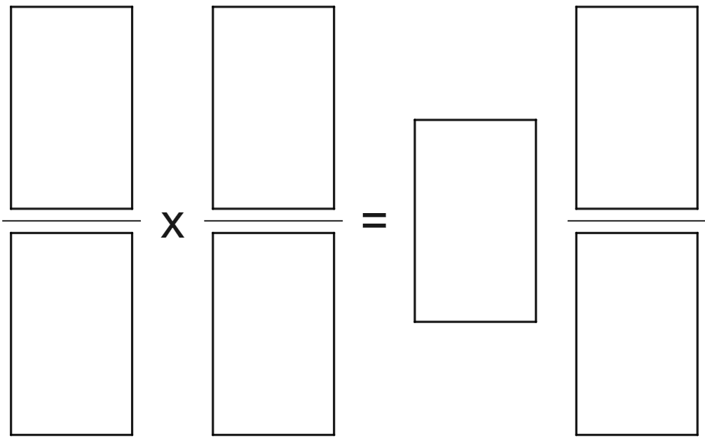
Image created using Desmos and is licensed under the Desmos Terms of Service.
- Students are to use the integers from 1 to 9 at most once to try to obtain the largest possible result. Teachers can print this from Appendix E ‘Open middle problem’ if desired.
- Similar open middle problems can be found at the ‘Open middle’ website (bit.ly/OMMultFrac).

Assessment and Differentiation

Suggested opportunities for differentiation
Explore
- The Desmos graph to simulate cake cutting and the paper folding activity support students to attempt, reflect and improve. These activities also support students to enter the concept of fraction multiplication by first manipulating concrete materials.
- Challenge students to consider what fractions of paper would be difficult to represent using the paper folding method shown. We hope students will conclude that given we create the fractions using multiplication, prime numbers are especially difficult to create in the denominator.
Summarise
- The use of Desmos graphs for fraction multiplication supports more students to have access to these activities and the ability to reflect on trends in results.
Apply
- The general link to the ‘Open middle’ website (bit.ly/OMMultFrac) includes a range of further problems, improving access for students furthering the challenge available.

Suggested opportunities for assessment
Launch
- Student responses to the initial activity can serve as a pre-test to determine students’ abilities with fraction interpretation.
Explore
- Teachers can collect Appendices B and C as evidence of students’ ability to interpret and work with fraction representations to support multiplications.
Summarise
- Appendix D provides evidence of students’ understanding of fraction multiplication.

Appendix A

Dinner and dessert recipes

Vegetarian stir-fry
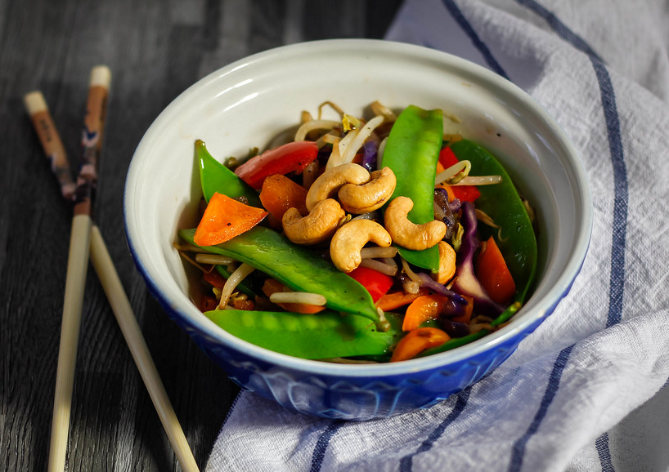
‘vegetable stir-fry’ by wuestenigel is licensed under CC BY 2.0.
Table 1 – ingredients for the full recipe serving 8 people
Ingredients | Modified quantities
$\frac{1}{2}$ red capsicum
$\frac{3}{4}$ cup of water
$\frac{1}{4}$ cup of oyster sauce
2 teaspoons of honey
$\frac{1}{3}$ bunch of celery
$400$ grams of green beans
$3$ carrots
$2$ cups of mushrooms
$1\frac{1}{2}$ cups of jasmine rice

Chocolate cupcakes
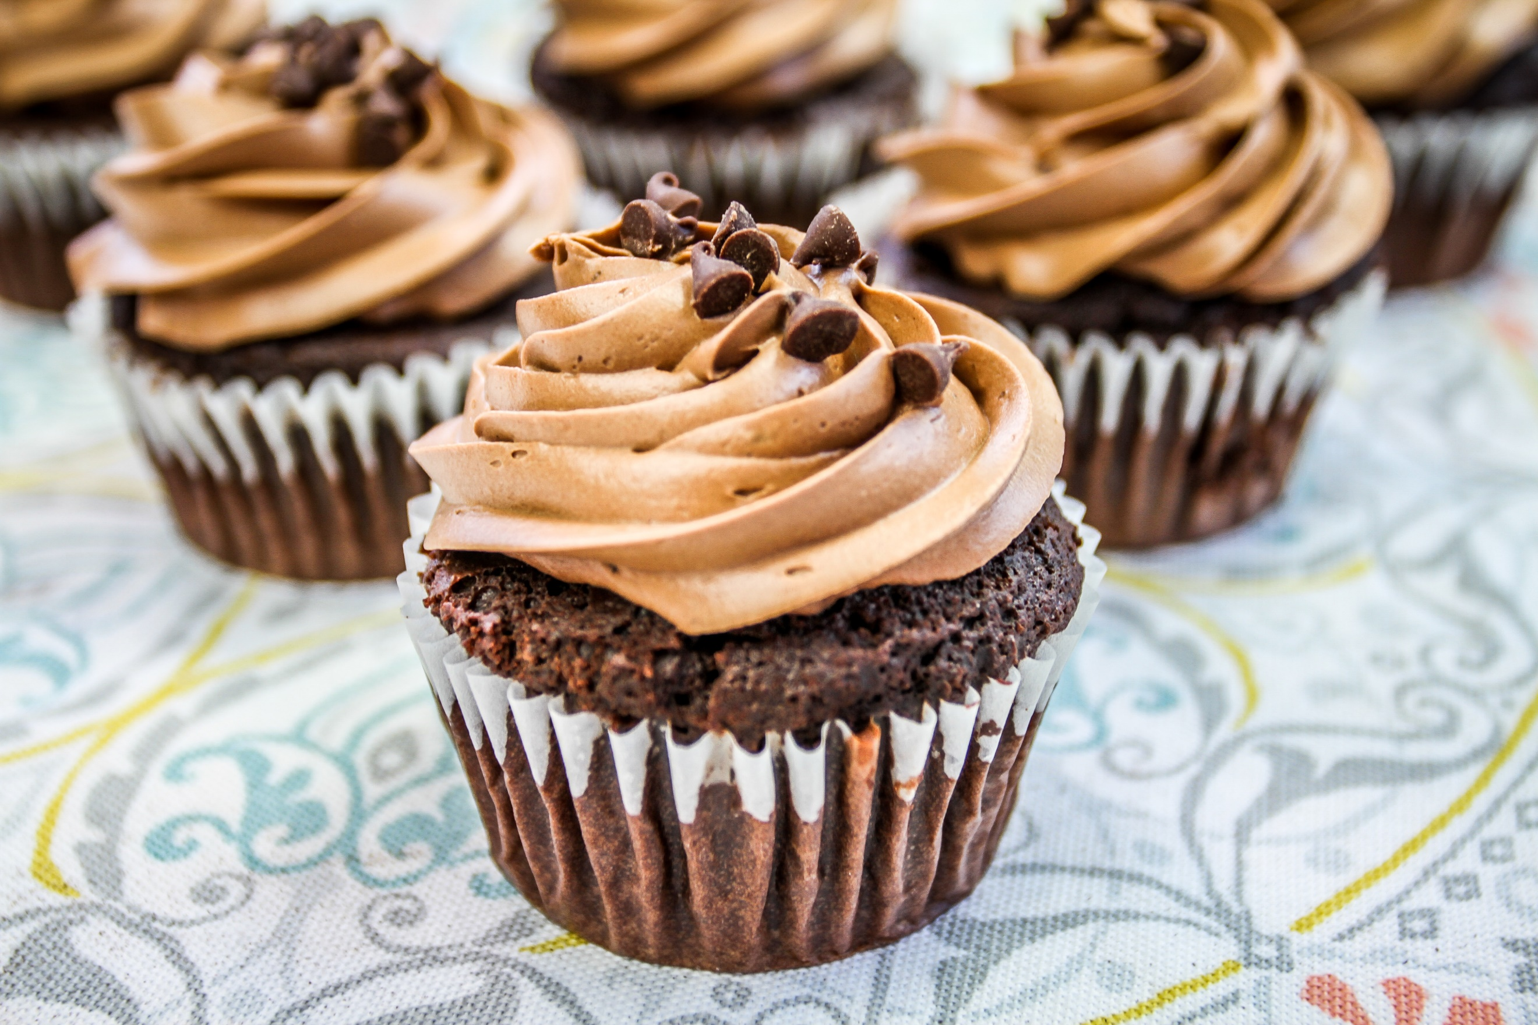
Photo by Mike Meeks on Unsplash
Table 2 – ingredients for the full recipe making 12 cupcakes
Ingredients | Modified quantities
$1\frac{1}{2}$ cups flour
$\frac{3}{4}$ cup of caster sugar
$\frac{1}{2}$ cup of butter
2 eggs
$\frac{1}{3}$ cup of milk
2 teaspoons of vanilla extract
$1\frac{1}{4}$ cups of soft icing sugar
$\frac{1}{4}$ cup cocoa powder

Appendix B

One quarter of everything
Use representations to multiply each quantity of ingredient by $\frac{1}{4}$.
Table 3 – one quarter of the vegetarian stir-fry ingredients
Original ingredient quantity | Representation | One quarter quantity
$\frac{1}{2}$ red capsicum | 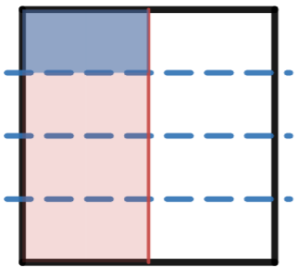 | $$\frac{1}{8}$$
$\frac{3}{4}$ cup of water | 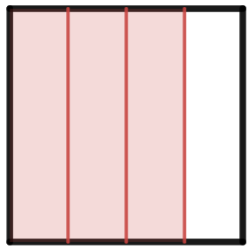
$\frac{1}{4}$ cup of oyster sauce
2 teaspoons of honey | 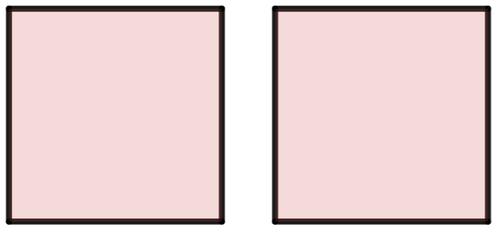
$\frac{1}{3}$ bunch of celery | 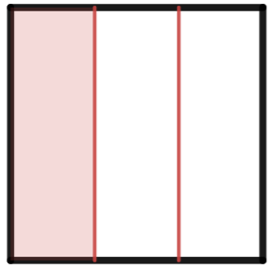
$400$ grams of green beans | 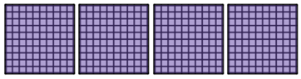
$3$ carrots
$2$ cups of mushrooms
$1\frac{1}{2}$ cups of jasmine rice | 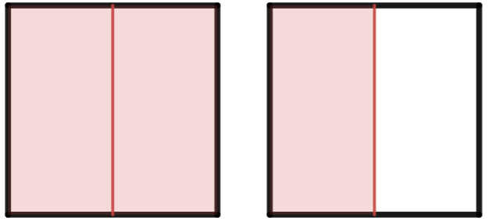
Images created using Desmos and is licensed under the Desmos Terms of Service.

Appendix C

One third of everything
Use representations to multiply each quantity of ingredient by $\frac{1}{3}$.
Table 4 – one third of the chocolate cupcake ingredients
Original ingredient quantity | Representation | One third quantity
$1\frac{1}{2}$ cups flour |  | $$\frac{3}{6}=\frac{1}{2}$$
$\frac{3}{4}$ cup of caster sugar
$\frac{1}{2}$ cup of butter
2 eggs
$\frac{1}{3}$ cup of milk
2 teaspoons of vanilla extract
$1\frac{1}{4}$ cups of soft icing sugar | 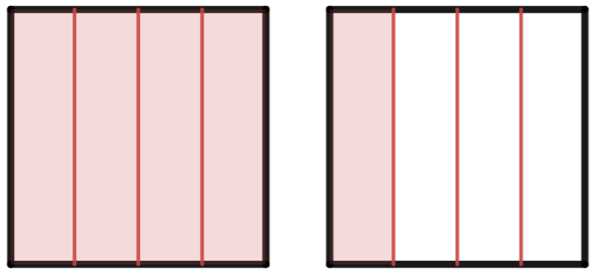
$\frac{1}{4}$ cup cocoa powder
Images created using Desmos and is licensed under the Desmos Terms of Service.

Appendix D

Representing multiplication of fractions and decimals
Represent and evaluate each multiplication. Some representations are started for you.
Table 5 – representing multiplication of fractions and decimals
Calculation | Representation | Solution
$$\frac{1}{4}×\frac{2}{5}$$ | 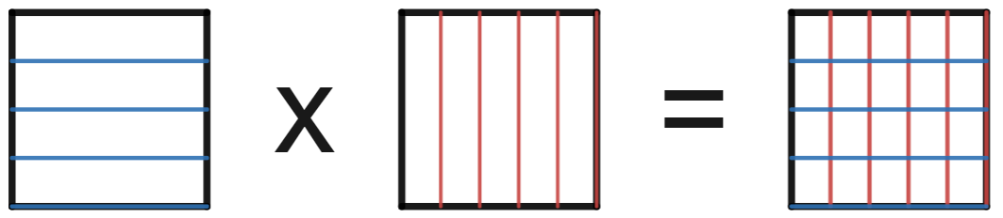
$$\frac{3}{4}×\frac{2}{5}$$
$$\frac{3}{4}×\frac{4}{5}$$
$$\frac{5}{4}×\frac{4}{5}$$ | 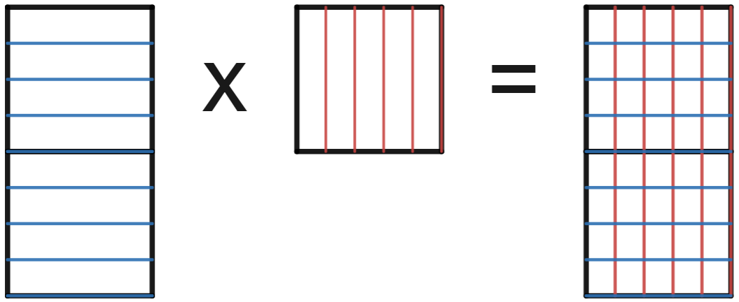
$$\frac{5}{10}×\frac{4}{5}$$
$$0.5×\frac{4}{5}$$
$$0.5×0.8$$
$$0.5×1.8$$ | 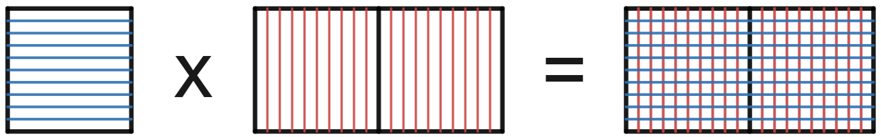
$$1.5×1.8$$ | 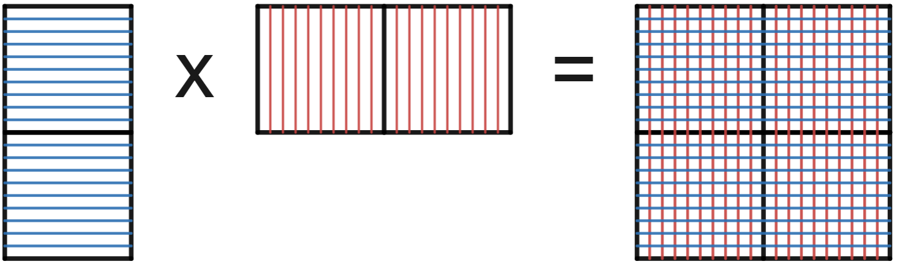
$$\frac{15}{10}×1.8$$ | 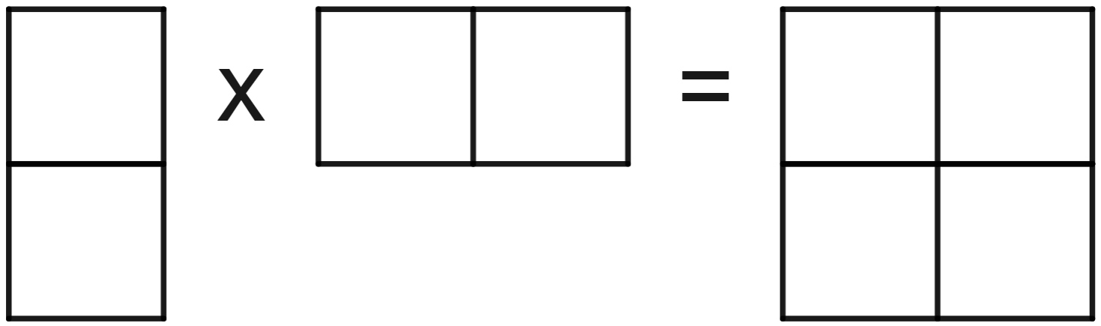
$$\frac{15}{10}×\frac{18}{10}$$
$$\frac{3}{2}×\frac{9}{5}$$
$$\frac{3}{2}×\frac{2}{5}$$
Images created using Desmos and is licensed under the Desmos Terms of Service.

Appendix E

Open middle problem
Use the integers from 1 to 9 at most once to make a product of fractions that makes this equation correct.

Sample solutions

Appendix A – dinner and dessert recipes

Vegetarian stir-fry
Table 6 – solution for Table 1
Ingredients | Modified quantities
$\frac{1}{2}$ red capsicum | $\frac{1}{8}$ red capsicum
$\frac{3}{4}$ cup of water | $\frac{3}{16}$ cup of water
$\frac{1}{4}$ cup of oyster sauce | $\frac{1}{16}$ cup of oyster sauce
2 teaspoons of honey | $\frac{1}{2}$ teaspoons of honey
$\frac{1}{3}$ bunch of celery | $\frac{1}{12}$ bunch of celery
$400$ grams of green beans | $100$ grams of green beans
$3$ carrots | $\frac{3}{4}$ carrots
$2$ cups of mushrooms | $\frac{1}{2}$ cups of mushrooms
$1\frac{1}{2}$ cups of jasmine rice | $\frac{3}{8}$ cups of jasmine rice

Chocolate cupcakes
Table 7 – solution for Table 2
Ingredients | Modified quantities
$1\frac{1}{2}$ cups flour | $\frac{1}{2}$ cups flour
$\frac{3}{4}$ cup of caster sugar | $\frac{1}{4}$ cup of caster sugar
$\frac{1}{2}$ cup of butter | $\frac{1}{6}$ cup of butter
2 eggs | $\frac{2}{3}$ eggs
$\frac{1}{3}$ cup of milk | $\frac{1}{9}$ cup of milk
2 teaspoons of vanilla extract | $\frac{2}{3}$ teaspoons of vanilla extract
$1\frac{1}{4}$ cups of soft icing sugar | $\frac{5}{12}$ cups of soft icing sugar
$\frac{1}{4}$ cup cocoa powder | $\frac{1}{12}$ cup cocoa powder

Appendix B – one quarter of everything
Table 8 – solution for Table 3
Original ingredient quantity | Representation | One quarter quantity
$\frac{1}{2}$ red capsicum |  | $$\frac{1}{8}$$
$\frac{3}{4}$ cup of water | 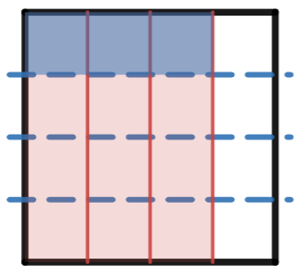 | $$\frac{3}{16}$$
$\frac{1}{4}$ cup of oyster sauce | 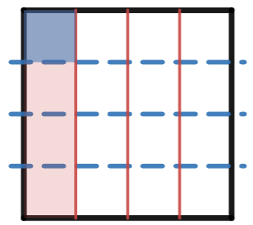 | $$\frac{1}{16}$$
2 teaspoons of honey | 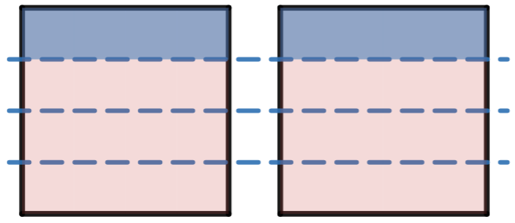 | $$\frac{2}{4}=\frac{1}{2}$$
$\frac{1}{3}$ bunch of celery | 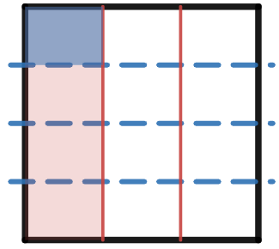 | $$\frac{1}{12}$$
$400$ grams of green beans | 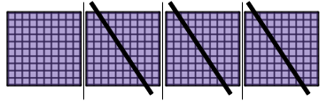 | $100$ grams
$3$ carrots | 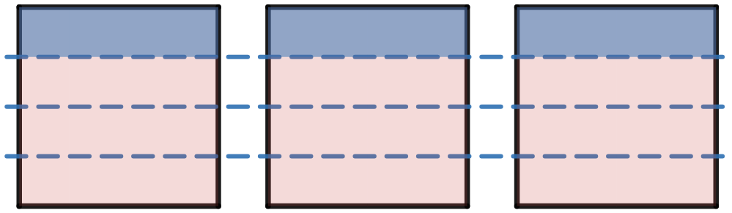 | $$\frac{3}{4}$$
$2$ cups of mushrooms |  | $$\frac{2}{4}=\frac{1}{2}$$
$1\frac{1}{2}$ cups of jasmine rice | 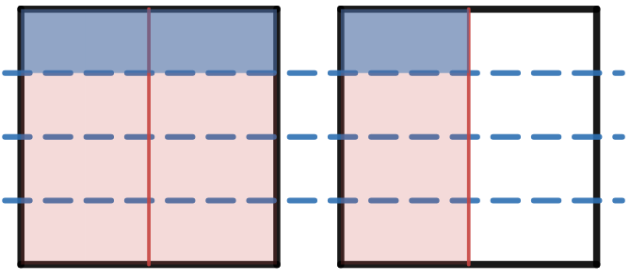 | $$\frac{3}{8}$$
Images created using Desmos and is licensed under the Desmos Terms of Service.

Appendix C – one third of everything
Table 9 – solution for Table 4
Original ingredient quantity | Representation | One quarter quantity
$1\frac{1}{2}$ cups flour | 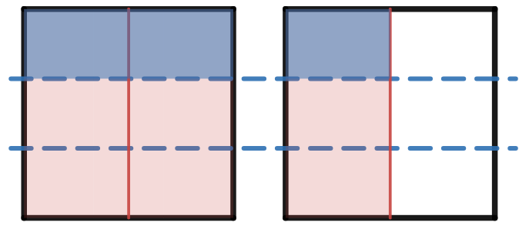 | $$\frac{3}{6}=\frac{1}{2}$$
$\frac{3}{4}$ cup of caster sugar | 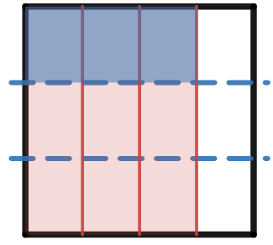 | $$\frac{3}{12}=\frac{1}{4}$$
$\frac{1}{2}$ cup of butter | 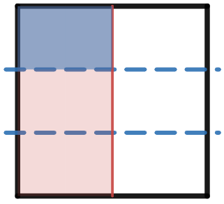 | $$\frac{1}{6}$$
2 eggs | 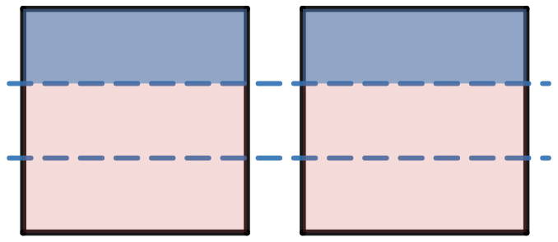 | $$\frac{2}{3}$$
$\frac{1}{3}$ cup of milk | 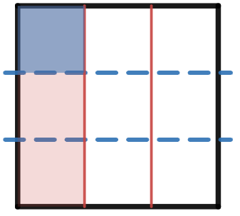 | $$\frac{1}{9}$$
2 teaspoons of vanilla extract |  | $$\frac{2}{3}$$
$1\frac{1}{4}$ cups of soft icing sugar | 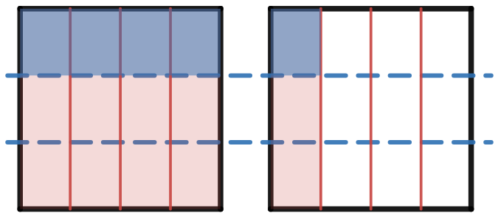 | $$\frac{5}{12}$$
$\frac{1}{4}$ cup cocoa powder | 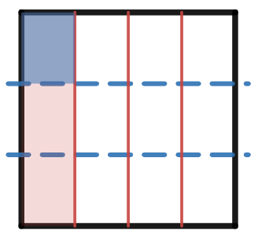 | $$\frac{1}{12}$$
Images created using Desmos and is licensed under the Desmos Terms of Service.

Appendix D – representing multiplication of fractions and decimals
Table 10 – solution for Table 5
Calculation | Representation | Solution
$$\frac{1}{4}×\frac{2}{5}$$ | 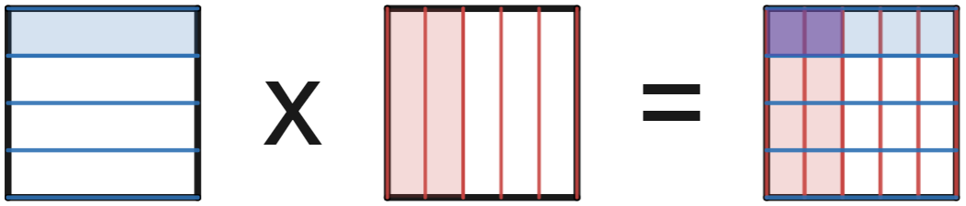 | $$\frac{2}{20}=\frac{1}{10}$$
$$\frac{3}{4}×\frac{2}{5}$$ | 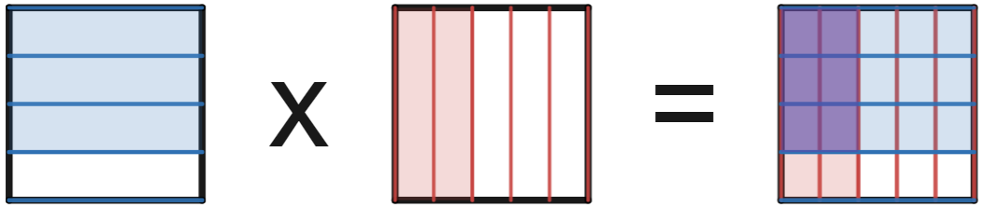 | $$\frac{6}{20}=\frac{3}{10}$$
$$\frac{3}{4}×\frac{4}{5}$$ | 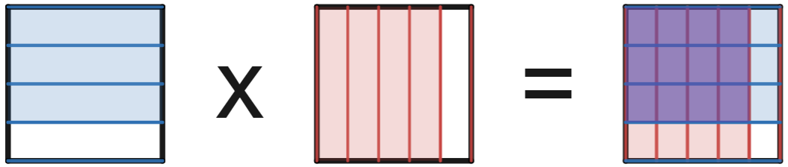 | $$\frac{12}{20}=\frac{3}{5}$$
$$\frac{5}{4}×\frac{4}{5}$$ | 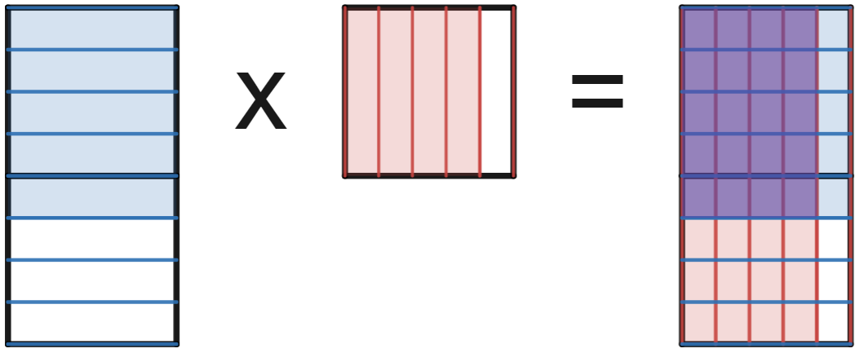 | $$\frac{20}{20}=1$$
$$\frac{5}{10}×\frac{4}{5}$$ | 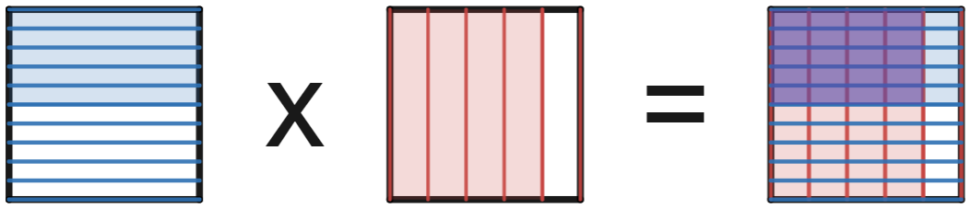 | $$\frac{20}{50}=\frac{2}{5}$$
$$0.5×\frac{4}{5}$$ |  | $$\frac{20}{50}=\frac{2}{5}$$
$$0.5×0.8$$ | 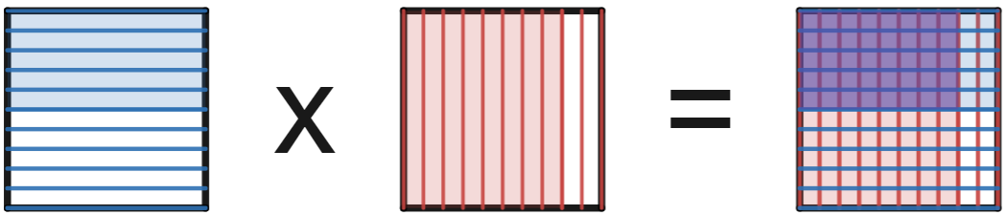 | $$\frac{40}{100}=\frac{2}{5}$$
$$0.5×1.8$$ | 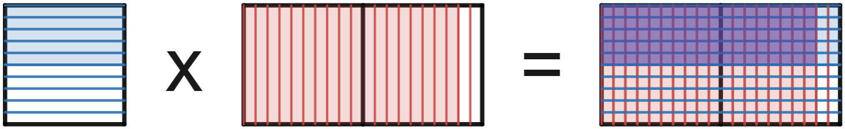 | $$\frac{90}{100}=\frac{9}{10}$$
$$1.5×1.8$$ | 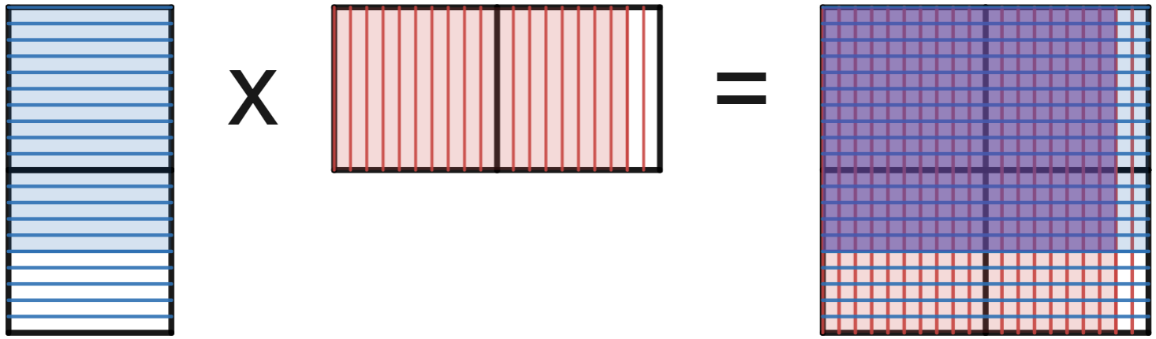 | $$\frac{270}{100}=\frac{27}{10}$$
$$\frac{15}{10}×1.8$$ | 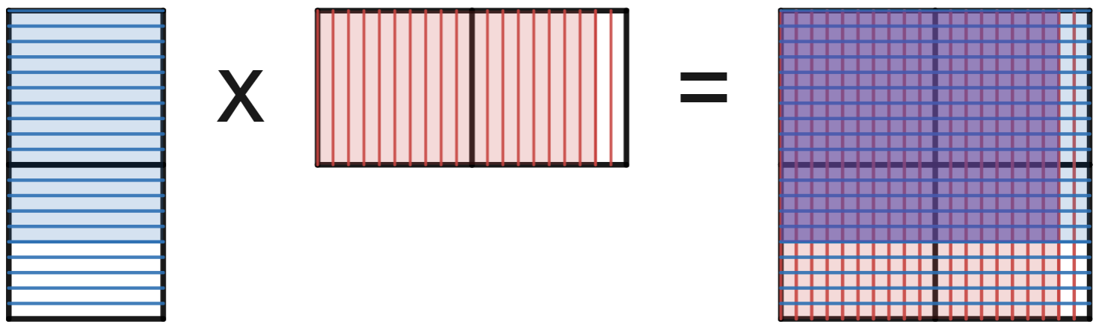 | $$\frac{270}{100}=\frac{27}{10}$$
$$\frac{15}{10}×\frac{18}{10}$$ |  | $$\frac{270}{100}=\frac{27}{10}$$
$$\frac{3}{2}×\frac{9}{5}$$ | 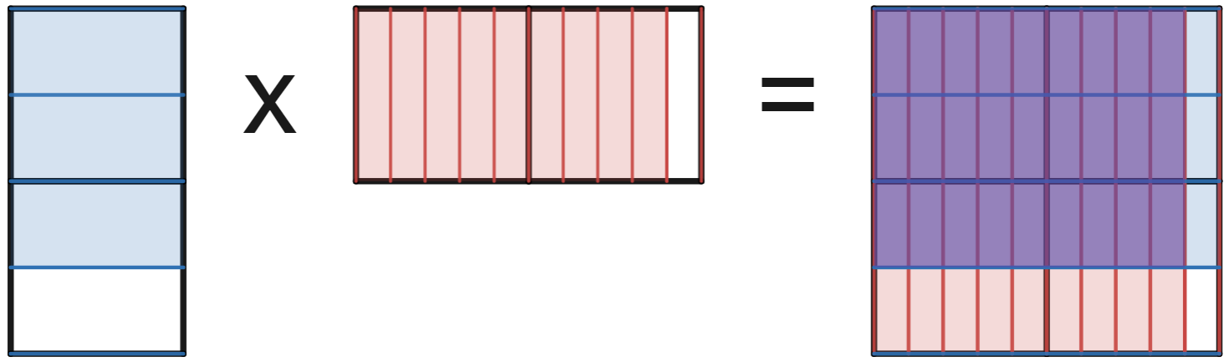 | $$\frac{27}{10}$$
$$\frac{3}{2}×\frac{2}{5}$$ | 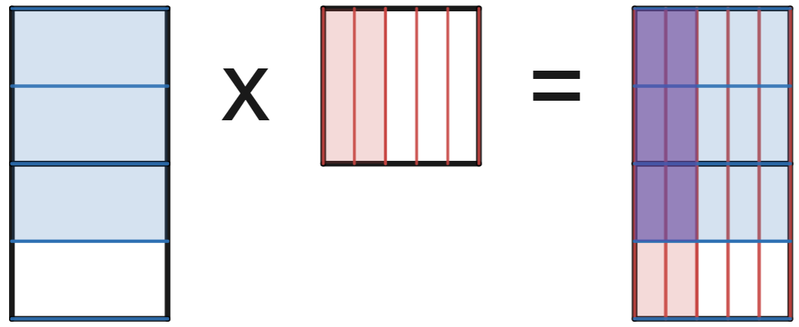 | $$\frac{6}{10}=\frac{3}{5}$$
Images created using Desmos and is licensed under the Desmos Terms of Service.

Appendix E – open middle problem
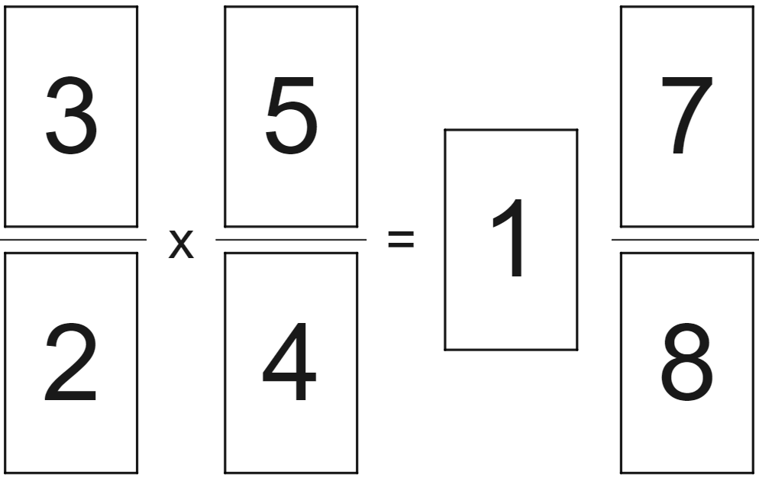

References
This resource contains NSW Curriculum and syllabus content. The NSW Curriculum is developed by the NSW Education Standards Authority. This content is prepared by NESA for and on behalf of the Crown in right of the State of New South Wales. The material is protected by Crown copyright.
Please refer to the NESA Copyright Disclaimer for more information https://educationstandards.nsw.edu.au/wps/portal/nesa/mini-footer/copyright.
NESA holds the only official and up-to-date versions of the NSW Curriculum and syllabus documents. Please visit the NSW Education Standards Authority (NESA) website https://educationstandards.nsw.edu.au/ and the NSW Curriculum website https://curriculum.nsw.edu.au/home.
Mathematics K–10 Syllabus © NSW Education Standards Authority (NESA) for and on behalf of the Crown in right of the State of New South Wales, 2022.
© State of New South Wales (Department of Education), 2023
The copyright material published in this resource is subject to the Copyright Act 1968 (Cth) and is owned by the NSW Department of Education or, where indicated, by a party other than the NSW Department of Education (third-party material).
Copyright material available in this resource and owned by the NSW Department of Education is licensed under a Creative Commons Attribution 4.0 International (CC BY 4.0) licence.
This licence allows you to share and adapt the material for any purpose, even commercially.
Attribution should be given to © State of New South Wales (Department of Education), 2023.
Material in this resource not available under a Creative Commons licence:
- the NSW Department of Education logo, other logos and trademark-protected material
- material owned by a third party that has been reproduced with permission. You will need to obtain permission from the third party to reuse its material.
Links to third-party material and websites
Please note that the provided (reading/viewing material/list/links/texts) are a suggestion only and implies no endorsement, by the New South Wales Department of Education, of any author, publisher, or book title. School principals and teachers are best placed to assess the suitability of resources that would complement the curriculum and reflect the needs and interests of their students.
If you use the links provided in this document to access a third-party's website, you acknowledge that the terms of use, including licence terms set out on the third-party's website apply to the use which may be made of the materials on that third-party website or where permitted by the Copyright Act 1968 (Cth). The department accepts no responsibility for content on third-party websites.

