A quick guess
Students make fast estimates comparing which will be larger when multiplying and sharing quantities of items. They examine the impact of multiplying and dividing by numbers greater than and less than one and develop and articulate methods for estimating when multiplying with fractions.

Visible learning
It is recommended that the learning intentions and success criteria not be revealed to students until the summarise section of this lesson.

Learning intentions
- To understand why multiplying quantities by numbers greater than one makes the quantity grow larger.
- To understand why multiplying quantities by numbers less than one makes the quantity become smaller.
- To be able to estimate fractions of quantities.

Success criteria
- I can explain the effect of multiplying quantities by numbers either side of one.
- I can apply strategies to estimate calculations with fractions and decimals.

Syllabus outcomes
A student:
- develops understanding and fluency in mathematics through exploring and connecting mathematical concepts, choosing and applying mathematical techniques to solve problems, and communicating their thinking and reasoning coherently and clearly MAO-WM-01
- represents and operates with fractions, decimals and percentages to solve problems MA4-FRC-C-01
Mathematics K–10 Syllabus © NSW Education Standards Authority (NESA) for and on behalf of the Crown in right of the State of New South Wales, 2022.
Please use the associated PowerPoint A quick guess to display images in this lesson.

Activity structure

Warm up
Students should complete this activity without a calculator.
- Display Figure 1.
Figure 1 – three different multi-packs of potato chips
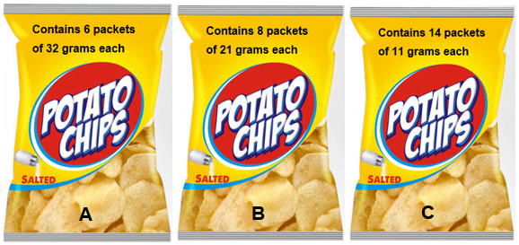
‘Chips Packaging Mock PSD Template’ by Designbolts is licensed under CC BY-NC-ND 3.0
- Inform students that all 3 of these multi-packs of chips are the same price.
- Use a Pause-Pose-Pounce-Bounce question strategy [PDF 200KB] (bit.ly/pausepouncebounce) to have students share which multi-pack they think represents the best value.
The ‘pause’ component of this strategy is particularly important in this activity. The aim is to give students enough time to process the question and think of approaches to a solution, whilst encouraging students to focus on estimates over full calculations.
- Have students share their strategy for comparing the packets of chips.
- Lead students to the concept that we can estimate by rounding each mass to the nearest 10.

Launch
Students play a game of Would you rather, where they are given scenarios and need to decide which they would prefer. The scenarios are not designed for students to calculate solutions, but to consider factors and make an initial estimate.
- Have all students stand in the centre of the room.
- Use slides 3–6 of the PowerPoint A quick guess to show the Would you rather…? scenarios on the screen, 2 at a time, or read them out. Students preferring the first option move to the left of the room, and students preferring the second move to the right.
The scenarios compared in the associated PowerPoint file include the list below.
- Share a chocolate bar with one friend or share a box of chocolates with 9 friends.
- Win $1000 on your own or win $10 000 with 3 friends.
- Have one regular slice of round cake or have $1\frac{1}{2}$ fun size chocolate bars.
- Share a lottery ticket with 9 friends that costs $10 with a $\frac{1}{1000}$ chance of winning $1 000 000 or flip a coin where you win $1000 if it shows heads and lose $5 if it shows tails.
- Have students engage in a short Think-Pair-Share (bit.ly/thinkpairsharestrategy) with someone on their side of the room to justify why they have chosen a particular answer on each turn.
Students can share their methods which could include some calculations; however, it is best for the teacher not to demonstrate the solutions with any calculations at this point. The scenarios where calculations are possible can be revisited at the end of the lesson when students should have a better understanding of how to approach the scenarios.

Explore
- Use slides 7–10 from the A quick guess PowerPoint for explicit teaching of finding fractions of quantities.
The explicit teaching technique used in the associated PowerPoint is ‘Your turn.’ The first slide is a worked example which should be displayed for the students and then use the following steps.
- Reveal the question to students and its solution.
- Students read in silence.
- Students individually think and explain to themselves what is happening in each step.
- Students hold up a thumbs up to the teacher when they have finished reading and have some sort of understanding.
- Think-Pair-Share. Students explain the solution to their partner.
- In pairs, students then answer the self-explanation questions.
- Finally, randomly select students to share their answers with the whole class.
- Display the Desmos graph ‘Fractions of quantities’ (bit.ly/DesmosFracOfQuantity) on the teacher screen.
- Inform students that we will find $\frac{1}{2}$, $\frac{3}{5}$ and $1\frac{1}{4}$ (or $\frac{5}{4}$) of $100. Adjust the ‘Quantity’ slider to show 100, as shown below.
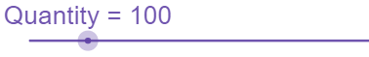
Image created using Desmos and is licensed under the Desmos Terms of Service.
- Adjust the fraction using the sliders to show a denominator of 2 and a numerator of 1.
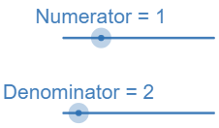
Image created using Desmos and is licensed under the Desmos Terms of Service.
- Use a Pause-Pose-Pounce-Bounce question strategy to ask students to explain why $\frac{1}{2}$ of $100$, or $\frac{1}{2}×100$ is equal to 50.
- Adjust the sliders to show $\frac{3}{5}$ and then $1\frac{1}{4}$ of $100, reflecting on each solution.
- Conclude with students that when multiplying a quantity by a fraction, we divide by the denominator into the appropriate number of parts and multiply by the numerator to find the new quantity.
- Hand students a copy of Appendix A, ‘Fractions of quantities’.
- Organise students into visibly random groups of 3 (bit.ly/visiblegroups).
If possible, have groups work at vertical, non-permanent surfaces (bit.ly/VNPSstrategy).
- Give students access to the Desmos graph ‘Fractions of quantities’ (bit.ly/DesmosFracOfQuantity) and have them complete the values in the table in question 1 of Part 1 of Appendix A. Instruct students to stop at question 1 and not continue to question 2.
If devices are unavailable, students can use a calculator to divide quantities by the denominator and multiply by the numerator of the fraction. This process is advised to support connection to the concept rather than entering full fractions into the calculator.
- Have students put away devices, including calculators and attempt the table in question 2. Students are to make estimates of each result based on the results and trends they have seen in the table of question 1.
- Once completed, have students review their estimates by checking the solutions in a calculator.

Summarise
- Still working in their original groups, have students answer questions in part 2 of Appendix A, reflecting on how they made their estimates in part 1.
- Use a Pose-Pause-Pounce-Bounce question strategy to ask students to share how they made estimates for each of the fractions and their reflections from questions 2 and 3. Encourage students to articulate their reasoning and build on previous responses.
- Conclude with students that multiplying a quantity by a fraction greater than 1 increases the quantity and multiplying by a fraction less than 1 decreases the quantity.
Teachers are advised to reveal the learning intentions and success criteria to students at this point.
- Have students write notes to their future forgetful selves (bit.ly/notesstrategy), including one significant trend they have learned when multiplying quantities by fractions and the properties from step 3 regarding multiplying by fractions greater than and less than 1.

Apply

Cardcraft: Fraction frenzy

Equipment
- One deck of playing cards per group, picture cards removed.
- One copy of Appendix B ‘Cardcraft game board’ per student, printed.

Method
- Keep students in their groups of 3, and hand each group a deck of cards.
- On each turn, all players take 3 cards.
- Players are to place these 3 cards somewhere on their game board to obtain the highest possible multiplication result.

Figure 2 shows an example of a move that could be played with the cards 2, 4 and 7, with the move being equal to $\frac{2}{4}×7$ which gives $3\frac{1}{2}$. This image is also available on slide 11 of the A quick guess PowerPoint.
Figure 2 – two quarters multiplied by 7
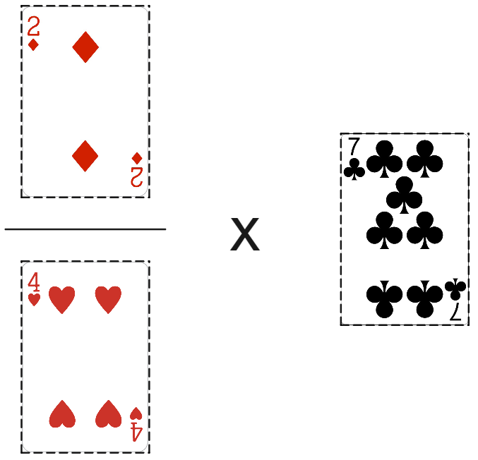
‘Playing Cards PNG Transparent Images’ by Rojal is licensed under CC BY-NC 4.0
- The player with the highest multiplication wins the round and collects all used cards from that round.
- The game ends when all cards are played.
- At the end of the game, the player with the most cards wins.
- After several games have been played, have students engage in a discussion around the following reflection questions.
- What did you notice when placing your cards each turn?
- When you picked a large number card, where did you place it?
- When you picked a small number card, where did you place it?

Assessment and differentiation

Suggested opportunities for differentiation
Launch
- The choices in the Would you rather task are not based on calculations but allow for students to use estimations and discuss the factors these estimations are based on.
Explore
- The use of the Desmos graph allows students to perform calculations maintaining connection to the underlying concept.
- Moving forward, students can be challenged to draw bar models to represent their calculations, like those shown in the Desmos graph.
Apply
- To allow students greater access to the game, they can continue using the Desmos graph to calculate their score.
- Students can be challenged to answer the question of whether it is better to make your fraction larger or your quantity larger, justifying their decision with examples.

Suggested opportunities for assessment
Launch
- Student responses during the Think-Pair-Share activity can give evidence to the factors they are using to develop estimates of fractions of quantities.
Explore
- Teachers can collect Appendix A as evidence of students’ ability to interpret calculations of fractions of quantities and to notice and generalise patterns in results.
Apply
- Student responses during the Think-Pair-Share activity can give evidence to the factors they are using to develop estimates of fractions of quantities.

Appendix A

Fractions of quantities – Part 1
- Complete the table by finding fractions of each quantity on the left using either a calculator or the Desmos graph ‘Fractions of quantities’ (bit.ly/DesmosFoQ).
Quantity | $$\frac{1}{2}$$ | $$1\frac{1}{2}$$ | $$\frac{2}{3}$$ | $$\frac{1}{4}$$ | $$1\frac{1}{4}$$ | $$\frac{1}{5}$$ | $$\frac{3}{5}$$ | $$\frac{5}{12}$$
200 grams
100 grams
500 grams
5 kg
10 kg
12 kg
$120
$720
$725
$737
- $120 (Debt)

- Complete the table below without the use of a calculator or Desmos graph, making estimates of the fractions of each of the quantities on the left.
Quantity | $$\frac{1}{2}$$ | $$1\frac{1}{2}$$ | $$\frac{2}{3}$$ | $$\frac{1}{4}$$ | $$1\frac{1}{4}$$ | $$\frac{1}{5}$$ | $$\frac{3}{5}$$ | $$\frac{5}{12}$$
8 kg
26 kg
250 grams
84 grams
$112
$225

Fractions of quantities – Part 2
- Write a statement about how you estimate a fraction of a quantity for each fraction listed in the table.
Fraction | How to find this fraction of a quantity
$$\frac{1}{2}$$
$$1\frac{1}{2}$$
$$\frac{2}{3}$$
$$\frac{1}{4}$$
$$1\frac{1}{4}$$
$$\frac{1}{5}$$
$$\frac{3}{5}$$
$$\frac{5}{12}$$
- Circle the fractions used in Part 1 that are less than 1 in the space below.
$$\frac{1}{2}$$ | $$1\frac{1}{2}$$ | $$\frac{2}{3}$$ | $$\frac{1}{4}$$ | $$1\frac{1}{4}$$ | $$\frac{1}{5}$$ | $$\frac{3}{5}$$ | $$\frac{5}{12}$$
- What do you notice about the fractions that are less than 1, when you multiply them with a quantity?

Appendix B

Cardcraft game board
Place your 3 cards into the 3 spots below to form a multiplication.
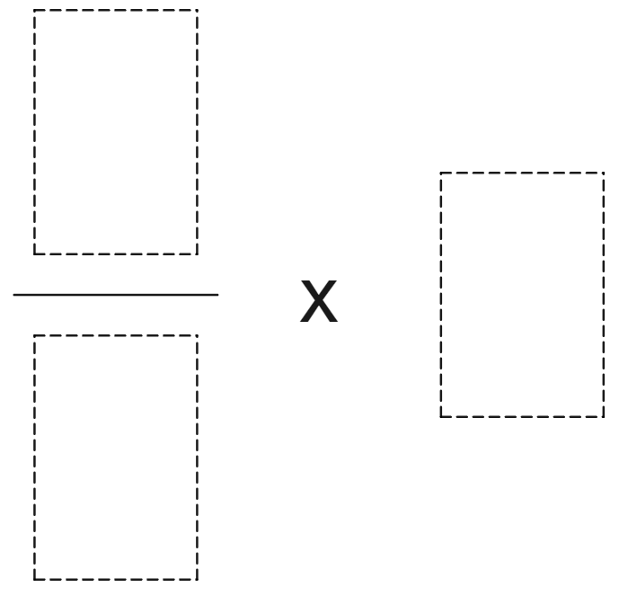
Image created using Desmos and is licensed under the Desmos Terms of Service.

Sample solutions

Appendix A – fractions of quantities – Part 1
Answer to Question 1
Quantity | $$\frac{1}{2}$$ | $$1\frac{1}{2}$$ | $$\frac{2}{3}$$ | $$\frac{1}{4}$$ | $$1\frac{1}{4}$$ | $$\frac{1}{5}$$ | $$\frac{3}{5}$$ | $$\frac{5}{12}$$
200 grams | $100$g | $300$g | $133.3$g | $50$g | $250$g | $40$g | $120$g | $83.3$g
100 grams | $50$g | $150$g | $66.7$g | $25$g | $125$g | $20$g | $60$g | $41.7$g
500 grams | $250$g | $750$g | $333.3$g | $125$g | $625$g | $100$g | $300$g | $208.3$g
5 kg | $2.5$kg | $7.5$kg | $3.3$kg | $1.25$kg | $6.25$kg | $1$kg | $3$kg | $2.1$kg
10 kg | $5$kg | $15$kg | $6.7$kg | $2.5$kg | $12.5$kg | $2$kg | $6$kg | $4.2$kg
12 kg | $6$kg | $18$kg | $8$kg | $3$kg | $15$kg | $2.4$kg | $7.2$kg | $5$kg
$120 | $$\$60$$ | $$\$180$$ | $$\$80$$ | $$\$30$$ | $$\$150$$ | $$\$24$$ | $$\$72$$ | $$\$50$$
$720 | $$\$360$$ | $$\$1080$$ | $$\$480$$ | $$\$180$$ | $$\$900$$ | $$\$144$$ | $$\$432$$ | $$\$300$$
$725 | $$\$362.5$$ | $$\$1087.5$$ | $$\$483.3$$ | $$\$181.3$$ | $$\$906.3$$ | $$\$145$$ | $$\$435$$ | $$\$302.1$$
$737 | $$\$368.5$$ | $$\$1105.5$$ | $$\$491.3$$ | $$\$184.3$$ | $$\$921.3$$ | $$\$147.4$$ | $$\$442.2$$ | $$\$307.1$$
- $120 (Debt) | $$-\$60$$ | $$-\$180$$ | $$-\$80$$ | $$-\$30$$ | $$-\$150$$ | $$-\$24$$ | $$-\$72$$ | $$-\$50$$

Answer to Question 2. Note that the sample solutions in the table below display possible estimates.
Quantity | $$\frac{1}{2}$$ | $$1\frac{1}{2}$$ | $$\frac{2}{3}$$ | $$\frac{1}{4}$$ | $$1\frac{1}{4}$$ | $$\frac{1}{5}$$ | $$\frac{3}{5}$$ | $$\frac{5}{12}$$
8 kg | $4$kg | $12$kg | $6$kg | $2$kg | $10$kg | $1.8$kg | $4.5$kg | $3.5$kg
26 kg | $13$kg | $39$kg | $16$kg | $6.5$kg | $32.5$kg | $5$kg | $15$kg | $12$kg
250 grams | $125$g | $375$g | $160$g | $62.5$g | $312.5$g | $50$g | $150$g | $110$kg
84 grams | $42$g | $126$g | $50$g | $21$g | $105$g | $18$g | $48$g | $35$g
$112 | $$\$56$$ | $$\$168$$ | $$\$75$$ | $$\$28$$ | $$\$140$$ | $$\$20$$ | $$\$65$$ | $$\$50$$
$225 | $$\$112.5$$ | $$\$337.5$$ | $$\$145$$ | $$\$55$$ | $$\$280$$ | $$\$45$$ | $$\$130$$ | $$\$100$$

Fractions of quantities – Part 2
- Write a statement about how you estimate a fraction of a quantity for each fraction listed in the table below.
Fraction | How to find this fraction of a quantity
$$\frac{1}{2}$$ | Split the number in 2, keep one of these equal halves. Sometimes we should round first, then halve.
$$1\frac{1}{2}$$ | Add one half on to one.
$$\frac{2}{3}$$ | A little bit more than one half.
$$\frac{1}{4}$$ | Half of one half.
$$\frac{5}{4}$$ | Add a quarter on to one.
$$\frac{1}{5}$$ | Bit less than a quarter.
$$\frac{3}{5}$$ | A bit more than one half, but less than 2 thirds.
$$\frac{5}{12}$$ | A little bit less than one half.
- Circle the fractions used in Part 1 that are less than 1 in the space below.
- What do you notice about the fractions that are less than 1, when you multiply them with a quantity?
Sample answer: When you multiply a quantity by a fraction that is less than 1, the quantity becomes smaller.

References
This resource contains NSW Curriculum and syllabus content. The NSW Curriculum is developed by the NSW Education Standards Authority. This content is prepared by NESA for and on behalf of the Crown in right of the State of New South Wales. The material is protected by Crown copyright.
Please refer to the NESA Copyright Disclaimer for more information https://educationstandards.nsw.edu.au/wps/portal/nesa/mini-footer/copyright.
NESA holds the only official and up-to-date versions of the NSW Curriculum and syllabus documents. Please visit the NSW Education Standards Authority (NESA) website https://educationstandards.nsw.edu.au/ and the NSW Curriculum website https://curriculum.nsw.edu.au/home.
Mathematics K–10 Syllabus © NSW Education Standards Authority (NESA) for and on behalf of the Crown in right of the State of New South Wales, 2022.
© State of New South Wales (Department of Education), 2023
The copyright material published in this resource is subject to the Copyright Act 1968 (Cth) and is owned by the NSW Department of Education or, where indicated, by a party other than the NSW Department of Education (third-party material).
Copyright material available in this resource and owned by the NSW Department of Education is licensed under a Creative Commons Attribution 4.0 International (CC BY 4.0) licence.
This licence allows you to share and adapt the material for any purpose, even commercially.
Attribution should be given to © State of New South Wales (Department of Education), 2023.
Material in this resource not available under a Creative Commons licence:
- the NSW Department of Education logo, other logos and trademark-protected material
- material owned by a third party that has been reproduced with permission. You will need to obtain permission from the third party to reuse its material.
Links to third-party material and websites
Please note that the provided (reading/viewing material/list/links/texts) are a suggestion only and implies no endorsement, by the New South Wales Department of Education, of any author, publisher, or book title. School principals and teachers are best placed to assess the suitability of resources that would complement the curriculum and reflect the needs and interests of their students.
If you use the links provided in this document to access a third-party's website, you acknowledge that the terms of use, including licence terms set out on the third-party's website apply to the use which may be made of the materials on that third-party website or where permitted by the Copyright Act 1968 (Cth). The department accepts no responsibility for content on third-party websites.

