That’s about right
Students will estimate the value of square roots and cube roots.
Students will need at least one digital device per pair to interact with Desmos during this lesson.

Visible learning

Learning intention
- To be able to calculate cube roots and square roots.

Success criteria
- I can estimate the square root of any non-square whole number.
- I can identify and describe approximate solutions in the context of square roots.

Syllabus outcomes
A student:
- develops understanding and fluency in mathematics through exploring and connecting mathematical concepts, choosing and applying mathematical techniques to solve problems, and communicating their thinking and reasoning coherently and clearly MAO-WM-01
- operates with primes and roots, positive-integer and zero indices involving numerical bases and establishes the relevant index laws MA4-IND-C-01
Mathematics K–10 Syllabus © NSW Education Standards Authority (NESA) for and on behalf of the Crown in right of the State of New South Wales, 2022.
Please use the associated That’s about right PowerPoint to display images in this lesson.

Activity structure

Launch
Students will need one calculator per group of 3 for this activity.
- Ask students to calculate $\sqrt{12}$.
Students should quickly realise that this isn’t a whole number. Advancing questions could include:
- What numbers have you tried so far?
- What numbers were too big? What numbers were too small?
- What other numbers are between your too big and too small numbers?
- How close to 12 can you get?
- Use the Pause-Pose-Pounce-Bounce question strategy [PDF 200KB] (bit.ly/pausepouncebounce) for students to share their strategies.
- Summarise the trial and error, and guess and check strategies that students have been using.

Explore
- Assign students the Desmos classroom activity ‘Estimating square roots’ (bit.ly/estimateofroots). Students work through the activity examining how to estimate square roots.
Teachers will need to set up a Desmos class and assign the activity to the class. Information on how to set up a Desmos classroom activity, can be found at https://bit.ly/Desmosactivitysetup.
- After completing the Desmos activity, discuss the activity. Useful questions include:
- When did the colour of the square change?
- Why do you think we use the word ‘estimate’?
- How might we estimate the cube root of a number?

Summarise
- Working in visibly random groups of 3 (bit.ly/visiblegroups), at a vertical non-permanent surface (bit.ly/VNPSstrategy), give each group one card from Appendix A ‘Target number’.
- Explain that their aim is to find an estimate for the square root of their target number.
- Challenge groups to swap target numbers with another group and see if they can get a final estimate in less guesses.
- Continue swapping target numbers until you are satisfied that students have had enough practise.
- Use the Pause-Pose-Pounce-Bounce question strategy [PDF 200KB] (bit.ly/pausepouncebounce) to generate a discussion about squares and square roots. Useful questions include:
- Can you describe how to estimate a square root?
- How did you know what decimal to try first?
- How might you improve your estimate?
- What happens if you square the estimate?
- Why is it called ‘square root’?
Encourage students to describe their method of estimating and improving their estimate of the square root of a number. A discussion should encourage students to revisit the concept of squaring a number, linking the length of a square with its area, and to appreciate that when a square root is squared, the operations cancel each other.

Apply

That’s about right
Students will play a game using their estimation skills to try to estimate the square root of the target numbers as accurately as they can and earn the most points.
- Students will play the game ‘That’s about right’. The game can be played in groups of 2 or 3 players.
- Display slides 3–4 from the That’s about right PowerPoint.
- Discuss how to use the table and the example.

Equipment
- Appendix B ‘That’s about right score card’, one for each player.
- Calculator, one per group.

How to play
Step 1: Assign one player as the Numbers person.
- Place the calculator in front of the Numbers person.
- Note, the Numbers person is not to use the calculator until after all players have made their estimate.
Step 2: All players should make an estimate for the square root of the value shown in the ‘Target’ column in Round 1.
Step 3: The Numbers person uses the calculator to square the estimate value for each player. Each player will write the value from the calculator in the column ‘Estimate squared’.
Step 4: The Numbers person will then calculate the difference between the target integer and the square of their estimate. Players can write the difference value in the column ‘Difference’.
Step 5: Allocate points using the points scale.
Step 6: Assign a new Numbers person and play the next round, adding the points from the previous round.
Step 7: Play 5 rounds, taking turns to be the Numbers person each time. After 5 rounds, the person with the highest points is the winner.

Estimating square roots as a fraction
- Show students the video ‘Estimating square roots using visual manipulatives’ (3:06) (https://bit.ly/FractionalRoots). The video shows how to estimate the square root of non-square integers with fractions.
- Students are to work in visibly random groups of 3, at a vertical non-permanent surface (bit.ly/VNPSstrategy).
- Distribute a set of Appendix D ‘Problem-solving cards’ to each group. Ask students to solve the questions on the cards.
- Use a gallery walk (bit.ly/DLSgallerywalk) to provide an opportunity for peer feedback. Ask students to move around the room in their groups, looking at the work of others. Direct them to use coloured markers to provide feedback, using a ☺️ to indicate a strategy that they like, a 😐 to indicate something they have a question about or unsure of and a ☹️to indicate a solution that may need to be reviewed.
- After completing the gallery walk, students should be given time to return to their own boards to act on the feedback provided.

Assessment and differentiation

Suggested opportunities for differentiation
Launch
- Students should be encouraged to use any of the methods they have seen so far to find the $\sqrt{12}.$
- For low readiness students, being able to recognise that the answer will be between 3 and 4 may be sufficient.
- The ‘trial and error’ or ‘guess and check’ approach of this activity, means that all students should be able to make an attempt.
Explore
- The use of the Desmos classroom activity will allow students to ‘play’ with the square without having to do the calculations by hand. They can observe how the length of the side and the size of the area change as they adjust the size of the square.
- Teachers can use the pacing feature of Desmos classroom to manage progress through the slides, or to pause the activity to draw attention to or discuss questions.
Summarise
- Provide a number line to support students in locating a better estimate.
- Challenge students to find the cube root of their target number.
Apply
- Consider distributing cards to students only when they are ready.

Suggested opportunities for assessment
Launch
- Monitor that students understand how to estimate a reasonable value for the square root of a number.
Explore
- Student responses can be monitored through the Desmos teacher dashboard and used as both formative and summative assessment.
- Monitor students when they are completing the slide activity in Desmos that they can estimate the value of square roots and then cube roots.
Summarise
- Monitor the reasoning used by students to estimate the square root and that they comprehend that the squaring and finding the square root are the opposite of each other.
Apply
- Monitor student responses to the problem-solving questions. The second question involves a cube root.

Appendix A

Target number
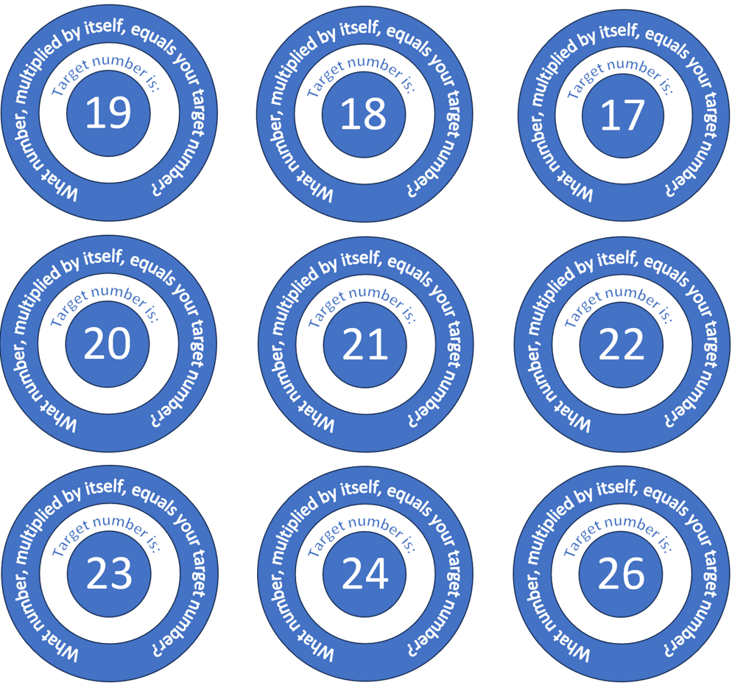
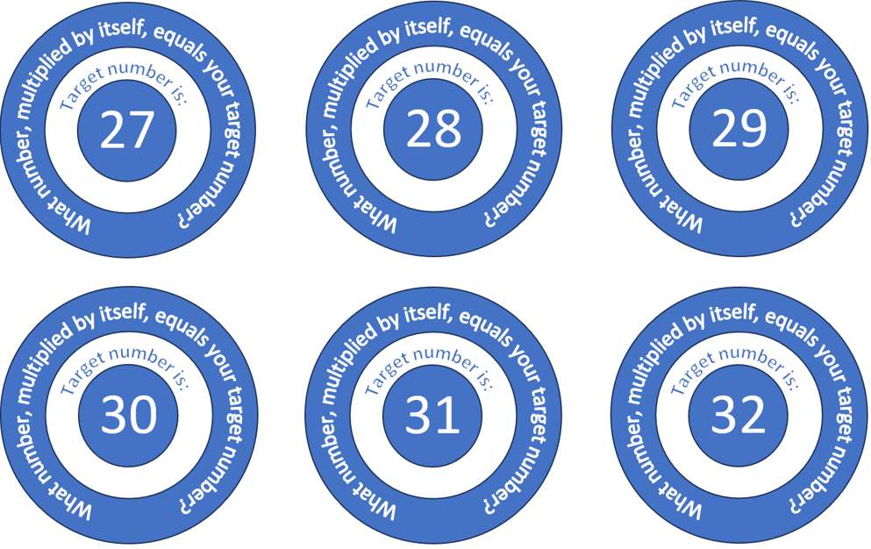

Appendix B

That’s about right score card
Table 1 – points scale
Limits | How close was your estimate? | Points
$$≤0.1$$ | (less than or equal to 0.1) | 10
$$>0.1, ≤0.3$$ | (greater than 0.1 and less than or equal to 0.3) | 6
$$>0.3, ≤0.8$$ | (greater than 0.3 and less than or equal to 0.8) | 2
$$>0.8$$ | (greater than 0.8) | 0
Table 2 – student score card
Round | Target | Estimate the value of the square root | Estimate squared | Difference | Points
Example | 20 | $$\sqrt{20}=4.5$$ | 20.25 | $$20-20.25=0.25$$ | 6
1 | 40
2 | 52
3 | 78
4 | 105
5 | 150
Total points: _____

Appendix C

Estimating square roots as a fraction
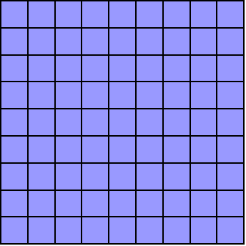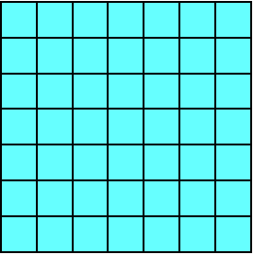
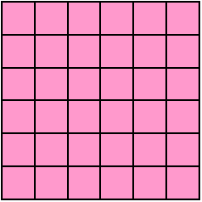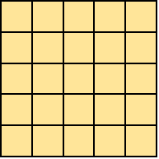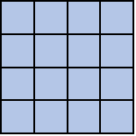
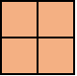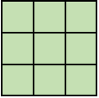
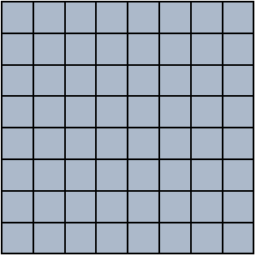

Appendix D

Problem-solving cards
A gardener has enough fertiliser to spread over an area of 10 square metres. What would be the dimensions of a square garden bed with this area?
In a chemistry experiment, Lucy grows a blue crystal of copper sulphate that is cubic and has a volume of 798 cubic millimetres. How long is each edge of the cube?
Given that n is an integer, and the difference between $\sqrt{n}$ and 9 is less than 1, how many different possibilities are there for n?

Sample solutions

Launch
The value of $\sqrt{12}$ to 9 decimal places is $3.464101615$.

Appendix A – target number
Target estimates, to 3 decimal places, are:
$$\sqrt{17}=4.123$$
$$\sqrt{18}=4.243$$
$$\sqrt{19}=4.359$$
$$\sqrt{20}=4.472$$
$$\sqrt{21}=4.583$$
$$\sqrt{22}=4.690$$
$$\sqrt{23}=4.796$$
$$\sqrt{24}=4.899$$
$$\sqrt{26}=5.099$$
$$\sqrt{27}=5.196$$
$$\sqrt{28}=5.292$$
$$\sqrt{29}=5.385$$
$$\sqrt{30}=5.477$$
$$\sqrt{31}=5.568$$
$$\sqrt{32}=5.657$$

Appendix D – problem-solving cards
Question 1: Length is $\sqrt{10}=3.2 m$.

Question 2: Edge is $\sqrt[3]{798}=9.3 mm$ (1dp).

Question 3: There are 2 possible ways to calculate the difference.
Either $\sqrt{n}-9$ or $9-\sqrt{n}$.
For $\sqrt{n}-9$, use $9=\sqrt{81}$, so $\sqrt{81}-\sqrt{n}<1$.
We know that $9-8=1$, and $\sqrt{64}=8$.
So, $\sqrt{81}-\sqrt{64}=1$. That means we can’t go lower than $8$, or $\sqrt{64}$.
For $9-\sqrt{n}$, use $9=\sqrt{81}$, so $\sqrt{n}-\sqrt{81}>1$.
We know that $10-9=1$, and $\sqrt{100}=10$.
So, $\sqrt{100}-\sqrt{81}=1$. That means we can’t go higher than $10$, or $\sqrt{100}$.
Therefore, $100>n>64$.
That is, the value of $n$ should be a number greater than 64 and less than 100.

References
This resource contains NSW Curriculum and syllabus content. The NSW Curriculum is developed by the NSW Education Standards Authority. This content is prepared by NESA for and on behalf of the Crown in right of the State of New South Wales. The material is protected by Crown copyright.
Please refer to the NESA Copyright Disclaimer for more information https://educationstandards.nsw.edu.au/wps/portal/nesa/mini-footer/copyright.
NESA holds the only official and up-to-date versions of the NSW Curriculum and syllabus documents. Please visit the NSW Education Standards Authority (NESA) website https://educationstandards.nsw.edu.au/ and the NSW Curriculum website https://curriculum.nsw.edu.au/home.
Mathematics K–10 Syllabus © NSW Education Standards Authority (NESA) for and on behalf of the Crown in right of the State of New South Wales, 2022.

© State of New South Wales (Department of Education), 2023
The copyright material published in this resource is subject to the Copyright Act 1968 (Cth) and is owned by the NSW Department of Education or, where indicated, by a party other than the NSW Department of Education (third-party material).
Copyright material available in this resource and owned by the NSW Department of Education is licensed under a Creative Commons Attribution 4.0 International (CC BY 4.0) licence.
This licence allows you to share and adapt the material for any purpose, even commercially.
Attribution should be given to © State of New South Wales (Department of Education), 2023.
Material in this resource not available under a Creative Commons licence:
- the NSW Department of Education logo, other logos and trademark-protected material
- material owned by a third party that has been reproduced with permission. You will need to obtain permission from the third party to reuse its material.
Links to third-party material and websites
Please note that the provided (reading/viewing material/list/links/texts) are a suggestion only and implies no endorsement, by the New South Wales Department of Education, of any author, publisher, or book title. School principals and teachers are best placed to assess the suitability of resources that would complement the curriculum and reflect the needs and interests of their students.
If you use the links provided in this document to access a third-party's website, you acknowledge that the terms of use, including licence terms set out on the third-party's website apply to the use which may be made of the materials on that third-party website or where permitted by the Copyright Act 1968 (Cth). The department accepts no responsibility for content on third-party websites.

