The magical factor trees
Students will examine square roots and cube roots, linking their knowledge of squares and cubes. They will use factor trees to write a number as a product of its prime factors in index notation.
Students will need at least one digital device per pair to interact with Desmos during this lesson.

Visible learning

Learning intentions
- To be able to apply index notation to represent whole numbers as products of powers of prime numbers.
- To be able to calculate cube roots and square roots.

Success criteria
- I can represent a whole number greater than one as a product of its prime factors using index notation.
- I can use the notations for square root and cube root.
- I can recognise and describe the relationship between squares and square roots, and cubes and cube roots for positive numbers.
- I can show that $\sqrt{ab}=\sqrt{a}×\sqrt{b}$ using numerical examples.

Syllabus outcomes
A student:
- develops understanding and fluency in mathematics through exploring and connecting mathematical concepts, choosing and applying mathematical techniques to solve problems, and communicating their thinking and reasoning coherently and clearly MAO-WM-01
- operates with primes and roots, positive-integers and zero indices involving numerical bases and establishes the relevant index laws MA4-IND-C-01
Mathematics K–10 Syllabus © NSW Education Standards Authority (NESA) for and on behalf of the Crown in right of the State of New South Wales, 2022.
Please use the associated PowerPoint The magical factor trees to display images in this lesson.

Activity structure

Launch
- Display slide 2 from the PowerPoint. Use a Think-Pair-Share (bit.ly/thinkpairsharestrategy) to allow the students to discuss what they notice and what they wonder.
- Move to slide 3, which includes the original photo and 2 closer photos of the installation. Ask students what they now notice and wonder.
During this part of the discussion, you can provide the following information about the installation:
Thousands of mini bronze figurines were created and placed to either take the place of paving stones or be paced under them, giving the illusion that the figurines are lifting the pavers. The installation is meant to embody a grassroots movement. With the varying ages, sex, and ethnicity of the figures, it also represents a united mass.
- Verbally explain the following scenario to students:
A prefect group has decided to replicate the Grass Roots installation, to promote unity and diversity at their school.
Every student will create a small, green, clay figurine of themselves, like the figurines in the Grass Roots installation.
The figurines will now be placed in rows, with each row having the same number of figurines to make a square.
- Display slide 4. Students are to work in visibly random groups of 3 (bit.ly/visiblegroups), at a vertical non-permanent surface (bit.ly/VNPSstrategy) to solve the problem ‘How many figurines will be in each row if there are 784 students at the school.’
- Use the Pause-Pose-Pounce-Bounce question strategy [PDF 200KB] (bit.ly/pausepouncebounce) to engage students in a class discussion about how they solved the problem.

Explore
- Assign students the Desmos classroom activity ‘What is a square root?’ (bit.ly/whatisasquareroot). Students work through the activity, examining square roots as integer values.
Teachers will need to set up a Desmos classroom and assign the activity to the class. Information on how to set up a Desmos classroom activity, can be found at https://bit.ly/Desmosactivitysetup.
- Distribute Appendix A ‘Squares, cubes and their roots’. Working individually, ask students to complete Table 1.
- Display slide 5. Use a Think-Pair-Share (bit.ly/thinkpairsharestrategy) to allow the students to discuss what they think the notation means and why the answer is 4.
- Display slide 6 and explain the concept and language of cube roots.
Emphasise the language used to say that when finding a cube root, we are looking for a number that multiplies by itself 3 times. Ensure that students are not using the language to suggest that we are looking for a number that divides by itself 3 times.
- Working individually, ask students to complete Table 2 from Appendix A.
- Engage students in a class discussion comparing the values in the table 1 and 2. Questions that may be useful include:
- What similarities do you notice between the 2 tables?
- What differences do you notice between the 2 tables?

Summarise
Students will use factor trees to write numbers as a product of their prime factors, using index notation. They will then use the representations to identify square and cube roots.
- Using a Think-Pair-Share, ask students to figure out $\sqrt{196}$.
- Use the Pause-Pose-Pounce-Bounce question strategy questioning technique to share student strategies and to discuss what made this task difficult. Ask them how difficult it would be to calculate $\sqrt[3]{3375}$?
- Explain that we are going to look at a method which will help them to calculate roots of numbers.
- Display slides 7–10 of The magical factor trees PowerPoint for explicit teaching of using a factor tree to find the square root of a number.
Remind students of simple strategies to start their factor tree: use the divisibility tests, from the ‘Area models and divisibility tests’ lesson to check if the number can be divided by 2, 3, 4, 5, 6 or 10. Encourage the students to aim for a higher number to start, to break the number down more quickly.
Teachers may need to review the definition of a prime number: a number with only two factors, one and itself.
The explicit teaching technique used in the associated PowerPoint is ‘Your turn.’ The first slide is a worked example which should be displayed for the students and then use the following steps.
      - Reveal the question to students and its solution.
      - Students read in silence.
      - Students individually think and explain to themselves what is happening in each step.
      - Students hold up a thumbs up to the teacher when they have finished reading and have some sort of understanding.
      - Think-Pair-Share. Students explain the solution to their partner.
      - In pairs students then answer the self-explanation questions.
      - Finally, randomly select students to share their answers with the whole class.
- Students complete the questions in rows 1 to 4 on the worksheet in Appendix B ‘Using a factor tree to find the root of a number’.
- Display slides 15–18 of The magical factor trees PowerPoint for explicit teaching of using a factor tree to identify integer cube roots.
- Students complete the questions in row 5 of the worksheet in Appendix B.

Apply

Two truths and a lie
- Display slide 19 from The magical factor trees PowerPoint. Ask students to read the statements on the slide and identify the lie and justify why it is a lie.
- Display slide 20 from The magical factor trees PowerPoint to reveal the lie. Ask students to explore the property to determine if it works for all numbers. Useful questions include:
- Does it work with other square numbers?
- How might a factor tree help us see this?
- Could it work with a cubic number?

Problem solving cards
- Assign students to work in visibly random groups of 3, at a vertical non-permanent surface (bit.ly/VNPSstrategy).
- Distribute a set of Appendix C ‘Problem-solving cards’ to each group.
- Ask students to solve the questions on the cards.
- Use a gallery walk (bit.ly/DLSgallerywalk) to provide an opportunity for peer feedback. Ask them to move around the room in their groups, looking at the work of others. Direct them to use the coloured markers to provide feedback, using a ☺️ to indicate a strategy that they like, a 😐 to indicate something they have a question about or unsure of and a ☹️to indicate a solution that may need to be reviewed.
- After completing the gallery walk, allow students time to return to their own boards and act on the feedback provided.

Assessment and differentiation

Suggested opportunities for differentiation
Explore
- The use of the Desmos classroom activity will allow students to explore the squares without having to do the calculations by hand. They can observe how the length of the side and the size of the area change as they adjust the size of the square.
- Teachers can use the pacing feature of Desmos classroom to restrict students to slides, or to pause the activity to draw attention to or discuss questions.
- An investigation into higher roots, the language we use and how we might find them may occur.
Summarise
- Modify the numbers in the worksheet in Appendix B to suit the readiness of your students. Some students may need to use a calculator to assist with their calculations.
Apply
- Challenge students to explore if the property works with division, that is if $\sqrt{\frac{a}{b}}=\frac{\sqrt{a}}{\sqrt{b}}$.
- There are many variations to the 5 number activity. These include:
- changing the number of numbers being used
- changing the number of points
- changing the range of numbers being used
- using other number properties such as even numbers, numbers divisible by 9, and so on
- changing the operation from addition to multiplication, subtraction or even division.

Suggested opportunities for assessment
Launch
- Monitor student understanding of the relationship between squaring a number and finding the square root of a number.
Explore
- Student responses can be monitored through the Desmos teacher dashboard and used as both formative and summative assessment.
- Monitor that students can use divisibility tests to draw a factor tree. Students with low readiness should begin by looking for divisibility by 2 or 5.
- Monitor that students can express a number as a product of its prime factors in index form.
- Assess completed tables in Appendix A.
Summarise
- Assess completed tables in Appendix B.
Apply
- Monitor the reasoning used by students to identify the lie and that they comprehend that the property applies to all roots.
- Monitor student responses to the problem-solving questions.

Appendix A

Squares, cubes and their roots
Complete the following tables.
Table 1 – square roots
Base number | Diagram | Square | Square root
1 |  | $$1^{2}=1$$
2 | 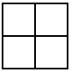 | $$2^{2}=4$$ | $$\sqrt{4}=2$$
3 | 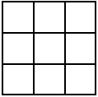
4
5 | 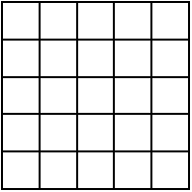
6 | 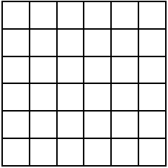 |  | $$\sqrt{36}=6$$
7 | 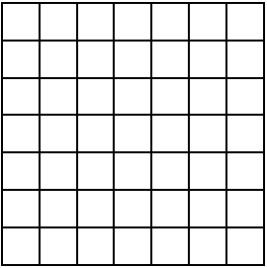 | $$7^{2}=49$$
8 | 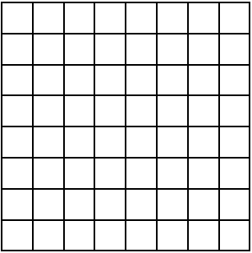
9
10

Table 2 – cube roots
Base number | Diagram | Cube | Cube root
1 | 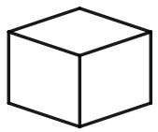 |  | $$\sqrt[3]{1}=1$$
2 | 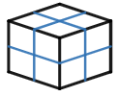 | $$2^{3}=8$$ | $$\sqrt[3]{8}=2$$
3 | 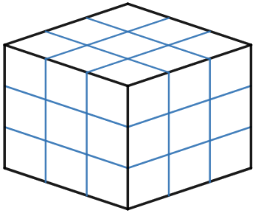
4 | 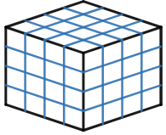
5 | 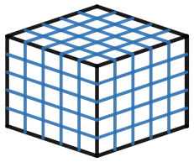
6 | 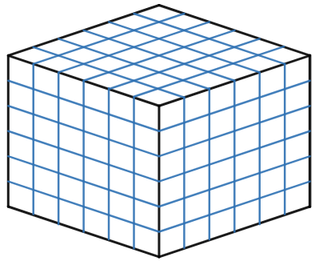
7 | 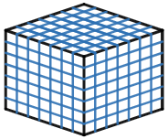
8 | 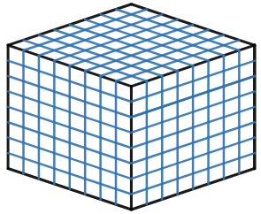 |  | $$\sqrt[3]{64}=4$$
9 | 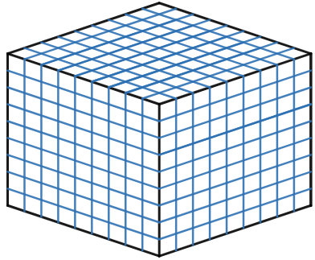 | $$9^{3}=729$$
10 | 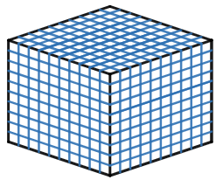

Appendix B

Using a factor tree to find the root of a number
Fill in the blank spaces to find the square roots and cube roots.
1 | Use a factor tree to find $\sqrt{9}$.  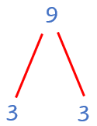  $$9=3^{2}$$  $$∴\sqrt{9}=___$$ | Use a factor tree to find $\sqrt{25}$.  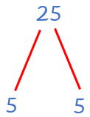  $$25={___}^{2}$$  $$∴\sqrt{25}=___$$ | Use a factor tree to find $\sqrt{49}$.  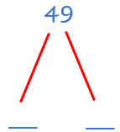  $$49={___}^{2}$$  $$∴\sqrt{49}=___$$

2 | Use a factor tree to find $\sqrt{16}$.  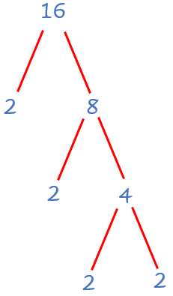  $$16=2×2×2×2$$  $$16=\left(2×2\right)×\left(2×2\right)$$  $$16=4^{2}$$  $$∴\sqrt{16}=___$$ | Use a factor tree to find $\sqrt{36}$.  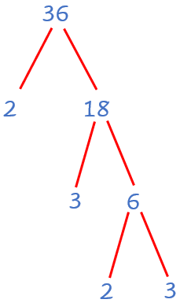  $$36=2×3×2×3$$  $$36=\left(___×___\right)×\left(___×___\right)$$  $$36={___}^{2}$$  $$∴\sqrt{36}=___$$ | Use a factor tree to find $\sqrt{100}$.  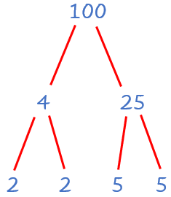  $$100=___×___×___×___$$  $$100=\left(__×__\right)×\left(__×__\right)$$  $$100={___}^{2}$$  $$∴\sqrt{100}=___$$

3 | Use a factor tree to find $\sqrt{225}$.  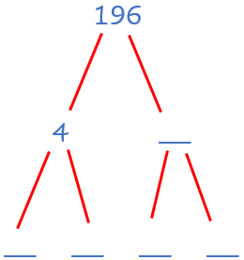  $$225=\left(__×__\right)×\left(__×__\right)$$  $$225={__}^{2}$$  $$∴\sqrt{225}=__$$ | Use a factor tree to find $\sqrt{441}$.  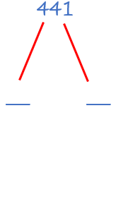  $$441=\left(__×__\right)×\left(__×__\right)$$  $$441={__}^{2}$$  $$∴\sqrt{441}=__$$ | Use a factor tree to find $\sqrt{576}$.  $$576=$$  $$576={__}^{2}$$  $$∴\sqrt{576}=__$$

4 | Use a factor tree to find $\sqrt{1089}$.  $$1089=$$ | Use a factor tree to find $\sqrt{1764}$.  $$1764=$$ | Use a factor tree to find $\sqrt{3136}$.  $$3136=$$

5 | Use a factor tree to find $\sqrt[3]{8}$.  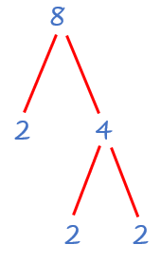  $$8=2×2×2$$  $$8={__}^{3}$$  $$∴\sqrt[3]{8}=__$$ | Use a factor tree to find $\sqrt[3]{216}$.  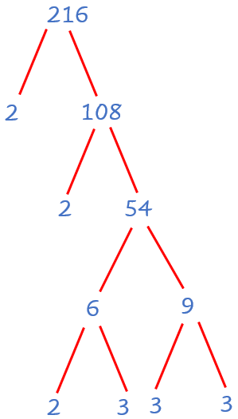  $$216=2×2×2×3×3×3$$  $$=\left(__×__\right)×\left(__×_\right)×\left(__×__\right)$$  $$216={___}^{3}$$  $$∴\sqrt[3]{216}=___$$ | Use a factor tree to find $\sqrt[3]{3375}$.  $$3375=__×__×__×__×__×__$$  $$=\left(__×__\right)×\left(__×__\right)×\left(__×__\right)$$  $$3375={___}^{3}$$  $$∴\sqrt[3]{3375}=___$$

Appendix C

Problem-solving cards
Question 1
Zoe builds a large square from 1764 small square tiles. What are the dimensions of the large square?
Question 2
Take any 5 numbers between 1 and 99 inclusive. Write them in ascending order.
Now add the first and the second; the second and the third; the third and the fourth; and the fourth and the fifth.
Score points as follows: every square number is worth 2 points; every cube number is worth 3 points; every prime number is worth 2 points. (Numbers that are both squares and cubes only get 3 points.)
What is the highest score that you can get? In how many ways can you get it?
What is the lowest score that you can get? In how many ways can you get it?

Sample solutions

Launch
The figurines would be in rows of 28, to make a square.

Appendix A – squares, cubes and their roots
Base number | Square | Square root | Cube | Cube root
1 | $$1^{2}=1$$ | $$\sqrt{1}=1$$ | $$1^{3}=1$$ | $$\sqrt[3]{1}=1$$
2 | $$2^{2}=4$$ | $$\sqrt{4}=2$$ | $$2^{3}=8$$ | $$\sqrt[3]{8}=2$$
3 | $$3^{2}=9$$ | $$\sqrt{9}=3$$ | $$3^{3}=27$$ | $$\sqrt[3]{27}=3$$
4 | $$4^{2}=16$$ | $$\sqrt{16}=4$$ | $$4^{3}=64$$ | $$\sqrt[3]{64}=4$$
5 | $$5^{2}=25$$ | $$\sqrt{25}=5$$ | $$5^{3}=125$$ | $$\sqrt[3]{125}=5$$
6 | $$6^{2}=36$$ | $$\sqrt{36}=6$$ | $$6^{3}=216$$ | $$\sqrt[3]{216}=6$$
7 | $$7^{2}=49$$ | $$\sqrt{49}=7$$ | $$7^{3}=343$$ | $$\sqrt[3]{343}=7$$
8 | $$8^{2}=64$$ | $$\sqrt{64}=8$$ | $$8^{3}=512$$ | $$\sqrt[3]{512}=8$$
9 | $$9^{2}=81$$ | $$\sqrt{81}=9$$ | $$9^{3}=729$$ | $$\sqrt[3]{729}=9$$
10 | $${10}^{2}=100$$ | $$\sqrt{100}=10$$ | $${10}^{3}=1000$$ | $$\sqrt[3]{1000}=10$$

Appendix B – using a factor tree to find the root of a number
1 | Use a factor tree to find $\sqrt{9}$.  $$9=3^{2}$$  $$∴\sqrt{9}=_3_$$ | Use a factor tree to find $\sqrt{25}$.  $$25={_5__}^{2}$$  $$∴\sqrt{25}=_5__$$ | Use a factor tree to find $\sqrt{49}$.  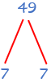  $$49={_7__}^{2}$$  $$∴\sqrt{49}=_7__$$

2 | Use a factor tree to find $\sqrt{16}$.  $$16=2×2×2×2$$  $$16=\left(2×2\right)×\left(2×2\right)$$  $$16=4^{2}$$  $$∴\sqrt{16}=_4__$$ | Use a factor tree to find $\sqrt{36}$.  $$36=2×3×2×3$$  $$36=\left(2×3\right)×\left(2×3\right)$$  $$36={_6__}^{2}$$  $$∴\sqrt{36}=_6__$$ | Use a factor tree to find $\sqrt{100}$.  $$100=2×2×5×5$$  $$100=\left(2×5\right)×\left(2×5\right)$$  $$100={10}^{2}$$  $$∴\sqrt{100}=_10_$$

3 | Use a factor tree to find $\sqrt{225}$.  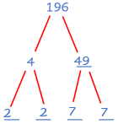  $$225=\left(2×7\right)×\left(2×7\right)$$  $$225={_14_}^{2}$$  $$∴\sqrt{225}=_14_$$ | Use a factor tree to find $\sqrt{441}$.  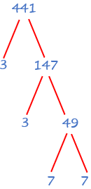  $$441=\left(3×7\right)×\left(3×7\right)$$  $$441={21}^{2}$$  $$∴\sqrt{441}=_21_$$ | Use a factor tree to find $\sqrt{576}$.  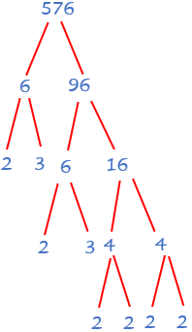  $$576=\left(2×2×2×3\right)×\left(2×2×2×3\right)$$  $$441={24}^{2}$$  $$∴\sqrt{441}=_24_$$

4 | Use a factor tree to find $\sqrt{1089}$.  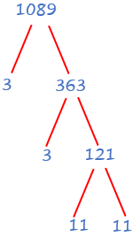  $$1089=$$ | Use a factor tree to find $\sqrt{1764}$.  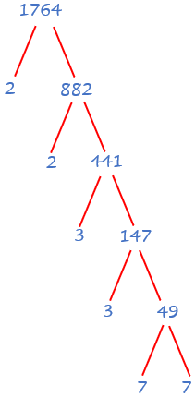  $$1764=$$ | Use a factor tree to find $\sqrt{3136}$.  $$3136=$$

5 | Use a factor tree to find $\sqrt[3]{8}$.  $$8=2×2×2$$  $$8={__}^{3}$$  $$∴\sqrt[3]{8}=__$$ | Use a factor tree to find $\sqrt[3]{216}$.  $$216=2×2×2×3×3×3$$  $$=\left(__×__\right)×\left(__×_\right)×\left(__×__\right)$$  $$216={___}^{3}$$  $$∴\sqrt[3]{216}=___$$ | Use a factor tree to find $\sqrt[3]{3375}$.  $$3375=__×__×__×__×__×__$$  $$=\left(__×__\right)×\left(__×__\right)×\left(__×__\right)$$  $$3375={___}^{3}$$  $$∴\sqrt[3]{3375}=___$$

Appendix C – problem-solving cards
Question 1
Length of $\sqrt{7056}=84$ tiles
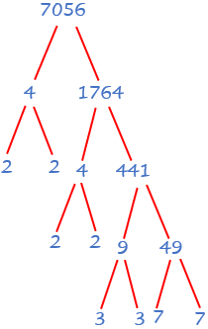

Question 2
The highest total possible is 12, since the highest number of points available for each of the 4 numbers is 3.
The only cubes less than 200 are 1, 8, 27, 64 and 125.
One way of getting 12 points is to have chosen the numbers 1, 7, 20, 44 and 81.
The smallest total is zero.
One example is 1, 5, 7, 8, and 10.
The sums here are 6, 12, 15 and 18, none of which are powers or primes.

References
This resource contains NSW Curriculum and syllabus content. The NSW Curriculum is developed by the NSW Education Standards Authority. This content is prepared by NESA for and on behalf of the Crown in right of the State of New South Wales. The material is protected by Crown copyright.
Please refer to the NESA Copyright Disclaimer for more information https://educationstandards.nsw.edu.au/wps/portal/nesa/mini-footer/copyright.
NESA holds the only official and up-to-date versions of the NSW Curriculum and syllabus documents. Please visit the NSW Education Standards Authority (NESA) website https://educationstandards.nsw.edu.au/ and the NSW Curriculum website https://curriculum.nsw.edu.au/home.
Mathematics K–10 Syllabus © NSW Education Standards Authority (NESA) for and on behalf of the Crown in right of the State of New South Wales, 2022.

© State of New South Wales (Department of Education), 2023
The copyright material published in this resource is subject to the Copyright Act 1968 (Cth) and is owned by the NSW Department of Education or, where indicated, by a party other than the NSW Department of Education (third-party material).
Copyright material available in this resource and owned by the NSW Department of Education is licensed under a Creative Commons Attribution 4.0 International (CC BY 4.0) licence.
This licence allows you to share and adapt the material for any purpose, even commercially.
Attribution should be given to © State of New South Wales (Department of Education), 2023.
Material in this resource not available under a Creative Commons licence:
- the NSW Department of Education logo, other logos and trademark-protected material
- material owned by a third party that has been reproduced with permission. You will need to obtain permission from the third party to reuse its material.
Links to third-party material and websites
Please note that the provided (reading/viewing material/list/links/texts) are a suggestion only and implies no endorsement, by the New South Wales Department of Education, of any author, publisher, or book title. School principals and teachers are best placed to assess the suitability of resources that would complement the curriculum and reflect the needs and interests of their students.
If you use the links provided in this document to access a third-party's website, you acknowledge that the terms of use, including licence terms set out on the third-party's website apply to the use which may be made of the materials on that third-party website or where permitted by the Copyright Act 1968 (Cth). The department accepts no responsibility for content on third-party websites.

