A big problem with small numbers
Students explore the exponential growth that occurs with powers, particularly with powers of ten.

Visible learning

Learning intentions
- To be able to evaluate numbers expressed in index notation.
- To understand the growing effect of an exponent on the magnitude of a number.

Success criteria
- I can repeatedly multiply a number by itself.
- I can represent multiples of 10 in index form.
- I can compare the value of numbers written in index form.

Syllabus outcomes
A student:
- develops understanding and fluency in mathematics through exploring and connecting mathematical concepts, choosing and applying mathematical techniques to solve problems, and communicating their thinking and reasoning coherently and clearly MAO-WM-01
- operates with primes and roots, positive-integer and zero indices involving numerical bases and establishes the relevant index laws MA4-IND-C-01
Mathematics K–10 Syllabus © NSW Education Standards Authority (NESA) for and on behalf of the Crown in right of the State of New South Wales, 2022.

Activity structure
Please use the associated PowerPoint A big problem with small numbers to display images in this lesson.

Launch

A big problem with small numbers
- Display slide 3 of the PowerPoint. Ask students to read the slide.
Slides 3–7 tell a story about a traveller who presents a king with the game of chess. As an expression of his gratitude, the king offers to reward the traveller. The traveller tricks the king by asking the king to pay him with a grain of rice on the first day, 2 grains of rice on the second day, 4 grains of rice on the third day, doubling the amount each day, for 64 days, which is the number of squares on a chessboard. There are many variations to this story, from as early as 1256, with rice or wheat the most common gift in the story.
- Display slide 4 of the PowerPoint. After reading the dialogue, ask the students to engage in a Think-Pair-Share (bit.ly/thinkpairsharestrategy) to discuss the offer made by the traveller.
- Display slide 5 of the PowerPoint. After reading the dialogue, use a Pose-Pause-Pounce-Bounce question strategy [PDF 200KB] (bit.ly/pausepouncebounce) to discuss why the workers think there is a problem. Prompting questions may include:
- What do you notice the worker ants are saying?
- How many is 8 squared?
- What do you think the problem may be?
- Why do you think the king should be worried?
- Can you predict how many grains of rice will need to be paid on the last day?
- Display slide 6 of the PowerPoint. Students engage in a Think-Pair-Share (bit.ly/thinkpairsharestrategy) to discuss the number of grains of rice and what they think about the size of the numbers. Challenge students to see if they could write the numbers in a different way.
Students may choose to write the sum that is used to get the number of grains in each square. For instance,
2 = 2 x 1, 4 = 2 x (2 x 1), 8 = 2 x (2 x (2 x 1))
- Display slide 7 of the PowerPoint. Encourage the students to calculate more values on the chessboard. Use the Pose-Pause-Pounce-Bounce strategy to discuss the king’s problem. Questions that may be posed include:
- How much rice will be needed on day 8?
- Which deal was a better one for the king?
- At what point do the numbers get too big to keep going?
- How can we calculate the amount of rice on the last day?
There is no need for the values to be added to the table on the PowerPoint or for students to be given a copy of the table. Instead, write a selection of the values on the board.
Information to support student discussion could include:
- There are approximately 50 000 grains of rice in one kilogram of rice.
  - The amount of rice on day 64 was more than the amount of rice produced in the world in 2023.

Explore

Zooming out
- Inform the students that they will be watching the video ‘Powers of Ten’ (9:00) (https://bit.ly/zoomingpowersof10).
- Tell them that the video begins with a scene of a picnic in Chicago and then begins to zoom out by multiples of 10.
The video zooms out by a multiple of 10 each time, to ${10}^{24}$. It then zooms back in again, returning to the original view at 5:57. The video then begins to zoom in by multiples of 10, showing negative powers of 10. Teachers may wish to stop at 5:57. The video is old-fashioned but is an effective demonstration of the magnitude of powers of 10.
- After watching the video, return it to the 0:09 second marker. At this point the video explains what its purpose is. Use the Pose-Pause-Pounce-Bounce question strategy, asking students what they noticed, what they think and what they wonder. Extending prompts could include:
- What is meant by ‘the effect of adding another zero’, which is written on the screen?
- Why did the zoom stop at ${10}^{24}$?
- What did they notice about the indices?
- What did they notice about the base number?
Link the Launch activity, which demonstrates powers of 2, with the video showing powers of 10. Discuss the difference between doubling each value and multiplying by 10 and the usefulness of the indices in both cases to represent large numbers.

How many zeroes in a billion?
- Display slide 9 of the PowerPoint. Ask students to read the statements. Engage students in a Think-Pair-Share (bit.ly/thinkpairsharestrategy) to discuss the 2 statements.
- Display slide 10 of the PowerPoint. Ask students to raise their left hand if they think Statement 1 is correct or raise their right hand if they think Statement 2 is correct.
- When ready, tell students that both statements are correct. Lead a discussion about the use of words and numbers to communicate. Extending prompts could include:
- What is the value of one trillion?
- What comes next, after one trillion?
- Why did the problem only arise in the second half of the 20th century?
The statements refer to a difference in how people communicate when referring to numbers. The smaller value of one billion was originally used in the USA. The larger value of one billion was originally used in England and many parts of the world. In 1974, the Prime Minister of England declared that the government would officially begin using the value of 1 000 000 000 as the reference for one billion, to avoid confusion. He acknowledged that many people in England would continue to use the larger value.
- Pose the question: If the king had offered one million grains of rice for one million days, so ${1 000 000}^{2}$, would that still have been a better deal?
Encourage students to calculate the value of ${1 000 000}^{2}$ by adding the number of zeroes together. This will give the value of the UK billion.
Students should be able to recognise that one million days is more than one person’s lifetime.

Summarise
Distribute a copy of Appendix A ‘Mix n Match’ to each student. Students should match the items that represent the same value. This can be done by colouring the cells that match with the same colour or by cutting the cards up and gluing them together in their book.

Apply

Would you rather?
- Divide students into visibly random groups of 3 (bit.ly/visiblegroups).
- Distribute a copy of Appendix B ‘Would you rather?’ to each group or to each student. Students should work through the ‘Would you rather …’ questions, calculating the numerical terms and discussing which option they think they would choose. They should record their thoughts on the question cards.

If there is one set of cards per group, each group needs to decide on an answer. The group members may need to use critical thinking and effective communication skills to convince another team member to agree. If that proves difficult, you might suggest the group members may need to use the Paper, scissors, rock game to make a final decision.
If each student has a set of cards, the group should discuss the questions, communicating what they think they’d rather do before each student records their own ideas.
- Engage the class in a discussion, providing opportunities for groups to present their own thoughts and challenge other groups to reconsider their choice.
Students should be encouraged to recognise that others may have a different opinion or the same opinion for different reasons. It’s important that they accept that different opinions may still be valid.

Assessment and Differentiation

Suggested opportunities for differentiation
Launch
- Ask students to identify when the king’s alternative offer became a better offer for the king to make.
- Challenge students to come up with their own alternative offer for the king.
Explore
- Students could be extended by investigating negative indices, as seen in the video.
- Students could be extended by investigating what numbers come after one quadrillion.
Apply
- Teachers could provide blank ‘Would you rather?’ cards for students to write their own scenarios.

Suggested opportunities for assessment
Launch
- Monitor student responses during discussion to assess their understanding of the rate of growth of numbers in index form.
Explore
- Monitor student responses after watching the video to determine if students understand that an increase of one in the index represents a multiplication of 10.
Summarise
- Observe whether students are correctly able to link terms, values and labels together in the ‘Mix n Match’ activity.
Apply
- Monitor if students have calculated the numerical terms correctly and used appropriate comparisons when comparing the scenarios.

Appendix A

Mix n Match
$$100 000$$ | $$10×10×10$$
One hundred | $${10}^{1}$$
$$1000$$ | $$10×10$$
$$10×10×10×10$$ | $${10}^{6}$$
$${10}^{4}$$ | $$1 000 000$$
$${10}^{5}$$ | One hundred thousand
One thousand | $$10$$
Ten | $$10×10×10×10×10×10$$
$${10}^{3}$$ | One million
$$1×10$$ | $$10×10×10×10×10$$
$$100$$ | Ten thousand
$$10 000$$ | $${10}^{2}$$
Appendix B

Would you rather?
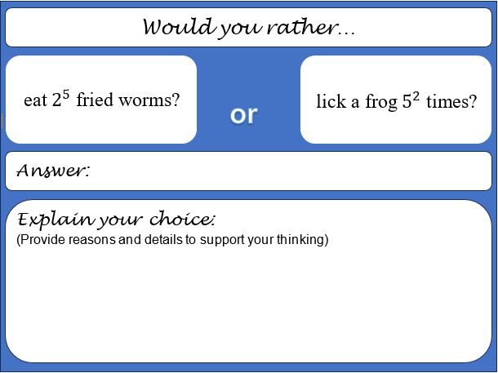
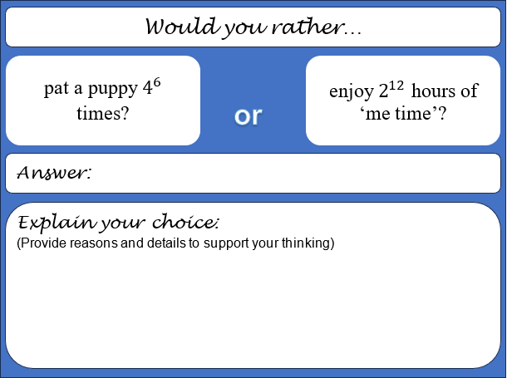
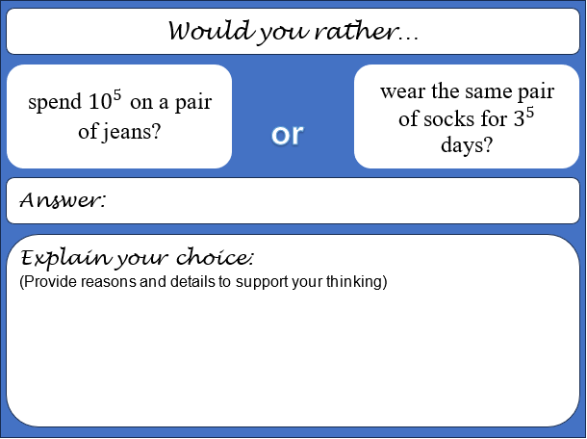
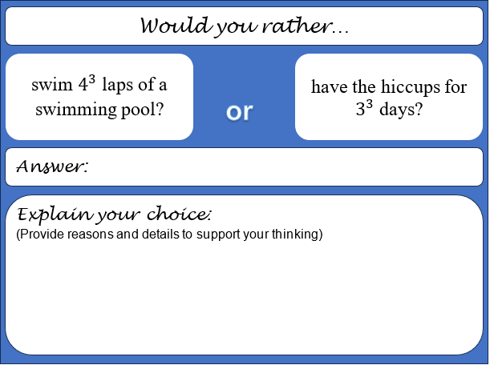
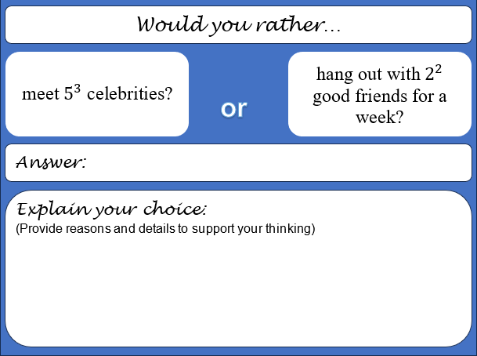
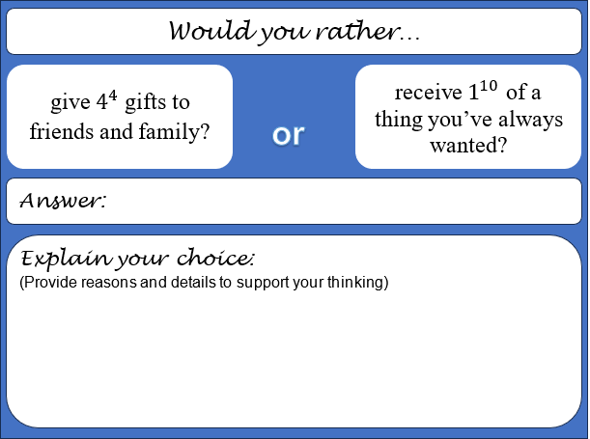
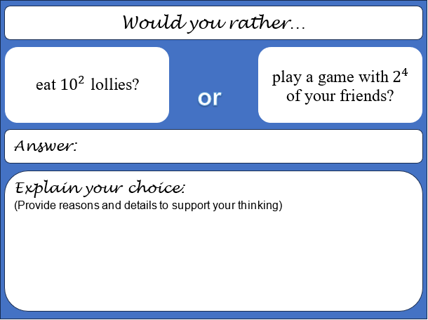
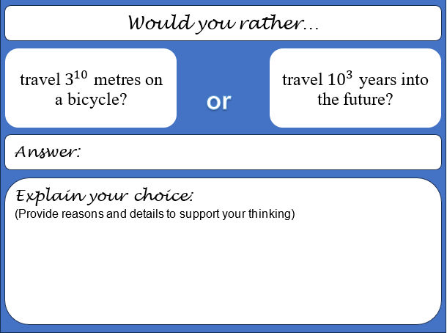
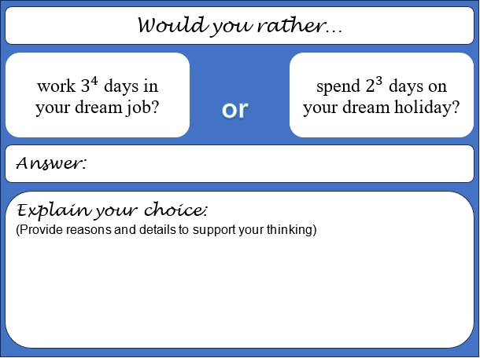
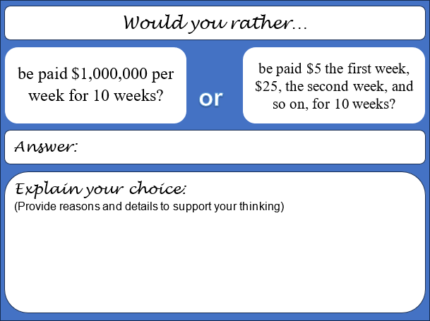

Sample solutions

Explore – how many zeroes in a billion?
After a billion comes: quadrillion, quintillion, sextillion, septillion, octillion, nonillion, and decillion. Note, there are more after that. Students should be able to make a connection between the prefix of each name and the number itself.

Appendix A – Mix n Match
$$10$$ | $${10}^{1}$$
$$1×10$$ | Ten

$$100$$ | $${10}^{2}$$
$$10×10$$ | One hundred

$$1 000$$ | $${10}^{3}$$
$$10×10×10$$ | One thousand

$$10 000$$ | $${10}^{4}$$
$$10×10×10×10$$ | Ten thousand

$$100 000$$ | $${10}^{5}$$
$$10×10×10×10×10$$ | One hundred thousand

$$1 000 000$$ | $${10}^{6}$$
$$10×10×10×10×10×10$$ | One million

Appendix B – would you rather?
- eat $2^{5}$ fried worms  - lick a frog $5^{2}$ times? | $$2^{5}=32$$  $$5^{2}=25$$
- work $3^{4}$ days in your dream job  - spend $2^{3}$ days on your dream holiday? | $$3^{4}=81$$  $$2^{3}=8$$
- travel $3^{10}$ metres on a bicycle  - travel ${10}^{3}$ years into the future? | $$3^{10}=59049$$  $${10}^{3}=1000$$
- eat ${10}^{2}$ lollies  - play a game with $2^{4}$ of your friends? | $${10}^{2}=100$$  $$2^{4}=16$$
- give $4^{4}$ gifts to friends and family  - receive $1^{10}$ of a thing you’ve always wanted? | $$4^{4}=256$$  $$1^{10}=1$$
- meet $5^{3}$ celebrities  - hang out with $2^{2}$ good friends for a week? | $$5^{3}=125$$  $$2^{2}=4$$
- pat a puppy $4^{6}$ times  - enjoy $2^{12}$ hours of ‘me time’? | $$4^{6}=4096$$  $$2^{12}=4096$$
- spend ${10}^{5}$ on a pair of jeans  - wear the same pair of socks for $3^{5}$ days? | $${10}^{5}=100,000$$  $$3^{5}=243$$
- swim $4^{3}$ laps of a swimming pool  - have the hiccups for $3^{3}$ days? | $$4^{3}=64$$  $$3^{3}=27$$
- be paid $1,000,000 per week for 10 weeks  - be paid $5 the first week, $25, the second week, and so on, for 10 weeks? | $$\$1,000,000×10=\$10,000,000$$  $${\$5}^{10}=\$9,765,625$$

Suggested opportunities for differentiation – blank template
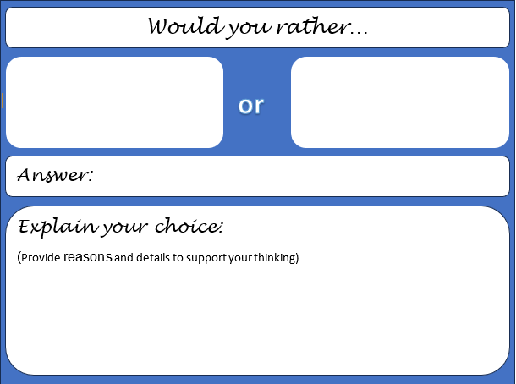

References
This resource contains NSW Curriculum and syllabus content. The NSW Curriculum is developed by the NSW Education Standards Authority. This content is prepared by NESA for and on behalf of the Crown in right of the State of New South Wales. The material is protected by Crown copyright.
Please refer to the NESA Copyright Disclaimer for more information https://educationstandards.nsw.edu.au/wps/portal/nesa/mini-footer/copyright.
NESA holds the only official and up-to-date versions of the NSW Curriculum and syllabus documents. Please visit the NSW Education Standards Authority (NESA) website https://educationstandards.nsw.edu.au/ and the NSW Curriculum website https://curriculum.nsw.edu.au/home.
Mathematics K–10 Syllabus © NSW Education Standards Authority (NESA) for and on behalf of the Crown in right of the State of New South Wales, 2022.

© State of New South Wales (Department of Education), 2023
The copyright material published in this resource is subject to the Copyright Act 1968 (Cth) and is owned by the NSW Department of Education or, where indicated, by a party other than the NSW Department of Education (third-party material).
Copyright material available in this resource and owned by the NSW Department of Education is licensed under a Creative Commons Attribution 4.0 International (CC BY 4.0) license.
This license allows you to share and adapt the material for any purpose, even commercially.
Attribution should be given to © State of New South Wales (Department of Education), 2023.
Material in this resource not available under a Creative Commons license:
- the NSW Department of Education logo, other logos and trademark-protected material
- material owned by a third party that has been reproduced with permission. You will need to obtain permission from the third party to reuse its material.
Links to third-party material and websites
Please note that the provided (reading/viewing material/list/links/texts) are a suggestion only and implies no endorsement, by the New South Wales Department of Education, of any author, publisher, or book title. School principals and teachers are best placed to assess the suitability of resources that would complement the curriculum and reflect the needs and interests of their students.
If you use the links provided in this document to access a third-party's website, you acknowledge that the terms of use, including licence terms set out on the third-party's website apply to the use which may be made of the materials on that third-party website or where permitted by the Copyright Act 1968 (Cth). The department accepts no responsibility for content on third-party websites.

