Area models and divisibility tests
Students explore area models and use them to develop and explain divisibility tests.

Visible learning

Learning intentions
- To be able to represent multiplication and division of integers using area models.
- To understand divisibility tests for 2, 3, 4, 5, 6 and 10.

Success criteria
- I can use an area model to explain a large multiplication.
- I can construct an area model to represent division.
- I can explain why a number is or is not divisible by another integer.

Syllabus outcomes
A student:
- develops understanding and fluency in mathematics through exploring and connecting mathematical concepts, choosing and applying mathematical techniques to solve problems, and communicating their thinking and reasoning coherently and clearly MAO-WM-01
- operates with primes and roots, positive-integers and zero indices involving numerical bases and establishes the relevant index laws MA4-IND-C-01
Mathematics K–10 Syllabus © NSW Education Standards Authority (NESA) for and on behalf of the Crown in right of the State of New South Wales, 2022.
Please use the associated PowerPoint Area models and divisibility tests to display images in this lesson.

Activity structure

Warm up

Blockout
This activity is based on the game ‘Blockout’ from the ‘Maths for love’ website (bit.ly/MFLBlockout).

Equipment
- Two 6-sided dice per group of students.
- Different coloured highlighter pens per group of students.
- One copy of Appendix A ‘Blockout gameboard’ per group.
- One device with internet access per group of students (optional).

Method
- Players are to choose colours, then take turns rolling the dice and shading in a rectangle. If a player rolls a 2 and a 5, they can shade in 10 squares, either a 2 by 5 rectangle, or 1 by 10. This example is shown in Figure 1 below, available on slide 2 of the Area models and divisibility tests PowerPoint.
Figure 1 – a roll of 2 and 5
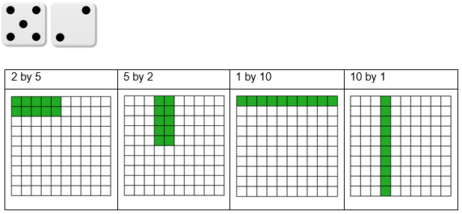
- Players can place their rectangle anywhere in the grid on Appendix A.
Students can alternatively play the game in pairs, online, using the Polypad interactive ‘Blockout’ (bit.ly/PolypadBlockout).
Students can highlight the 2 dice and select roll.
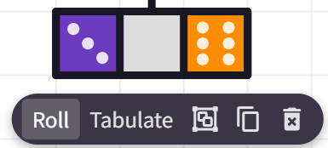
They then copy a coloured rectangle.
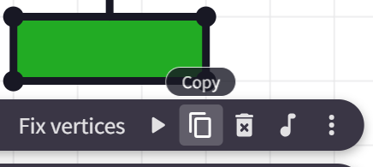
Students can drag the corners to modify the rectangle, and then drag to place it in the grid.
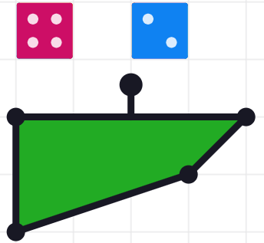
Images created using the free virtual manipulatives at Polypad.org.
- No player can shade a square that is already shaded.
- If a player cannot take their turn, they must pass. An example of a player that cannot take their turn is shown below in Figure 2, also available on slide 3 of the Area models and divisibility tests PowerPoint.
Figure 2 – a roll that cannot be played
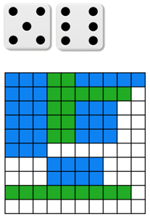
- If each player passes twice in a row, the game ends.
- At the end of the game, players count the number of squares shaded in their colour. The winner is the player with the highest number of squares shaded.
Alternatively, students can play collaboratively, where the aim is to fill as many squares as possible as a team.

Launch
- Display Figure 3 to students. The image is available on slide 4 of the Area models and divisibility tests PowerPoint.
Figure 3 – a large pile of tiny, coloured chocolate treats
‘Smarties confectionery lenses’ by eismannhans is in the Public Domain.
- Present the following problem to students.
Michael is having a movie night with his best friend Allen and wants to invite some other friends. He has a 640 gram bucket of tiny, coloured chocolate treats to share, but he knows that Allen gets upset if there isn’t enough for everyone to have exactly the same amount. Michael knows the bucket has 708 chocolate treats inside.
- Have students engage in a Think-Pair-Share (bit.ly/thinkpairsharestrategy), without access to a calculator, to answer the following questions. The questions can be displayed using Slide 5 of the Area models and divisibility tests PowerPoint.
- Can Michael and Allen share the chocolates equally between the 2 of them? How do you know?
- Can Michael invite one more friend and share the chocolates equally among three people? How do you know?
- Michael has enough chairs for 10 people, including himself and Allen. What is the largest number of people he can have at the movie night and still share the chocolates equally?
The purpose of this launch is to encourage students to consider and talk about factors that impact divisibility. Allow students to express and share their strategies for answering the three questions. There is no need to formalise this here, as this will occur in the Summarise section.

Explore
Explain to students that to solve Michael’s problem with certainty, we need to understand division and will be exploring an area model to help.

Area models for multiplication

Base-10 block area models
If base-10 blocks are unavailable, the following representations can be created online by students using the Desmos graph ‘Base 10 area model multiplication’ (bit.ly/DesmosB10AM) or drawn with pen and paper.
- Give pairs of students base 10 blocks and have them display the start of the area model for $17×24$, as shown in Figure 4 below, available on Slide 6 of the Area models and divisibility tests PowerPoint.
Figure 4 – area model with base 10 blocks
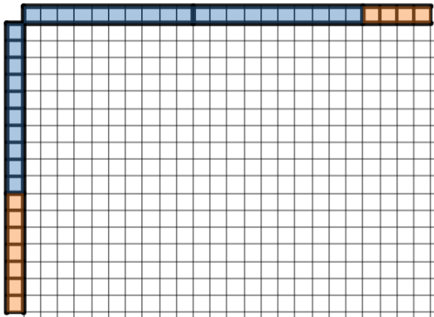
Image created using Desmos and is licensed under the Desmos Terms of Service.
- Allow students time in a Think-Pair-Share (bit.ly/thinkpairsharestrategy) to complete the answer with their remaining blocks.
- Show the answer, as displayed in Figure 5 below, available on Slide 7 of the Area models and divisibility tests PowerPoint.
Figure 5 – complete area model with base-10 blocks
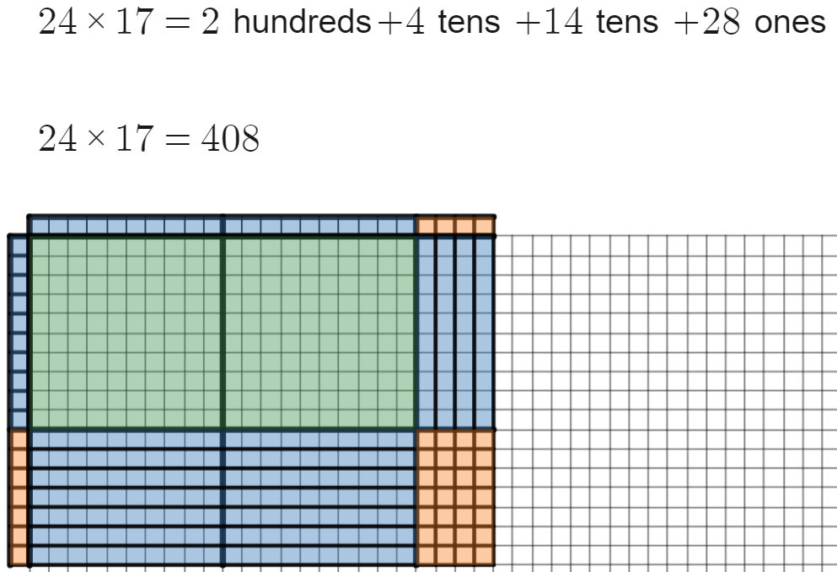
Image created using Desmos and is licensed under the Desmos Terms of Service.
- Hand students Appendix B ‘Area model multiplication 1’ and have pairs calculate multiplications with numbers up to two digits, constructing the area models with their base-10 blocks.

Area models for larger multiplications
- Display the Desmos graph ‘Area model animation tens’ (bit.ly/DesmosAnimationAM) for students on the teacher screen. Start the animation by pressing the play button at the top left of screen.
- Ask students to consider what they estimate the answer for $324×125$ is. Use a Pose-Pause-Pounce-Bounce question strategy [PDF 200KB] (bit.ly/pausepouncebounce) to gather and discuss student responses.
- Use the Desmos graph ‘Area model multiplication’ (bit.ly/DesmosMultAM) to demonstrate how to construct an area model for the multiplication. Drag the slider labelled ‘Show multiplication’ to reveal the area model and the associated calculations.
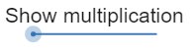
Image created using Desmos and is licensed under the Desmos Terms of Service.
The Desmos graph above allows for multiplication with numbers up to $999×999$ with no scale so areas are visible and clear. To show these areas to scale, use the Desmos graph ‘Scale area model – Hundreds, tens and ones’ (bit.ly/DesmosScaleAM).
- Hand students Appendix C ‘Area model multiplication 2’ and have students calculate multiplications with numbers up to 3 digits, drawing the area models for each calculation by hand in the space provided. Students can be given access to the Desmos graph ‘Area model – Multiplication’ (bit.ly/DesmosMultAM) to assist if devices with internet access are available.

Area model representation for division
- Ask students to consider what they estimate the answer for $154÷11$ is. Use a Pose-Pause-Pounce-Bounce question strategy to gather and discuss student responses.
- Display Figure 6, available on Slide 8 of the Area models and divisibility tests PowerPoint.
Figure 6 – 154 divided by 11 model
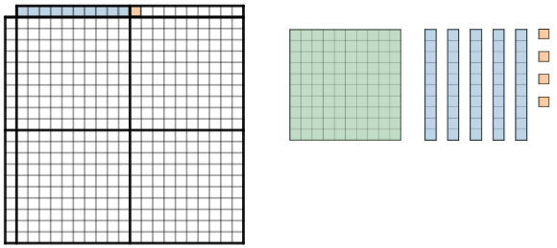
Image created using Desmos and is licensed under the Desmos Terms of Service.
- Have students engage in a Think-Pair-Share to consider how they would use this model to display $154÷11$.
- Conclude that we need to form a rectangle with the pieces to the right that make 154 in the grid with 11 displayed across the top.
- Have students gather these pieces with their base-10 blocks.
- Have students attempt to form a rectangle with the pieces available from 154 to determine a solution that lines up with the 11 across the top.
- Use a Pose-Pause-Pounce-Bounce question strategy to gather solutions from students.
- Explain the solution to students, either in Polypad or by displaying Table 1, available as an image on Slide 9 of the Area models and divisibility tests PowerPoint.
Table 1 – solution to $154÷11$
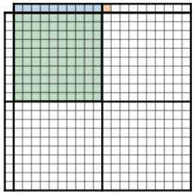 | 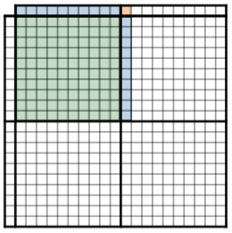 | 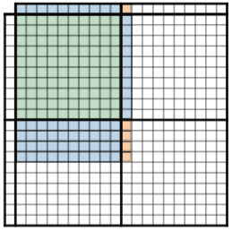 | 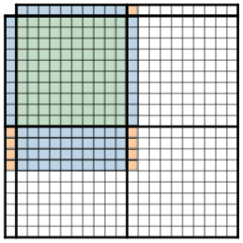
Image created using Desmos and is licensed under the Desmos Terms of Service.
- Ask students to consider whether they believe that $155÷11$ would give us a solution? Use the Pose-Pause-Pounce-Bounce method to have students contribute reasons why it would not work.
Guide students towards the area model as a source for their reasoning. Use the prompt ‘what would happen if we tried to arrange the 155 blocks into a rectangle underneath 11?’
- Display the Desmos graph ‘Area model division’ (bit.ly/DesmosDivideAM) and demonstrate the division $25÷5$.
Teachers can adjust the division using the sliders ‘Dividend’ and ‘Divisor.
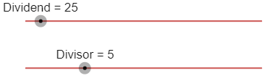
Then form the area model by dragging the areas down until the total matches the dividend.
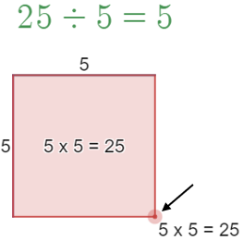
Images created using Desmos and is licensed under the Desmos Terms of Service.
- Demonstrate using this graph that $26÷5$ does not work and discuss with students what happens in this circumstance.
- Inform students that we will be testing some numbers to see if they are divisible by our common digits.
- Hand students a copy of Appendix D ‘Divisibility tests’.
- Instruct students to attempt to use an area model to display each number in the first table divided by 2, 3, 4, 5, 6 and 10 and record a solution for all that can be solved.
Students can use base-10 blocks or draw area models on paper if this is preferred.
Alternatively, students can be given access to devices to construct area models to test divisions.
- The Desmos graph ‘Area model base blocks’ (bit.ly/DesmosAMBlocks) allows students to simulate manipulating physical base-10 blocks into an area model.
- Base-10 blocks can also be simulated using the ‘Number Tiles and Cubes’ section of the ‘Mathigon Polypad’ website(mathigon.org/polypad#number-tiles).
- The Desmos graph ‘Area model division’ (bit.ly/DesmosDivideAM) also allows students to use an area model without base-10 blocks to represent divisions.

Summarise
- Have students engage in a Think-Pair-Share, using the hints in the table at the bottom of Appendix D to consider how we can tell if a dividend is divisible by 2, 3, 4, 5, 6 or 10.
- Have students attempt to write rules for divisibility for 2, 3, 4, 5, 6 and 10 in the table without teacher assistance.
Encourage students to look for trends. Use the prompt ‘what do the numbers that are divisible by this divisor’ have in common?’.
- Return to the problem from the Launch activity and have students produce a solution to the problem using their divisibility tests.
As students are not required to develop divisibility tests for 7, 8 and 9, they can be told or shown that 708 chocolates are not divisible by these numbers. As 708 is divisible by 2 (it is even) and 3 ($7+0+8=15$ and $15=3×5$), it is therefore divisible by 6 making 6 the largest group of people Michael can have at his movie night.
- Have students write notes to their future self (bit.ly/notesstrategy), giving examples to support each of the divisibility rules.

Apply

Shikaku
- Hand students a copy of Appendix E ‘Shikaku’.
- Students are to use a highlighter to draw rectangles on the grid, according to the following rules.
- Each rectangle must contain exactly one number from the grid.
- The number inside the rectangle needs to equal the number of squares used to form the rectangle. For example, the number 9 can sit inside a 1 by 9 rectangle, or a 3 by 3 rectangle.
- The goal is to fill all squares in the grid, with no rectangles overlapping.
A sample solution is available for viewing at the end of this document.
If devices with internet access are available, Shikaku can be played online using the ‘Maths Resources’ website (bit.ly/ShikakuMadness).

First to 50 – divisibility tests

Equipment
- Two 6-sided or 9-sided dice per group of 3 students.
- One copy of Appendix F ‘First to 50 scorecard’ per student.

Method
- Students take turns in the game, completing each of the following steps on their turn.
- Roll 2 dice.
- Make a 2-digit number from your 2 digits. For example, if you roll a 2 and a 5, this could be 25 or 52.
- Write the number in the next row of the table and put crosses in the columns of the divisors that your number is divisible by.
- Add one point to your total score for every tick in your row. For example, the number 52 is divisible by 2 and 4, so the table would look like the table below.
Number | $$÷2$$ | $$÷3$$ | $$÷4$$ | $$÷5$$ | $$÷6$$ | $$÷10$$ | Total score
52 | x |  | x |  |  |  | 2
- The winner is the first player to reach 50 points.
- Once students have finished playing the game, they should discuss the following reflection questions.
- What strategy did you use to score points?
- Which divisors were the easiest to score points from?
- Which divisors were the hardest to score points from?
- Why are some divisors easier to find numbers that will divide them nicely?

Assessment and differentiation

Suggested opportunities for differentiation
Explore
- Students who find using area models challenging can continue to explore using tens and ones only, ‘Scale area model – Tens and ones’ (https://bit.ly/DesmosAMTen).
- The development of the area model follows a concrete (base-10 blocks and Polypad manipulatives) pictorial (drawing area models) and abstract approach to learning about multiplication and division. This is shown to support student’s developing deep understanding about concepts.
Summarise
- Students should be challenged to write formal explanations as to why the divisibility tests work.
- Students can be challenged to examine divisibility tests for further divisors, particularly 7, 8 and 9, when resolving the launch activity.
Apply
- Both the online and printed Shikaku problems have harder and easier problems for students operating at all levels.
- Students who are excelling in the ‘First to 50’ game can be given 3 dice and form 3-digit numbers.

Suggested opportunities for assessment
Warm up and apply
- The block out and shikaku games provide opportunities for teachers to observe students’ knowledge of factors of numbers.
Summarise
- Appendix D provides evidence of a student’s ability to express reasoning, while describing divisibility tests. Teachers can ask students to use the evidence in the first table to justify their decisions of which dividends are divisible by the various divisors.

Appendix A

Blockout gameboard
- Each player takes a turn rolling 2 dice. Multiply the 2 numbers.
- Shade a rectangle on the grid below that has this number of squares.
- You cannot shade a square that has already been shaded. If you cannot fit a rectangle you must pass. If all players pass in a row, the game ends.
- The winner is the player with the most shaded squares at the end.
Image created using the free virtual manipulatives at Polypad.org.

Appendix B

Area model multiplication 1
Question | Representation using base-10 blocks | Answer
$$19×21$$
$$23×51$$
$$29×29$$

Appendix C

Area model multiplication 2
Question | Representation using base-10 blocks | Answer
$$113×144$$
$$364×571$$
$$862×555$$

Appendix D

Divisibility tests
Test each dividend and record if it is divisible by 2, 3, 4, 5, 6 and 10.
Dividend | $$÷2$$ | $$÷3$$ | $$÷4$$ | $$÷5$$ | $$÷6$$ | $$÷10$$
$$20$$ | 10 | Not divisible
$$35$$
$$39$$
$$30$$
$$24$$
$$15$$
$$28$$
$$20$$

Write a rule to help us know if a number is divisible by 2, 3, 4, 5, 6, or 10.
Test | Hint | Rule
$$2$$ | Look at the last digit
$$3$$ | Add all digits together
$$4$$ | Look at the last 2 digits
$$5$$ | Look at the last digit
$$6$$ | Look at the rules above
$$10$$ | Look at the last digit

Appendix E

Shikaku

Beginner
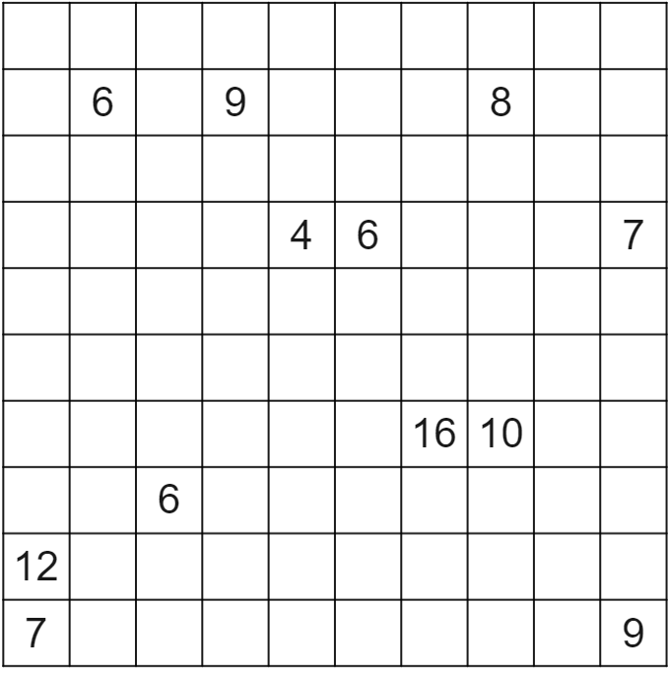
Image created using Desmos and is licensed under the Desmos Terms of Service.

Advanced
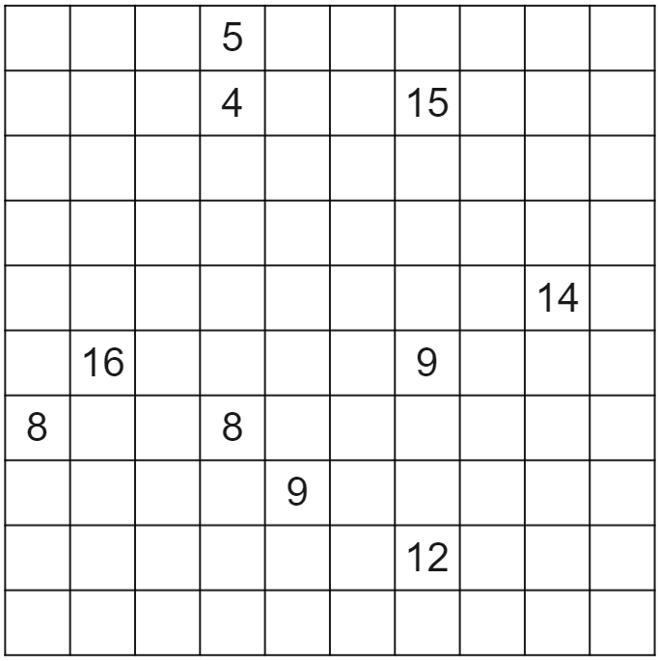
Image created using Desmos and is licensed under the Desmos Terms of Service.

Appendix F

First to 50 scorecard
Number | $$÷2$$ | $$÷3$$ | $$÷4$$ | $$÷5$$ | $$÷6$$ | $$÷10$$ | Total score

Sample solutions

Appendix B – area model multiplication 1
Question | Representation using base-10 blocks | Answer
$$19×21$$ | 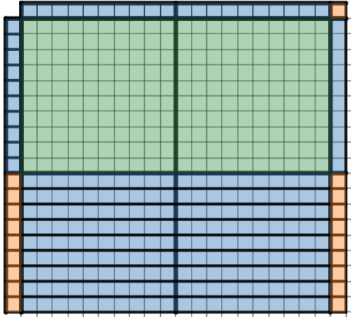 | $$399$$
$$23×51$$ | 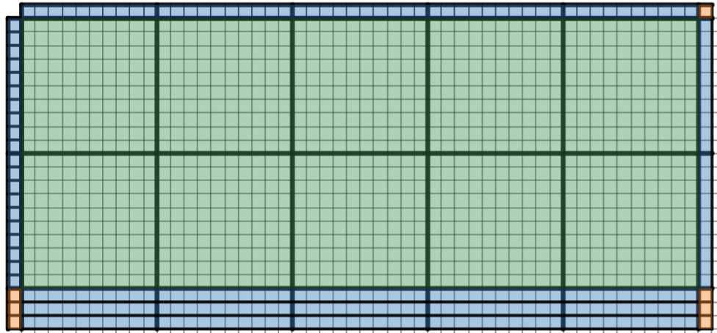 | $$1173$$
$$29×29$$ | 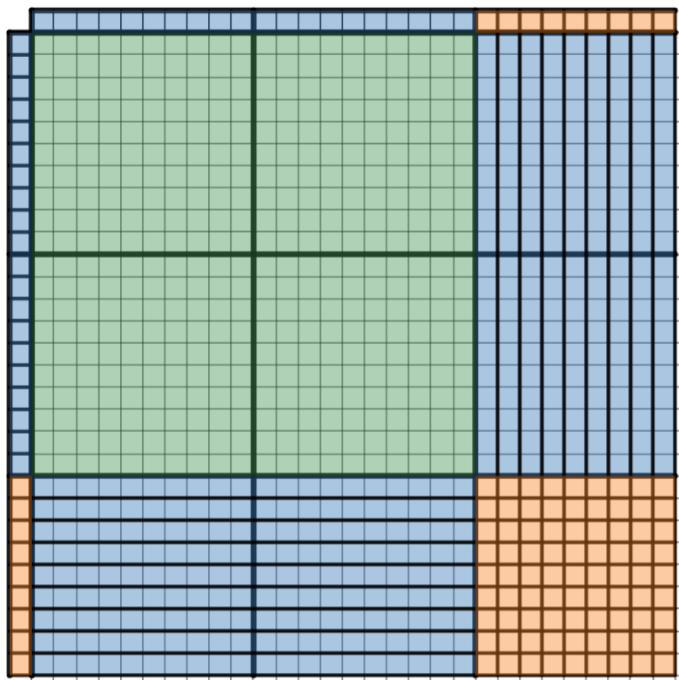 | $$841$$
Image created using Desmos and is licensed under the Desmos Terms of Service.
.

Appendix C – area model multiplication 2
Question | Representation using base-10 blocks | Answer
$$113×144$$ | 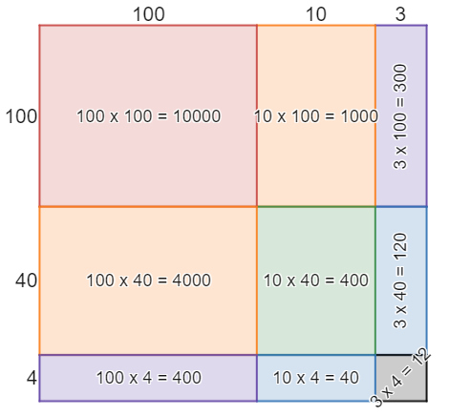 | $$16 272$$
$$364×571$$ | 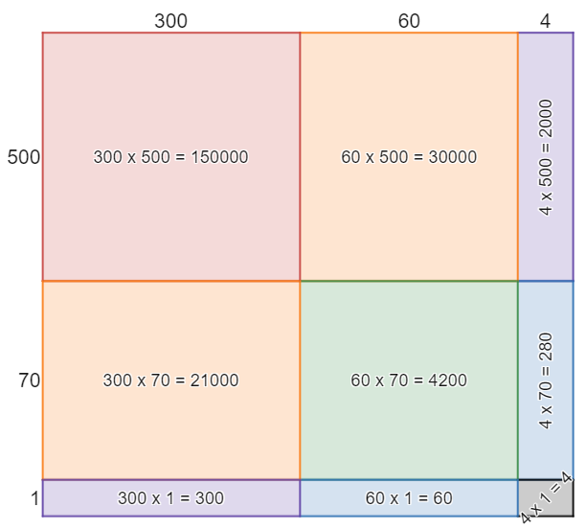 | $$207 844$$
$$862×555$$ | 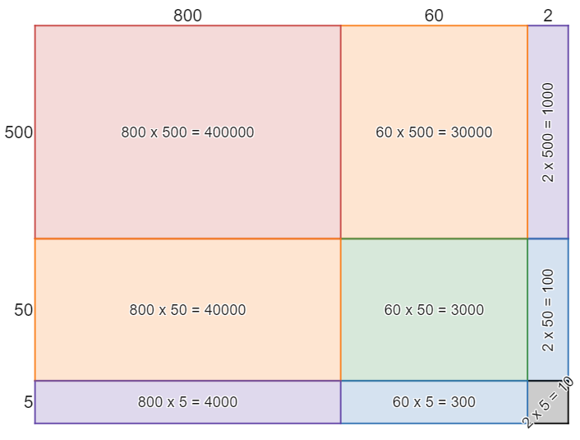 | $$478 410$$
Image created using Desmos and is licensed under the Desmos Terms of Service.

Appendix D – divisibility tests
Dividend | $$÷2$$ | $$÷3$$ | $$÷4$$ | $$÷5$$ | $$÷6$$ | $$÷10$$
$$20$$ | 10 | Not divisible | 5 | 4 | Not divisible | 2
$$35$$ | Not divisible | Not divisible | Not divisible | 7 | Not divisible | Not divisible
$$39$$ | Not divisible | 13 | Not divisible | Not divisible | Not divisible | Not divisible
$$30$$ | 15 | 10 | Not divisible | 6 | 5 | 3
$$24$$ | 12 | 8 | 6 | Not divisible | 4 | Not divisible
$$15$$ | Not divisible | 5 | Not divisible | 3 | Not divisible | Not divisible
$$28$$ | 14 | Not divisible | 7 | Not divisible | Not divisible | Not divisible

Test | Hint | Rule
$$2$$ | Look at the last digit | If the last digit is even, it is divisible by 2.
$$3$$ | Add all digits together | If the digits sum to a multiple of 3, it is divisible by 3.
$$4$$ | Look at the last 2 digits | If the last 2 digits are a multiple of 4, it is divisible by 4.
$$5$$ | Look at the last digit | If the last digit is a 5 or a 0, it is divisible by 5.
$$6$$ | Look at the rules above | If the number is divisible by 2 and 3, it is divisible by 6.
$$10$$ | Look at the last digit | If the last digit is a 0, it is divisible by 10.

Appendix E – Shikaku

Beginner
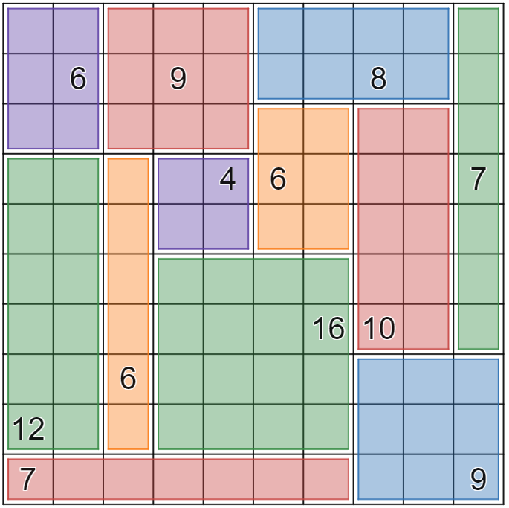
Image created using Desmos and is licensed under the Desmos Terms of Service.

Advanced
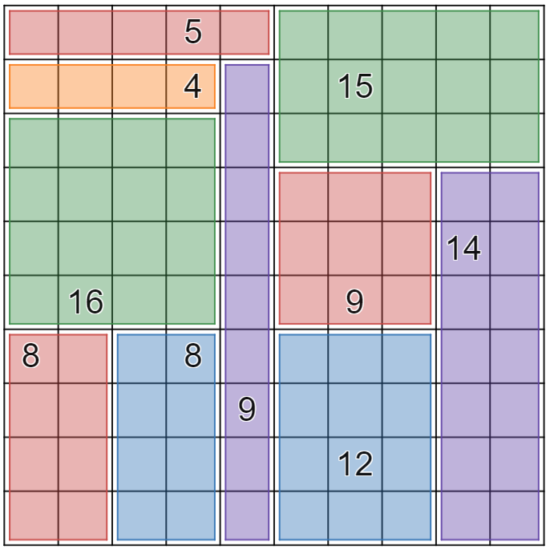
Image created using Desmos and is licensed under the Desmos Terms of Service.

References
This resource contains NSW Curriculum and syllabus content. The NSW Curriculum is developed by the NSW Education Standards Authority. This content is prepared by NESA for and on behalf of the Crown in right of the State of New South Wales. The material is protected by Crown copyright.
Please refer to the NESA Copyright Disclaimer for more information https://educationstandards.nsw.edu.au/wps/portal/nesa/mini-footer/copyright.
NESA holds the only official and up-to-date versions of the NSW Curriculum and syllabus documents. Please visit the NSW Education Standards Authority (NESA) website https://educationstandards.nsw.edu.au/ and the NSW Curriculum website https://curriculum.nsw.edu.au/home.
Mathematics K–10 Syllabus © NSW Education Standards Authority (NESA) for and on behalf of the Crown in right of the State of New South Wales, 2022.

© State of New South Wales (Department of Education), 2023
The copyright material published in this resource is subject to the Copyright Act 1968 (Cth) and is owned by the NSW Department of Education or, where indicated, by a party other than the NSW Department of Education (third-party material).
Copyright material available in this resource and owned by the NSW Department of Education is licensed under a Creative Commons Attribution 4.0 International (CC BY 4.0) licence.
This licence allows you to share and adapt the material for any purpose, even commercially.
Attribution should be given to © State of New South Wales (Department of Education), 2023.
Material in this resource not available under a Creative Commons licence:
- the NSW Department of Education logo, other logos and trademark-protected material
- material owned by a third party that has been reproduced with permission. You will need to obtain permission from the third party to reuse its material.
Links to third-party material and websites
Please note that the provided (reading/viewing material/list/links/texts) are a suggestion only and implies no endorsement, by the New South Wales Department of Education, of any author, publisher, or book title. School principals and teachers are best placed to assess the suitability of resources that would complement the curriculum and reflect the needs and interests of their students.
If you use the links provided in this document to access a third-party's website, you acknowledge that the terms of use, including licence terms set out on the third-party's website apply to the use which may be made of the materials on that third-party website or where permitted by the Copyright Act 1968 (Cth). The department accepts no responsibility for content on third-party websites.

