Sharing, grouping and negating
Students examine division as equal sharing and forming sized groups to consider how each view of division has applications it is more suited to. Students then extend these 3 views to considering scenarios for dividing with negative numbers, using counters to represent operations.

Visible learning
It is recommended that the learning intentions and success criteria not be revealed to students until the Summarise section of this lesson.

Learning intentions
- To understand why dividing a negative integer and a positive integer gives a negative result.
- To understand why dividing 2 negative integers gives a positive result.

Success criteria
- I can divide with positive and negative numbers.
- I can represent division with negatives using counters.
- I can give reasons for results when dividing with negatives.

Syllabus outcomes
A student:
- develops understanding and fluency in mathematics through exploring and connecting mathematical concepts, choosing and applying mathematical techniques to solve problems, and communicating their thinking and reasoning coherently and clearly MAO-WM-01
- compares, orders and calculates with integers to solve problems MA4-INT-C-01
Mathematics K–10 Syllabus © NSW Education Standards Authority (NESA) for and on behalf of the Crown in right of the State of New South Wales, 2022.
Please use the associated PowerPoint Sharing, grouping and negating to display tables and images in this lesson.

Activity structure

Launch
- Display Table 1, which is available on slide 2 of the Sharing, grouping and negating PowerPoint, with solutions on slide 3.
Table 1 – money scenarios
Scenario | Solution
$21 is shared equally among 3 children. How much will each child receive?
James has $30 and wants to buy boxes of chocolates for friends that cost $6. How many boxes of chocolates can he buy?
- Have students engage in a Think-Pair-Share (bit.ly/thinkpairsharestrategy) to answer these 2 questions and to consider what was the same in the 2 questions and what was different.
It is important at this step that it is identified that both problems are best solved with division.
- Show the representations of each of the solutions using Table 2 which is also available on slide 4 of the Sharing, grouping and negating PowerPoint.
Table 2 – representing money scenarios
Scenario | Solution
$21 is shared equally among 3 children. How much will each child receive? | 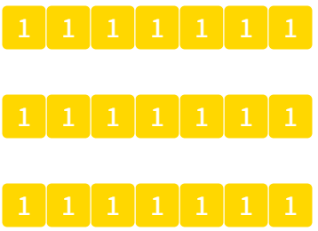
James has $30 and wants to buy boxes of chocolates for friends that cost $6. How many boxes of chocolates can he buy? | 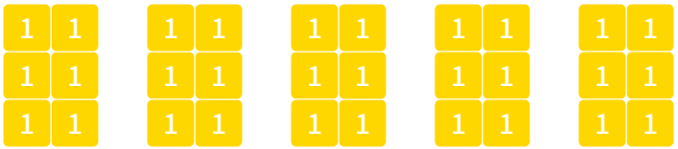
Images created using the free virtual manipulatives at Polypad.org.
- Have students complete a notice/wonder list (bit.ly/noticewonderstrategy) in their pairs and share with the class.
- Highlight the fact that while they are both solved with division, the solution to the first problem is the number in each group and the solution to the second problem is the number of groups.
- Display Table 3, which is also available on slide 5 of the Sharing, grouping and negating PowerPoint and as an example in Appendix A ‘Applying division’.
Table 3 – types of division
Division | Scenario | Operation | Solution
Equal sharing | $21 is shared equally among 3 children. How much will each child receive? | $$21÷3$$ | $$\$7$$
Sized groups | James has $30 and wants to buy boxes of chocolates for friends that cost $6. How many boxes of chocolates can he buy? | $$30÷6$$ | $5$ boxes
- Define 2 types of division with students.
- Division as equal sharing is where we share equally and the solution is the number in each group.
- Division as sized groups is where we form groups of a certain size and the solution is the number of groups we form.
- Organise students into visibly random groups of 3 (bit.ly/visiblegroups).
- Hand students a copy of Appendix A ‘Applying division’ and have them fill in the empty cells of the tables, analysing and creating questions that use each type of division.
Students can be given large piles of counters and asked to represent each division as shown in Table 2. Alternatively, they can form these representations using number tiles in Polypad (mathigon.org/polypad) or draw representations.
- Bring the class together and reflect on which type of division was easiest and most difficult to create an example of.
- Ask students to consider how you might represent $\left(-15\right)÷3$. Ask: If we start with the dividend, $(-15)$, would it be best to try to share this into $3$ equal groups, or to try to make groups of size $3$?
- Inform students that this is what we will be trying to answer throughout the lesson.

Explore

Equipment
- A large pile of counters or base-10 blocks per group of students.
- One copy of Appendix B ‘Exploring debt’ per student, printed.

Representing division
- With students still in their groups from the previous activity, hand out large sets of counters and copies of Appendix B.
- Ask the class to consider why the first problem is listed as equal sharing. Use a Pause-Pose-Pounce-Bounce question strategy [PDF 200KB] (bit.ly/pausepouncebouncestrategy)
- to gather student contributions.
Students should share that because we are sharing $30 equally, we are making 5 groups but we do not yet know the size. Hence, we share equally and count the size of the groups to determine a solution.
- Have students represent the divisions physically using counters, before drawing representations.
- Select students randomly to share the type of division for each problem, what it looks like represented and a solution.
It is important to identify why a particular question is either best addressed as equal sharing or sized groups. For example, in the second problem in the table, we know Blake has $35 and we are making groups of size $5 for each train ticket he will purchase before counting the number of groups to determine a solution.

Equal sharing with negatives
- Display Table 4 which shows the third problem from Appendix B, which is available on slide 6 of the Sharing, grouping and negating PowerPoint.
Table 4 – equal sharing with negatives
Scenario | Type of Division | Representation | Operation
Julianna owes a friend $20. She and her three sisters agree that they will all pay an equal amount back. What is the amount of each girl’s debt? | Equal sharing |  | $$(-20)÷4=$$
- Ask randomly selected students to share why the expression now has a negative in front of it.
- Conclude with students that the negative represents that the $20 is owed.
- Display Figure 1, which is also available on slide 7 of the Sharing, grouping and negating PowerPoint.
Figure 1 – $20 debt represented as negative ones.
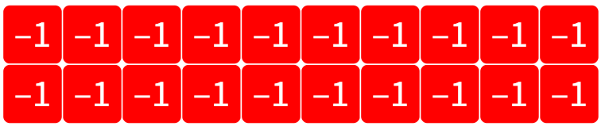
Image created using the free virtual manipulatives at Polypad.org.
- Inform students that this is our total of $20 represented as debt and have them discuss in their groups how we would represent this debt equally shared amongst the 4 sisters.
- Ask randomly selected students to share their methods before displaying the solution in Figure 2, also available as slide 8 in the Sharing, grouping and negating PowerPoint.

Figure 2 – $20 debt equally shared negative ones
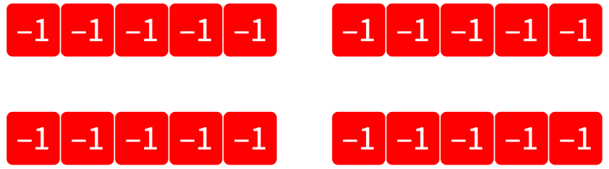
Image created using the free virtual manipulatives at Polypad.org.
- Conclude with students that this representation shows that $\left(-20\right)÷4=(-5)$ because there are $(-5)$ tiles in each group.
- Discuss with students why this would not work as sized groups, because we can’t make groups of size 4 when all we have is 20 negative ‘ones’.
Teachers should acknowledge that this is another way of approaching the same problem. The approach students originally wrote, as displayed in the solutions at the end of this document, is still a correct and valid approach to solving the problem.

Sized groups with negatives
- Display Table 5 which shows the fourth problem from Appendix B, which is available on slide 9 of the Sharing, grouping and negating PowerPoint.
Table 5 – sized groups with negatives
Scenario | Type of Division | Representation | Operation
Mark borrowed $8 a week from his parents until he owed them $40. How many weeks did he borrow money for? | Sized groups |  | $$(-40)÷(-8)=$$
- Ask randomly selected students to share why the expression now has two negative values in it.
- Conclude with students that the negative represents that the $40 and the $8 is borrowed and therefore owed.
- Display Figure 3, which is also available on slide 10 of the Sharing, grouping and negating PowerPoint.
Figure 3 – $40 debt represented as negative ones
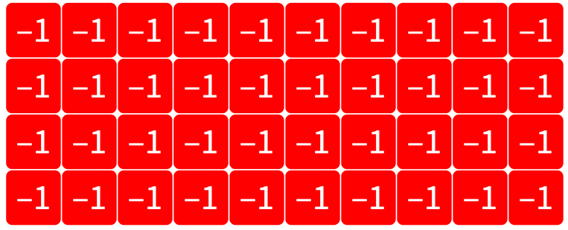
Image created using the free virtual manipulatives at Polypad.org.
- Inform students that this is our total of $40 debt represented as negative ‘ones’ and have them discuss in their groups how we would represent this debt as groups of size negative $8.
- Ask randomly selected students to share their methods before displaying the solution in Figure 4, also available as Slide 11 in the Sharing, grouping and negating PowerPoint.
Figure 4 – $40 debt as groups of 8 negative ones
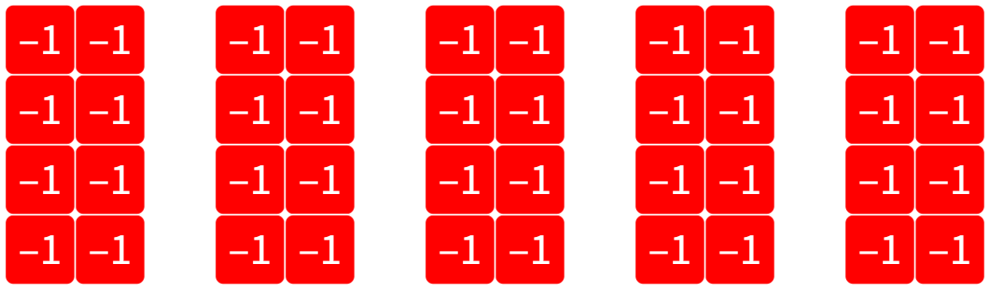
Image created using the free virtual manipulatives at Polypad.org.
- Conclude with students that this representation shows that $\left(-40\right)÷\left(-8\right)=5$ because there are $5$ groups.
- Discuss with students why this would not work as equal sharing, because we can’t make $(-8)$ groups.

Summarise
- Conclude with students that common trends appear in the way we represent division problems:
- The first number, called the dividend, is the number of tiles we start with (positive or negative).
- The second number, call the divisor, tells us either the size of the groups or the number groups we want to make.
- Use Slides 12–23 from the Sharing, grouping and negating PowerPoint for explicit teaching of division with negative numbers.
The explicit teaching technique used in the associated PowerPoint is ‘Your turn.’ The first slide is a worked example which should be displayed for the students and then use the following steps.
      - Reveal the question to students and its solution.
      - Students read in silence.
      - Students individually think and explain to themselves what is happening in each step.
      - Students hold up a thumbs up to the teacher when they have finished reading and have some sort of understanding.
      - Think-Pair-Share. Students explain the solution to their partner.
      - In pairs, students then answer the self-explanation questions.
      - Finally, randomly select students to share their answers with the whole class.
      - Review the notes section of the PowerPoint slides to find important considerations for teachers when engaging in class discussions.

- Students are to write notes to their future forgetful self (bit.ly/notesstrategy). Some examples the students may like to use to ensure they have covered all possibilities are listed below.
- $15÷\left(-3\right)$
- $\left(-15\right)÷\left(-3\right)$
- $\left(-15\right)÷3$
- Hand students a copy of Appendix C ‘Division with negatives practice’ and have them complete individually.

Apply
- Students complete the ‘Integer Venns’ activity in Appendix D. Students are asked to create a 2 number multiplication that satisfies each section of the Venn diagram.
- If they believe a section is impossible to fill, they need to provide justification of their reasoning.
- Two versions of this task have been created. The second uses similar initial criteria from the 2-circle version but adds in criteria to increase the complexity of the task.

Assessment and differentiation

Suggested opportunities for differentiation
Explore
- Students can be challenged to generalise their rules for dividing with negative numbers before revealing the interpretations in the summarise section. For example, students should be asked to consider why the result of a negative total divided by a negative divisor will always be positive (because the result will be the number of groups formed, which cannot be negative).
Apply
- When completing the Venn diagrams in Appendix D, higher achieving students should be challenged to try and make as few changes to their sums between regions as possible.
- Students could be challenged to create their own criteria for an Integer Venn, complete with sample solutions.

Suggested opportunities for assessment
Launch
- Teachers should monitor student interactions during groupwork to assess their abilities with addition of positive integers and remediate where required.
Explore
- Appendix B can be collected as evidence of students’ ability to create and test a rule for dividing with negatives.
- Teachers are encouraged to listen to discussions for evidence of student understanding of negative numbers.
Summarise
- Appendix C can be collected as evidence of students’ ability to divide with negative numbers.
Apply
- Students can be challenged to complete the integer Venn with as little change between expressions as possible and their success in this task gives evidence of their understanding of division with integers.

Appendix A

Applying division
The tables below show 2 types of division scenarios, the related operation used to solve the problem and the solution. Complete the second and third tables by reviewing or creating scenarios related to each situation.

Finance
Division | Scenario | Operation | Solution
Equal sharing | $21 is shared equally among 3 children. How much will each child receive? | $$21÷3$$ | $$\$7$$
Sized grouping | James has $30 and wants to buy boxes of chocolates for friends that cost $6. How many boxes of chocolates can he buy? | $$30÷6$$ | $5$ boxes

People
Division | Scenario | Operation | Solution
 | How many teams of 5 can be made from a crowd of 45 people?
 | There are 6 large tables in a classroom for 24 students. How many students should sit at each table?

Time
Division | Scenario | Operation | Solution
Sized grouping |  |  | $6$ TV episodes
Equal sharing |  |  | $5$ minutes

Appendix B

Exploring debt
Represent each problem with counters and then fill in the table by drawing the representation, writing the type of division (equal sharing or sized groups) and a solution to the problem. The first problem is completed for you.
Problem | Type of division | Representation | Solution
$30 is to be shared amongst 6 people. How much money does each person get? | Equal sharing | 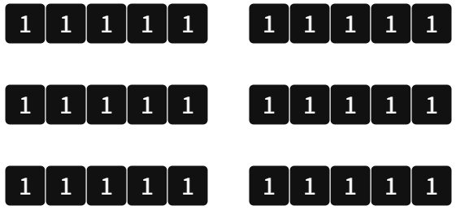 | $$30÷6=\$5$$
A return train ticket to school costs $5 and Blake has $35 in his bank account. For how many days can Blake buy a train ticket before he needs more money?
Julianna owes a friend $20. She and her three sisters agree that they will all pay an equal amount back. What is the amount of each girl’s debt?
Mark borrowed $8 a week from his parents until he owed them $40. How many weeks did he borrow money for?
Image created using the free virtual manipulatives at Polypad.org.

Appendix C

Division with negatives practice
Question | Representation using counters | Answer
$$8÷2$$
$$\left(-8\right)÷2$$
$$\left(-8\right)÷\left(-2\right)$$
$$8÷\left(-2\right)$$
$$\left(-12\right)÷2$$
$$\left(-12\right)÷4$$
$$\left(-12\right)÷6$$
$$\left(-12\right)÷\left(-6\right)$$
$$\left(-12\right)÷\left(-4\right)$$
$$\left(-12\right)÷\left(-2\right)$$
$$12÷\left(-2\right)$$
$$12÷\left(-4\right)$$
$$12÷\left(-6\right)$$
$$\left(-12\right)÷\left(-3\right)÷\left(-2\right)$$

Appendix D

Integer Venns

Two circle Venn
Think of a 2 number division that could belong in each region. If you think a region is impossible to fill, convince me why!
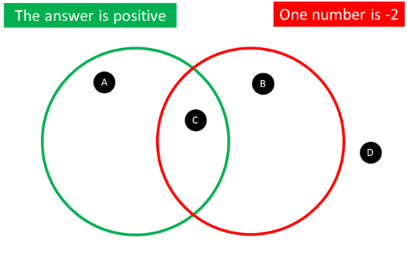

Three circle Venn
Think of a 2 number division that could belong in each region. If you think a region is impossible to fill, convince me why!
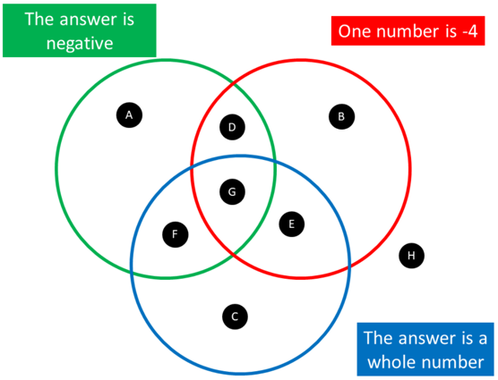

Sample solutions

Appendix A – applying division

People
Division | Scenario | Operation | Solution
Sized grouping | How many teams of 5 can be made from a crowd of 45 people? | $$45÷5$$ | $9$ teams
Equal sharing | There are 6 large tables in a classroom for 24 students. How many students should sit at each table? | $$24÷6$$ | 4 students

Time
Division | Scenario | Operation | Solution
Sized grouping | How many 20-minute episodes of my favourite show can I watch in 2 hours? | $$120÷20$$ | $6$ TV episodes
Equal sharing | In a 60-minute lesson, how long will 12 students each have to present their speech? | $$60÷12$$ | $5$ minutes

Appendix B – exploring debt
Problem | Type of division | Representation | Solution
$30 is to be shared amongst 6 people. How much money does each person get? | Equal sharing |  | $$30÷6=\$5$$
A return train ticket to school costs $5 and Blake has $35 in his bank account. For how many days can Blake buy a train ticket before he needs more money? | Sized groups | 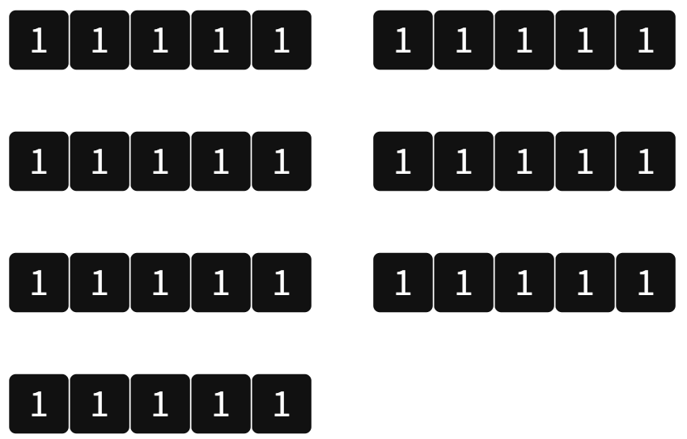 | $35÷5=7$ days
Julianna owes a friend $20. She and her three sisters agree that they will all pay an equal amount back. What is the amount of each girl’s debt? | Equal sharing | 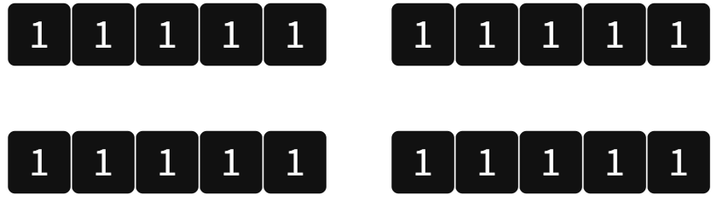 | $$20÷4=\$5$$
Mark borrowed $8 a week from his parents until he owed them $40. How many weeks did he borrow money for? | Sized groups | 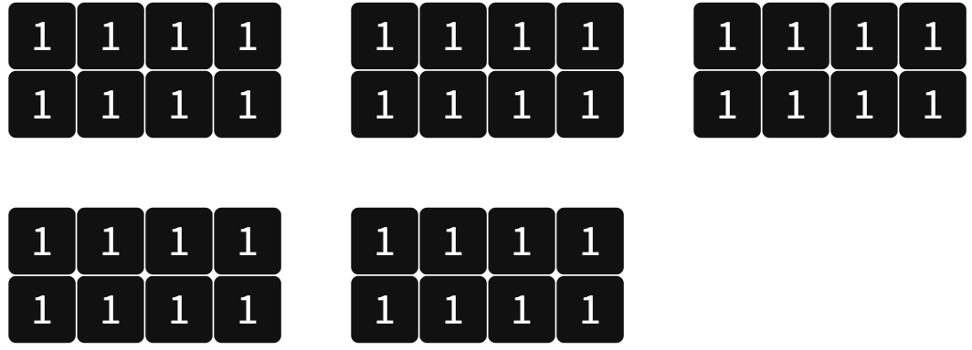 | $40÷8=5$ weeks.
Image created using the free virtual manipulatives at Polypad.org.

Appendix C – division with negatives practice
Question | Representation using counters | Answer
$$8÷2$$ |  | $$4$$
$$\left(-8\right)÷2$$ | 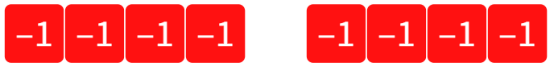 | $$\left(-4\right)$$
$$\left(-8\right)÷\left(-2\right)$$ | 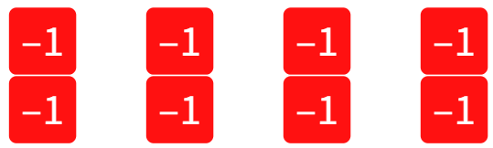 | $$4$$
$$8÷\left(-2\right)$$ | 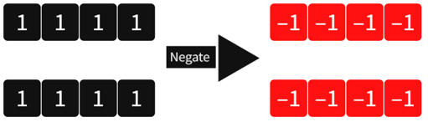 | $$\left(-4\right)$$
$$\left(-12\right)÷2$$ |  | $$\left(-6\right)$$
$$\left(-12\right)÷4$$ | 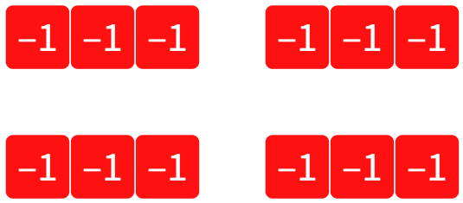 | $$\left(-3\right)$$
$$\left(-12\right)÷6$$ | 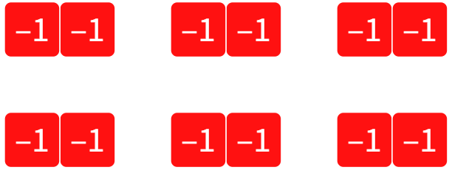 | $$\left(-2\right)$$
$$\left(-12\right)÷\left(-6\right)$$ | 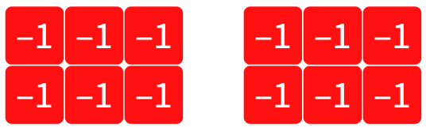 | $$2$$
$$\left(-12\right)÷\left(-4\right)$$ | 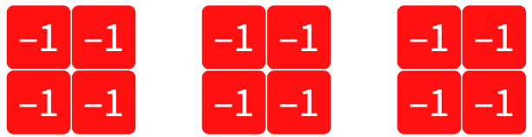 | $$3$$
$$\left(-12\right)÷\left(-2\right)$$ | 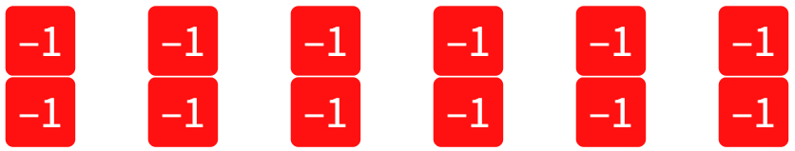 | $$6$$
$$12÷\left(-2\right)$$ | 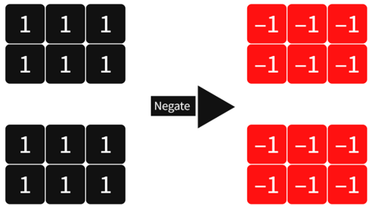 | $$\left(-6\right)$$
$$12÷\left(-4\right)$$ | 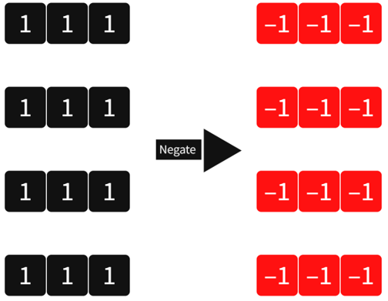 | $$\left(-3\right)$$
$$12÷\left(-6\right)$$ | 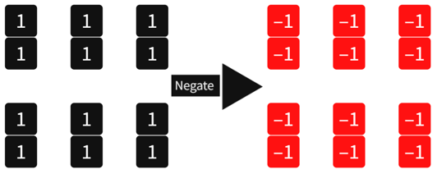 | $$\left(-2\right)$$
$$\left(-12\right)÷\left(-3\right)÷\left(-2\right)$$ | 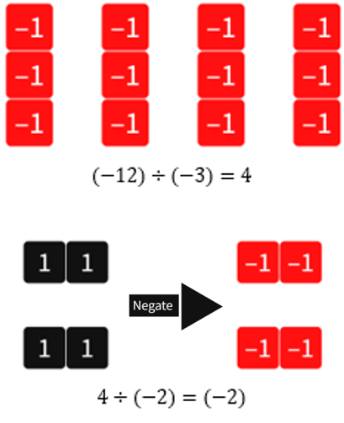 | $$4÷\left(-2\right)=\left(-2\right)$$
Images created using the free virtual manipulatives at Polypad.org.

Appendix D – integer Venns

Two circle Venn
Region A: $\left(-8\right)÷\left(-4\right)=2$
Region B: $10÷\left(-2\right)=\left(-5\right)$
Region C: $\left(-20\right)÷\left(-2\right)=10$
Region D: $12÷3=4$

Three circle Venn
Region A: $\left(-10\right)÷4=\left(-\frac{10}{4}\right)=\left(-\frac{5}{2}\right)$ or $\left(-2.5\right)$
Region B: $\left(-10\right)÷\left(-4\right)=\left(\frac{-10}{-4} \right)=\frac{10}{4}=\frac{5}{2}$ or $2.5$
Region C: $15÷3=5$
Region D: $10÷\left(-4\right)=\left(\frac{10}{-4}\right)=\left(-\frac{10}{4}\right)=\left(-\frac{5}{2}\right)$ or $\left(-2.5\right)$
Region E: $\left(-4\right)÷\left(-2\right)=2$
Region F: $4÷\left(-2\right)=\left(-2\right)$
Region G: $\left(-4\right)÷2=\left(-2\right)$
Region H: $6÷4=\frac{6}{4}=\frac{3}{2}$ or $1.5$

© State of New South Wales (Department of Education), 2023
The copyright material published in this resource is subject to the Copyright Act 1968 (Cth) and is owned by the NSW Department of Education or, where indicated, by a party other than the NSW Department of Education (third-party material).
Copyright material available in this resource and owned by the NSW Department of Education is licensed under a Creative Commons Attribution 4.0 International (CC BY 4.0) licence.
This licence allows you to share and adapt the material for any purpose, even commercially.
Attribution should be given to © State of New South Wales (Department of Education), 2023.
Material in this resource not available under a Creative Commons licence:
- the NSW Department of Education logo, other logos and trademark-protected material
- material owned by a third party that has been reproduced with permission. You will need to obtain permission from the third party to reuse its material.
Links to third-party material and websites
Please note that the provided (reading/viewing material/list/links/texts) are a suggestion only and implies no endorsement, by the New South Wales Department of Education, of any author, publisher, or book title. School principals and teachers are best placed to assess the suitability of resources that would complement the curriculum and reflect the needs and interests of their students.
If you use the links provided in this document to access a third-party's website, you acknowledge that the terms of use, including licence terms set out on the third-party's website apply to the use which may be made of the materials on that third-party website or where permitted by the Copyright Act 1968 (Cth). The department accepts no responsibility for content on third-party websites.

