Negative groups of negatives
Students develop and use a variety of representations, including counters and zero pairs, to model multiplication of positive and negative integers. They will play a game involving dice and cards to practise representing products.

Visible learning
In this lesson, the learning intentions and success criteria are introduced within the Summarise section, rather than at the beginning of the lesson.

Learning intentions
- To understand why multiplying a negative integer and a positive integer gives a negative result.
- To understand why multiplying two negative integers gives a positive result.

Success criteria
- I can multiply positive and negative integers.
- I can represent multiplication with negative integers using counters.
- I can give reasons for results when multiplying with negatives integers.

Syllabus outcomes
- develops understanding and fluency in mathematics through exploring and connecting mathematical concepts, choosing and applying mathematical techniques to solve problems, and communicating their thinking and reasoning coherently and clearly MAO-WM-01
- compares, orders and calculates with integers to solve problems MA4-INT-C-01
Mathematics K–10 Syllabus © NSW Education Standards Authority (NESA) for and on behalf of the Crown in right of the State of New South Wales, 2022.

Activity structure
Please use the associated PowerPoint Negative groups of negatives to display images in this lesson.

Launch

First to 100

Equipment
- One 6-sided dice per group of students
- One deck of playing cards per group of students, picture cards removed
- One printed copy of Appendix A ‘Scorecard’ per group of students
- One device with internet access per group of students (optional)

Method
- Organise students into visibly random groups of 3 (bit.ly/visiblegroups) and hand each group a 6-sided dice, a deck of playing cards (picture cards removed) and a single copy of Appendix A ‘Scorecard’.
- Instruct students that they are to take turns rolling the dice and randomly selecting a playing card from the deck. An example turn is shown in Figure 1, which can be found on slide 2 of the Negative groups of negatives PowerPoint.
Figure 1 – dice and playing card example
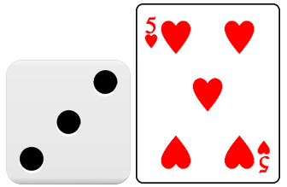
This Photo by Unknown Author is licensed under CC BY-SA.
- Students attempt to represent the multiplication of these 2 numbers using the Desmos graph ‘Dice and Cards’ (bit.ly/DesmosDiceCards). Students use the Number of groups slider shown below to represent the number on their dice.
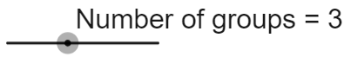
- Students then move the Number in each group slider shown below to represent the number of their chosen card.
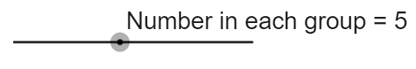
- Display the example from Figure 1 in Desmos as shown in
Figure 2. Figure 2 can be displayed using slide 3 of the Negative groups of negatives PowerPoint.
Figure 2 – three groups of 5
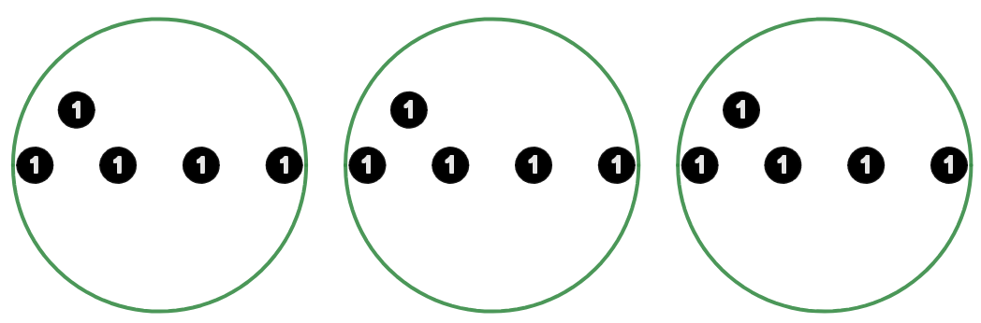
Image created using Desmos and is licensed under the Desmos Terms of Service.
If devices are unavailable, students can either be shown the representation in Figure 2 and then encouraged to draw this for their activity, or, if available, use counters with different colours on each side, for example black and red. The idea would be to have students use one colour every time. For instance, using the black side so that the other side (red) is available to represent negative ‘ones’ later in the lesson.
- Students should record their calculation and score as well as their new total after each turn. Example turns are shown at the top of Appendix A.
- The winner is the first player to reach 100.
- After playing the game a few times, have students discuss the following reflection questions as a group:
- How many turns did it take you to get to 100?
- What are the largest and smallest totals you scored on a single turn?
- What are the largest and smallest totals you could score on a single turn?
- What are the largest and smallest number of turns you can take before reaching 100?

First to 100 with negative cards
- Inform students that we are going to play the game again but that red cards now represent negative numbers.
- Students using devices and the Desmos graph ‘Dice and Cards’ (bit.ly/DesmosDiceCards) can be shown how to use the Positive/negative switch shown below to turn on the ability to switch between ‘ones’ and ‘negative ones’.
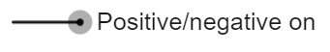
- Students then use the Black card (Positive) switch shown below to change black ‘ones’ counters to red ‘negative ones’ counters.
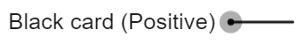
Students drawing their representations need to have 2 different colours to represent the totals on the red and black cards. Students using 2-sided counters should be encouraged to use the second colour when representing a red card.
- Have students play the game with this new rule, recording their results on the second table in Appendix A.
The purpose of this second game is for students to develop their own ways of interpreting groups of negative numbers and to test their interpretations by playing the game to see if they hold up to different situations.
If students are stuck or ask for assistance, encourage them to look at how nearby groups have interpreted the negative cards. Alternatively, teachers should consider advancing questions to support students to develop a hypothesis, such as ‘do you expect getting a negative card will be a good or a bad thing for your score?’.
- Have students discuss the following questions in groups:
- How did you change your result when the card was red?
- Can you show why this was the answer?
It is important at this stage to conclude that just as 3 × 5 can be considered as 3 groups of 5, 3 × (−5) can be considered as 3 groups of (−5), read as ‘three groups of negative five’.

Explore

First to 100 with 2 cards

Equipment
- One deck of playing cards per group of students, picture cards removed
- One new, printed copy of Appendix A ‘Scorecard’ per group of students.
- One device with internet access per group of students (optional)
- One copy of Appendix B ‘Interpreting cards’ per student

Method
- Collect dice so that students are left with a deck of cards. Hand them a new copy of Appendix A.
- Instruct students that they will now get their 2 numbers by drawing 2 cards from the deck. Black cards are still positive and red cards are still negative.
- Display Table 1, which is available on slide 4 of the Negative groups of negatives PowerPoint.

Table 1 – two playing cards example
Turn 1  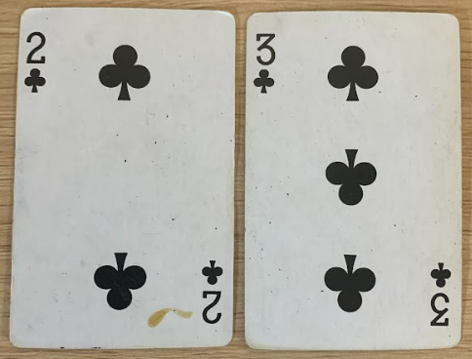 | Turn 2  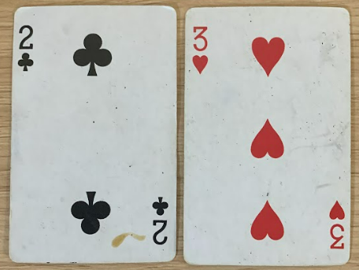
Turn 3  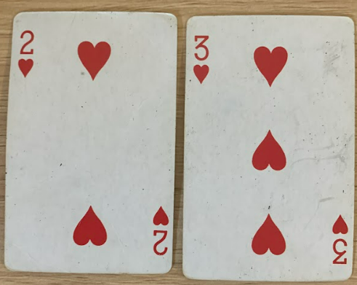 | Turn 4  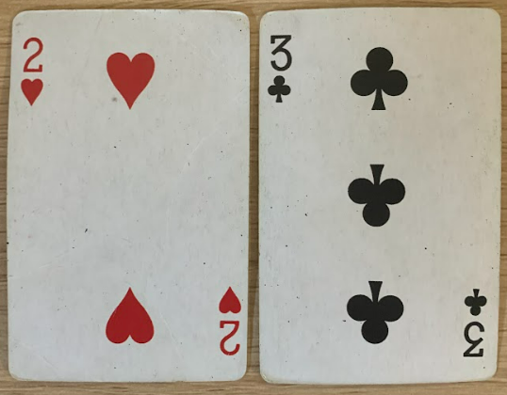
- Have students engage in a Think-Pair-Share (bit.ly/thinkpairsharestrategy) to consider what the result of each of these 4 example ‘turns’ might be.
Emphasise that one card still represents the number of groups and the other card represents the number in each group.
Prompts to support student discussion could include:
- What multiplication does each pair of cards represent?
- Do you know the results of the top 2 from what was decided in the previous game?
- If ‘Turn 2’ is negative 6, what do think will happen in ‘Turn 3’ when we change one card?
- Conclude that each operation is 6, but that we need to make decisions as to whether each will be positive or negative.
- Allow students to play the game, deciding whether a multiplication is a positive or negative result based on what they have discussed in step 4.
During this task students will need to consider what negative groups of negatives are and teachers should allow this productive struggle. It is suggested to allow students to make a decision about double negative results, apply it to multiple turns and consider whether it works.
- Hand each student a copy of Appendix B and have them complete the task individually, based on the decisions made during their game.

Summarise
The representations chosen for this section of the lesson are inspired and adapted from the work of Peter Mattock. If the representations are unclear, teachers can view the YouTube video of Peter Mattock’s ‘Multiplication of Negative numbers (14:35)’ (bit.ly/YouTubePMMultInt).
The explicit teaching resources below use representations to give meaning to 3 different types of integer multiplication. The teacher notes section of the PowerPoint is essential to understanding the steps that are being used.
- Use slides 5–16 from the Negative groups of negatives PowerPoint for explicit teaching of multiplication with negative numbers.
The explicit teaching technique used in the PowerPoint is ‘Your turn’. The first slide is a worked example which should be displayed for the students before using the following steps.
- Reveal the question to students and its solution.
- Students read in silence.
- Students individually explain to themselves what is happening in each step.
- Students hold a thumbs up to the teacher when they have finished reading and have some sort of understanding.
- Think-Pair-Share. Students explain the solution to their partner.
- In pairs, students then answer the self-explanation questions.
- Finally, randomly select students to share their answers with the whole class.
- Review the notes section of the PowerPoint slides to find important considerations for teachers when engaging in class discussions.
- Ask students to consider their solutions to Appendix B, having completed the explicit teaching, ‘Your turn’ PowerPoint.
- Use a Pause-Pose-Pounce-Bounce question strategy [PDF 200KB] (bit.ly/pausepouncebouncestrategy) to obtain student answers to the questions in Appendix B.
- Students are to write notes to their future forgetful self (bit.ly/notesstrategy). Some examples the students may like to use to ensure they have covered all possibilities are listed below.
- $5×(-3)$
- $\left(-5\right)×3$
- $\left(-5\right)×(-3)$
- Hand students a copy of Appendix C ‘Multiplication with negatives practice’ and have them complete the activity individually. This resource has been designed using Variation Theory (variationtheory.com/introduction/).

Apply

Activity 1 – integer Venns
- Students complete the ‘Integer Venns’ activity in Appendix D. Students are asked to create a 2-number multiplication that satisfies each section of the Venn diagram.
- If they believe a section is impossible to fill, they need to justify their reasoning.
- Two versions of this task have been created. The second uses the same initial criteria from the 2-circle version but adds criteria to increase the complexity of the task.

Activity 2 – open middle problem
- Challenge students to complete the open middle problem displayed on slide 18 of the Negative groups of negatives PowerPoint. This problem is also displayed in Figure 3 and is inspired by the problem at the ‘Open middle’ website, (bit.ly/OMMultIntegers2).
Figure 3 – open middle problem
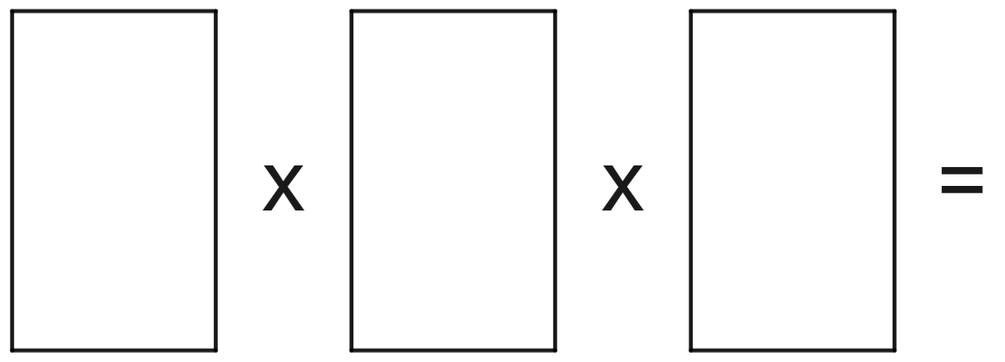
Image created using Desmos and is licensed under the Desmos Terms of Service.
- Students are to use the integers from −9 to 9 at most once to try to obtain the largest possible result. Teachers can print this from Appendix E ‘Open middle problem’ if desired.
- Have students consider the question ‘What would happen if we had 3 negative numbers multiplied together?’

Assessment and differentiation

Suggested opportunities for differentiation
Overall
- Teachers may choose to introduce different scenarios that require multiplying with negatives over different lessons rather than all at once. For example, a similar structure can be followed by using slides 6 to 9 of the associated PowerPoint in a single lesson and focusing only on representing positive numbers of groups of negative numbers. Appendix D would need to be provided once all scenarios had been considered.
Launch
- Using the Desmos graph to represent multiplications can support students who are still developing their multiplicative thinking skills. Students can move the slider to match the cards and dice to participate and view what is happening.
Explore
- Teachers are encouraged to support students to make decisions by asking prompting questions when they define how to work with 2 red cards. For example, asking ‘What if we drew 2 red 5’s’.
- Challenge students to express their ideas with a generalised rule.
Apply
- When completing the Venn diagrams in Appendix D, higher achieving students should be challenged to try and make as few changes to their sums between regions as possible.
- Students could be challenged to create their own criteria for an integer Venn, complete with sample solutions.

Suggested opportunities for assessment
Explore
- Appendix B can be collected as evidence of students’ ability to create and test a rule for multiplying with negatives.
- Teachers are encouraged to listen to discussions for evidence of student understanding of negative numbers.
Summarise
- Appendix C can be collected as evidence of students’ ability to multiply with negative numbers.
Apply
- Students can be challenged to complete the integer Venn with as little change between expressions as possible. Their success in this task gives evidence of their understanding of multiplication with integers.

Appendix A

Scorecard
Use the tables under each heading to record each player’s calculation, scores and total in the game. The example table below shows each player’s results for 2 turns. The winner is the first player to reach a total of 100.
Player 1 | Total | Player 2 | Total | Player 3 | Total
For example, $3×5=15$ | $$15$$ | For example, $2×10=20$ | $$20$$ | For example, $1×2$ | $$2$$
For example, $2×7=14$ | $$15+14=29$$ | For example, $3×4=12$ | $$20+12=32$$ | For example, $5×8=40$ | $$2+40=42$$

Game 1
Player 1 | Total | Player 2 | Total | Player 3 | Total

Game 2
Player 1 | Total | Player 2 | Total | Player 3 | Total

Appendix B

Interpreting cards
- Complete the table below, writing the result in the last column.
Cards drawn | Operation | Result
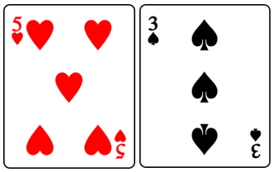 | $$\left(-5\right)×3$$
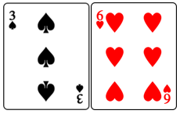 | $$3×(-6)$$
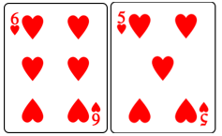 | $$\left(-6\right)×(-5)$$
- Describe what happens when you multiply a negative number by a positive number.
- Describe what happens when you multiply a negative number by another negative number.

Appendix C

Multiplication with negatives practice
Question | Representation using counters | Answer
$$2×4$$
$$2×(-4)$$
$$3×(-4)$$
$$(-4)×3$$
$$\left(-4\right)×(-3)$$
$$\left(-2\right)×(-3)$$
$$3×(-6)$$
$$(-3)×6$$
$$(-3)×(-6)$$
$$7×(-1)$$
$$(-1)×7$$
$$1×(-7)$$
$$(-1)×(-7)$$
$$\left(-1\right)×\left(-2\right)×(-3)$$

Appendix D

Integer Venns

2-circle Venn
Think of a 2-number multiplication that could belong in each region. If you think a region is impossible to fill, convince me why!
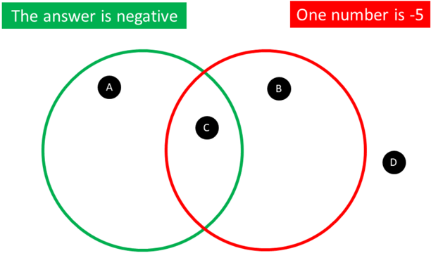

3-circle Venn
Think of a 2 number multiplication that could belong in each region. If you think a region is impossible to fill, convince me why!
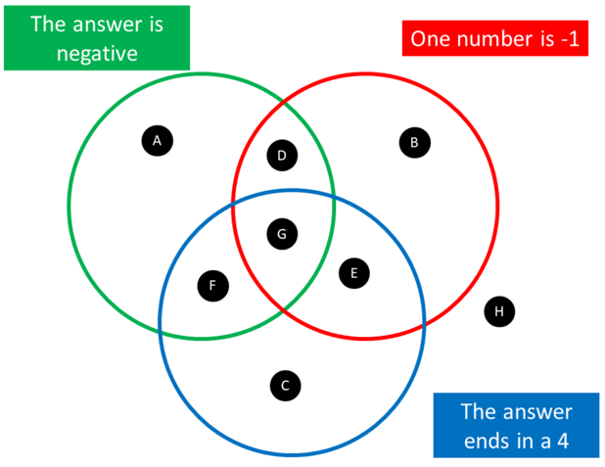

Appendix E

Open middle problem
Use the integers from −9 to 9, at most once, to obtain the largest possible result

Sample solutions

Appendix B – interpreting cards
- Complete the table below, writing the result in the final column.
Cards drawn | Operation | Result
 | $$\left(-5\right)×3$$ | $$-15$$
 | $$3×(-6)$$ | $$-18$$
 | $$\left(-6\right)×(-5)$$ | $$30$$
- Describe what happens when you multiply a negative number by a positive number.
We get groups of negative numbers, which gives a negative total.
- Describe what happens when you multiply a negative number by another negative number.
We ‘uncount’ negative numbers, which leaves a positive total.

Appendix C – multiplication with negatives practice
Question | Representation using counters | Answer
$$2×4$$ |  | $$8$$
$$2×(-4)$$ |  | $$-8$$
$$3×(-4)$$ | 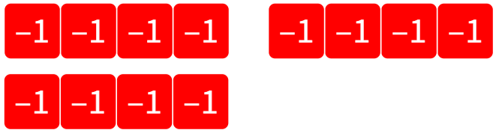 | $$-12$$
$$(-4)×3$$ | 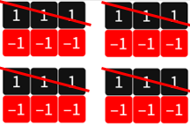 | $$-12$$
$$\left(-4\right)×(-3)$$ | 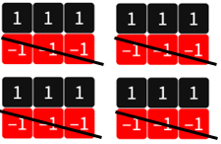 | $$12$$
$$\left(-2\right)×(-3)$$ |  | $$6$$
$$3×(-6)$$ | 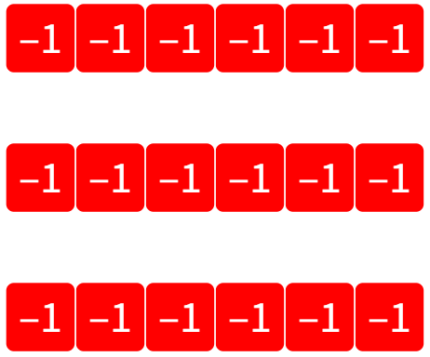 | $$-18$$
$$(-3)×6$$ | 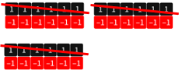 | $$-18$$
$$(-3)×(-6)$$ | 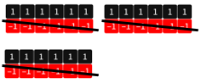 | $$18$$
$$7×(-1)$$ |  | $$-7$$
$$(-1)×7$$ |  | $$-7$$
$$1×(-7)$$ |  | $$-7$$
$$(-1)×(-7)$$ |  | $$7$$
$$\left(-1\right)×\left(-2\right)×(-3)$$ | 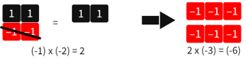 | $$2×\left(-3\right)=(-6)$$

Appendix D – integer Venns

2-circle Venn
Region A: $(-3)×3=(-9)$
Region B: $\left(-5\right)×\left(-3\right)=15$
Region C: $\left(-5\right)×3=-15$
Region D: $\left(-4\right)×\left(-3\right)=12$

3-circle Venn
Region A: $(-3)×3=(-9)$
Region B: $\left(-5\right)×\left(-1\right)=5$
Region C: $7×2=14$
Region D: $\left(-1\right)×2=(-2)$
Region E: $\left(-1\right)×\left(-4\right)=4$
Region F: $\left(-4\right)×6=(-24)$
Region G: $\left(-1\right)×14=(-14)$
Region H: $\left(-7\right)×\left(-3\right)=21$

Appendix E – open middle problem
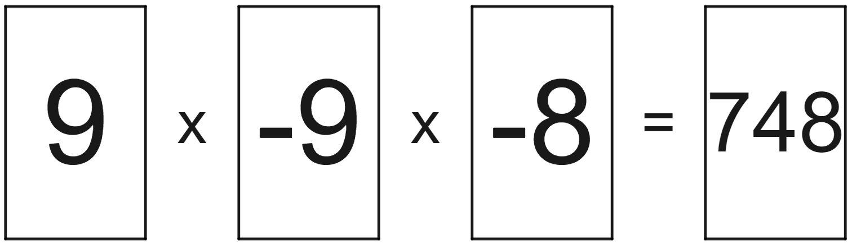
© State of New South Wales (Department of Education), 2023
The copyright material published in this resource is subject to the Copyright Act 1968 (Cth) and is owned by the NSW Department of Education or, where indicated, by a party other than the NSW Department of Education (third-party material).
Copyright material available in this resource and owned by the NSW Department of Education is licensed under a Creative Commons Attribution 4.0 International (CC BY 4.0) licence.
This licence allows you to share and adapt the material for any purpose, even commercially.
Attribution should be given to © State of New South Wales (Department of Education), 2023.
Material in this resource not available under a Creative Commons licence:
- the NSW Department of Education logo, other logos and trademark-protected material
- material owned by a third party that has been reproduced with permission. You will need to obtain permission from the third party to reuse its material.
Links to third-party material and websites
Please note that the provided (reading/viewing material/list/links/texts) are a suggestion only and implies no endorsement, by the New South Wales Department of Education, of any author, publisher, or book title. School principals and teachers are best placed to assess the suitability of resources that would complement the curriculum and reflect the needs and interests of their students.
If you use the links provided in this document to access a third-party's website, you acknowledge that the terms of use, including licence terms set out on the third-party's website apply to the use which may be made of the materials on that third-party website or where permitted by the Copyright Act 1968 (Cth). The department accepts no responsibility for content on third-party websites.

