Laying the foundations of algebra
Students use algebra tiles to represent and simplify algebraic expressions.

Visible learning

Learning intentions
- To be able to simplify algebraic expressions.

Success criteria
- I can identify like terms.
- I can represent terms using algebra tiles.
- I can simplify algebraic expressions by adding and subtracting like terms.

Syllabus outcomes
A student
- develops understanding and fluency in mathematics through exploring and connecting mathematical concepts, choosing and applying mathematical techniques to solve problems, and communicating their thinking and reasoning coherently and clearly MAO-WM-01
- generalises number properties to operate with algebraic expressions including expansion and factorisation MA4-ALG-C-01
Mathematics K–10 Syllabus © NSW Education Standards Authority (NESA) for and on behalf of the Crown in right of the State of New South Wales, 2022.

Activity structure
The activities in this lesson are based on ‘Collecting Like Terms – Sorting Terms’ by Chris McGrane (https://startingpointsmaths.com/2018/09/20/collecting-like-terms-sorting-terms/).

Launch

Equipment
- Appendix A ‘Like term cards’, printed (one copy per pair)
- Scissors (one per pair)

Method
- Assign pairs.
- Issue the cards from Appendix A ‘Like term cards’ to pairs and ask them to cut out the cards.
- Ask students to group the cards into categories that make sense to them. Explain that they will be asked to justify their groupings.
- Select random pairs to explain how they have chosen to group the cards. Some students may group according to positives and negatives, others may put all the constants together, and hopefully some will group according to like terms.
These cards introduce some like terms that students did not encounter in the previous lesson. For instance, $x^{2}$ and $xy.$ It also asks them to consider if the order of the components in the term matter.

Explore

Equipment
- Devices (optional)
- Class set of Appendix B ‘Polypad algebra tiles’, printed
- Class set of Appendix C ‘Algebra tiles practice’, printed

Method
- Introduce students to Polypad Algebra Tiles (. The different tiles are shown in Appendix B, which students can have nearby as a guide for this activity.
A tutorial for teachers unfamiliar with Algebra Tiles is on the Mathigon website (bit.ly/tutorialalgebra).
The $x$ tile has a length of $x$ and a width of 1. The $xy$ tile has a length of $x$ and a width of $y$, and so on.
Students need to understand that the names of the tiles are arbitrary and could easily have been labelled with $a$ and $b$ or any other letters.
There is also a negative version of each of these tiles.
- Demonstrate, using slide 2 of the Laying the foundations of algebra PowerPoint, how $5x$ can be modelled by joining 5, $x$ tiles together.
- Complete the worked examples and ‘Your turn’ problems in the Laying the foundations of algebra PowerPoint (slides 3–13).
The explicit teaching technique used in the associated PowerPoint is ‘Your turn.’ The first slide is a worked example which should be displayed for the students and then use the following steps.
- Reveal the question to students and its solution.
- Students read in silence.
- Students individually think and explain to themselves what is happening in each step.
- Students hold up a thumbs up to the teacher when they have finished reading and have some sort of understanding.
- Think-Pair-Share. Students explain the solution to their partner.
- In pairs, students then answer the self-explanation questions.
- Finally, randomly select students to share their answers with the whole class.
- Students will model the scenarios from Appendix C ‘Algebra tiles practice’ using Polypad Algebra Tiles (or by drawing the tiles) and then writing a simplified expression.
Encourage students to rearrange the tiles to group for likeness, and use zero pairs to assist in simplifying the expressions.
The questions have been designed to remind students that $2x+(-3x)$ is equivalent to $2x-3x$.
Students could be encouraged to consider how many ways they could write each expression.

Summarise
- Using a Think-Pair-Share (bit.ly/thinkpairsharestrategy), students discuss any patterns that they noticed or strategies they used when simplifying the expressions in Appendix C ‘Algebra tiles practice’.
- Using a questioning strategy such as Pose-Pause-Pounce-Bounce (bit.ly/pausepouncebounce), ask students to share their patterns and strategies with the class.
- Students will model the scenarios from Appendix D ‘Building on like terms’ using Polypad Algebra Tiles (or by drawing the tiles) and then writing a simplified expression.
This activity builds on from the previous ‘Algebra tiles practice’ by incorporating a larger variety of terms including $x^{2} \text{and }xy$ terms.
The very last question cannot be modelled with algebra tiles and is designed to see if students have built enough conceptual understanding to move away from visual representations. Students should be encouraged to continue using algebra tiles for as long as they need them.

Apply
- Students can complete the ‘Algebra Pyramids’ from Appendix E.
- Students requiring a further challenge can complete the ‘Algebraic Perimeters’ questions from the Transum website (https://bit.ly/AlgebraicPerimeters). There are a range questions at different levels for students to complete.
The Algebraic Perimeters activity links back to the previous lesson ‘Stepping through unknowns’ where students represented the perimeter of different areas using the length of their paces.

Assessment and differentiation

Suggested opportunities for differentiation
Launch
- Students might benefit from engaging with a concrete manipulative, such as counters, to first establish grouping and zero pairs.
- Encourage students to create their own algebraic expressions using the blank card, then challenge their peers to solve them.
Explore
- Students should continue modelling with algebra for as long as it takes them to develop a conceptual understanding of like terms.
Apply
- Students should be encouraged to create their own pyramids for other students to complete.
- The Transum ‘Algebraic Perimeter’ activity is self-checking and consists of several different levels of questions. Although it is an online activity, students should be encouraged to write an expression for the perimeter in their books, before simplifying it.

Suggested opportunities for assessment
Launch
- Walk around the room and observe how students are grouping the cards. This will provide immediate feedback on their initial understanding of 'like terms'. You could also ask them to explain their grouping method for further insight into their thinking.

Explore
- Observe how students are approaching simplifying expressions, for example, do they begin by grouping like terms?
- Teachers could also create an exit ticket to check if students understand that $2x-4y=2x+(-4y)$.

Appendix A

Like term cards
$$5x$$ | $$2x$$
$$-3x$$ | $$-x$$
$$2y$$ | $$-3y$$
$$y$$ | $$4$$
$$-7$$ | $$xy$$
$$x7$$ | $$x^{2}$$
$${-3x}^{2}$$ | $$4yx$$
$$2xz$$ | $$\frac{1}{2}xy$$

Appendix B

Polypad algebra tiles
 | $$1 ×1=1$$
 | $$x×1=x$$
 | $$y×1=y$$
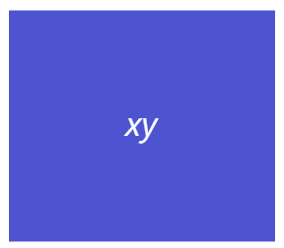 | $$x×y=xy$$
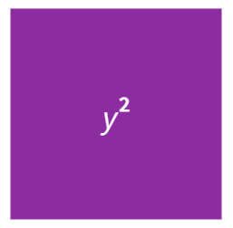 | $$y×y=y^{2}$$
 | $$x×x=x^{2}$$
Images created using the free virtual manipulatives at Polypad.org.

Appendix C

Algebra tiles practice
Question | Drawing of model | Simplified expression
$$5x+2x$$
$$\left(-3x\right)+(-x)$$
$$\left(-3x\right)-x$$
$$5x+2x+\left(-3x\right)+(-x)$$
$$5x+2x-3x-x$$
$$5x+4$$
$$5x+2x+4$$
$$5x+(-3x)+4$$
$$5x-3x+4$$
$$5x+(-x)+(-7)$$
$$5x-x-7$$
$$2x+\left(-x\right)+y+(-7)$$
$$2x-x+y-7$$
$$5x+y$$
$$5x+2x+\left(-3y\right)+y$$
$$5x+2x-3y+y$$
$$\left(-3x\right)+\left(-x\right)+2y+(-3y)$$
$$\left(-3x\right)-x+2y-3y$$
$$2y+\left(-3y\right)+y+4+(-7)$$
$$2y-3y+y+4-7$$

Appendix D

Building on like terms
Question | Drawing of model | Simplified expression
$$x^{2}+y^{2}+x^{2}+y^{2}$$
$${6x}^{2}+y^{2}+x^{2}+y^{2}$$
$${6x}^{2}+5y^{2}+x^{2}+y^{2}$$
$${6x}^{2}+5y^{2}+4x^{2}+y^{2}$$
$${6x}^{2}+5y^{2}+4x^{2}+{3y}^{2}$$
$${6x}^{2}+5y^{2}-4x^{2}+{3y}^{2}$$
$${6x}^{2}+5y^{2}-4x^{2}-{3y}^{2}$$
$${6x}^{2}-5y^{2}-4x^{2}-{3y}^{2}$$
$${6x}^{2}-5y-4x^{2}-3y$$
$${6x}^{2}-5xy-4x^{2}-3xy$$
$${6x}^{2}-5xy-4x^{2}-3yx$$
$${6x}^{2}+5xy+4x+3y$$
$${6x}^{2}-5x^{2}y-4x^{2}-3x^{2}y$$

Appendix E

Algebra pyramids
Use the algebraic terms and expressions in the pyramids to fill in the blanks. The first one is an example to help you.
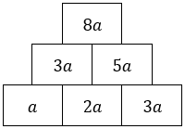 | 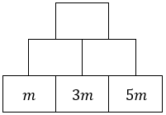
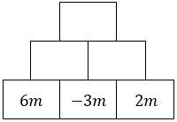 | 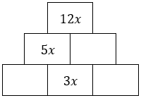
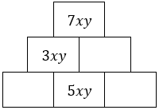 | 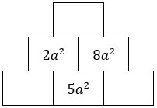
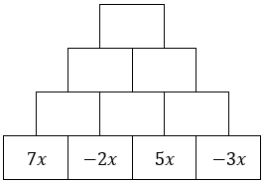 | 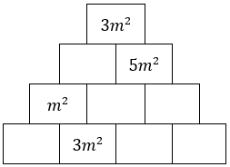

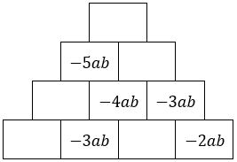 | 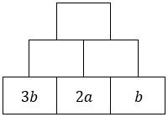
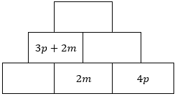 | 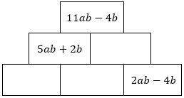
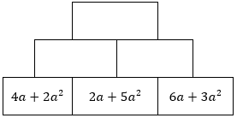 | 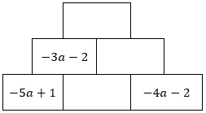
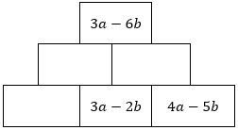 | 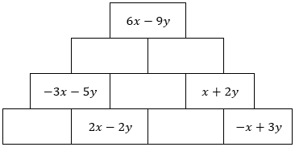
- Create your own. Fill in some cells with single algebraic terms and leave some blank.  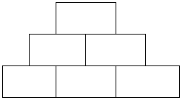 | - Create your own. Fill in some cells with algebraic expressions and leave some blank.  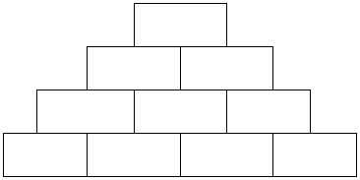

Sample solutions

Appendix C – algebra tiles practice
Question | Drawing of model | Simplified expression
$$5x+2x$$ | 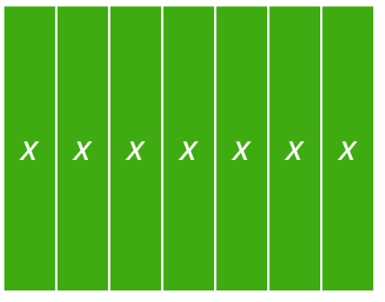 | $$7x$$
$$\left(-3x\right)+(-x)$$ | 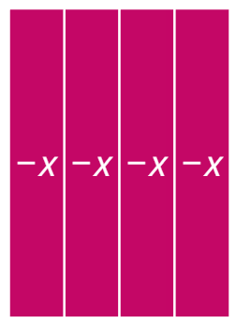 | $$-4x$$
$$\left(-3x\right)-x$$ |  | $$-4x$$
$$5x+2x+\left(-3x\right)+(-x)$$ | 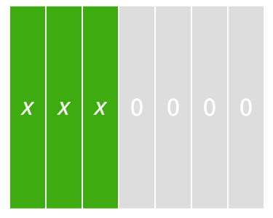 | $$3x$$
$$5x+2x-3x-x$$ |  | $$3x$$
$$5x+4$$ | 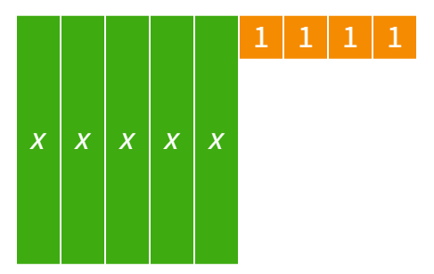 | $$5x+4$$
$$5x+2x+4$$ | 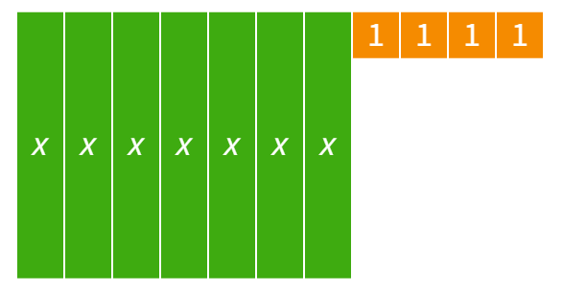 | $$7x+4$$
$$5x+(-3x)+4$$ | 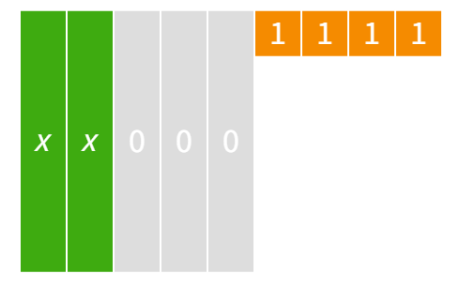 | $$2x+4$$
$$5x-3x+4$$ |  | $$2x+4$$
$$5x+(-x)+(-7)$$ | 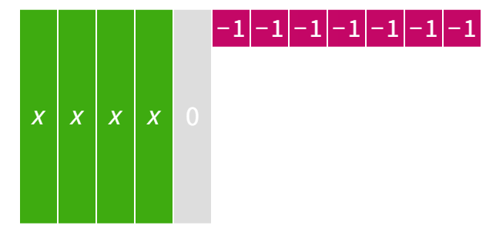 | $$4x-7$$
$$5x-x-7$$ |  | $$4x-7$$
$$2x+\left(-x\right)+y+(-7)$$ | 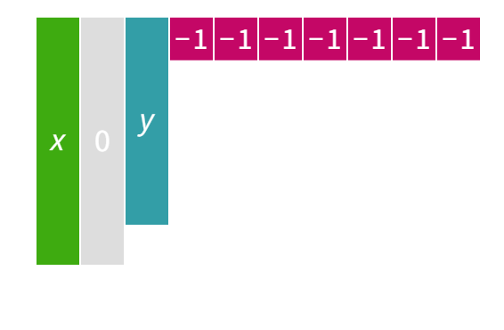 | $$x+y-7$$
$$2x-x+y-7$$ |  | $$x+y-7$$
$$5x+y$$ | 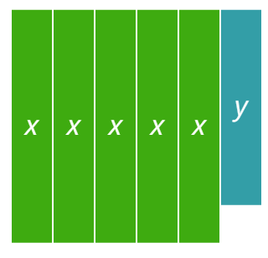 | $$5x+y$$
$$5x+2x+\left(-3y\right)+y$$ | 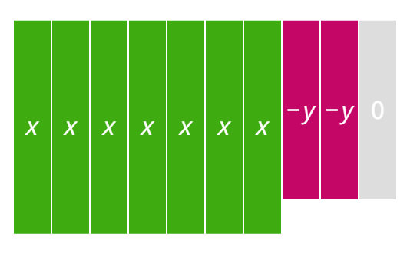 | $$7x-2y$$
$$5x+2x-3y+y$$ |  | $$7x-2y$$
$$\left(-3x\right)+\left(-x\right)+2y+(-3y)$$ | 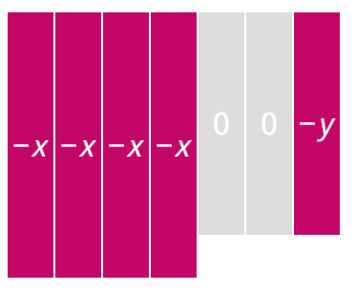 | $$-4x-y$$
$$\left(-3x\right)-x+2y-3y$$ |  | $$-4x-y$$
$$2y+\left(-3y\right)+y+4+(-7)$$ | 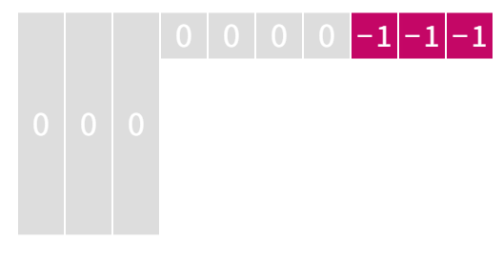 | $$-3$$
$$2y-3y+y+4-7$$ |  | $$-3$$
Image created using the free virtual manipulatives at Polypad.org.

Appendix D – building on like terms
Question | Drawing of model | Simplified expression
$$x^{2}+y^{2}+x^{2}+y^{2}$$ | 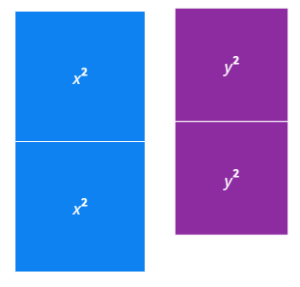 | $$2x^{2}+2y^{2}$$
$${6x}^{2}+y^{2}+x^{2}+y^{2}$$ | 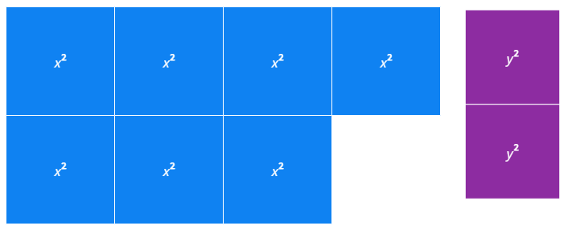 | $$7x^{2}+2y^{2}$$
$${6x}^{2}+5y^{2}+x^{2}+y^{2}$$ | 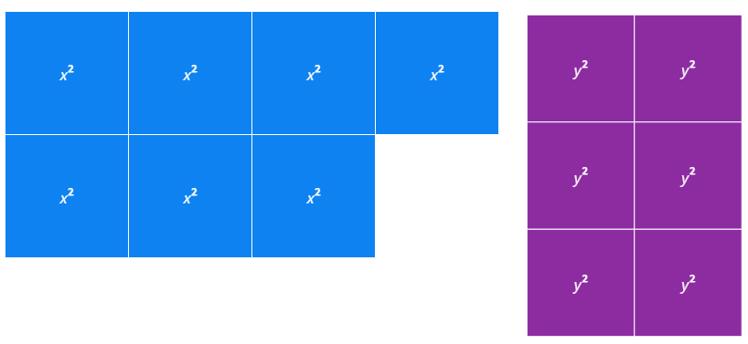 | $$7x^{2}+6y^{2}$$
$${6x}^{2}+5y^{2}+4x^{2}+y^{2}$$ | 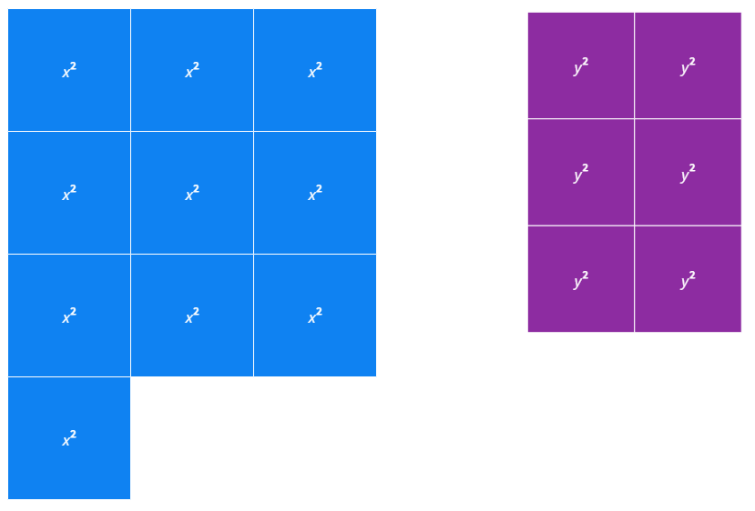 | $$10x^{2}+6y^{2}$$
$${6x}^{2}+5y^{2}+4x^{2}+{3y}^{2}$$ | 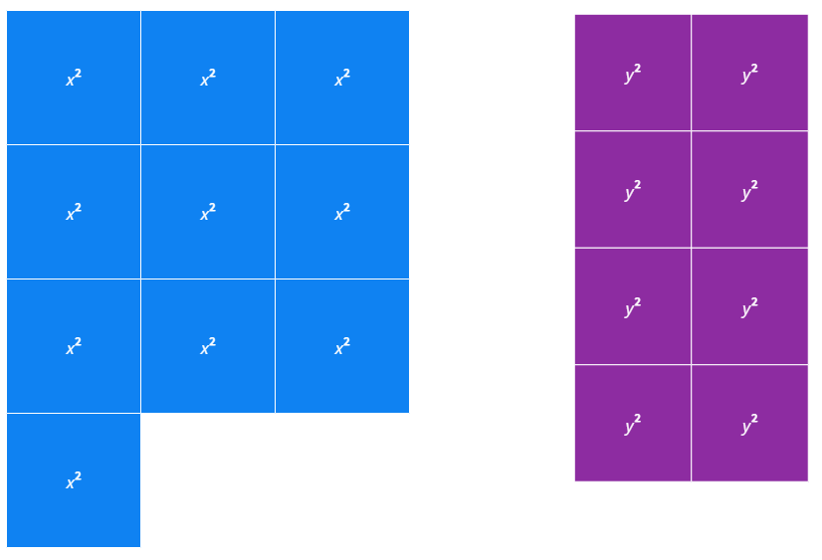 | $$10x^{2}+8y^{2}$$
$${6x}^{2}+5y^{2}-4x^{2}+{3y}^{2}$$ | Students will initially add 6 $x^{2}$ tiles and then remove 4 of them. | $$2x^{2}+8y^{2}$$
$${6x}^{2}+5y^{2}-4x^{2}-{3y}^{2}$$ | Students will initially add 6 $x^{2}$ tiles and then remove 4 of them and add 5 $y^{2}$ tiles and remove 3 of them. | $$2x^{2}+2y^{2}$$
$${6x}^{2}-5y^{2}-4x^{2}-{3y}^{2}$$ | Students will need to add zero pairs to have enough $y^{2}$ tiles to subtract.  Alternatively, they can think of this as:  $${6x}^{2}+-5y^{2}-4x^{2}+{-3y}^{2}$$ | $2x^{2}-8y^{2}$ or  $$2x^{2}+-8y^{2}$$
$${6x}^{2}-5y-4x^{2}-3y$$ | Students will need to add zero pairs to have enough $y$ tiles to subtract.  Alternatively, they can think of this as:  $${6x}^{2}+-5y-4x^{2}+ -3y$$ | $$2x^{2}-8y$$
$${6x}^{2}-5xy-4x^{2}-3xy$$ | Students will need to add zero pairs to have enough $xy$ tiles to subtract.  Alternatively, they can think of this as:  $${6x}^{2}+-5xy-4x^{2}+ -3xy$$ | $$2x^{2}-8xy$$
$${6x}^{2}-5xy-4x^{2}-3yx$$ | Students need to realise that $xy$ is equivalent to $yx$ and that the question is a repeat of the one above. | $$2x^{2}-8xy$$
$${6x}^{2}+5xy+4x+3y$$ | Students should realise that there are no like terms in this question | $$6x^{2}+5xy+4x+3y$$
$${6x}^{2}-5x^{2}y-4x^{2}-3x^{2}y$$ | There are no algebra tiles to model the term $x^{2}y$. Students will hopefully have built enough conceptual knowledge to complete this question without the aid of the tiles | $$2x^{2}-8x^{2}y$$

Appendix E – algebra pyramids
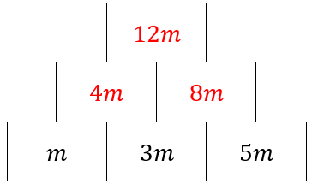 | 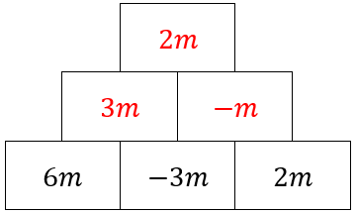 | 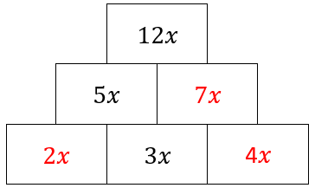
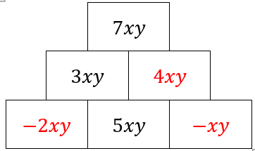 | 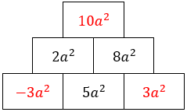 | 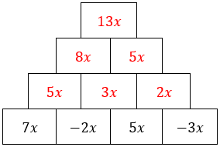
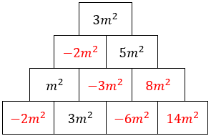 | 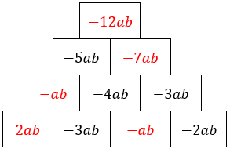 | 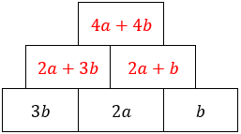
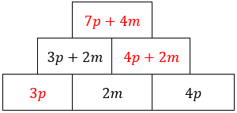 | 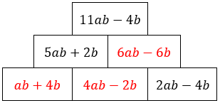 | 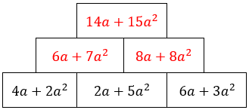
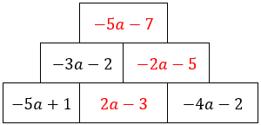 | 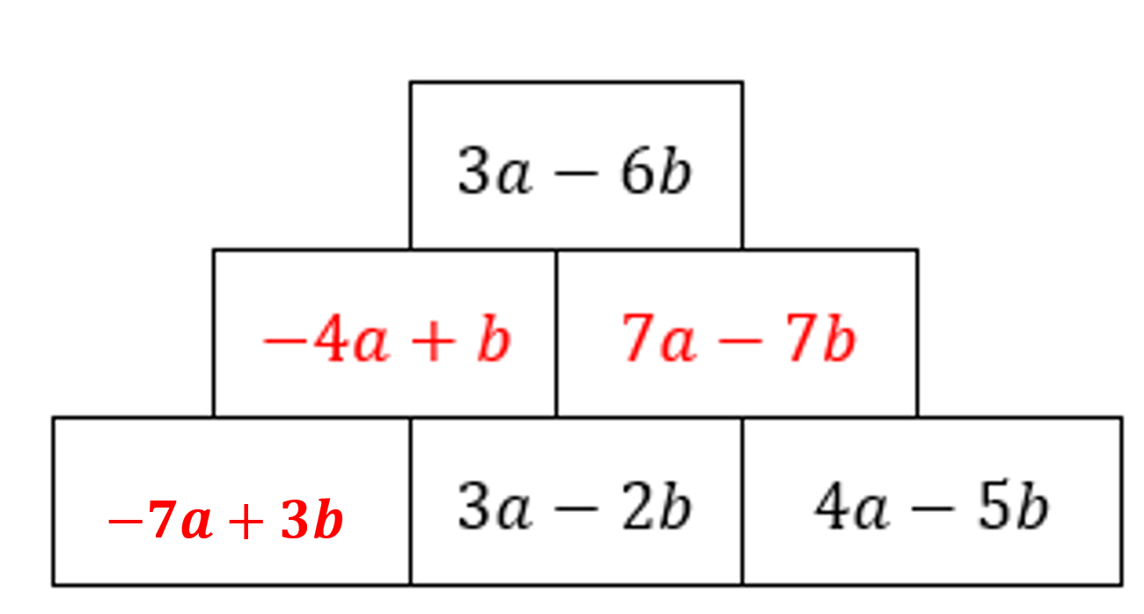 | 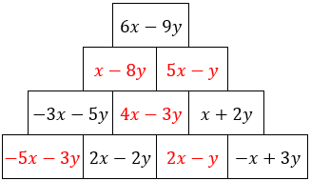

References
This resource contains NSW Curriculum and syllabus content. The NSW Curriculum is developed by the NSW Education Standards Authority. This content is prepared by NESA for and on behalf of the Crown in right of the State of New South Wales. The material is protected by Crown copyright.
Please refer to the NESA Copyright Disclaimer for more information https://educationstandards.nsw.edu.au/wps/portal/nesa/mini-footer/copyright.
NESA holds the only official and up-to-date versions of the NSW Curriculum and syllabus documents. Please visit the NSW Education Standards Authority (NESA) website https://educationstandards.nsw.edu.au/ and the NSW Curriculum website https://curriculum.nsw.edu.au/home.
Mathematics K–10 Syllabus © NSW Education Standards Authority (NESA) for and on behalf of the Crown in right of the State of New South Wales, 2022.
© State of New South Wales (Department of Education), 2023
The copyright material published in this resource is subject to the Copyright Act 1968 (Cth) and is owned by the NSW Department of Education or, where indicated, by a party other than the NSW Department of Education (third-party material).
Copyright material available in this resource and owned by the NSW Department of Education is licensed under a Creative Commons Attribution 4.0 International (CC BY 4.0) licence.
This licence allows you to share and adapt the material for any purpose, even commercially.
Attribution should be given to © State of New South Wales (Department of Education), 2023.
Material in this resource not available under a Creative Commons licence:
- the NSW Department of Education logo, other logos and trademark-protected material
- material owned by a third party that has been reproduced with permission. You will need to obtain permission from the third party to reuse its material.
Links to third-party material and websites
Please note that the provided (reading/viewing material/list/links/texts) are a suggestion only and implies no endorsement, by the New South Wales Department of Education, of any author, publisher, or book title. School principals and teachers are best placed to assess the suitability of resources that would complement the curriculum and reflect the needs and interests of their students.
If you use the links provided in this document to access a third-party's website, you acknowledge that the terms of use, including licence terms set out on the third-party's website apply to the use which may be made of the materials on that third-party website or where permitted by the Copyright Act 1968 (Cth). The department accepts no responsibility for content on third-party websites.

