Stepping through unknowns
Students use pronumerals to represent unknown distances and add like terms to simplify expressions.

Visible learning

Learning intentions
- To be able to simplify algebraic expressions.

Success criteria
- I can identify like terms.
- I can simplify algebraic expressions by adding and subtracting like terms.

Syllabus outcomes
A student:
- develops understanding and fluency in mathematics through exploring and connecting mathematical concepts, choosing and applying mathematical techniques to solve problems, and communicating their thinking and reasoning coherently and clearly MAO-WM-01
- generalises number properties to operate with algebraic expressions including expansion and factorisation MA4-ALG-C-01
Mathematics K–10 Syllabus © NSW Education Standards Authority (NESA) for and on behalf of the Crown in right of the State of New South Wales, 2022.

Activity structure

Launch
- Use the Stepping through unknowns PowerPoint (Slide 2) to present the following scenario to students:
Johnny and his mother were measuring his height, but they only had a 30 cm ruler. 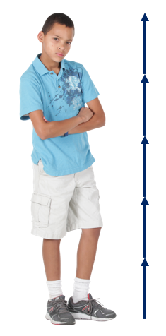
Johnny’s mother recorded his height as 30 cm + 30 cm + 30 cm + 30 cm + 30 cm. Johnny told his mum ‘It would have been easier to record it as 5 × 30 cm’.
- Ask students to discuss the following questions in pairs
- Who is right?
- Could Johnny’s height also have been written in other ways?
- Can you draw a diagram to show who is right?
This is a chance to revisit the commutative property of multiplication that says
5 × 30 = 30 × 5.
- Randomly choose pairs to share their thoughts and diagrams to justify their reasoning.
- Move to Slide 3 in the Stepping through unknowns PowerPoint to present the following scenario.
Johnny realises that the ruler they were using is broken, so they are not sure exactly how long it is.
- Ask students to discuss ‘How could we record Johnny’s height now?’ in their pairs.
- Call on random pairs to explain their strategy.
Highlight strategies that record the height using pronumerals to represent the length of the ruler. For instance, 5 × ruler or 5 × r.
- Move to slide 4 in the Stepping through unknowns PowerPoint to present the following scenario.
Johnny found out that his Mum rounded off his height to the nearest ruler. He was a bit taller than 5 rulers. They find a smaller object and use it to measure the rest of his height.
- Ask students to discuss ‘How could we record Johnny’s height now?’ in pairs. They could also consider whether it would have mattered if Johnny’s Mum had used the smaller object first and then finished measuring with the ruler?
We want students to understand that 5 × r + 2 × p = 2 × p + 5 × r.
- Johnny and his mum finally find an intact ruler and measure the original ruler as being 28 cm long, and the smaller object that they used as 8 cm long.
- Ask students to discuss ‘How tall is Johnny?’ in their pairs.
- Ask random pairs to share their strategy for calculating Johnny’s height.
We are looking to see whether students used an additive strategy such as:
- 28 + 28 + 28 + 28 + 28 + 8 + 8
or if they used a multiplicative strategy such as:
- 5 × 28 + 2 × 8.
If students use a mixture of strategies, you could hold a discussion around which strategy is more efficient.

Explore
In visibly random groups of 3 (bit.ly/visiblegroups), students will use their individual walking paces to calculate and compare the perimeters of designated areas around the school.

Equipment
- Tape measures or meter rulers (one per group of 3)
- Pens
- Appendix A ‘Perimeter recording sheet’, printed (one copy per group)

Method
You might like to model the steps below using the example in the Stepping through unknowns PowerPoint (slides 5–8), prior to taking students outside.
- Begin with one student from each group pacing out and recording the length of each side of a predetermined perimeter. The group collectively decides on the best method to document the total perimeter. For example, they might record ‘Perimeter = 125 paces’.

- With a different perimeter, assign 2 different students to pace out different lengths of the perimeter. Given that each student's pace length will vary, they need to devise a way to record the number of paces for each portion of the perimeter and the total perimeter. For example, they might record
8 × J + 30 × M + 37 × J + 40 × M + 20 × J
This will be the first-time students consider adding like terms. Students should identify that they cannot add Jack and Mary’s paces together as they are different lengths, but they can find the total number of paces that Mary walked and the total number of paces that Jack walked.
For example, 8 × J + 30 × M + 37 × J + 40 × M + 20 × J = 55 × J + 70 × M
- With a different perimeter, assign different lengths to all 3 members of the group. They need to figure out how to record each individual length and the total perimeter. For example, they might record ‘3 × J + 20 × M + 22 × M + 25 × B + 17 × J’.
Challenge students to consider the order in which they added their side lengths. For instance, would it matter if we re-arranged
3 × J + 20 × M + 22 × M + 25 × B + 17 × J
to
25 × B + 22 × M + 20 × M + 3 × J + 17 × J?
Ask students to draw a diagram to justify their answer.
- Each student walks 10 paces, records the overall distance (using a tape measure or meter ruler), and then divides this total distance by 10 to determine their average pace length.
- With their individual pace lengths determined, students use this data to calculate the actual perimeter (in standard units like meters or centimetres) of the regions they previously measured using paces.
This should be done by students at vertical non-permanent surfaces (bit.ly/VNPSstrategy) in the classroom and is not on the perimeter recording sheet.

Summarise
- Use the Stepping through unknowns PowerPoint (slides 9–12) to establish the definitions for term, expression, coefficient, pronumeral and simplify.
- Students will write notes to their future forgetful selves (bit.ly/notesstrategy) for each definition.
- Use the worked examples and ‘your turn’ problems to summarise how to represent scenarios and add with like terms (slides 13–18).
- Students should complete the questions from Appendix B ‘Independent practice’.

Apply

Sorting terms activity
The activities in this lesson are based on ‘Collecting Like Terms – Sorting Terms’ by Chris McGrane (https://startingpointsmaths.com/2018/09/20/collecting-like-terms-sorting-terms/).

Equipment
- Appendix C ‘Sorting terms’, printed (one copy per pair of students)
- Scissors (one per pair of students).

Method
- Assign students pairs.
- Print and distribute Appendix C.
- Students cut out each card.
- Ask pairs to group the cards together in any way they like. Using a questioning strategy such as Pose-Pause-Pounce-Bounce question strategy ([PDF 200KB] bit.ly/pausepouncebounce), ask students to share how they grouped the terms and why.
- Pose the following challenge to students (this is also on slide 19 of the Stepping through unknowns PowerPoint):
- What do cards 1 and 2 make?
- What do cards 3 and 4 make?
- What do cards 1, 2, 3 and 4 make?
- What do cards 1 and 8 make?
- What do cards 1, 2 and 8 make?
- What do cards 1, 3 and 8 make?
- What do cards 1, 4 and 9 make?
- What do cards 2, 4, 7 and 9 make?
- What do cards 1 and 7 make?
- What do cards 1, 2, 7 and 6 make?
- What do cards 3, 4, 5 and 6 make?
- What do cards 5, 6, 7, 8 and 9 make?
- The following challenge can then be posed (this is also on slide 20 of the Stepping through unknowns PowerPoint):
- Which cards do I require to make $x$?
- Which cards do I require to make -2$x$?
- Which cards do I require to make 0?
- Which cards do I require to make 7$x$ + 3$y$ +4?
- Which cards do I require to make an expression with 3 negative terms?
If students argue that they cannot make any of the expressions in question 6, challenge them to convince you why, and then allow them to use the blank card to complete the challenge.

Equivalent expressions
- Display this problem from Open Middle (www.openmiddle.com/equivalent-expressions-4).
- Students should work on mini whiteboards (bit.ly/miniwhiteboards).
- There are multiple answers, so students should compare their answer with a partner and attempt to find all variations.

Assessment and differentiation

Suggested opportunities for differentiation
Explore
- Assign 3 predetermined perimeters in a common location. This way, students are clear on the activity directions and teacher can supervise, assess, and redirect.
- By combining groups at the end of the activity, students can compare the perimeter they calculated for the same spots and discuss why answers might not be the same, as a precursor to error in measurement.
Apply
- The blank card can be used to pose this challenge:
- Fill in the blank card so that you can make the expression 3$x$ + 3$y$ + 3.
- How many new expressions can be made with the introduction of the blank card?

Suggested opportunities for assessment
Explore
- If students require additional scaffolding and/or supervision, they could complete a similar activity using smaller objects. For example, how many paperclips is the perimeter of an object.
Summarise
- Hinge point questions could be asked using a finger voting strategy to ensure students have understood the concepts from the PowerPoint before commencing the independent practice.
- Students’ notes to their future forgetful selves can be collected or uploaded to an online classroom. The teacher can then assess students’ notes and address misconceptions in the following lesson.

Appendix A

Perimeter recording sheet
Perimeter 1
Perimeter location:
Total perimeter (paces) by student 1:
Perimeter 2
Perimeter location:
Student 1: |  | paces
Student 2: |  | paces
Total perimeter (paces):
Perimeter 3
Perimeter location:
Student 1: |  | paces
Student 2: |  | paces
Student 3: |  | paces
Total perimeter (paces):
Determining pace length
Student 1 pace length:
Student 2 pace length:
Student 3 pace length:

Appendix B

Independent practice
Question | Answer
$$a+a+a+a$$
$$b+b+b+b$$
$$2b+b+b+b$$
$$b+2b+b+b$$
$$b+2b+b+c$$
$$b+2b+c+b$$
$$3a-a-a-a$$
$$3a-a-a+b$$
$$3a-a+b+b$$
$$3a-a+b-b$$
$$3a-a+c$$
$$3a-a+2b+c$$

Appendix C

Sorting terms
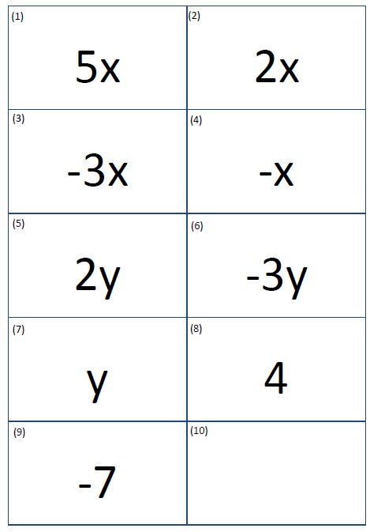

Sample solutions

Appendix B – independent practice
Question | Answer
$$a+a+a+a$$ | $$4a$$
$$b+b+b+b$$ | $$4b$$
$$2b+b+b+b$$ | $$5b$$
$$b+2b+b+b$$ | $$5b$$
$$b+2b+b+c$$ | $$4b+c$$
$$b+2b+c+b$$ | $$4b+c$$
$$3a-a-a-a$$ | $$0$$
$$3a-a-a+b$$ | $$a+b$$
$$3a-a+b+b$$ | $$2a+2b$$
$$3a-a+b-b$$ | $$2a$$
$$3a-a+c$$ | $$2a+c$$
$$3a-a+2b+c$$ | $$2a+2b+c$$

References
This resource contains NSW Curriculum and syllabus content. The NSW Curriculum is developed by the NSW Education Standards Authority. This content is prepared by NESA for and on behalf of the Crown in right of the State of New South Wales. The material is protected by Crown copyright.
Please refer to the NESA Copyright Disclaimer for more information https://educationstandards.nsw.edu.au/wps/portal/nesa/mini-footer/copyright.
NESA holds the only official and up-to-date versions of the NSW Curriculum and syllabus documents. Please visit the NSW Education Standards Authority (NESA) website https://educationstandards.nsw.edu.au/ and the NSW Curriculum website https://curriculum.nsw.edu.au/home.
Mathematics K–10 Syllabus © NSW Education Standards Authority (NESA) for and on behalf of the Crown in right of the State of New South Wales, 2022.

© State of New South Wales (Department of Education), 2023
The copyright material published in this resource is subject to the Copyright Act 1968 (Cth) and is owned by the NSW Department of Education or, where indicated, by a party other than the NSW Department of Education (third-party material).
Copyright material available in this resource and owned by the NSW Department of Education is licensed under a Creative Commons Attribution 4.0 International (CC BY 4.0) licence.
This licence allows you to share and adapt the material for any purpose, even commercially.
Attribution should be given to © State of New South Wales (Department of Education), 2023.
Material in this resource not available under a Creative Commons licence:
- the NSW Department of Education logo, other logos and trademark-protected material
- material owned by a third party that has been reproduced with permission. You will need to obtain permission from the third party to reuse its material.
Links to third-party material and websites
Please note that the provided (reading/viewing material/list/links/texts) are a suggestion only and implies no endorsement, by the New South Wales Department of Education, of any author, publisher, or book title. School principals and teachers are best placed to assess the suitability of resources that would complement the curriculum and reflect the needs and interests of their students.
If you use the links provided in this document to access a third-party's website, you acknowledge that the terms of use, including licence terms set out on the third-party's website apply to the use which may be made of the materials on that third-party website or where permitted by the Copyright Act 1968 (Cth). The department accepts no responsibility for content on third-party websites.

