Which numbers go here?
Students investigate alternative representations for numbers, leading to algebraic expressions.

Visible learning

Learning intentions
- To be able to write algebraic expressions.
- To be able to substitute numbers into an algebraic expression and calculate the result.

Success criteria
- I can write an expression for a number that comes before or after a number in the grid.
- I can write an algebraic expression for a number that comes before or after a variable in the grid.
- I can substitute a number into an algebraic expression.

Syllabus outcomes
- develops understanding and fluency in mathematics through exploring and connecting mathematical concepts, choosing and applying mathematical techniques to solve problems, and communicating their thinking and reasoning coherently and clearly MAO-WM-01
- generalises number properties to operate with algebraic expressions including expansion and factorisation MA4-ALG-C-01
- compares, orders and calculates with integers to solve problems MA4-INT-C-01
Mathematics K–10 Syllabus © NSW Education Standards Authority (NESA) for and on behalf of the Crown in right of the State of New South Wales, 2022.

Activity structure

Launch
- Navigate to the Grid Algebra website (https://gridalgebra.com/free).
- Drag the file ‘1 to 24 grid.json’ onto the grid on the screen. Visit the Grid Algebra website (gridalgebra.com/intro/overview) for more instructions on how to use the software.
Figure 1 – number grid of multiplication tables
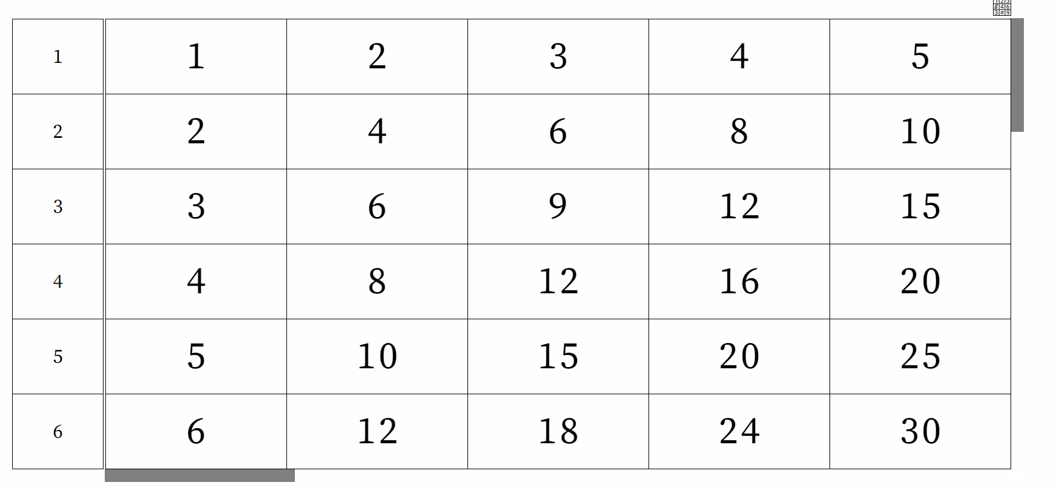
- Ask students what they notice and what they wonder about the grid (bit.ly/noticewonderstrategy).
Students might draw attention to the multiplicative nature of the grid. In this unit, we are going to focus on the additive relationships by moving left and right across a row. In the next unit on ‘Multiplicative thinking’ we will focus on the multiplicative relationships that are represented in the grid by moving up and down.
Students need to identify that the very first number in each row identifies how the numbers in the row increase as you move across the grid.
- Challenge students to predict which numbers come next if we move to the right. What numbers would appear if we moved to the left? Ask students to explain their reasoning.
- Students complete the ‘Which numbers go here?’ worksheet in Appendix A. The last row has been left blank for the teacher to provide a challenge number for their students.

Explore
- Navigate to the Grid Algebra website (https://gridalgebra.com/free).
- Drag the file ‘Introducing letters.json’ onto the grid/screen.
Figure 2 – number grid
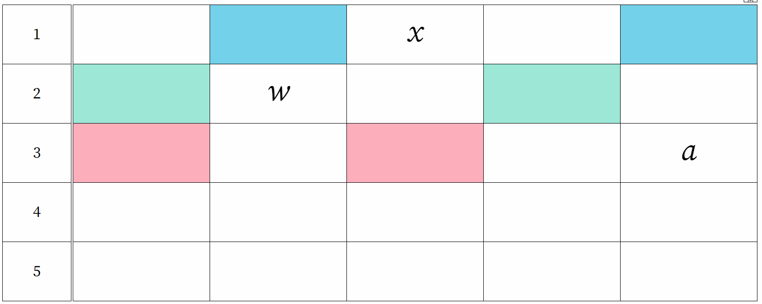
Image created using Grid Algebra.
- Discuss with students what we could write in the highlighted cells.
- Click on the letter $x$ and drag it to the blue cell on the left to display the correct expression.
Figure 3 – number grid
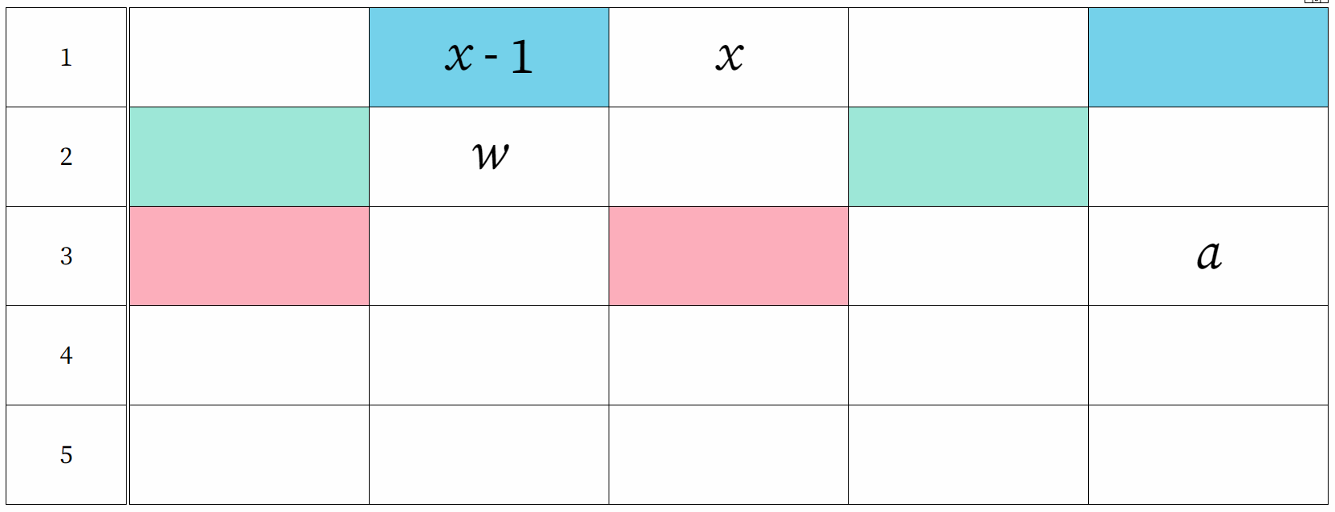
Image created using Grid Algebra.

- Click on the letter $x$ and drag it to the blue cell on the right to display the correct expression.
Figure 4 – number grid
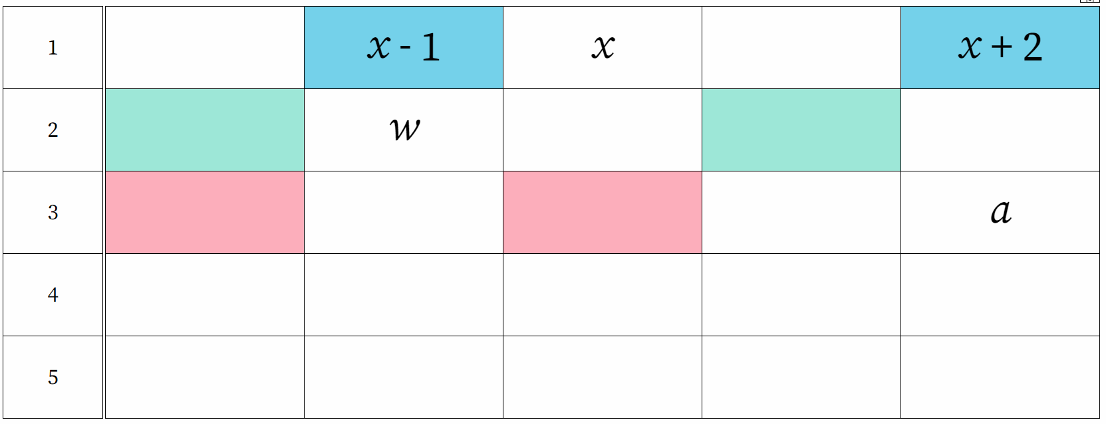
Image created using Grid Algebra.
Teachers should introduce the terms ‘variables’ and ‘expressions’ to students at this point.
- Ask students what expressions we could write in the remaining cells in the first row.
- Repeat the above process with the remaining letters.
Figure 5 – number grid
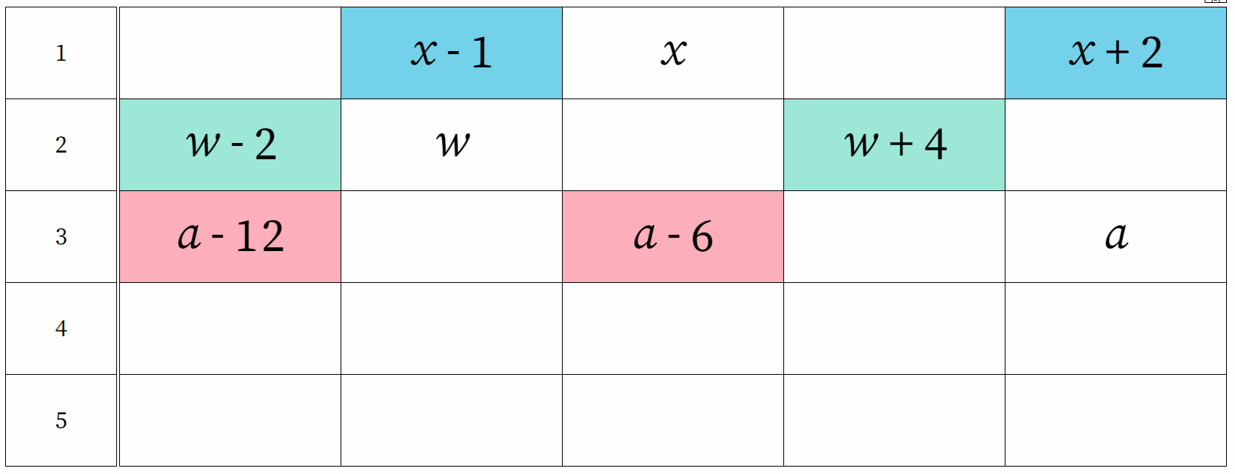
Image created using Grid Algebra.

- Select students to choose letters for the remaining 2 rows (4 and 5) and where to place them.
- From the menu, click on the letter chooser and select a new letter
Figure 6 – menu display
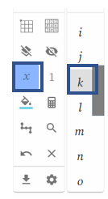
Image created using Grid Algebra.
- Click in a cell to place the letter
Figure 7 – number grid highlighting 'k'
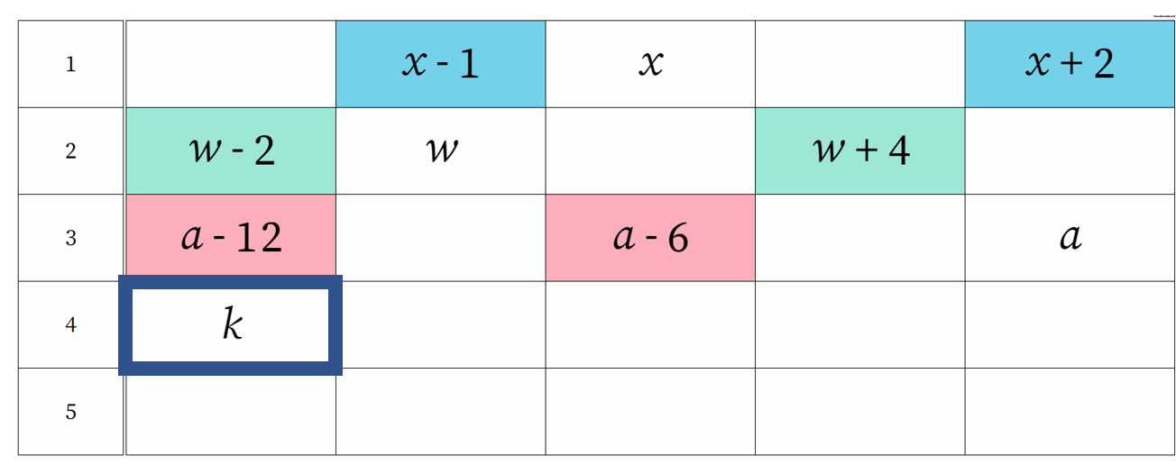
Image created using Grid Algebra.
- As a Think-Pair-Share (bit.ly/thinkpairsharestrategy), ask the students to complete rows 4 and 5. Randomly pick pairs to share their answers with the class, asking them to justify their reasoning.
- Choose a number at random to replace $x.$ Ask students to calculate what the other cells in the row would be now.
- Choose various other values for $x$ and the other letters and ask students to calculate the remaining cells in the row.
Introduce the term ‘substitution’ and highlight the fact that substituting in different values results in different answers.

Summarise
Students should write ‘notes to their future forgetful self” (bit.ly/notesstrategy) to summarise their learning from the explore section.

Apply
Students complete the ‘Introducing letters’ worksheet in Appendix B. The last few grids have been left blank for the teacher to provide challenge numbers for their students.

Assessment and differentiation

Suggested opportunities for differentiation
- Challenge students by considering what comes before and after negative numbers.
- Challenge students by considering what comes before and after fractions or decimals.
- For students who are struggling, restrict the grid to numbers less than 10.
- Challenge students by substituting negatives, fractions and decimals.

Suggested opportunities for assessment
- Teachers should monitor student answers during class discussions to assess their understanding.
- Teachers could choose to ask students to complete an exit ticket where they complete a table similar to those in Appendices A and B.
- Teachers could choose to collect the worksheets in Appendices A and B to check for understanding.

Appendix A

Which numbers go here?
Write in the numbers that should appear in the highlighted cells.
1 |  | 4

1 | 5

1 |  |  | 0

2 |  |  | 8

4 |  |  | 8

5 |  | 20

$$\frac{1}{2}$$ |  |  | 1

$$\frac{1}{3}$$ |  |  | 2

$$\frac{2}{5}$$ |  | 0

Appendix B

Introducing letters
- Write in the expressions that should appear in the highlighted cells.
1 |  | $$x$$

1 | $$y$$

1 |  |  | $$k$$

2 |  |  | $$m$$

4 |  |  | $$c$$

5 |  | $$p$$

- Roll a die and use the result to replace $x$ in the first table of the worksheet. Calculate the numbers that belong in the remaining cells in the table.
- Repeat for each of the letters in the tables on the worksheet.

Sample solutions

Appendix A – Which numbers go here?
1 | 3 | 4 |  | 6

1 | 5 | 6 |  |  | 9

1 |  | (-1) | 0 |  | 2

2 | 4 |  | 8 |  | 12

4 | 0 |  | 8 |  | 16

5 | 15 | 20 |  | 30

$$\frac{1}{2}$$ | 0 |  | 1 | $$1\frac{1}{2}$$

$$\frac{1}{3}$$ |  | $$1\frac{2}{3}$$ | 2 |  | $$2\frac{2}{3}$$

$$\frac{2}{5}$$ |  | 0 | $$\frac{2}{5}$$ |  | $$1\frac{1}{5}$$

Appendix B – introducing letters
1 | $$x-1$$ | $$x$$ |  | $$x+2$$

1 | $$y$$ | $$y+1$$ |  |  | $$y+4$$

1 |  | $$k-1$$ | $$k$$ |  | $$k+2$$

2 | $$m-4$$ |  | $$m$$ |  | $$m+4$$

4 | $$c-8$$ |  | $$c$$ |  | $$c+8$$

5 | $$p-5$$ | $$p$$ |  | $$p+10$$

References
This resource contains NSW Curriculum and syllabus content. The NSW Curriculum is developed by the NSW Education Standards Authority. This content is prepared by NESA for and on behalf of the Crown in right of the State of New South Wales. The material is protected by Crown copyright.
Please refer to the NESA Copyright Disclaimer for more information https://educationstandards.nsw.edu.au/wps/portal/nesa/mini-footer/copyright.
NESA holds the only official and up-to-date versions of the NSW Curriculum and syllabus documents. Please visit the NSW Education Standards Authority (NESA) website https://educationstandards.nsw.edu.au/ and the NSW Curriculum website https://curriculum.nsw.edu.au/home.
Mathematics K–10 Syllabus © NSW Education Standards Authority (NESA) for and on behalf of the Crown in right of the State of New South Wales, 2022.

© State of New South Wales (Department of Education), 2023
The copyright material published in this resource is subject to the Copyright Act 1968 (Cth) and is owned by the NSW Department of Education or, where indicated, by a party other than the NSW Department of Education (third-party material).
Copyright material available in this resource and owned by the NSW Department of Education is licensed under a Creative Commons Attribution 4.0 International (CC BY 4.0) licence.
This licence allows you to share and adapt the material for any purpose, even commercially.
Attribution should be given to © State of New South Wales (Department of Education), 2023.
Material in this resource not available under a Creative Commons licence:
- the NSW Department of Education logo, other logos and trademark-protected material
- material owned by a third party that has been reproduced with permission. You will need to obtain permission from the third party to reuse its material.
Links to third-party material and websites
Please note that the provided (reading/viewing material/list/links/texts) are a suggestion only and implies no endorsement, by the New South Wales Department of Education, of any author, publisher, or book title. School principals and teachers are best placed to assess the suitability of resources that would complement the curriculum and reflect the needs and interests of their students.
If you use the links provided in this document to access a third-party's website, you acknowledge that the terms of use, including licence terms set out on the third-party's website apply to the use which may be made of the materials on that third-party website or where permitted by the Copyright Act 1968 (Cth). The department accepts no responsibility for content on third-party websites.

