How to deal with different denominators
At this point, students understand that fractions with different denominators can’t be added until the denominators are made the same. Students will explore examples where fractions do not share a common denominator and one denominator is not a multiple of another.
Students will need at least one digital device per pair to interact with Desmos during this lesson.

Visible learning

Learning intention
- To be able to add and subtract fractions when the denominators do not share a common factor.

Success criteria
- I can find the lowest common denominator for 2 fractions.
- I can add and subtract fractions when the denominators don’t share a common factor.
- I can use visual representations to aid in addition of fractions.

Syllabus outcomes
A student:
- develops understanding and fluency in mathematics through exploring and connecting mathematical concepts, choosing and applying mathematical techniques to solve problems, and communicating their thinking and reasoning coherently and clearly MAO-WM-01
- represents and operates with fractions, decimals and percentages to solve problems MA4-FRC-C-01
Mathematics K–10 Syllabus © NSW Education Standards Authority (NESA) for and on behalf of the Crown in right of the State of New South Wales, 2022.

Activity structure

Warm up
- Assign the Desmos’ ‘Fractions polygraph’ activity to your class (bit.ly/fractionspolygraph).
- Students play 1–2 rounds of Desmos’ ‘Fractions polygraph’.
Polygraph is a partnered guessing game with a focus on vocabulary and discourse. Each round, players are matched into pairs and assigned ‘Picker’ and ‘Guesser’ roles. The Picker selects a card; the Guesser asks yes or no questions for the Picker to answer to narrow the field of cards down to one.
This is an opportunity to informally assess and correct students’ vocabulary and comprehension of visual representations.

Launch
- Write up the following questions or display slide 2 of the How to deal with different denominators PowerPoint:
A. $\frac{1}{2}+\frac{1}{3}<1$
B. $\frac{1}{4}+\frac{2}{3}>1$
C. $\frac{1}{5}+\frac{2}{3}<1$
- Explain to students the rules of two truths and a lie:
- Two of the expressions are true and one is a lie (untrue).
- Students work in pairs to determine which expression is a lie.
- Conduct a finger vote, where one finger is A, 2 fingers is B, 3 fingers is C, to collect student responses.
- Use Pose-Pause-Pounce-Bounce question strategy ([PDF 200KB] bit.ly/pausepouncebounce) to hear students’ explanations.
- Use slides 3–5 of the How to deal with different denominators PowerPoint to model why statements A and C are true, and B is untrue.
- Students should create their own set of 2 truths and a lie. Each expression must include fractions.
Student expressions could focus on fractions with different denominators or could include fractions with the same denominator or fractions where one denominator is a multiple of another: $\frac{1}{4}+\frac{1}{2}=\frac{2}{6}$, $1-\frac{1}{3}=\frac{2}{3}$, $\frac{3}{8}+\frac{1}{4}=\frac{5}{8}$.

Explore
- Provide students one laptop between 2 and have them access the Desmos graph ‘Addition of fractions’ (bit.ly/additionoffractions).
- The representation of $\frac{1}{3}+\frac{1}{5}$ is shown. Students explored this example in the previous lesson.
Figure 1 – Desmos representation of adding fractions $\frac{1}{3}+\frac{1}{5}$
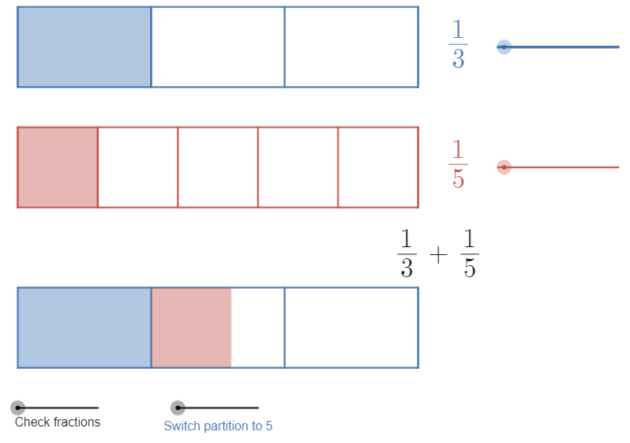
Image created using Desmos and is licensed under the Desmos Terms of Service.

- Remind students of the exploration they undertook in the previous lesson where they dragged the Switch partition to … between both options to verify that $\frac{1}{3}+\frac{1}{5}$ can’t be added in their current form as the shaded amount does not line up precisely with either the thirds or fifths partitions.
- Ask students to set the partition to 3, so that it looks like Figure 1.
- Instruct students to experiment with the blue slider (adjacent to $\frac{1}{3}$).
Figure 2 – Desmos blue slider
Image created using Desmos and is licensed under the Desmos Terms of Service.
- In their pairs, students discuss what they notice about dragging the blue slider.
- Facilitate a class discussion categorising what students noticed and wondered about what is changing and what is staying the same.
Examples of what students might notice or wonder:
- The shaded amount stays the same (the quantity).
- The partition gets more precise.
- The blue slider only shows fractions that are equivalent to $\frac{1}{3}$.
- Ask students to predict what the red slider might change.
- Pairs should now drag the red slider to explore what stays the same and what changes.
Figure 3 – Desmos red slider
Image created using Desmos and is licensed under the Desmos Terms of Service.
- Display 2 fractions, such as $\frac{3}{9}+\frac{2}{10}$, created by dragging the blue and red sliders. It’s important to remind students that this expression is equivalent to $\frac{1}{3}+\frac{1}{5}$. We are creating equivalent fractions.
Figure 4 – Desmos representation of adding fractions $\frac{3}{9}+\frac{2}{10}$
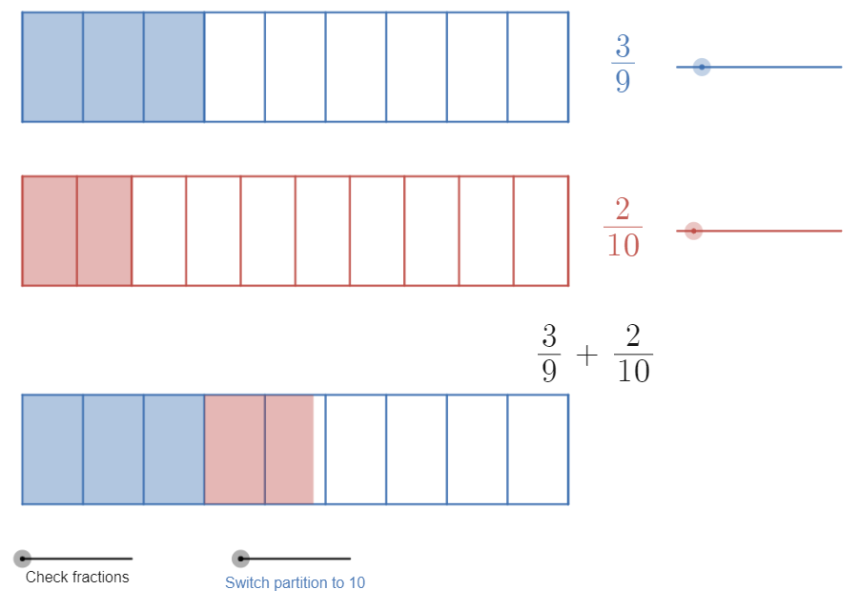
Image created using Desmos and is licensed under the Desmos Terms of Service.
- Highlight to students that for $\frac{3}{9}+\frac{2}{10}$, the shaded area doesn’t line up with the partitions, so we still can’t express the sum.
- Ask students to suggest what 2 fractions need to have in common to be added. They should recall that if the denominators are the same, we can add the fractions.
Some students might recall from the previous lesson that if one denominator is a multiple of another, they can add these fractions. This should be noted visibly on the board as a point to come back to, as students can verify this using the Desmos graph with fractions such as $\frac{5}{15}+\frac{1}{5}$.
- Challenge students to drag the red and blue sliders to make the denominators the same and hence find the sum (by counting the number of shaded parts).
- Challenge students to find all the equivalent fraction combinations for which $\frac{1}{3}+\frac{1}{5}$ can be added, recording these and the solutions.
- Ask students to share a sum they found, encouraging mathematical language. For example, ‘5 fifteenths plus 3 fifteenths are equal to 8 fifteenths.’

- Write a list of sums on the board. Possible equivalent expressions include:
$$\frac{5}{15}+\frac{3}{15}=\frac{8}{15}$$
$$\frac{10}{30}+\frac{6}{30}=\frac{16}{30}$$
$$\frac{15}{45}+\frac{9}{45}=\frac{26}{45}$$
$$\frac{20}{60}+\frac{12}{60}=\frac{32}{60}$$
It is an important concept that students understand that all these variations are correct and equivalent, and each can be used to add $\frac{1}{3}+\frac{1}{5}$ which we otherwise couldn’t add.
- Explain to students that we need to better understand what is happening here so that we can apply this concept to add any fractions.
- Ask students:
- Why does the blue slider only show some denominators?
Answer: Equivalent fractions are made by multiplying. We can’t multiply by decimals since decimals can’t exist in fractions. It’s like mixing languages.
- What do we call the sequence {3, 6, 9, 12, 15, …}?
Answer: We know this sequence as the multiples of 3, or you might have referred to them as the 3 times tables.
- What do we call the sequence {5, 10, 15, 20, 25, …}?
Answer: The multiples of 5.
- Explain to students that 15 is the lowest common multiple, so if we express our fractions in fifteenths, that will be the simplest way of expressing the sum.
- Model to students how to use the Modify fractions slider in the Desmos graph:
- Ensure you have the window maximised.
- Scroll in or out to adjust the zoom.
- Drag the Modify fractions slider to the right.
Figure 5 – modify fractions slider
Image created using Desmos and is licensed under the Desmos Terms of Service.
- The numerator and denominator for each fraction can then be adjusted.
- Drag the Modify fractions slider back to the left to hide this feature.
- Write the following list of expressions on the board. These are also on slide 6 of the How to deal with different denominators PowerPoint.
- $\frac{1}{2}+\frac{1}{5}$
- $\frac{1}{5}+\frac{1}{2}$
- $\frac{2}{5}+\frac{1}{2}$
- $\frac{2}{5}+\frac{1}{3}$
- $\frac{2}{5}-\frac{1}{3}$
- $\frac{5}{6}-\frac{3}{5}$
- Challenge students to:
- Represent each fraction from the list above using the Desmos graph.
- Find the equivalent fractions with the lowest common denominator.
- Write the original sum and the equivalent sum in their notes.
The final two questions are subtraction. Students should be able to use the Desmos graph to find the equivalent fractions with the lowest common denominator. Then they simply need to subtract rather than add.
If you would like to model a subtraction more explicitly, you could use the Desmos graph ‘Subtraction fractions’ (bit.ly/subtractionfractions).

Summarise
- Use slides 7–18 from the How to deal with different denominators PowerPoint for explicit teaching of adding and subtracting fractions with different denominators.
The explicit teaching technique used in the associated PowerPoint is ‘Your turn.’ The first slide is a worked example which should be displayed for the students and then use the following steps.
- Reveal the question to students and its solution.
- Students read in silence.
- Students individually think and explain to themselves what is happening in each step.
- Students hold up a thumbs up to the teacher when they have finished reading and have some sort of understanding.
- Think-Pair-Share. Students explain the solution to their partner.
- In pairs, students then answer the self-explanation questions.
- Finally, randomly select students to share their answers with the whole class.
- Students should annotate their ‘Your turn’ problems with notes to their future forgetful selves (bit.ly/notesstrategy).
- Print and distribute Appendix A ‘Adding and subtracting fractions’. Students work independently to answer all questions.
- Use the Pose-Pause-Pounce-Bounce question strategy ([PDF 200KB] bit.ly/pausepouncebounce) to facilitate a discussion with students about:
- Patterns they noticed.
- Were any sums easier than others?
- Looking at set 2 underneath set 1, what is different about the fractions?

Apply
- Display Figure 6, which is also in the PowerPoint (slide 19).
- Students are to use the digits 1 to 9, at most one time each, to fill in the boxes to make a true statement.
Figure 6 – non-routine problem
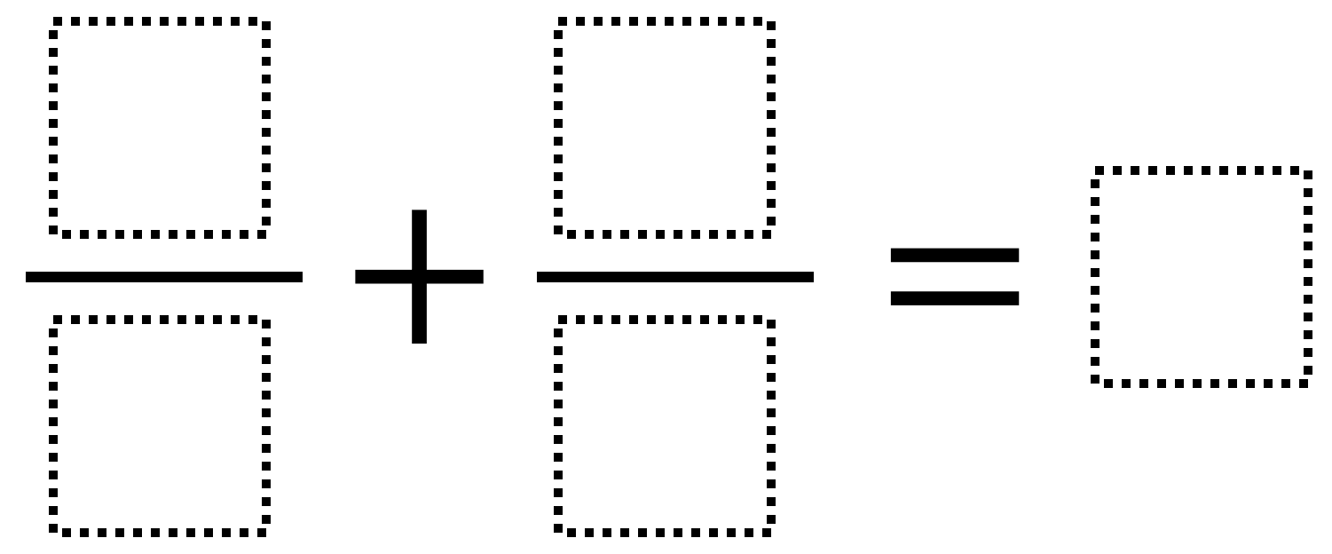
‘Adding fractions 6’ by Open Middle is licensed under CC BY-NC-SA 4.0.

Assessment and differentiation

Suggested opportunities for differentiation
Explore
- If students are quick to generalise the concept or have previously learned to add fractions with different denominators, they can be challenged to remove the Desmos graph sooner.
- Students could be challenged to complete the same processes in the example but with algebraic numerators.
Summarise
- Area models for adding fractions could be used, where the 1st denominator is rows, 2nd denominator is columns. This is a nice visual tool, however students haven’t yet dealt with multiplication or area, which should be considered when using area models.
Apply
- If students are quick to complete the puzzle. More can be found at Open Middle (www.openmiddle.com).
- Replace the + with a – to provide a simple extension opportunity.
- Students could be challenged to create their own ‘fill in the digits’ puzzle for adding or subtracting fractions.

Suggested opportunities for assessment
- The launch is an opportunity to assess any misconceptions students have developed. These should be addressed prior to adding fractions with different denominators.
- Review students’ solutions and notes to future forgetful selves.
- Create an exit ticket where students need to add or subtract 2 fractions with different denominators.
- Have students submit digitally or print out their individual work from activity 2 in the applied section of the lesson.
Appendix A

Adding and subtracting fractions
- Evaluate each expression.
- $\frac{1}{5}+\frac{1}{3}$
- $\frac{1}{3}-\frac{1}{5}$
- $\frac{1}{2}+\frac{1}{3}$
- $\frac{1}{2}-\frac{1}{3}$
- Evaluate each expression.
- $\frac{3}{5}+\frac{4}{3}$
- $\frac{3}{5}-\frac{4}{3}$
- $1\frac{1}{5}+\frac{2}{3}$
- $2\frac{1}{4}-\frac{5}{4}$
- Fill in each missing fraction to make each equation true:
- $\frac{1}{6}+\frac{}{}=\frac{5}{11}$
- $\frac{5}{6}-\frac{}{}=\frac{5}{11}$
- $\frac{2}{3}+\frac{}{}=1\frac{2}{15}$
- $1\frac{3}{7}-\frac{}{}=\frac{22}{35}$
- Alice and Bob are making a pizza. They have 2 different kinds of cheese, mozzarella and cheddar.
On her pizza, Alice uses $\frac{3}{4}$ cup of the mozzarella cheese and $\frac{1}{3}$ cup of the cheddar cheese.
On his pizza, Bob uses $\frac{1}{2}$ cup of the mozzarella cheese and $\frac{2}{5}$ cup of the cheddar cheese.
How many cups of cheese will they use in total? Express your answer as a mixed number in lowest terms.
- Find the perimeter of each shape:
- 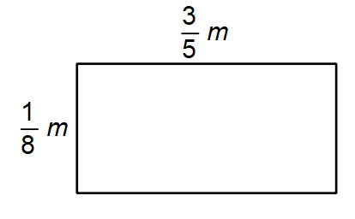
- 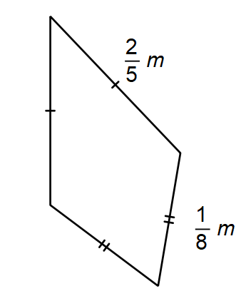
- 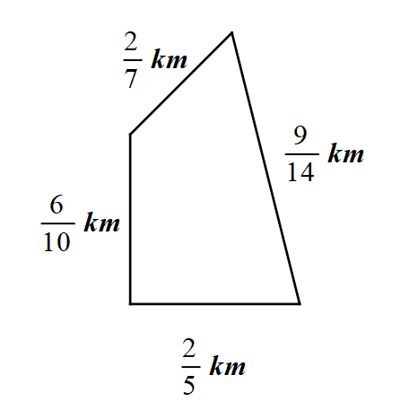

Sample solutions

Appendix A – adding and subtracting fractions

- $\frac{8}{15}$
- $\frac{2}{15}$
- $\frac{5}{6}$
- $\frac{1}{6}$

- $\frac{29}{15}=1\frac{14}{15}$
- $-\frac{11}{15}$
- $1\frac{13}{15}$
- $1$

- $\frac{19}{66}$
- $\frac{25}{66}$
- $\frac{7}{15}$
- $\frac{4}{5}$
- $\frac{3}{4}+\frac{1}{3}+\frac{1}{2}+\frac{2}{5}$
$$\frac{119}{60}$$
There are many ways to simplify the above expression. Students should compare methods with a partner.

- $\frac{1}{8}+\frac{1}{8}+\frac{3}{5}+\frac{3}{5}$$$\frac{2}{8}+\frac{6}{5} \\ \frac{1}{4}+\frac{6}{5} \\ \frac{5}{20}+\frac{24}{20} \\ \frac{29}{20} \\ 1\frac{9}{20} m$$
- $\frac{1}{8}+\frac{1}{8}+\frac{2}{5}+\frac{2}{5}$$$\frac{2}{8}+\frac{4}{5} \\ \frac{1}{4}+\frac{4}{5} \\ \frac{5}{20}+\frac{16}{20} \\ \frac{21}{20} \\ 1\frac{1}{20} m$$
- $\frac{2}{7}+\frac{9}{14}+\frac{2}{5}+\frac{6}{10}$$$\frac{4}{14}+\frac{9}{14}+\frac{4}{10}+\frac{6}{10} \\ \frac{13}{14}+\frac{10}{10} \\ \frac{13}{14}+1 \\ 1\frac{13}{14} km$$

Apply
There are many answers. Here are 3 possibilities:
$\frac{8}{2}+\frac{9}{3}=7$ , $\frac{3}{1}+\frac{4}{2}=5$ , $\frac{2}{4}+\frac{3}{6}=1$

References
This resource contains NSW Curriculum and syllabus content. The NSW Curriculum is developed by the NSW Education Standards Authority. This content is prepared by NESA for and on behalf of the Crown in right of the State of New South Wales. The material is protected by Crown copyright.
Please refer to the NESA Copyright Disclaimer for more information https://educationstandards.nsw.edu.au/wps/portal/nesa/mini-footer/copyright.
NESA holds the only official and up-to-date versions of the NSW Curriculum and syllabus documents. Please visit the NSW Education Standards Authority (NESA) website https://educationstandards.nsw.edu.au/ and the NSW Curriculum website https://curriculum.nsw.edu.au/home.
Mathematics K–10 Syllabus © NSW Education Standards Authority (NESA) for and on behalf of the Crown in right of the State of New South Wales, 2022.

© State of New South Wales (Department of Education), 2023
The copyright material published in this resource is subject to the Copyright Act 1968 (Cth) and is owned by the NSW Department of Education or, where indicated, by a party other than the NSW Department of Education (third-party material).
Copyright material available in this resource and owned by the NSW Department of Education is licensed under a Creative Commons Attribution 4.0 International (CC BY 4.0) licence.
This licence allows you to share and adapt the material for any purpose, even commercially.
Attribution should be given to © State of New South Wales (Department of Education), 2023.
Material in this resource not available under a Creative Commons licence:
- the NSW Department of Education logo, other logos and trademark-protected material
- material owned by a third party that has been reproduced with permission. You will need to obtain permission from the third party to reuse its material.
Links to third-party material and websites
Please note that the provided (reading/viewing material/list/links/texts) are a suggestion only and implies no endorsement, by the New South Wales Department of Education, of any author, publisher, or book title. School principals and teachers are best placed to assess the suitability of resources that would complement the curriculum and reflect the needs and interests of their students.
If you use the links provided in this document to access a third-party's website, you acknowledge that the terms of use, including licence terms set out on the third-party's website apply to the use which may be made of the materials on that third-party website or where permitted by the Copyright Act 1968 (Cth). The department accepts no responsibility for content on third-party websites.

