Same same
Students build understanding of how and why fractions with common denominators can be added.

Visible learning

Learning intention
- To be able to add and subtract fractions with the same denominator.

Success criteria
- I can represent fractions on a number line.
- I can add and subtract fractions with the same denominator.

Syllabus outcomes
A student:
- develops understanding and fluency in mathematics through exploring and connecting mathematical concepts, choosing and applying mathematical techniques to solve problems, and communicating their thinking and reasoning coherently and clearly MAO-WM-01
- represents and operates with fractions, decimals and percentages to solve problems MA4-FRC-C-01
Mathematics K–10 Syllabus © NSW Education Standards Authority (NESA) for and on behalf of the Crown in right of the State of New South Wales, 2022.

Activity structure

Warm up
There are 2 suggested warm-ups for this activity. Both act as revision of equivalent fractions.

Fraction bingo
This activity requires access to fraction wall sets or you can use Appendix D ‘Fraction wall’ as a printed handout and have students colour-in instead of taking away fractions. Alternatively, a virtual fraction wall could also be used (visnos.com/demos/fraction-wall).
This warm-up is a game where the students use dice to create fractions. These fractions or equivalent fractions can be eliminated from the fraction wall. The first to completely clear the board is the winner.
Figure 1 – fraction wall and 2 ten-sided dice
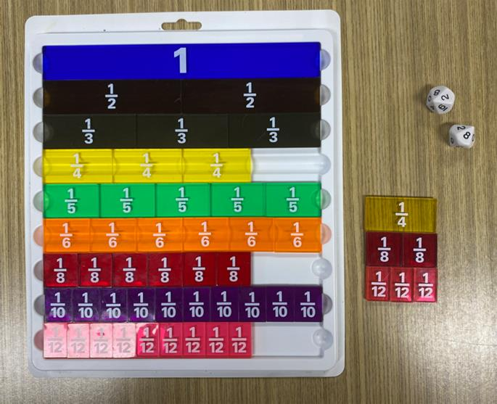
- Roll two 10-sided dice either physically or using virtual manipulatives such as Mathigon Polypad (mathigon.org/polypad#polyhedral-dice). The lower number is always the numerator and the higher, the denominator. For example, if an 8 and 2 are rolled then the fraction is $\frac{2}{8}$.
- Students then remove either 2 eighth pieces or an equivalent fraction from their fraction wall. For example: $\frac{1}{4}$ could be taken out or $\frac{2}{8}$ or $\frac{3}{12}$, but only one of those options.
- The goal is to be the first to clear out your fraction wall and call out Bingo!
You can use whichever dice you have available; however, this will impact the fractions that can be rolled.
A brief discussion about which fractions can be rolled using the chosen dice could be part of explaining the rules. For example, on two 10-sided dice the only way to remove twelfth pieces is by using an equivalent fraction.

Buzz game
- Have the entire class stand in a circle.
- Call out a fraction that the class will count by, for example $\frac{1}{4}$.
It is important to guide the language used by students carefully in this activity. Students should be encouraged to say, ‘one quarter’ and avoid saying ‘one over four’. This extends to other fractions, for example $\frac{3}{5}$ should be read as ‘three fifths’. This language supports students seeing fractions as a quantity, a number in its own right, as opposed to 2 separate numbers.
- Students then take turns by saying the next number in the sequence. For example, randomly select a student to begin and they would say $\frac{1}{4}$. The student next to them would then say $\frac{2}{4}$, and so on. Students should count in mixed numbers.
- When a student says a fraction that can be simplified, they must do so with a hand on their head, so that other students recognise the fraction has been simplified. For example, the students who say $\frac{1}{2}$, $1$, $1\frac{1}{2}$, and so on, should do so with a hand on their head.
- The game can then be played with a variety of rules such as:
- Starting back at zero again and counting by a different fraction.
- Reverse play and have students subtract.
- Using elimination when students get the fraction incorrect or forget to put their hand on their head for a fraction that is equivalent to an integer, depending on your students.

Launch
- Display Figure 2, explaining that it is a ruler with 3 different sized nails displayed on it labelled A, B and C. This is slide 2 in the Same same PowerPoint.
Figure 2 – ruler with nails
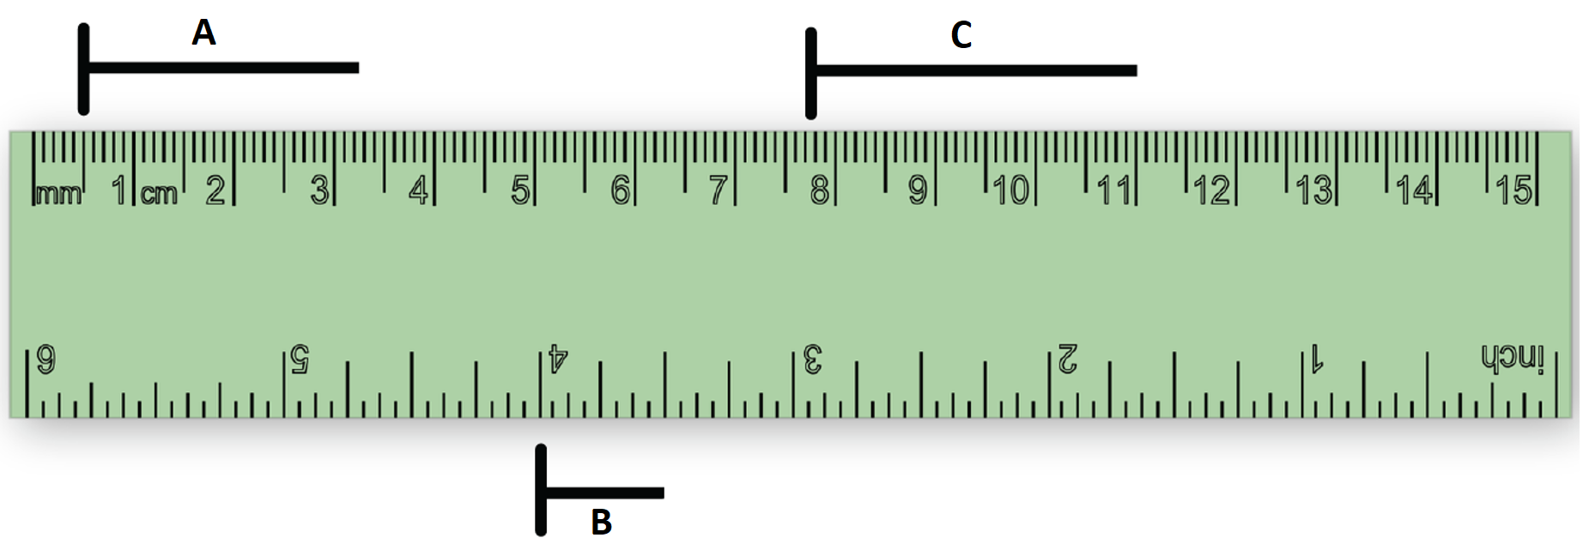
- Ask students the question: Which nail is closest to $3\frac{1}{4}$ cm in length?
- Students should think independently before discussing with a partner.
- To see student responses, use a finger vote with the class where they hold up one finger if they believe nail A is closest to $3\frac{1}{4}$ cm, hold up 2 fingers to vote for nail B and hold up 3 fingers to vote for nail C.
- Ask students to share the strategies they used to find the $3\frac{1}{4}$ cm nail through a class discussion using the Pause-Pose-Pounce-Bounce question strategy ([PDF 200KB] bit.ly/pausepouncebounce).

Explore

Explicit teaching
- Display the Same same PowerPoint.
- Print and distribute Appendix A ‘Your turn problems’, to each student. Students will complete these as you work through the PowerPoint.
- Use slides 3–14 from the Same same PowerPoint for explicit teaching of adding and subtracting fractions with the same denominator using vectors on a number line.
The explicit teaching technique used in the associated PowerPoint is ‘Your turn.’ The first slide is a worked example which should be displayed for the students and then use the following steps.
- Reveal the question to students and its solution.
- Students read in silence.
- Students individually think and explain to themselves what is happening in each step.
- Students hold up a thumbs up to the teacher when they have finished reading and have some sort of understanding.
- Think-Pair-Share. Students explain the solution to their partner.
- In pairs, students then answer the self-explanation questions.
- Finally, randomly select students to share their answers with the whole class.
- Students should then complete the ‘Independent practice’ problems from Appendix A.

Summarise
- Pose the following set of questions and have students write notes to their future forgetful selves (bit.ly/notesstrategy) on how to add each type of question. These can be displayed using slide 15 of the Same same PowerPoint.
- $\frac{1}{5}+\frac{2}{5}$
- $\frac{2}{5}-\frac{1}{5}$
- $\frac{1}{5}-\frac{2}{5}$
- $1\frac{1}{5}+\frac{2}{5}$
Make it clear that students can draw a number line to help in adding and subtracting fractions. The goal is to picture $\frac{1}{5}+\frac{2}{5}$ in their minds, so that they understand why $\frac{3}{5}$ is the solution.
- Using a questioning technique, ask students to share some of their notes to future selves. When doing this be sure to build on their responses to explicitly summarise the key takeaway of the lesson:
If fractions have the same denominator we can add and subtract numerators because they are the same unit.
You might like to develop an informal definition, such as: If the ‘how much’ is the same ($\frac{}{4}+\frac{}{4}$), we can add, and add the ‘how many’ ($\frac{2}{}+\frac{1}{}$).
- Print and distribute Appendix B ‘Adding and subtracting fractions worksheet’, which contains practice questions for students to work through independently.
The number lines from Appendix B could be printed, placed in plastic pockets and adhered to a wall, so that students can write with whiteboard markers at vertical non-permanent surfaces (bit.ly/VNPSstrategy).
- Students should be prompted to check their answers with another student who has finished.

Apply

Complementary events
This apply section assumes students have seen probability prior to this lesson. If this is not the case, the apply could still be used with additional scaffolding or an alternative application could be used.
- Print and distribute Appendix C ‘Complementary events’.
- Remind students of the definition of complementary events in probability: ‘Two events are said to be complementary when one event occurs if and only if the other does not. The probabilities of 2 complementary events add up to one’.
- Write the following prompts on the board (from slide 15 in the PowerPoint):
- The probability of rolling a 6 on a 6-sided die is $\frac{1}{6}$.
- The probability of rolling an even number on a 6-sided die is $\frac{3}{6}$.
- The probability of being born on a weekday is $\frac{5}{7}$.
Note, these are all theoretical probabilities. Students may recognise that the probability of being born on a weekday is not as simple as five days out of seven. This can be discussed and explored, while still using the theoretical probabilities for this problem.
- Instruct students to represent each event and its complement on the number lines provided, using vectors, as they have done previously in this lesson. Suggested solutions are in the associated PowerPoint (slides 17–19).

Desmos summary
- Assign devices, one between each pair.
- Direct students to the Desmos activity ‘Adding fractions with the same denominator’ (bit.ly/desmossamedenominators).
- Students work through the activity, discussing each slide with their partner.

Assessment and differentiation

Suggested opportunities for differentiation
- By starting with an activity using a fraction wall, students should be encouraged to use these manipulatives throughout the lesson.
- Best practice is to model the use of correct vocabulary; however, students might benefit from developing their own informal definitions when working with fractions. Defining the numerator as ‘how many’ and the denominator as ‘how much’ or ‘the size of the piece’ could be used as interim definitions.
- If students are struggling to place fractions on a number line, the ‘Animal rescue’ game (bit.ly/animalrescuegame) could be used to build their confidence.
- Students can be extended throughout the lesson by incorporating algebraic numerators.

Suggested opportunities for assessment
- By moving about the classroom during the warm-up activity, teachers can assess students’ understanding of equivalent fractions.
- Notes to future forgetful self could be collected to form part of the summative assessment for this unit. These notes could also be brought back after a while and used to answer questions on an exit slip or quick quiz.

Appendix A

Your turn problems
- How would you represent 2 x 5?
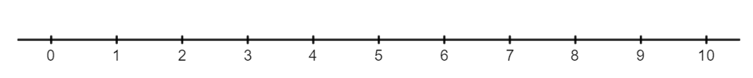
- How would you represent $\frac{2}{6}+\frac{1}{6}$?
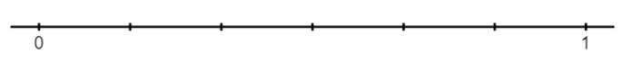
- How would you represent $\frac{4}{6}-\frac{1}{6}$?

Independent practice
Represent each expression on the number line provided.
- $\frac{1}{2}+\frac{1}{2}+\frac{1}{2}$
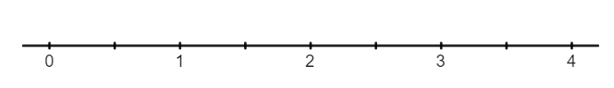
- $\frac{1}{2}-\frac{1}{2}-\frac{1}{2}$
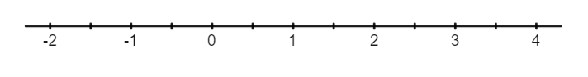
- $2-\frac{1}{4}+\frac{3}{4}$
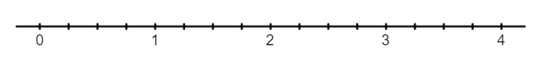
- $3-1\frac{1}{3}+\frac{2}{3}$

Appendix B

Adding and subtracting fractions worksheet
- Evaluate each expression:
- $\frac{1}{4}+\frac{2}{4}$
- $\frac{3}{4}-\frac{1}{4}$
- $\frac{2}{9}+\frac{7}{9}$
- $\frac{7}{9}+\frac{5}{9}$
- $\frac{7}{9}-\frac{5}{9}$
- $\frac{4}{9}-\frac{3}{9}$
- $\frac{5}{8}-\frac{3}{8}+\frac{1}{8}$
- $\frac{3}{8}+\frac{2}{5}+\frac{2}{8}+\frac{1}{5}$
- $1\frac{3}{8}+\frac{2}{8}-1\frac{1}{8}$
- $\frac{2}{5}+\frac{3}{8}+1\frac{1}{5}-\frac{5}{8}$
- Fill in each missing fraction to make each equation true:
- $\frac{1}{5}+\frac{}{}=\frac{4}{5}$
- $\frac{6}{7}-\frac{}{}=\frac{3}{7}$
- $\frac{4}{5}+\frac{}{}=\frac{3}{5}$
- $\frac{2}{7}+\frac{}{}+\frac{}{}=1\frac{1}{5}$
- $\frac{2}{7}+\frac{}{}-\frac{}{}=1\frac{1}{5}$
- $1\frac{5}{7}+\frac{}{}-\frac{}{}=1\frac{3}{5}$
- Find the perimeter of each shape:
- 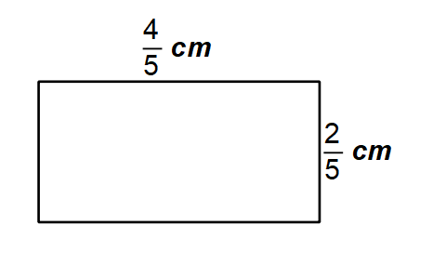
- 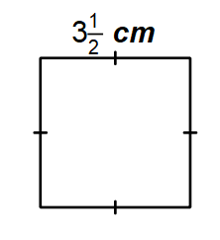
- 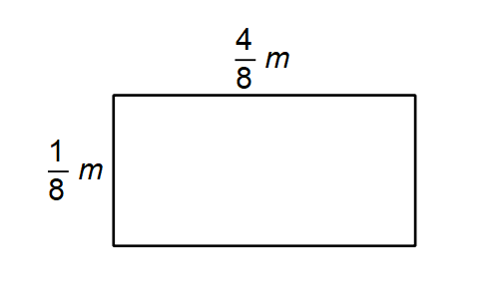

Appendix C

Complementary events
Represent each event and its complement on the number lines.
The probability of rolling a 6 on a 6-sided die is $\frac{1}{6}$.
The probability of rolling an even number on a 6-sided die is $\frac{3}{6}$.
The probability of being born on a weekday is $\frac{5}{7}$.

Appendix D

Fraction wall
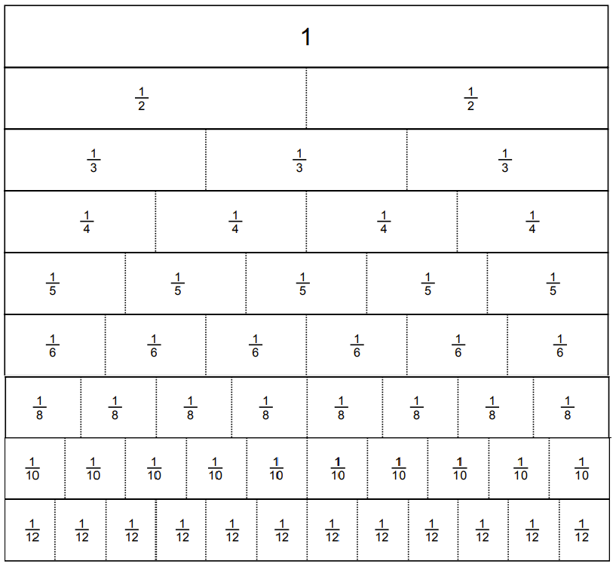

Sample solutions

Appendix A – your turn problems
- 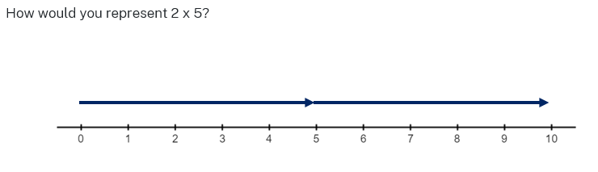
- 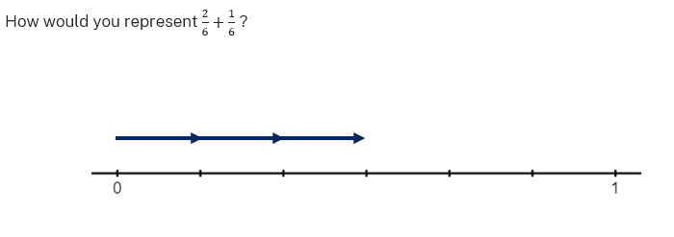
- 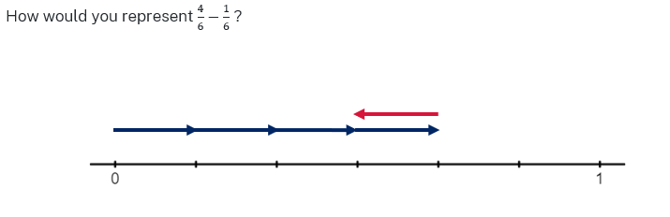

Appendix B – adding and subtracting fractions

- $\frac{3}{4}$
- $\frac{2}{4}=\frac{1}{2}$
- $\frac{9}{9}=1$
- $\frac{12}{9}=\frac{4}{3}$
- $\frac{2}{9}$
- $-\frac{1}{9}$
- $\frac{3}{8}$
- $\frac{5}{8}+\frac{3}{5}$
- $\frac{4}{8}=\frac{1}{2}$
- $1\frac{3}{5}-\frac{2}{8}$

- $\frac{1}{5}+\frac{3}{5}=\frac{4}{5}$
- $\frac{6}{7}-\frac{3}{7}=\frac{3}{7}$
- $\frac{4}{5}+\frac{-1}{5}=\frac{3}{5}$
- $\frac{2}{7}+\frac{5}{7}+\frac{1}{5}=1\frac{1}{5}$
- $\frac{2}{7}+1\frac{1}{5}-\frac{2}{7}=1\frac{1}{5}$
- $1\frac{5}{7}+\frac{2}{7}-\frac{2}{5}=1\frac{3}{5}$

- $\frac{4}{5}+\frac{4}{5}+\frac{2}{5}+\frac{2}{5}$$$\frac{12}{5} \\ 2\frac{2}{5} cm$$
- $3\frac{1}{2}+3\frac{1}{2}+3\frac{1}{2}+3\frac{1}{2}$$$12+2 \\ 14 cm$$
- $\frac{1}{8}+\frac{1}{8}+\frac{4}{8}+\frac{4}{8}$$$\frac{10}{8} \\ 1\frac{2}{8}$$$1\frac{1}{4}$

Appendix C – complementary events
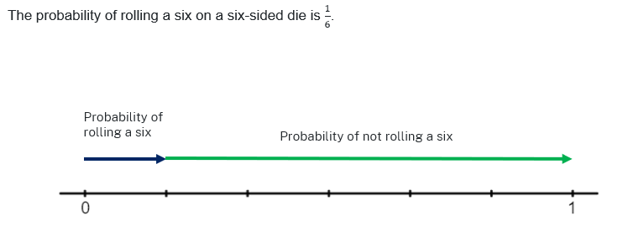
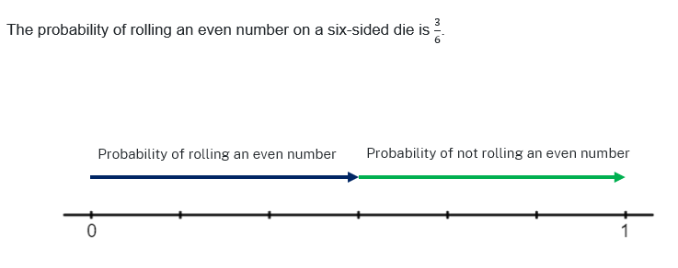
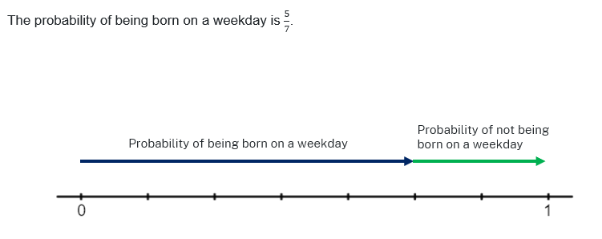

References
This resource contains NSW Curriculum and syllabus content. The NSW Curriculum is developed by the NSW Education Standards Authority. This content is prepared by NESA for and on behalf of the Crown in right of the State of New South Wales. The material is protected by Crown copyright.
Please refer to the NESA Copyright Disclaimer for more information https://educationstandards.nsw.edu.au/wps/portal/nesa/mini-footer/copyright.
NESA holds the only official and up-to-date versions of the NSW Curriculum and syllabus documents. Please visit the NSW Education Standards Authority (NESA) website https://educationstandards.nsw.edu.au/ and the NSW Curriculum website https://curriculum.nsw.edu.au/home.
Mathematics K–10 Syllabus © NSW Education Standards Authority (NESA) for and on behalf of the Crown in right of the State of New South Wales, 2022.
© State of New South Wales (Department of Education), 2023
The copyright material published in this resource is subject to the Copyright Act 1968 (Cth) and is owned by the NSW Department of Education or, where indicated, by a party other than the NSW Department of Education (third-party material).
Copyright material available in this resource and owned by the NSW Department of Education is licensed under a Creative Commons Attribution 4.0 International (CC BY 4.0) licence.
This licence allows you to share and adapt the material for any purpose, even commercially.
Attribution should be given to © State of New South Wales (Department of Education), 2023.
Material in this resource not available under a Creative Commons licence:
- the NSW Department of Education logo, other logos and trademark-protected material
- material owned by a third party that has been reproduced with permission. You will need to obtain permission from the third party to reuse its material.
Links to third-party material and websites
Please note that the provided (reading/viewing material/list/links/texts) are a suggestion only and implies no endorsement, by the New South Wales Department of Education, of any author, publisher, or book title. School principals and teachers are best placed to assess the suitability of resources that would complement the curriculum and reflect the needs and interests of their students.
If you use the links provided in this document to access a third-party's website, you acknowledge that the terms of use, including licence terms set out on the third-party's website apply to the use which may be made of the materials on that third-party website or where permitted by the Copyright Act 1968 (Cth). The department accepts no responsibility for content on third-party websites.

