Bonuses and penalties
Students learn to subtract integers in the context of receiving bonuses and penalties. Students explore the concept that receiving a bonus can be considered equivalent to removing a penalty. Students model contexts using black and red counters to model positive and negative numbers.

Visible learning

Learning intentions
- To subtract integers with or without the aid of a visual representation.
- To construct a directed number sentence to model a situation.

Success criteria
- I can use counters to represent positive and negative numbers.
- I can use counters to subtract directed numbers.
- I can write a directed number sentence for a given situation.

Syllabus outcomes
A student:
- develops understanding and fluency in mathematics through exploring and connecting mathematical concepts, choosing and applying mathematical techniques to solve problems, and communicating their thinking and reasoning coherently and clearly MAO-WM-01
- compares, orders and calculates with integers to solve problems MA4-INT-C-01
Mathematics K–10 Syllabus © NSW Education Standards Authority (NESA) for and on behalf of the Crown in right of the State of New South Wales, 2022.

Activity structure

Launch
- Display slide 2 from the Bonuses and Penalties PowerPoint or write the following on the board.
Figure 1 – equations
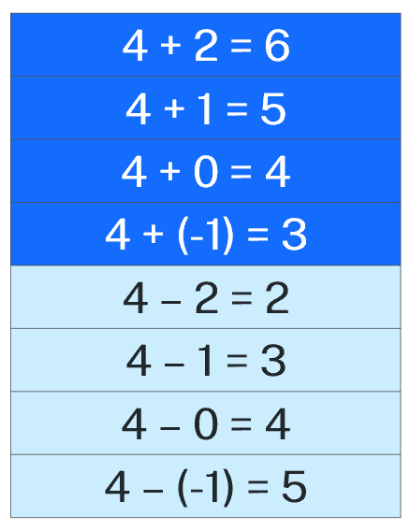
- In pairs, students should discuss what they notice and what they wonder (bit.ly/noticewonderstrategy).
- Select random pairs to share their thoughts.
- Challenge students to consider how they might represent each question using counters.
- Challenge students to think of a scenario for each one. For example, ‘I have $4 in my bank account, and I deposit another $2’.
- Explain to students that in this learning episode we will be exploring scenarios similar to the last question 4 − (-1) = 5.

Explore
- Verbally explain the following scenario to students. ‘Avery earns a flat rate of $5 pocket money a week. She can then earn ‘bonus’ money by doing extra jobs around the house but can also receive ‘penalties’ for forgetting to complete jobs. If she does a job particularly well or does a job that is not her responsibility, her mother will sometimes remove penalties.’
- Students will play the game ‘Bonuses and penalties’ as outlined below.

Bonuses and penalties

Equipment:
- 1 set of cards from Appendix A ‘Bonus and penalty cards’ per group.
- A collection of red and black counters (these can be physical counters, virtual counters using Polypad (mathigon.org/polypad#number-cards), or hand drawn on paper).

Game rules:
- Students play in randomly selected groups of 3.
- Each student begins with 5 black and 5 red counters.
- Students shuffle the cards and place them face down in the centre of the group.
- The first player selects a card and follows the card instructions, adjusting their counters accordingly. For example, ‘you vacuumed the house, 2 bonuses’ means that the player takes 2 black counters from the bank, while ‘you forgot to feed the dog, 1 penalty’ means you take a red counter.
- At the end of the game, each player receives $1 for each black counter and loses $1 for each red counter they have. The player with the most money wins.
This game has been adapted from Bonuses and penalties [PDF 119KB] (bit.ly/nzmathsbonuses) by NZ Maths.

- After students have finished playing, lead a class discussion so students can share anything they noticed during the game. Prompts could include:
- What did you do if you had no penalties to remove?
The game is designed to demonstrate that receiving a bonus is equivalent to removing a penalty. For instance, adding on 2 is equivalent to subtracting (-2).

Summarise
- Ask students to model the following questions using red and black counters:
- (-4) − (-2)
- (-4) + 2
- In a Think-Pair-Share (bit.ly/thinkpairsharestrategy), ask students to discuss why each question gives the same answer.
- Pick students at random to share their thoughts.
- Ask students to model the following question:
- 4 − (-2)
- Use slides 3–10 from the PowerPoint Bonuses and penalties to demonstrate how we deal with this situation.
- Students are to complete the questions from Appendix B ‘Using zero pairs’.

Apply

Connect 3
- Students are to play the NRICH game ‘Connect 3’ (bit.ly/nrichconnectthree).
Equipment
- Device with access to ‘Connect 3’ interactive game (bit.ly/nrichconnectthree).
or
- Printable game board, available at the website.
- Two spinners, one with the numbers 1, 2, 3, -4, -5, -6 and the second with the numbers -1. -2. -3, 4, 5, 6.
- Counters
Method
- Students play in pairs. Player 1 spins both spinners.
- They choose what order to place the numbers in and whether to add or subtract them to produce one of the totals shown on the board.
- They cover their selected total with a counter.
- Player 2 then takes their turn according to the rules above.
- The winner is the first person to place 3 of their counters in a straight line.
- Challenge students to consider the following questions:
- Some numbers can only be made in one way, but some can be made in many different ways.
- Can you work out the number of different ways of achieving each of the different totals?
- Does this influence the way in which you might choose to play the game?

Assessment and differentiation

Suggested opportunities for differentiation
Counters are used throughout this learning episode to assist in developing conceptual understanding. Students should be encouraged to continue using counters for as long as necessary.
Apply – integer Venns
- Two versions of this task have been created. The second, uses the same initial criteria from the two-circle version, but adds in an additional criteria to increase the complexity of the task.
- Students will find it easiest to fill sections A, B and C where they only need to satisfy one condition. They can then move on to D, E and F before considering sections G and H.
- Higher achieving students should be challenged to try and make as few changes to their sums between regions as possible.
- Students could be challenged to create their own criteria for an Integer Venn, complete with sample solutions.

Suggested opportunities for assessment
- Teachers should monitor student discussions and answers during class to assess their understanding and use of correct terminology.
- Teachers could choose to ask students to complete (using visual representations if necessary) an exit ticket containing a subtraction problem involving negative numbers.
- Teachers could choose to collect the Appendix B or C to check for understanding.
Appendix A

Bonus and penalty cards
You cooked dinner for the family  2 bonuses | You tidied your bedroom  1 bonus | You slept in  1 penalty
You were kicking a ball and broke a window  5 penalties | You babysat your little brother  Remove 2 penalties | You put the bin out  1 bonus
You cleaned up the kitchen  Remove 1 penalty | You missed the bus  1 penalty | You got 100% in your maths test  Remove 3 penalties
You emptied the dishwasher  2 bonuses | You mowed your neighbour’s lawn  Remove 2 penalties | You missed your music lesson  3 penalties
You walked the dog  1 bonus | You completed your homework early  Remove 1 penalty | You spent your lunch money on lollies  2 penalties
You did the ironing  2 bonuses | You lost your phone  4 penalties | You were put in detention at school  2 penalties

Appendix B

Using zero pairs
Question | Representation using counters | Answer
5 + 1
5 − (-1)
1 − (-5)
3 + 5
3 − (-5)
5 − (-3)
(-5) + 6
(-5) − (-6)
(-6) − (-5)
(-6) + 5
(-2) − (-3)
(-2) + 3
(-3) − (-2)
(-3) + 2

Appendix C

Integer Venns
Think of a 2 number subtraction sum that could belong in each region. If you think a region is impossible to fill, convince me why!
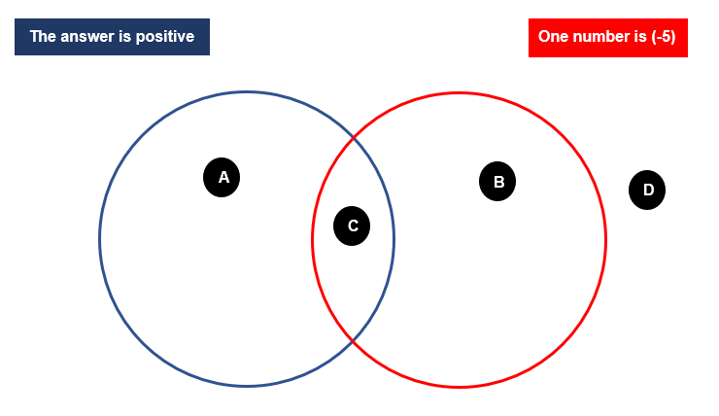

Think of a 2 number subtraction sum that could belong in each region. If you think a region is impossible to fill, convince me why!
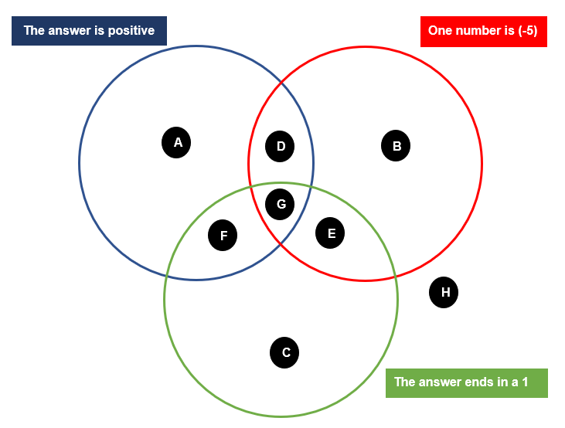

Sample solutions

Appendix B – using zero pairs
Question | Representation using counters | Answer
5 + 1 | 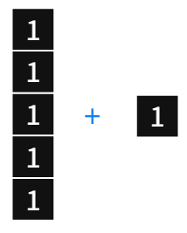 | 6
5 − (-1) | 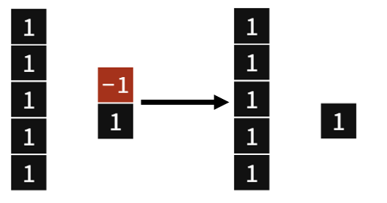 | 6
1 − (-5) | 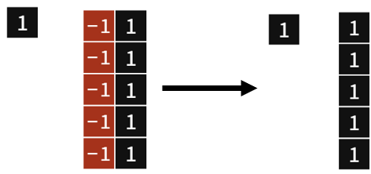 | 6
3 + 5 | 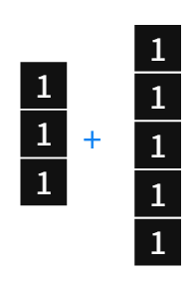 | 8
3 − (-5) | 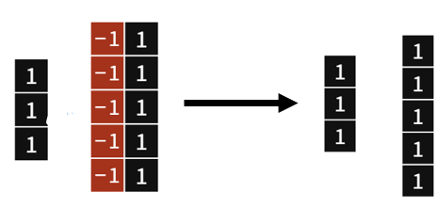 | 8
5 − (-3) | 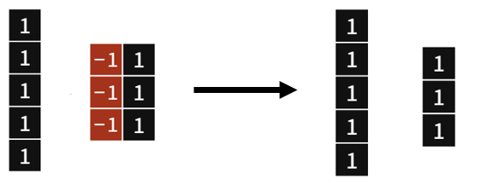 | 8
(-5) + 6 | 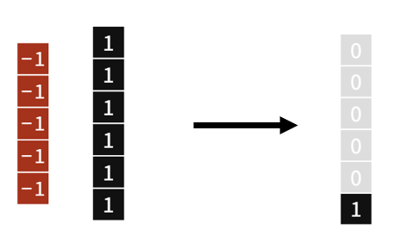 | 1
(-5) − (-6) | 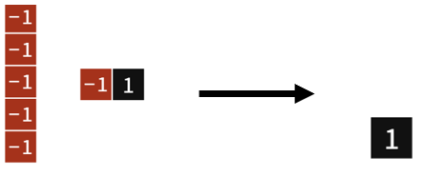 | 1
(-6) − (-5) | 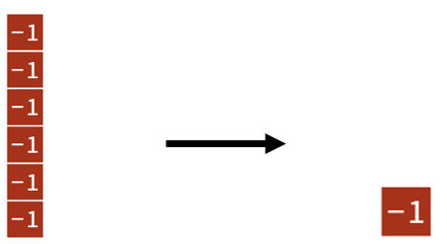 | (-1)
(-6) + 5 | 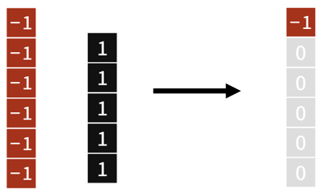 | (-1)
(-2) − (-3) | 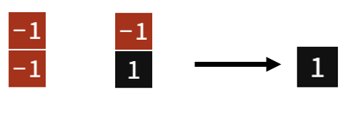 | 1
(-2) + 3 | 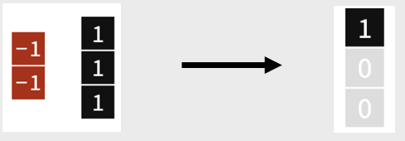 | 1
(-3) − (-2) | 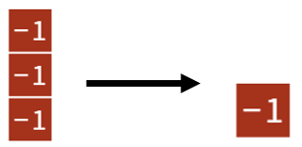 | (-1)
(-3) + 2 |  | (-1)
Images created using the free virtual manipulatives at Polypad.org.

Appendix C – integer Venns

Two circle Venn
Region A: 7 − (-10) = 17
Region B: (-5) + 2 = (-3)
Region C: (-2) − (-5) = 3
Region D: (-6) + 4 = (-2)

Three circle Venn
Region A: 7 − (-10) = 17
Region B: (-5) + 2 = (-3)
Region C: (-7) + (-4) = (-11)
Region D: (-2) − (-5) = 3
Region E: (-5) − 6 = -11
Region F: 7 − (-4) = 11
Region G: (-5) − (-6) = 1
Region H: (-6) + 4 = (-2)

References
This resource contains NSW Curriculum and syllabus content. The NSW Curriculum is developed by the NSW Education Standards Authority. This content is prepared by NESA for and on behalf of the Crown in right of the State of New South Wales. The material is protected by Crown copyright.
Please refer to the NESA Copyright Disclaimer for more information https://educationstandards.nsw.edu.au/wps/portal/nesa/mini-footer/copyright.
NESA holds the only official and up-to-date versions of the NSW Curriculum and syllabus documents. Please visit the NSW Education Standards Authority (NESA) website https://educationstandards.nsw.edu.au/ and the NSW Curriculum website https://curriculum.nsw.edu.au/home.
Mathematics K–10 Syllabus © NSW Education Standards Authority (NESA) for and on behalf of the Crown in right of the State of New South Wales, 2022.
© State of New South Wales (Department of Education), 2023
The copyright material published in this resource is subject to the Copyright Act 1968 (Cth) and is owned by the NSW Department of Education or, where indicated, by a party other than the NSW Department of Education (third-party material).
Copyright material available in this resource and owned by the NSW Department of Education is licensed under a Creative Commons Attribution 4.0 International (CC BY 4.0) licence.
This licence allows you to share and adapt the material for any purpose, even commercially.
Attribution should be given to © State of New South Wales (Department of Education), 2023.
Material in this resource not available under a Creative Commons licence:
- the NSW Department of Education logo, other logos and trademark-protected material
- material owned by a third party that has been reproduced with permission. You will need to obtain permission from the third party to reuse its material.
Links to third-party material and websites
Please note that the provided (reading/viewing material/list/links/texts) are a suggestion only and implies no endorsement, by the New South Wales Department of Education, of any author, publisher, or book title. School principals and teachers are best placed to assess the suitability of resources that would complement the curriculum and reflect the needs and interests of their students.
If you use the links provided in this document to access a third-party's website, you acknowledge that the terms of use, including licence terms set out on the third-party's website apply to the use which may be made of the materials on that third-party website or where permitted by the Copyright Act 1968 (Cth). The department accepts no responsibility for content on third-party websites.

